- Right click on empty space at Lotus Note Home page and select “Open Application”
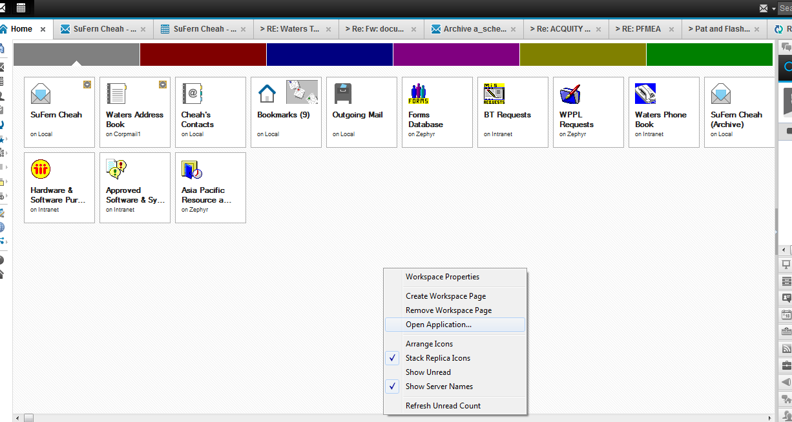
- Then, select “Zephyr” from the “Look in” drop down list.
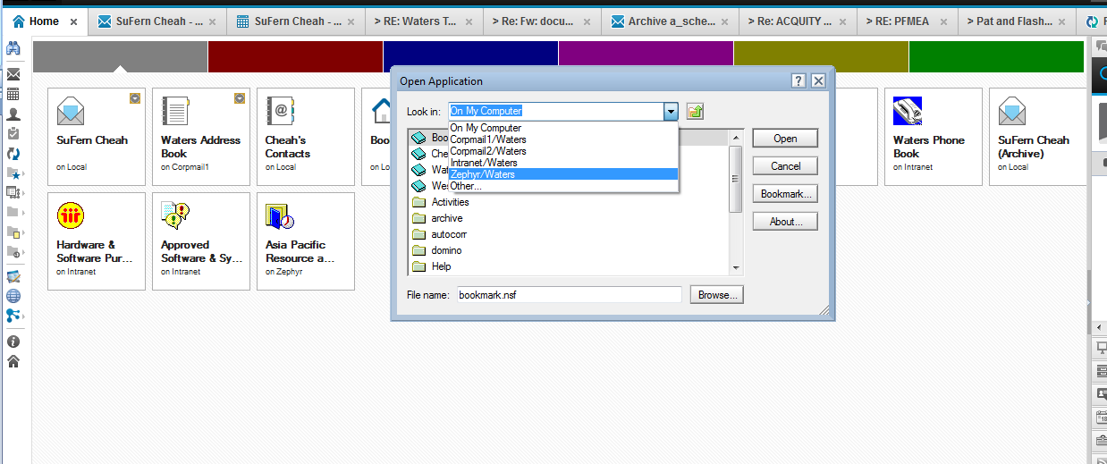
- Select “Form Database” ,then click “open”.
