Log on to Avaya IP Phone on Desktop

Step 1: Click ‘Start’ menu and check that you have the Avaya application installed on your computer
Note: If it is already installed on your computer, skip to Step 3
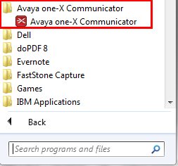

Step 2: Install Avaya application on your computer
Click on the setup exe file to start installation
The setup file can be found here
Once double clicked on the setup file, follow the instructions on the screen to complete installation
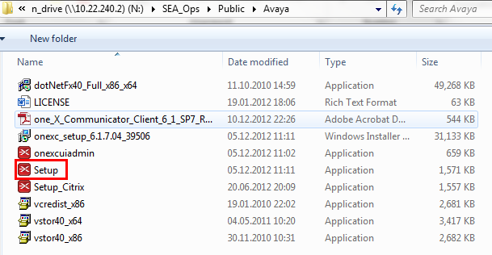

Step 3: Launch Avaya application
Locate the application within the Start menu and click on Avaya one-X Communicator

After launch, go right-top corner ‘setting’ and update server address below,
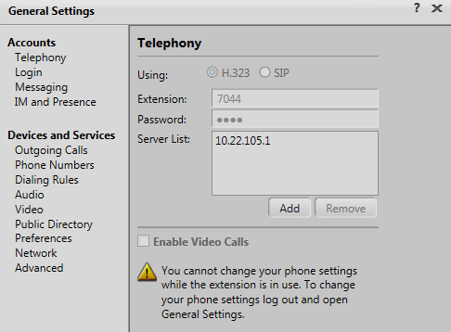

Step 4: Log on to your extension
Key in your extension and enter the password (default password: 1235)
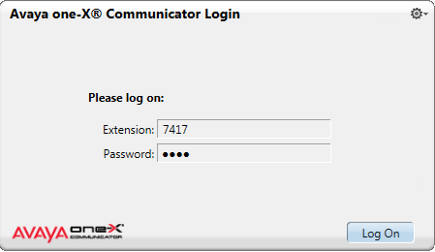

Click ‘Yes’
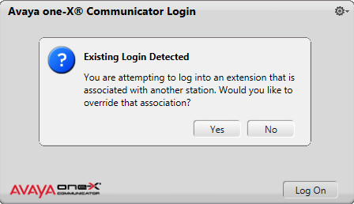

Step 5: Use your IP phone via the Avaya application on your desktop over the network (Internet/WIFI)
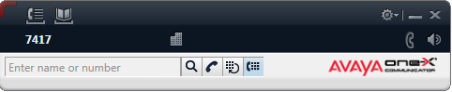

Step 6: Logging off
Click on the setting icon and select ‘Log Off’
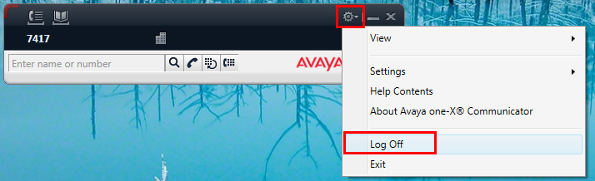

Step 7: Re-login on your Avaya phone
Press the # key on your phone
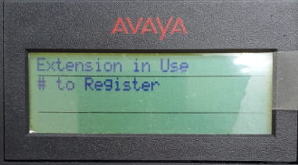

Then select ‘Yes’
