Content Table
1. Purpose 2
2. Scope 2
3. Definitions and Abbreviations 2
4. Roles and Responsibilities 2
5. References / Related Documents 2
6. Forms 3
7. Health & Safety 3
8. Procedure 4
9. Appendices / Attachments 21

Purpose
1.1 The purpose of this Work Instruction is to effectively document the steps an individual (Originator) will perform to:
- Find and use the correct Global Quality Document Template
- Edit the Word file in SAP
- Create a Document Information Record (DIR) in SAP
- Populate the necessary data fields of the DIR
- Create a Distribution List
- Submit the DIR for review
- Submit the DIR for approval

1.2 This document must be used in conjunction with Quality Document 730000295MP (Quality
System Document Control), which provides policy information about Quality Documents. Information contained in 730000295MP will not be repeated in this work instruction.

scope
The scope of this Work Instruction applies to Quality Documents that are part of Waters’ Milford Quality
Management System Documentation. It also applies to Global Quality Documents created at Waters’
Manchester, UK; Taunton, MA and Wexford, IR sites. It is limited to Document Type QAX (Policy,
Operating Procedure, Work Instruction, Forms / Reports).

definitions and Abbreviations
Refer to Definitions section in document 730000295MP.
Term | Definition / Abbreviation
N/A | N/A

roles and responsibilities
Roles | Responsibilities
Originator | Person responsible for reading and understanding Quality Document 730000295MP  (Quality System Document Control).
All other roles / responsibilities are described in the corresponding section within document 730000295MP.

references / related documents
Doc No: | Document Title
730000525 | WI – Establishing a Temporary Substitute in SAP
730000630 | Waters GDC Record Keeping Procedure
730000737 | WI - RDE Data Services Guide for Review
730000827 | Index of DMS-related SAP Administrative Functions
730000295MP | Quality System Document Control
730000326MP | Corporate Electronic Records & Electronic Signatures Policy – 21 CFR Part 11
WAT000050MP | Waters Record Retention Corporate Policy
730000489 | WI - Milf/Tn QAX Quality Docs – Reviewer
730000490 | WI - Milf/Tn QAX Quality Docs – Approver

forms
Doc No: | Document Title
730000483 | Global Work Instruction / Operating Procedure Template
730001103 | Global Policy Template
730001104 | Global Report / Form Template

Health & Safety
No Health & Safety specific considerations.

Equipment/Materials of use Required - Not Applicable

procedure

Process Workflow (creation to release)
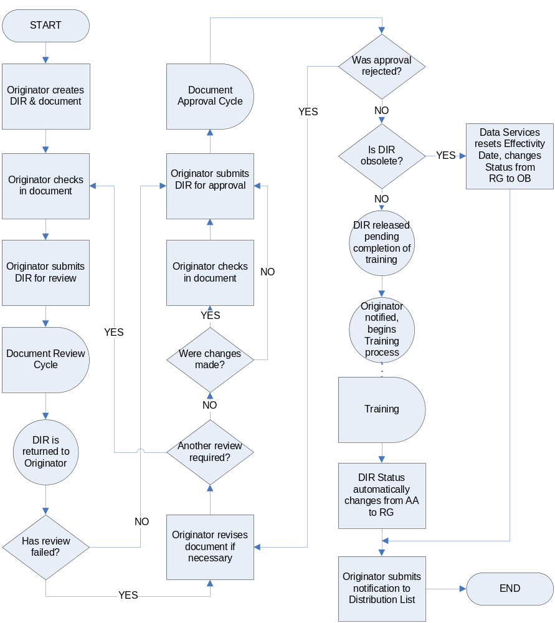

General Information

The Document Type has a predetermined signature network based on Lab/Office.

The Sub-Document Type is determined using the following guidelines:

Policy (POLICY) – a high-level document that provides interpretation of a regulation or standard and provides rules, objectives or guidance on the purpose or operation of the subject

Procedure (PROCED) – a series of interrelated steps that control a logically distinct process or activity. This may be in the form of text only or text and a flow diagram.

Work Instructions (WKINST) – a series of detailed interrelated steps that control a logically distinct process or activity. Work Instructions are more detailed than a Procedure, and may include keystroke-by-keystroke instructions. This may be in the form of text only or text and a flow diagram.

Form (FORMS) – a document for information to be inserted into, or provides information to support business operations; reference documents. (templates, logs, etc.)

Three (3) Core Reviewer roles are assigned to each Quality Document: the Process Owner, Quality Systems and Configuration Analyst. Additional Reviewers may be added as needed. Additional Reviewers without a unique SAP ID will be required to do an offline review. For reference, their comments may be converted to a PDF and attached to Services For Objects. Reference Section 8.2.4.2 for instructions.

Three (3) Core Approval roles are assigned to each Quality Document: the Process Owner Quality Systems and Configuration Analyst. No additional Approvers may be added.

All Core Reviewers and Approvers must complete Electronic Signature Training, an LMS Training Session accessible on the portal. In order to acquire the appropriate Authorization Roles and Signature Strategy, and IT Request must be submitted. Refer to the LMS Training Session for instructions.

A new Lab/Office requires configuration within SAP which must follow a particular protocol. It must go through development and testing before it can be implemented in production. There is a delay inherent in this process.

The template used for creating and revising Quality Documents may be found in SAP: document 730000483 for Sub-Document Types PROCED, WKINST; document 730001103 for Sub-Document Type: POLICY; 730001104 for Sub-Document Type: FORMS.
- Requirements for creating Sub-Document Type FORMS are that the form, or template, contains a document number and version, indicate the Policy, Procedure, Work Instruction to which it refers, and follows a defined review and approval process. Any document submitted in a format inconsistent with the current template and requirements will be rejected.

Creating, revising and/or approving a Quality Document requires a unique SAP ID.

In order to receive an email notification in Lotus Notes, Originators, Reviewers and Approvers must establish an Automatic Forward in their SAP Business Workplace. See Quality Document 730000497 (WI – Establishing an Automatic Forward from an SAP Business Workplace) for detailed instructions.

To help prevent delays in processing DIR-related tasks, a Temporary Substitute should be arranged before a planned absence. See Quality Document 730000525 (WI – Establishing a Substitute in SAP).
- It is recommended that all users creating and/or revising Quality Documents have a folder c:\PLMworkspace on their hard drive. Documents should be saved to this folder and attached to DIRs from this folder. This provides uniformity in the source names.

Once the last approval has been entered, the DIR status will automatically change to AA (Approved Awaiting Release), and the Effectivity Date will be determined by the number of days in the default Effectivity Period. This delay before release is necessary to complete training for all affected individuals.

Process Details – each subsection relates to a step in Section 8.1 - Process Workflow

Originator creates DIR and document

Creating a DIR for the initial release of a new Quality Document (if creating a new version of an existing DIR, proceed to Step 8.2.1.2; if obsoleting a DIR, follow instructions outlined in Steps 8.2.1.2 – 8.2.1.3, then skip to 8.2.3.
- From the SAP Main Menu, use transaction CV01N (Create Document)
- Enter Document Type QAX, leaving all other fields blank
- Enter Class Code 730 and press ENTER
- SAP will automatically assign a six-digit Core Number
- Note that the field for Suffix is greyed out as it is no longer used for new DIRs
- Press ENTER or click the OK button
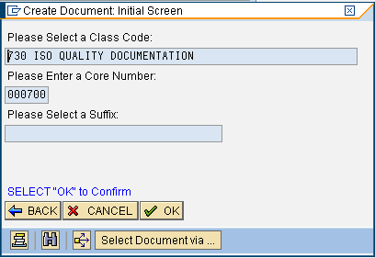
- Proceed to Step 8.2.1.3

Creating a new version of an existing DIR (if creating the initial release of a new DIR, go back to Step 8.2.1.1).
- From the SAP Main Menu, use transaction CV04N (Find Document)
- Enter search criteria to find your DIR/document and click the Execute button
- Double-click the Version you want to “copy,” most likely the one at Release General status
- From the menu select Document, New Version
- No changes are required to the pop-up window. Click the green check mark or press the ENTER key to continue.
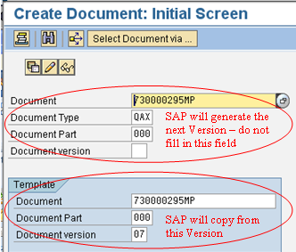
- You will receive a confirmation pop-up window. Click the Continue button.
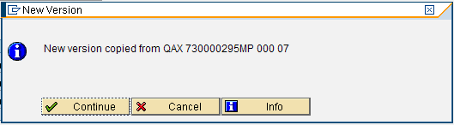
- You may receive a pop-up window where you will select which Object Links you want to copy. Only the Document Info Record link should be listed. Click the green check mark or press the ENTER key to continue.
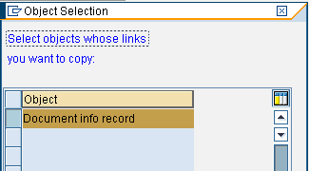
- From the Document Data tab, delete the PDF file(s) attached to the DIR.
  - Click once on the PDF to highlight it, then click the trashcan icon at the bottom of the screen.
  - If obsoleting the document, delete all file(s) attached to the DIR.

Entering and changing data in the DIR fields
These steps are followed whether creating an initial release, creating a new version of an existing DIR, or obsoleting a DIR. If you are creating a new version of an existing DIR, some fields described may already contain data. Leave the data as is or change the data, as appropriate.

- From the Document Data tab:
  - enter the Description (name or title of the document) – There is a 40-character maximum so you may need to abbreviate
  - use the matchcode to select the appropriate Lab/Office
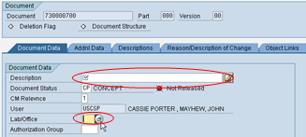
  - If you don’t know the Lab/Office, you may use the 24-Month Procedures List found on the world drive at \world\quality\24-Month Procedure Master List.

- From the Additional Data tab use the matchcodes to select the:
  - Review-by Date, by which all Reviewers should complete their task
  - Effectivity Date, if entered, will be overwritten by the default effectivity period
  - Sub-Document Type
  - Project Code, always N/A for QAX DIRs
  - Model Code, always N/A for QAX DIRs
  - Additional Reviewers (optional) – see Section 8.3.1 for details

- From the Reason/Description of Change tab:
This tab contains a free-form text field that automatically creates an electronic stamp containing the SAP User ID, Date and Time that text was created. When text is saved, the system moves it into the upper half of the panel, which is read-only and cannot be modified. Additional text may be added to clarify or append to a previous entry, or it may be stand-alone text.
  - enter the text “Reason for Change:” and press ENTER to go to the next line.
  - enter information that explains why this document is being created or obsoleted. Why is it required? What purpose does it serve? If being obsolete, is it being replaced by or incorporated into another document?
  - press ENTER twice, enter the text “Description of Change:” and press ENTER to go to the next line.
  - enter information that explains what is to be done with this document. For an initial release, this need only contain the release information though additional text may be entered. (Release Document 730000xxx, Version xx to Status RG.)
- From the Object Links tab:
This tab contains all the documents that are referenced within your Quality Document and must also include current versions of 730000295MP, WAT000050MP and the template being used – 730000483. It establishes a link between them to easily identify relationships.
  - When obsoleting a document remove all document links. In all other instances, enter data as directed below.
  - Click the Document Info Record tab.
  - Click once in the blank Document field, use the matchcode to search for a referenced document, then double-click the highest released version.
  - Press the ENTER key to see and verify the document Description.
  - Repeat for all other referenced documents.

- From the Menu Bar at the top of the screen:
  - Select Environment, Document Distribution, Recipient List, Create
  - Press ENTER through the next screen
  - In the Description field, enter the Number of your document.
When you have completed the following steps, the Recipient List section will contain the names of all the individuals who are affected by or must comply to the document being created, and therefore must be trained to the document. These individuals must also be notified when a document is obsoleted. NOTE: In addition to your list of users, every Distribution List must include five representatives from Quality: RoseMarie Stamboulides, Dena Lewis, Anca Mirica, Jacqui Gill, Sabine Ternieden Beekes.

  - Click once in the Recipient Name field, then click the matchcode.
  - With Internal User selected, press the ENTER key or click the green check mark
  - Use the pop-up window to search for your first recipient, then click the green check mark. Press ENTER and the Description field will automatically be populated.
  - In the Type field, use the matchcode to choose RML.
  - Repeat for remaining individuals.
  - Click the Save icon at the top of the screen.

- Click the Display < - - > Change icon.
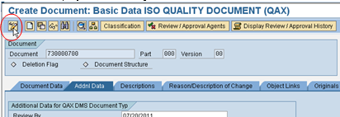
- Save Changes? Click Yes.

Creating the Word document (may also use other formats)
- Open another SAP session
- Use transaction CV04N to search for the appropriate global quality document template
  - Operating Procedure, Work Instruction = 730000483
  - Policy = 730001103
  - Report / Form = 730001104
- Double-click on the highest released version of the document
- Right-click once on the Word file and choose Copy To from the menu
- In Original field of the pop-up window, it is recommended you save the file to your PLMworkspace folder on the hard drive, changing the default Document Number to that of your new DIR, then click the green check mark to continue.
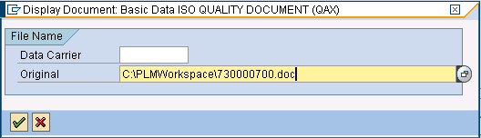
- Open the newly saved document and enter the information required in the header/footer and sections of the template.
  - Do not double-click the Original file to open it. This creates a copy of the Original file, and any changes will not be saved to the Original file.
  - To open the Original file, click it once to highlight it then click the Change Original icon.
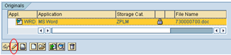
- Make changes to the document. When complete, save your changes and exit the document.

Originator checks in document

Attach the Word file to the DIR
- Use transaction CV04N to query your new DIR.
- From the query results, double-click the DIR to open it
- Click the Display < - - > Change icon
- Click the Open Original icon at the bottom of the screen. You may have to scroll down
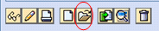
- Use the pop-up window to navigate to your PLMworkspace folder and choose your document. Click the document once to highlight it, then click the Open button, OR double-click the document.
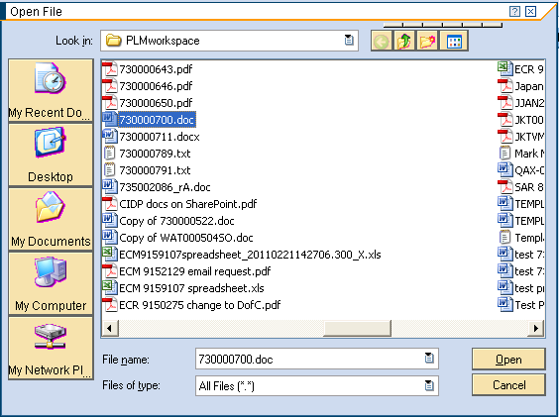
- The document is attached to the DIR, but note the padlock is open. Click the document once to highlight it, then click the Check In icon.
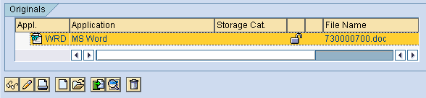
- This closes the padlock.

Originator submits DIR for review
- From the Document Data tab, use the matchcode to change the Document Status to OR (Out for Review).
- Click the Save icon at the top of the screen.

There is a procedural delay while the DIR is in the review cycle.

Additional Reviewer is added
If necessary, the DIR Originator or a qualified DDA Administrator may add an Additional Reviewer to the DIR while it is at status OR (Out for Review) or UR (Under Review). This action will cause the system to send a task and notification to the new Additional Reviewer.
Reference Step 8.3.2 for instructions.

Additional Reviewer does not have a unique SAP ID
Additional Reviewers who do not have a unique SAP ID cannot complete their review electronically.
- The Additional Reviewer may email comments to the Originator, who generates and saves a PDF of the email. The file name should be descriptive, as this will become the Title of the attachment. (example: 730000295MP John Smith review.pdf)
- The PDF is attached to the DIR:
  - With the DIR in display or change mode, click once on the right side of the Services for Objects icon
  - From the drop-down menu select Create, Create Attachment
  - Navigate to the saved PDF
  - Double-click the PDF, or click it once to highlight it then click the Done button
  - You are returned to the DIR main page
- To view attachments:
  - With the DIR in display or change mode, click once on the right side of the Services for Objects icon
  - From the drop-down menu select Attachment List
  - All attachments are listed. Double-click an attachment to view it.
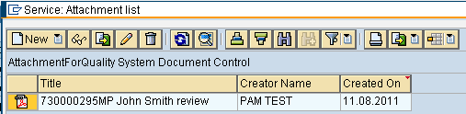

Review is cancelled
A review should be cancelled only in special circumstances. The DIR must be submitted for a new review cycle, all reviewers must complete their reviews within this new review cycle.
If necessary, the DIR Originator or a qualified DDA Administrator may change the DIR status from OR (Out for Review) or UR (Under Review) to CP (Concept). This action will cause the system to:
- send a Lotus Notes email to all Reviewers stating that the review was cancelled, and whether they had completed their review
- remove the review task from pending reviewers
- send a task and notification to the Originator

DIR is returned to Originator

Originator receives a task and notification in their SAP Business Workplace
- If all reviewers passed the review, the task will read “Review Complete.”
- If any reviewer(s) failed the review, the task will read “Review Failed.”

Double click the task to open the DIR
- Click the Review/Approval History button to see Reviewers’ comments
- The screen is split in two frames. You may need to drag the frame up to see all entries
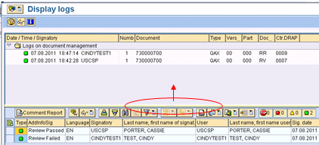
- Comments are viewable from the lower frame. Entries with text in the Language field have a comment attached.
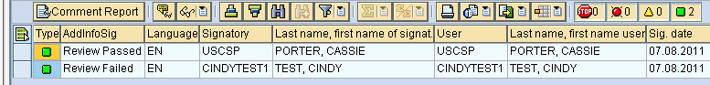
  - Individual comments may be viewed by clicking the grey button to the left of the entry, then clicking the Comment icon.
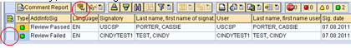
  - A pop-up window contains the individual comment.
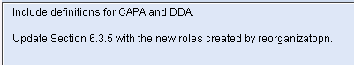:
  - All comments may be consolidated into a single printable report by clicking the Comment Report button, choosing one or more Print Options, and clicking the Execute button.
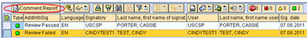.
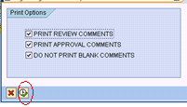
  - In this example, the report appears as:
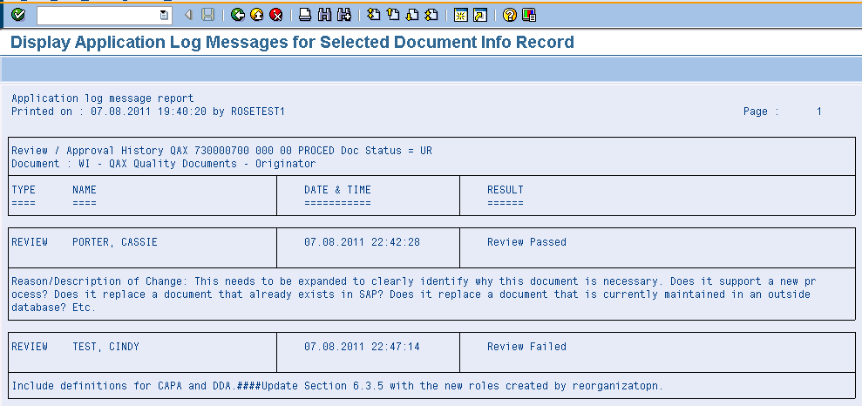
  - Print the report by clicking the Print icon. Or exit the report by clicking any of the three “directional” icons.
- Based on the Reviewers’ comments, modify the DIR as needed.
- Based on the Reviewers’ comments, modify the Original file as needed.
  - Do not double-click the Original file to open it. This creates a copy of the Original file, and any changes will not be saved to the Original file.
  - To open the Original file, click it once to highlight it then click the Change Original icon.
- Make changes to the document. When complete, save your changes and exit the document.
- Reopen the DIR in change mode. Note that the padlock is open.
  - Click the document once to highlight it, then click the Check In icon.
  - This closes the padlock.

Originator determines whether changes warrant an additional review cycle.

An additional review cycle is required if:
- any Reviewer comments state an additional review cycle is required
- the Lab/Office value was changed
- the intent of the document is changed
- the extent of the changes warrant it
- the review cycle was cancelled

If the DIR is sent for another review cycle, Section 8.2.5 is repeated at the cycle’s end.

Originator submits DIR for approval

From the Document Data tab, use the matchcode to change the Document Status to OP (Out for Approval).
- Click the Save icon at the top of the screen.

There is a procedural delay while the DIR is in the approval cycle.

If any Approver rejects the DIR, the task is removed from the SAP Business Workplace of any Approver who had not completed their task, and a new task and notification is sent to the Originator.
    - The Originator must update the DIR and/or document as needed and send the DIR back out for approval.
    - All Approvers will be required to complete the approval cycle.

When all Approvers have approved the DIR, the status changes to AA (Approved Awaiting Release) to allow training to be completed before the DIR is released for general use.

DIR is returned to Originator

Originator receives a task and notification in their SAP Business Workplace
- If the DIR was approved, the task will read “Approval.”
- If an Approver rejected the DIR, the task will read “Approval Failed.”

If the DIR was approved, skip to Step 8.2.10.

If the DIR was rejected, double-click the task to open the DIR
Click the Review/Approval History button to see Approvers’ comments
- The screen is split in two frames. You may need to drag the frame up to see all entries
- Comments are viewable from the lower frame. Entries with text in the Language field have a comment attached.
  - Individual comments may be viewed by clicking the grey button to the left of the entry, then clicking the Comment icon.
A pop-up window contains the individual comment.
:
  - All comments may be consolidated into a single printable report by clicking the Comment Report button, choosing one or more Print Options, and clicking the Execute button.
.

In this example, the report appears as:

Print the report by clicking the Print icon. Or exit the report by clicking any of the three “directional” icons.
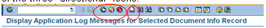

- Based on the Approvers’ comments, modify the DIR as needed.
- Based on the Approvers’ comments, modify the Original file as needed.
  - Do not double-click the Original file to open it. This creates a copy of the Original file, and any changes will not be saved to the Original file.
  - To open the Original file, click it once to highlight it then click the Change Original icon.
  - Make changes to the document. When complete, save your changes and exit the document.
- Resubmit the DIR for approval
- Repeat Step 8.2.9 until all Approvers pass the DIR.

Training

The Status of the DIR is AA (Approved Awaiting Release) and the system has assigned an Effectivity Date based on the Corporate default period as determined by Global Learning and Development.

Initiate training for all affected individuals
- Training must be completed prior to the Effectivity Date of the DIR
- Training Records are generated and submitted for inclusion in Trainees’ employment file
- If training is not completed prior to the Effectivity Date, the Process Owner may request that the Effectivity Date be extended. Contact a site DDA Administrator.

The Status of the DIR will automatically be changed from AA to RG on the Effectivity Date.
- If training has been completed prior to the Effectivity Date, the Process Owner may request the Effectivity Date be modified to the current or later date. Contact a site DDA Administrator.

Originator distributes notification of release

The Originator receives a task and notification in their SAP Business Workplace

From the menu choose Environment, Document Distribution, Start Distribution
- Press the ENTER key or click the green check mark
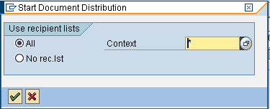

- Select “Distribute Immediately” if it does not already contain a tick mark, then click the Execute icon
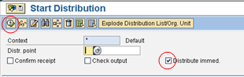

- A message is received indicating the distribution package has been created.

Individuals in the Distribution List receive a notification in their SAP Business Workplace
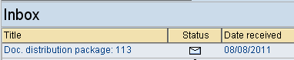

- Double-click the notification to open the message
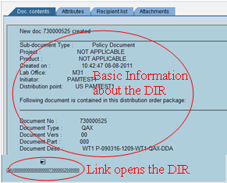

Related Processes

Selecting Additional Reviewers
NOTE: Check the Review/Approval Agents button prior to following these steps. An individual listed as a Core Reviewer is not to be added as an Additional Reviewer. A Core Reviewer is identified with a C in the Review Type field.

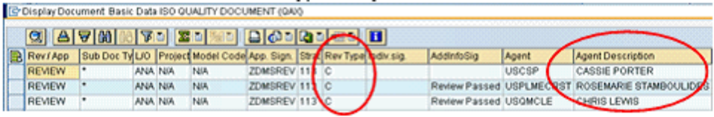

- from the Additional Data tab click the matchcode for Additional Reviewers
- double-click “User”
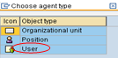
- Enter any part of the SAP User ID, Last Name and/or First Name, using asterisk as a wildcard
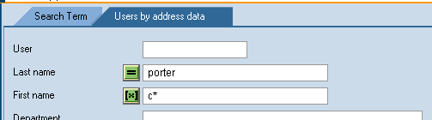
- press ENTER or click the green check mark
- double-click the entry that identifies the individual you want, taking care to select a valid ID
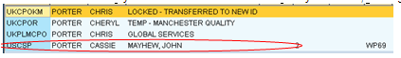

- the SAP User ID is displayed

- press ENTER and the individual’s name is displayed

- click the matchcode to select the next Additional Reviewer, and continue as above
- you must press ENTER after each selection before the name will appear in the list
- repeat for each Additional Reviewer

Entering Additional Reviewers while DIR is at Status Out for Review or Under Review
NOTE: Check the Review/Approval Agents button prior to following these steps. An individual listed as a Core Reviewer is not to be added as an Additional Reviewer. A Core Reviewer is identified with a C in the Review Type field.
NOTE: The DIR must be in change mode.
- Click the Review/Approval Agents button
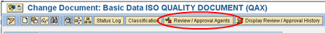
- Verify whether they are already listed as a Reviewer.
  - If they are, click the red X to cancel the transaction.
  - If they are not, click the Add Review Agent button
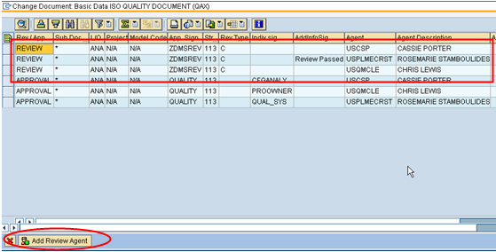
- Enter the Additional Reviewer’s SAP ID, or click the matchcode to search for it by name.
- double-click “User”
- Enter any part of the SAP User ID, Last Name and/or First Name, using asterisk as a wildcard
- press ENTER or click the green check mark
- double-click the entry that identifies the individual you want, taking care to select a valid ID

- The SAP ID will be displayed. Click the green checkmark to continue
- A pop-up window will appear indicating that the new Addl Reviewer will be added when the DIR is saved. Click the green checkmark to continue.
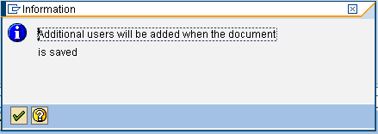

- Repeat steps to add other Additional Reviewers if required.
- Click the Red X to exit the Review/Approval Agents screen
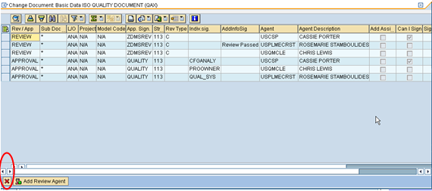
- Click the Save icon.
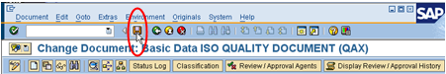

Appendices / Attachments
Not Applicable.

DOCUMENT HISTORY

Version: | 03 | Originator: | RoseMarie Stamboulides | Change ID: | N/A
Summary of Change: Current Global WI/Operating Procedure template used; complete re-write; updated references to global document templates, as applicable.

