Log into SAP W/O single sign on from any system with SAP installed
You need to know your SAP password from before SSO or get BT to reset it.
To reset: Call 4772 and get your password in SAP reset, make it clear that you want to reset your SAP password not SSO password. (I had them set ti to the same as my SSO).

Once you have your SAP password you can log into any SAP computer as follows:
From the SAP Logon pad, select SNC Logon Without Single Sign-On
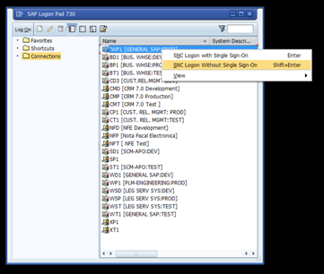
Log in with your SAP user (same as CORP username) and password.
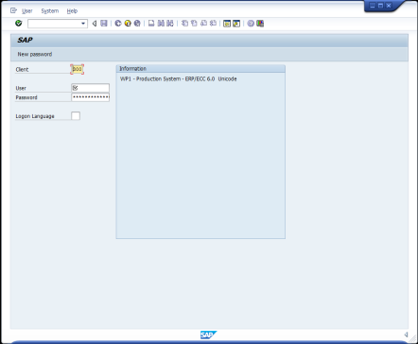

I recommend setting your SAP password to the same as CORP password and maintaining it as such so you do not forget it. The SAP password does not expire, but the CORP one does every 90 days.

To change you SAP password:
Go to the Logon screen without single sign on as above.
Type in your user
Type in your password, DO NOT HIT ENTER.
Click User on the menu.
Click New password
Enter new password.
