Contents
New Process for documenting test equipment in SAP 2
Summary (document structure and formatting in SAP) 2
Creating a Test Equipment DIR 5
In the “Create Document: Initial Screen” screen: 13
Click the green Back button. 13
At the “SAP Easy Access” screen: 14
Create a new document – type cv02n and press the <Enter> key. 14
At the “Change Document: Initial Screen” screen: 15
Create Document Links 19
Send DIR out for review 21
Review Documents 28
Releasing Documents 34

New Process for documenting test equipment in SAP

Summary (document structure and formatting in SAP)
The number format for test equipment is TE00#####XX, as below:
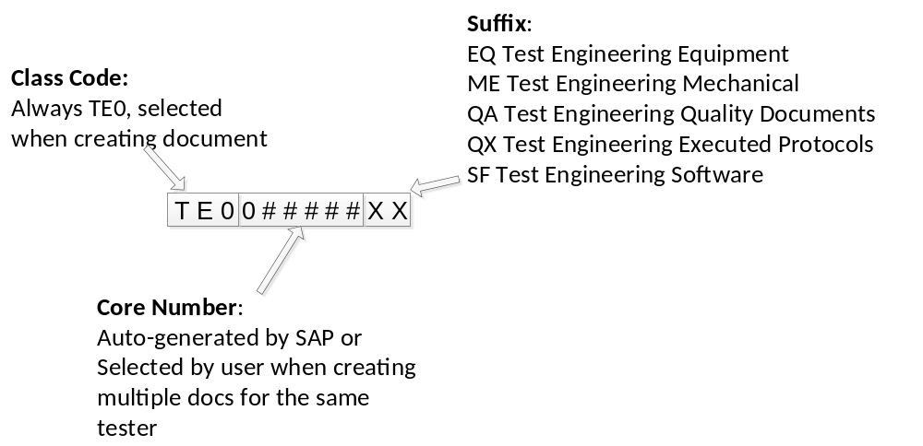
All Test Equipment Design Documents are Type TEE (similar to TSP / CAL for procedures)
The Class Code is TE0, this is the first 3 digits of the number (similar to 735 for TE procedures)
The Core number can be auto-generated by SAP or manually entered. New equipment numbers must always be auto-generated (EQ suffix). Core numbers will start at 084000 for auto-generation.
When creating a new tester, the EQ suffix should be auto-generated to create a new core number. The remaining documents should be created by manually entering the 6-digit core number generated when the EQ number was created.
If we wish to put legacy files into SAP we can do so by manually entering the 6-digit core number matching that of the existing TE number (i.e. TE0######XX where ###### is 0 followed by the 5-digit TE number.
Be extremely thorough to ensure correct numbers are being generated, and only generate TE0 DIRs.
There are five suffixes that must be used; these become the last 2 characters of the number in SAP. The numbers created with each suffix, while containing the same core number, are unique DIRs at unique revisions and can be revised together or independently. Note that QA and QX DIRs cannot be on the same ECR as EQ, ME, or SF DIRs because of different workflows in the signature structure.
EQ Test Engineering Equipment | This is the main Test equipment file and contains all of the TEDDs.  BOM, schematics, test equipment design plan, design review(s)
ME Test Engineering Mechanical | This contains CAD drawings for fixtures enclosures etc.. A 999XXXXXX Dir may be substituted for this document if the Master Model concept is used to create the CAD files.
QA Test Engineering Quality Documents | This contains all of the Validation / verification / qualification protocols.
QX Test Engineering Executed Protocols | This contains all executed protocols. This will require revision anytime a protocol is run for any test system with the TE number.  This document also contains release forms for each test system.
SF Test Engineering Software | This will contain a document indicting the test software revision and location of any necessary software including, but not limited to, Source Labview, C or other), Waters’ instrument firmware, Waters’ instrument firmware source, Empower (or other chromatography) projects, etc.
There are eight Subdocument Types that must be selected:
INSFIN Instrument Final Test: | Used for EQ suffix DIRs for final instrument Test equipment.
OTHER Other Test Equipment: | Used for EQ suffix DIRs for testers that are not for Final Instruments, subassemblies, or PCBs, such as tools.
PCBFCT PCB Function Test: | Used for EQ suffix DIRs for PCB functional testers.
PCBICT PCB Function Test: | Used for EQ suffix DIRs for PCB in – circuit testers.
SUBSPR Subassembly / Spare Test: | Used for EQ suffix DIRS for Spare / Subassembly testers.
TEMECH Test Engineering Mech Document: | Used for all ME suffix DIRS
TEQUAL Test Engineering Quality Docs: | Used for both QA and QX suffix DIRS.
TESFTW Test Engineering Software: | Used for SF suffix DIRs.
The suffixes provide us the ability to search in SAP for by suffix for certain type DIRs. The subdocument types are necessary to enable the review functionality in SAP.
The test equipment DIRs, test procedures and calibration/maintenance procedures will all be linked as below where arrows indicate linkages:
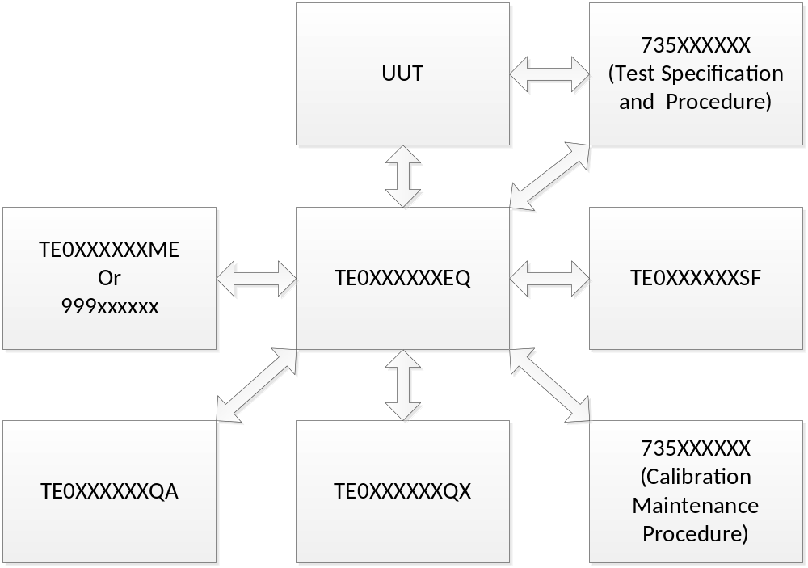
In addition there are a few other things necessary to create each DIR in SAP:
Lab/Office must be set to AKH
Model and/or Project code must be selected, N/A is a valid selection for both, but one or the other can be set to a valid entry

TEE DIRs need to be released via ECR. Each tester will require a minimum of 2 ECRs for release. EQ, ME, and SF DIRs can be released on one ECR; QX and QA DIRs must be on another ECR. The Quality document types (QX and QA) cannot be mixed with the others as they require a different workflow. This is true at release and for subsequent changes.

The remainder of this document describes how to create these DIRs in SAP.

Creating a Test Equipment DIR
Follow this process to create all DIRs as required. The example below will show the EQ suffix DIR, but applies to the other suffix DIR types as well.
At the “SAP Easy Access” screen:
Create a new document – type cv01n and press the <Enter> key.
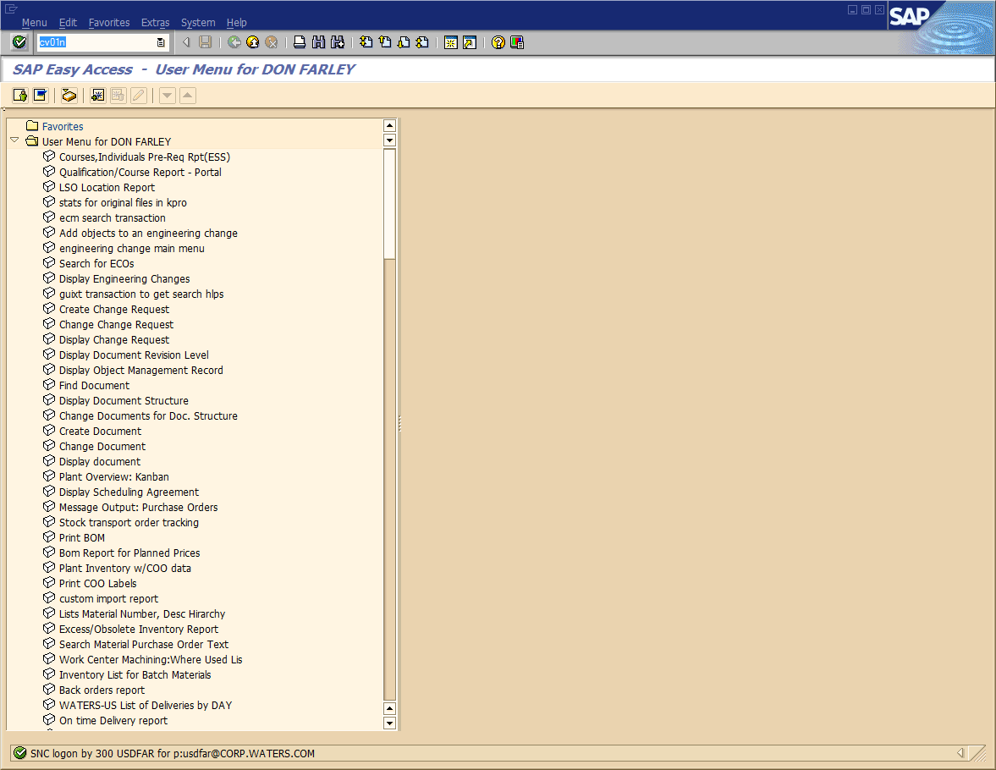
Form the “Create Document: Initial Screen”:
Select or type the “Document Type” TEE, and press the <Enter> key.
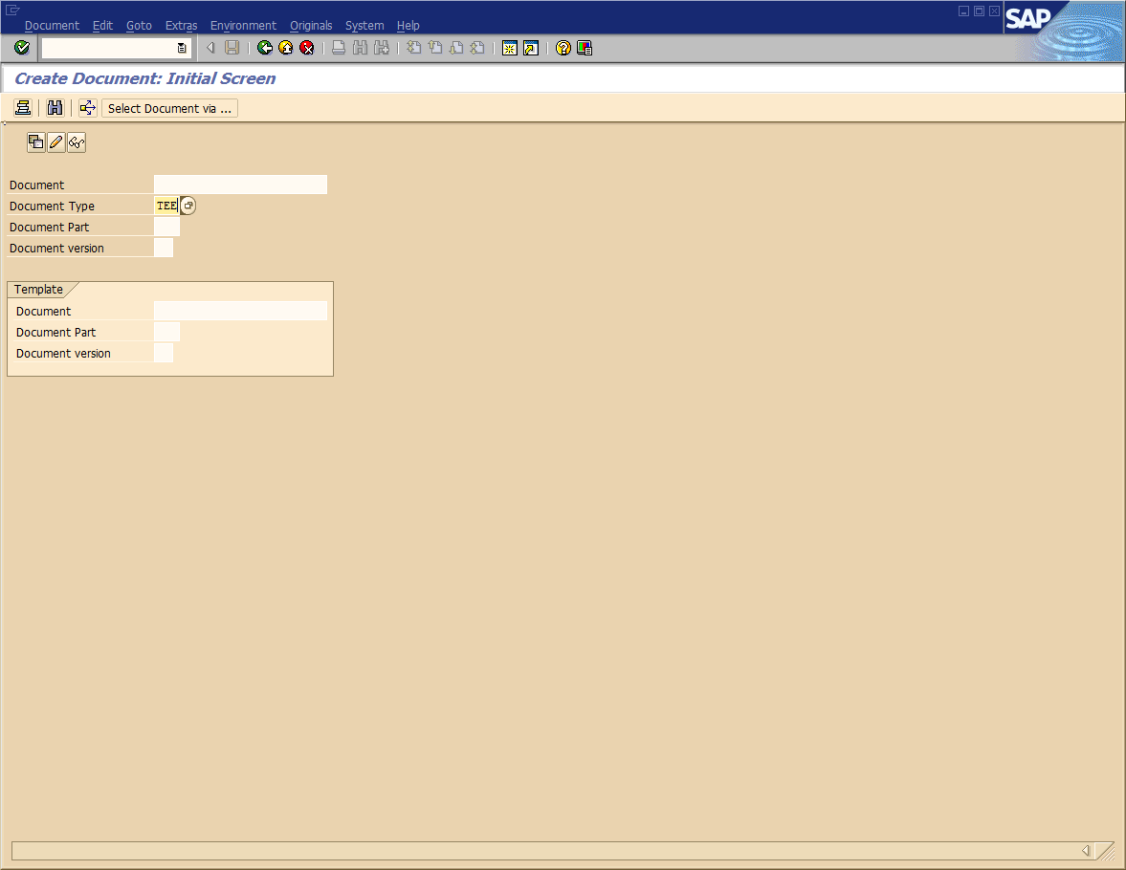
In the “Create Document: Initial Screen” dialog box:
Select Class Code TE0 TEST EQUIPMENT DESIGN FILE
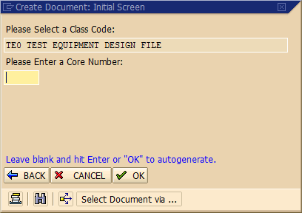
If this is a new EQ suffix DIR, leave the Core Number blank and click the OK button to generate a new number,
OR
If you are creating one of the other DIRs or a legacy record, enter your 6-digit Core Number (e.g. 08XXXX), and then click the OK button.
Select the correct suffix:
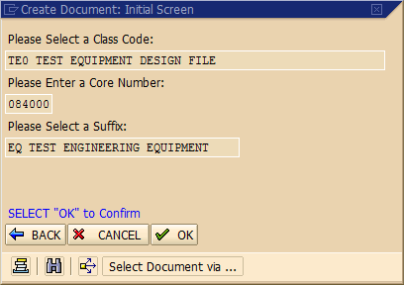
and then click the OK button.
In the “Create Document: Basic Data TEST ENG EQUIPMENT (TEE)” screen:
Enter your description. There is a “long text” available if necessary, but it’s best to fit the description in the field for searching.
Enter or select Lab/Office AKH — TEST/MFG ENGINEERING (MILFORD).
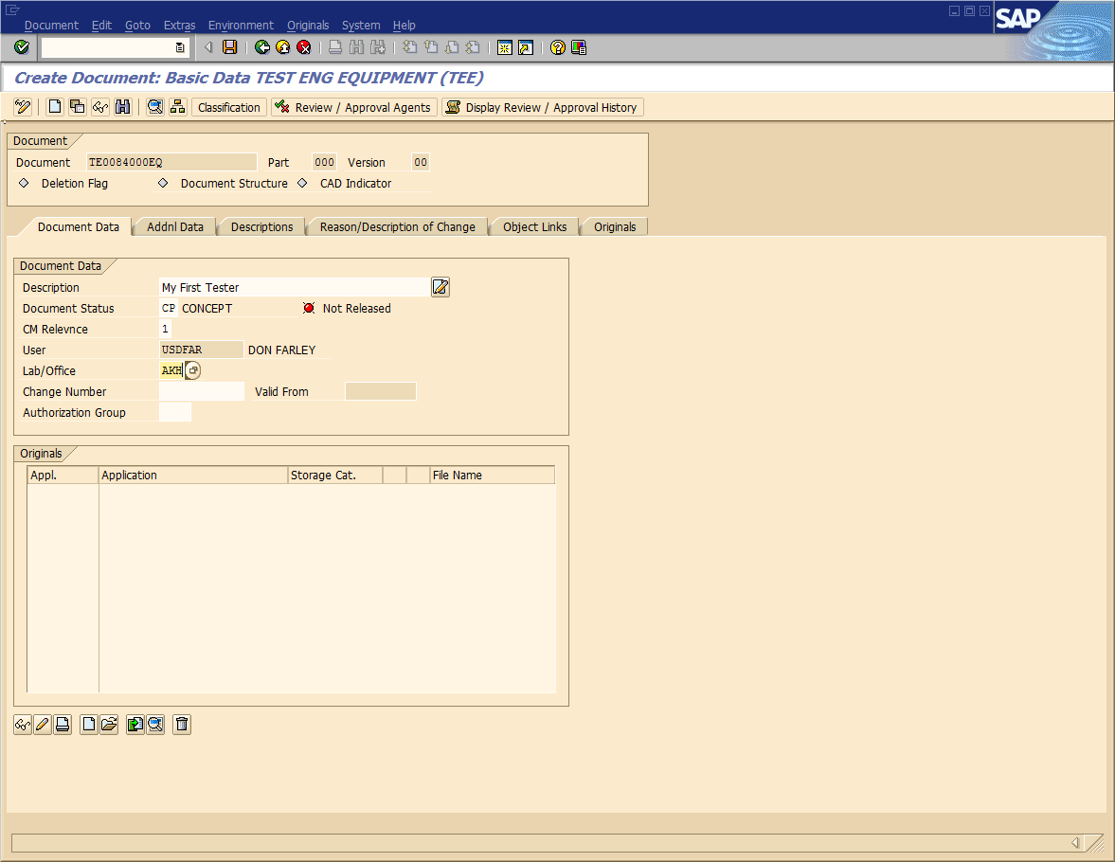
In the “Create Document: Basic Data TEST ENG EQUIPMENT (TEE)” screen:
Select the Addnl Data tab
Select N/A for Project Code and Model Code. If in fact a project or model code is available, it can be entered but the workflow IS NOT controlled by this — it is simply a system requirement that they are filled out.
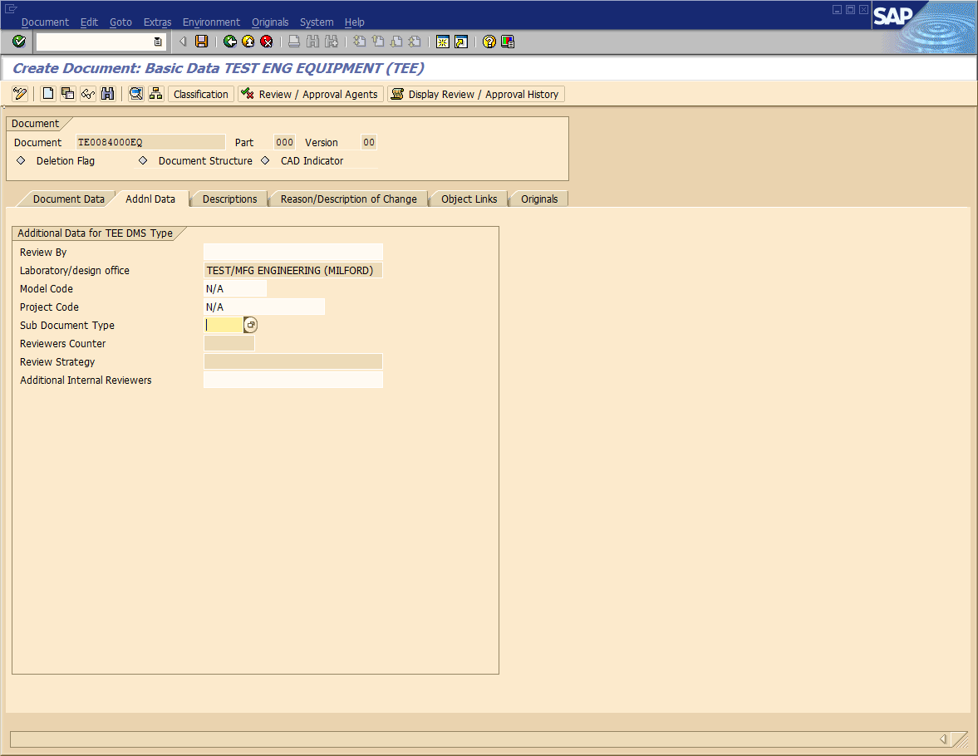
In the “Create Document: Basic Data TEST ENG EQUIPMENT (TEE)” screen:
On the Addnl Data tab, select the dropdown next to Sub Document Type, select the appropriate subdocument type, and hit the green checkmark at the bottom.
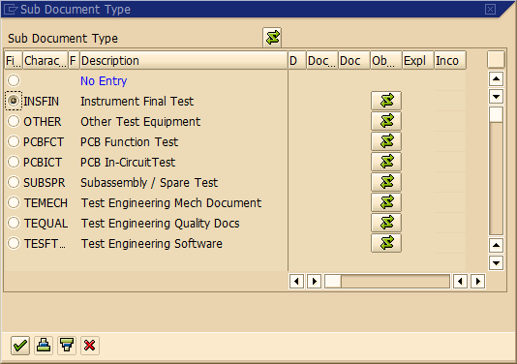
Click the Save button to save your DIR. You have now created the DIR.
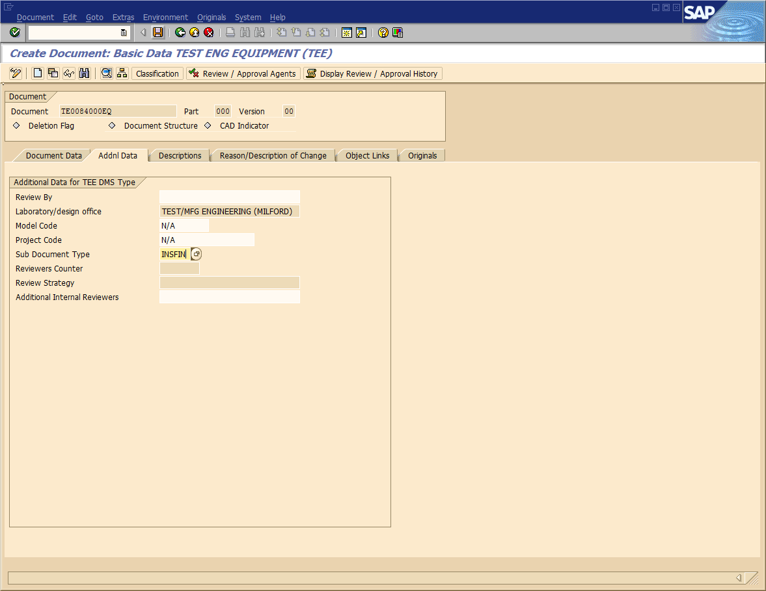

In the “Create Document: Initial Screen” screen:

Click the green Back button.

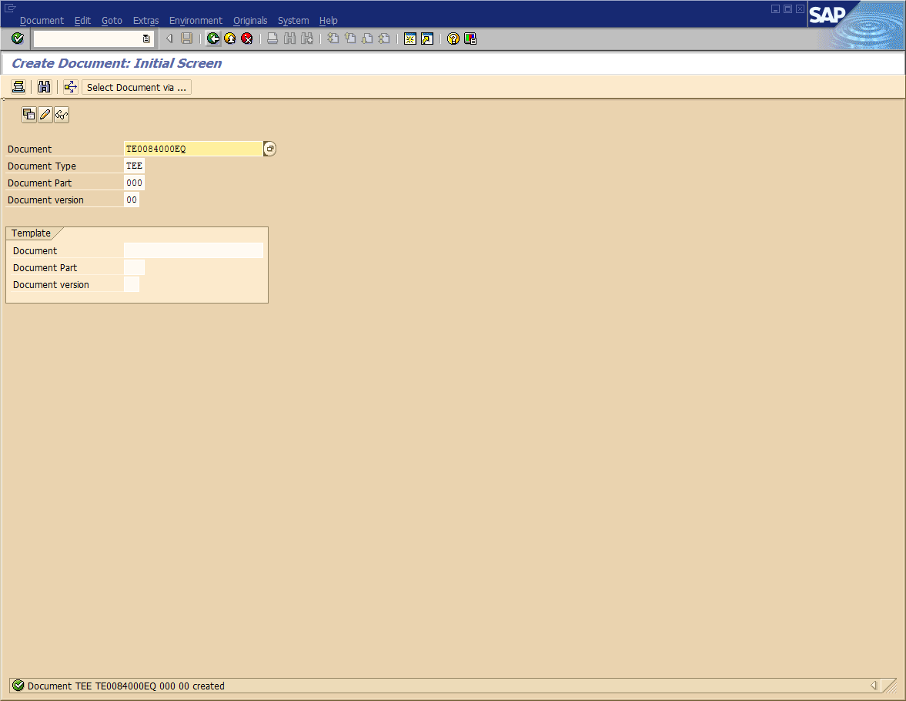

At the “SAP Easy Access” screen:

Create a new document – type cv02n and press the <Enter> key.

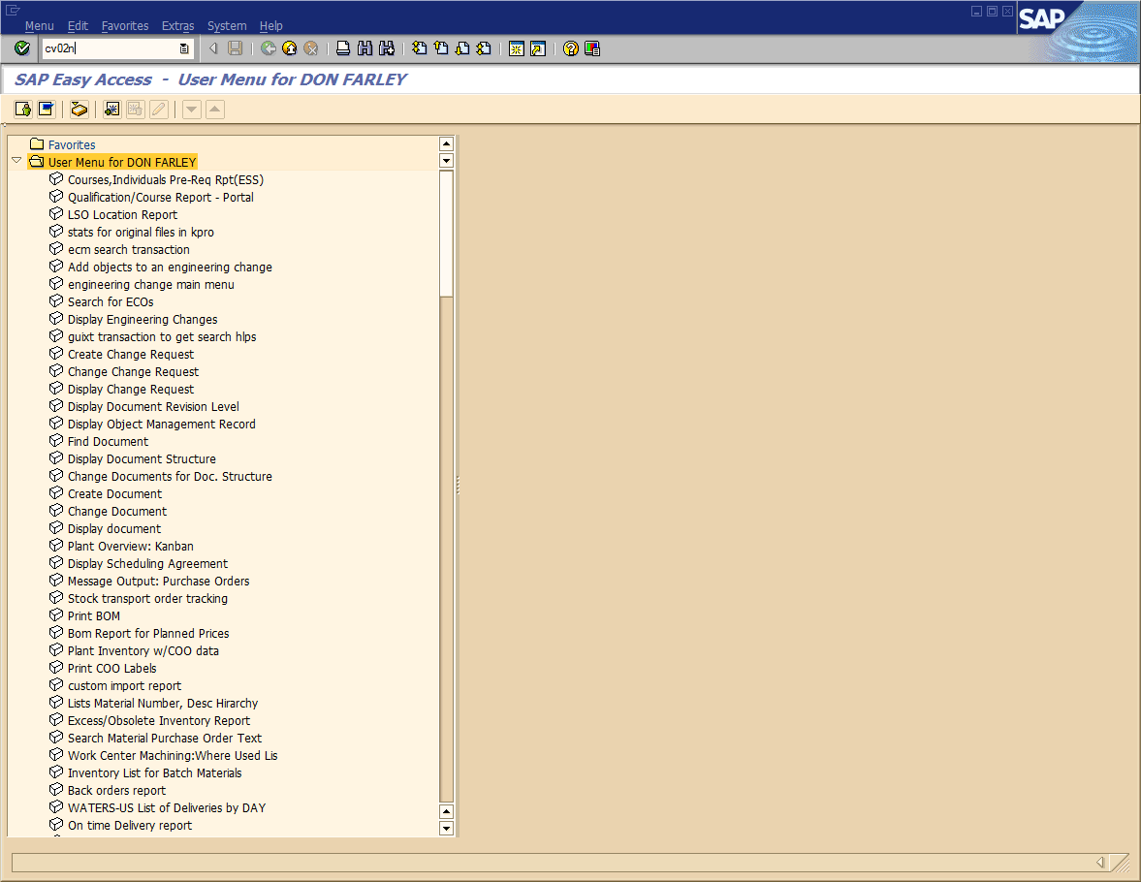
At the “Change Document: Initial Screen” screen:
If the document number you just created is not already there, type it in the Document field and then click on the green checkmark button.
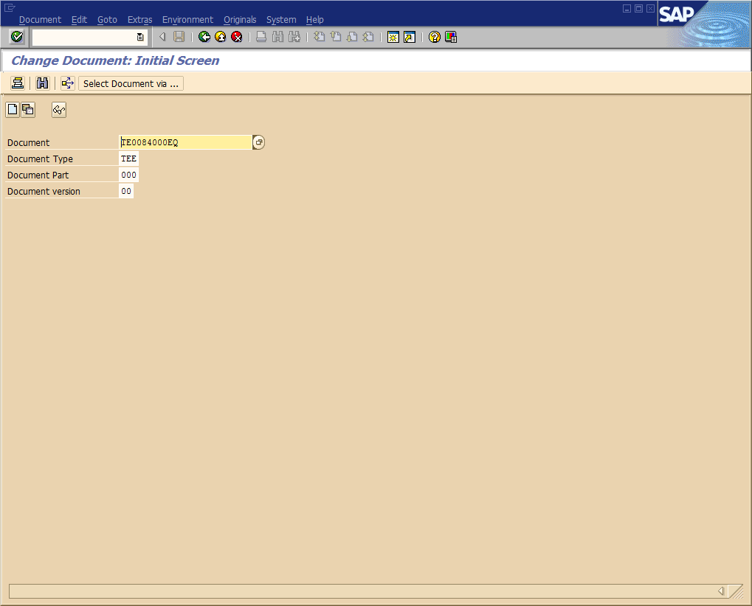
Upload Documents
At the “Change Document: Basic Data TEST ENG EQUIPMENT (TEE)” screen:
Click the Open Original button,
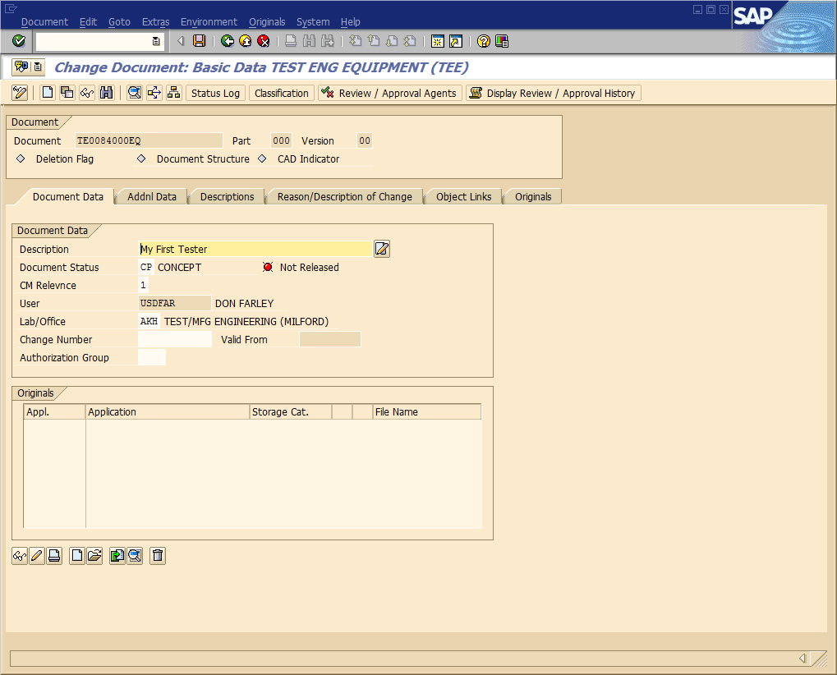
Navigate to the file to be uploaded,
Select the file
Click the Open button
Repeat for as many files as necessary.
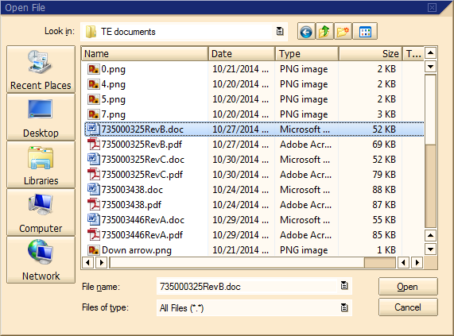
At the “Change Document: Basic Data TEST ENG EQUIPMENT (TEE)” screen:
Highlight all the original file(s) you’ve opened (you can use <Ctrl>click or <Shift>click to select more than one at a time). Then click the Check In Orig. button to upload the file(s) into SAP. Remember that this will REMOVE THE FILE(S) FROM YOUR HARD DRIVE!
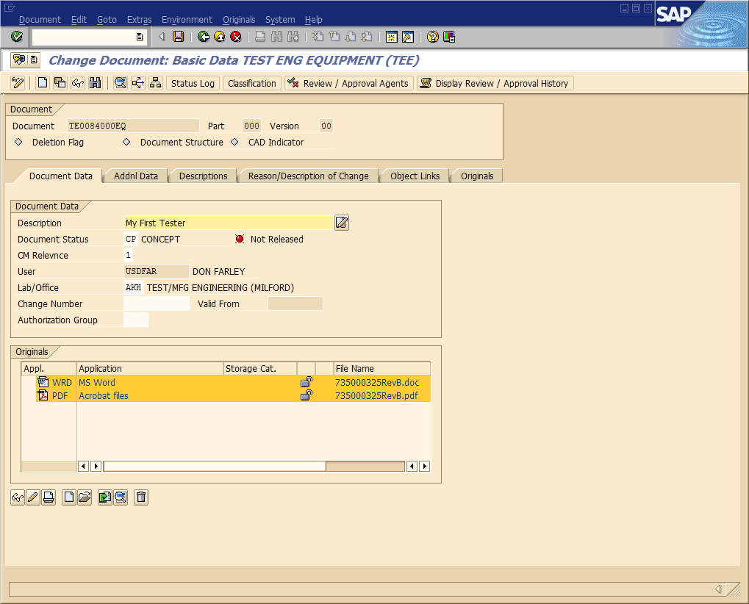
If you’re done with this DIR or just want to save your work at this point, click the Save button ().

Create Document Links
Once you have 2 or more DIRs created to link together:
At the “Change Document: Basic Data TEST ENG EQUIPMENT (TEE)” screen:
Select the Object Links tab.
Select the Document info record tab.
Provide the document type (Ty.) and the document number (Document) and press the <Enter> key.
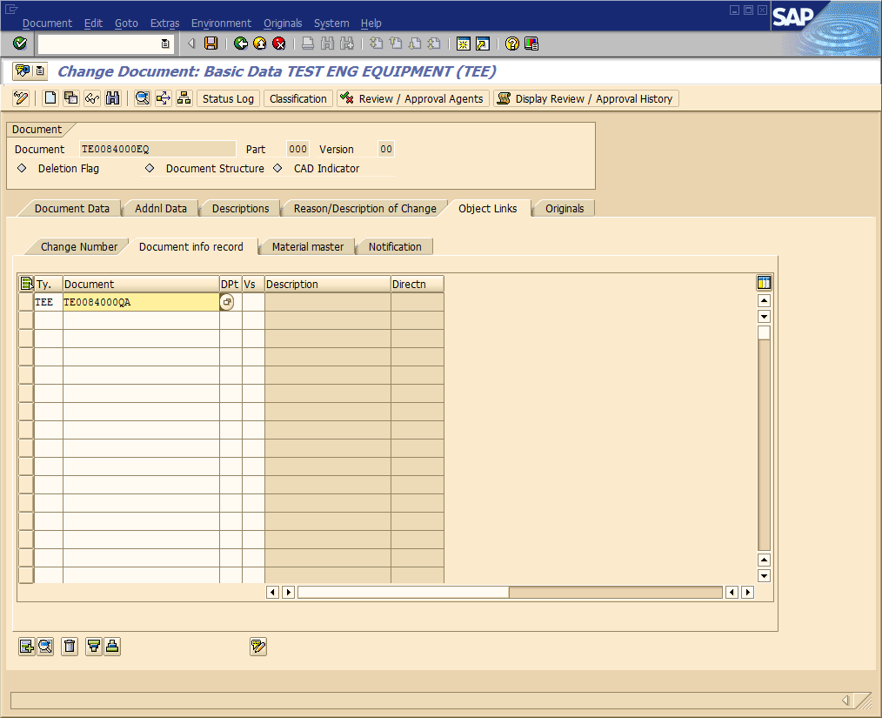
The document link is created.
Repeat as many times as necessary to create appropriate links.
Click on the Save button to save your DIR.
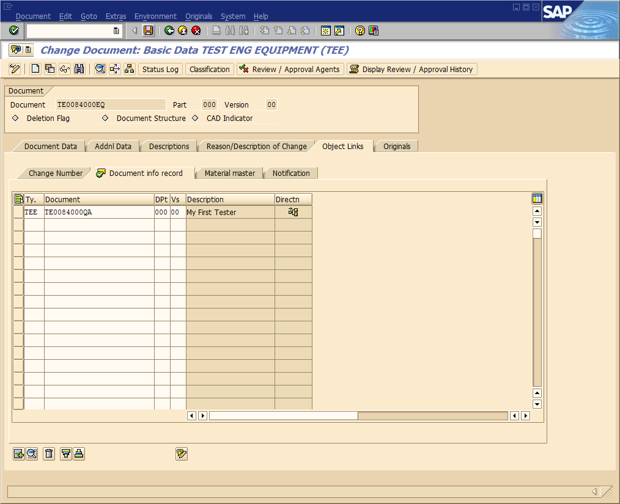

Send DIR out for review
We have the ability to send documents out for review by peers or other groups prior to moving to ready status and an ECR. This section describes how to do so.
At the “Change Document: Basic Data TEST ENG EQUIPMENT (TEE)” screen:
Select the Addnl Data tab.
Select the dropdown at the right of the “Review By” field and choose a date by which the review must be completed.
Note: Users are given until this date to review the DIR. If the review is not completed by the date selected, it is simply cancelled for that reviewer.
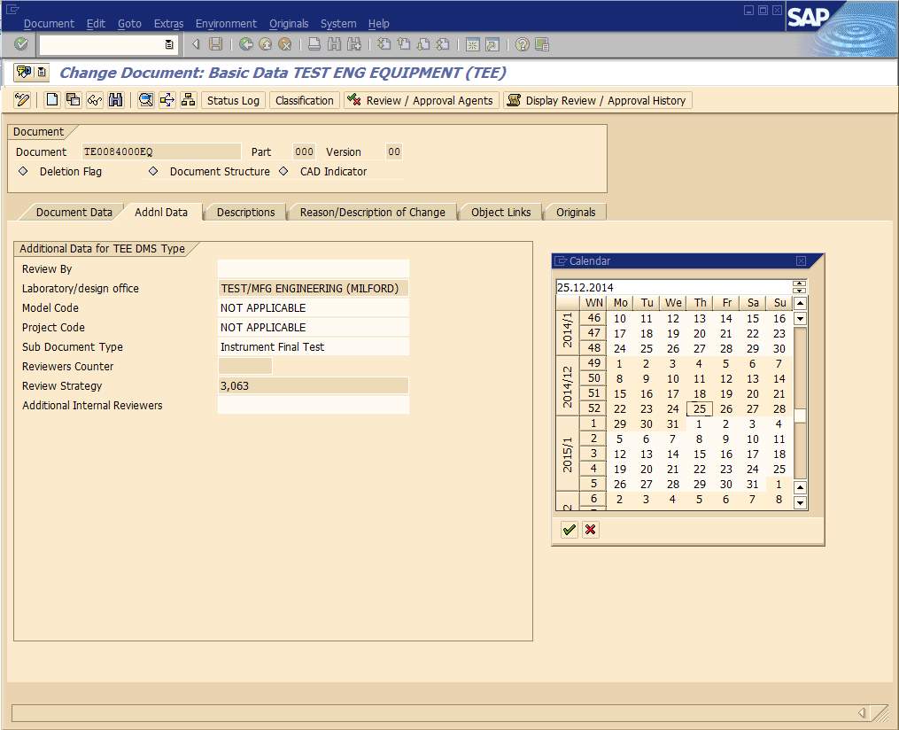
Select the dropdown at the right of the “Additional Internal Reviewers” field.
Select User and click the green checkmark button.
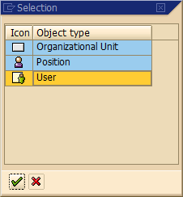
Type the last name of the user you want to review your DIR enclosed with *’s and click the green checkmark button.
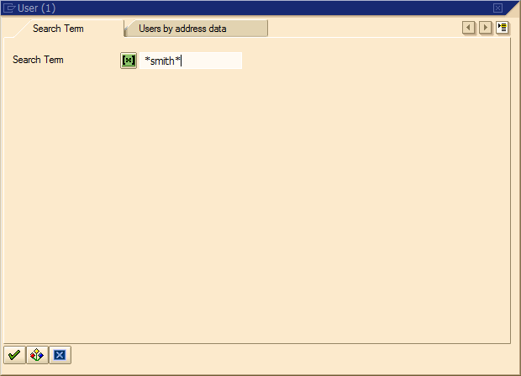
Select the correct user (when more than one) and click the green checkmark button..
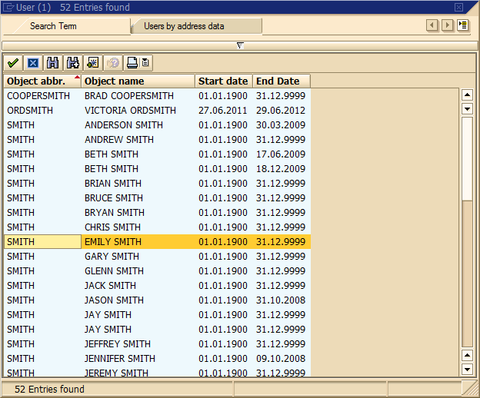
Put the cursor in the field with the user’s name and press the <Enter> key to save it.
Repeat to select multiple users.
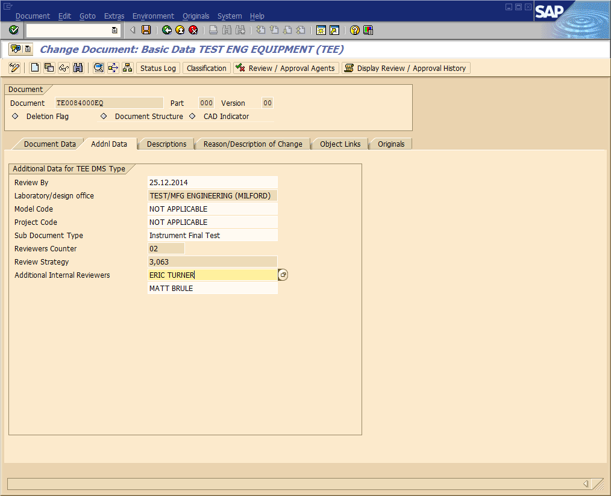
Select the Document Data tab.
Select the dropdown at the right of the “Document Status” field.
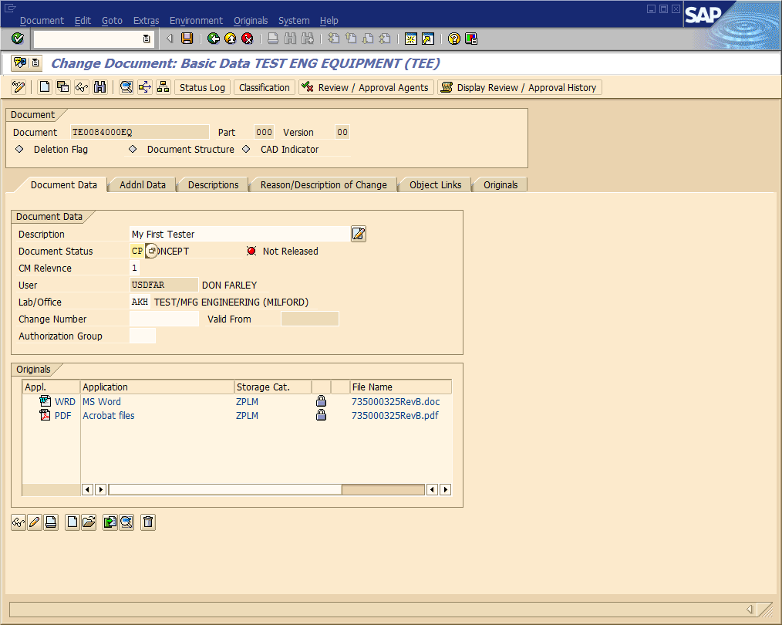
Select Out for Review and click the green checkmark button.
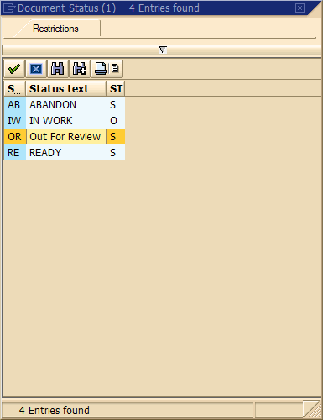
Click on the Save button to save your DIR.
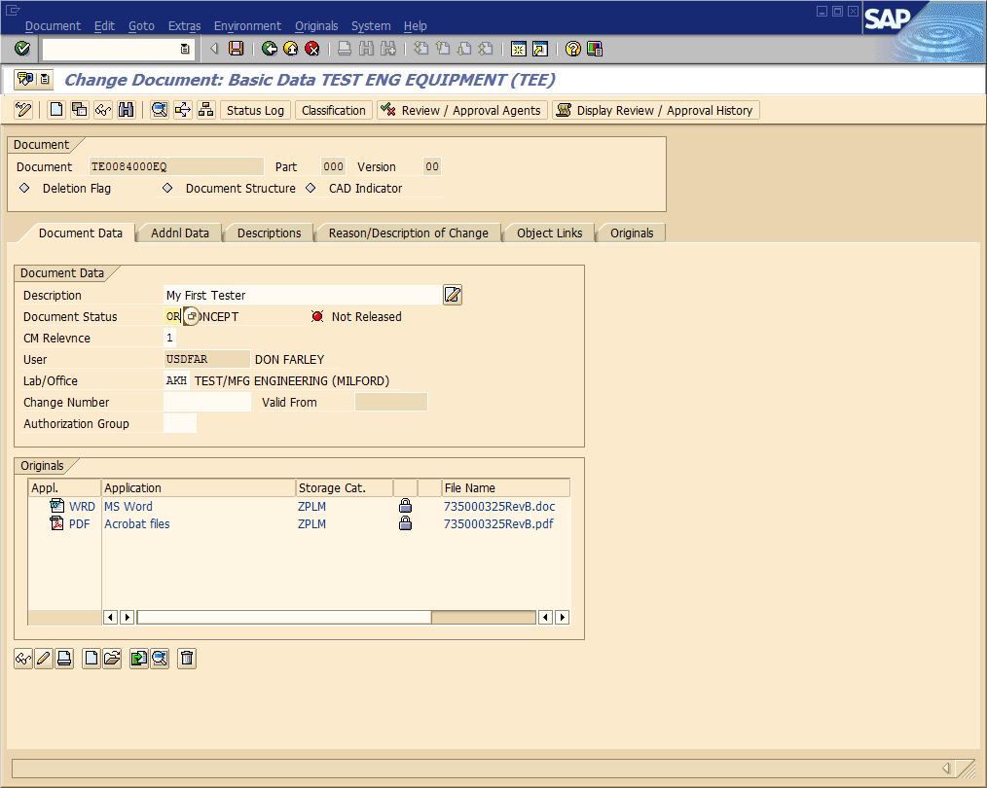

Review Documents
You will receive email notification of the need to review a document.
To review:
At the “SAP Easy Access” screen:
Click on the SAP Business Workplace icon.
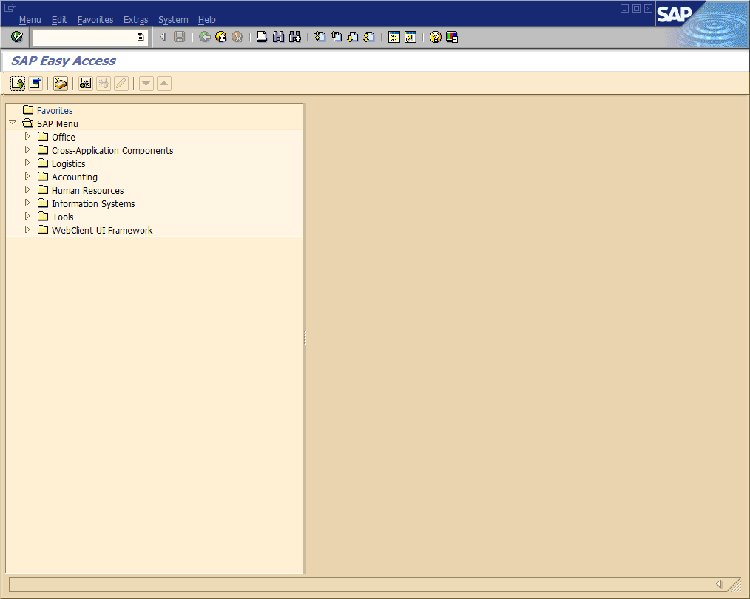
Go to your SAP Inbox:
Click on the Inbox icon.
Double-click the document number in the review notice.
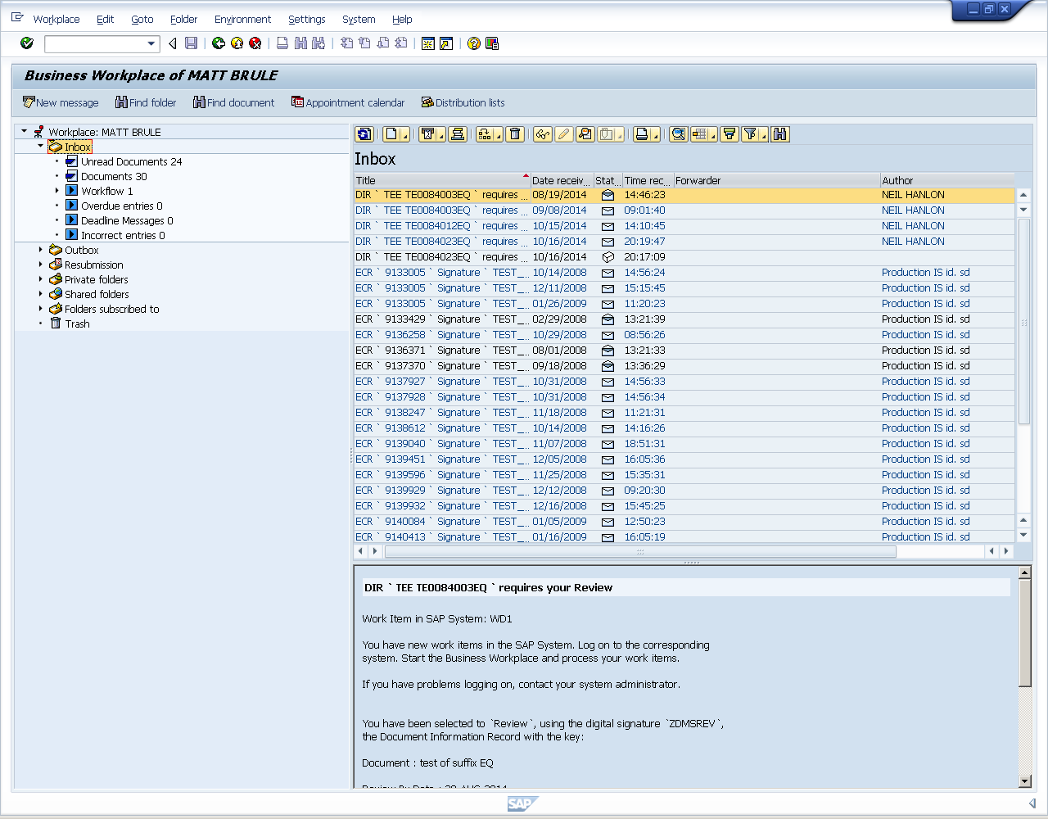
Review all documents in the DIR.
When finished reviewing, select the dropdown at the right of the “Document Status” field.
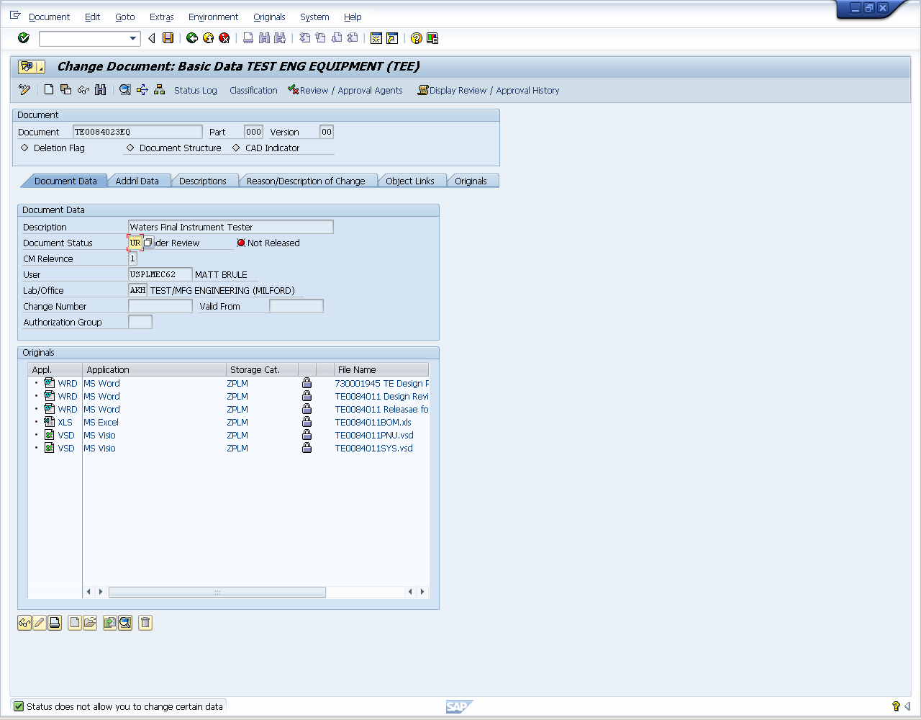
Select either Review Failed or Review Passed and click the green checkmark button.
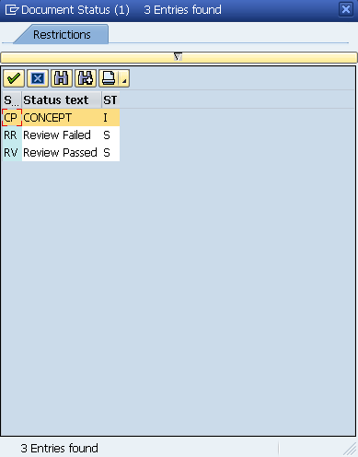
Click on the Save button to save your DIR.
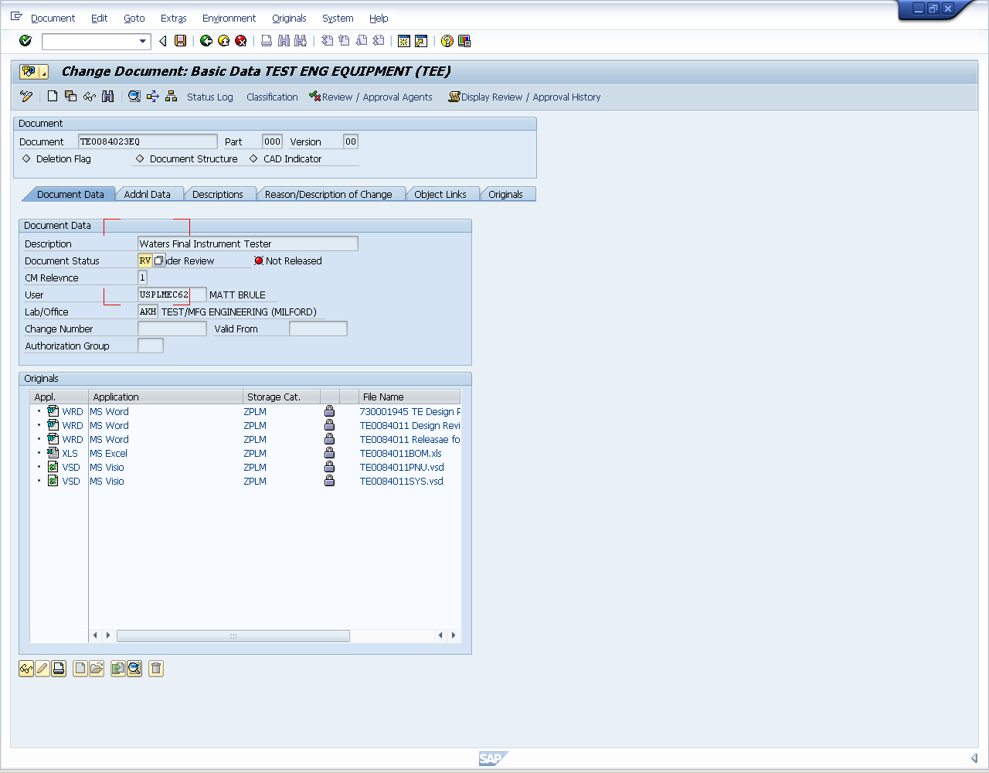
Enter your SAP password, and then close the window.
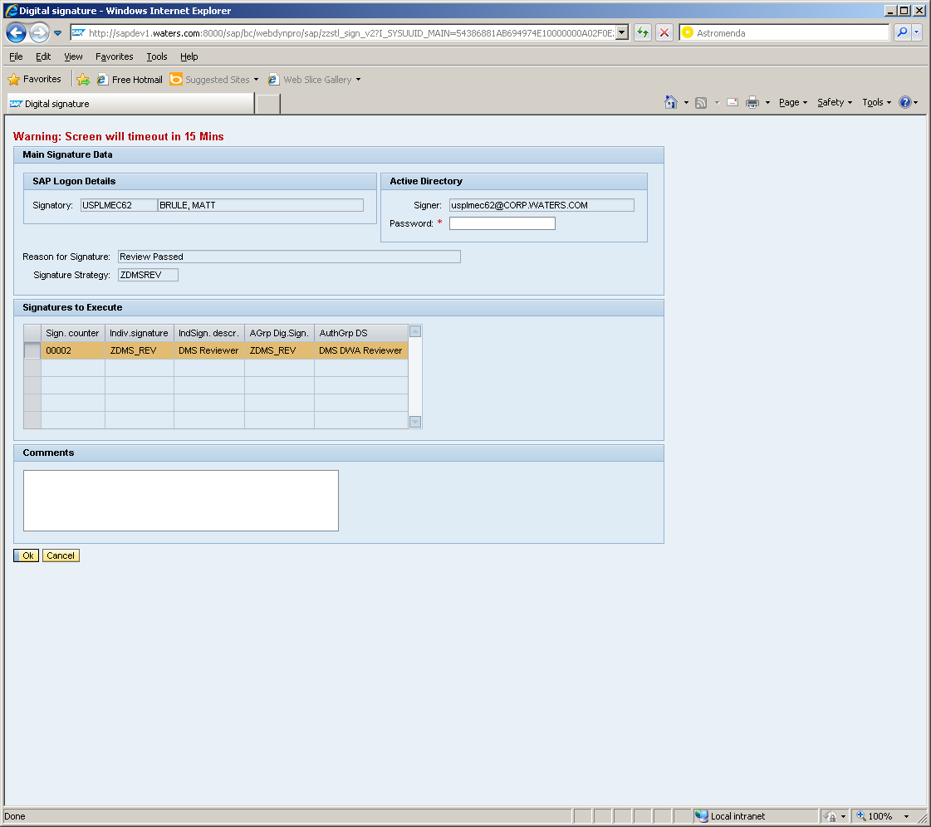
Reviewing is complete.

Releasing Documents
To release (change) your DIR(s):
The process is the same as is currently done to release/change our procedures.
Make sure all DIRs are correct, properly linked, and at Ready (RE) status.
Create your proposals and ECRs…..
Remember: EQ, ME, and SF DIRs can be released on one ECR; QX and QA DIRs must be on another ECR.

