Contents
New Process for documenting test equipment in SAP 2
Summary (document structure and formatting in SAP) 2
Creating a Test Equipment DIR 5
Upload Document(s) 6
Create Document Links 6
Send DIR out for review 6
Review Documents 7
To release (change) DIR(s): 7

New Process for documenting test equipment in SAP

Summary (document structure and formatting in SAP)
The number format for test equipment is TE00#####XX, as below:
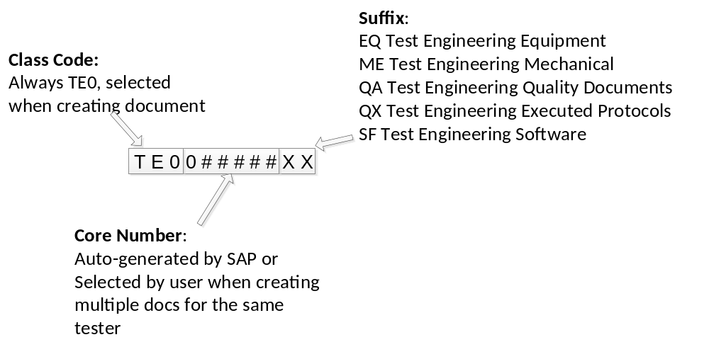
All Test Equipment Design Documents are Type TEE (similar to TSP / CAL for procedures)
The Class Code is TE0, this is the first 3 digits of the number (similar to 735 for TE procedures)
The Core number can be auto-generated by SAP or manually entered. New equipment numbers must always be auto-generated (EQ suffix). Core numbers will start at 084000 for auto-generation.
When creating a new tester, the EQ suffix should be auto-generated to create a new core number. The remaining documents should be created by manually entering the 6-digit core number generated when the EQ number was created.
If we wish to put legacy files into SAP we can do so by manually entering the 6-digit core number matching that of the existing TE number (i.e. TE0######XX where ###### is 0 followed by the 5-digit TE number.
Be extremely thorough to ensure correct numbers are being generated, and only generate TE0 DIRs.
There are five suffixes that must be used; these become the last 2 characters of the number in SAP. The numbers created with each suffix, while containing the same core number, are unique DIRs at unique revisions and can be revised together or independently. Note that QA and QX DIRs cannot be on the same ECR as EQ, ME, or SF DIRs because of different workflows in the signature structure.
EQ Test Engineering Equipment | This is the main Test equipment file and contains all of the TEDDs.  BOM, schematics, test equipment design plan, design review(s)
ME Test Engineering Mechanical | This contains CAD drawings for fixtures enclosures etc.. A 999XXXXXX Dir may be substituted for this document if the Master Model concept is used to create the CAD files.
QA Test Engineering Quality Documents | This contains all of the Validation / verification / qualification protocols.
QX Test Engineering Executed Protocols | This contains all executed protocols. This will require revision anytime a protocol is run for any test system with the TE number.  This document also contains release forms for each test system.
SF Test Engineering Software | This will contain a document indicting the test software revision and location of any necessary software including, but not limited to, Source Labview, C or other), Waters’ instrument firmware, Waters’ instrument firmware source, Empower (or other chromatography) projects, etc.
There are eight Subdocument Types that must be selected:
INSFIN Instrument Final Test: | Used for EQ suffix DIRs for final instrument Test equipment.
OTHER Other Test Equipment: | Used for EQ suffix DIRs for testers that are not for Final Instruments, subassemblies, or PCBs, such as tools.
PCBFCT PCB Function Test: | Used for EQ suffix DIRs for PCB functional testers.
PCBICT PCB Function Test: | Used for EQ suffix DIRs for PCB in – circuit testers.
SUBSPR Subassembly / Spare Test: | Used for EQ suffix DIRS for Spare / Subassembly testers.
TEMECH Test Engineering Mech Document: | Used for all ME suffix DIRS
TEQUAL Test Engineering Quality Docs: | Used for both QA and QX suffix DIRS.
TESFTW Test Engineering Software: | Used for SF suffix DIRs.
The suffixes provide us the ability to search in SAP for by suffix for certain type DIRs. The subdocument types are necessary to enable the review functionality in SAP.
The test equipment DIRs, test procedures and calibration/maintenance procedures will all be linked as below where arrows indicate linkages:
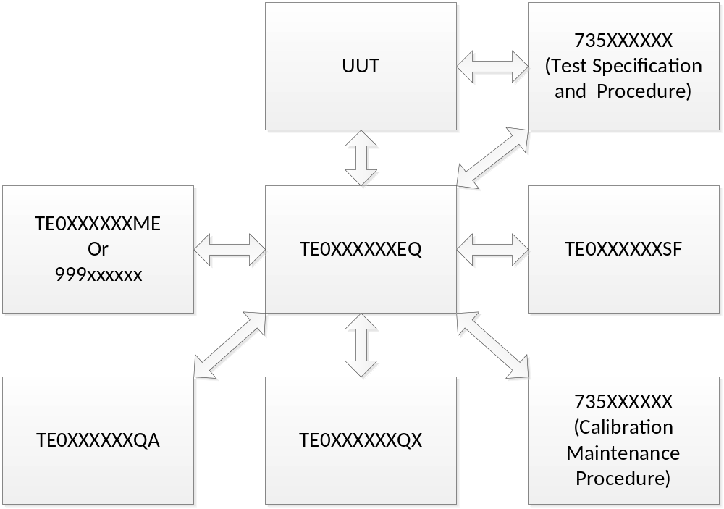
In addition there are a few other things necessary to create each DIR in SAP:
Lab/Office must be set to AKH
Model and/or Project code must be selected, N/A is a valid selection for both, but one or the other can be set to a valid entry

TEE DIRs need to be released via ECR. Each tester will require a minimum of 2 ECRs for release. EQ, ME, and SF DIRs can be released on one ECR; QX and QA DIRs must be on another ECR. The Quality document types (QX and QA) cannot be mixed with the others as they require a different workflow. This is true at release and for subsequent changes.

The remainder of this document describes how to create these DIRs in SAP.

Creating a Test Equipment DIR
Create a new document: cv01n
Document Type TEE,
Select Class Code TE0
Core Number blank or 6-digit Core Number,
Suffix: EQ, ME, QA, QX, SF,
Document Data tab:
Description: description “long text” if needed, best to fit the description in field for searching.
Lab/Office AKH
Addnl Data tab
Model Code and Project Code: N/A or actual code (must fill in both)
Sub Doc: INSIN, OTHER, PCBFCT PCBICT, SUBSPR, TEMECH, TEQUAL, TESFT,
Object Links
Create material links in material master tab
Create DIR links Other TEE DIRS, CAL, TSP here
Add files, Document Data tab
, navigate to file(s), select, check in, remember it is gone!
Save

Repeat for remaining 4 DIRs

Send DIR out for review
Select the Addnl Data tab.
Select the dropdown at the right of the “Review By” field and choose a date by which the review must be completed.
Select the dropdown at the right of the “Additional Internal Reviewers” field.
Select User and click the green checkmark button.
Type the last name of the user you want to review your DIR enclosed with *’s and click the green checkmark button.
Select User from list
Document Data Tab
Set status to review
Save

Review Documents
You will receive email notification of the need to review a document.
To review:
Change document CV02N (can get there from inbox)
Review all documents in the DIR.
Select review passed or review failed in document status
Save
Enter your SAP password, and then close the window.
Reviewing is complete.

To release (change) DIR(s):
The process is the same as is currently done to release/change our procedures.
Make sure all DIRs are correct, properly linked, and at Ready (RE) status.
Create your proposals and ECRs…..
Remember: EQ, ME, and SF DIRs can be released on one ECR; QX and QA DIRs must be on another ECR.

