A Semi-Theoretical Explanation of the Analytic Hierarchy Process (AHP)

Technical Paper 007/sb

Dr Stuart Burge

Abstract:

This paper presents a semi-theoretical explanation aimed at readers who wish to know more about the tool and its underlying mathematical basis. It is not complete in that it does not contain a complete set of formal proofs.

The paper discusses the differences between relative and absolute judgements and how AHP provides a framework for complex decisions to be made using absolute judgements allowing for the checking of consistency.

The paper introduces the eigenvalue problem that lies at the mathematical heart of the process and how consistency ratios can be determined as a measure of decision quality.

- Introduction and Background

The Analytic Hierarchy Process AHP is actually a fascinating piece of work that ties together several aspects pertinent to Systems Engineering. These are:

- Managing complexity: here George Miller’s human processing limitation of 7 ± 2 often used to manage complexity
- Managing risk: Systems Engineering can be considered to be a set of decisions that have various degrees of uncertainty that is related to the time line of a project/programme

The AHP provides a theoretical underpinning for both aspects. This short paper aims to bridge the gaps between pure mathematical descriptions of AHP and the “just do this” process based descriptions.

Section 2.0 explores humans and judgments and how through framing the decision questions, absolute judgments can be made to form a pairwise decision matrix. The structure and solution of are described in section 3, together with the formulation of consistency ratios.

2.0 Judgements

To start this semi theoretical explanation of AHP I want to talk about human judgements. Our ability to make, or perhaps not make, a judgement is central to the AHP.

A judgement is the ability to make considered decisions or come to sensible conclusions that can take several forms:

- The mental ability to perceive and distinguish relationships. For example; tiredness may affect a driver’s judgment of speed
- The ability to form an opinion by distinguishing and evaluating. For example; he felt that this gig was better than the band’s last one at this venue because the sound quality was superior
- The capacity to assess situations or circumstances and draw sound conclusions. For example; given the time of day, and the distance we have walked, I propose a taxi home would be sensible

Judgments, however, come in two basic forms: absolute and relative.
An absolute judgment is where it is possible to identify the magnitude of something – for instance, the brightness of a light, the loudness of a tone, or the curvature of a line. Such judgments are usually in terms of standards in memory about similar “somethings”. For example, this restaurant is twice as big as the one in Manchester, this car is 25% more expensive than that one.

A relative judgment is the identification of some relation between two “somethings” that are both present to the observer/judge. For example, that shirt is “bluer” than that one, you are taller than your friend.

Decision making tools like Pairwise Comparisons and Pugh Matrices rely on our ability to make relative judgments. Indeed, we are rather good at it. Given two choices and a decision criterion we can usually pick the winner. Decision tools based on using relative judgments unfortunately suffer from inconsistency, particularly where the decision involves several criteria – which of course is the everyday reality we all face.

Inconsistency can be described as:

- A is better than B
- B is better than C
- C is better than A

Unwittingly, when making decisions that involve several criteria we are frequently inconsistent despite our good intentions.

The beauty of the AHP is that it gets us to use absolute judgments, which in turn enables us to compute how consistent we have been. Consistency is a necessary (but not sufficient) condition in decision making and therefore presents a superior approach over other decision making approaches.

3.0 The AHP Mathematical Approach

To explain the AHP I will use an example for which we know the correct answer. Imagine there are 5 cylinders with different heights as shown in figure 1.

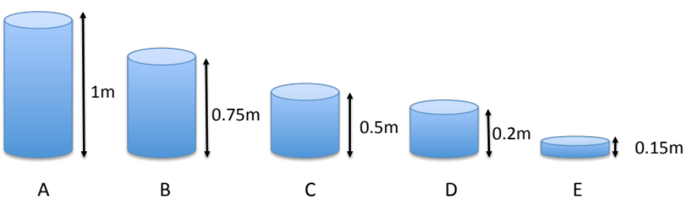

Figure 1: Five cylinders of different but known height

If we were making relative judgments, we would be able to say that cylinder A is taller than cylinder C and so on. However, in this case (because we the actual heights) we can make absolute judgments and make statements like

Cylinder A is 1.333 times taller than cylinder B
Cylinder A is 2 times taller than cylinder C

Given the five cylinders it is possible to construct a 5x5 matrix that contains all the absolute judgments between the various cylinder heights

$$\left[\begin{matrix}{h_{A}}/{h_{A}} & {h_{A}}/{h_{B}} & {h_{A}}/{h_{C}} & {h_{A}}/{h_{D}} & {h_{A}}/{h_{E}} \\ {h_{B}}/{h_{A}} & {h_{B}}/{h_{B}} & {h_{B}}/{h_{C}} & {h_{B}}/{h_{D}} & {h_{B}}/{h_{E}} \\ {h_{C}}/{h_{A}} & {h_{C}}/{h_{B}} & {h_{C}}/{h_{C}} & {h_{C}}/{h_{D}} & {h_{C}}/{h_{E}} \\ {h_{D}}/{h_{A}} & {h_{D}}/{h_{B}} & {h_{D}}/{h_{C}} & {h_{D}}/{h_{D}} & {h_{D}}/{h_{E}} \\ {h_{E}}/{h_{A}} & {h_{E}}/{h_{B}} & {h_{E}}/{h_{C}} & {h_{E}}/{h_{D}} & {h_{E}}/{h_{E}}\end{matrix}\right]$$

For our cylinder example this matrix would be

$$\left[\begin{matrix}1 & 1.333 & 2 & 5 & 6.666 \\ 0.75 & 1 & 1.5 & 3.75 & 5 \\ 0.5 & 0.666 & 1 & 2.5 & 3.333 \\ 0.2 & 0.266 & 0.4 & 1 & 1.333 \\ 0.15 & 0.2 & 0.3 & 0.75 & 1\end{matrix}\right]$$

This matrix has a special structure since ${h_{i}}/{h_{j}=1/{{h_{j}}/{h_{i}}}}$. Also ${h_{i}}/{h_{i}=1}$ giving

$$\left[\begin{matrix}1 & {h_{A}}/{h_{B}} & {h_{A}}/{h_{C}} & {h_{A}}/{h_{D}} & {h_{A}}/{h_{E}} \\ 1/{{h_{A}}/{h_{B}}} & 1 & {h_{B}}/{h_{C}} & {h_{B}}/{h_{D}} & {h_{B}}/{h_{E}} \\ 1/{{h_{A}}/{h_{C}}} & 1/{{h_{B}}/{h_{C}}} & 1 & {h_{C}}/{h_{D}} & {h_{C}}/{h_{E}} \\ 1/{{h_{A}}/{h_{D}}} & 1/{{h_{B}}/{h_{D}}} & 1/{{h_{C}}/{h_{D}}} & 1 & {h_{D}}/{h_{E}} \\ 1/{{h_{A}}/{h_{E}}} & 1/{{h_{B}}/{h_{E}}} & 1/{{h_{C}}/{h_{E}}} & 1/{{h_{D}}/{h_{E}}} & 1\end{matrix}\right]$$

This reciprocal matrix has an interesting eigenstructure. It is assumed at this point that you the reader has encountered linear algebra and is familiar with the basics of eigenvalues and eigenvectors – if not either stop at this point and accept that the AHP works (provided you follow the rules) or get into basic linear algebra.

If the eigenvalues of the above are calculated they will be (5, 0, 0, 0, 0) irrespective of the values of ${h_{i}}/{h_{j}}$. In fact if we had n cylinders and computed the equivalent matrix the eigenvalues would be (n, 0, 0, … ,0). The non-zero eigenvalue is called $λ_{max}$. Perhaps more interesting is that the eigenvector associated with the non-zero eigenvalue (i.e. in this example the 5) will be:

$$\left[\begin{matrix}1 \\ {h_{A}}/{h_{B}} \\ {h_{A}}/{h_{C}} \\ {h_{A}}/{h_{D}} \\ {h_{A}}/{h_{E}}\end{matrix}\right]$$

The implication of this vector is quite profound because it is the absolute judgements about the heights of the cylinders. In this example of course we knew these, but when applying the AHP to real world decision making the issue is that they absolute judgements are not known – but we can ask a group of experts to give their considered absolute judgements. There is no doubt that this group will be making judgements as opposed to measurements (like in our cylinder example) and therefore there are issues of uncertainty. This uncertainty has several dimensions but one that can be calculated is the consistency. The concept of consistency was introduced early but we can now define it mathematically as

$${h_{i}}/{h_{k}}=({h_{i}}/{h_{j}})({h_{j}}/{h_{k}})$$

This equation is not obviously intuitive (well I don’t think so) but it mathematically states the example of consistency given earlier.

Let us suppose that the cylinders actually exist and a group is asked to make judgements about the heights just by simple comparison. In posing the problem we would ask the group very specific questions around which they would make their judgements. Moreover, the questions only need to be asked for the upper (or lower) triangle because the other triangle will be the reciprocals. The questions would be – and their answers!!

Question | Answer
How much taller is cylinder A than cylinder B? | 1.25
How much taller is cylinder A than cylinder C? | 2
How much taller is cylinder A than cylinder D? | 5
How much taller is cylinder A than cylinder E? | 7
How much taller is cylinder B than cylinder C? | 1.5
How much taller is cylinder B than cylinder D? | 4
How much taller is cylinder B than cylinder E? | 5
How much taller is cylinder C than cylinder D? | 2.5
How much taller is cylinder C than cylinder E? | 3
How much taller is cylinder D than cylinder E? | 1.4

Which means we can formulate the reciprocal matrix

$$\left[\begin{matrix}1 & 1.25 & 2 & 5 & 7 \\ 0.8 & 1 & 1.5 & 4 & 5 \\ 0.5 & 0.666 & 1 & 2.5 & 3 \\ 0.2 & 0.25 & 0.4 & 1 & 1.4 \\ 0.143 & 0.2 & 0.333 & 0.714 & 1\end{matrix}\right]$$

This matrix is slightly different from the earlier one and therefore will have a different eignestructure.

For a consistent matrix, the non-zero eigenvalue = n (5 in our case). For matrices involving human judgment, the condition ${h_{i}}/{h_{k}}=({h_{i}}/{h_{j}})({h_{j}}/{h_{k}})$ does not hold as human judgments are inconsistent to a greater or lesser degree. In such a case we find that the actual eigenvalue $λ_{max}≥n.$ The difference, if any, between λ_{max} and n is an indication of the inconsistency of the judgments. If $λ_{max}=n$then the judgements have turned out to be consistent.

To make the AHP easy to use a Consistency Index can be calculated from (λmax‐n)/(n‐1). This can be assessed against judgments made completely at random! The originator of the AHP, Saaty, calculated large samples of random matrices of increasing order and the Consistency Indices of those matrices. Table 1 below shows the results that Saaty obtained from random simulations. What he did was to choose the entries for different size of matrix (up to 15x15) and randomly assign above main diagonal {1/9, 1/8,...,1, 2,...,8, 9}. The entries below the diagonal were calculated by taking reciprocals. The main diagonal was completed as 1.0s. These matrices were used to compute the consistency index. Amazingly Saaty did this 50,000 times and used the average which he called the random index. The results are given in table 1 below:

Order | 1 | 2 | 3 | 4 | 5 | 6 | 7 | 8 | 9 | 10 | 11 | 12 | 13 | 14 | 15
Random Index | 0 | 0 | 0.52 | 0.89 | 1.11 | 1.25 | 1.35 | 1.40 | 1.45 | 1.49 | 1.52 | 1.54 | 1.56 | 1.58 | 1.59
First order differences |  | 0 | 0.52 | 0.37 | 0.22 | 0.14 | 0.1 | 0.05 | 0.05 | 0.04 | 0.03 | 0.02 | 0.02 | 0.02 | 0.01

Table 1: The AHP random index values

A true Consistency Ratio is calculated by dividing the Consistency Index for the set of judgments by the value for the corresponding Random Index. That is:

$$CR={CI}/{RI}$$

Saaty suggests that if that the Consistency Ratio exceeds 0.1 the set of judgments may be too inconsistent to be reliable. This cutoff of 0.1 come from the concept of order of magnitude and is essential in any mathematical consideration of changes in measurement. Suppose we have a numerical value say between 1 and 10 for some measurement and we want to know whether change in this value is significant or not, the following reasoning is usually applied:

- A change of a whole integer value is critical because it changes the magnitude and identity of the original number significantly.
- If the change in value is of the order of a percent or less, it would be so small (by two orders of magnitude) and would be considered negligible.

In attempting to make consistent judgments, changes that are too large can cause dramatic change in our understanding, and values that are too small cause no change in our understanding. In between we are left with only values of one order of magnitude smaller that we can deal with incrementally to change our understanding. It follows that our allowable consistency ratio should be not more than about .10. The requirement of 10% cannot be made smaller such as 1% or .1% without trivializing the impact of inconsistency.

In practice, Consistency Ratios of more than 0.1 sometimes have to be accepted. If the Consistency Ratio equals 0 then that means that the judgments are perfectly consistent. Indeed, if we return to the 5 Cylinder problem then

$$CR={(λmax‐n)/(n‐1)}/{1.11}={{(5-5)}/4}/{1.11}=0$$

Which is what we would expect because we know the exact measurements of the cylinders.

Another interesting features comes from the first order differences of the Random Indices given in table 1. If these are plotted against the order number the following figure 2 results.

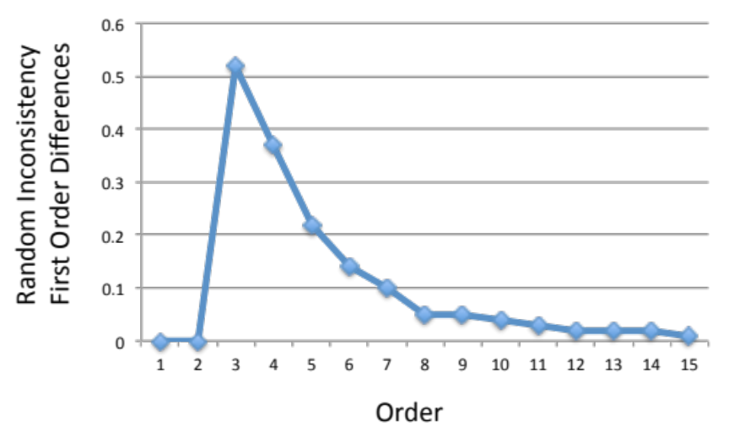
Figure 2: Random Inconsistency first order differences

Figure 2 is a plot of these differences and shows the importance of the number seven as a cutoff point beyond which the differences are less than 0.10 where we are not sufficiently sensitive to make accurate changes in judgment on several elements simultaneously.

4.0 Summary

This paper has presented a semi-theoretical explanation tool and its underlying mathematical basis. It is not complete in that it does not contain a complete set of formal proofs.

The paper has discussed the differences between relative and absolute judgements and how AHP provides a framework for complex decisions to be made using absolute judgements allowing for the checking of consistency.

The paper has introduced the eigenvalue problem that lies at the mathematical heart of the process and how consistency ratios can be determined as a measure of decision quality.

