Test Engineering Guidance Document
Contents
SAP 2
SAP Overview 2
Opening SAP 2
Adding Favorites 2
Common SAP Icons 4
SAP Theme and Option Changes 4
Getting Around SAP 5
Common Interface Actions 5
Stopping Slow or Runaway Transactions 6
SAP Guidance (Tips) 6
To use SAP without Single Sign On (SSO) 7
Material/Product Information 9
MM03 Linked Documents: 9
Creating Documents 9
Engineering Change Requests (ECR) 10
Initiating Proposal 10
Submitting ECR 12
ECR Approvals 13
eOESR User Guide 14
Submitting eOESR 14
Reviewing/Responding eOESR 15
Waters Portal 17
LMS Training 17
Org Chart 17
Visual Directory 17
Expense Report 17
Waters Connections 18
Service Assist 18
Graphical Parts Locator 19
Reference Information 21
BitBucket (Software Storage) 22
Setting Up Atlassian, Git, and Tortoise Git 22
Resources: 28
Stock Room Request 29
TE Access 29
Templates 30
Transferring Large Files 30
Word/SAP/NI Tips 31
Downloading LabVIEW 31
To allow locked content control text boxes in Word be deleted: 32
Looking up a model code in SAP: 33
Creating two separate instances in Excel 2007-Present: 33
Equipment FSE Training Manuals 33
Appendix A 34

SAP

SAP Overview

Opening SAP
- Click SAP Login Icon  to open the Logon Pad.
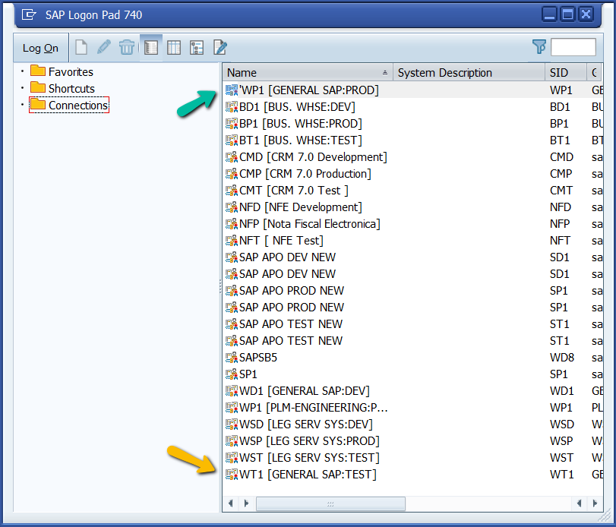
- Double Click WP1 [General SAP:PROD]
- If you have a wish to try something out with little fear of causing a problem, try the test server by double clicking WT1 to enter the “Test” server.
(Note: This is only for testing, the information in WT1 database is not updated or correct.)

Adding Favorites
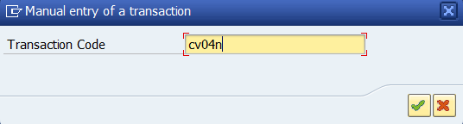
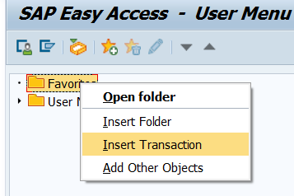
- With the user menu open right-click on “Favorites”
- Type in the Transaction code you wish to have saved as a favorite (CV04N Find Document) and click the Check mark button.
- Appendix A of this document has a list of some of the more commonly used Transaction codes.

Common SAP Icons
 | Execute
or | Enter/Check
Back, Log-off, and Cancel
(Bring you back a screen)
Open Original
(Moves original Document to the server)
Edit
(Moves Document from server to C:\PLMworkspace)
Check in
(Moves documents out of C:\PLMworkspace to server)
 | Find (CTRL-F) and Find Next (Ctrl-G)
or | Export to Spreadsheet
 | Filter
Get Variant of saved inputs, Change layout of list,
(Icon is used for many other action)
 | Paste from Clipboard
 | Open New Window
 | Layout Options
 | Multiple Selection

SAP Theme and Option Changes
- There are many options that can be change in how SAP is displayed which can be found by clicking the customized layout button and then clicking options.
- The Search function can be a quick way to find something specific you wish to change.
- For Example, Sounds. SAP tends to make lots of noise so let’s turn off the sound.
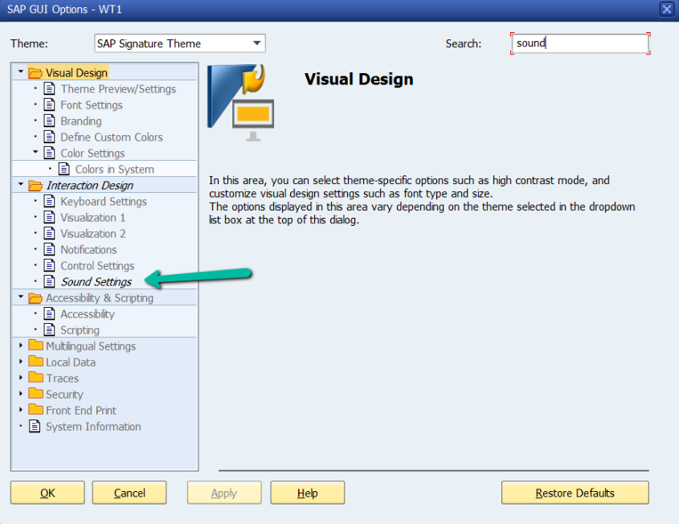
- Type in “sound” in the Search box and press enter.
- Notice that some folders where opened and Sound Settings is shown in italics.
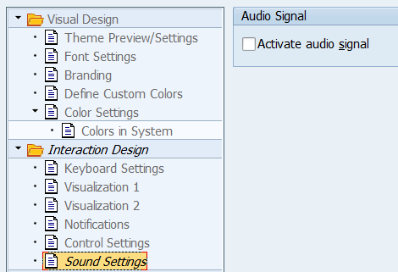
- Clicking sound setting will give you the option to Activate or Deactivate the Audio Signal.
- Click Apply to save your choice.

Getting Around SAP
- When using SAP, each transaction lives in its own window.
- To open another window for another transaction code, click .
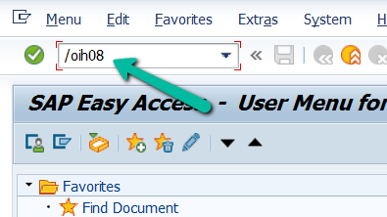
- If the Transaction code is known, it can be typed into the space shown below with the prefix “/o” as shown.
- You can also use the prefix “/n” to change the present window to the new Transaction code.
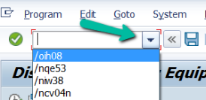
- Click the drop down to see a list of previously inserted T-codes.

Common Interface Actions
- SAP has some helpful tools that are available in most windows.
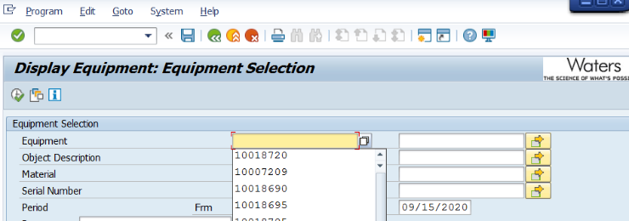
- Using “IH08” as an example. Selecting a blank field and pressing “backspace” produces a list of previously used entries.
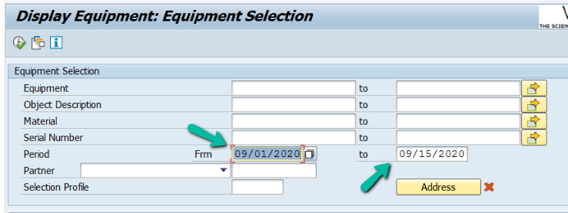
- In some cases you can enter a range.
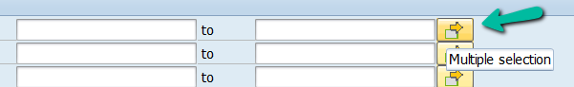
- If you have a list or want to look at more than one at a time, if available, click the Multiple selection button.
- Within the Multiple Selection window you can type in the selection of data, or backspace to find a list of previous entries or paste in a list, it is best practice to use the paste from clipboard button instead of “ctrl-v”.
- All present entries can be deleted via the trash icon.
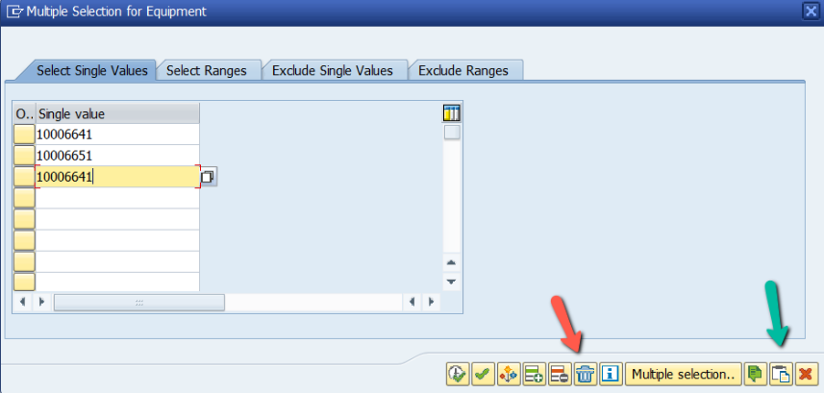
- Press “execute” button to paste the entries into the field.
- Double clicking on a field brings up the define selection options windows.
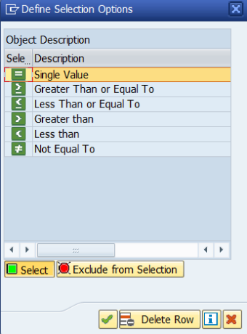
- This window allows for the use of sorting logic.

Stopping Slow or Runaway Transactions
In some cases, SAP can get stuck completing a search which doesn’t allow you to open more windows.
You can stop the transaction by clicking in the corner of the window as shown and clicking “Stop Transaction”
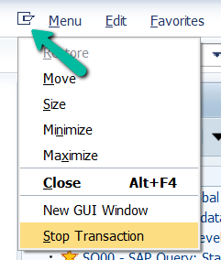

SAP Guidance (Tips)
When using released documents (from SAP) in manufacturing or for setup / calibration / verification / validation, the document should be printed (PDF when available), direct from SAP, by right clicking on the document, selecting print, and directing the print to the appropriate device. Stamped documents can also be obtained by using “MAIL” as the output device. This will email a “stamped” PDF that can be printed to any printer with your Adobe Acrobat (or any PDF viewer).
More SAP tips and common transactions in the SAP cheat sheet Appendix A
Common Transactions:
- CV01N – Create document
- CV02N – Change document
- CV04N – Find document
- MM03 – display material
- MMBE – Stock Overview
- CS15 – Single-Level Where-Used List
- ZP21 – Where used
- ZCHANGE – Engineering Change Requests
- SOBN01 – Find SAP Users Name or ID

Change “OVR” (Overwrite) to “INS” (Insert) to prevent overwriting text when typing in SAP text fields.


This can also be set to “INS” by default by changing the Local Layout options as shown below.
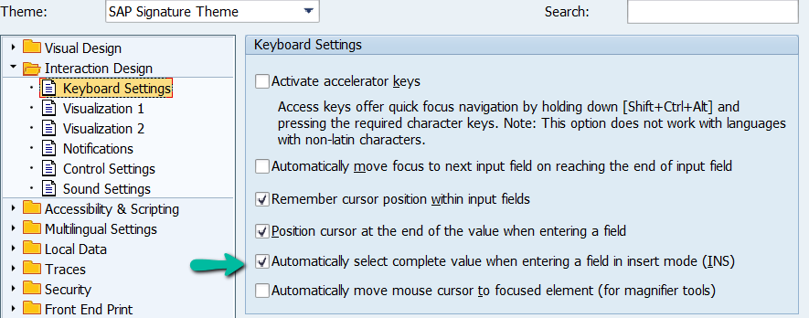
If you want to know which T-code is active in the window you can click the arrow shown and get windows details. If you click one of the details it will change what is shown on footer for the session.
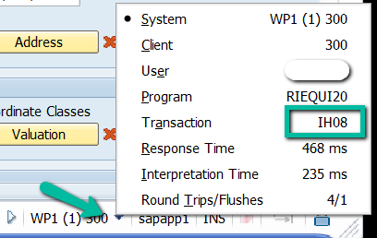


To use SAP without Single Sign On (SSO)
You need to know your SAP password from before SSO or get BT to reset it.
To reset: Call 4772 and get your password in SAP reset, make it clear that you want to reset your SAP password not SSO password. (I had them set it to the same as my SSO).
Once you have your SAP password you can log into any SAP computer as follows:
From the SAP Logon pad, select SNC Logon Without Single Sign-On
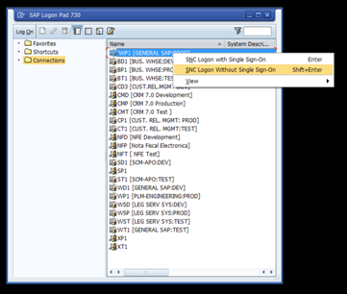

Log in with your SAP user (same as CORP username) and password.
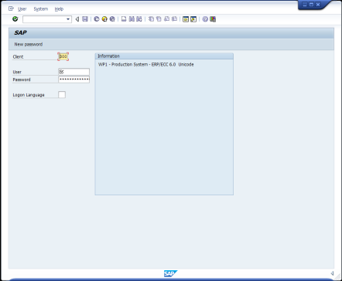

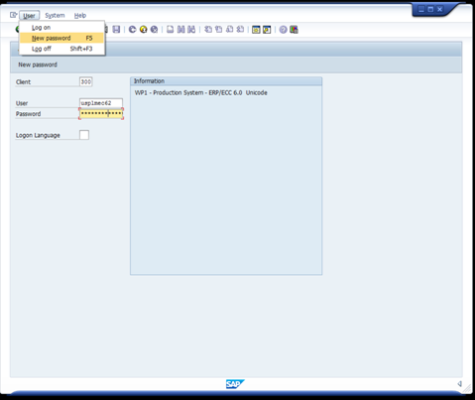
It is a good idea to set your SAP password to the same as CORP password and maintain it as such so you do not forget it. The SAP password does not expire, but the CORP one does every 90 days.

To change you SAP password:
Go to the Logon screen without single sign on as above.
Type in your user
Type in your password, DO NOT HIT ENTER.
Click User on the menu.
Click New password
Enter new password.

If you put in the wrong password a couple times, than each time and you open SAP you will get a message with attempts on your account. This can be cleared by entering in the wrong password enough times to Lock the account. You will then need I.T. to unlock it and the message will go away. You could try I.T. first and ask them to fix the message as well.

Material/Product Information

MM03 Linked Documents:
- In SAP, use transaction MM03 to display a material (by part number).
- Click to view “Basic Data 1”.
- Click “Additional Data” which is listed above the section tabs.
- Click the tab “Document Data” to find all linked documents (ASP, TSP, DWG, etc)

Creating Documents
To create a new document (TSP, TEE, etc.) perform the following steps.
- In SAP, execute transaction cv01n –create document.
- If creating a new document (no previous version) perform the following:
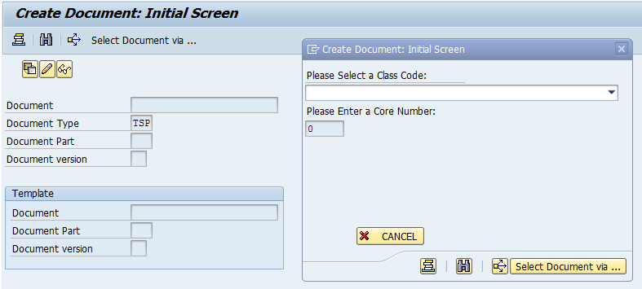
  - Specify the Document type you would like to create. Leave the remaining fields within the cv01n transaction window blank and click Enter.
  - Select the class code that is appropriate for the document being created (735 = TSP, TE0 = Test Equipment, TMD = Temporary Manufacturing Deviation).
  - Enter a unique core number for the document being created OR leave blank to autogenerate a number (NOTE: for test equipment the core number = 0TENUMBER).
  - Enter a suffix if required. (For TEE documents this will be QA, QX, EQ, SF or ME).
[EQ = Equipment Folder, SF = Software File(s) (Document(s) noting revision and location of Source Code), ME = Mechanical Drawing(s), QA = Validation Product(s), QX = Executed Validation Product(s)]
NOTE: Reference 730001834 for more info regarding TEE Documents
  - Fill in the required fields within the DIR window and attach the document to the DIR.
    - Description: The title of the document
    - Lab/Office: AKH = Test/Mfg Engineering (Milford)
- If creating a document from a previous revision perform the following:
  - Specify the document number and document type of the new revision of document being created.
  - Click “Enter”. This will create a copy from the most recent version of the DIR. Click the green check mark to copy the “Material Master”.
  - If the previous version is incorrect (Abandoned and has incorrect links) change the document version in the “Template” section of the “Create Document” screen to copy an appropriate version. See below.
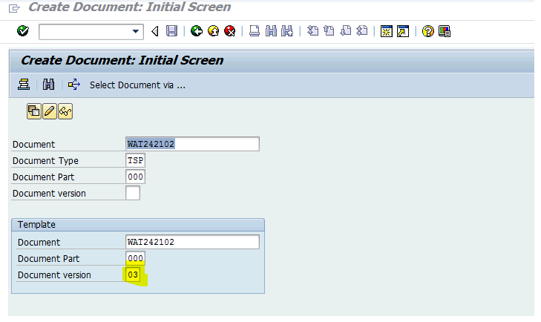

Engineering Change Requests (ECR)

Initiating Proposal
- Use SAP transaction “ZCHANGE” to access the engineering change request menu.
- Select “Create a Proposal” then press the Enter key when the Reference: Proposal screen appears.
- Fill in all required fields:
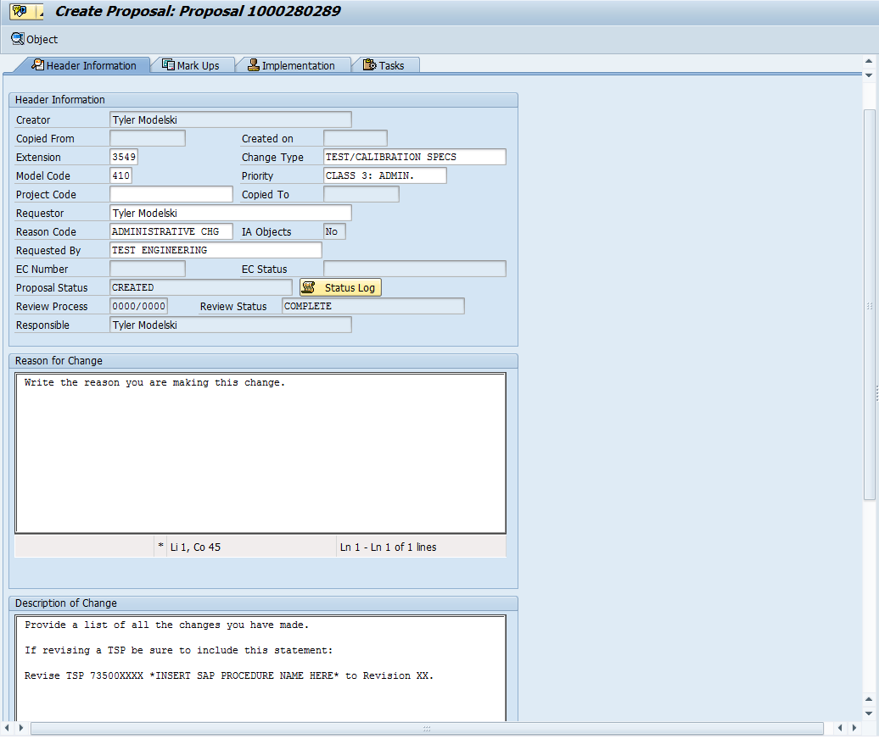
Extension: Creators telephone extension to be reached with questions.
Change Type: Test/Calibration Specs. This will almost always be the choice for TE.
Model Code/Project Code: Only one of these fields is required. Model code is the code of the upper level assembly this change will affect, if there are multiple upper level assemblies then choose one. This code affects the approvers of the ECR.
Priority: This will almost always be Class 3: Admin for TE.
Requestor: Name of the person requesting the change.
Reason Code: This will most likely be 1 of three codes: Administrative Chg (for document changes), Specification Change or Quality Document Chg.
Requested By: This section will always be Test Engineering.

- Complete “Implementation” section with a risk assessment of the change.
  - Select the Assessment by clicking the box(es) shown below which will fill in the overview text.
  - Explain the Rationale for your assessment choices in the text box for ALL 4 Hazard Rationale.
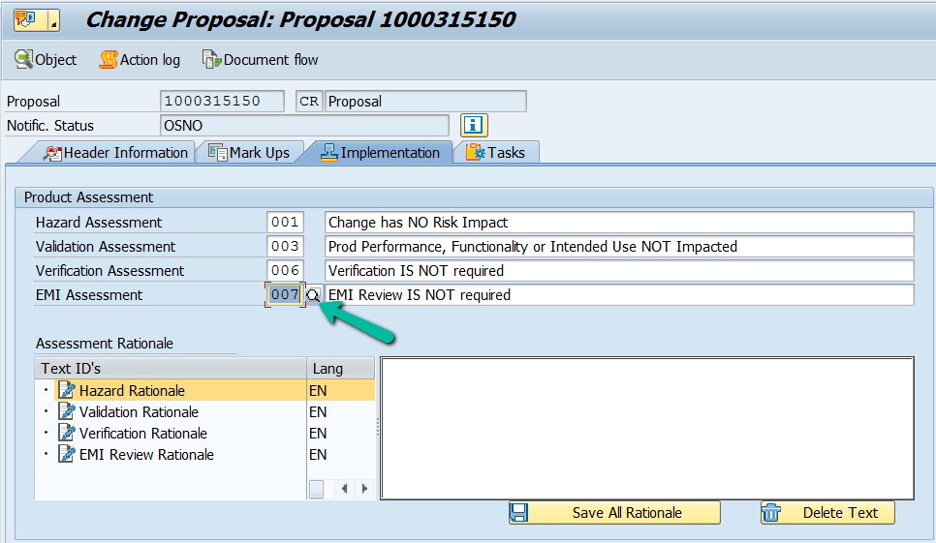
Tip: This data should import into the ECR, but it is safe copy the text in the comments section into a word document. It can then be pasted in the implementation section of the ECR.

- The Proposal needs to be saved before the ECR can be initiated. Saving will close the window.
- Use “Search for Proposals” and check the box “My Proposals” to open again.
- In the “Action Box” on the right side of the Proposal window, select “Initiate ECR”.
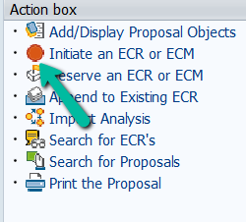
(NOTE: Do NOT “Submit” the proposal. This will route the proposal to an approval process that is not needed for proposals.)
This step generates an ECR with the fields that were filled in.

Submitting ECR
- Use the “ZCHANGE” transaction in SAP to access the engineering change system.
- Select “Search for ECRs”. Select the “My changes” check box and click the green check mark.
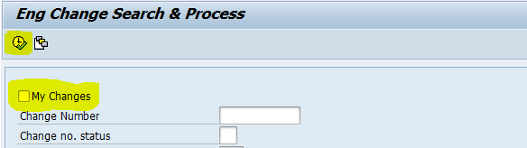
- Find the ECR that was created from the proposal and double click it. The ECR description, model code, change type, and priority fields are generated from the proposal. If you need to edit these fields within the ECR select “ECR Mgt.” from the headers row.
- To add objects (an SAP dir including a test procedure, cal/PM docs, design docs, qualification docs, etc) click “Edit Obj.”
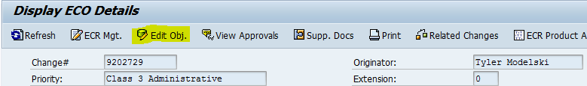

- Within the edit objects window fill in the fields shown below. Save changes.
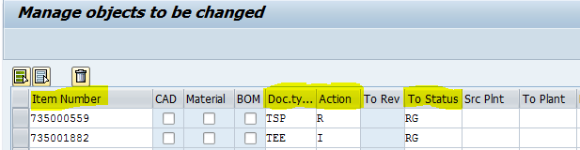

Item Number: The number of the DIR in SAP for the test procedure, CAL/PM procedure, design doc, or qualification doc being changed.
Document Type: Specify the type of SAP document being changed.
Action: I = initial release, R = revision change
To Status: RG = Release general (this may also be OB if object is being obsolete or in some cases PP pre-production).
(NOTE: Documents need to be in Ready status, documents In-Work (IW) need to be changed to Concept and saved before they can be changed to Ready.)
- Select ECR Product Assessment and copy the risk assessment information from the “Implementation” section of the original proposal.
- Submit the ECR for approval.

ECR Approvals
To view the status of approvals for an ECR do the following:
- From within the ECR, click “ECR Mgt”.
- Click the “Service for Objects” menu button then “workflow” and “workflow overview”.
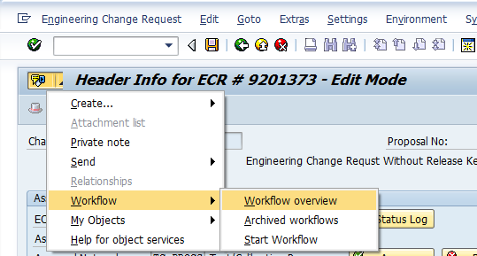
- Double click “ECR ‘ XXXXXXX ‘ Processing Workflow”. You can scroll down to view who has approved the ECR and who is left to approve the ECR.
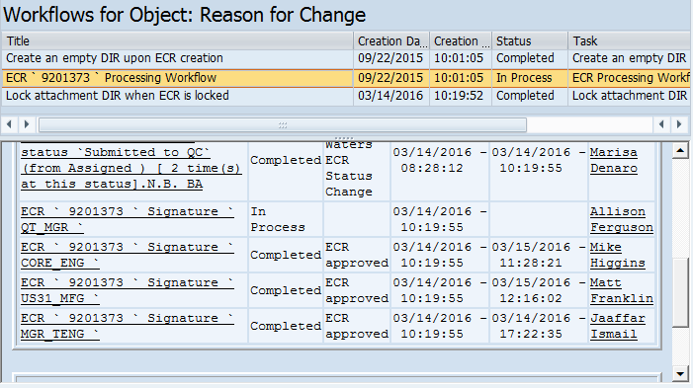

eOESR User Guide

Submitting eOESR
- Navigate to the eOESR URL: http://10.2.241.78/fmi/iwp/res/iwp_auth.html;jsessionid=05E110785BFF32CE15C24EFE.wpc1
- Select the “OESR” link.
- Login with “Account Name and Password”.
  - Account Name: CORP Username
  - Password (default): password
- To create an OESR request click “Create New OESR Record”.
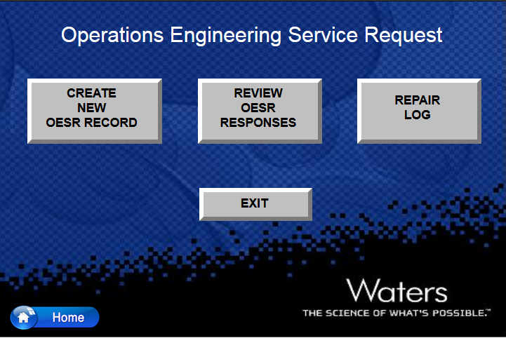

- Fill in all required fields on the OESR form. All fields are required to be filled in prior to saving.
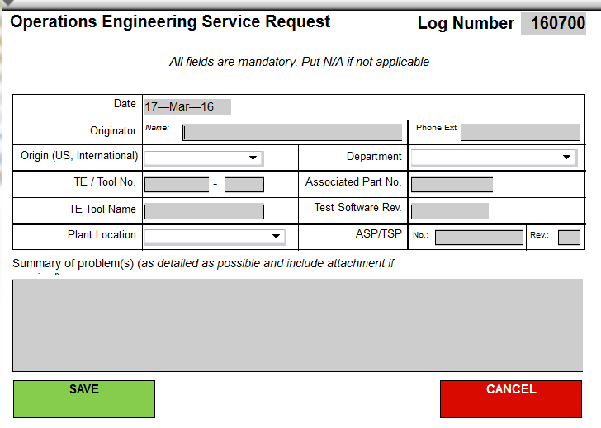

- When ready to submit the OESR, click “Save”. This will save the request into the OESR database.
- Notify operations engineering support via email by selecting “Email OESR”. Ops eng support will assign the OESR to the appropriate person.
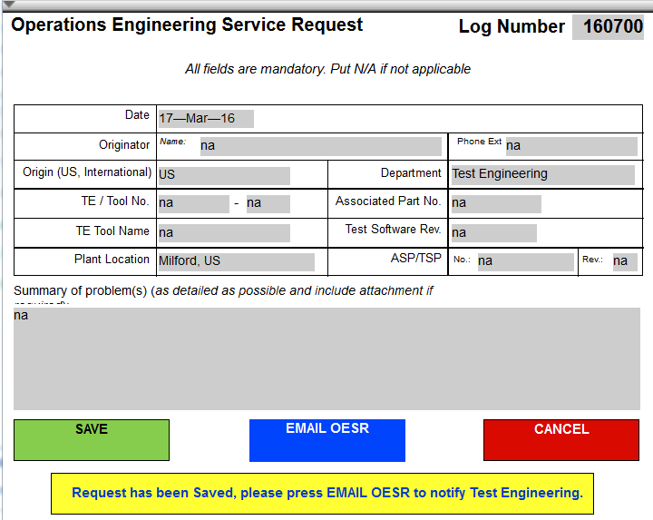

Reviewing/Responding eOESR
- Navigate to the eOESR URL: http://10.2.241.78/fmi/iwp/res/iwp_auth.html;jsessionid=05E110785BFF32CE15C24EFE.wpc1
- Select the “OESR” link.
- Login with “Account Name and Password”.
  - Account Name: CORP Username
  - Password (default): password
- To review/respond to an OESR request click “Review OESR Responses”.
- Once in the OESR database, select the “down” arrow to drop down navigation options.
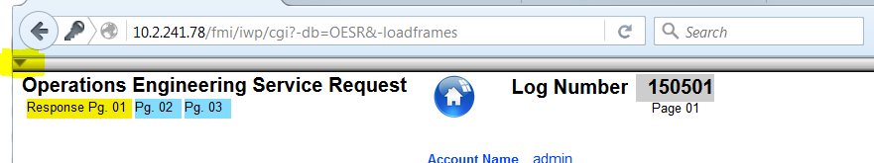

- Use the arrow keys in the top left corner to scroll through the OESRs in the database. Click the grey circle to sort based on criteria specified in the sort menu.
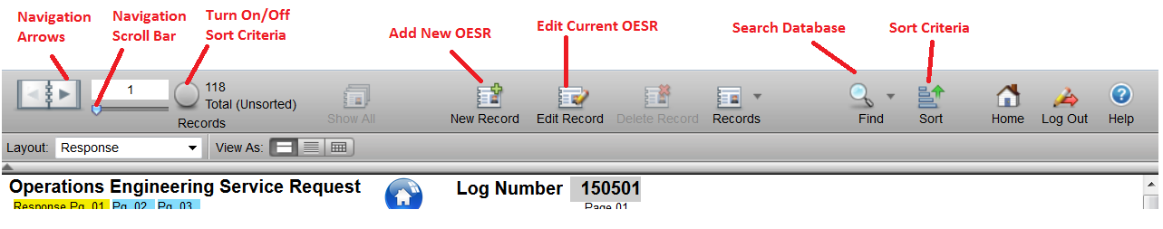
- The “Find” button can be used to search the database. The find button opens a window that is identical to a blank OESR form. Enter text into the fields to filter the database based on the criteria entered. Click “Perform Find” in the
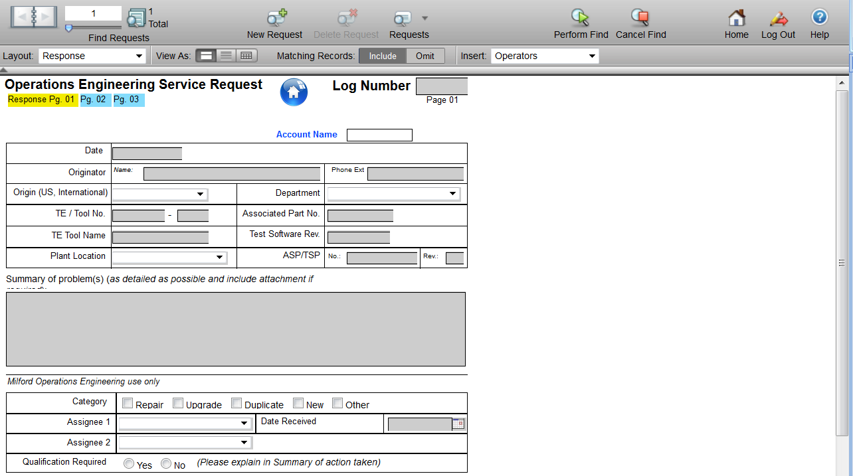

- When assigned to an OESR, respond by clicking “Edit Record”. Fill in the following fields:
  - Qualification Required
  - Summary of Action Taken
  - Recommendation
An explanation of qualification (yes or no) needs to be provided in the Summary section.
- Once finished, set the date complete and click “Submit” in the menu bar.

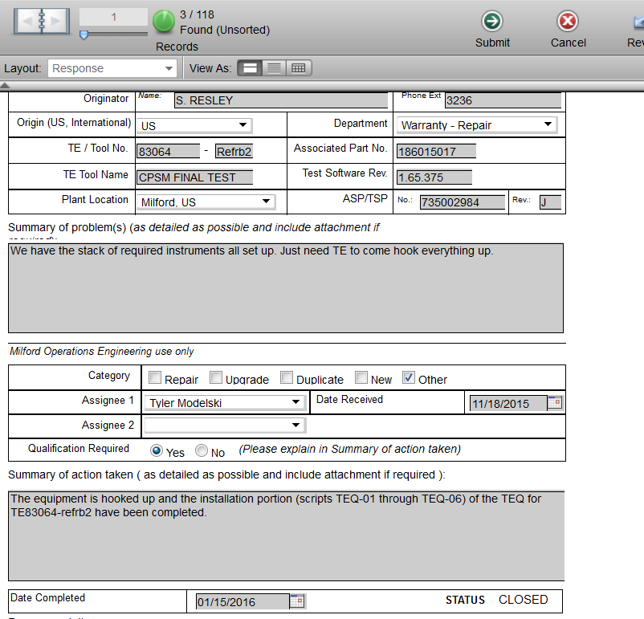

Waters Portal
portal.waters.com

LMS Training
There is a link on the Main Page and under Success Factors in the Employee Self Service

Org Chart
See Employee Self Service
The Org Chart can be used to find employees/Managers in/of a specific cost center by using the dropdown in the search box and scrolling to the right to Cost Center

Visual Directory
https://waters.officespacesoftware.com

Expense Report
See Employee Self Service

Waters Connections
connect.waters.com

Service Assist
Service Assist is a great location to get information on PM Kit’s for instruments, reference documentation, and Illustrated parts location.
- From the Waters Connections Home page “connect.waters.com”. Click on Apps and then Public Wikis
or https://connect.waters.com/wikis/home?lang=en-us#!/wiki/Service%20Assist
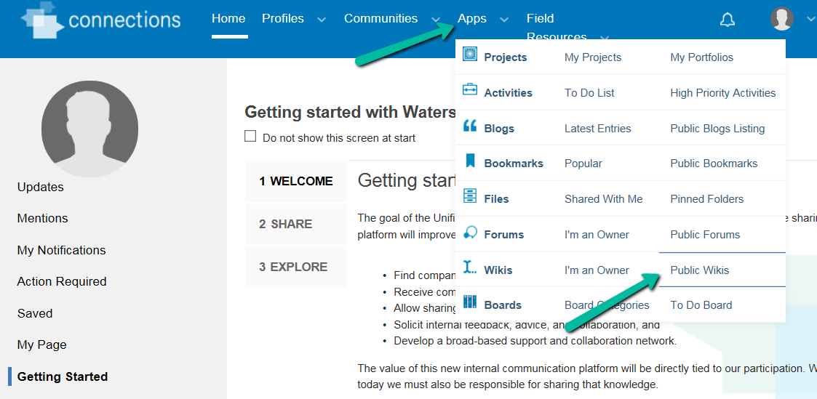
- Under the “Most Visits” select Service Assist or type in Service in the search box.
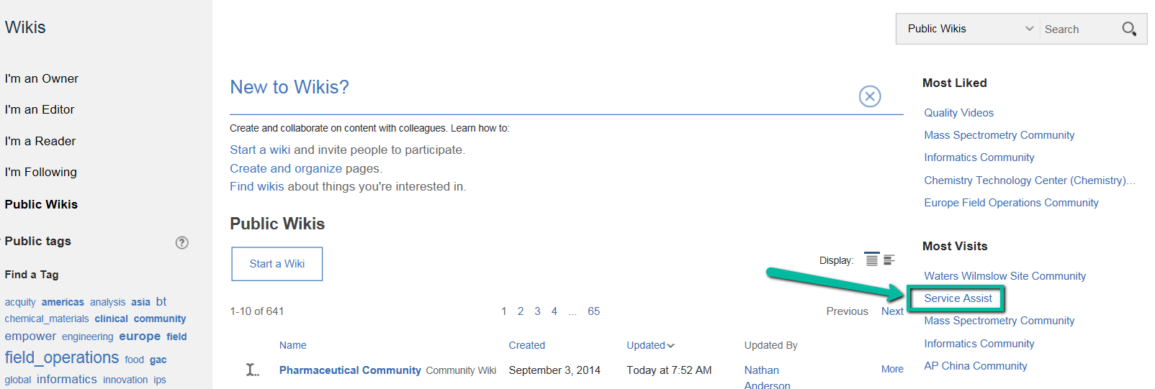
- There is a Large amount of information available in this Wiki.
- Most of the commonly needed information can be found by starting in the Part Locators & Reference Info.
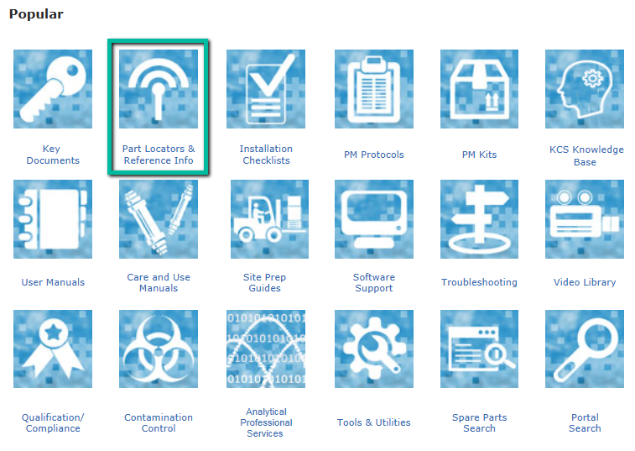
- Using the dropdowns, you can select the type of equipment you wish information on.
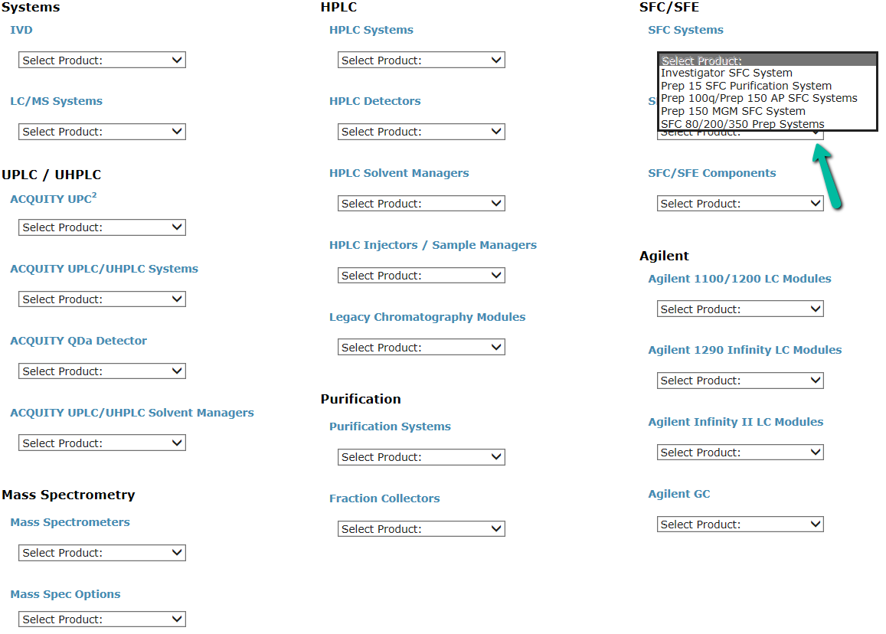

Graphical Parts Locator
- From the Waters Quality parts locator 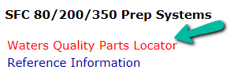you can bring up a Graphical Parts Locator for a system or a piece of equipment. Highlight the equipment of interest to see more details and select to go to the next level of parts detail.
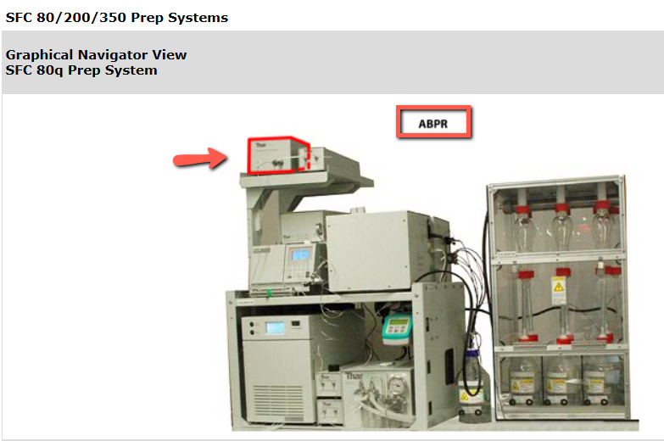
- Some graphical levels are not avaible with highlight and click, they can be seen however by selecting subcomponent views noted as “(Not Shown).
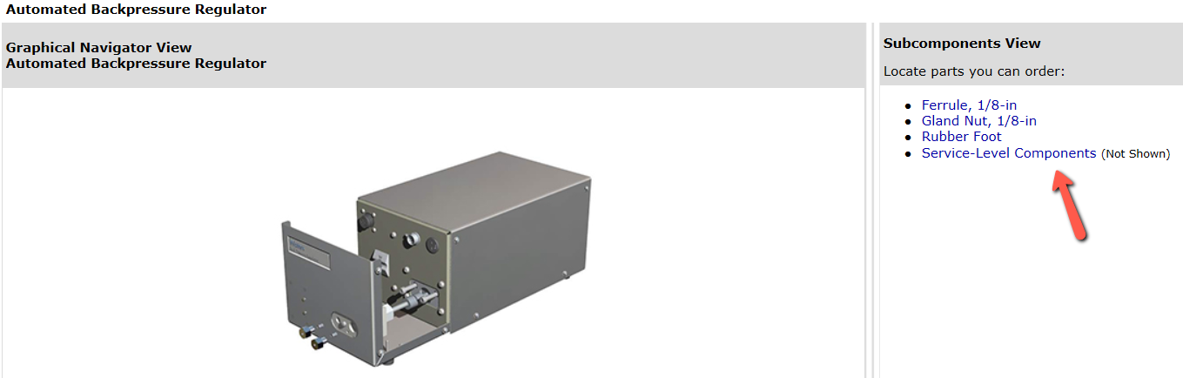
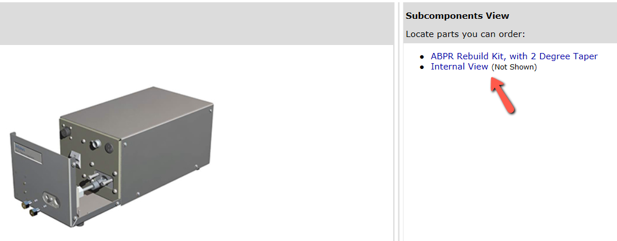
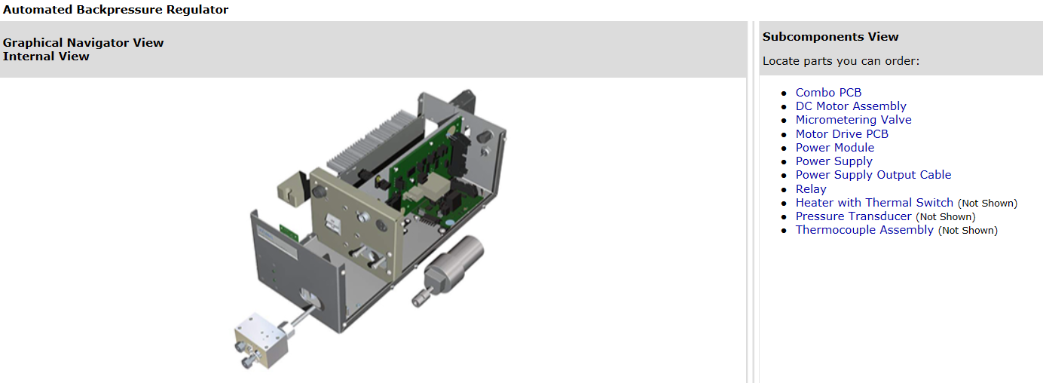
- Some BOM information and Where Used can be access through this site as well.
- Enter a Part number and click the BOM Button to see the items that make up a Kit or a Sub assembly.
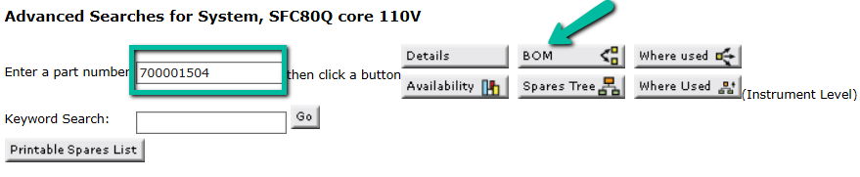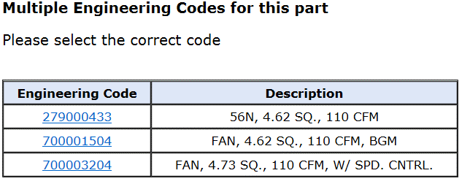
- Click “Where Used” to find other locations the part may by applied.
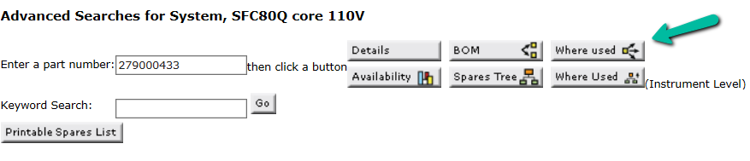
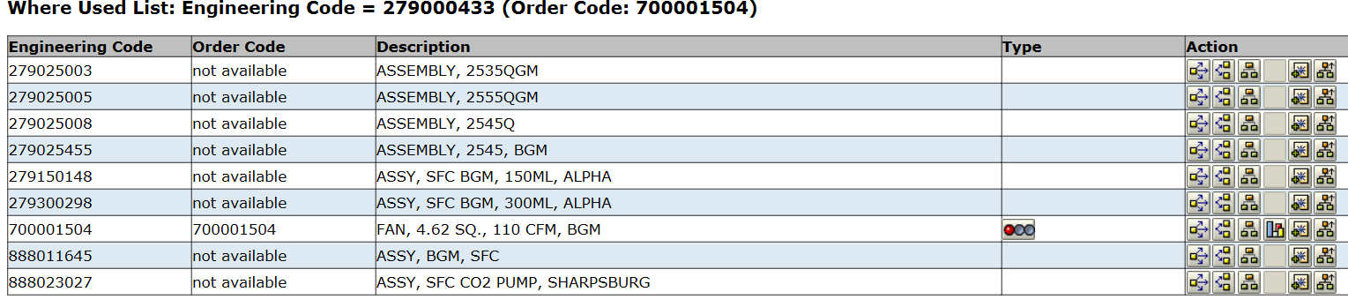

Reference Information

- From the GLP Home page select an instrument from the dropdowns.
- Click Reference Information 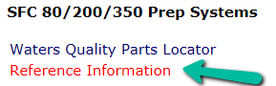
- Selecting a topic may show more options. 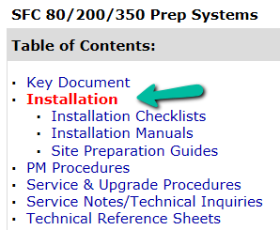
- Selecting a Topic or Sub-Topic shows Reference material related to your selection.
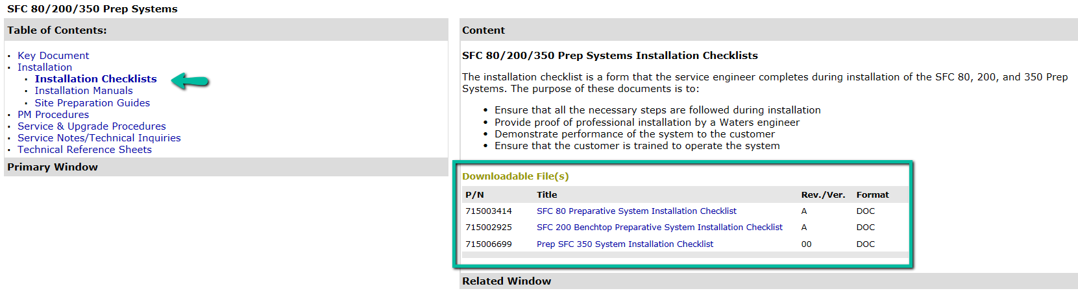
- Service Notes/Technical Inquiries normally directs you to Lotus notes via a clickable link.
- Some reference material is not clickable yet will give you the P/N for the Document which you can then locate with SAP CV04N.

BitBucket (Software Storage)

Setting Up Atlassian, Git, and Tortoise Git

- Login to Atlassian (code.waters.com) and click on BitBucket.

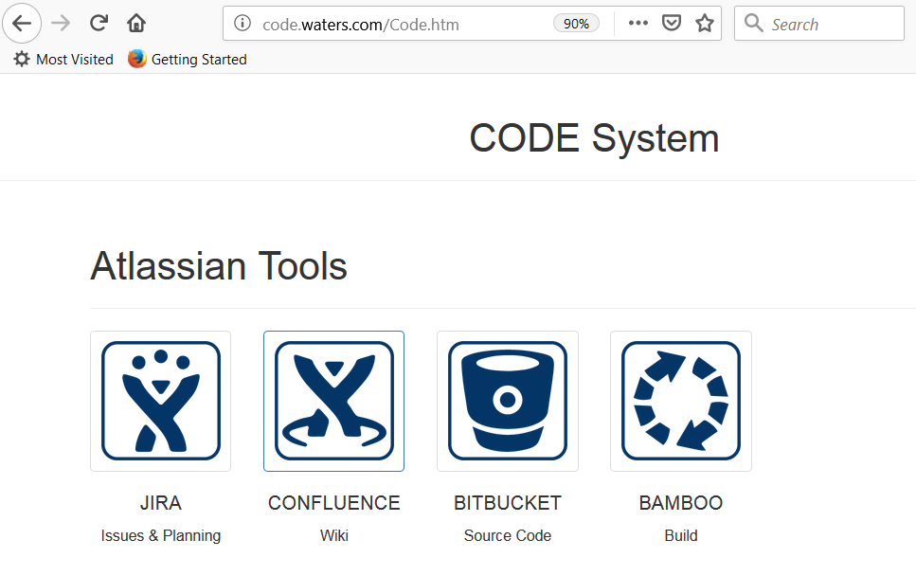
- In BitBucket, select Projects.

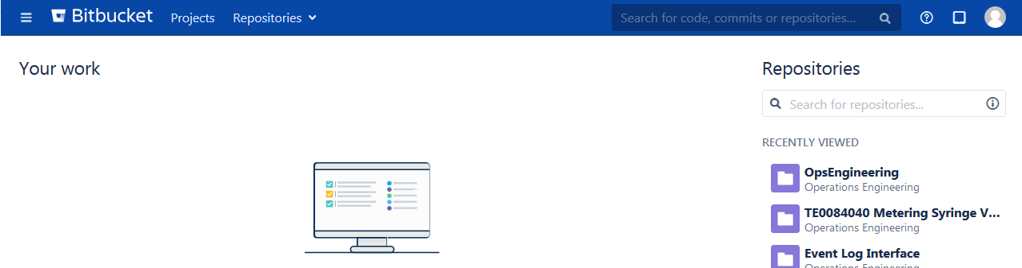

- Within the Projects list, select Operations Engineering.

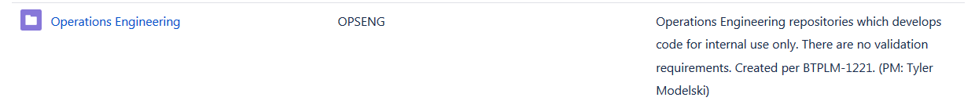

- Within the project, select Create Repository (or the + button on the left side).

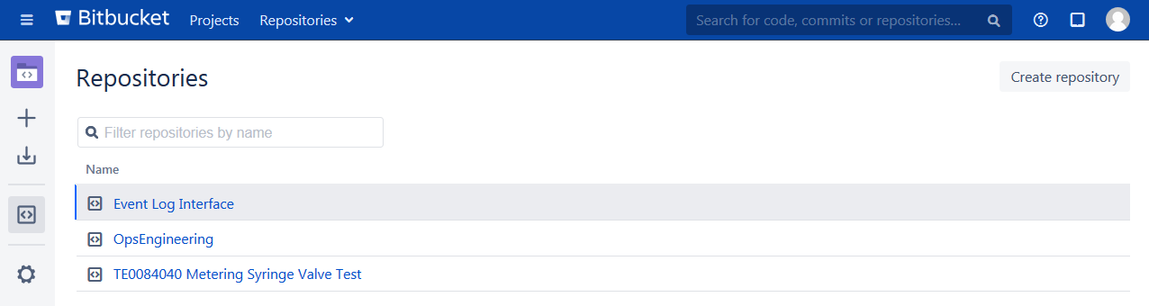
- Create a repository for the test code. Name is TE00XXXXX INSERT TESTER NAME HERE. This will create a blank repository in BitBucket.

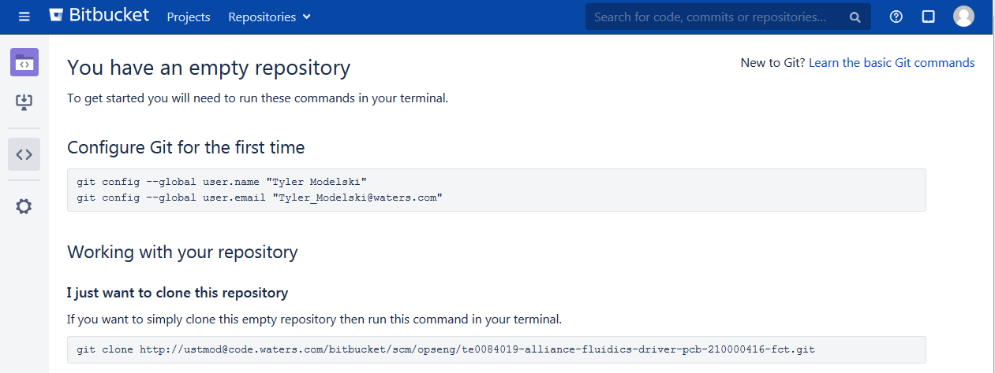

- Install Git on your local development workstation.
https://git-scm.com/download/win

- Install TortoiseGit on your local development workstation.
https://tortoisegit.org/download/

- Configure git for your username and email using Git Bash command line interface. Simply type “Git Bash” from the start menu to find the interface.

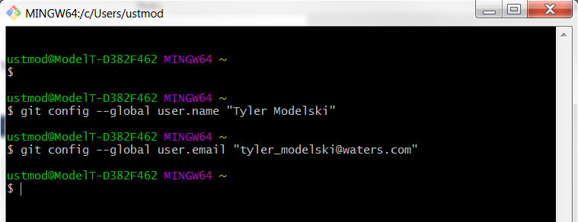

- Right click in your workspace and select Git Clone.

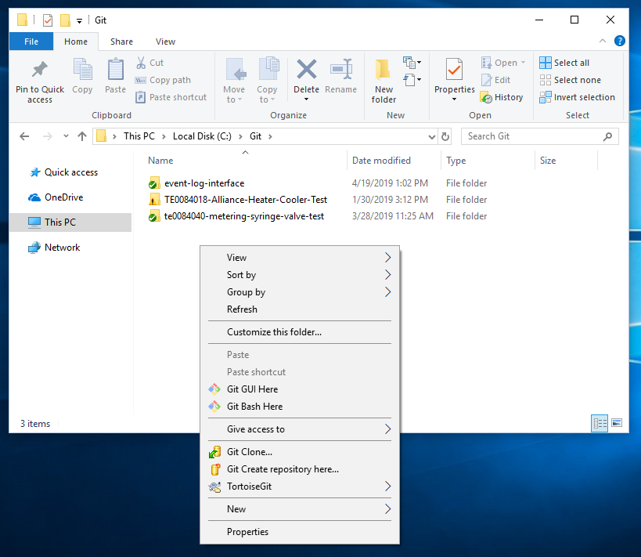

- Copy and paste the URL from the empty repository (including your username and password) into the clone interface and click OK.
Example: http://ustmod@code.waters.com/bitbucket/scm/opseng/te0084019-alliance-fluidics-driver-pcb-210000416-fct.git

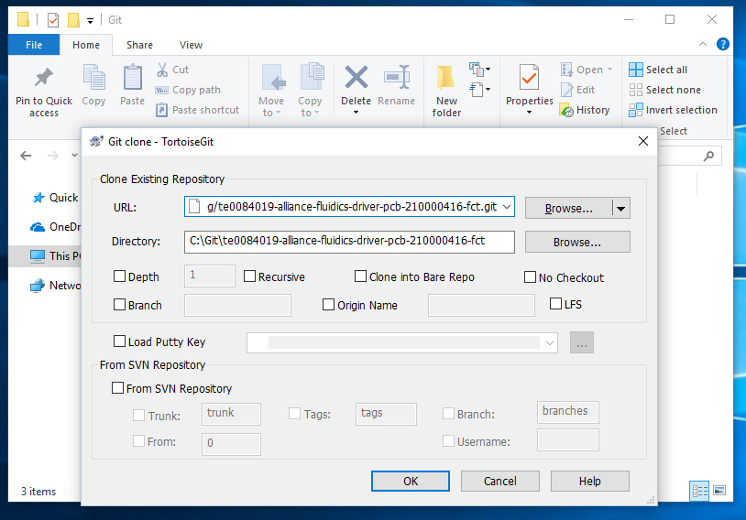
- Enter your credentials for Atlassian.

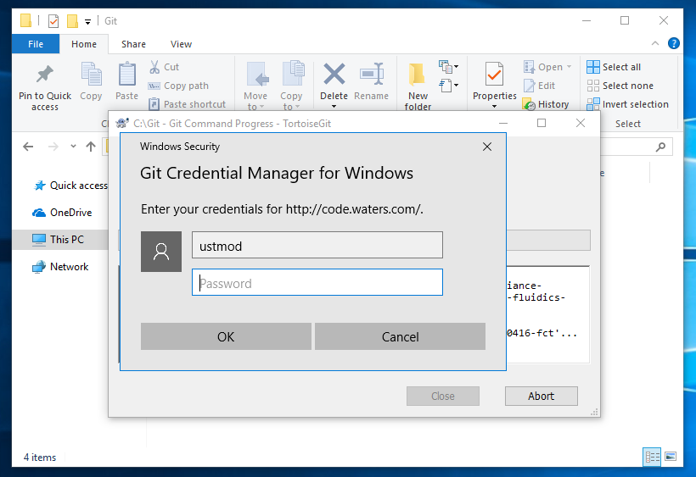

- The repository is now setup for use. Add your code into the workspace location created.

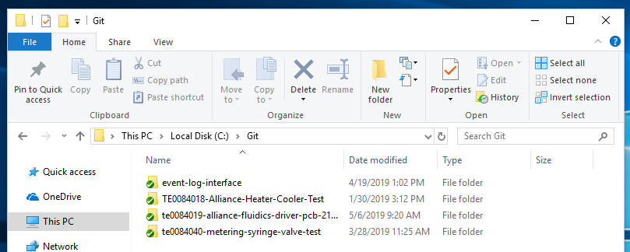

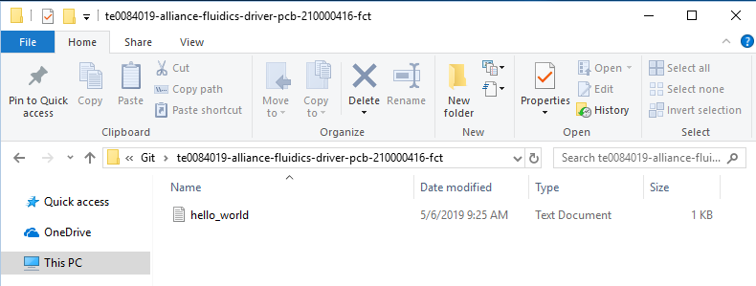

- Right click on the workspace folder and select Git Commit master.
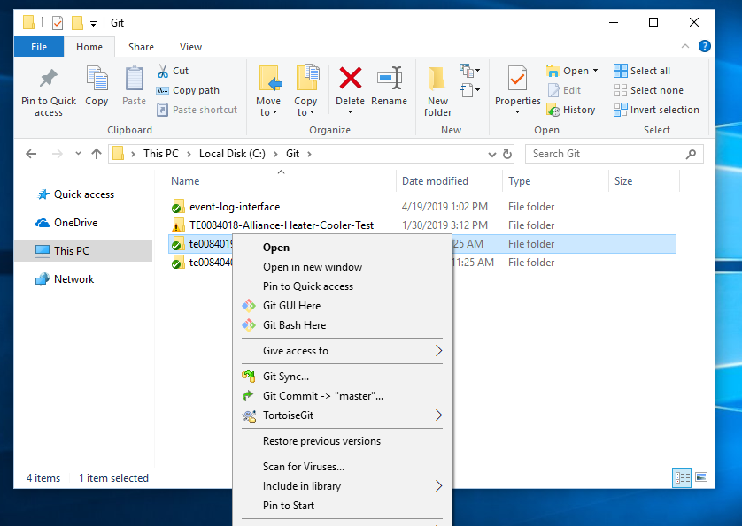

- Select the files you want to commit. If you want to commit All select “All”. Click “Commit”.
  - NOTE: In the future, this will only display the files that have CHANGED.
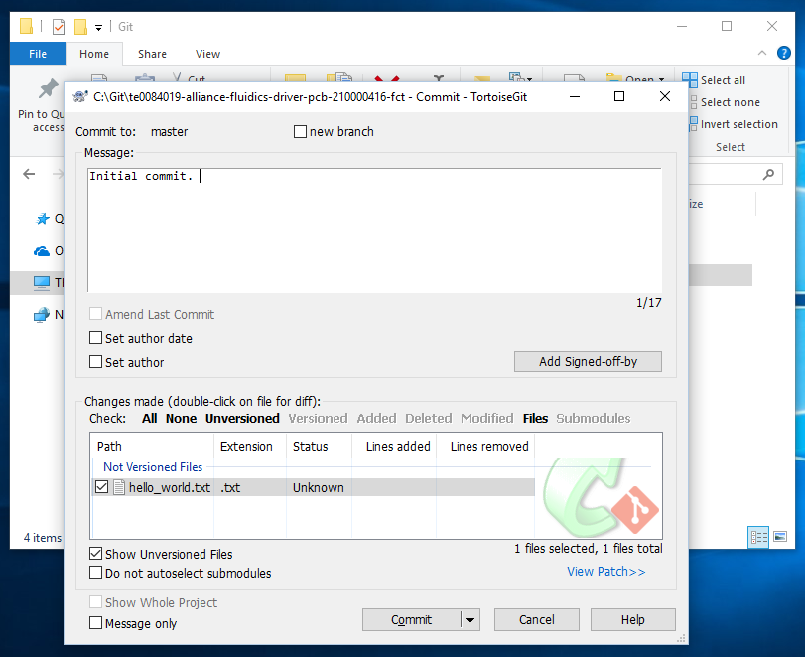

- Push your changes to BitBucket. Right click on the workspace directory and select “Push”. Click OK.
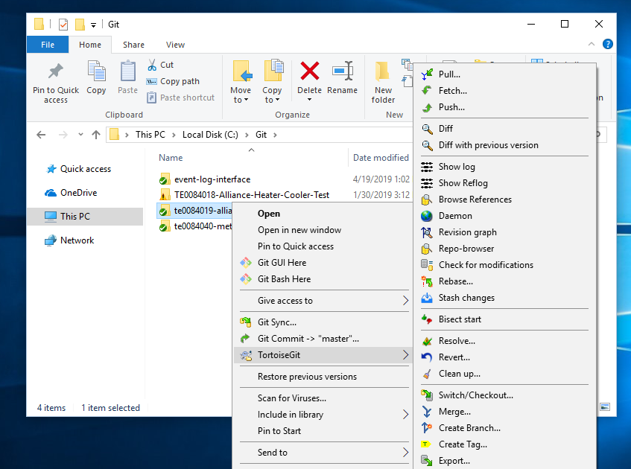

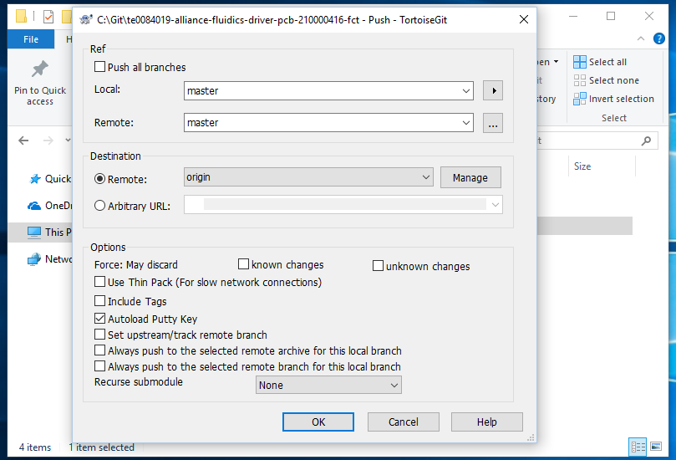

- Navigate back to Atlassian. The change has now been pushed to the server.
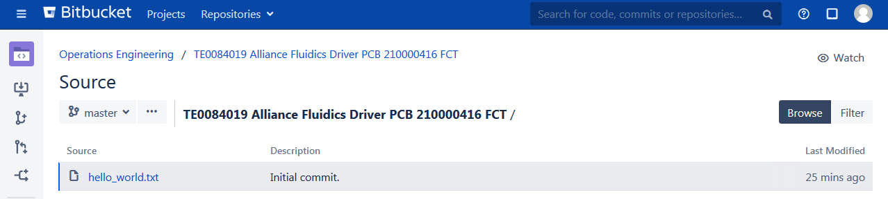

Resources:

- Use the following instructions as a resource by clicking the link to “this Tutorial”.
  - NOTE: These instructions use ssh keys and GitHub. Ignore this. Simply copy and paste the link to your repository from Atlassian when performing a clone.
https://knowledge.ni.com/KnowledgeArticleDetails?id=kA00Z0000019OWSSA2

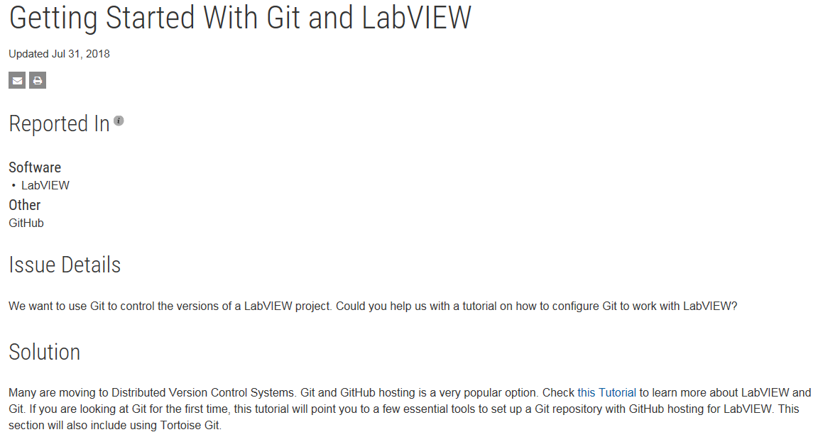

Stock Room Request
Obtain the Latest Requests forms for US10 and US31
US10 Stock Requests are emailed to Stock_Request@waters.com
US31 Stock requests are emailed to or hand delivered to a Planner for a signature and then placed in the Stock room for picking.

TE Access
Test Station:
Username: TEXXXXX-XX Password: TEXXXXX-XX
Test Station Admin:
Username: TE-1 Password: adminTEXXXXX-XX
Empower Admin:
Username: system Password: metsys
VNC Viewer (Milford):
Username: TEXXXXX-XX Password: testeng
VNC Viewer (Singapore):
Username: IP Address Password: testeng
eOESR Default:
Username: CORP Username Password (default): password
SigmaSure Guest:
Username: guest@waters.com Password: waters
Newly Imaged TE PC
Username: TE-1 Password: Testeng1!

Templates
Test Equipment Design Plan: 730001945
Test Equipment Design Review Checklist: 730001946
Test Equipment Release Form: 730001947
TEQ: 730001936
TEV: 730001937
TEQA: 730001938
TMD: 730002479
TSP: 730002013
CAL/PM: 730002014
Work Instruction / Operating Procedure: 730000483

Transferring Large Files
Here are the steps for transferring files, especially larger ones.
For example, a 1.5GB file copied using Windows Explorer to a mapped drive took 3 days. The same file using Files.waters.com took just over 2 hours.

- Using your browser go to: https://files.waters.com/
- Enter in your SAP Login and Password
- Select "Send Files" tab
- Deselect Guest Email Addresses (unless you want to use this feature)
- Press NEXT
- Browse to your file to upload
- Press UPLOAD (Files will then be uploaded to site)
- A URL will now be provided. Copy that URL Link to be used later.
- Press DONE
- Remote Desktop into the CM server you want to connect to
- On the Remote Server, launch IE
- Paste the URL Link into the browser
- The Files.waters.com site will open with your files shown
- Select the file you want to download
- Press DOWNLOAD
- Select "Save". Browse to location to save to
- Done

Word/SAP/NI Tips

Downloading LabVIEW
Perform the following steps to install LabVIEW version 2014 or 2015 using Waters Corporate NI License Agreement:
- Navigate to the following server on the network: \\ni-lic
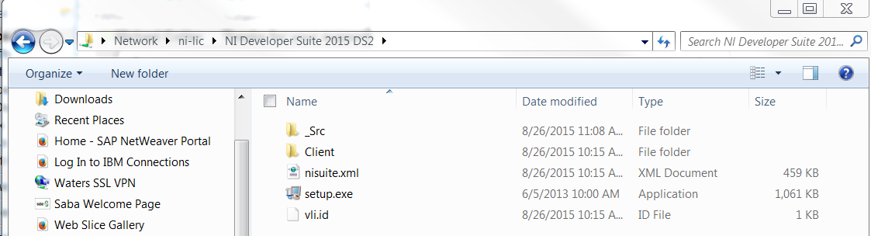

- Open the folder for the version of LabVIEW you would like to install.
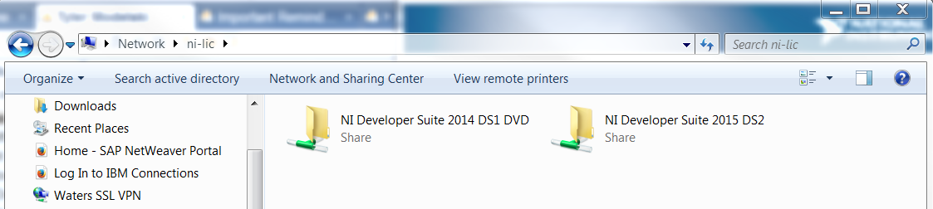

- Double click the setup.exe to launch the installer application.
- Enter your personal information for your username. When finished, click “copy all to computer” and then click “Next”.
- At the Volume License Configuration Page, select “National Instruments Users Milford” and then click “Next”.
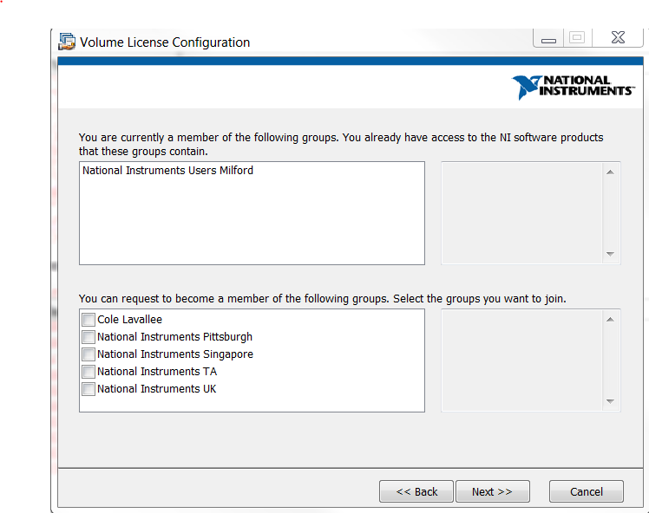

- At the 2nd Volume License Configuration Page, click “Proceed” to request permissions for the listed licensed products in the installer.
- When prompted with the “NI Developer Suite” installer, click “Next” at each window until prompted with the “Product List” selection shown below.
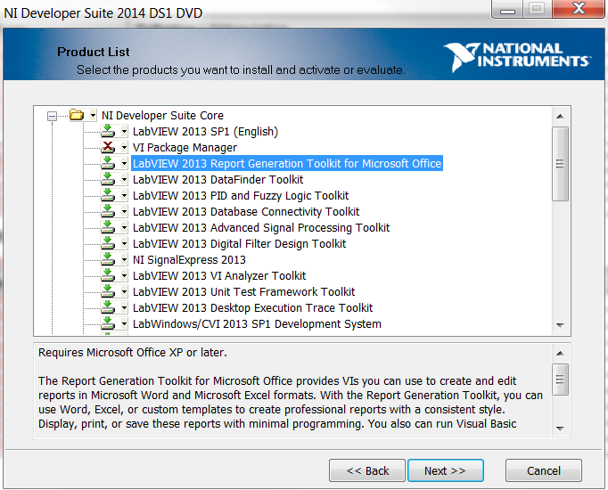
- Select the items in which you would like to install by clicking the dropdown arrow to the left of each product. The installer gives you the default products to install.
- Click “Next” through the remainder of windows and “Agree” to the license agreements.
- Follow the remainder of onscreen prompts to complete the installation.

To allow locked content control text boxes in Word be deleted:
- Navigate to Word Options from the start menu.
- Go to the "Popular" tab.
- Click the box titled "Show Developer tab in Ribbon" then click OK. You now have the developer tab.
- Select the content control text box you want to delete then navigate to the developer tab in the ribbon menu bar.
- Click "Properties" in the controls section of the developer tab.
- Deselect "Content control cannot be deleted"
- You can now delete the text box.

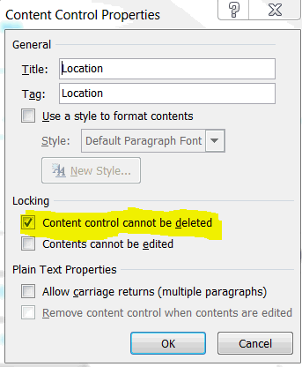

Looking up a model code in SAP:
A model code can be looked up is SAP under Display Material (MM03), Classification tab in the PLM4UG Folders. It will work for all top level numbers and some subassemblies. If the subassembly is not classified, then perform a 'where used' to get a top level product and look that number up to get your applicable model code.

Creating two separate instances in Excel 2007-Present:
When working in Excel 2007, the program does not automatically create 2 separate windows with 2 unique spreadsheets. This can be frustrating when working in two spreadsheets because you cannot have them open next to each other. There is a work around:
- Close all excel instances.
- Open the first spreadsheet that you are working in.
- Navigate to the taskbar and right click on the Excel pin. Click “Microsoft Excel 2007”. This will open a new spreadsheet in a separate window.
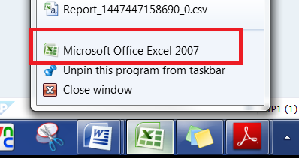
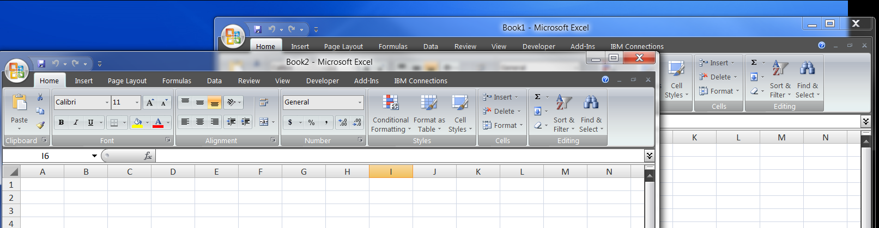

Equipment FSE Training Manuals

Some training manuals and workbooks used during inhouse service training an be found in SAP CV04N.
The document prefix is normally 760 and the document types are QAX.
Likewise, service Install manuals and Preventative Maintenance Protocols prefix is normally 715 and the doc type is SRV.

Appendix A
SAP Cheat Sheet
Where Used |  | Display QNOTES (Instrument RA's) |  | Display Material (Revision Changes)
CS15 |  | QM11 |  | MM03
Select Direct box |  | Select Completed and Postponed boxes (Notif. Status) |  | Enter p/n of material
Type in Material p/n |  | Enter Date range in Notif. Date fields |  | Enter
Select icon with paper and arrow (upper left) |  | Type in p/n in Material field |  | Select Basic Data 2
Type in Plant (US31, EI10, US10, SD01, etc) |  | Select Execute |  | Select Eyeglasses icon - Displays all rev changes
 |  | Double click on the Notif. to look at info further.
 |  | Can also look at the order if necessary
BOM (Bill of Material) |  | FMEA's & Test Spec Documents |  | BOM of Sales Kit
CS12, CS11 or CS03 |  | MM03 |  | CS03
Type in Material p/n |  | Enter p/n of assembly |  | Type in p/n in material field
Type in Plant (US31, EI10, US10, SD01, etc) |  | Enter |  | Type in US10 or appropriate Plant in plant field
Tyep in Best or PP01 in BOM application field |  | Select Basic Data 1 |  | Type in 5 for BOM usage
Select Execute |  | Select Additional data icon at top |  | Hit enter
 |  | Select Document data tab
Display Equipment |  | Standard Cost |  | ECO's (Look at Actual ECO changes)
IE03 |  | VK13 |  | Utilize MM03 to get the ECO #'s
Select right hand icon next to Equp field |  | Condition type is ZMAN |  | CC33
Select Material Serial Numbers tab |  | ENTER |  | Type in ECO number in Change Number box
Type in Serial number or use * as a wildcard (A01487*) |  | Enter the Material number |  | To get description, select Change header box icon
Enter |  | EXECUTE = F8 |  | Select Environment/Reporting/Documents
Select which equipment interested in |  |  |  | Select a DRW document to get the Assy drawing
Stock Overview |  | Standard Cost of a component (Not on Sales Deck) |  | ECO's by part number of assembly
MMBE |  | MD04 |  | CC13
Type in material number |  | Type in part number |  | Enter part number in material box
Type in plant |  | Type in US31 for plant |  | Enter
US31 - Milford |  | Enter |  | Double click on change # of interest
US10 - Franklin |  | Double click on part number (yellow) |  | Select chg long text hdr icon (Shift-7)
EI10 - Ireland |  | Select Costing 2 tab (use arrows to far right to change tabs)
SD01 - Distribution Kit in Franklin |  | Standard cost is located down in the lower right
Demand/Backlog/Consumption |  | Material Returned to Milford |  | Document/Drawing lookup
MD04 |  | VA12 (1xxxxxxx) or VA02 (6xxxxxxx) |  | CV04N
Enter p/n |  | type in RA#/Enter |  | Type in Document p/n
Enter plant - US10 |  | Environment/Display document Flow |  | Select Latest version/double click
to look at order, select, then spectacles button |  | Look for 84xxxx (returns) |  | Double click on appl document (PDF or MSWord)
if no info (detailed) - use NL10 for plant to get details |  | this means that it was received in Milford |  | will open in application for viewing
Select Expand Header Details Icon (upper left corner)
Select Total Consumption Tab
Service History by specific instrument |  | Sales History (returns) |  | Consumption
SQ01 |  | MCSI |  | MD04
use IE03 to get equipment # |  | Select S700 - Waters Worldwide History |  | Type in part number in Material field
Select far left button |  | Be sure System field is empty |  | Type in US10 (Franklin) in Plant field
Select SM (service management) |  | Type in material p/n |  | Select the Green Check Mark at upper left corner
Find H7 and Execute |  | Type in Day range from and to |  | Select Expand Header Details icon (to left of material
Enter equipment # |  | Type in RE for Returns in Sales document type |  | description line)
Select Display as Table |  | Clear period dates (at bottom of page) |  | Select arrow to right until Total Consumption Tab
Execute |  | Execute |  | Select Total Consumption Tab
Service History |  | ECO Review and Signoff |  | Find where material shipped
SQ01 |  | ZCHANGE |  | MB51
Select far left button |  | Select Search for ECR button or go to your workflow inbox |  | Type in p/n in material field
Select SM (service management) |  | Type in ECR# in Change Number location |  | Plant (shipped from) - US10, NL20, US20, etc
Find H8 and select it |  | Select Execute |  | Movement Type - 601
Execute |  | Select ECR Mgt Icon/Button |  | Customer (if only want FSE -15) Others (EDC-14, Japan-17)
 |  | Review information |  | Execute
Type in p/n in material field or Equipment Type |  | Select Approve Icon/Button - If OK |  | Scroll over to far right
Type in order finish dates |  | Select QT_MGR line (Highlighted) |  | Double click on Ref#
Select Display as Table |  | Enter your SAP password in the password location |  | At top in general tab - Double click on Delivery note
Execute |  | Select Enter Icon/Button (Green Checkmark) |  | Select Doc Flow icon (to right of trash can)
 |  |  |  | Select Order from PO line - select display document tab
To get in US Dollars |  |  |  | Double click on Ship to
Select column for currency and/or labor rate |  |  |  | Double click on ship to partner
Select Convert icon (2nd button from left or F3)
Type in USD
Enter
Software Documents |  | ECR quantities for “particular” product line |  | Utilize Find Doc
CC04 - Display Product Structure |  | ZCHANGE |  | CV04N
Need to find p/n of F/W first |  | search for an ECR |  | Type in Document p/n
Type in Product upper level p/n (2996 - 279002996) |  | Select a project Code in the Project Code field to display Beta |  | Select Latest version/double click
Use files under documents - look for lates rev (green light) |  | and preproduction ECR's |  | Select EXE file (download via serial port)
Should be a PRM type doc |  | Select a model code in the model code field to display |  | S37 file is the file that is flashed into PROM
 |  | production and later ECR's |  | The file you want is the PRM file
Display Inquiry |  | QA Review |  | List of RA's by p/n (Manufacturing) MRB Material
VA13 |  | ZQ31 |  | MB51
Type in IN# (Typically begins with 100xxxxxxx) |  | Remove US01 from Sales organization |  | Enter material p/n
Hit enter |  | Type in TR in the QA review status field |  | Enter F110 in Storage Location
 |  | Select Execute |  | Enter 657 in Movement Type
 |  |  |  | Movement Type 301 is for Demo's

What and where we have shipped product |  | To get text from Inquiries |  | To find where we have sent material
SQ00 |  | IW53 |  | SQ01
Select box into box icon (other user group) |  | At notification entry, select right most icon, which displays selection of service notifications |  | Select far left button
Select SM (service management) |  | Select all notification Status boxes |  | Select SM (service management)
Select CU report |  | Enter p/n in material field |  | Find E6 and select it
Select Execute icon |  | Enter date from and to |  | Execute
Type in p/n |  |  |  | Enter p/n
Select display as table |  | Select left most icon near list of notifications (this selects all notifications) |  | Enter date
If don’t know the p/n, type in model code from list |  | Select magnifying glass looking icon (Details) |  | Execute
To get order # - D2-CON report |  | Hit green back arrow to scroll by each record one by one |  | When shipping to Europe, there will sometimes be double
 |  |  |  | entries. Have to look at the serial number
Instrument RA's |  | MRB |  | To Review open orders
ZD07 |  | ZQ23 |  | MD04
Type in Sales Org - US01 |  | Enter Date |  | Type in Part number
Enter Date from and to |  | Enter Material |  | type in location (US10, NL20, US20, etc)
Enter material number of intstrument |  | R in Characteristic valuation |  | Enter
Enter RE for sales document type |  | Delete value in max # of hits |  | Double click on order to review
Select ALV display (box at bottom) |  | Enter location - US31 |  | select eyeglasses icon
Enter/Execute |  | Execute
To find responsible SQE (need lower level p/n - assy) |  | List Cost |  | Plant Definitions
MB51 |  | VK13 |  | US31 - Milford Manufacturing
Type in P/N in Material field |  | Condition Type is ZR00 |  | USR1 - NPI Manufacturing
Type in 101 for movement type (101=receipts) |  | Select key combination button |  | US10 - US Distribution (Milford)
Type in US31 for plant |  | select material |  | US20 - Asia Distribution
Execute |  | Enter US01 in Sales org field |  | NL20 - Europe Distribution
Note Vendor number and write down |  | Enter 01 in Distribution Channel |  | UK50 - Manchester
 |  | Enter material number |  | EI20 - Ireland
Type in MK03 transaction |  | Execute |  | JP10 - Japan Distribution (local)
Type in vendor number from above |  |  |  | BR10 - Brazil
US01 for purchase org
Select all icon (F7) at top left
Enter
Select QSL data
To Find number of assemblies built for given time period |  | To find a user’s name or SAP ID (given the other) |  | Model Code
MB51 |  | SOBN01 |  | MM03
Type in P/N in Material field |  | Enter what you know |  | Type P/N in Material field
Type in 101 for movement type (101=receipts) |  |  |  | Classification tab
Type in US31 for plant |  |  |  | Double click PLM4UG Folders
Type From and to Dates in Posting Date fields |  |  |  | Model code is displayed in Class field
Execute |  |  |  | Note if there is no classification tab, "where used" up a level
Scroll to bottom for Total built
To find the name of a cost center |  |  |  | Part Number from Model Code
ME2K |  |  |  | CL30N
Click the drop-down for cost center |  |  |  | Enter Model Code (class)
Type in the cost center (WPXX) |  |  |  | Enter Class Type (Z01 PLM4UG Folders)
Execute |  |  |  | Execute
 |  |  |  | Press "Find in initial class" button
To find out how much has been spent on a CEA
Use code KOB1
Enter US01 as Controlling Area
Use CEA# as your order
Make sure date range is correct

