Health Sciences Authority (HSA)
Tender Analysis Report
- for -
ACQUITY H-Class UPLC System coupled with ACQUITY Fluorescence Detector (FLD)
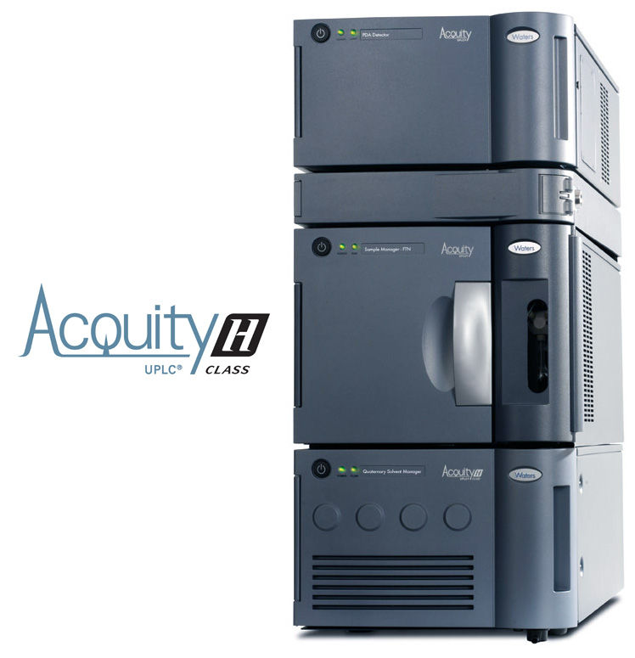

Date : 22 November 2017
Presented by : Waters Singapore Solution Centre
Prepared by : Chantel Lee (Applications Consultant)

Table of Contents

Section 1 – Analysis Objectives 3
Section 2 – Analysis Information 3
Section 3 – Sample Information 3
Section 4 – Instrument Parameters 4
Section 5 – Results 5
Section 6 – Summary 7

Section 1 – Analysis Objectives

The main objective is to develop an instrument method for Aflatoxins B & G analysis with the following requirements:-
- maximum run time of 4 minutes;
- resolution between closest eluting peaks must be at least 2
- S/N of all analyte peaks must be greater than 3; and
- no any form of derivatization should be used.

Section 2 – Analysis Information

Name of Analyst : Chantel Lee
Date of Sample Collection : 10 November 2017
Date of Analysis : 21 November 2017

Section 3 – Sample Information
Sample | Description
A | Direct analysis
B | Diluted by 40 times with given diluents (10% MeOH in 1% Acetic Acid)

Section 4 – Instrument Parameters
LC Parameters
Parameters | Description
LC Instrument | ACQUITY H-Class UPLC (50uL Sample Loop)
Column | ACQUITY BEH C18, 2.1 x 100 mm, 1.7um
Run Time | 5 min
Mobile Phase | A = Water  B = Methanol  C = Acetonitrile  Isocratic Elution 64:18:18 A:B:C
Flow Rate | 0.4 mL/min
Wash Solvent | 50/50 Water/ACN
Purge Solvent | 90/10 Water/Methanol
Column Temperature (ºC) | 30
Sample Temperature (ºC) | 4
Injection Volume (µL) | 20

Detector Parameters
Parameters | Description
Detector | ACQUITY Fluorescence Detector (FLD) (Large Volume Flow Cell)
Excitation Channel | 365 nm
Emission Channel | 0.00 min – 456 nm  2.65 min – 429 nm
Sampling Rate | 20 pts/sec
PMT Gain | 10
Filter Time Constant | Normal

Section 5 – Results
Sample A
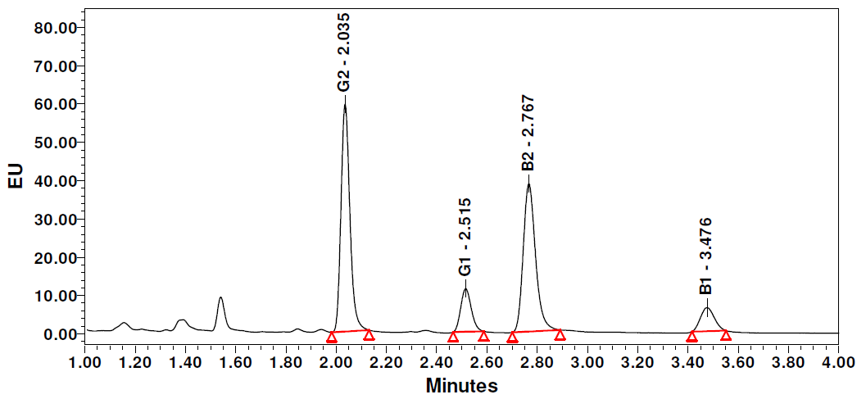
Aflatoxins | Retention Time (min) | Peak Area | Peak Height | Peak Width at Half Height (min) | S/N (USP)* | Resolution**
G2 | 2.035 | 1,461,039 | 593,540 | 0.037 | 8,454.30 | -
G1 | 2.515 | 349,696 | 115,146 | 0.046 | 1,408.27 | 6.84
B2 | 2.767 | 1,320,105 | 386,537 | 0.051 | 1,297.01 | 3.04
B1 | 3.476 | 244,740 | 62,427 | 0.062 | 303.04 | 7.46

*S/N(USP) is auto-calculated by Empower using the formula: $\frac{S}{N}=2 ×( \frac{Height-\left(0.5 × {Noise}/{Scaling}\right)}{{Noise}/{Scaling}})$
** Resolution is calculated using the formula: $R_{s}= \frac{\left(t_{2}- t_{1}\right)×1.18}{( w_{0.5h, 1}+w_{0.5h, 2} )}$
Sample B
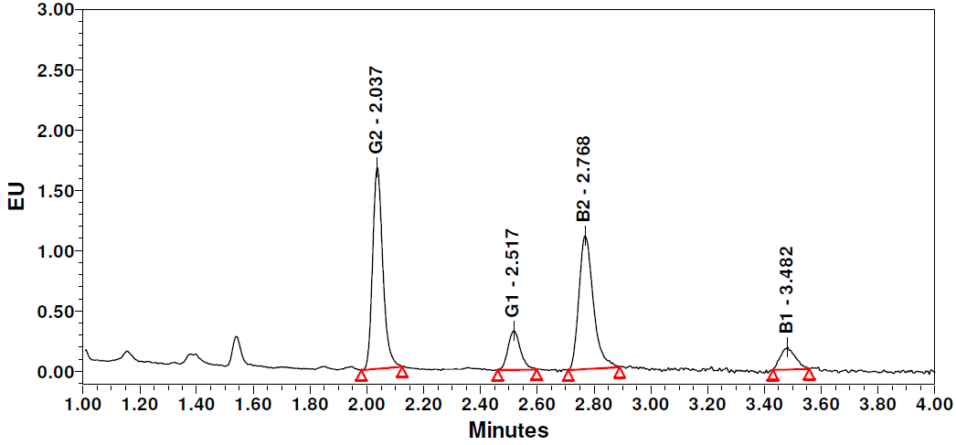
Aflatoxins | Retention Time (min) | Peak Area | Peak Height | Peak Width at Half Height (min) | S/N (USP)* | Resolution**
G2 | 2.037 | 41,763 | 16,678 | 0.038 | 235.80 | -
G1 | 2.518 | 9,912 | 3,251 | 0.046 | 39.28 | 6.76
B2 | 2.768 | 39,040 | 11,038 | 0.053 | 36.10 | 2.98
B1 | 3.482 | 6.714 | 1,846 | 0.059 | 8.21 | 7.52

*S/N(USP) is auto-calculated by Empower using the formula: $\frac{S}{N}=2 ×( \frac{Height-\left(0.5 × {Noise}/{Scaling}\right)}{{Noise}/{Scaling}})$
** Resolution is calculated using the formula: $R_{s}= \frac{\left(t_{2}- t_{1}\right)×1.18}{( w_{0.5h, 1}+w_{0.5h, 2} )}$

Section 6 – Summary
- A UPLC-FLR method under 4 minutes was used to analyze 4 aflatoxins: B1, B2, G1 and G2.
- Baseline separation was achieved for all the 4 aflatoxins (resolution > 2.98).
- All the analyte peaks have S/N larger than 8.6.
- The ACQUITY H-Class UPLC system is capable of auto-blending up to four-solvents, avoiding the needs of solvent pre-mixing which can be prone to human error.
- The ACQUITY H-Class UPLC coupled with ACQUITY FLD using the large volume flow cell, provides the needed analysis sensitivity for the analysis of aflatoxins B and G without derivatization.

