

Illicit Drugs Laboratory
LC Evaluation Results
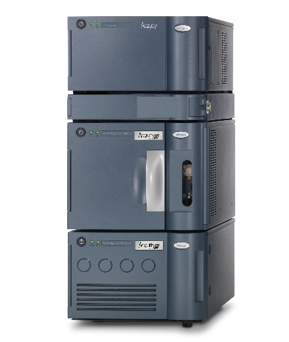
ACQUITY UPLC H-Class PLUS with
ACQUITY PDA Detector
(Empower 3)

Date: 24 Dec 2019
Prepared by: Chantel Lee (Applications Consultant)

SECTION A

SECTION B

Content

Section A
- Summary Sheet
- Excel Sheet
- Additional Report 1
- Sequence Print out (Sample Set Table)
- Threshold Criteria Check Report
- Calibration/Sample and Peak Purity Reports

Section B
- Summary Sheet
- Additional Report 2
- Spectral Contrast Algorithm Literature
- Sequence Print out (Sample Set Table)
- Threshold Criteria Check Report
- Library Information Report
- Sample, Peak Purity and Library Matching Reports

