Tandem Quadrupole Mass Spectrometry

Sample Analysis Report

Customer: Singapore Food Agency

Samples: DR-STD
DR-BLK A, DR-BLK B
DR-SPK A, DR-SPK B

Instruments: ACQUITY UPLC I Class
Xevo TQ-XS

Prepared by: Lee Jun Xiang (Applications Consultant

Waters Solution Centre

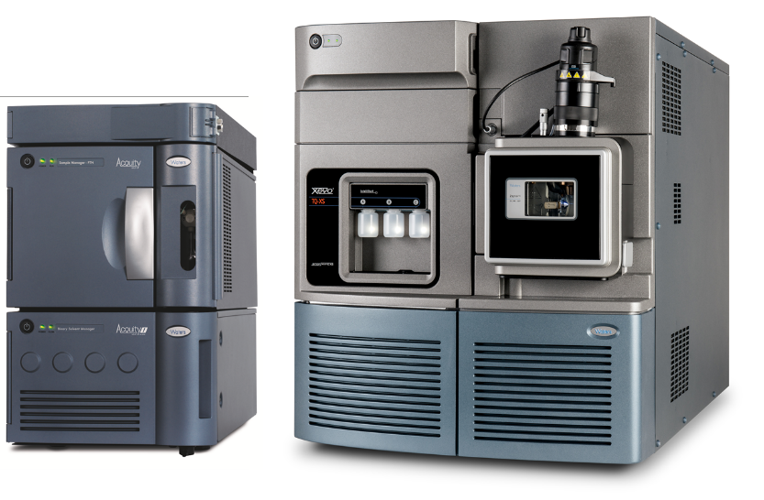

Table of Contents
1 Executive Summary 1
2 Instrument Methods 3
2.1 UPLC Method 3
2.2 MS Method 4
2.2.1 Setting up a screening method for potential drugs substance in sample 4
3 Results 6
3.1 Screening of potential compounds in DR-STD (0.1 ppm) 6
3.2 Setting up a screening and quantitation method for samples (DR-BLK A, DR-BLK B, DR-SPK A, DR-SPK B) 17
3.3 Screening and Quantitation result for DR-BLK A, DR-BLK B, DR-SPK A and DR-SPK B using established MRM method and calibration curves 28
3.3.1 Results for DR-BLK A, DR-BLK B 28
3.3.2 Results for DR-SPK A, DR-SPK B 30
4 Conclusions 37
5 List of Figures 38
6 List of Tables 38

Executive Summary
Screening of standards DR-STD
- Standard DR-STD was screened using an MRM method that was established using Quanpedia. Out of the 250 potential compounds, 84 compounds were identified. Table 1 contains the summary of the list of compounds being identified in DR-STD (0.1 ppm).
- Calibration curves were established for all the detected analytes to further screen and quantitate for samples DR-BLK A, DR-BLK B, DR-SPK A and DR-SPK B. All calibration curves achieve good linearity of >0.995.
Screening and quantitation of samples DR-BLK A, DR-BLK B, DR-SPK A and DR-SPK B
- Triplicate analysis of the samples was performed. Total number of compounds identified in the samples are summarized as follow:
  - DR-SPK A: 32 drugs identified
  - DR-SPK B: 30 drugs identified
  - DR-BLK A: 5 drugs identified
  - DR-BLK B: 4 drugs identified
- Quantitation result and identities of all the drugs detected in the samples are shown in Table 2.

DR-STD (0.1)ppm
S/N | Drugs identified | S/N | Drugs identified
1 | 16-beta-hydroxy stanozolol | 43 | Lasalocid
2 | 17-alpha-methyltestosterone | 44 | Mabuterol
3 | 4-Epichlortetracycline | 45 | Maduramycin
4 | 4-Epioxytetracycline | 46 | Mapenterol
5 | 4-Epitetracycline | 47 | Marbofloxacin
6 | 5-Hydroxyflunixin | 48 | Metronidazole
7 | 6-alpha-Methylprednisolone | 49 | Metronidazole-hydroxy
8 | Albendazole | 50 | Monensin
9 | Altrenogest | 51 | Monepantel sulfone
10 | Amoxicillin | 52 | Nafcillin
11 | Ampicillin | 53 | Nandrolone
12 | Brombuterol | 54 | Narasin
13 | Buqinolate | 55 | Norfloxactin
14 | Carbmazepine | 56 | Novobiocin
15 | Cefalexin | 57 | Oxacillin
16 | Cefazolin | 58 | Oxibendazole
17 | Cefoperazone | 59 | Penicillin G
18 | Ceftiofur | 60 | Penicillin V
19 | Cephalothin | 61 | Prednisolone
20 | Cephradine | 62 | Ractopamine
21 | Chlortetracycline | 63 | Robenidin
22 | Cimbuterol | 64 | Ronidazole
23 | Clenbuterol | 65 | Salbutamol
24 | Clenpenterol | 66 | Sarafloxacin
25 | Clopidol | 67 | Stanozolol
26 | Cloxacillin | 68 | Sulfadimethoxine/Sulfadoxine
27 | Decoquinate | 69 | Sulfanilamide
28 | Desacetylcefapirin | 70 | Terbutaline
29 | Dexamethasone | 71 | Thiabendazole
30 | Dicloxacillin | 72 | Tildipirosin
31 | Difloxacin | 73 | Vancomycin
32 | Dimetridazole | 74 | Virginiamycin
33 | Doramectin | 75 | Zilpaterol
34 | Doxycycline/Tetracycline | 76 | 17-alpha-ethylnylestradiol
35 | Enrofloxacin | 77 | betamethasone
36 | Epi-testosterone/Testosterone | 78 | Diclazuril
37 | Eprinomectin | 79 | Diethylstilbesterol
38 | Flumequine | 80 | Estradiol
39 | Furazolidone | 81 | Estriol
40 | Hydoxy dimetridazole | 82 | Estrone
41 | Ipronidazole | 83 | Ethyl estradiol
42 | Ipronidazole hydroxy | 84 | Nicarbazin
Table 1: List of drugs identified in DR-STD (0.1 ppm)

S/N | DR-SPK A |  | S/N | DR-SPK B |  | S/N | DR-SPK A |  | S/N | DR-SPK B
S/N | Drugs identified | Conc (ppb) | S/N | Drugs identified | Conc (ppb) | S/N | Drugs identified | Conc (ppb) | S/N | Drugs identified | Conc (ppb)
1 | 16-beta-hydroxy stanozolol | 3.02 | 1 | 16-beta-hydroxy stanozolol | 2.7 | 24 | Salbutamol | 0.12 | 24 | Stanozolol | 1.7
2 | 4-epioxytetracycline | 2.07 | 2 | 4-epioxytetracycline | 3.0 | 25 | Stanozolol | 2.72 | 25 | Sulfanilamide | 67.9
3 | Albendazole | 309.19 | 3 | Albendazole | 58.2 | 26 | Sulfanilamide | 84.70 | 26 | Zilpaterol | 0.1
4 | Altrenogest | 0.08 | 4 | Amoxicillin | 1.0 | 27 | Zilpaterol | 0.12 | 27 | betamethasone | 0.7
5 | Amoxicillin | 0.51 | 5 | Ampicillin | 1.6 | 28 | betamethasone | 2.72 | 28 | Diethylstilbesterol | 0.3
6 | Ampicillin | 0.80 | 6 | Chlortetracycline | 39.4 | 29 | Diethylstilbesterol | 1.06 | 29 | Ethyl estradiol | 0.2
7 | Chlortetracycline | 21.63 | 7 | Clenbuterol | 0.2 | 30 | Estrone | 0.06 | 30 | 17-alpha-ethylnylestradiol | 0.3
8 | Clenbuterol | 0.22 | 8 | Dexamethasone | 6.7 | 31 | Ethyl estradiol | 1.04
9 | Dexamethasone | 6.78 | 9 | Dimetridazole | 0.7 | 32 | 17-alpha-ethylnylestradiol | 1.08
10 | Dimetridazole | 0.92 | 10 | Epi-testosterone/Testosterone | 13.9
11 | Furazolidone | 752.13 | 11 | Furazolidone | 773.8
12 | Hydoxy dimetridazole | 0.35 | 12 | Hydoxy dimetridazole | 0.3
13 | Ipronidazole | 1.22 | 13 | Ipronidazole | 1.2 | S/N | DR-BLK A |  | S/N | DR-BLK B
14 | Maduramycin | 2.51 | 14 | Maduramycin | 3.8 | S/N | Drugs identified | Conc (ppb) | S/N | Drugs identified | Conc (ppb)
15 | Metronidazole | 0.34 | 15 | Metronidazole | 0.3 | 1 | Albendazole | 130.1 | 1 | Albendazole | 49.4
16 | Metronidazole-hydroxy | 0.28 | 16 | Metronidazole-hydroxy | 0.3 | 2 | Altrenogest | 0.1 | 2 | Furazolidone | 363.1
17 | Monensin | 4.89 | 17 | Monensin | 5.4 | 3 | Furazolidone | 428.1 | 3 | Sulfanilamide | 78.5
18 | Nandrolone | 2.28 | 18 | Nandrolone | 2.1 | 4 | Monensin | 0.1 | 4 | 17-alpha-ethylnylestradiol | 0.3
19 | Novobiocin | 8.65 | 19 | Novobiocin | 8.5 | 5 | Sulfanilamide | 79.1
20 | Oxibendazole | 23.56 | 20 | Penicillin V | 28.1
21 | Penicillin V | 25.94 | 21 | Prednisolone | 8.4
22 | Prednisolone | 6.48 | 22 | Ractopamine | 0.2
23 | Ractopamine | 0.14 | 23 | Salbutamol | 0.1
Table 2: List of drugs identified and the amount present in sample (DR-SPK A, DR-SPK B, DR-BLK A and DR-BLK B)

Instrument Methods

UPLC Method
This method was used for screening and quantitation of drug residues in the standard (DR-STD) and samples (DR-BLK A, DR-BLK B, DR-SPK A and DR-SPK B). The UPLC system coupled to the MS system was ACQUITY UPLC I-Class System (SM-FTN). The UPLC conditions are as follows:
Binary Solvent Manager
- Analytical column: Acquity UPLC CSH C18, 1.7 µm, 100 × 2.1 mm column
- Injection volume: 10 µL
- Flow rate: 0.4 mL/min
- Mobile phase:
For positive ionization: A – 0.1% formic acid in H2O
B –0.1% formic acid in ACN:MeOH (50:50)
For negative ionization: A – H2O
B – ACN
- Mobile phase gradient: 1% B (0.0 min) → 20% B (4.0 min) → 50% B (5.0 min) → 99% B (7.0 to 9.0 min) → 1% B (9.1 to 12.0 min)
Sample Manager FTN
- Wash solvent: 50:30:40 water:acetonitrile: IPA
- Purge solvent: 10% ACN in water
- Sample temperature: 8 ºC
- Column temperature: 40 ºC

MS Method

Setting up a screening method for potential drugs substance in sample

The MRM method for the screening of drugs was established using information based on Quanpedia. Triplicate experiments of screening were performed on samples (DR-BLK A, DR-BLK B, DR-SPK A and DR-SPK B), Results obtained were then process using Targetlynx Software.

The MS system was Xevo TQ-XS. The instrument setting is as follows:
- Capillary voltage: 3.10 kV (ESI positive), 2.50 kV (ESI negative)
- Source temperature: 150 ºC
- Desolvation temperature: 400 ºC
- Cone gas flow: 150 L/h
- Nebuliser gas flow: 7 bar
- Desolvation gas flow: 1000 L/h

Results

Screening of potential compounds in DR-STD (0.1 ppm)
A list of 250 compounds containing various classes of drugs such as coccidiostatic agents, anti-biotics, beta-agonists, macrolides and glycopeptide antibiotic is provided. 2 MRM transition was used for screening of the potential compounds in the DR-STD. A total of 84 compounds, 75 in positive ionization mode and 9 in negative ionization mode, were identified in DR-STD. Table 3 show the compounds identified in the mixture along with the MRM transition used. Due to some suspected compounds being isomers and having the same fragmentation patterns, they are both being suspected due to the lack of retention time information. Figure 1 display the MRM chromatogram of the detected compounds at 10 ppb.
Table 3. List of detected compounds in DR-STD using MRM method with 2 MRM transitions
No | Compound | RT (min) | Quantifier Trace | Reference Trace |  | No | Compound | RT (min) |  | Quantifier Trace | Reference Trace
1 | 16-beta-hydroxy stanozolol | 6.38 | 345.1 > 81 | 345.1 > 95 |  | 7 | 6-alpha-Methylprednisolone | 6.43 |  | 375.4 > 357.3 | 375.4 > 339.3
2 | 17-alpha-methyltestosterone | 7.22 | 303.1 > 97 | 303.1 > 97 |  | 8 | Albendazole | 6.14 |  | 265.9 > 234.1 | 265.9 > 191.2
3 | 4-Epichlortetracycline | 4.45 | 479.3 > 444.2 | 479.3 > 462.2 |  | 9 | Altrenogest | 7.04 |  | 311 > 269 | 311 > 227
4 | 4-Epioxytetracycline | 4.05 | 461.1 > 426.1 | 461.1 > 443.2 |  | 10 | Amoxicillin | 2.16 |  | 366.1 > 349 | 366.1 > 133.7
5 | 4-Epitetracycline | 3.21 | 445.1 > 410.1 | 445.1 > 427.3 |  | 11 | Ampicillin | 3.84 |  | 350.1 > 105.9 | 350.1 > 159.9
6 | 5-Hydroxyflunixin | 7.04 | 313 > 226 | 313 > 252 |  | 12 | Brombuterol | 4.75 |  | 367.1 > 214 | 367.1 > 293.1
No | Compound | RT (min) | Quantifier Trace | Reference Trace |  | No | Compound | RT (min) |  | Quantifier Trace | Reference Trace
13 | Buqinolate | 6.20 | 361.8 > 260.2 | 361.8 > 204 |  | 28 | Desacetylcefapirin | 1.95 |  | 382 > 226 | 382 > 292
14 | Carbmazepine | 6.43 | 237 > 193 | 237 > 194 |  | 29 | Dexamethasone | 6.43 |  | 393.3 > 355.2 | 393.3 > 373.2
15 | Cefalexin | 3.65 | 348.2 > 158 | 348.2 > 139.9 |  | 30 | Dicloxacillin | 6.76 |  | 470 > 211.9 | 470 > 254
16 | Cefazolin | 5.60 | 455.1 > 323 | 455.1 > 156 |  | 31 | Difloxacin | 4.63 |  | 400.3 > 356.2 | 400.3 > 382.2
17 | Cefoperazone | 5.79 | 646.1 > 142.8 | 646.1 > 530.1 |  | 32 | Dimetridazole | 2.90 |  | 142 > 95.8 | 142 > 80.9
18 | Ceftiofur | 5.97 | 524.2 > 241.2 | 524.2 > 285 |  | 33 | Doramectin | 7.80 |  | 916.9 > 145 | 916.9 > 331.3
19 | Cephalothin | 6.20 | 419 > 315 | 419 > 359 |  | 34 | Doxycycline/Tetracycline | 3.21 |  | 445.2 > 410.1 | 445.2 > 428.1
20 | Cephradine | 4.10 | 350.1 > 158 | 350.1 > 176 |  | 35 | Enrofloxacin | 4.22 |  | 360.3 > 316.3 | 360.3 > 342.3
21 | Chlortetracycline | 5.22 | 479.1 > 444.1 | 479.1 > 462.1 |  | 36 | Epi-testosterone/Testosterone | 6.82 |  | 289.1 > 97 | 289.1 > 109
22 | Cimbuterol | 2.22 | 234.2 > 143 | 234.2 > 160 |  | 37 | Eprinomectin | 7.80 |  | 914.8 > 154 | 914.8 > 186.1
23 | Clenbuterol | 4.08 | 277.1 > 168.1 | 277.1 > 140 |  | 38 | Flumequine | 1.76 |  | 262.1 > 244 | 262.1 > 202
24 | Clenpenterol | 5.05 | 291.1 > 203 | 293.1 > 205 |  | 39 | Furazolidone | 6.49 |  | 226.2 > 139.2 | 226.2 > 122
25 | Clopidol | 3.76 | 192 > 101 | 192 > 103 |  | 40 | Hydoxy dimetridazole | 2.51 |  | 158 > 140.1 | 158 > 112
26 | Cloxacillin | 6.67 | 436.2 > 159.9 | 436.2 > 276.9 |  | 41 | Ipronidazole | 5.53 |  | 170 > 124 | 170 > 109.1
27 | Decoquinate | 7.76 | 418.3 >204.1 | 418.3 > 372.3 |  | 42 | Ipronidazole hydroxy | 4.96 |  | 186.1 > 127.9 | 186.1 > 167.9
No | Compound | RT (min) | Quantifier Trace | Reference Trace |  | No | Compound | RT (min) |  | Quantifier Trace | Reference Trace
43 | Lasalocid | 8.15 | 613.4 > 377.4 | 613.4 > 577.4 |  | 58 | Oxibendazole | 5.45 |  | 250 > 176.1 | 250 > 218.1
44 | Mabuterol | 4.97 | 311.1 > 217.1 | 311.1 > 237.1 |  | 59 | Penicillin G | 6.31 |  | 335.1 > 160 | 335.1 > 176
45 | Maduramycin | 8.17 | 939.5 > 877.6 | 939.5 > 719.5 |  | 60 | Penicillin V | 6.49 |  | 351.1 > 160.1 | 351.1 > 114
46 | Mapenterol | 5.35 | 325.1 > 237.1 | 325.1 > 217.1 |  | 61 | Prednisolone | 6.20 |  | 361.2 > 147 | 361.2 > 343.2
47 | Marbofloxacin | 3.30 | 363.1 > 72 | 363.1 > 320 |  | 62 | Ractopamine | 3.88 |  | 302.2 > 164.1 | 302.2 > 284.2
48 | Metronidazole | 2.64 | 172 > 82 | 172 > 128 |  | 63 | Robenidin | 6.10 |  | 334.2 > 111.1 | 334.2 > 155.2
49 | Metronidazole-hydroxy | 2.16 | 188 > 126 | 188 > 143.9 |  | 64 | Ronidazole | 3.00 |  | 201 > 140 | 201 > 55
50 | Monensin | 8.08 | 693.5 > 461.4 | 693.5 > 501.4 |  | 65 | Salbutamol | 1.78 |  | 240.2 > 148.1 | 240.2 > 222.1
51 | Monepantel sulfone | 6.76 | 504 > 186 | 504 > 165.9 |  | 66 | Sarafloxacin | 4.64 |  | 386.2 > 342.1 | 386.2 > 299.1
52 | Nafcillin | 6.75 | 415.2 > 199.2 | 415.2 > 171.1 |  | 67 | Stanozolol | 6.92 |  | 329 > 81 | 329 > 121
53 | Nandrolone | 6.69 | 275 > 109 | 275 > 257 |  | 68 | Sulfadimethoxine/Sulfadoxine | 7.04 |  | 311 > 156 | 311 > 92
54 | Narasin | 8.29 | 787.6 > 431.3 | 787.6 > 531.3 |  | 69 | Sulfanilamide | 5.28 |  | 173 > 156 | 173 > 92
55 | Norfloxactin | 3.68 | 320.1 > 233 | 320.1 > 276.1 |  | 70 | Terbutaline | 1.66 |  | 226.1 > 107 | 226.1 > 125
56 | Novobiocin | 7.41 | 613 > 189 | 613 > 133 |  | 71 | Thiabendazole | 5.35 |  | 202 > 130.9 | 202 > 174.9
57 | Oxacillin | 6.56 | 402.2 > 160 | 402.2 > 243.1 |  | 72 | Tildipirosin | 8.18 |  | 734.6 > 174 | 734.6 > 132
No | Compound | RT (min) | Quantifier Trace | Reference Trace |  | No | Compound | RT (min) |  | Quantifier Trace | Reference Trace
73 | Vancomycin | 2.99 | 725.8 > 100 | 725.8 > 144.2 |  | 79ª | Diethylstilbesterol |  | 6.52 | 267.1 > 237.1 | 267.1 > 251.1
74 | Virginiamycin | 6.56 | 526.4 > 508.3 | 526.4 > 355.1 |  | 80ª | Estradiol |  | 6.24 | 271.2 > 145.1 | 271.1 > 183.1
75 | Zilpaterol | 1.76 | 262.2 > 185.1 | 262.2 > 202.1 |  | 81ª | Estriol |  | 5.53 | 287.2 > 145 | 287.2 > 171
76ª | 17-alpha-ethylnylestradiol | 6.37 | 295.2 > 145.1 | 295.2 > 158.9 |  | 82ª | Estrone |  | 6.40 | 269.2 > 145.1 | 269.2 > 269
77ª | betamethasone | 5.87 | 361.2 > 307.2 | 361.2 > 325.2 |  | 83ª | Ethyl estradiol |  | 6.37 | 295 > 145 | 295 > 269
78ª | Diclazuril | 6.80 | 405.1 > 334.1 | 407.1 > 336.1 |  | 84ª | Nicarbazin |  | 6.47 | 301 > 107.1 | 301 > 137.2
Note: ª are compounds that are detected in negative mode

Figure 1(a) MRM chromatograms of detected compounds in DR-STD at 10ppb (Compound 1 ~ 12)
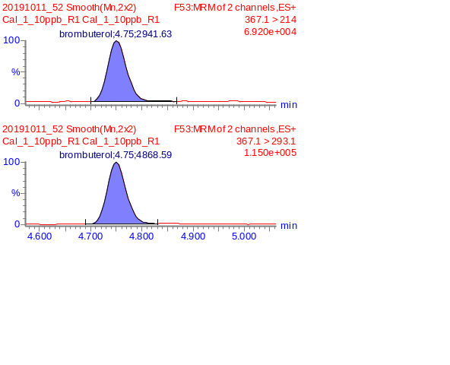
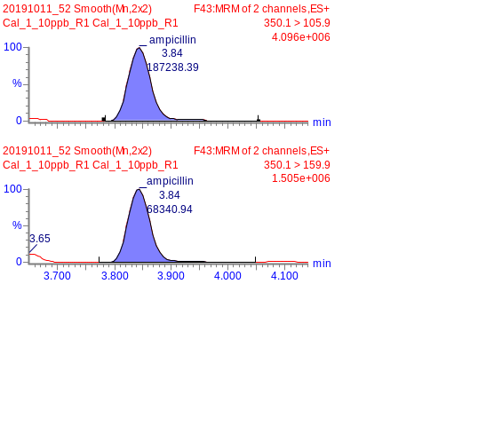
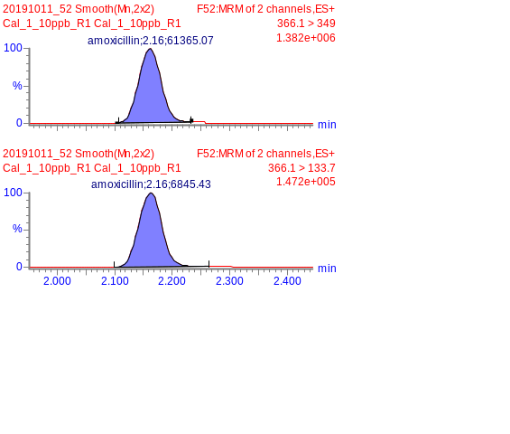
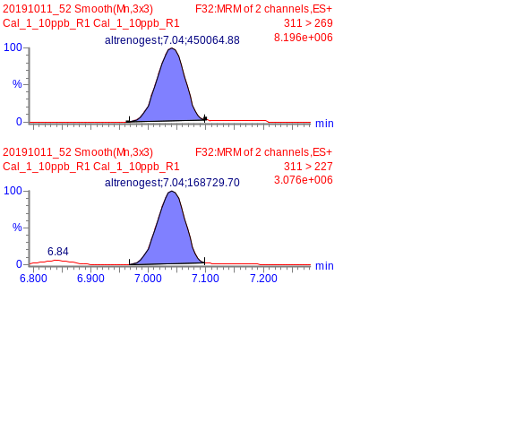
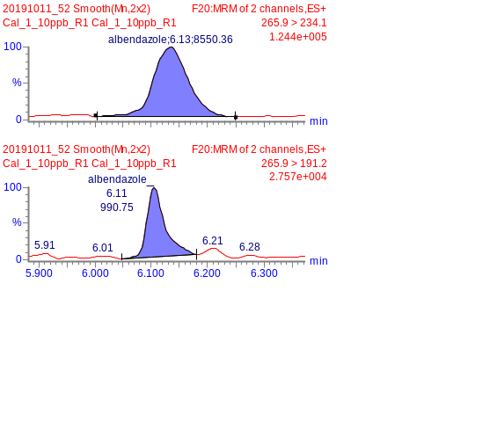
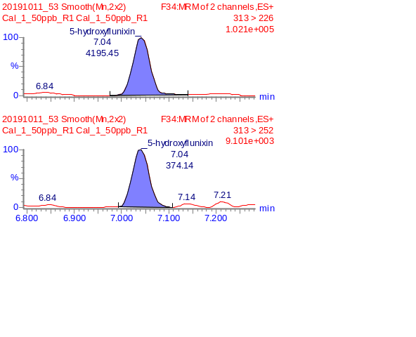
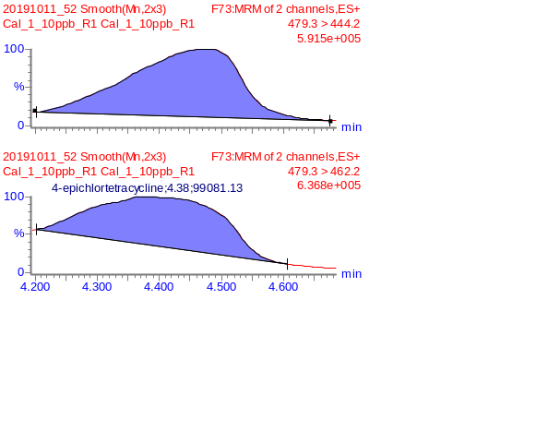
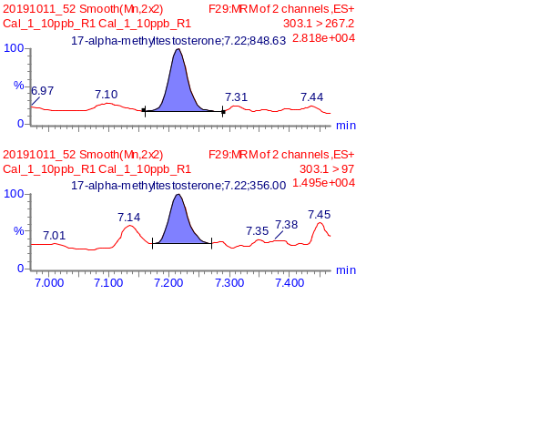
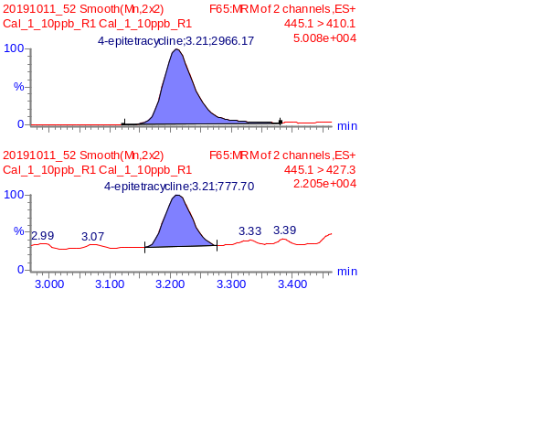
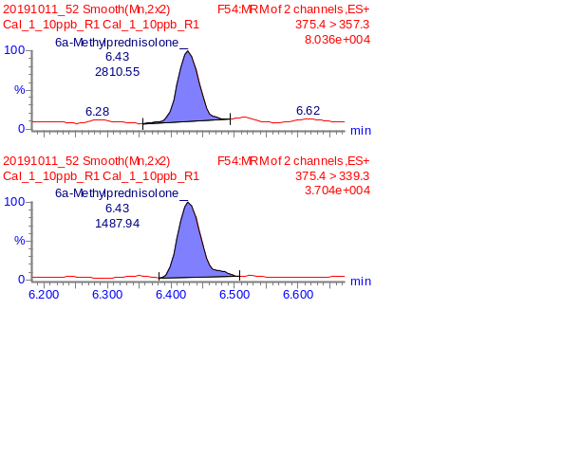
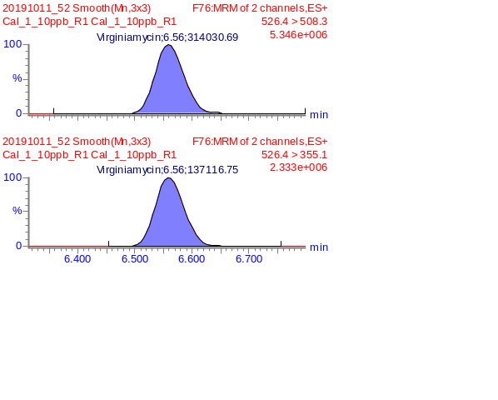
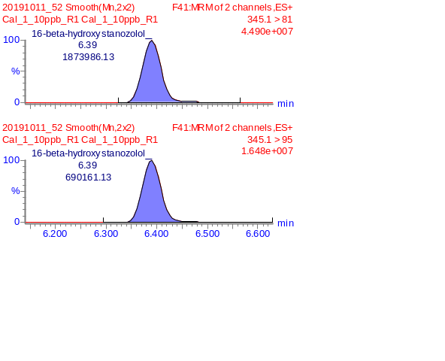
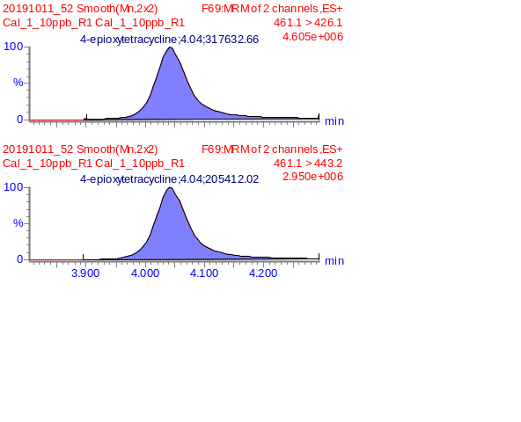

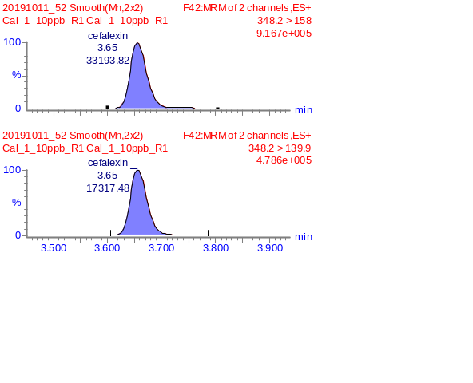
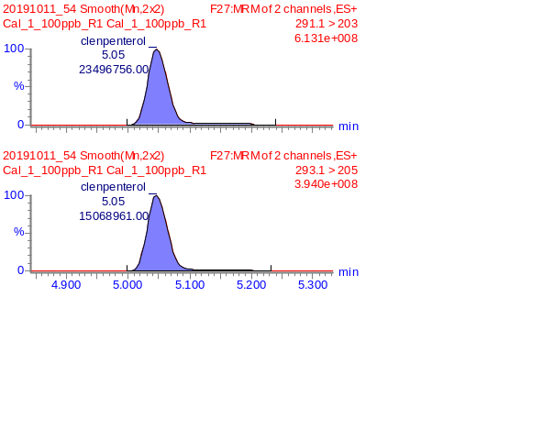
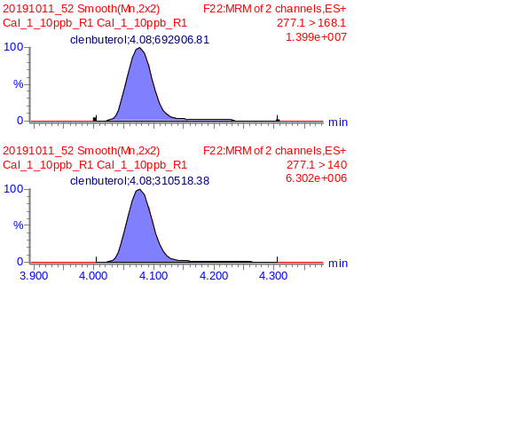
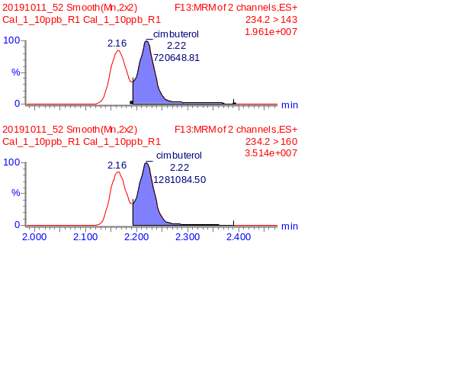
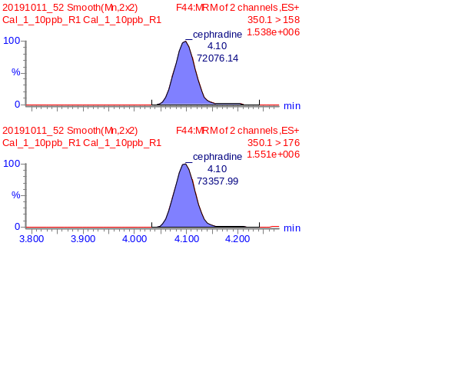
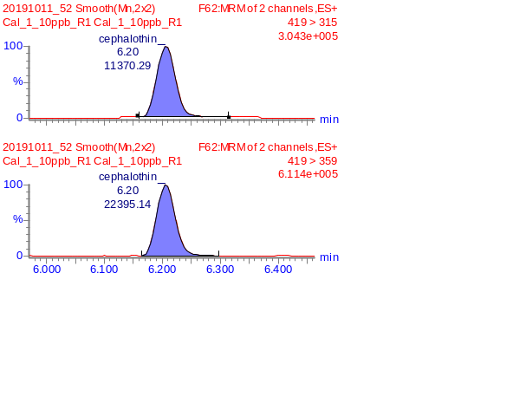
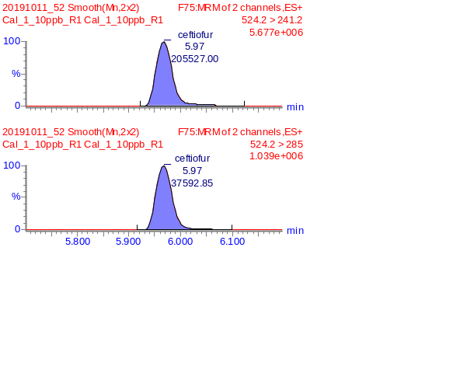
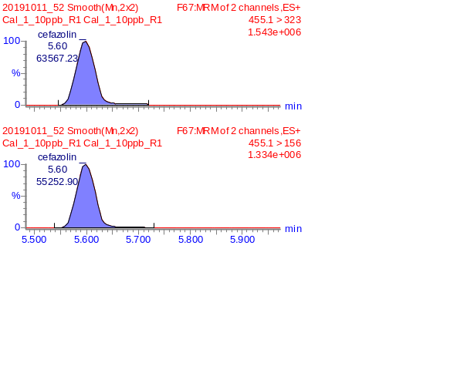
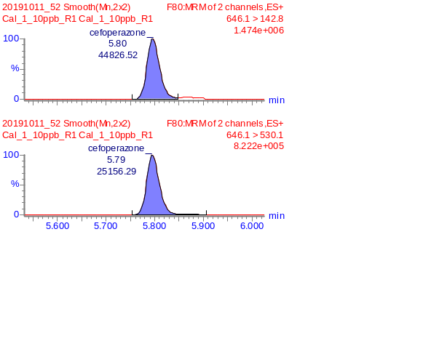
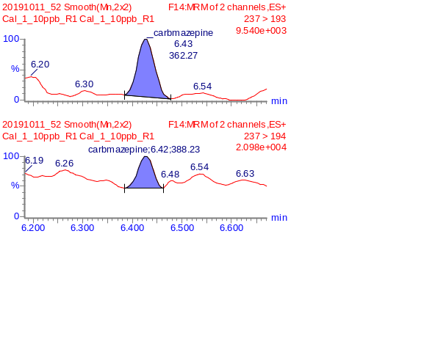
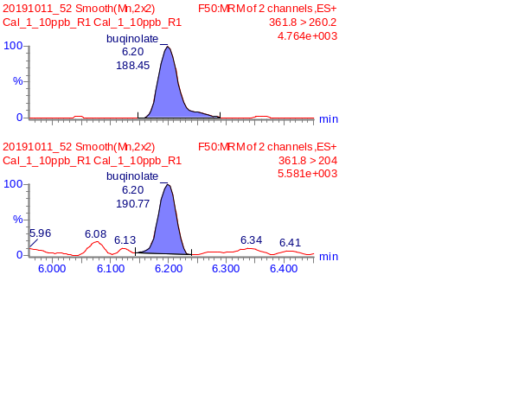
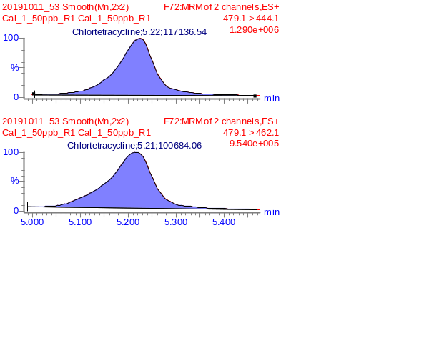
Figure 1(b) MRM chromatograms of detected compounds in DR-STD at 10ppb (Compound 13 ~ 24)

Figure 1 (c) MRM chromatograms of detected compounds in DR-STD at 10ppb (Compound 25 ~ 36)
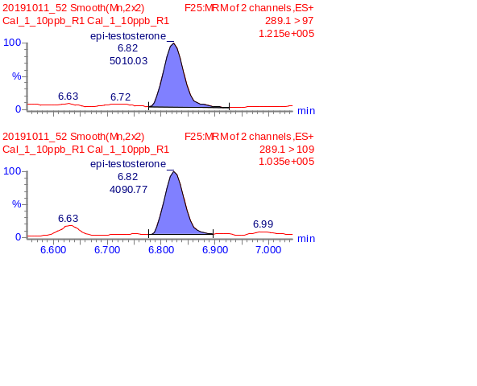
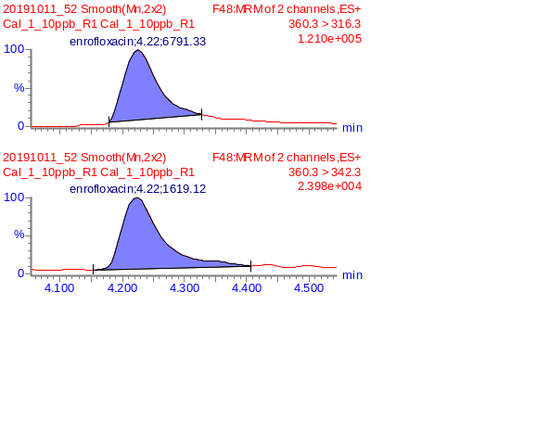
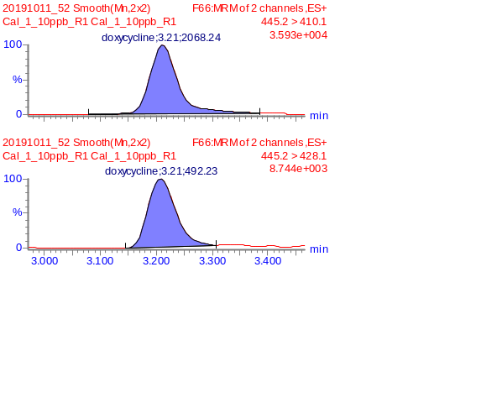
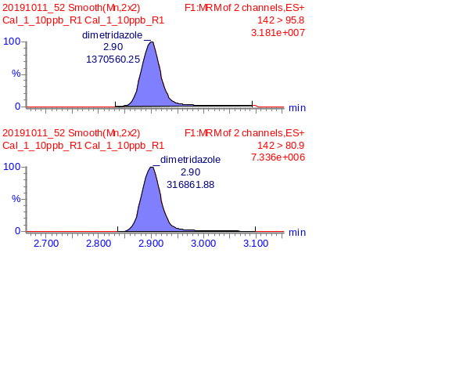
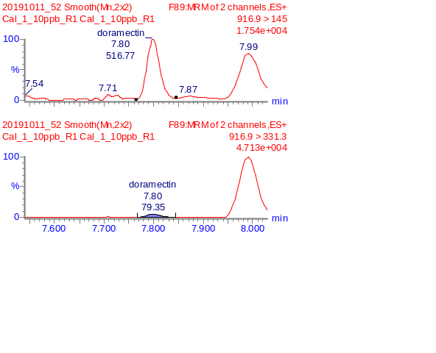
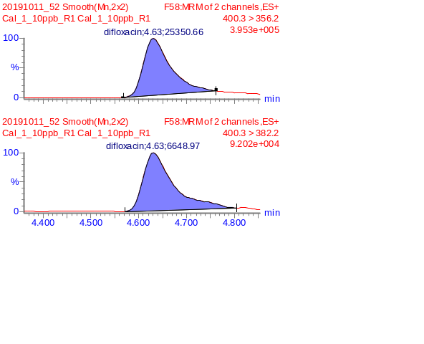
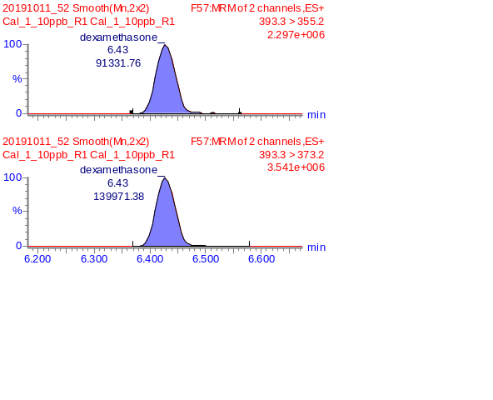
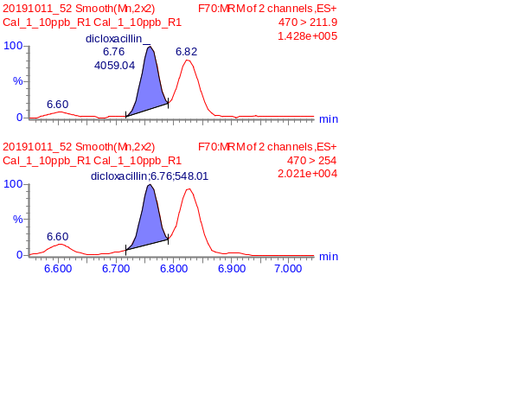
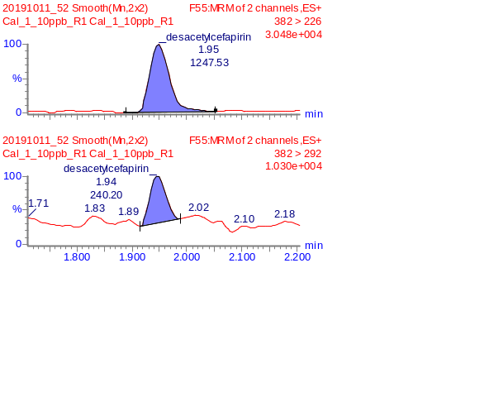
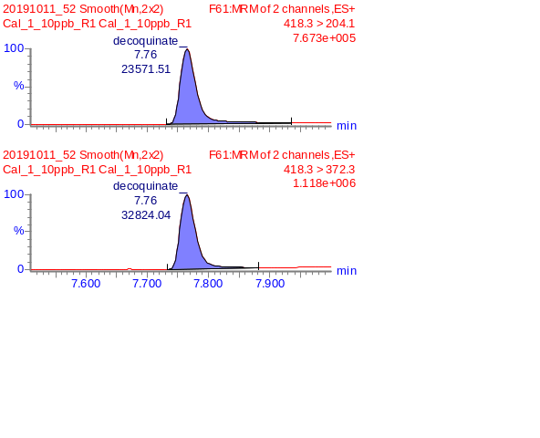
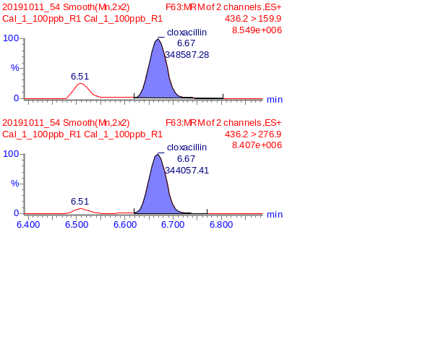
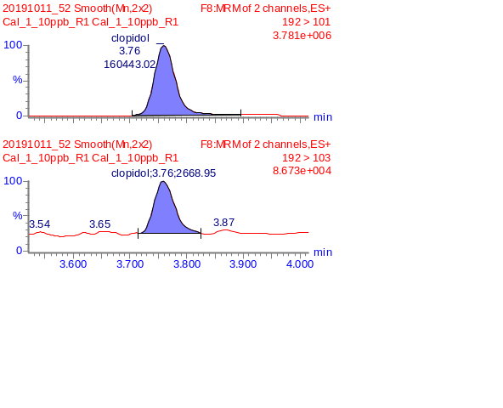

Figure 1(d) MRM chromatograms of detected compounds in DR-STD at 10ppb (Compound 37 ~ 48)

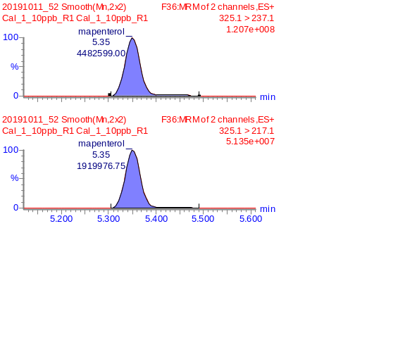
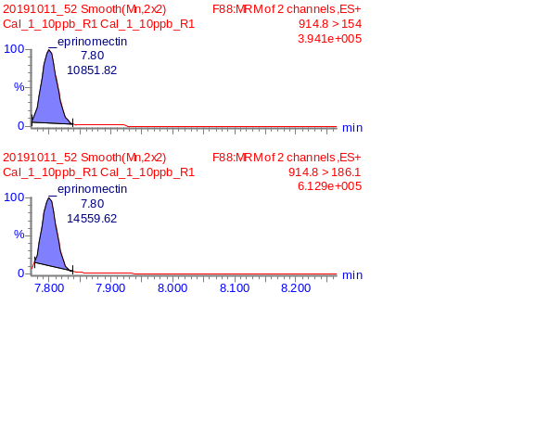
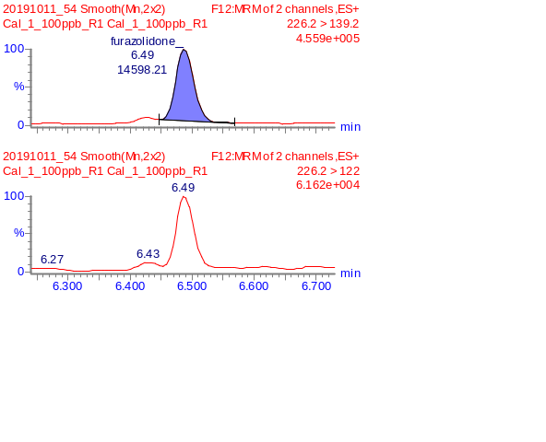
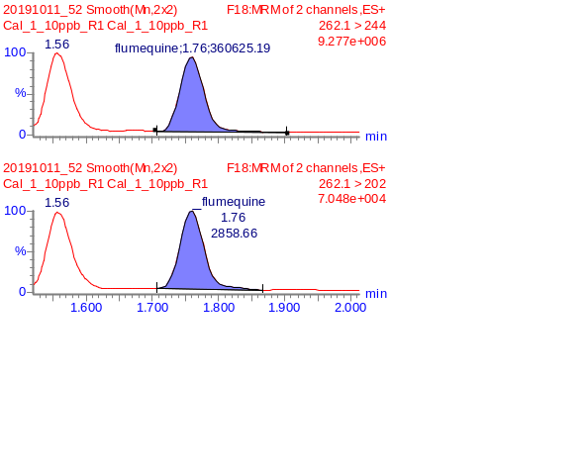
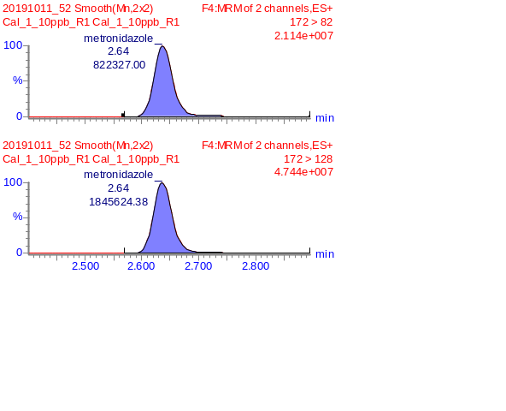
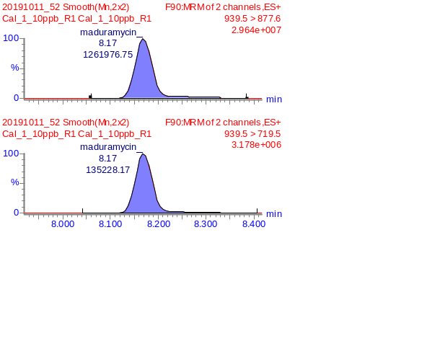
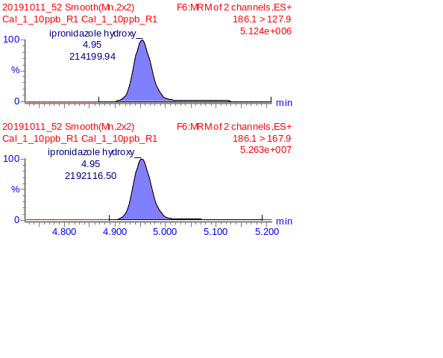
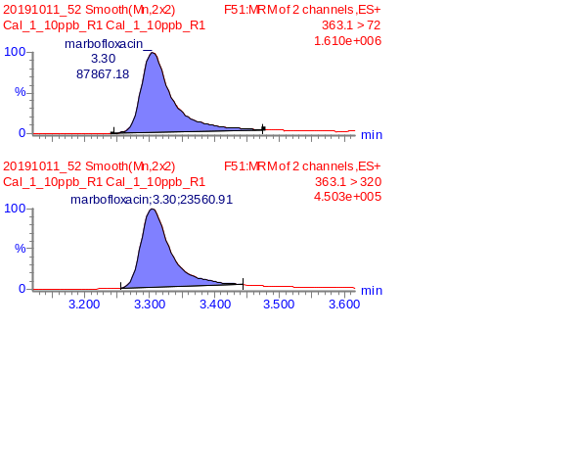
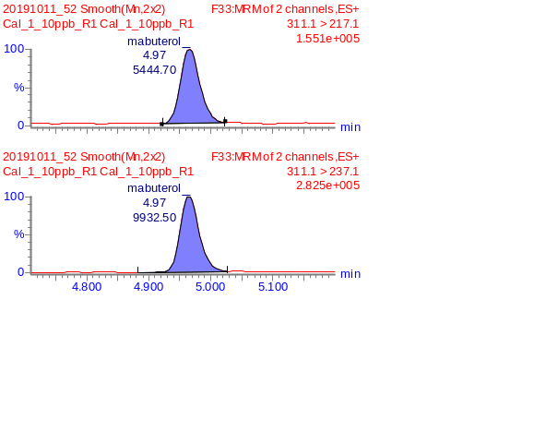
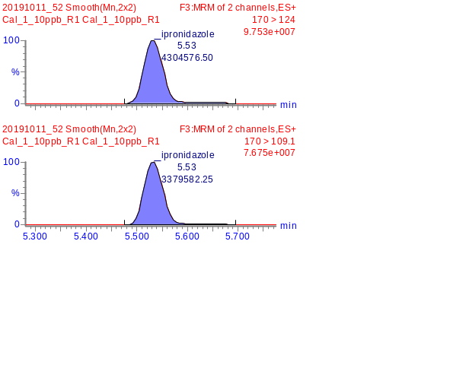
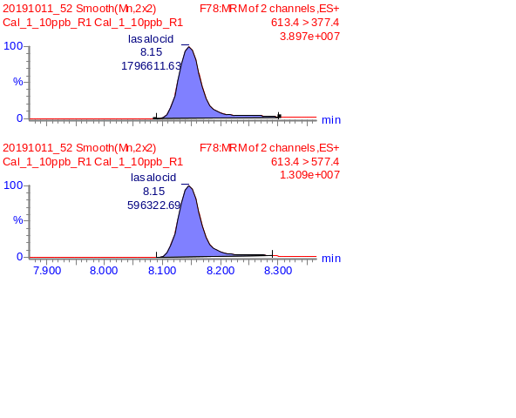
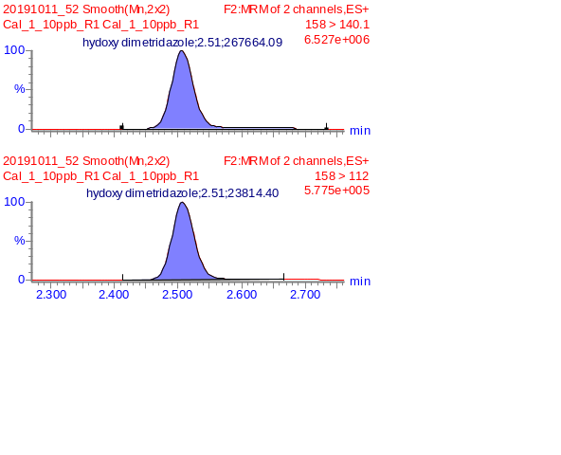

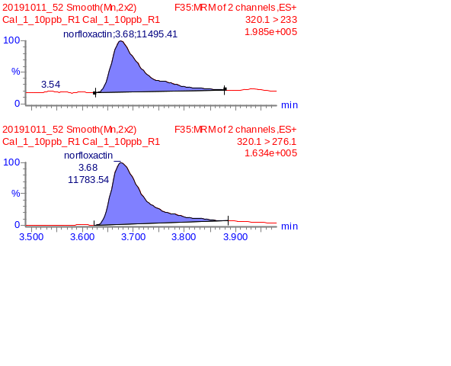
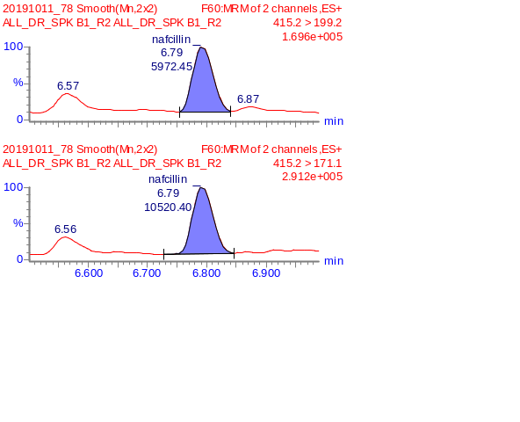
Figure 1(e) MRM chromatograms of detected compounds in DR-STD at 10ppb (Compound 49 ~ 60)
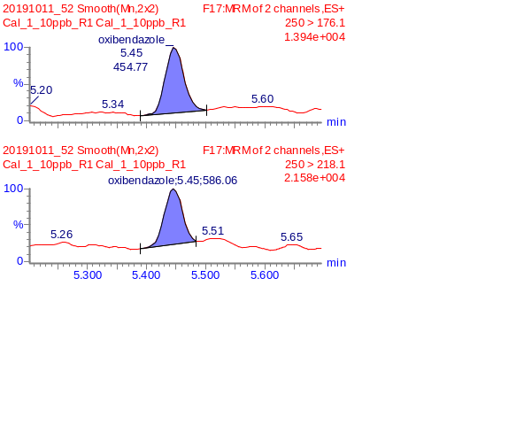
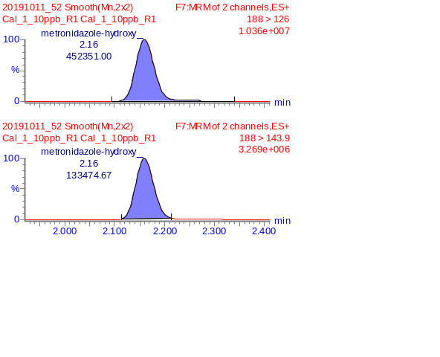
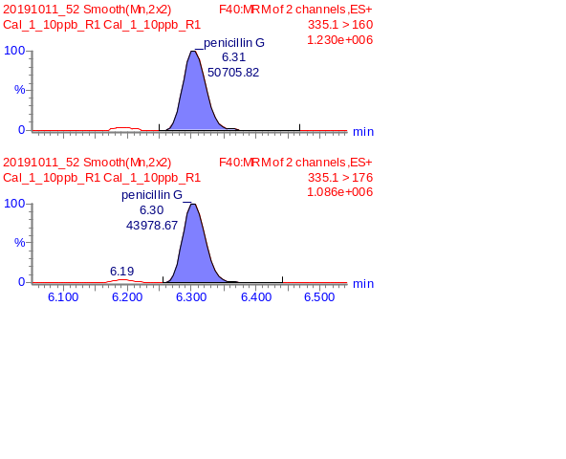
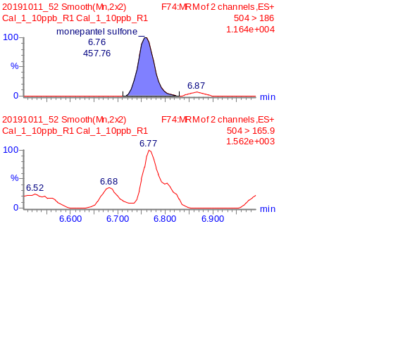
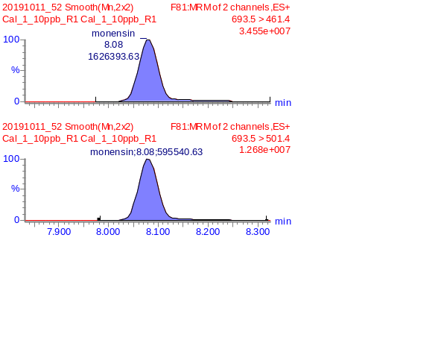
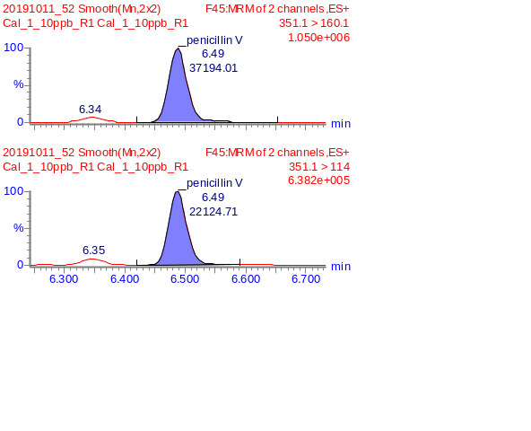
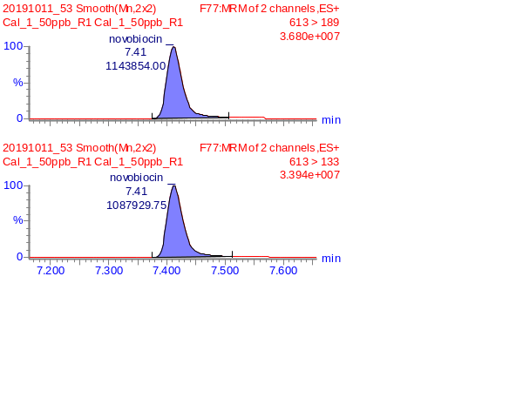
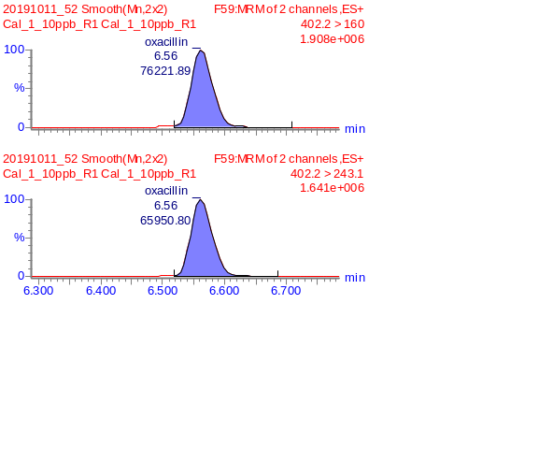
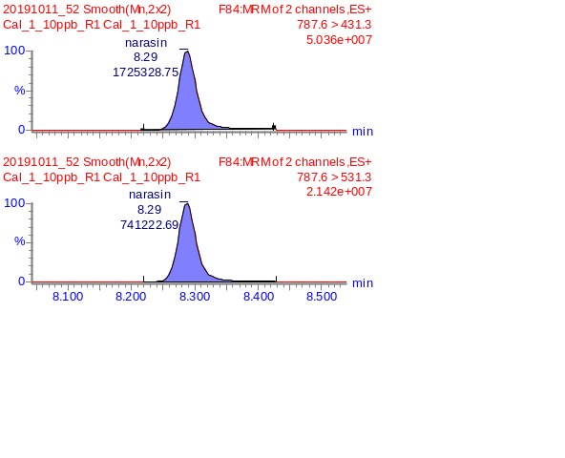
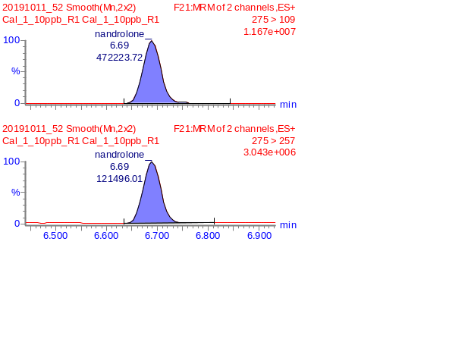

Figure 1 (f) MRM chromatograms of detected compounds in DR-STD at 10ppb (Compound 61 ~ 72)
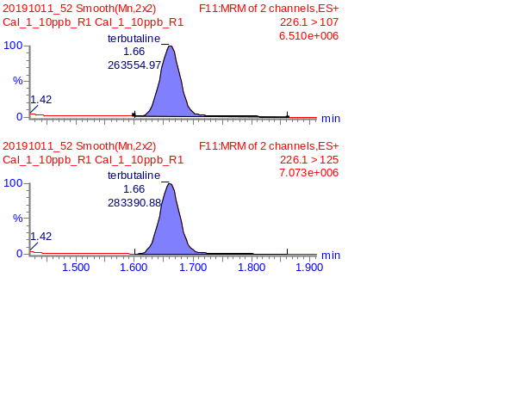
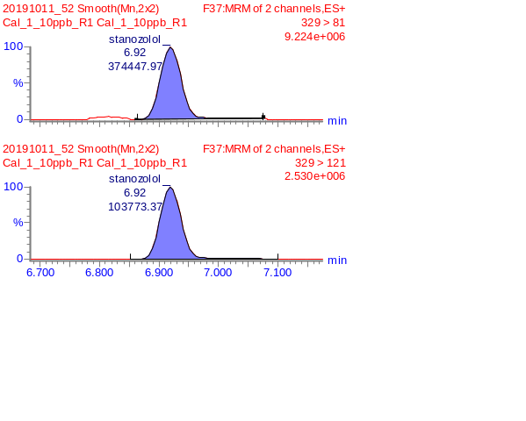
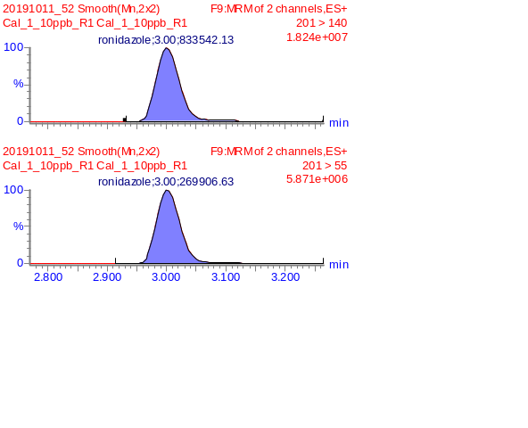
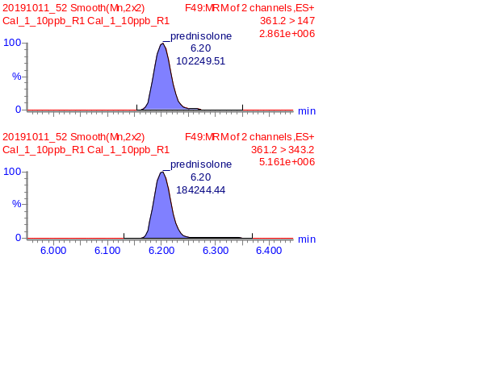

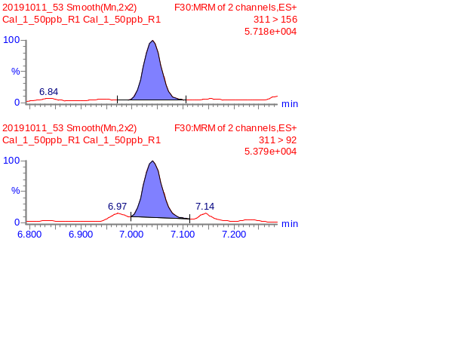
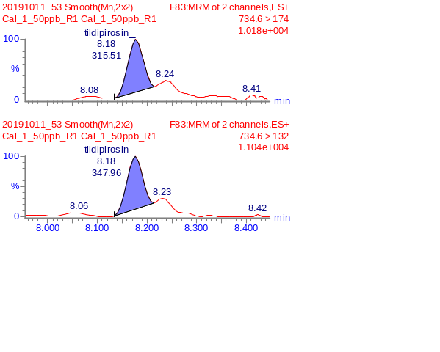
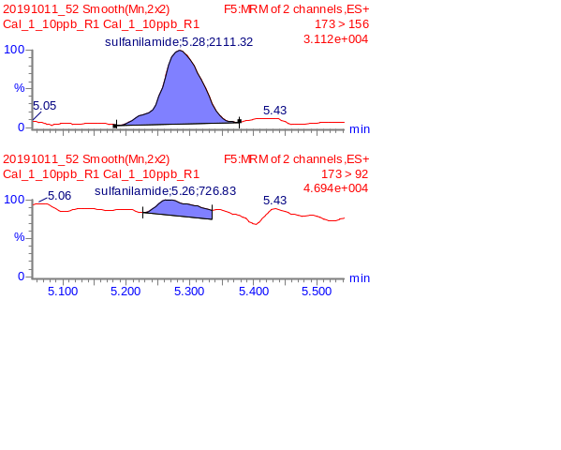
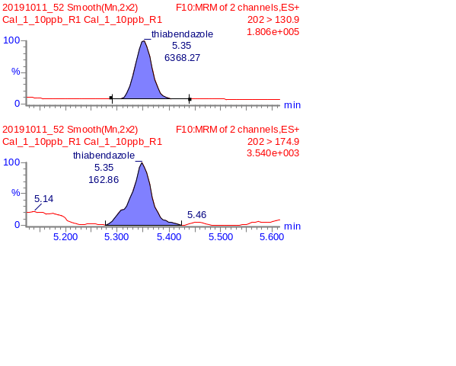
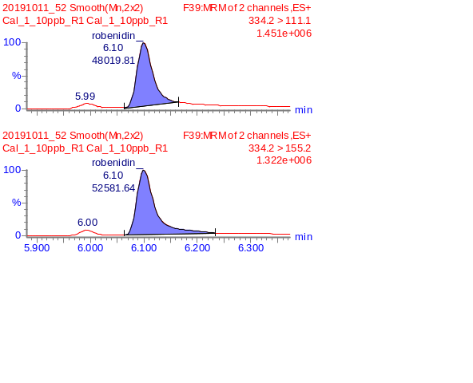
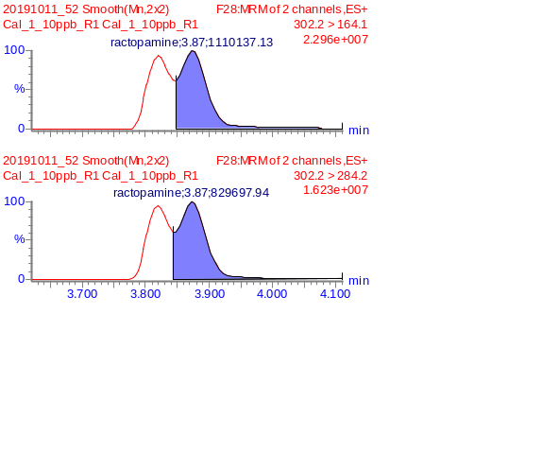
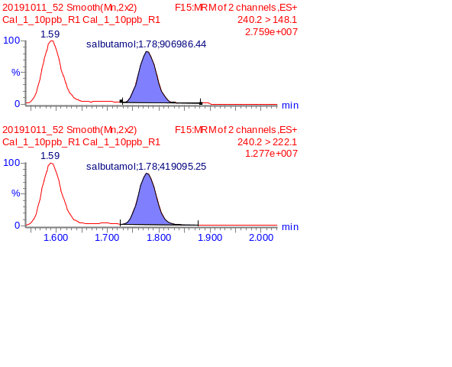
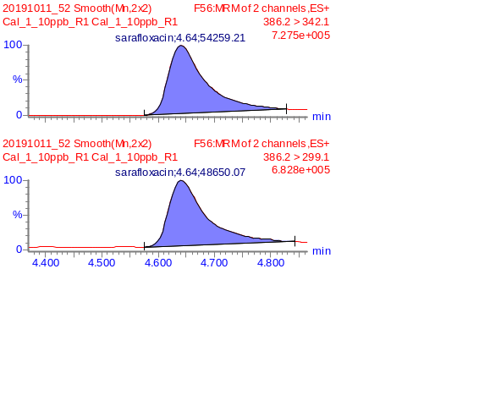

Figure 1(g) MRM chromatograms of detected compounds in DR-STD at 10ppb (Compound 73 ~ 84)
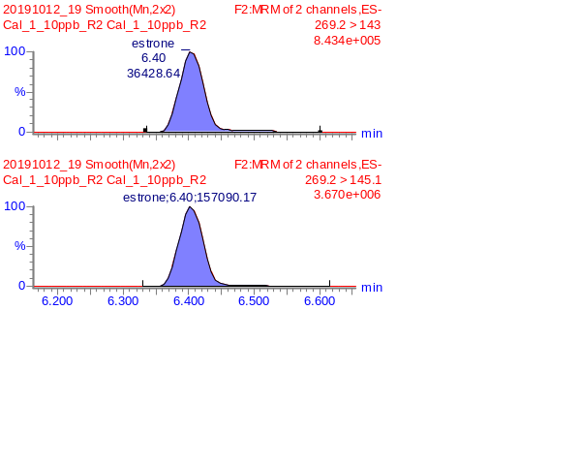
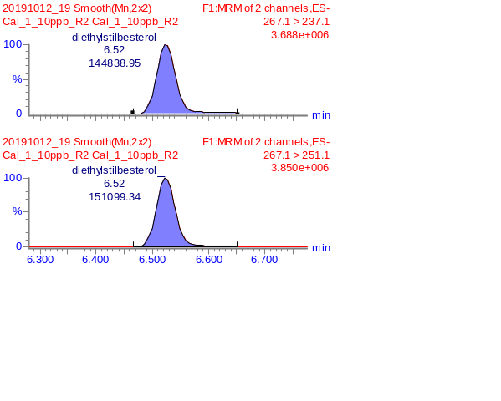
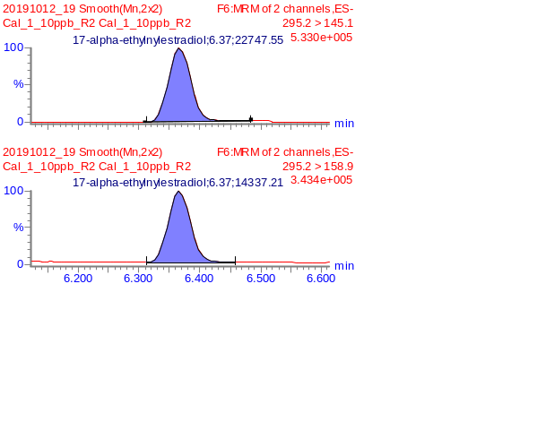
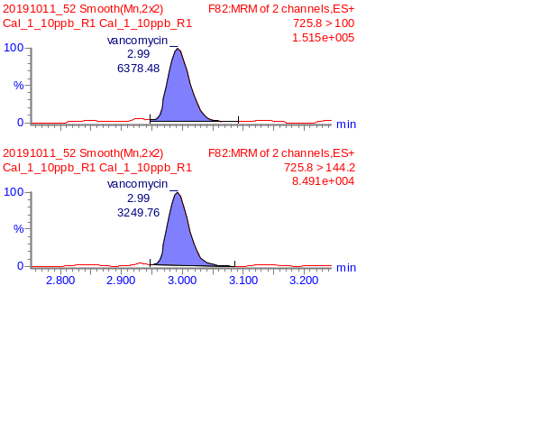
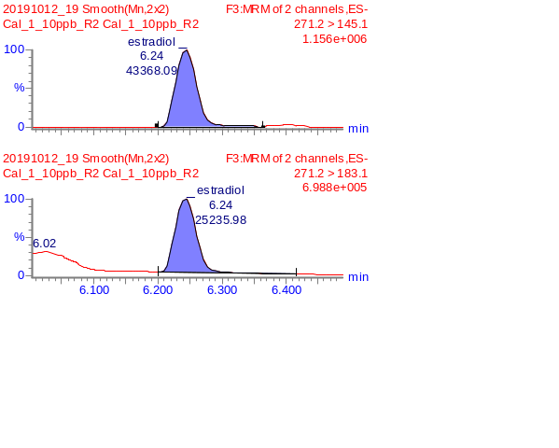
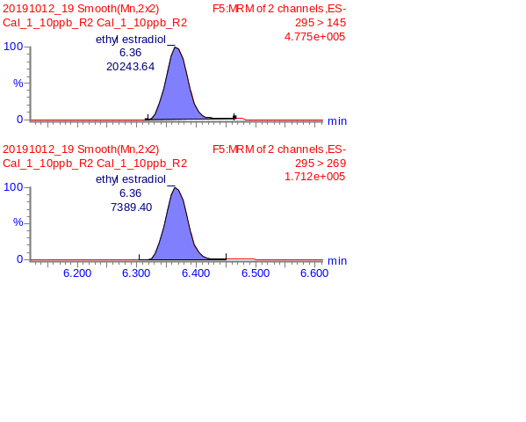
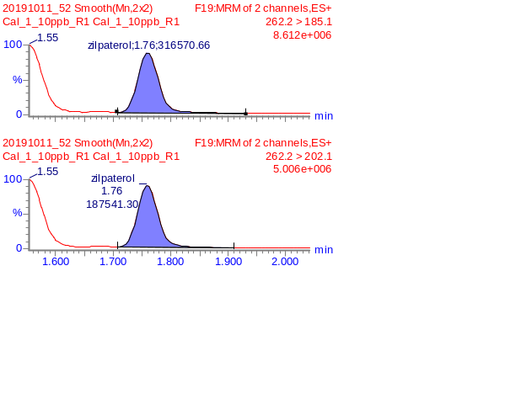
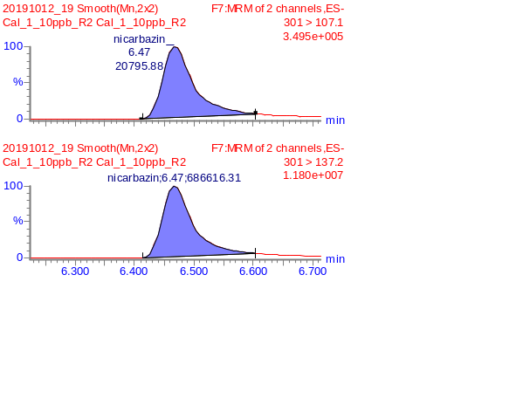
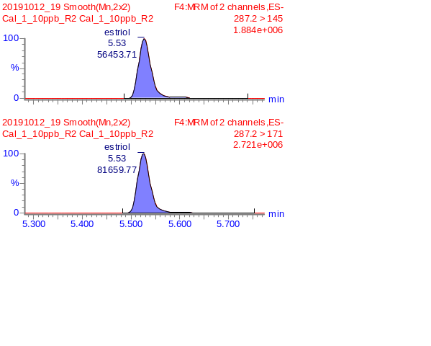
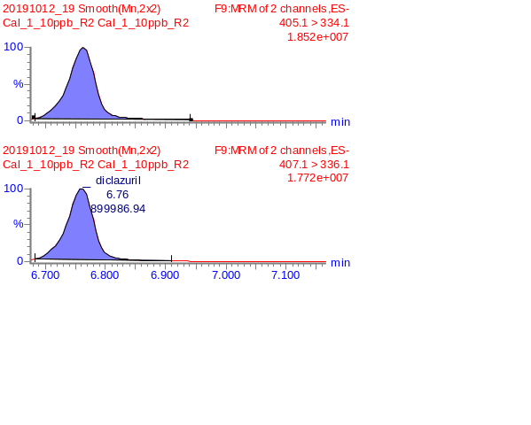
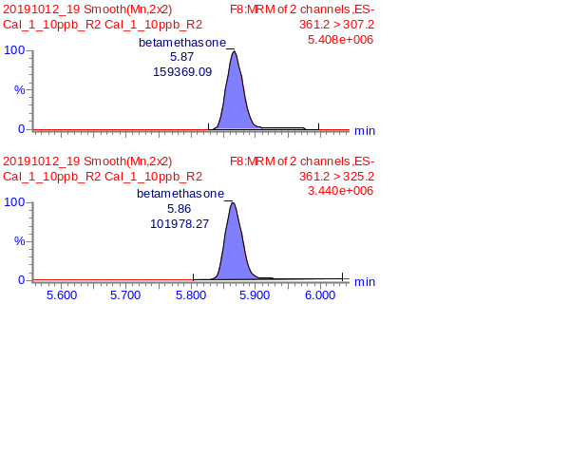

Setting up a screening and quantitation method for samples (DR-BLK A, DR-BLK B, DR-SPK A, DR-SPK B)
The standard mixture, DR-STD, was diluted with 10% MeOH into various concentrations: 0.02 ppb, 0.1 ppb, 1 ppb, 10 ppb, 50 ppb and 100 ppb. A calibration curve using the quantitation trace was established for quantitation of compounds that was spiked into the samples. Due to the different response for the different classes of compounds in the mixture, each analyte has different calibration ranges. Table 4 shows the range and linearity of the 84 compounds. Figure 2 shows the calibration curves of the individual analytes in neat solution.
Table 4. Calibration range and linearity of detected compounds in DR-STD
No | Compound | Linearity | Range (ppb) |  | No | Compound | Linearity | Range (ppb)
1 | 16-beta-hydroxy stanozolol | 0.999 | 0.1 ~ 100 |  | 11 | Ampicillin | 1.000 | 0.02 ~ 100
2 | 17-alpha-methyltestosterone | 0.999 | 10 ~ 100 |  | 12 | Brombuterol | 1.000 | 1 ~ 100
3 | 4-Epichlortetracycline | 0.999 | 0.1 ~ 100 |  | 13 | Buqinolate | 0.999 | 10 ~ 100
4 | 4-Epioxytetracycline | 0.999 | 0.1 ~ 100 |  | 14 | Carbmazepine | 0.999 | 10 ~ 100
5 | 4-Epitetracycline | 0.999 | 10 ~ 100 |  | 15 | Cefalexin | 1.000 | 0.1 ~ 100
6 | 5-Hydroxyflunixin | 0.997 | 10 ~ 100 |  | 16 | Cefazolin | 1.000 | 0.1 ~ 100
7 | 6-alpha-Methylprednisolone | 1.000 | 10 ~ 100 |  | 17 | Cefoperazone | 1.000 | 0.02 ~ 100
8 | Albendazole | 1.000 | 1 ~ 100 |  | 18 | Ceftiofur | 1.000 | 0.02 ~ 100
9 | Altrenogest | 1.000 | 0.02 ~ 10 |  | 19 | Cephalothin | 1.000 | 1 ~ 100
10 | Amoxicillin | 1.000 | 0.02 ~ 100 |  | 20 | Cephradine | 1.000 | 0.02 ~ 100
No | Compound | Linearity | Range (ppb) |  | No | Compound | Linearity | Range (ppb)
21 | Chlortetracycline | 0.999 | 1 ~ 100 |  | 36 | Epi-testosterone/Testosterone | 1.000 | 10 ~ 100
22 | Cimbuterol | 0.999 | 0.02 ~ 50 |  | 37 ^{B} | Eprinomectin | - | 50 ~ 100
23 | Clenbuterol | 0.999 | 0.02 ~ 50 |  | 38 | Flumequine | 0.9978 | 1 ~ 100
24 | Clenpenterol | 0.998 | 0.02 ~ 100 |  | 39 | Furazolidone | 1.000 | 10 ~ 100
25 | Clopidol | 1.000 | 0.1 ~ 10 |  | 40 | Hydoxy dimetridazole | 1.000 | 0.02 ~ 100
26 | Cloxacillin | 0.999 | 0.1 ~ 100 |  | 41 | Ipronidazole | 1.000 | 0.1 ~ 10
27 | Decoquinate | 0.997 | 10 ~ 100 |  | 42 | Ipronidazole hydroxy | 1.000 | 0.02 ~ 100
28 | Desacetylcefapirin | 0.999 | 10 ~ 100 |  | 43 | Lasalocid | 1.000 | 0.02 ~ 10
29 | Dexamethasone | 1.000 | 0.1 ~ 10 |  | 44 | Mabuterol | 1.000 | 1 ~ 100
30 | Dicloxacillin | 1.000 | 1 ~ 100 |  | 45 | Maduramycin | 0.997 | 0.1 ~ 10
31 | Difloxacin | 0.992 | 10 ~ 100 |  | 46 | Mapenterol | 0.998 | 0.02 ~ 50
32 | Dimetridazole | 0.9994 | 0.02 ~ 50 |  | 47 ^{B} | Marbofloxacin | - | 50 ~ 100
33 ^{B} | Doramectin | - | 50 ~ 100 |  | 48 | Metronidazole | 0.998 | 0.02 ~ 50
34 | Doxycycline/Tetracycline | 0.998 | 1 ~ 100 |  | 49 | Metronidazole-hydroxy | 1.000 | 0.02 ~ 100
35 ^{B} | Enrofloxacin | - | 50 ~ 100 |  | 50 | Monensin | 0.999 | 0.1 ~ 10
No | Compound | Linearity | Range (ppb) |  | No | Compound | Linearity | Range (ppb)
51 | Monepantel sulfone | 1.000 | 0.1 ~ 10 |  | 66 | Sarafloxacin | 0.997 | 10 ~ 100
52 | Nafcillin | 1.000 | 0.02 ~ 100 |  | 67 | Stanozolol | 0.998 | 1 ~ 100
53 | Nandrolone | 0.999 | 0.1 ~ 100 |  | 68 | Sulfadimethoxine/Sulfadoxine | 0.997 | 10 ~ 100
54 | Narasin | 0.995 | 0.02 ~ 10 |  | 69 | Sulfanilamide | 1.000 | 1 ~ 100
55 ^{B} | Norfloxactin | - | 50 ~ 100 |  | 70 | Terbutaline | 1.000 | 0.02 ~ 10
56 | Novobiocin | 0.998 | 0.1 ~ 50 |  | 71 | Thiabendazole | 1.000 | 10 ~ 100
57 | Oxacillin | 1.000 | 0.1 ~ 100 |  | 72 | Tildipirosin | 0.996 | 10 ~ 100
58 | Oxibendazole | 1.000 | 10 ~ 100 |  | 73 | Vancomycin | 1.000 | 1 ~ 100
59 | Penicillin G | 1.000 | 0.1 ~ 100 |  | 74 | Virginiamycin | 0.999 | 0.1 ~ 100
60 | Penicillin V | 1.000 | 0.1 ~ 100 |  | 75 | Zilpaterol | 1.000 | 0.1 ~ 10
61 | Prednisolone | 1.000 | 0.02 ~ 100 |  | 76 | 17-alpha-ethylnylestradiol | 0.999 | 0.1 ~ 50
62 | Ractopamine | 0.999 | 0.02 ~ 50 |  | 77 | betamethasone | 1.000 | 0.02 ~ 10
63 | Robenidin | 0.996 | 10 ~ 100 |  | 78 | Diclazuril | 0.999 | 0.1 ~ 10
64 | Ronidazole | 0.999 | 0.02 ~ 50 |  | 79 | Diethylstilbesterol | 1.000 | 0.1 ~ 10
65 | Salbutamol | 1.000 | 0.02 ~ 10 |  | 80 | Estradiol | 0.997 | 10 ~ 100
No | Compound | Linearity | Range (ppb) |  | No | Compound | Linearity | Range (ppb)
81 | Estriol | 1.000 | 0.1 ~ 10 |  | 83 | Ethyl estradiol | 0.999 | 0.1 ~ 50
82 | Estrone | 1.000 | 0.02 ~ 50 |  | 84 | Nicarbazin | 0.998 | 1 ~ 100

Note: ^{B} refers to compound having only 2 calibration points, thus linearity is not provided.

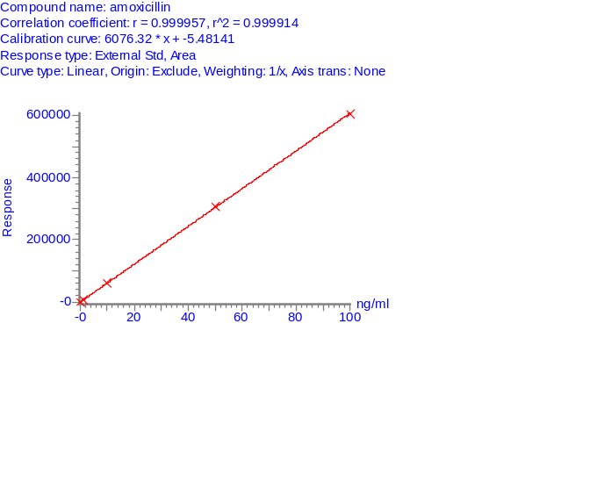
Figure 2(a) Calibration curve of 84 compounds found in DR-STD (Compound 1 ~ 12)
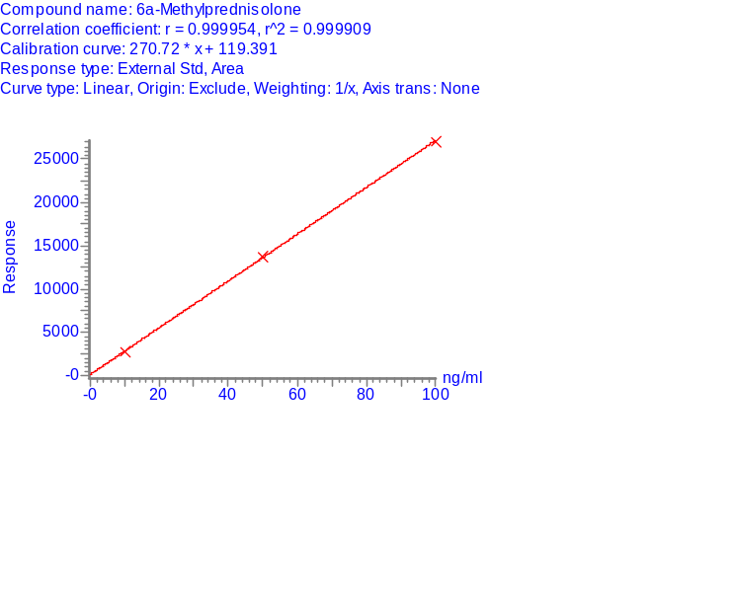
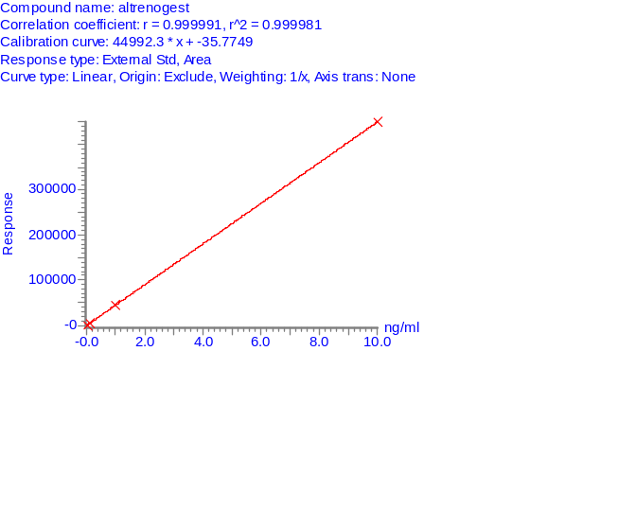
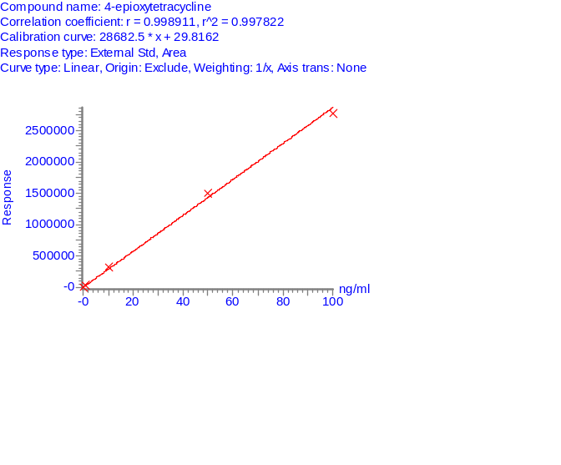
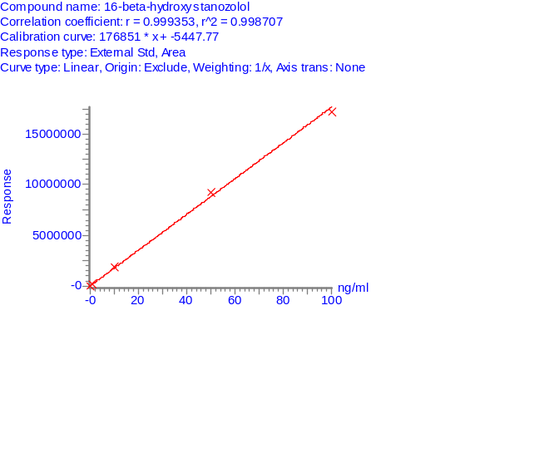

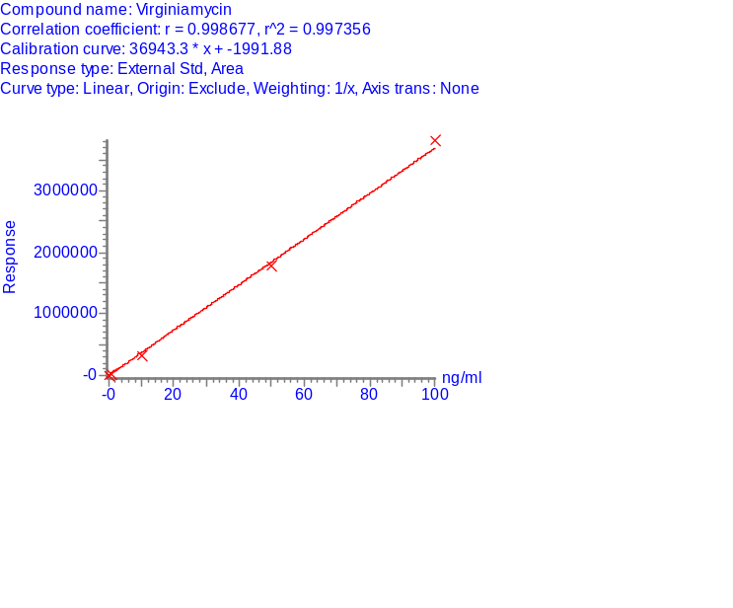

103
743
443
1

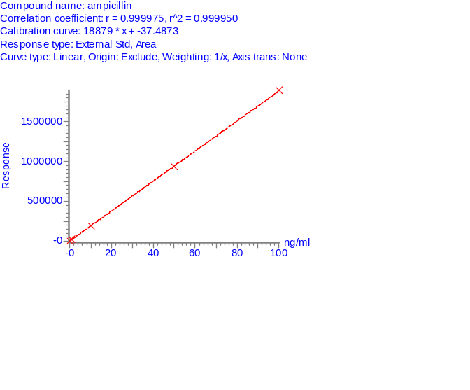
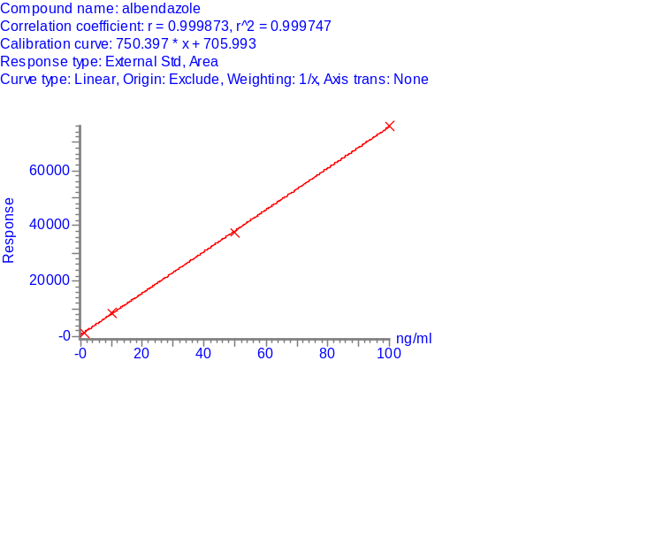
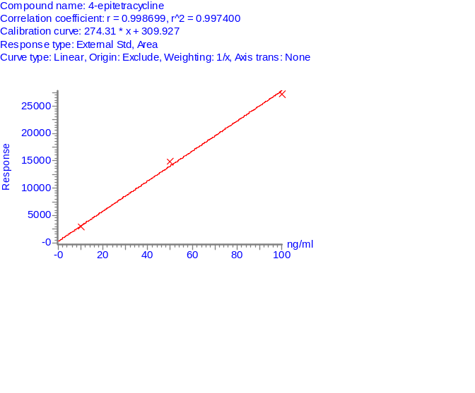
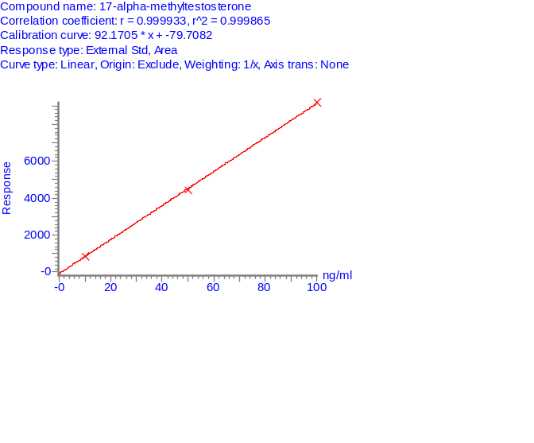

11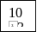3
543
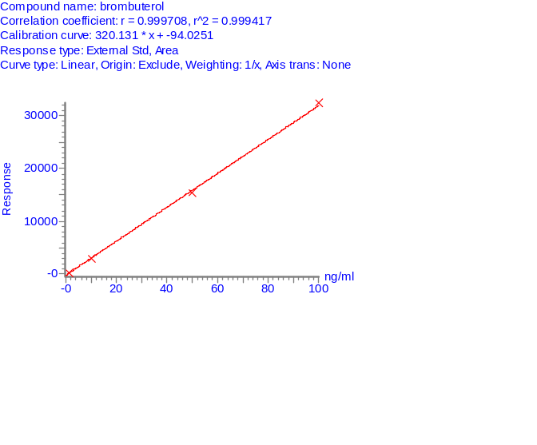
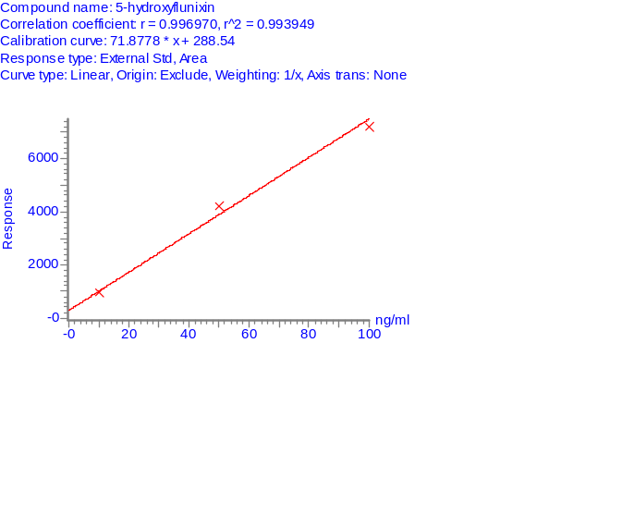
1203
943
843
643
33
2

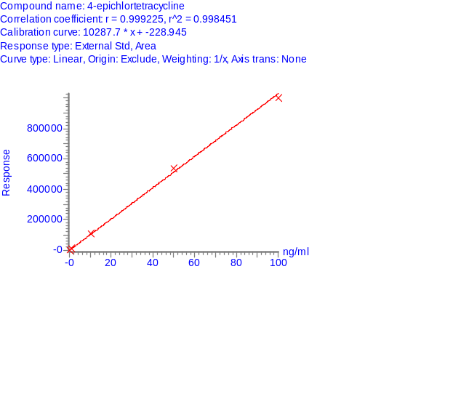

Figure 2(b) Calibration curve of 84 compounds found in DR-STD (Compound 13 ~ 24)
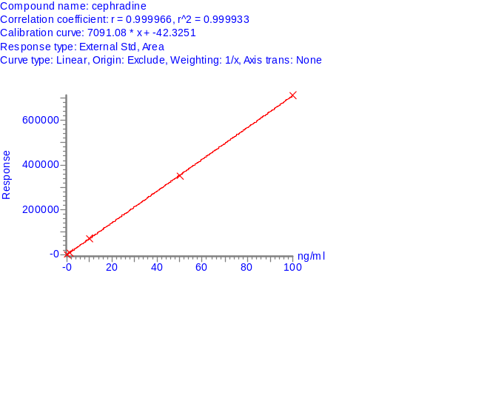
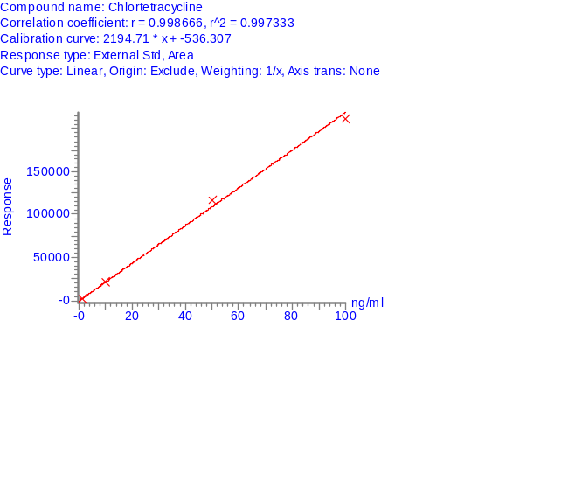
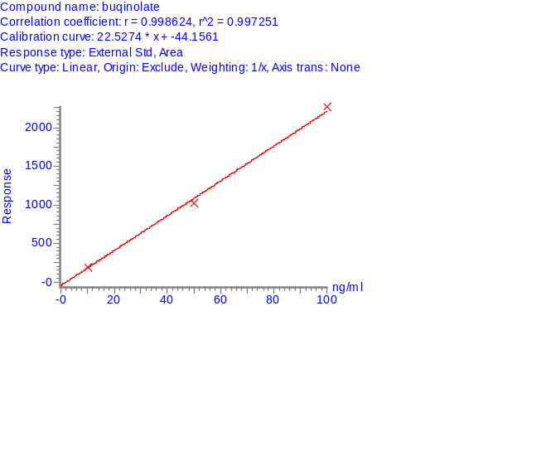
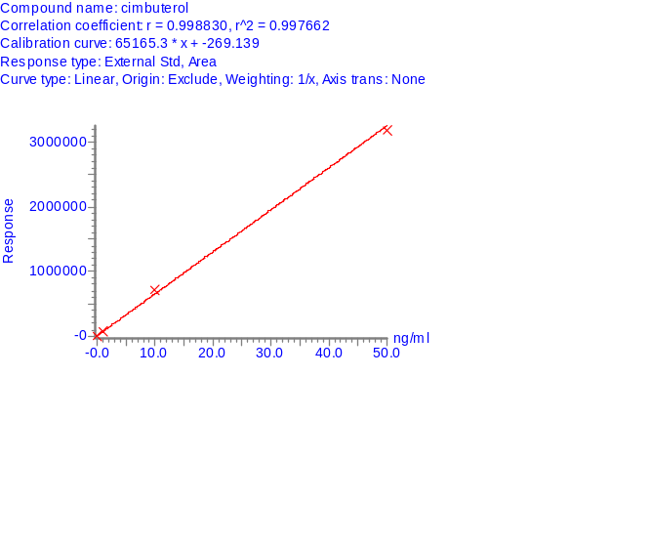
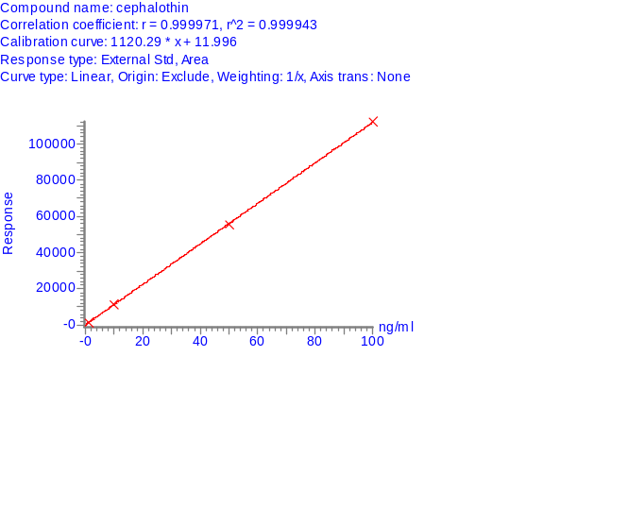
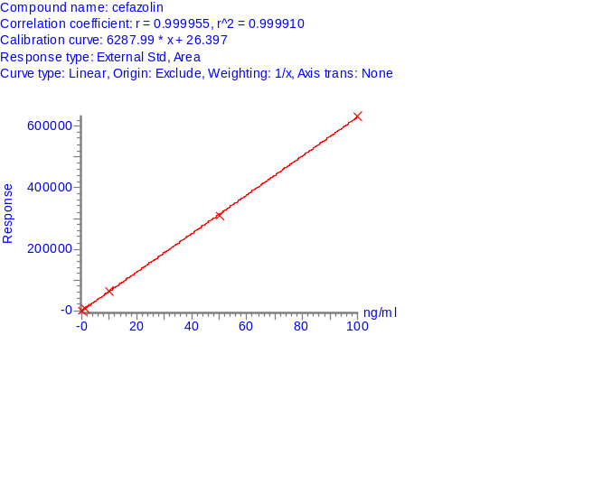

223
1943
1643
13

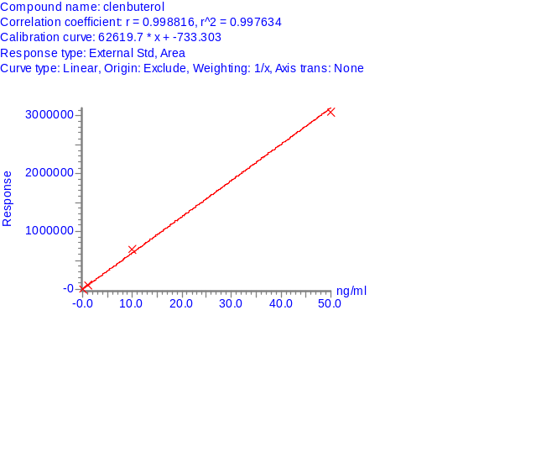
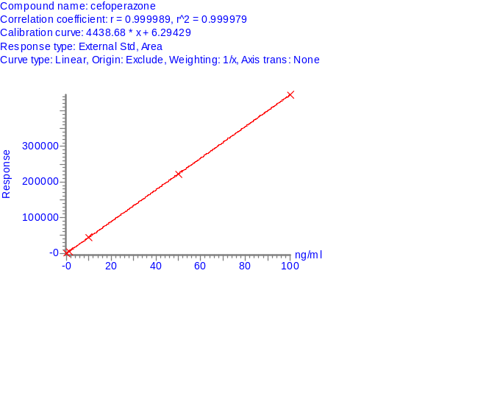
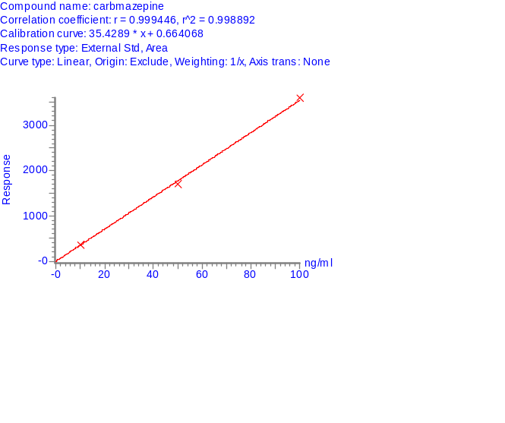

17
233
203
14

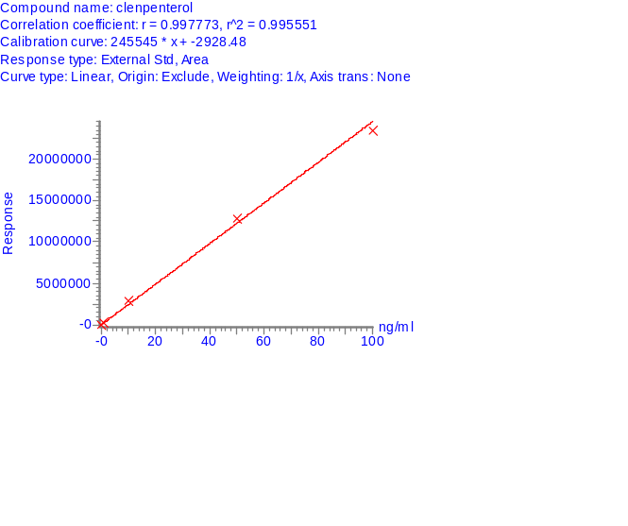
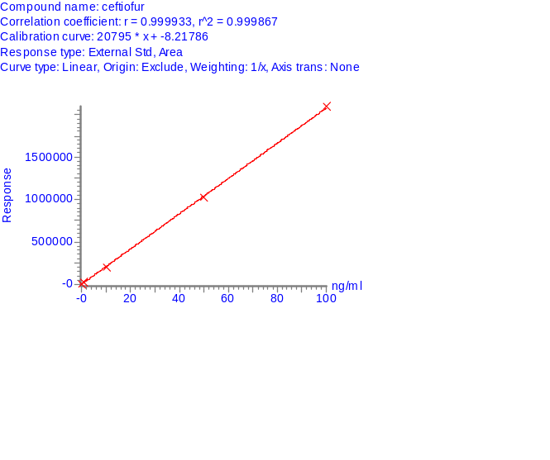
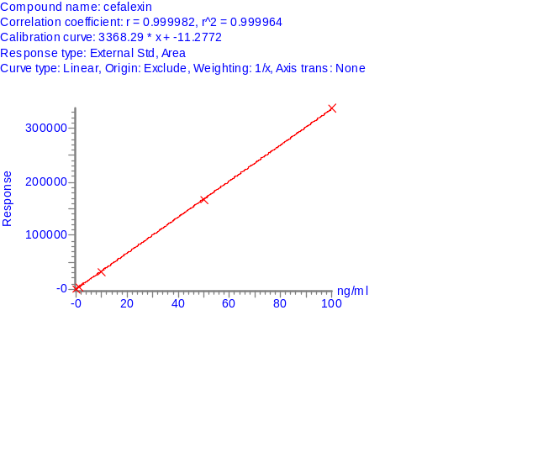

243
213
183
15

Figure 2(c) Calibration curve of 84 compounds found in DR-STD (Compound 25 ~ 36)
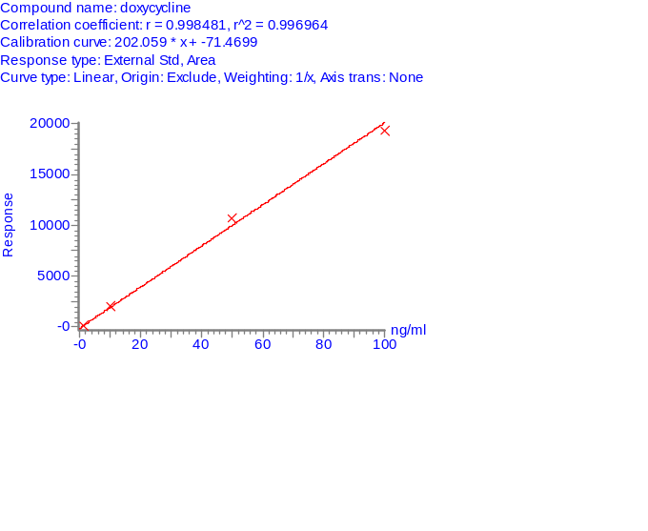
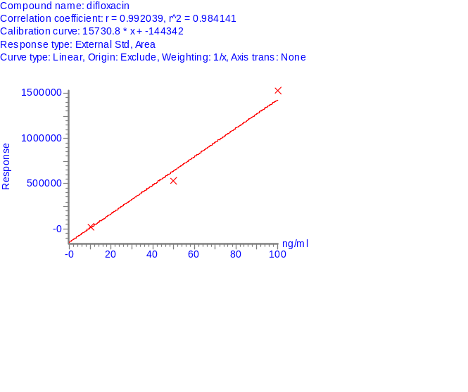
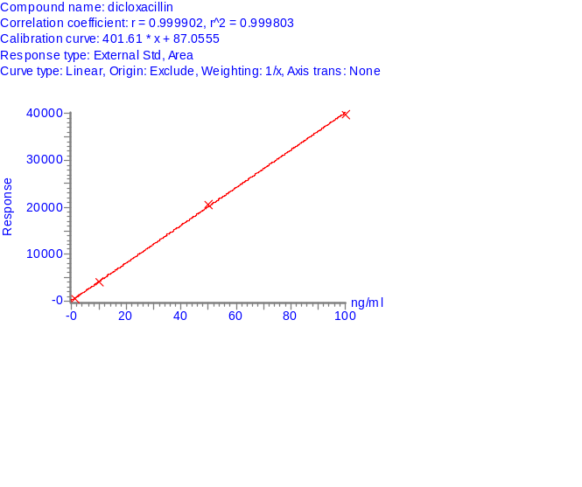
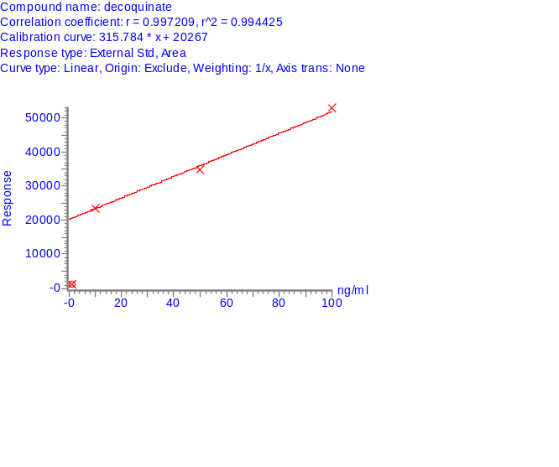
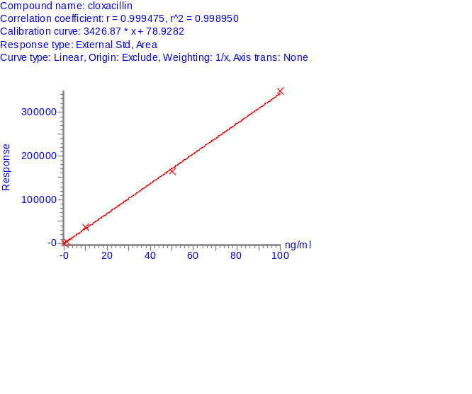
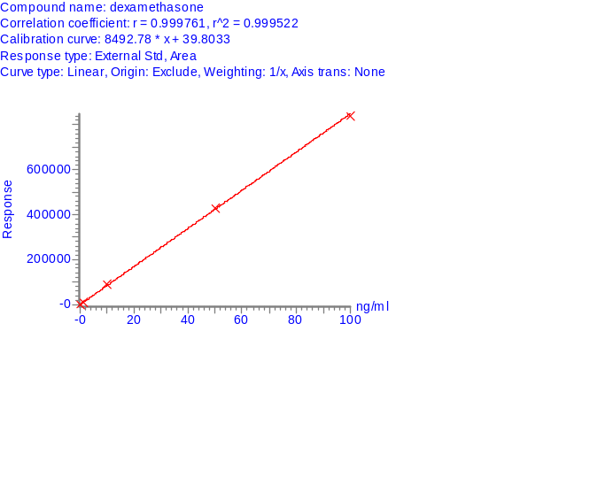
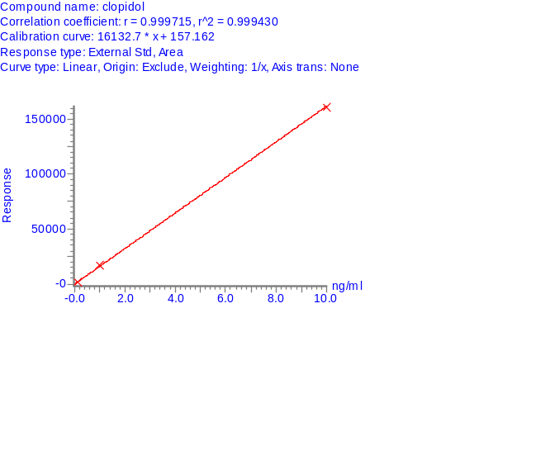
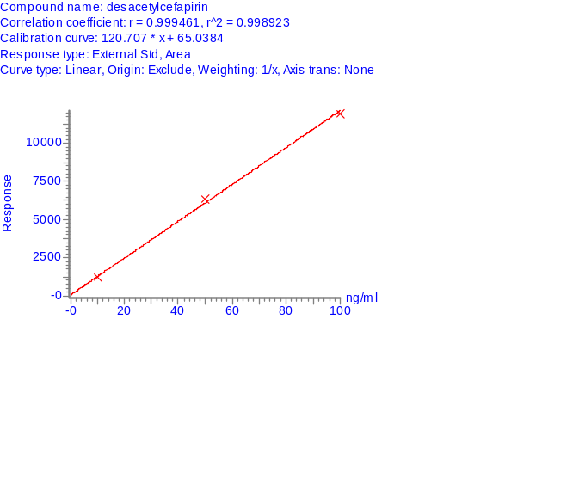

3143
283
25
343

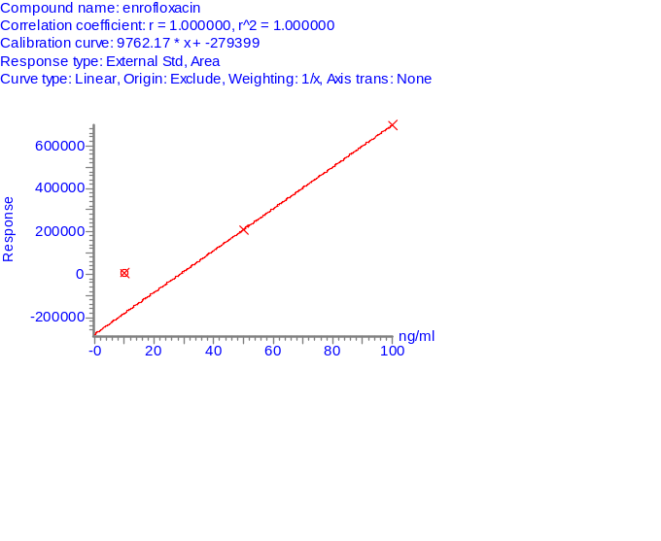
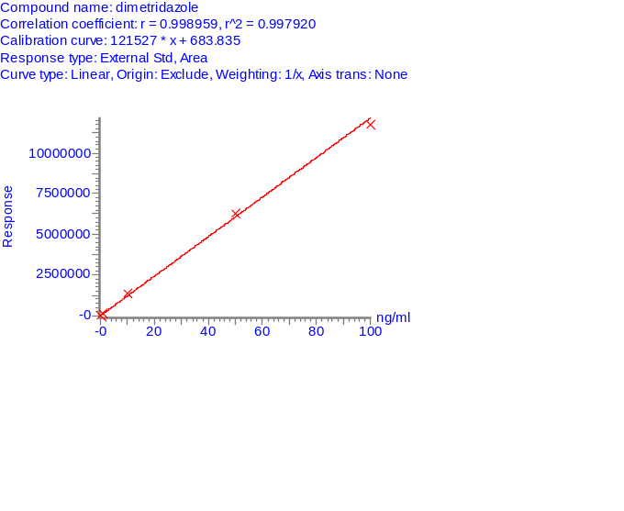

29
353
323
26

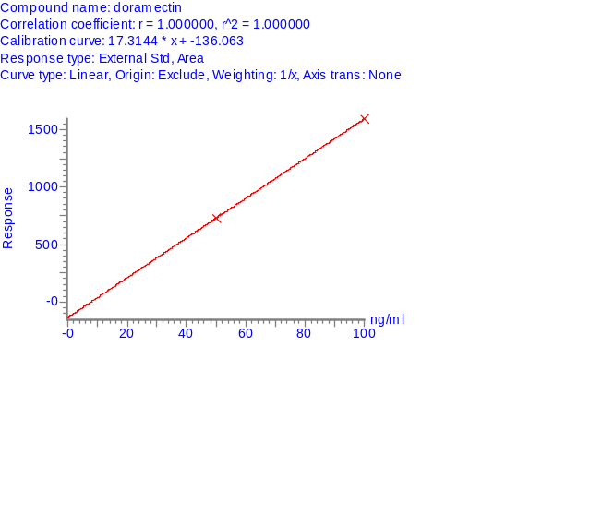
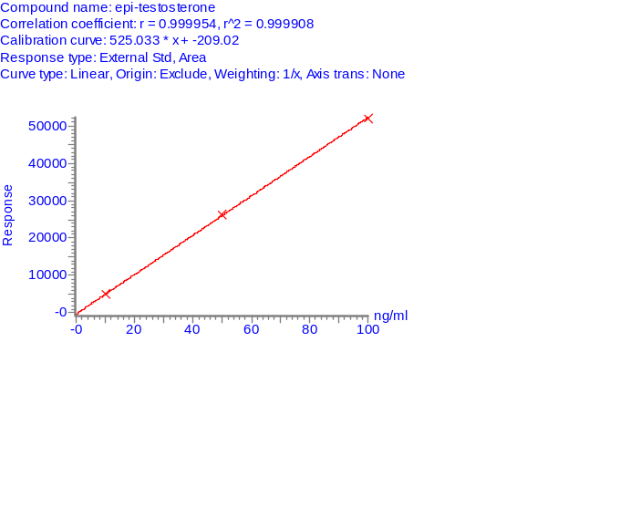

3633
303
333
27

Figure 2(d) Calibration curve of 84 compounds found in DR-STD (Compound 37 ~ 48)
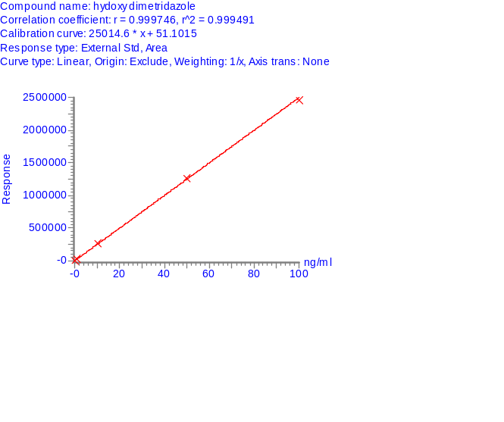
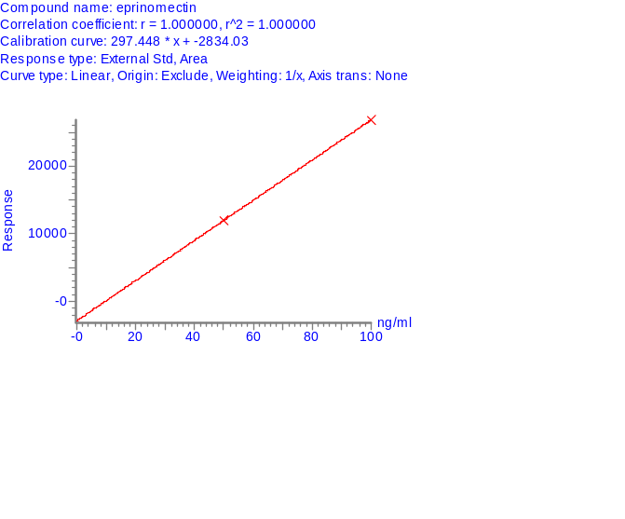
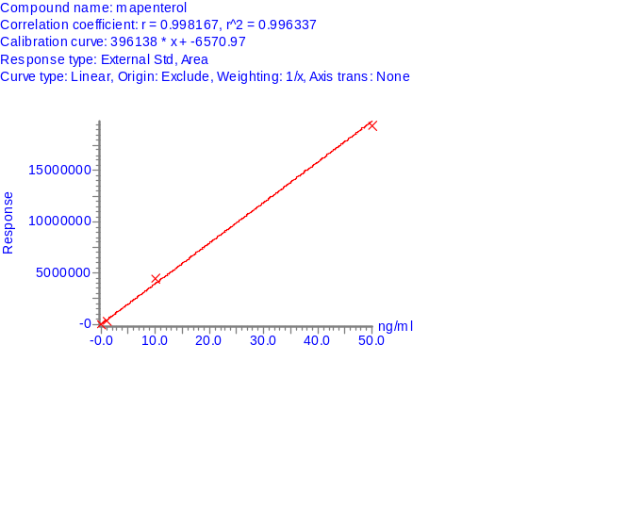
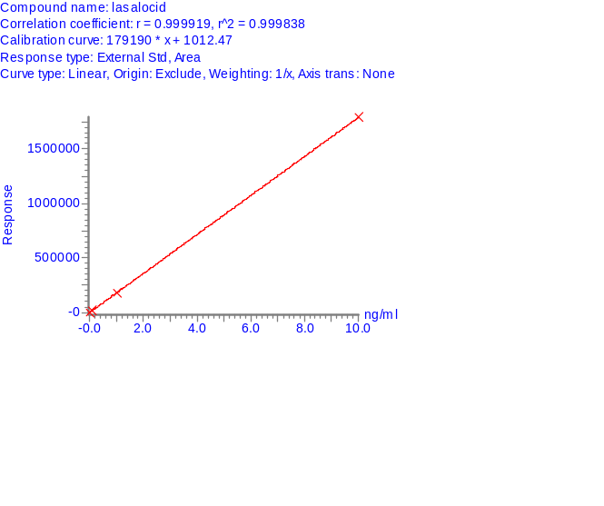

4343
403
37
463

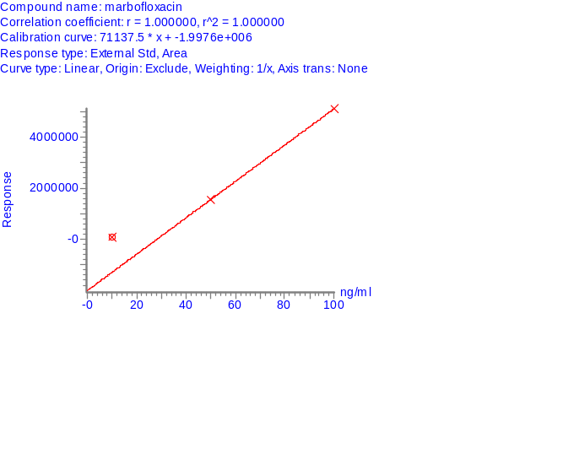
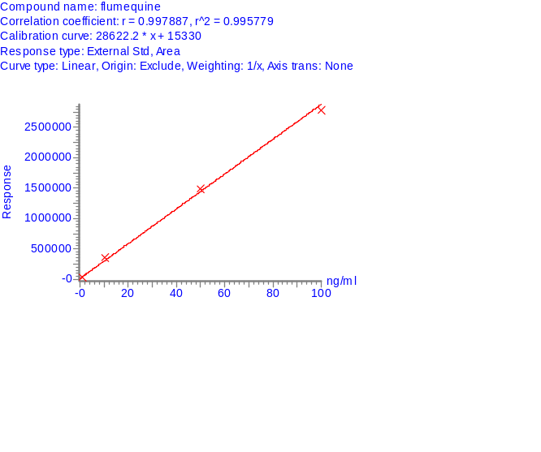
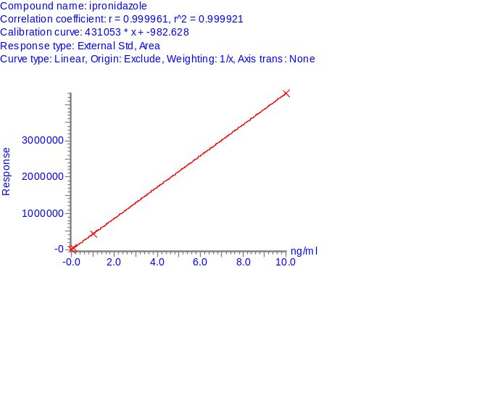
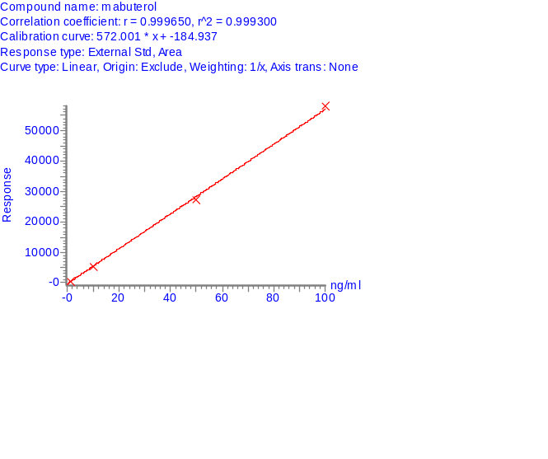

41
473
443
38
4833

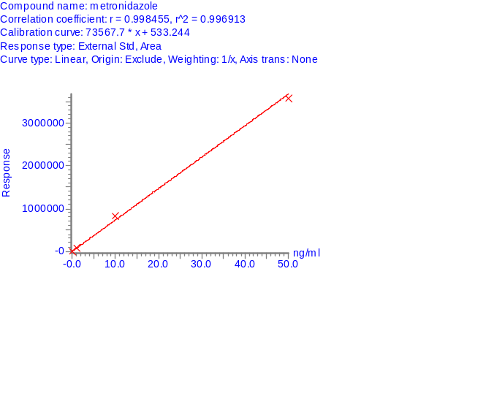
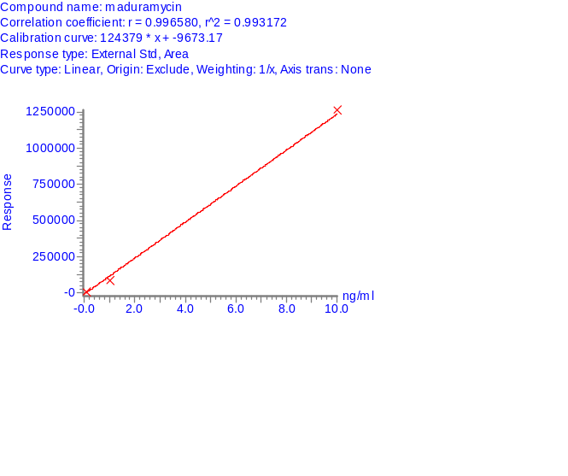
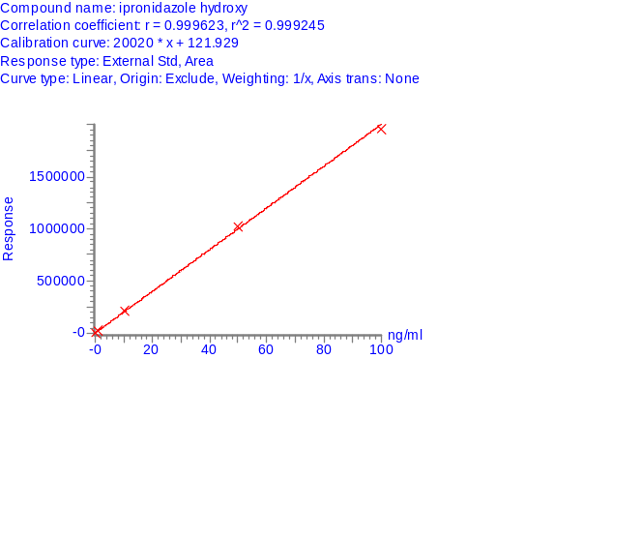
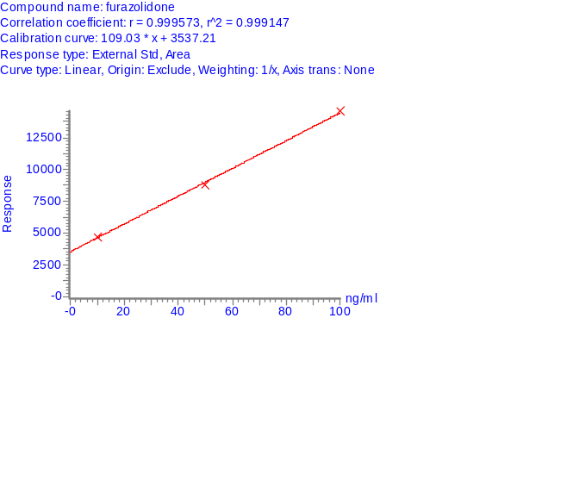

423
453
39

Figure 2(e) Calibration curve of 84 compounds found in DR-STD (Compound 49 ~ 60)
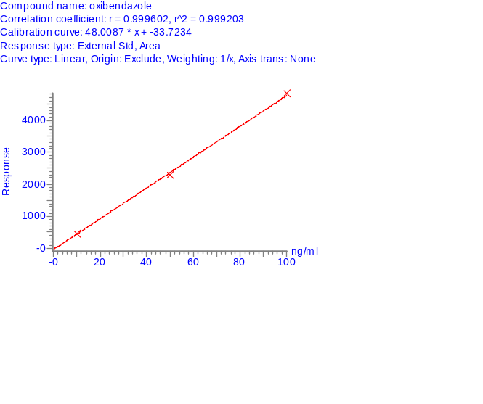
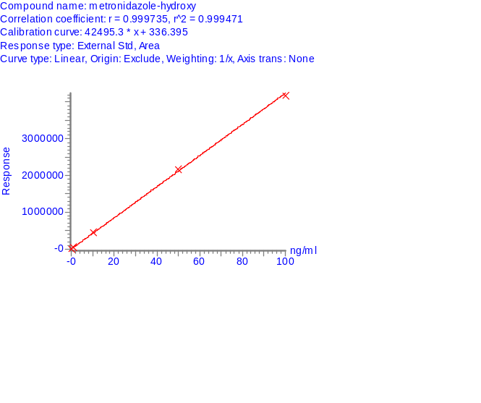
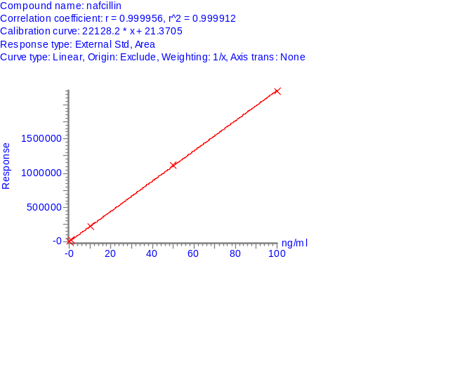
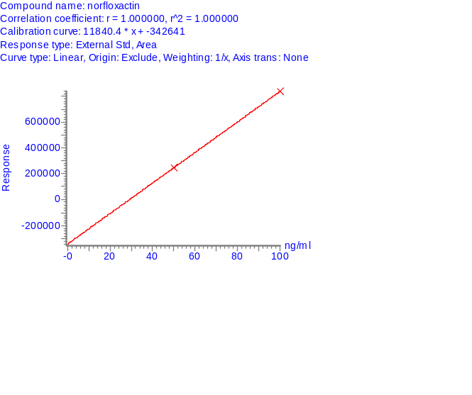

5543
523
49
583

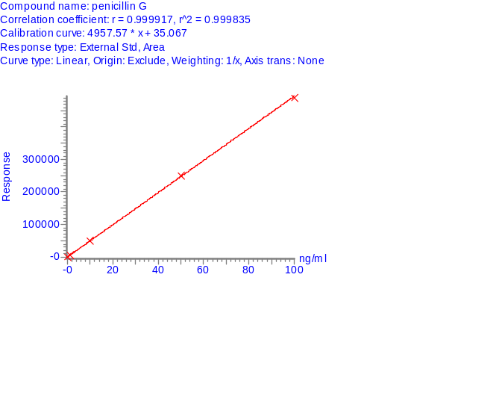
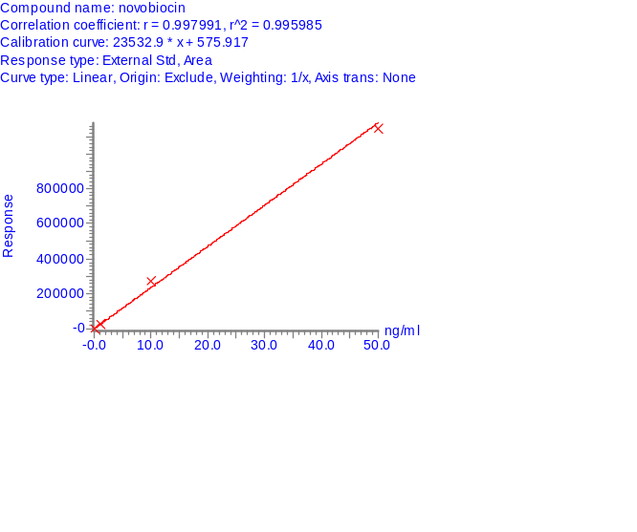
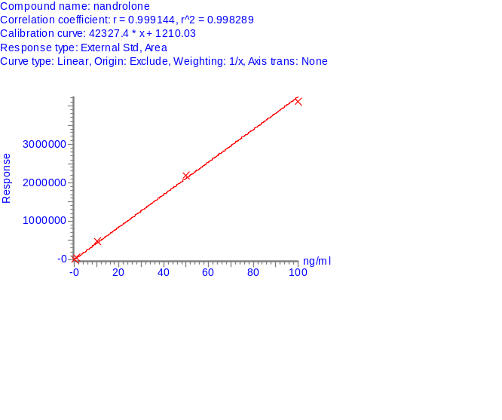
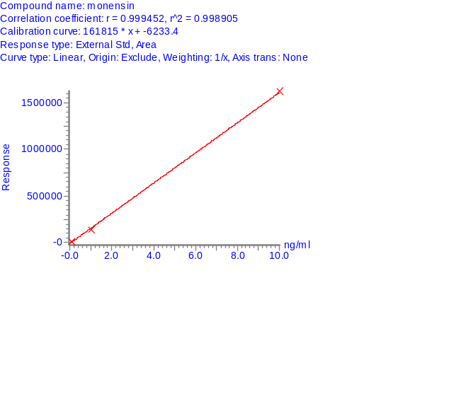

53
593
563
50
6033

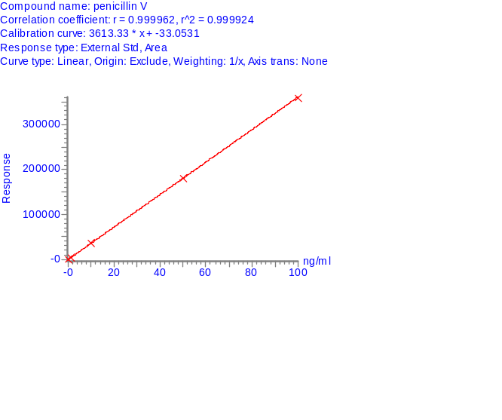
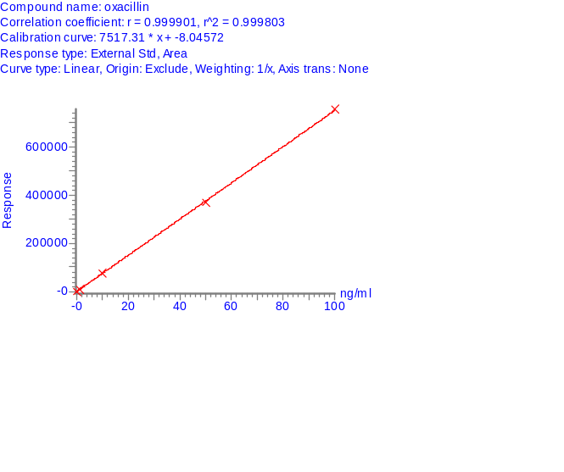
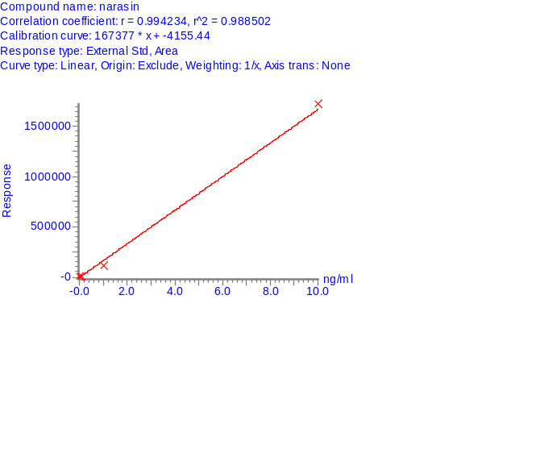
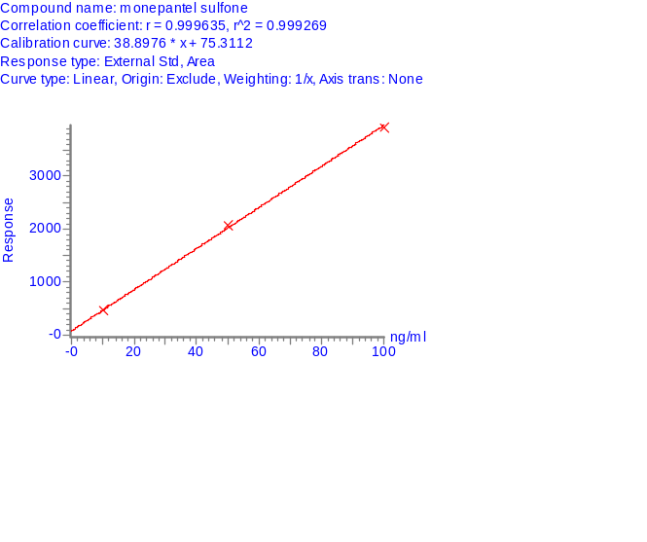

543
573
51

Figure 2(f) Calibration curve of 84 compounds found in DR-STD (Compound 61 ~ 72)
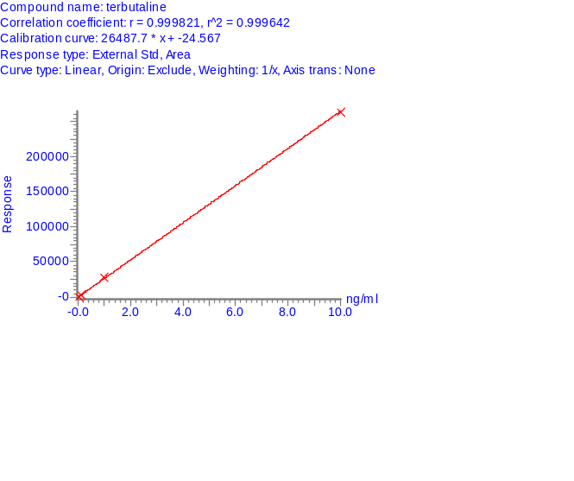
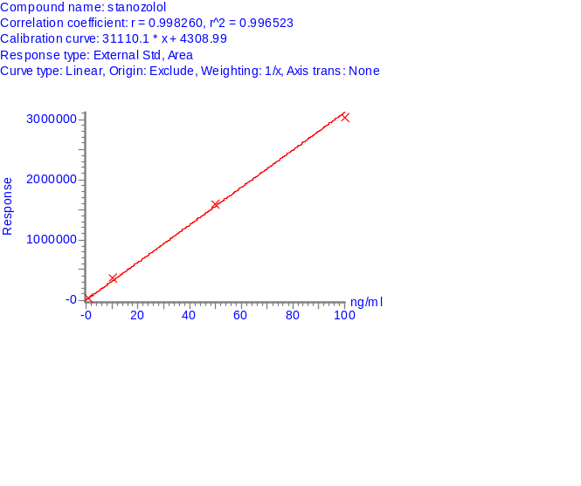
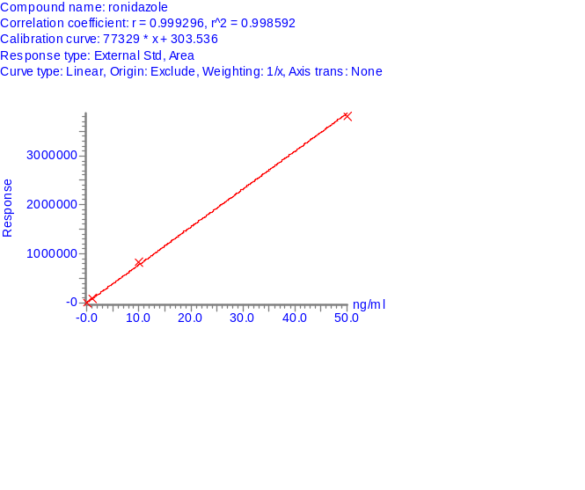
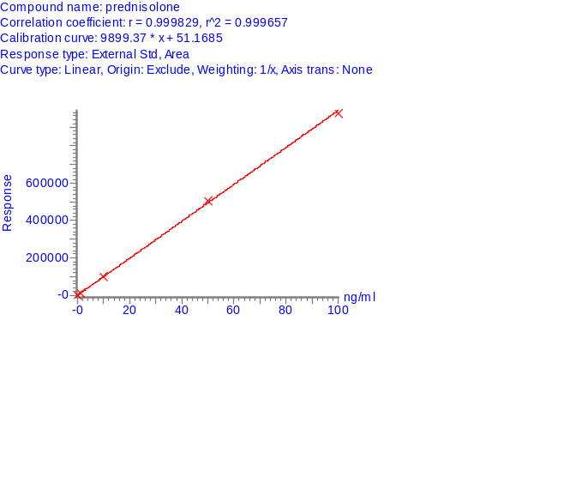

6743
643
61
703

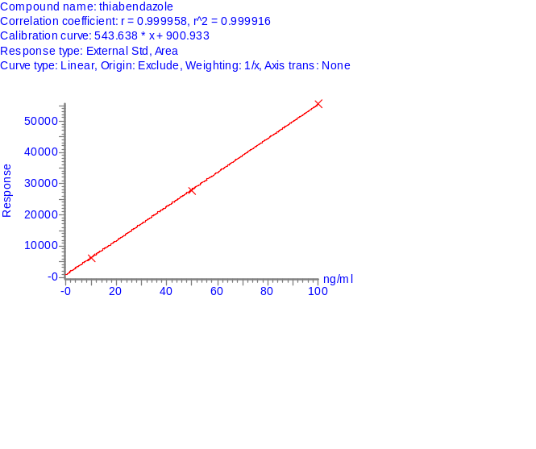
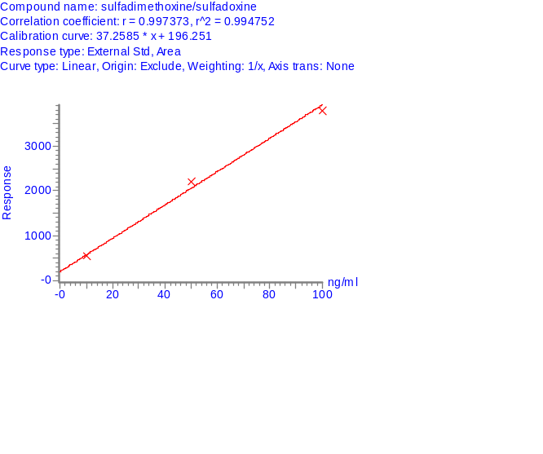
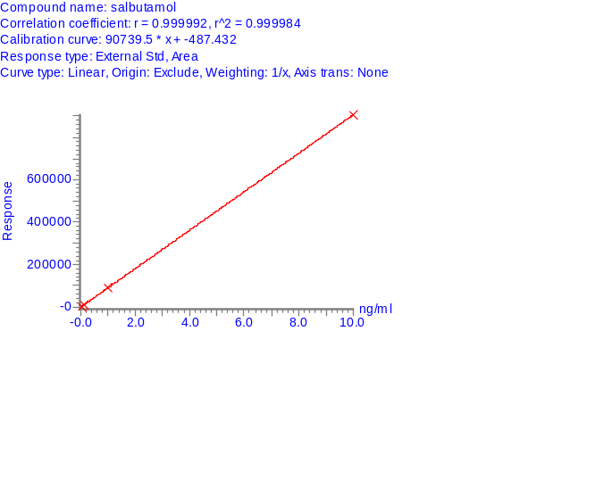
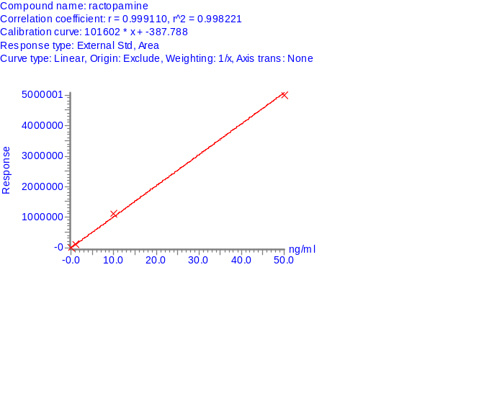

65
713
683
62
7233

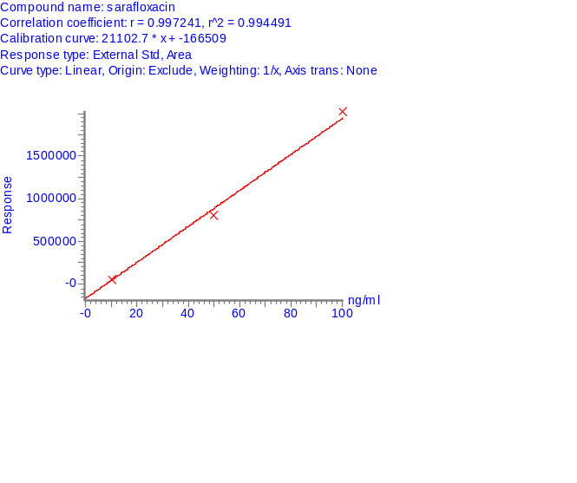
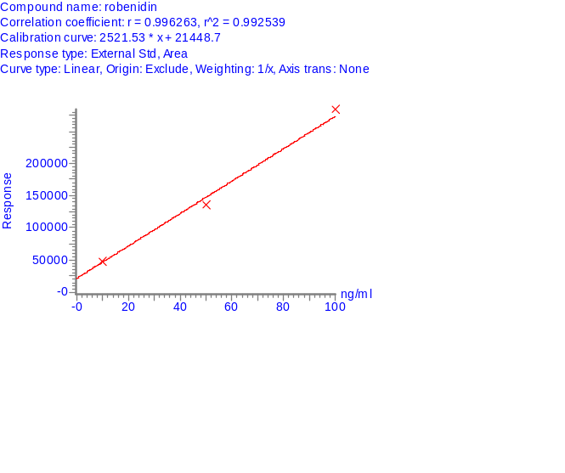
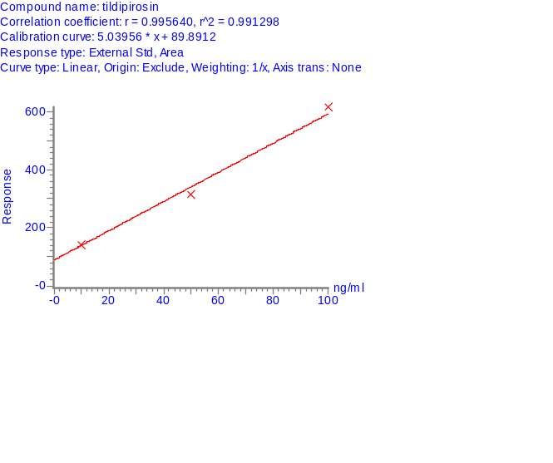
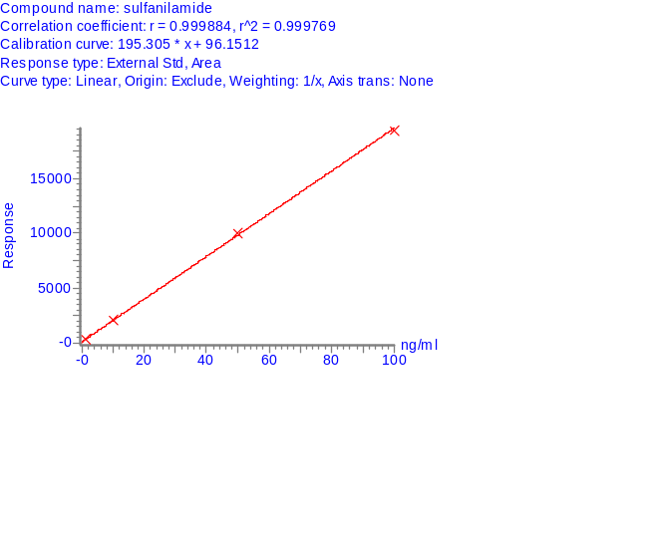

663
693
63

Figure 2(g) Calibration curve of 84 compounds found in DR-STD (Compound 73 ~ 84)
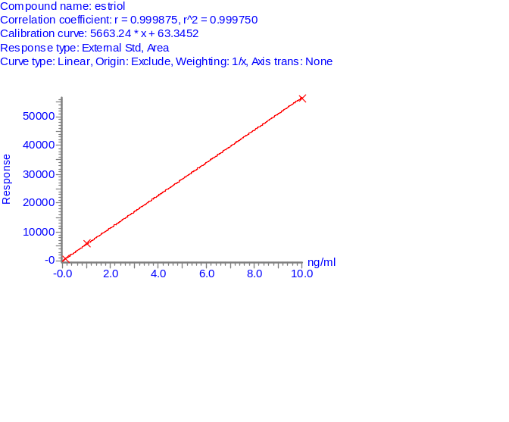
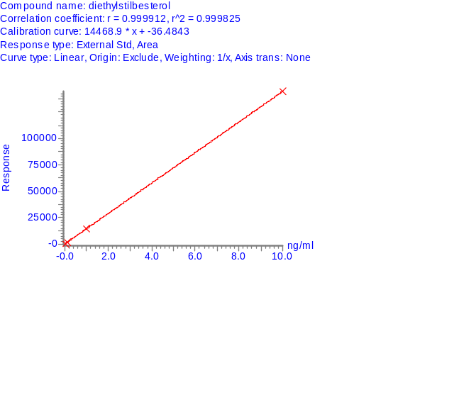
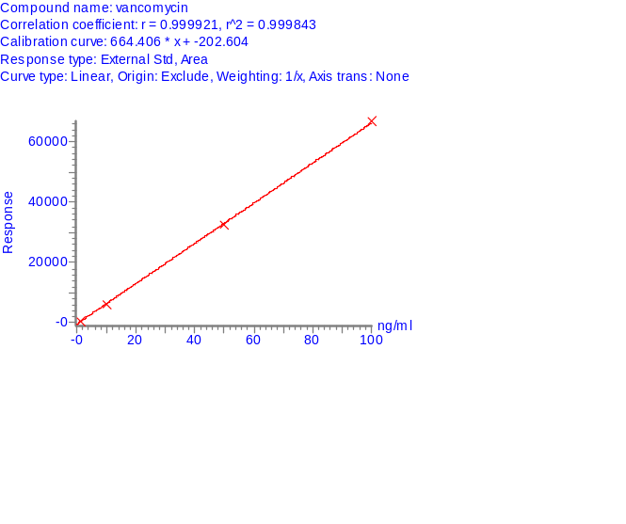
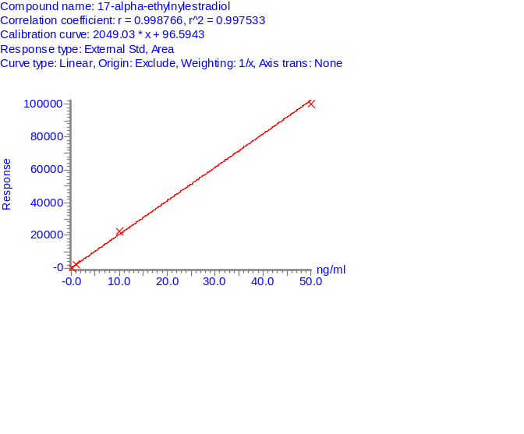

7943
763
73
823

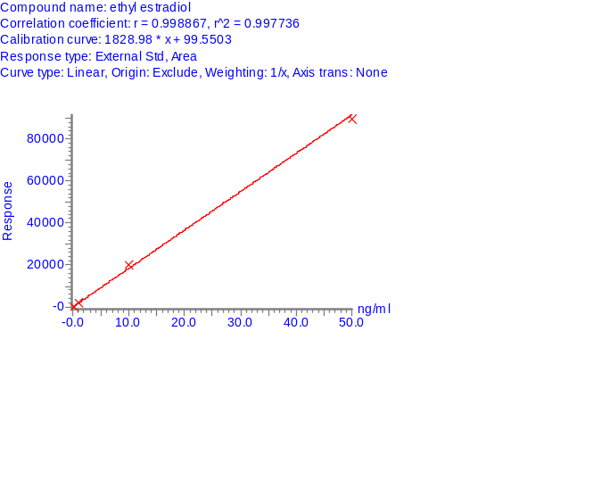
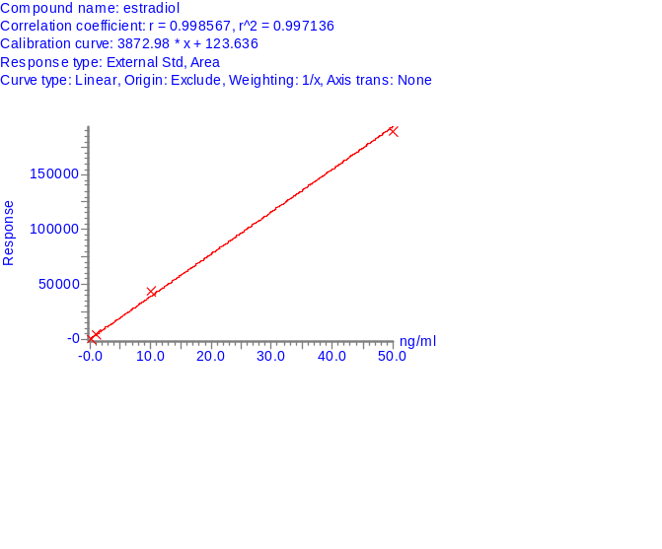
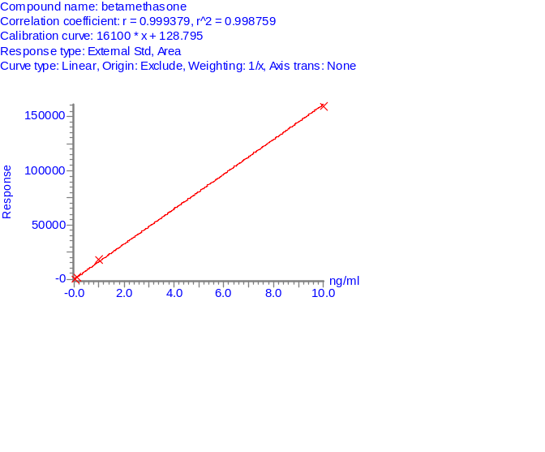
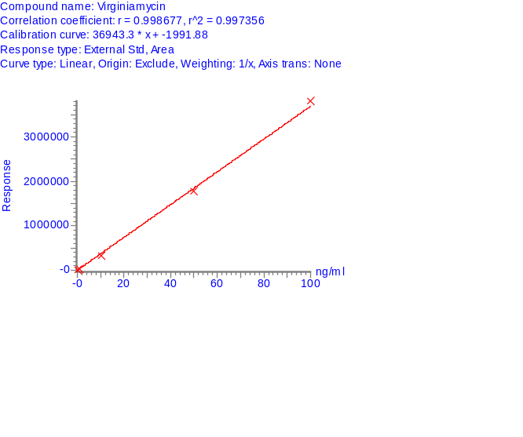

77
833
803
74
8433

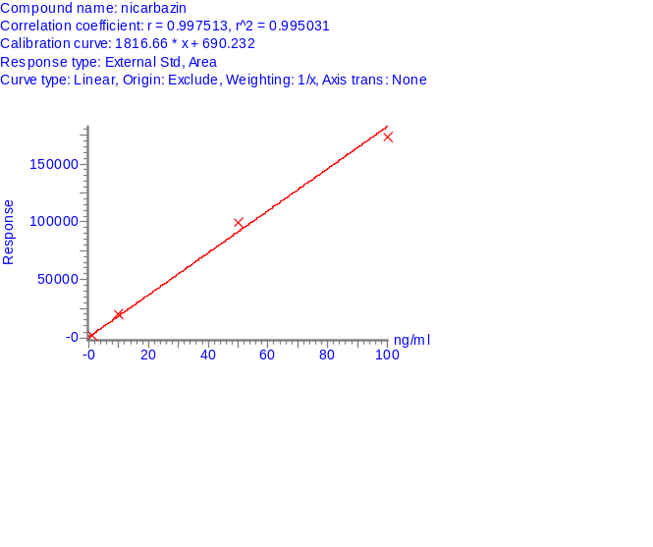
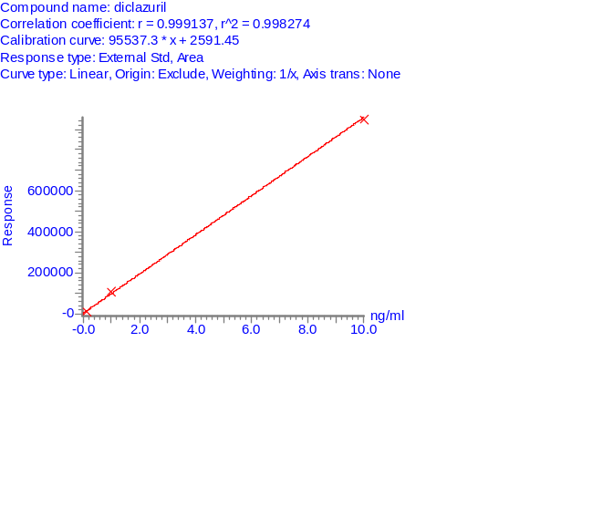
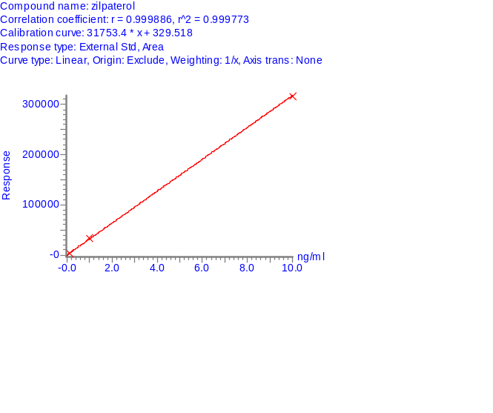

783
813
75

Screening and Quantitation result for DR-BLK A, DR-BLK B, DR-SPK A and DR-SPK B using established MRM method and calibration curves
Sample DR-BLK A, DR-BLK B, DR-SPK A and DR-SPK B were diluted with water (1:1, vol:vol) before LCMSMS injection. Triplicate analysis was performed on each sample to obtain reliable results. For each detected analyte in the sample, they were quantitated based on the calibration curve established with the standards.

Results for DR-BLK A, DR-BLK B

DR-BLK A and DR-BLK B are blank matrices provided. There are traces of drug residue detected in both blank matrices. 5 analytes were detected and quantitated in DR-BLK A while 4 analytes were detected and quantitated in DR-BLK B. Table 5 shows the drug residue detected and the amount present in the blank matrices. Figure 3 display the MRM chromatogram of detected analytes in DR-BLK A and Figure 4 display the MRM chromatogram of detected analytes in DR-BLK B

Table 5. List of detected compounds in DR-BLK A and DR-BLK B
No | Compounds | Conc (ppb)
No | Compounds | DR-BLK A | DR-BLK B
1 | Albendazole | 130.1 | 49.4
2 | Altrenogest | 0.1 | ND
3 | Furazolidone | 428.1 | 363.1
4 | Monensin | 0.1
5 | Sulfanilamide | 79.1 | 78.5
6 | 17-alpha-ethylnylestradiol |  | 0.3

Figure 3 MRM chromatograms of detected compounds in DR-BLK A
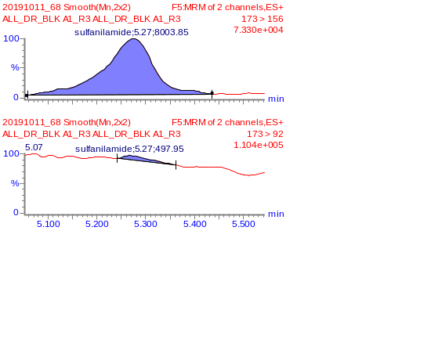
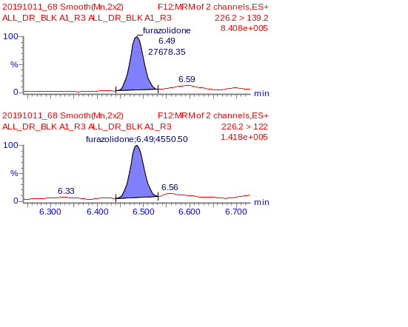
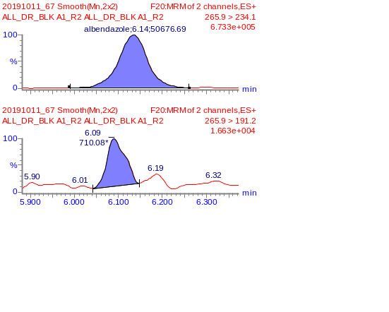

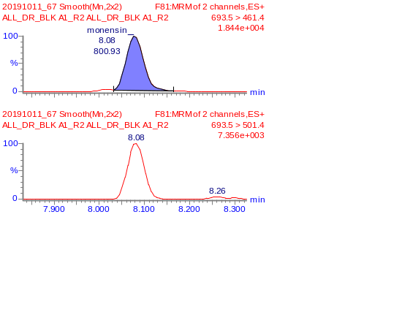
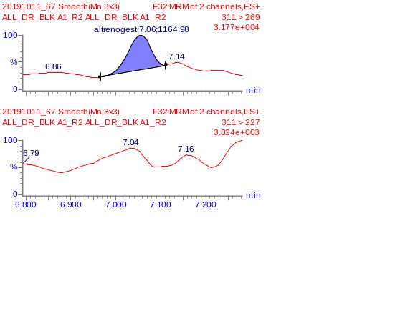

Figure 4 MRM chromatograms of detected compounds in DR-BLK B
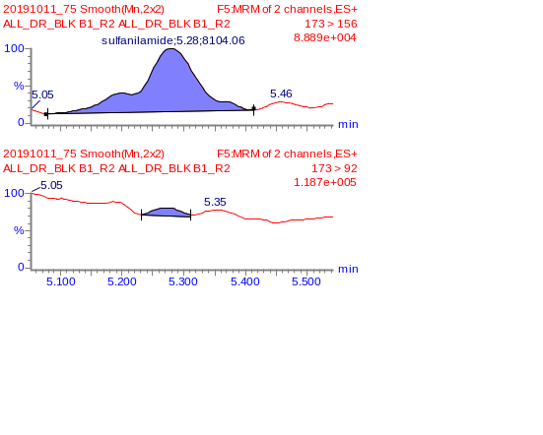
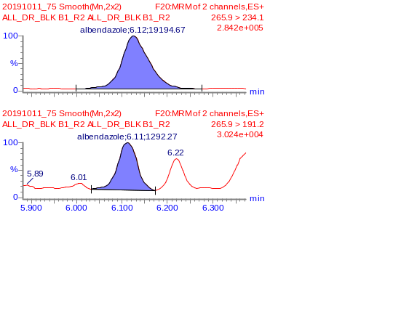

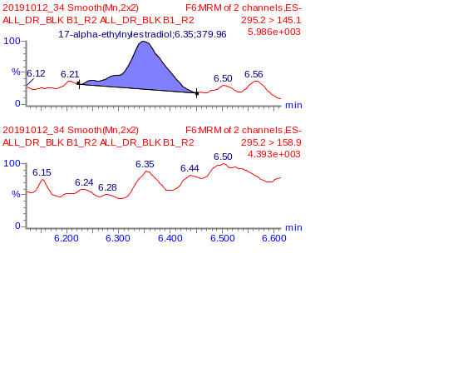
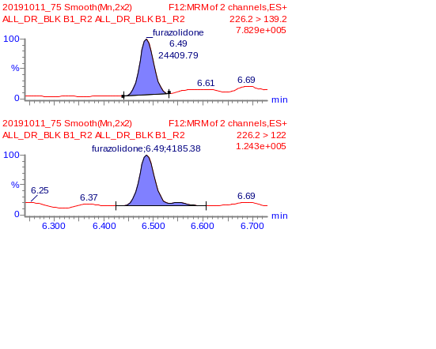

Results for DR-SPK A, DR-SPK B

DR-SPK A and DR-SPK B are spiked samples that was provided. A total of 32 analytes were detected in DR-SPK A and 30 analytes were detected in DR-SPK B. Due to the interference from the matrices, fronting and tailing are observed for some of the analytes. Table 6 list down the drug residues detected and the amount present in the spiked matrices. Figure 5 display the MRM chromatogram of detected analytes in DR-SPK A and Figure 6 display the MRM chromatogram of detected analytes in DR-SPK B

Table 6. List of detected compounds and its amount in DR-SPK A and DR-SPK B
No | Compounds | Conc (ppb)
No | Compounds | DR-SPK A | DR-SPK B
1 | 16-beta-hydroxy stanozolol | 3.02 | 2.67
2 | 4-epioxytetracycline | 2.07 | 3.00
3 | Albendazole | 309.19 | 58.22
4 | Altrenogest | 0.08 | ND
5 | Amoxicillin | 0.51 | 1.03
6 | Ampicillin | 0.80 | 1.62
7 | Chlortetracycline | 21.63 | 39.45
8 | Clenbuterol | 0.22 | 0.22
9 | Dexamethasone | 6.78 | 6.74
10 | Dimetridazole | 0.92 | 0.68
11 | Epi-testosterone/Testosterone | ND | 13.91
12 | Furazolidone | 752.13 | 773.79
13 | Hydoxy dimetridazole | 0.35 | 0.35
14 | Ipronidazole | 1.22 | 1.20
15 | Maduramycin | 2.51 | 3.75
16 | Metronidazole | 0.34 | 0.28
17 | Metronidazole-hydroxy | 0.28 | 0.28
18 | Monensin | 4.89 | 5.35
19 | Nandrolone | 2.28 | 2.10
20 | Novobiocin | 8.65 | 8.48
21 | Oxibendazole | 23.56 | ND
22 | Penicillin V | 25.94 | 28.15
23 | Prednisolone | 6.48 | 8.42
24 | Ractopamine | 0.14 | 0.16
25 | Salbutamol | 0.12 | 0.12
26 | Stanozolol | 2.72 | 1.72
27 | Sulfanilamide | 84.70 | 67.87
28 | Zilpaterol | 0.12 | 0.0.10
29 | 17-alpha-ethylnylestradiol | 1.08 | 0.30
30 | betamethasone | 2.72 | 0.68
31 | Diethylstilbesterol | 1.06 | 0.30
32 | Estrone | 0.06 | ND
33 | Ethyl estradiol | 1.04 | 0.24

Figure 5(a) MRM chromatograms of detected compounds in DR-SPK A
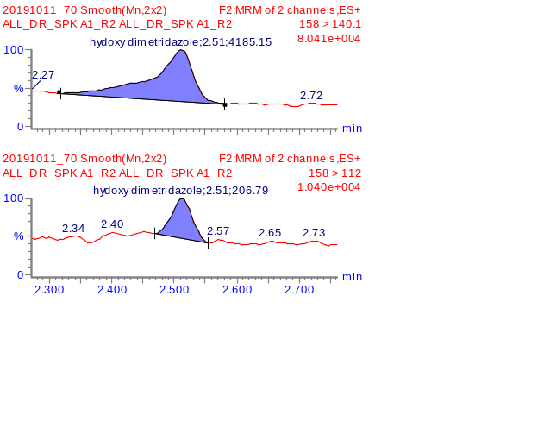
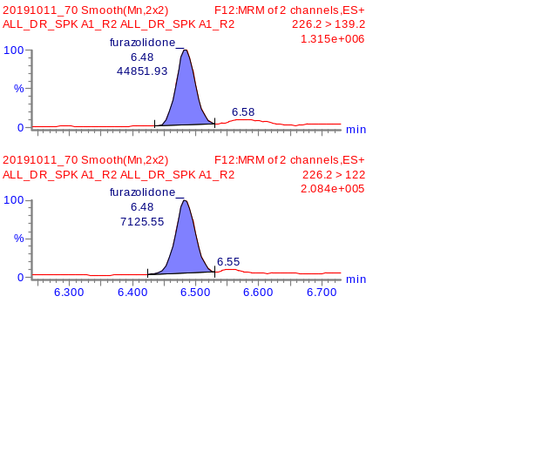
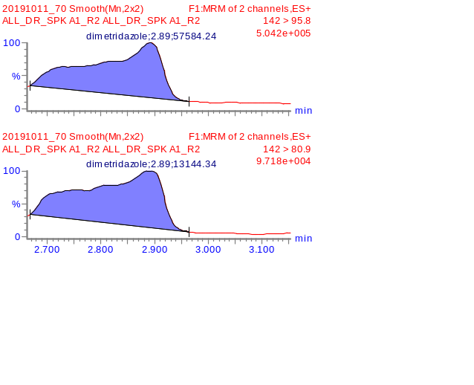
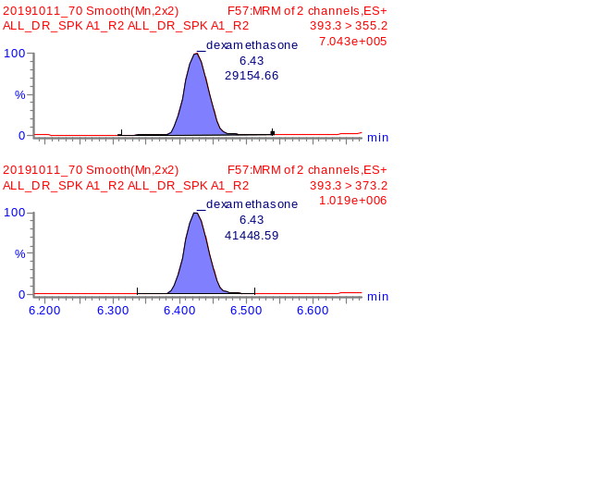
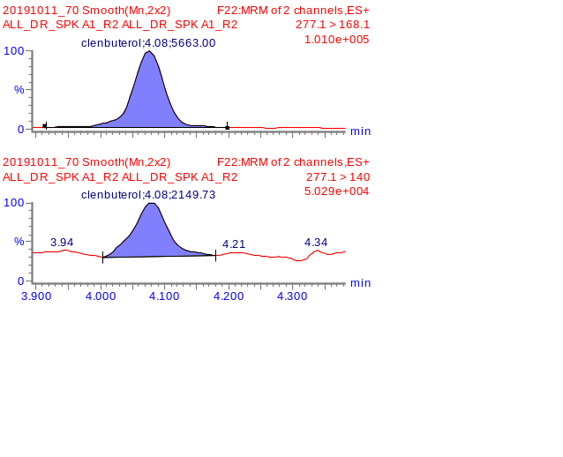
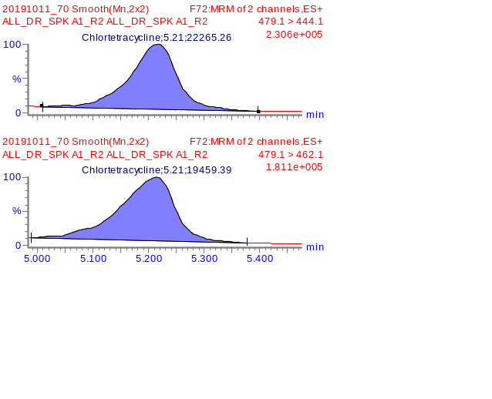
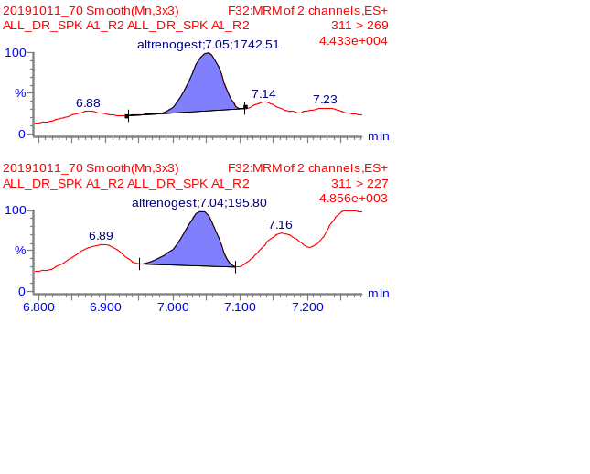
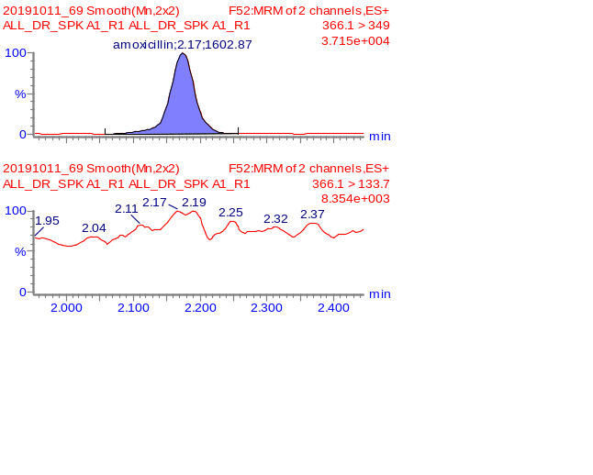
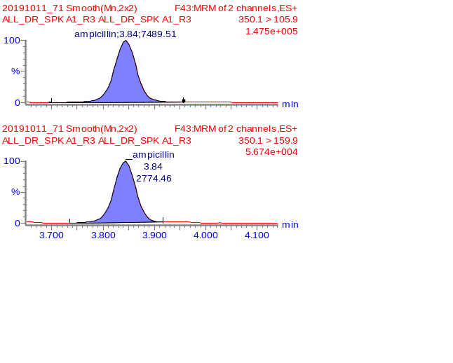
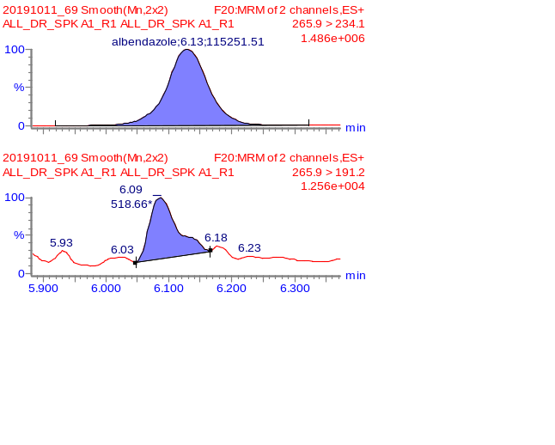
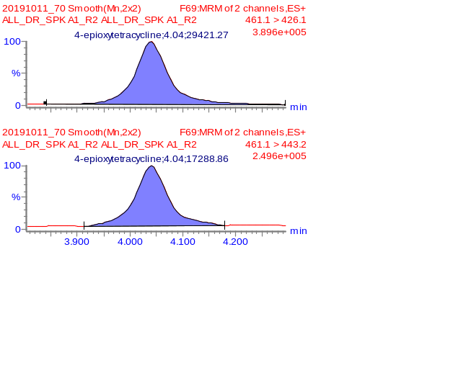
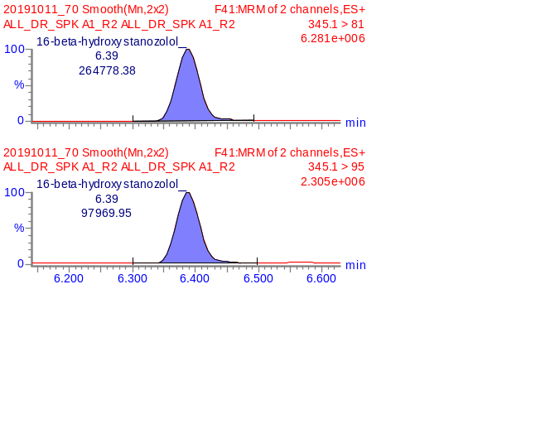

Figure 5(b) MRM chromatograms of detected compounds in DR-SPK A
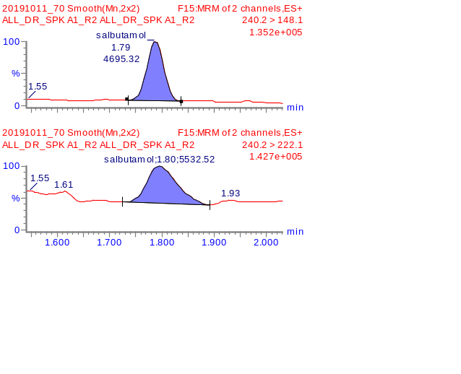
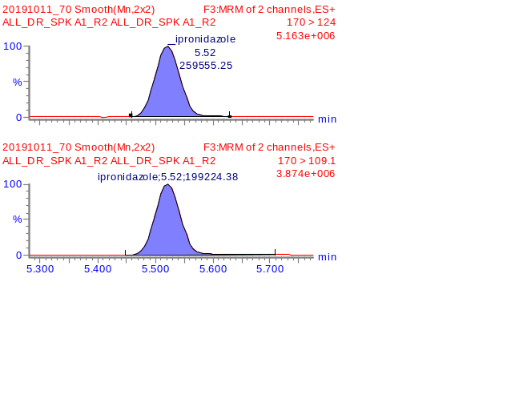
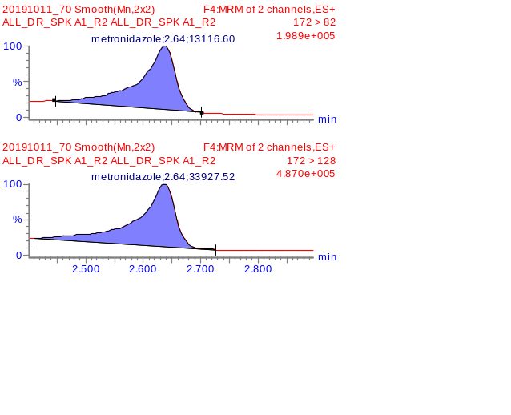
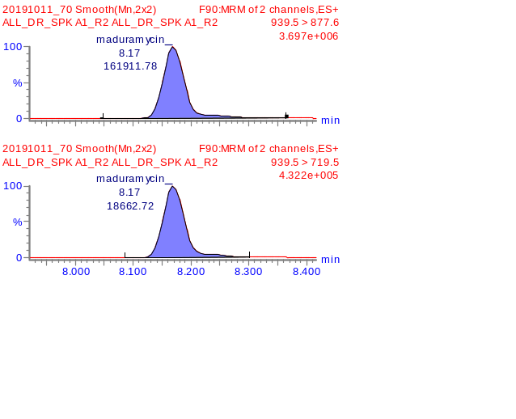
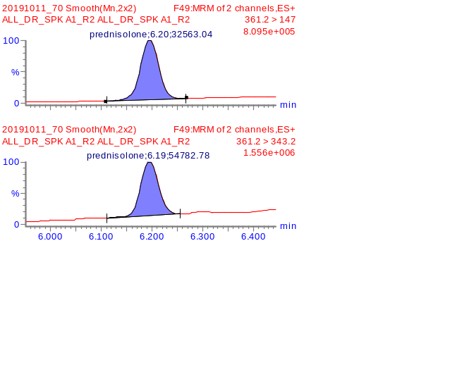
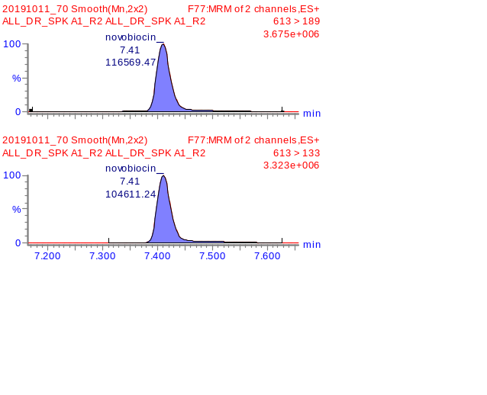
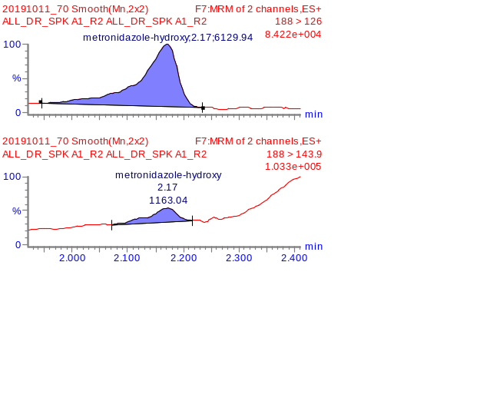
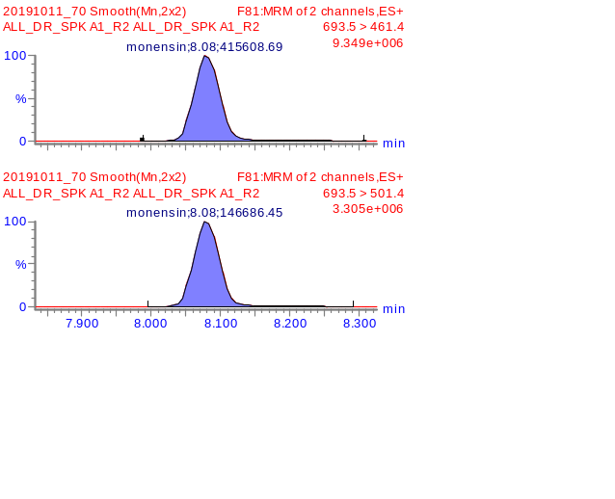
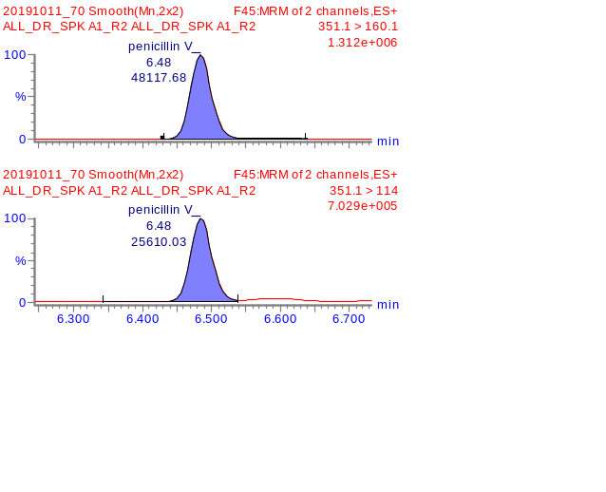
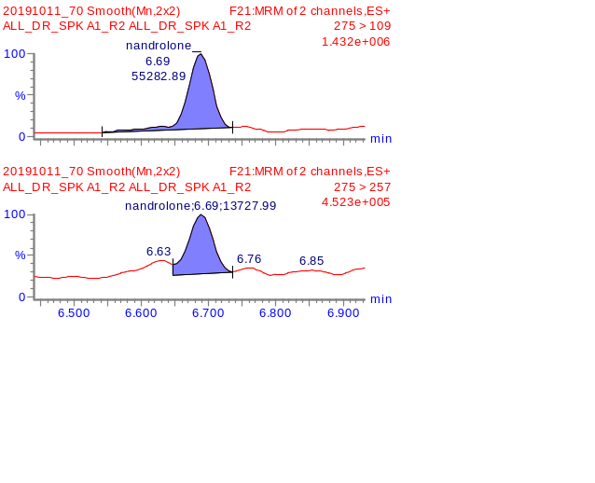
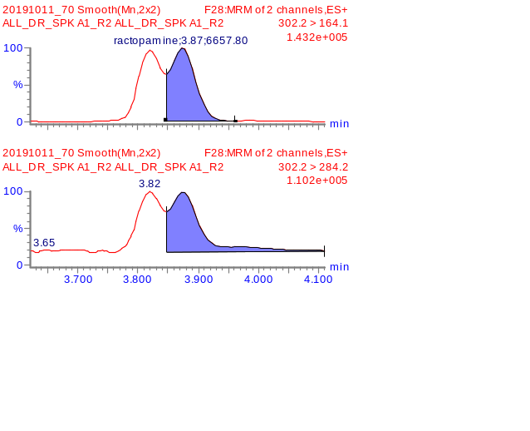
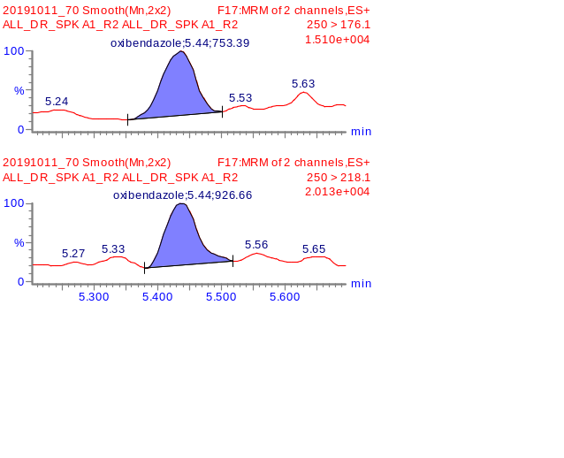

Figure 5(c) MRM chromatograms of detected compounds in DR-SPK A
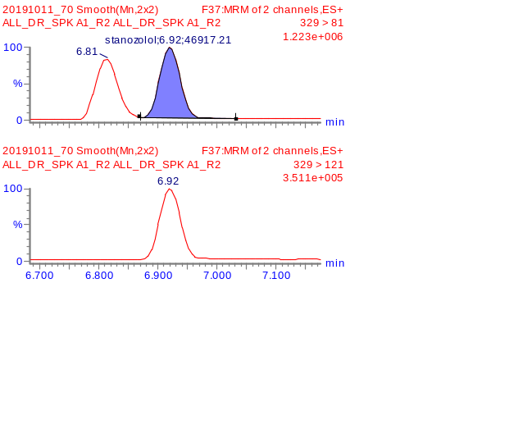
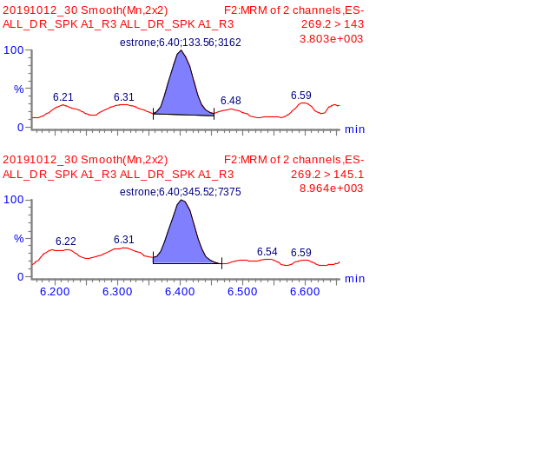
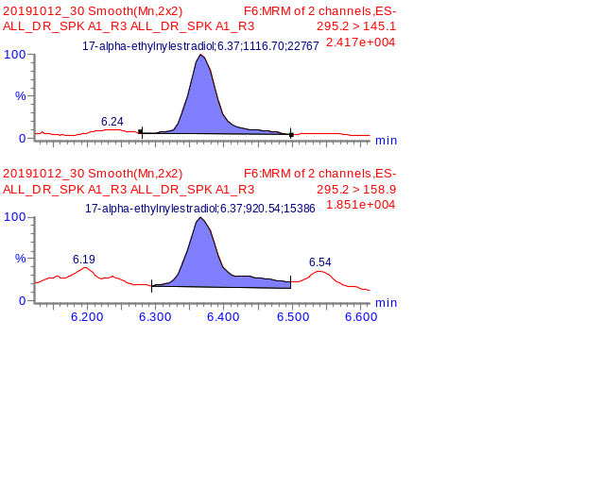

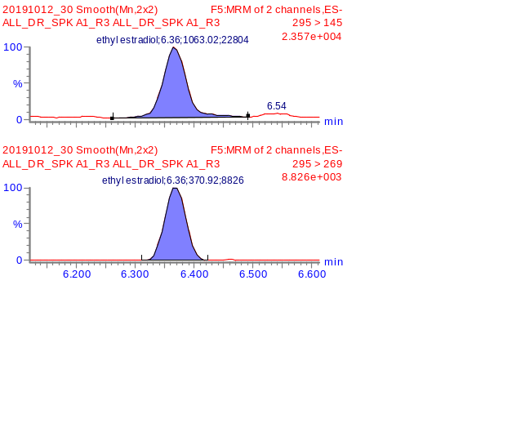
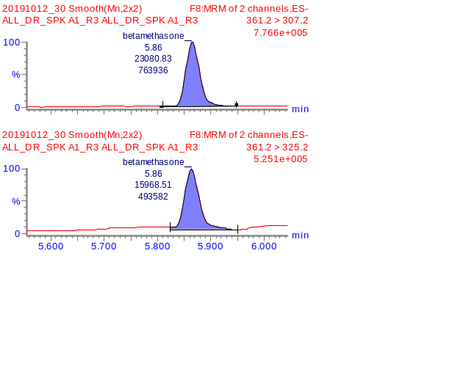
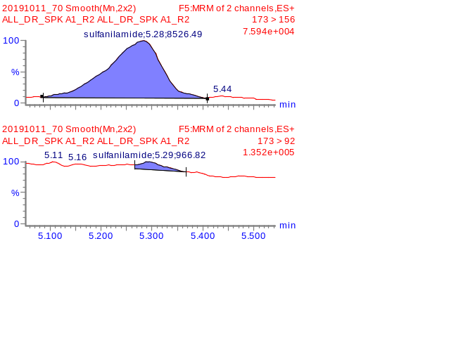

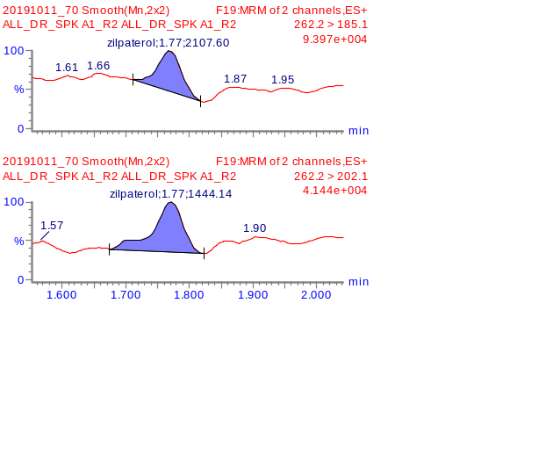
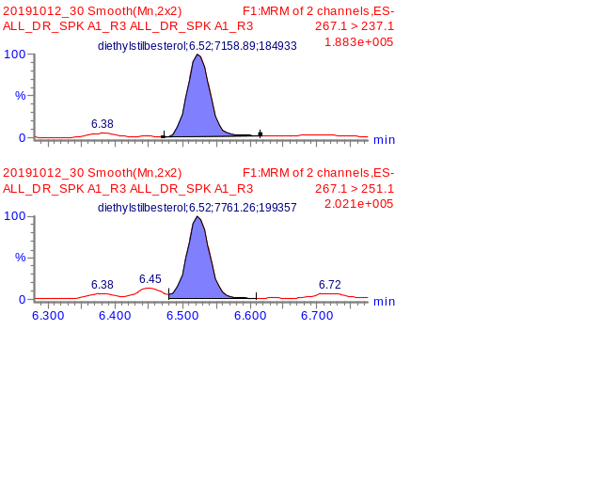

Figure 6(a) MRM chromatograms of detected compounds in DR-SPK B

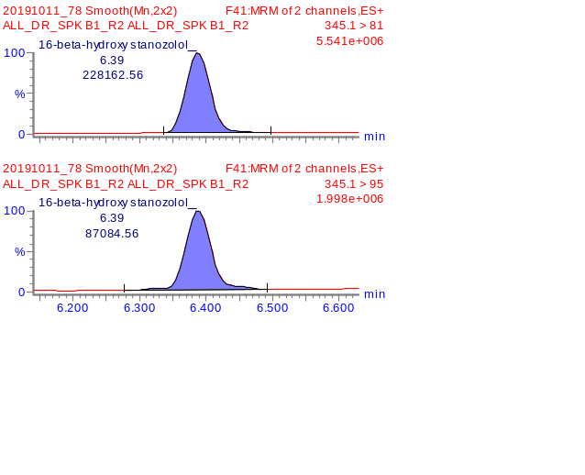
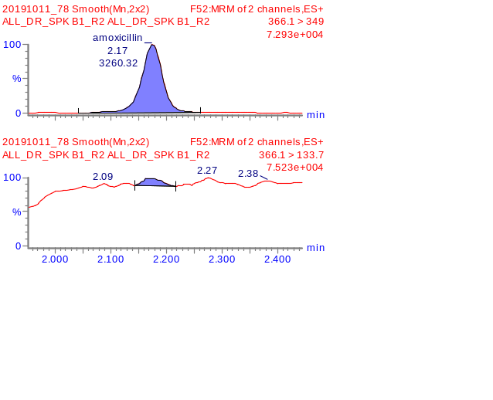
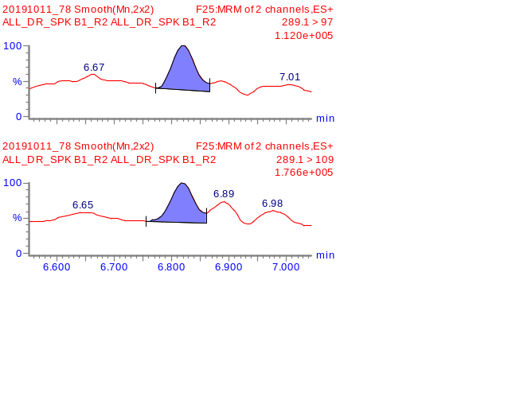
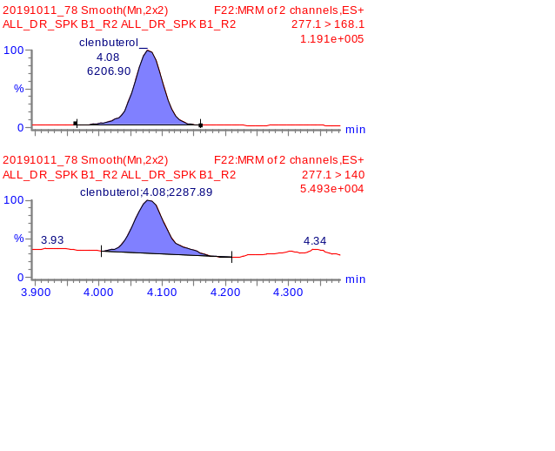

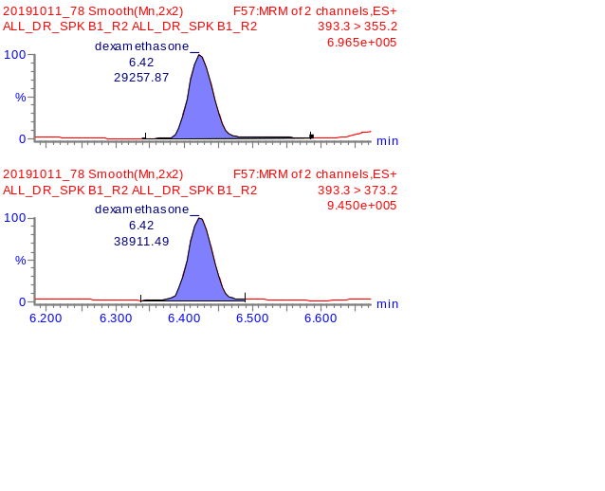
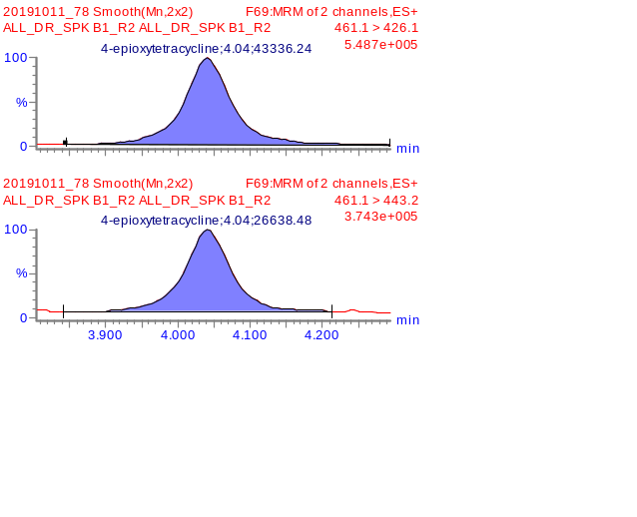
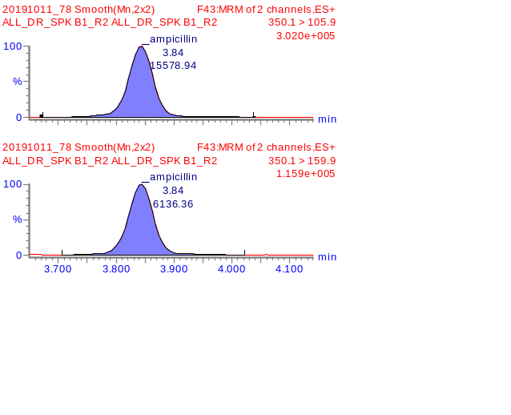
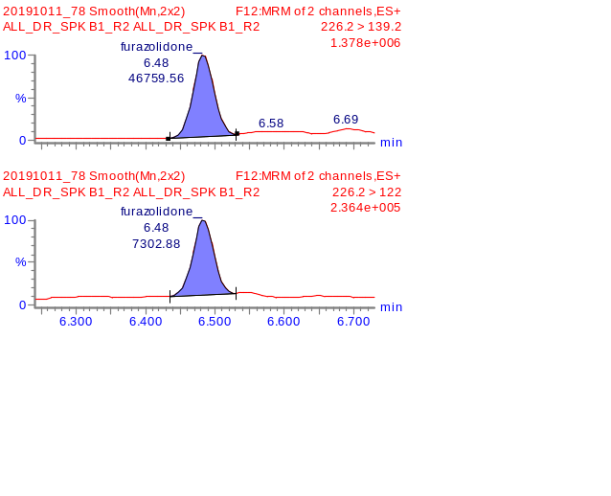

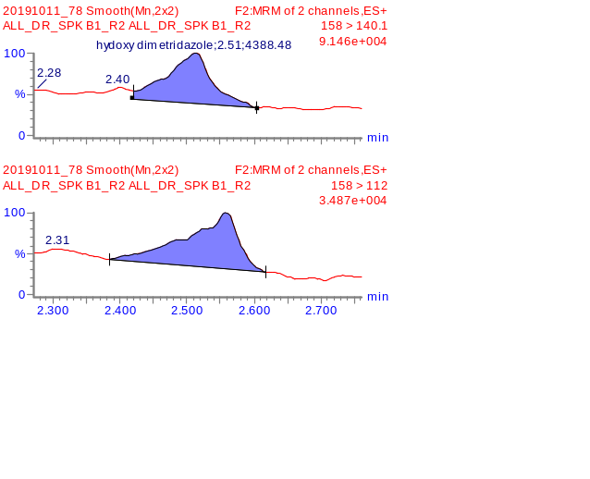
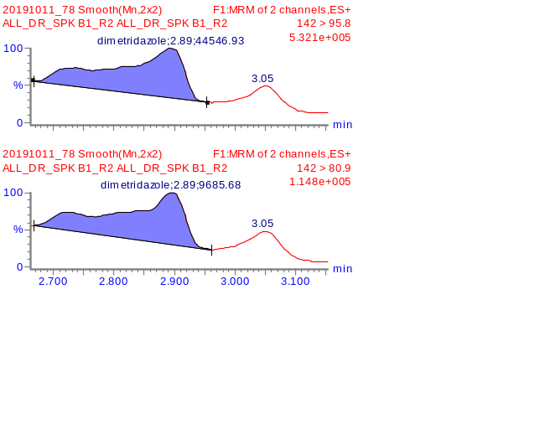
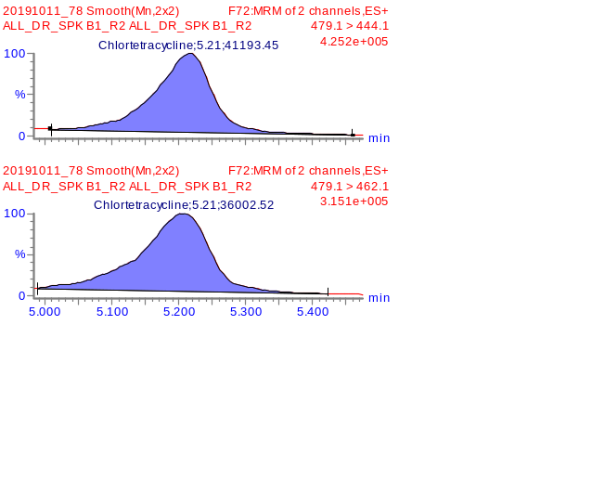

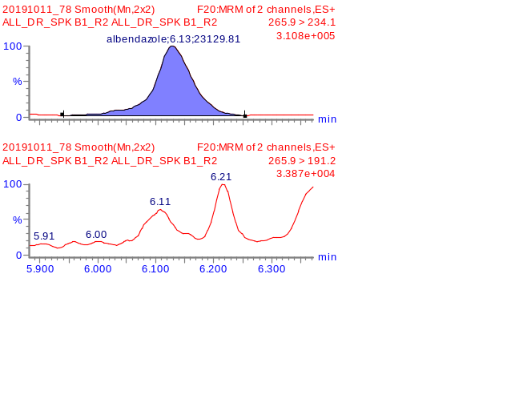

Figure 6(b) MRM chromatograms of detected compounds in DR-SPK B

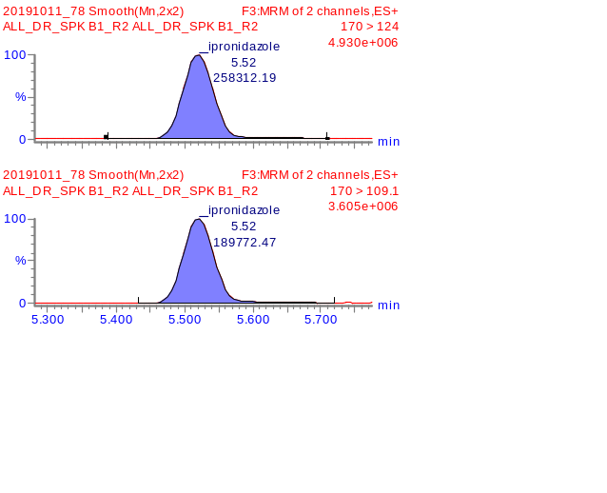
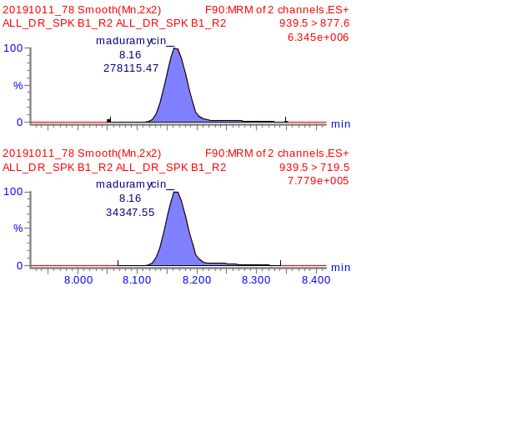
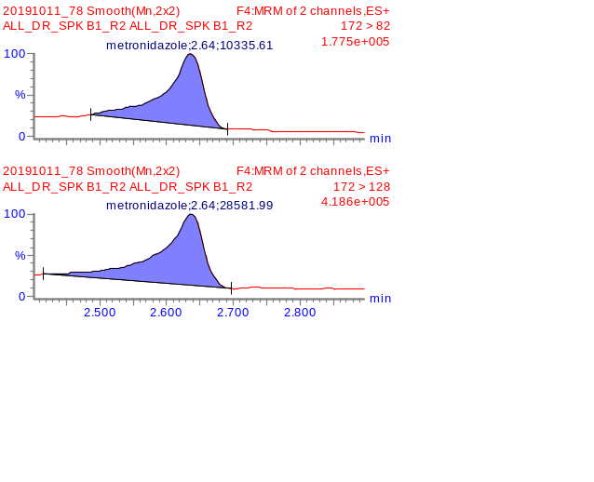
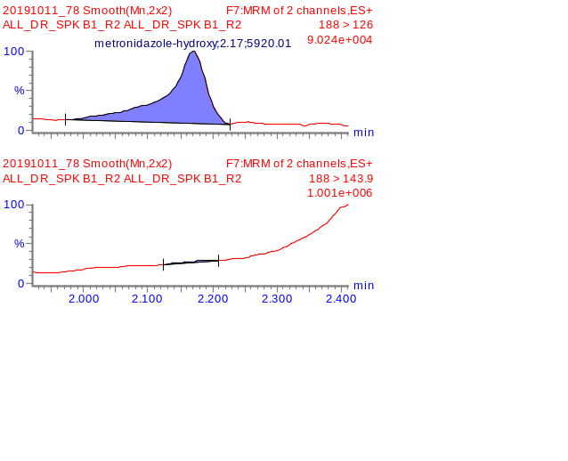
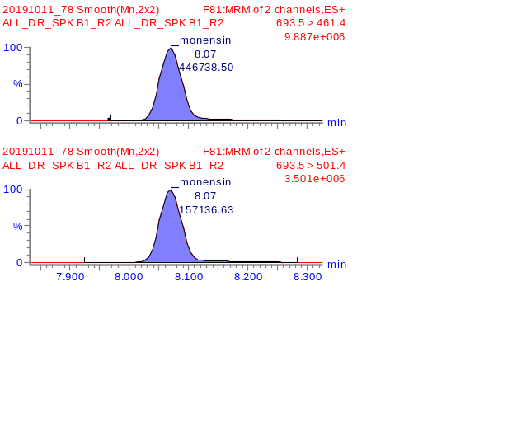
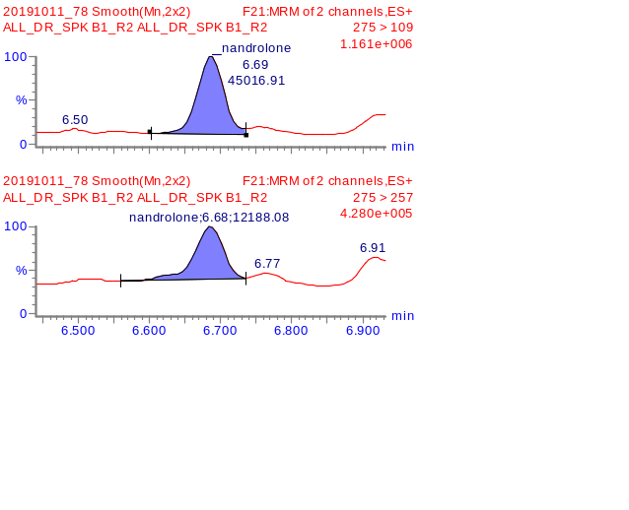
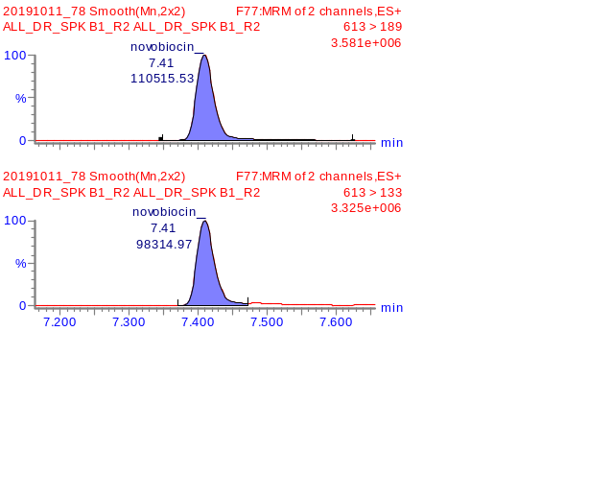
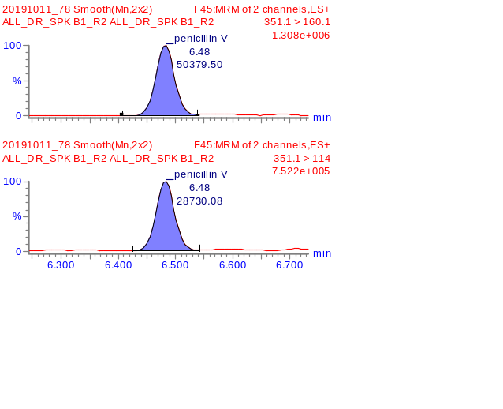
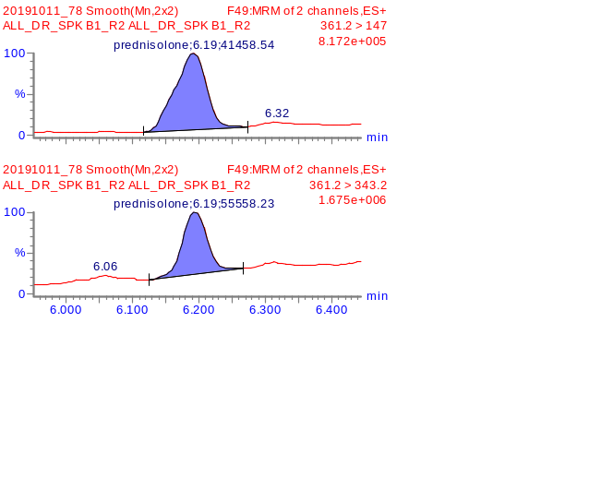
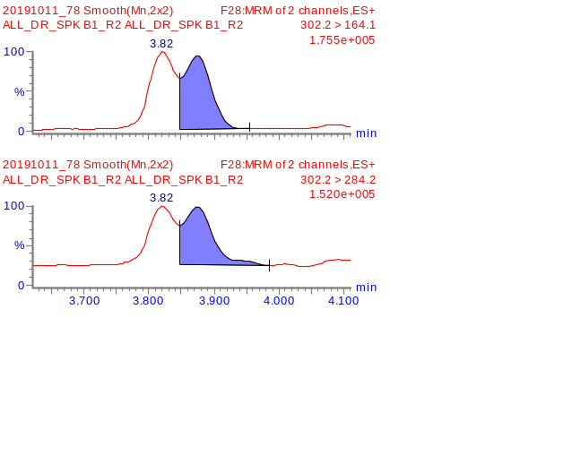
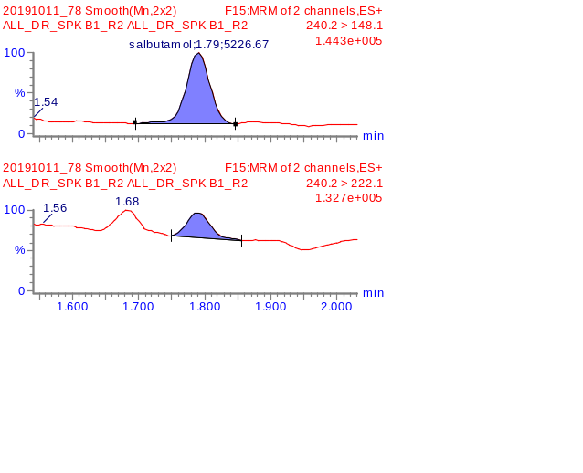
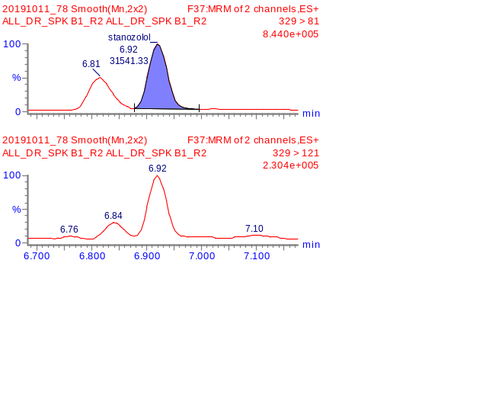

Figure 6(c) MRM chromatograms of detected compounds in DR-SPK B
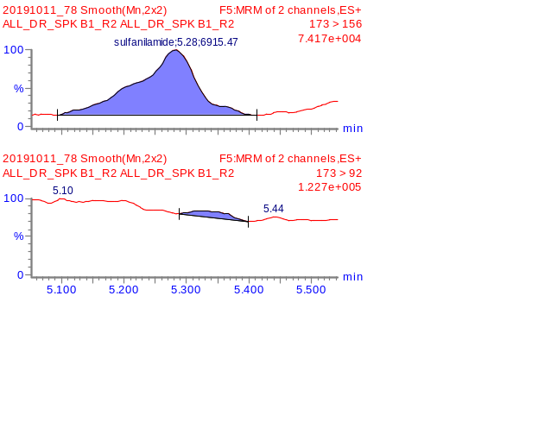
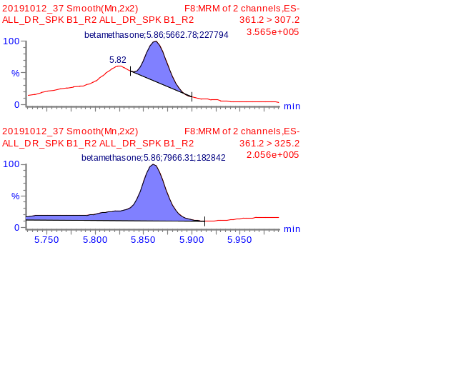
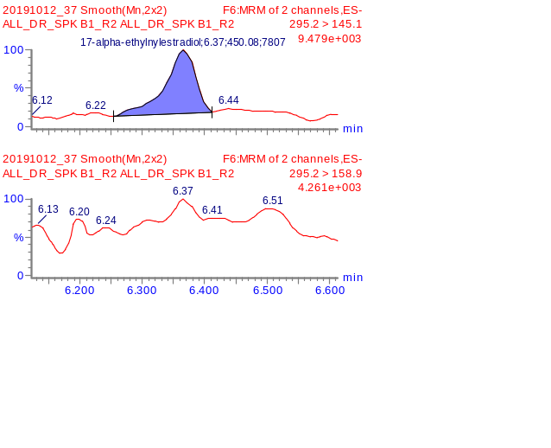
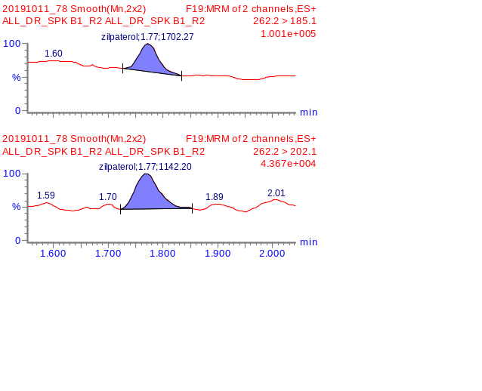
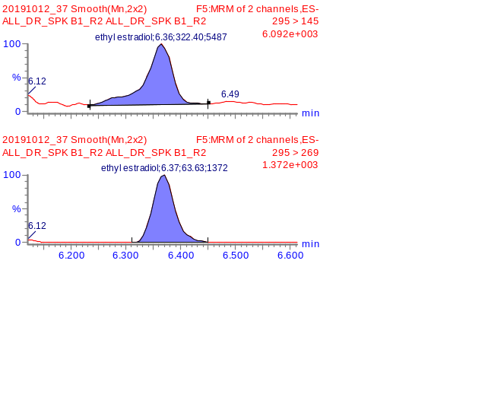
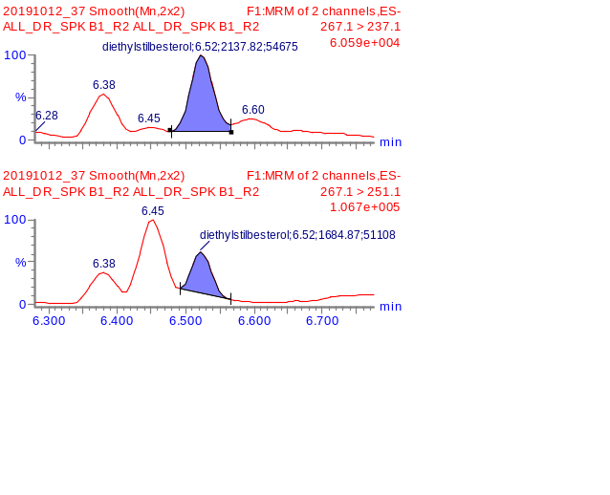

Conclusions
- Standard DR-STD was screened using an MRM method that was established using Quanpedia. Out of the 250 potential compounds, 84 compounds were identified

- Calibration curves were established for all the detected analytes to further screen and quantitate for samples DR-BLK A, DR-BLK B, DR-SPK A and DR-SPK B. All calibration curves achieve good linearity of >0.995.

- Triplicate analysis of the samples was performed. Total number of compounds identified in the samples are summarized as follow:

  - DR-SPK A: 32 drugs identified
  - DR-SPK B: 30 drugs identified
  - DR-BLK A: 5 drugs identified
  - DR-BLK B: 4 drugs identified

List of Figures
Page
Figure 1 MRM chromatograms of detected compounds in DR-STD at 10ppb 10 ~ 16
Figure 2 Calibration curve of 84 compounds found in DR-STD 21 ~ 27
Figure 3 MRM chromatograms of detected compounds in DR-BLK A 29
Figure 4 MRM chromatograms of detected compounds in DR-BLK B 29
Figure 5 MRM chromatograms of detected compounds in DR-SPK A 31 ~ 33
Figure 6 MRM chromatograms of detected compounds in DR-SPK B 34 ~ 36

List of Tables

Page
Table 1. List of drugs identified in DR-STD (0.1 ppm) 2
Table 2. List of drugs identified and the amount present in sample 3 (DR-SPK A, DR-SPK B, DR-BLK A and DR-BLK B)
Table 3. List of detected compounds in DR-STD using MRM method 6 ~ 9 with 2 MRM transitions
Table 4. Calibration range and linearity of detected compounds in DR-STD 17 ~ 20
Table 5. List of detected compounds in DR-BLK A and DR-BLK B 28
Table 6. List of detected compounds and its amount in DR-SPK A and DR-SPK B 30

