Part 4 Appendix C

Declaration of Compliance

TO: TAN TOCK SENG HOSPITAL (TTSH)

REQUEST FOR PROPOSAL NO: TTSH-FY19-NOV-01659

COMPLIANCE TO REQUEST FOR PROPOSAL

1 I,____Joanna Ang______________, having authority to sign for and on behalf of
__Waters Pacific Pte Ltd_____________________ hereby submit and offer to supply the goods and/or services tendered for herein subject to all parts of the Request for Proposal as follows:

Part 1 - Conditions of RFP
Part 2 - Standard Conditions of Contract
Part 3 – Technical and Functional Specifications

2 I further agree that in the event of being awarded the Request for Proposal or any
portion thereof, I shall supply the goods and/or services tendered upon and subject to the terms and conditions stated in all parts of the above Request for Proposal, except where the non-compliances stated have been accepted by the Company in writing.

Signature: | 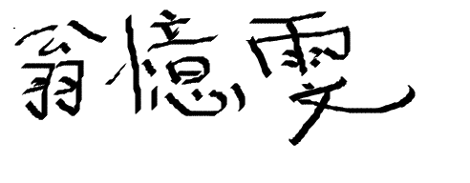
Designation of Office held: | Account Manager
Company: | Waters Pacific Pte Ltd
Date: | 19 December 2019
Stamp of Company: | 

Part 4 Appendix D2
Areas of Non-Compliance
(To complete where there is non-compliance)

The Participating Vendor shall comply with all the requirements stated in all parts of the RFP document except for those set out below, if any. A blank submission will be taken as “Nil”.

Parts | FULL COMPLIANCE  (YES/NO) | EXISTING CLAUSE AND PROVISION | pROPOSED PROVISION
 |  | (See Note A) | (See Note B)
Part 1 - Conditions of RFP | Yes / No
Part 2  Standard Conditions of Contract | Yes / No

Note A:
State the clause and reproduce the provision which you are unable to comply. Insert any proposed addition to the provision using a different color, and strike through those parts you propose to delete from the provision. DO NOT OVERWRITE THE EXISTING PROVISION WITH YOUR PROPOSED AMENDMENTS. You will be treated as being able to comply with any clauses not cited in the above table

Note B:
Provide the proposed provision and explanatory note for non-compliance. This is mandatory.

