Part 4 Appendix D

REQUEST FOR PROPOSAL NO: TTSH-FY19-NOV-01659

Contractor's Name and Postal Address


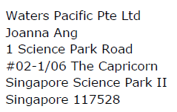

Signature : Joanna Ang Date : 19December 2019

Name : Joanna Ang

Designation : Account Manager

Mobile No : 96536605

Tel No : 65937104

Telefax No : -

E-mail address : Joanna_ang@waters.com

