SCAR Number  SGYYMMNN |  |  | SCAR-SG200701 |  | SCAR Assignee, Company (Supplier designated point of contact) |  |  |  | Amy Li Yan Yan, Micro Precision Calibration Pte Ltd
Section 1: Introduction (To be completed by Waters Supplier Quality / Quality Engineer)
Source (select all that apply):
 | CIT Number(s): |  |  |  |  |  | RMA Number(s):
 | Stop Ship Number(s): |  |  |  |  |  | Contract Manufacturer / Supplier declared:
 | NCR Number(s): |  |  |  |  |  | Other: Calibration cert no: 551220083592482 & 551220083320957
NC Statement, Requirement (Include, where applicable, part numbers, part descriptions, serial numbers, and date codes; requirement not met e.g. SOP number and revision) |  |  |  | Nonconformity Statement: There are multiple inaccuracies observed in the calibration records provided by Micro Precision Calibration.  Evidence 1: It was observed the calibration cert no. 551220083592482 dated 02 May 2020 contains multiples inaccuracies in the Notes section.  Evidence 2: It was observed on calibration cert no. 551220083320957 dated 11 Nov 2019 for equipment ID# WPPL0018 S/N# I22994G, the calibration date is 11 Nov 2019 and calibration due date is 11 Nov 2020. However, on the physical calibration sticker pasted on equipment by the service provider, the calibration date is 05 Nov 2019 and calibration due date is 05 Nov 2020.  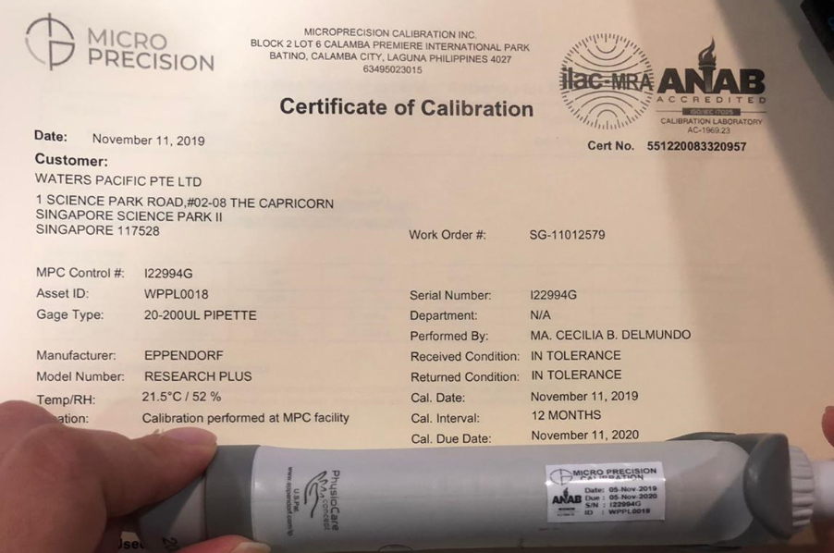
Initiated By (Waters Supplier Quality / Quality Engineer) |  |  |  | Name/ Title |  |  |  | Sign |  | Date
 |  |  |  | Lim Shaynee / Supplier Quality Engineer
Approval By (Waters Quality Manager/ Designee) |  |  |  | Tan Kah Chin / Senior Quality Assurance Manager
Issuance Date |  | Due Date for Sections 2 and 3 (Should be within 90 days from issuance.) |  | Remarks (if any): N/A
14.Jul.2020 |  | 12.Oct.2020

Section 2: Root Cause Analysis and Interim Containment Actions
Section 2A: Form a Team  List Team Members’ Names/ Function (minimum 2 personnel) | Amy Li-Sales Engineer  Leslie Rojas-Corporate QA
Section 2B: Implemented Interim Containment Actions (Temporary fixes to protect customer, including Correction Actions. Where applicable, Part Number(s), Part Description(s), Quantities, Action Owner should be included. If containment is documented via Waters NCR, Waters NCR number should be included). |  | Completion Date (DD.MM.YY)
Micro Precision had issue revised Calibration Certificate number 551220083694795, both softcopy and hard copy sent to CM_Flex.  Responsible: Li Yan Yan  The total of calibration certificate that MP-Singapore issued to Water SG are 177. When we review all the calibration certificate the we issued it is not affected by this issue. I will attach the list of equipment that MP-Singapore issued calibration certificate.  This is the evidence that the previous cert is already obsolete.  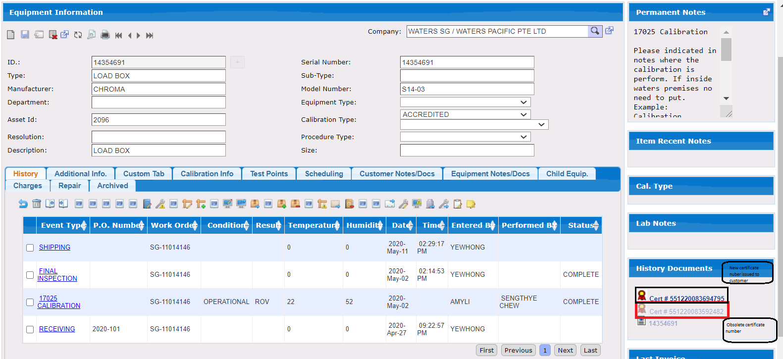  Completion Date: July 17, 2020 |  | 13.07.20
Micro Precision will issue correct calibration sticker for equipment ID# WPPL0018 S/N# I22994G with Cal Date 11-Nov-2019 and Due Date 11-Nov-2020  Responsible: Li Yan Yan  Conduct refresher training for all quality personnel regarding on the Quality Checking, Calibration Reports Processing and Final Inspection process of the calibrated equipment. Strictly implement initial checking  on all calibrated equipment to ensure if the equipment bears correct and updated calibration labels.  Responsible: Joel De Vera/ Laboratory Manager  Completion Date: July 15, 2020  Evidence  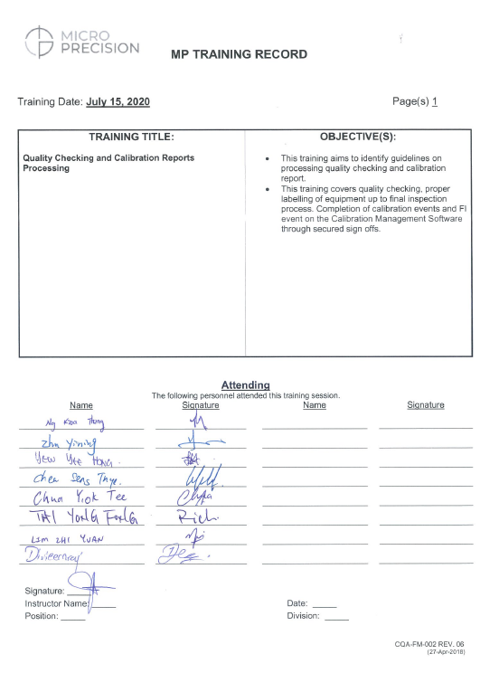 |  | 17.07.20

Section 2C: Root Cause Analysis (RCA) and Risk Assessment
(Objective evidence should be attached and referenced with running number e.g. Refer to Attachment 1).
Case 1:
The calibration technician unintentionally committed typographical error inputting the superseded certificate number same as the new one because he just copied the certificate number and paste it on the note. It is done by the same technician because the CSR personnel ask him to copy the superseded certificate number on the note part but he just copy the new certificate number instead of the old certificate number. And also for the Calibration Performed the technician input “at” but it should be “for” because it is calibrated in MPC Facility, See attachment 1:

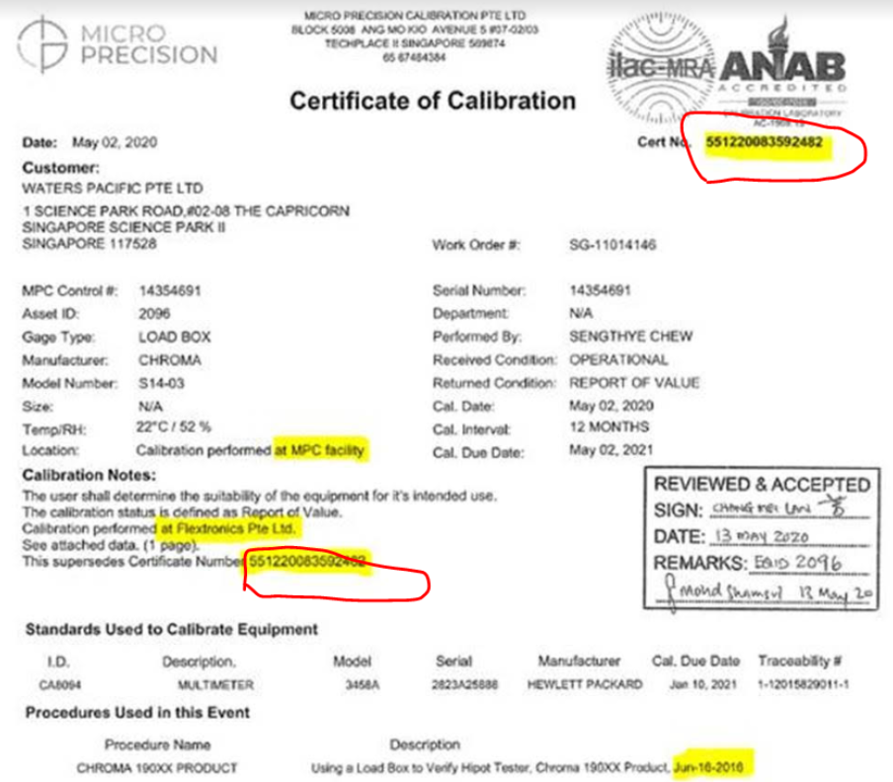

This is the evidence that the calibration is done in MPC facility.
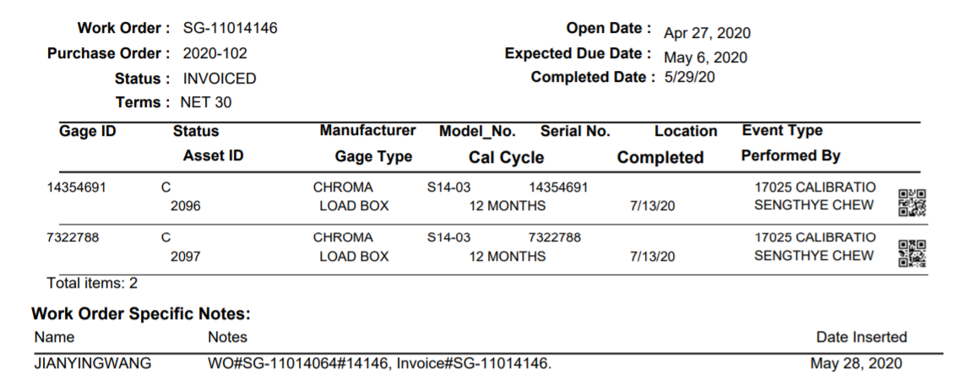

Case 2:
The calibration technician unintentionally committed typographical error inputting calibration date and due date for the unit with Equipment ID# WPPL0018 S/N I22994G. The one that they input on the physical sticker is 5 Nov 2019 to 5 Nov 2020 instead of 11 Nov 2019 to 11 Nov 2020. Likewise, this information has been overlooked by Final Inspection Personnel during the Final Inspection Process if the calibration dates and calibration due dates in certificate are matched with the calibration date and due date on the physical sticker.
See Attachment 1:

Section 2D: Plan of Permanent Corrective Action(s) (Each root cause n section 2 shall be addressed. Documentation shall be uploaded s appropriate. Where applicable , Part Number(s), Part Description(s), Quantities, Action Owner should be included). |  |  |  |  | Plan Date (DD.MM.YY)
Conduct refresher training for all technicians regarding on the Calibration Process Flow with focused on affixing correct and updated calibration sticker on the equipment prior endorsement to QC/FI process. Implement counter checking of the Team Leader on the calibration labeling of the equipment.  Responsible: Joel De Vera/ Laboratory Manager  Completion Date: July 15, 2020  Evidence:  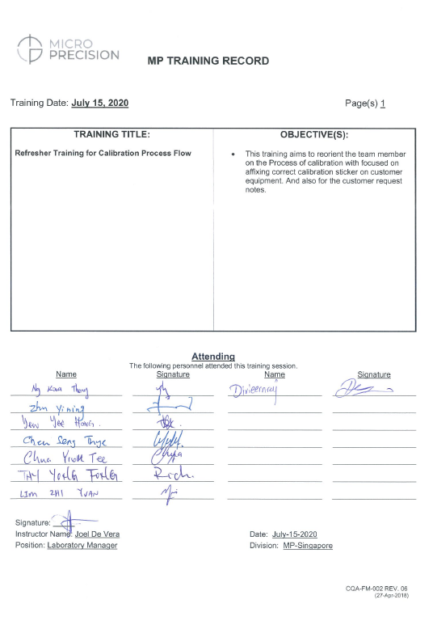  Conduct refresher training for all quality personnel regarding on the Quality Checking, Calibration Reports Processing and Final Inspection process of the calibrated equipment. Strictly implement initial checking on all calibrated equipment to ensure if the equipment bears correct and updated calibration labels.  Responsible: Joel De Vera/ Laboratory Manager  Completion Date: July 15, 2020  Evidence:  Waters has agree to split the account as per MP proposal below, The address will be the key indicator on the calibration certificate to differentiate sites of the the company, see attachment;  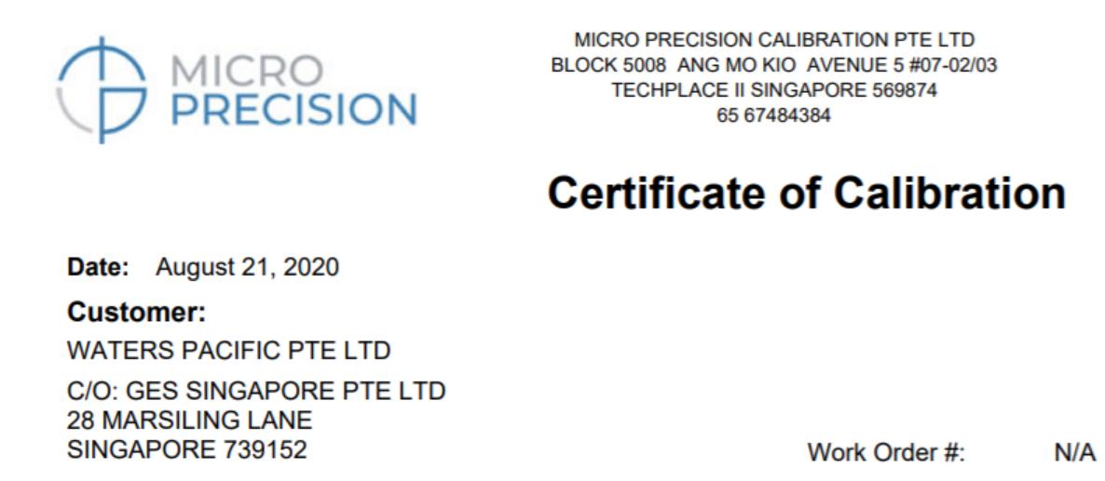  As a part of Final Inspection we put the serial number, cal date and the company name on the outside part of the packing of the unit. And also we hire a FI personnel that will check all the unit before it is shipped out to customer. Because before the Final Inspection is done by all the CSR so we hire one personnel that task to inspect all the equipment after QC completed the certificate.  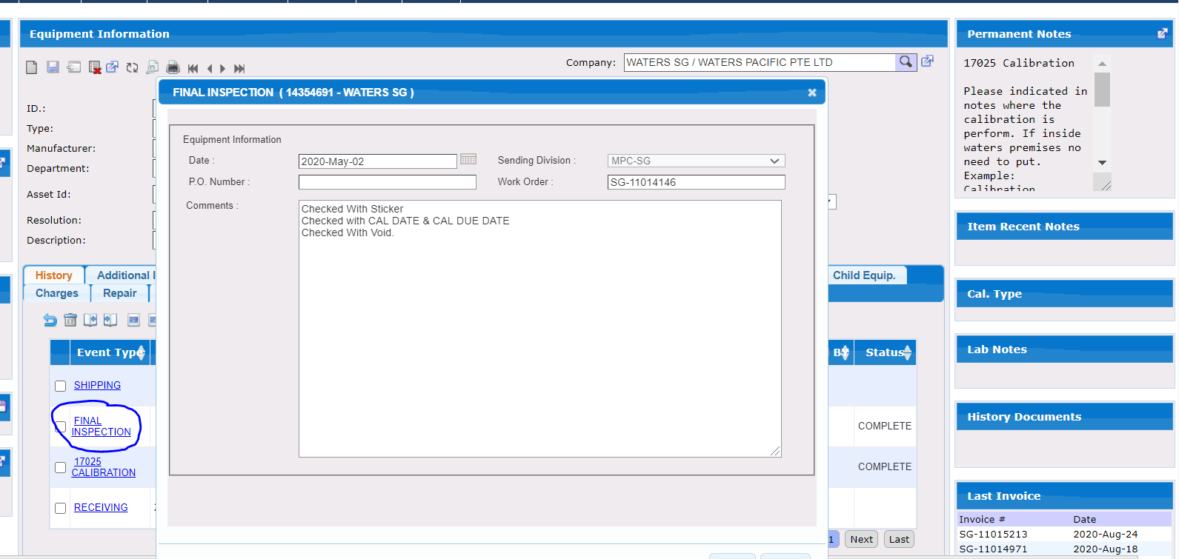 |  |  |  |  | 15.07.20
Section 2E: Plan Action(s) to Prevent Recurrence (Shall prevent problems on similar products, processes, locations or families. Documentation shall be updated as appropriate. Where applicable, Part Number(s), Part Description(s), Quantities, Action Owner should be included). |  |  |  |  | Plan Date (DD.MM.YY)
Root Cause Category |  | Select from Dropdown
Remarks (if any):
Submission By (by SCAR Assignee) |  | Req? | Name/ Title | Sign | Date
 |  | X
RCA Approval | Quality Manager/ Quality Supervisor (of SCAR Assignee) | X
RCA Approval | Waters Supplier Quality / Quality Engineer | X
RCA Approval | Other
Remarks (if any):

Section 3A: Implementation of Permanent Corrective Action(s) (Attach evidence) |  |  | Completion Date (DD.MM.YY)
Section 3B: Action(s) to Prevent Recurrence (Attach evidence) |  |  | Completion Date (DD.MM.YY)
Submission By (by SCAR Assignee) | Name/ Title | Sign | Date

Section 4: Verification and Validation (Shall confirm that actions do not adversely affect the finished device. Examples: Refer to: ECO Number, Validation Protocol Number, Risk Management File. Where not applicable, document rationale). |  |  |  |  |  |  | Completion Date (DD.MM.YY)
Verification of Effectiveness: (Evidence reviewed to confirm effectiveness of actions; such as number of records monitored). |  |  |  |  | Acceptance Criteria: (Results that needs to be observed for actions to be deemed effective). |  | Result  (Pass/ Fail)
 |  |  |  |  |  |  | Choose an item
Remarks (if any): Attached extension request WPPL-FM-25.

Submission By (by SCAR Assignee) |  |  | Req? | Name/ Title |  | Sign | Date
 |  |  | X
Approval |  | Quality Manager/ Quality Supervisor (of SCAR Assignee) | X
 |  | Management Rep/ QMS In-Charge (of SCAR Assignee) | X
CAPA Determination (by Waters SQE/ QE below. Ineffective SCAR with no CAPA issued should be justified) |  |  | No CAPA needed, SCAR Effective. No CAPA needed, justification in remarks.  CAPA number: CAPA- .
Approval | Waters Supplier Quality / Quality Engineer |  | Req? | Name/ Title |  | Sign | Date
Approval |  |  | X
Approval | Other |  | Req? | Name/ Title |  | Sign | Date
Final Approval | Waters Quality Manager / Designee) |  | X
Remarks (if any): Isolated occurrence of effectiveness fail. SCAR shall be revised and submitted before due date.

