Audit Nonconformity (ANC) Number XNC-SGYYMMNN |  | SNC-SG200701 |  | Assignee, Company (Supplier designated point of contact or WPPL Auditee) |  |  |  | Amy Li, Micro Precision Calibration Pte Ltd
Section 1: Introduction (To be completed by Waters Supplier Quality / Quality Engineer)
Category |  | CNC MNC NC |  |  | Failure Type | Production & Process Controls
Statement |  | Inconsistency of calibration procedure used for C011477
Requirement Standard, regulation or document that is not met |  | ISO 17025: 2017 Cl 7.2.1.3 The laboratory shall ensure that it uses the latest valid version of a method unless it is not appropriate or possible to do so. When necessary, the application of the method shall be supplemented with additional details to ensure consistent application.
Objective Evidence |  | Tektronic Equipment ID C011477 was calibrated using 2 different set of standards in 2 cycle. Technician SengThye Chew used standard CT2147 in Year 2020 calibration that was not called out in Procedure Tektronix TDS3000C. The calibration cert id affected are 551220082926506 and 551200831518677.
Initiated By (Waters Supplier Quality / Quality Engineer) |  |  | Name/ Title |  |  |  | Sign |  | Date
 |  |  | Lim Shaynee / Supplier Quality Engineer |  |  |  |  |  | 03.Aug.2020
Issuance Date | Due Date for Sections 2 and 3 (Should be within 90 days from issuance.) |  | Due Date for Section 2 (Should be within 21 days from issuance for internal NC and MNC; 3 days for Internal CNC.) |  |  |  | Remarks (if any): N/A
03.Aug.2020 | 01.Nov.2020 |  | N/A, Supplier Audit Nonconformity

Section 2: Root Cause Analysis and Interim Containment Actions
Section 2A: Form a Team  List Team Members’ Names/ Function (minimum 2 personnel) | Rheabelle Acuin - Regional Quality Manager-Asia/ Corporate Quality Administrator  Joel de Vera - Laboratory Manager  Jun Calimag - Corporate Technical and Quality Development Senior Officer
Section 2B: Implemented Interim Containment Actions (Temporary fixes to protect customer, including Correction Actions. Where applicable, Part Number(s), Part Description(s), Quantities, Action Owner should be included. If containment is documented via Waters NCR, Waters NCR number should be included). |  | Completion Date (DD.MM.YY)
Re-issue revised Calibration Certificate to reflect the correct standard equipment used during calibration based on the calibration procedure. Cert No. 551220083733159  Completed by: Jun Calimag/ Corporate Technical and Quality Development Senior Officer  Completed By: Jun Calimag |  | 27.Jul.2020

Section 2C: Root Cause Analysis (RCA) and Risk Assessment
(Objective evidence should be attached and referenced with running number e.g. Refer to Attachment 1).
The calibration technician inadvertently added the standard (CT2147) for the calibration of Tektronix TDS 3054C Digital Oscilloscope that is not declared in the procedure used Tektronix TDS3000C. Likewise, this standard declared was overlooked by the QC personnel during the Quality checking process such as checking the procedure use, the declared standard and comparing the calibration certificate from the previous certificate. Refer to Attachment 1
RCA Category |  | Corrective & Preventive Actions |  |  | Sub-Category |  | Man
RCA Category 2 (if any) |  | Select from Dropdown |  |  | Sub-Category 2 (if any) |  | Select from Dropdown
Section 2d: Plan of Permanent Corrective Action(s) (Each root cause in section 2 shall be addressed. Documentation shall be updated as appropriate. Where applicable, Part Number(s), Part Description(s), Quantities, Action Owner should be included). |  |  |  |  |  |  |  | Plan Date (DD.MM.YY)
Conducted a refresher training for all technician about the process of declaring the standard to be used in CMS database during calibration and the QC personnel about the QC process to be particular in the recommended standard declared in the procedure used.  Completed By: Joel De Vera/Laboratory Manager Rheabelle Acuin/ Regional Quality Manager |  |  |  |  |  |  |  | 27-28.July. 2020
Section 2E: Plan Action(s) to Prevent Recurrence (Shall prevent problems on similar products, processes, locations or families. Documentation shall be updated as appropriate. Where applicable, Part Number(s), Part Description(s), Quantities, Action Owner should be included). |  |  |  |  |  |  |  | Plan Date (DD.MM.YY)
Not Applicable |  |  |  |  |  |  |  | Not Applicable
Submission By (by Audit Nonconformity Assignee) |  |  | Req? | Name/ Title |  | Sign |  | Date
 |  |  | X | Joel de Vera - Laboratory Manager |  | 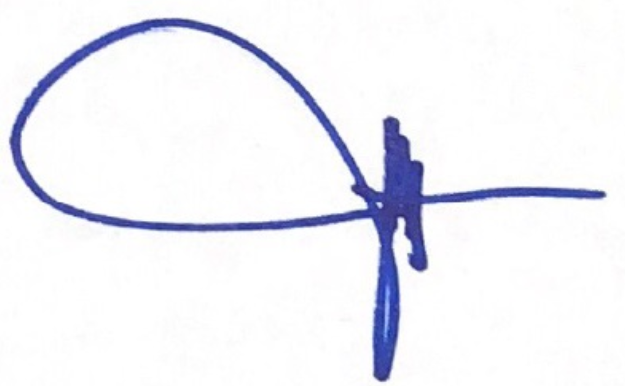 |  | 04.Aug.2020
RCA Approval | Quality Manager/ Quality Supervisor (of Assignee) |  | X | Rheabelle Acuin - Regional Quality Manager-Asia/ Corporate Quality Administrator |  |  |  | 04.Aug.2020
RCA Approval | Waters Supplier Quality / Quality Engineer |  | X
RCA Approval | Other
Remarks (if any):

Section 3A: Implementation of Permanent Corrective Action(s) (Attach evidence) |  |  | Completion Date (DD.MM.YY)
Refer to the attached Training Records (Attachment 2) |  |  | 27-28.July.2020
Section 3B: Action(s) to Prevent Recurrence (Attach evidence) |  |  | Completion Date (DD.MM.YY)
Not Applicable
Submission By (by Assignee) | Name/ Title | Sign | Date
Submission By (by Assignee) | Joel de Vera - Laboratory Manager |  | 04.Aug.2020

Section 4: Verification and Validation (Shall confirm that actions do not adversely affect the finished device. Examples: Refer to: ECO Number, Validation Protocol Number, Risk Management File. Where not applicable, document rationale). |  |  |  |  |  |  | Completion Date (DD.MM.YY)
Verification of Effectiveness: (Evidence reviewed to confirm effectiveness of actions; such as number of records monitored). |  |  |  |  | Acceptance Criteria: (Results that needs to be observed for actions to be deemed effective). |  | Result  (Pass/ Fail)
 |  |  |  |  |  |  | Choose an item
Remarks (if any): Attached extension request WPPL-FM-25.

Submission By (by Assignee) |  |  | Req? | Name/ Title |  | Sign | Date
 |  |  | X
Approval |  | Quality Manager/ Quality Supervisor (of Assignee) | X
 |  | Management Rep/ QMS In-Charge (of Assignee) | X
CAPA Determination (by Waters SQE/ QE below. Ineffective actions with no CAPA issued should be justified) |  |  | No CAPA needed, Actions Effective. No CAPA needed, justification in remarks.  CAPA number: CAPA- .
Approval | Waters Supplier Quality / Quality Engineer |  | Req? | Name/ Title |  | Sign | Date
Approval |  |  | X
Approval | Other
Final Approval | Waters Quality Manager / Designee) |  | X
Remarks (if any): Isolated occurrence of effectiveness fail. ANC shall be revised and submitted before due date.

