Audit Nonconformity (ANC) Number XNC-SGYYMMNN |  | SNC-SG200702 |  | Assignee, Company (Supplier designated point of contact or WPPL Auditee) |  |  |  | Amy Li, Micro Precision Calibration Pte Ltd
Section 1: Introduction (To be completed by Waters Supplier Quality / Quality Engineer)
Category |  | CNC MNC NC |  |  | Failure Type | Production & Process Controls
Statement |  | The organization unable to provide training evidence at the point of audit.
Requirement Standard, regulation or document that is not met |  | ISO 17025: 2017 Cl 6.2.5 The laboratory shall have procedure(s) and retain records for: c) training of personnel
Objective Evidence |  | There is no evidence that the technician (SengThye Chew) has been trained for the procedures being referenced in the calibration cert # 551220083694795 (Chroma 190XX Product) and 551220083350911 (Quadtech 6000 Plus Rev. A6)
Initiated By (Waters Supplier Quality / Quality Engineer) |  |  | Name/ Title |  |  |  | Sign |  | Date
 |  |  | Lim Shaynee / Supplier Quality Engineer |  |  |  |  |  | 03.Aug.2020
Issuance Date | Due Date for Sections 2 and 3 (Should be within 90 days from issuance.) |  | Due Date for Section 2 (Should be within 21 days from issuance for internal NC and MNC; 3 days for Internal CNC.) |  |  |  | Remarks (if any): N/A
03.Aug.2020 | 01.Nov.2020 |  | N/A, Supplier Audit Nonconformity

Section 2: Root Cause Analysis and Interim Containment Actions
Section 2A: Form a Team  List Team Members’ Names/ Function (minimum 2 personnel) | Rheabelle Acuin - Regional Quality Manager-Asia/ Corporate Quality Administrator  Joel de Vera - Laboratory Manager
Section 2B: Implemented Interim Containment Actions (Temporary fixes to protect customer, including Correction Actions. Where applicable, Part Number(s), Part Description(s), Quantities, Action Owner should be included. If containment is documented via Waters NCR, Waters NCR number should be included). |  | Completion Date (DD.MM.YY)
Not Applicable |  | Not Applicable

Section 2C: Root Cause Analysis (RCA) and Risk Assessment
(Objective evidence should be attached and referenced with running number e.g. Refer to Attachment 1).
As per requirements of the ISO 17025 Standard Clause 6.2.5.c, MP Laboratory has an existing procedure and is retaining
records for personnel. Technicians are assessed annually using the Technician Qualification Certificate (TQC) to record and
document their calibration capability; factors to considered for the TQC are educational background, experience in calibration,
and trainings on calibration processes. The training provided to them is on general basis, since the training requirements that was
aimed to complete are based on the scope of calibration capability of the lab and not per equipment or per procedure basis.
RCA Category |  | Records/ Documents/ Change Controls |  |  | Sub-Category |  | Methods (E.g. ASP, TSP)
RCA Category 2 (if any) |  | Select from Dropdown |  |  | Sub-Category 2 (if any) |  | Select from Dropdown
Section 2d: Plan of Permanent Corrective Action(s) (Each root cause in section 2 shall be addressed. Documentation shall be updated as appropriate. Where applicable, Part Number(s), Part Description(s), Quantities, Action Owner should be included). |  |  |  |  |  |  |  | Plan Date (DD.MM.YY)
No corrective action needed as MP Laboratory is compliant with the requirement for having procedure for training and training records are made available. It is not defined on the standard nor in the MP quality system requirements that capabilities of each technician acquired in training shall be based on specific model and or manufacturing procedure. |  |  |  |  |  |  |  | Not Applicable
Section 2E: Plan Action(s) to Prevent Recurrence (Shall prevent problems on similar products, processes, locations or families. Documentation shall be updated as appropriate. Where applicable, Part Number(s), Part Description(s), Quantities, Action Owner should be included). |  |  |  |  |  |  |  | Plan Date (DD.MM.YY)
Not Applicable |  |  |  |  |  |  |  | Not Applicable
Submission By (by Audit Nonconformity Assignee) |  |  | Req? | Name/ Title |  | Sign |  | Date
 |  |  | X | Joel de Vera - Laboratory Manager |  | 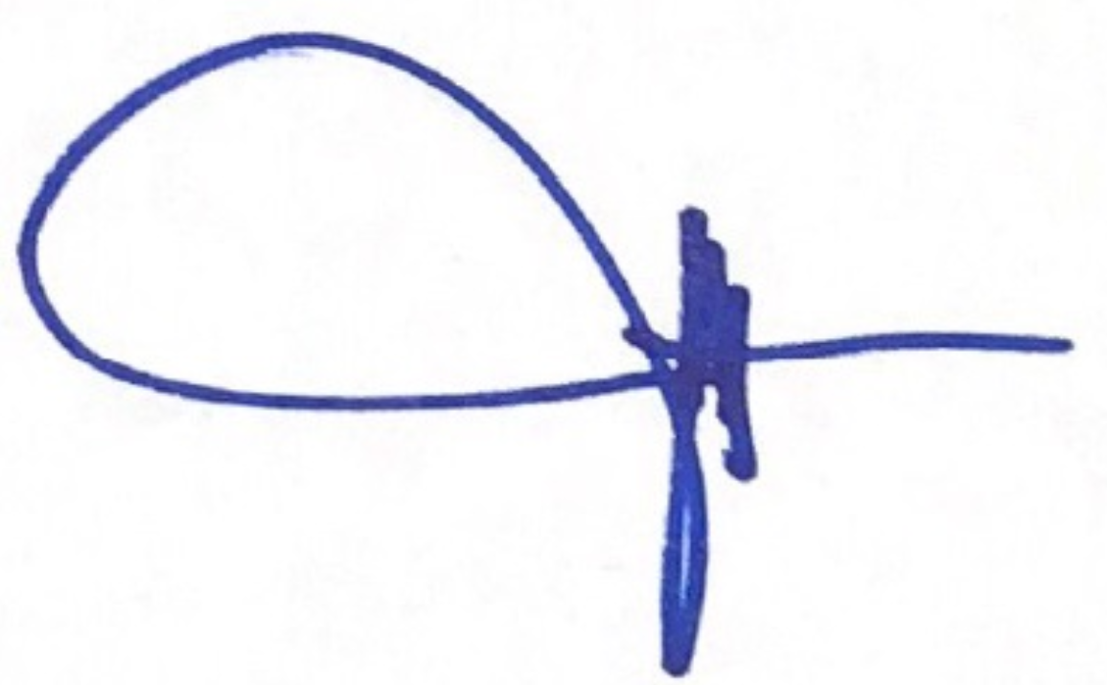 |  | 04.Aug.2020
RCA Approval | Quality Manager/ Quality Supervisor (of Assignee) |  | X | Rheabelle Acuin - Regional Quality Manager-Asia/ Corporate Quality Administrator |  |  |  | 04.Aug.2020
RCA Approval | Waters Supplier Quality / Quality Engineer |  | X
RCA Approval | Other
Remarks (if any):

Section 3A: Implementation of Permanent Corrective Action(s) (Attach evidence) |  |  | Completion Date (DD.MM.YY)
Not Applicable |  |  | Not Applicable
Section 3B: Action(s) to Prevent Recurrence (Attach evidence) |  |  | Completion Date (DD.MM.YY)
Not Applicable |  |  | Not Applicable
Submission By (by Assignee) | Name/ Title | Sign | Date
Submission By (by Assignee) | Rheabelle Acuin - Regional Quality Manager-Asia/ Corporate Quality Administrator |  | 04.Aug.2020

Section 4: Verification and Validation (Shall confirm that actions do not adversely affect the finished device. Examples: Refer to: ECO Number, Validation Protocol Number, Risk Management File. Where not applicable, document rationale). |  |  |  |  |  |  | Completion Date (DD.MM.YY)
Verification of Effectiveness: (Evidence reviewed to confirm effectiveness of actions; such as number of records monitored). |  |  |  |  | Acceptance Criteria: (Results that needs to be observed for actions to be deemed effective). |  | Result  (Pass/ Fail)
 |  |  |  |  |  |  | Choose an item
Remarks (if any): Attached extension request WPPL-FM-25.

Submission By (by Assignee) |  |  | Req? | Name/ Title |  | Sign | Date
 |  |  | X
Approval |  | Quality Manager/ Quality Supervisor (of Assignee) | X
 |  | Management Rep/ QMS In-Charge (of Assignee) | X
CAPA Determination (by Waters SQE/ QE below. Ineffective actions with no CAPA issued should be justified) |  |  | No CAPA needed, Actions Effective. No CAPA needed, justification in remarks.  CAPA number: CAPA- .
Approval | Waters Supplier Quality / Quality Engineer |  | Req? | Name/ Title |  | Sign | Date
Approval |  |  | X
Approval | Other
Final Approval | Waters Quality Manager / Designee) |  | X
Remarks (if any): Isolated occurrence of effectiveness fail. ANC shall be revised and submitted before due date.

