Audit Nonconformity (ANC) Number XNC-SGYYMMNN |  | SNC-SG200703 |  | Assignee, Company (Supplier designated point of contact or WPPL Auditee) |  |  |  | Amy Li, Micro Precision Calibration Pte Ltd
Section 1: Introduction (To be completed by Waters Supplier Quality / Quality Engineer)
Category |  | CNC MNC NC |  |  | Failure Type | Records/ Documents/ Change Controls
Statement |  | The organization unable to provide inspection record at the point of audit.
Requirement Standard, regulation or document that is not met |  | ISO 17025: 2017 Cl 8.4.1 The laboratory shall establish and retain legible records to demonstrate fulfilment of the requirements in this document.
Objective Evidence |  | There is no evidence of inspection/quality records performed by Jun Calimag per the requirements of Appendix 16 - Control of Records Table 3 – Quality Records & Retention Periods Page 7 of 9 of MP Calibration System Description Rev02 03-05-20.
Initiated By (Waters Supplier Quality / Quality Engineer) |  |  | Name/ Title |  |  |  | Sign |  | Date
 |  |  | Lim Shaynee / Supplier Quality Engineer |  |  |  |  |  | 03.Aug.2020
Issuance Date | Due Date for Sections 2 and 3 (Should be within 90 days from issuance.) |  | Due Date for Section 2 (Should be within 21 days from issuance for internal NC and MNC; 3 days for Internal CNC.) |  |  |  | Remarks (if any): N/A
03.Aug.2020 | 01.Nov.2020 |  | N/A, Supplier Audit Nonconformity

Section 2: Root Cause Analysis and Interim Containment Actions
Section 2A: Form a Team  List Team Members’ Names/ Function (minimum 2 personnel) | Rheabelle Acuin - Regional Quality Manager-Asia/ Corporate Quality Administrator  Joel de Vera - Laboratory Manager
Section 2B: Implemented Interim Containment Actions (Temporary fixes to protect customer, including Correction Actions. Where applicable, Part Number(s), Part Description(s), Quantities, Action Owner should be included. If containment is documented via Waters NCR, Waters NCR number should be included). |  | Completion Date (DD.MM.YY)
Not Applicable |  | Not Applicable

Section 2C: Root Cause Analysis (RCA) and Risk Assessment
(Objective evidence should be attached and referenced with running number e.g. Refer to Attachment 1).
During the audit of customer, it was observed that there is no evidence of inspection/quality records performed by Mr. Jun Calimag. The QC personnel that is completing the certificate is in the not in MP-Singapore because it is done remotely so that he will not see the actual unit. The basis for completing the certificate is the one that is on the procedure and the one that is input in our system. And the CSR personnel is the one that will do the Final Inspection on the unit before it is shipped to customers.
RCA Category |  | Records/ Documents/ Change Controls |  |  | Sub-Category |  | Man
RCA Category 2 (if any) |  | Select from Dropdown |  |  | Sub-Category 2 (if any) |  | Select from Dropdown
Section 2d: Plan of Permanent Corrective Action(s) (Each root cause in section 2 shall be addressed. Documentation shall be updated as appropriate. Where applicable, Part Number(s), Part Description(s), Quantities, Action Owner should be included). |  |  |  |  |  |  |  | Plan Date (DD.MM.YY)
CA1: Conducted refresher training for all quality and FI personnel regarding on the Quality Checking, Calibration Reports Processing and Final Inspection process of the calibrated equipment. Strictly implement initial checking on all calibrated equipment to ensure if the equipment bears correct calibration certificate.  Conducted by: Rheabelle M. Acuin/ Regional Quality Manager-Asia/ Corporate Quality Administrator  CA2: Update the Final Qualification Certificate for all the personnel that conduct final inspection on the unit of customer that based on our MPC-CSD.  Completed by: Rheabelle M. Acuin/ Regional Quality Manager-Asia/ Corporate Quality Administrator |  |  |  |  |  |  |  | 27.Jul.2020  03.Aug.2020
Section 2E: Plan Action(s) to Prevent Recurrence (Shall prevent problems on similar products, processes, locations or families. Documentation shall be updated as appropriate. Where applicable, Part Number(s), Part Description(s), Quantities, Action Owner should be included). |  |  |  |  |  |  |  | Plan Date (DD.MM.YY)
Not Applicable |  |  |  |  |  |  |  | Not Applicable
Submission By (by Audit Nonconformity Assignee) |  |  | Req? | Name/ Title |  | Sign |  | Date
 |  |  | X | Joel de Vera - Laboratory Manager |  | 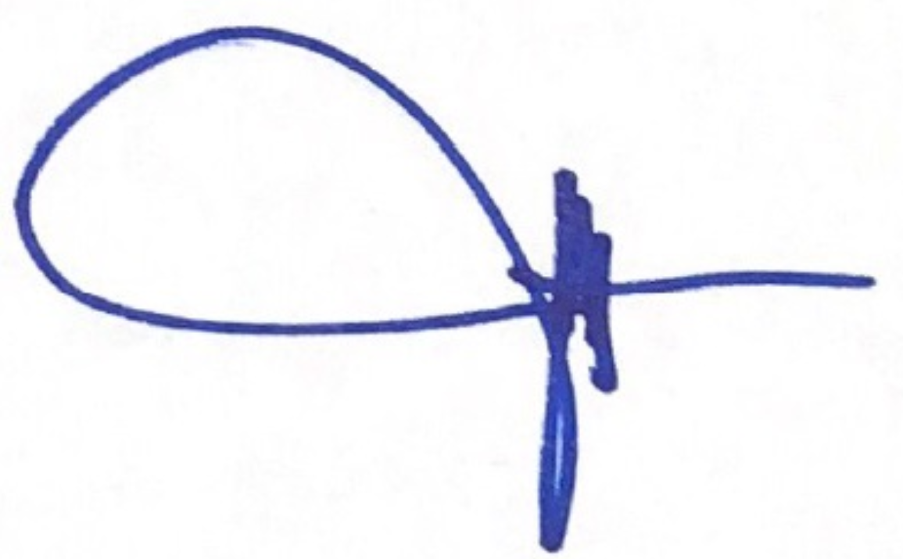 |  | 04.Aug.2020
RCA Approval | Quality Manager/ Quality Supervisor (of Assignee) |  | X | Rheabelle Acuin - Regional Quality Manager-Asia/ Corporate Quality Administrator |  |  |  | 04.Aug.2020
RCA Approval | Waters Supplier Quality / Quality Engineer |  | X
RCA Approval | Other
Remarks (if any):

Section 3A: Implementation of Permanent Corrective Action(s) (Attach evidence) |  |  | Completion Date (DD.MM.YY)
Refer to the attached Training Record (Attachment 1) and the MPC Initial/Final Inspector Qualification and Certificate (Attachment 2) |  |  | 27.July.2020  03.Aug.2020
Section 3B: Action(s) to Prevent Recurrence (Attach evidence) |  |  | Completion Date (DD.MM.YY)
Not Applicable |  |  | Not Applicable
Submission By (by Assignee) | Name/ Title | Sign | Date
Submission By (by Assignee) | Joel de Vera - Laboratory Manager |  | 04.Aug.2020

Section 4: Verification and Validation (Shall confirm that actions do not adversely affect the finished device. Examples: Refer to: ECO Number, Validation Protocol Number, Risk Management File. Where not applicable, document rationale). |  |  |  |  |  |  | Completion Date (DD.MM.YY)
Verification of Effectiveness: (Evidence reviewed to confirm effectiveness of actions; such as number of records monitored). |  |  |  |  | Acceptance Criteria: (Results that needs to be observed for actions to be deemed effective). |  | Result  (Pass/ Fail)
 |  |  |  |  |  |  | Choose an item
Remarks (if any): Attached extension request WPPL-FM-25.

Submission By (by Assignee) |  |  | Req? | Name/ Title |  | Sign | Date
 |  |  | X
Approval |  | Quality Manager/ Quality Supervisor (of Assignee) | X
 |  | Management Rep/ QMS In-Charge (of Assignee) | X
CAPA Determination (by Waters SQE/ QE below. Ineffective actions with no CAPA issued should be justified) |  |  | No CAPA needed, Actions Effective. No CAPA needed, justification in remarks.  CAPA number: CAPA- .
Approval | Waters Supplier Quality / Quality Engineer |  | Req? | Name/ Title |  | Sign | Date
Approval |  |  | X
Approval | Other
Final Approval | Waters Quality Manager / Designee) |  | X
Remarks (if any): Isolated occurrence of effectiveness fail. ANC shall be revised and submitted before due date.

