Content Table

1 PURPOSE 2
2 SCOPE 2
3 DEFINITIONS AND ABBREVIATIONS 2
4 ROLES AND RESPONSIBILITIES 3
5 REFERENCES / RELATED DOCUMENTS 3
6 FORMS 4
6.1 Records 4
7 HEALTH & SAFETY 4
7.1 Equipment/Materials of Use Required 5
8 INSTRUCTION 6
8.1 Adding Equipment to the Calibration/PM Tracker 6
8.2 Notification of Calibration Due 6
8.3 External Calibration/PM 7
8.4 Internal Calibration 7
8.5 Missing Equipment 8
9 APPENDICES / ATTACHMENTS 8

PURPOSE
The purpose of this work instruction is to outline the calibration and preventive maintenance (PM) program for assembly, measurement and test equipment located in WPPL site.
This work instruction is governed by the Control & Monitoring of Inspection Measuring & Testing Equipment (IMTE) Operating Procedure WPPL-SP-15.

SCOPE
The scope of this work instruction includes all tests and measuring equipment used at WPPL site for any Waters equipment requiring calibration. This work instruction was implemented on 22 December 2017, any equipment added to masterlist prior to 22 December 2017 may not have a Calibration/PM Change Request (WPPL-FM-87).

DEFINITIONS AND ABBREVIATIONS

Term / Abbreviation | Definition
Calibration | A process to ensure that equipment is capable of producing accurate results. This includes verifying measurements and/or making adjustment(s) to ensure measurement accuracy.
Reference Standard | An object with known and documented characteristics or values used in the calibration of Assembly, Measurement and Test Equipment. Reference standards shall be traceable to national or international standards, e.g., National Institute of Standards and Technology (NIST), where possible. Otherwise, independent, reproducible standards shall be used.
PM | Preventive Maintenance: The servicing, for the purpose of maintaining equipment in satisfactory working order, by performing systematic inspection, detection, and correction of potential failures. PM activities may include tests, measurements and parts replacement.
Assembly Equipment | Equipment used to aid the assembly of manufactured product. This may include jigs, fixtures, alignment stations, hand or power tools.
Measurement Equipment | Commercially-manufactured equipment used to take measurements (e.g. Digital Multi-Meter, Oscilloscope, Coordinate-Measuring Machine).
Test Equipment | Waters-manufactured equipment used to verify that manufactured product meets applicable specifications.
Calibration / PM Tracker | Database used to manage the Calibration / PM program, including maintaining records.
Due Date | Date that equipment is due for calibration or PM (must be performed by end-of-month)
Interval | The amount of time, in months, between calibration or PM cycles. Equipment shall be on a 12-month interval unless otherwise justified in the Calibration / PM database. Interval may be adjusted, if necessary.
“Calibration Not Required” Label | A label placed on measuring equipment that does not require calibration or PM. Justification shall be captured in the Calibration/PM database.
“Out of Service /  Do Not Use” Label | A label placed on equipment that is currently out of service, but not obsolete e.g., items that require service, calibration, PM, setup or qualification.
Out-of-Scope Equipment | Devices which do not yield critical measurements or provide precise conditions/parameters do not require calibration or PM. Note that “Calibration Not Required” labels shall not be applied to these assembly aids. This type of equipment may include, but is not limited to: 1-2-3 blocks, V-blocks, angle plates, sine plates, parallels, holding fixtures (which do not wear/degrade), heat guns, soldering irons, air guns, ultrasonic cleaners, signature pads, bar code scanners, light sources, microscopes, printers/labelers, presses, non-critical power fastener drivers & dispensers, feeler gauges, rulers, tape measures, yardsticks and beakers.
Remove Item | To take away and store an item not currently required to support production.
Obsolete Item | To remove and permanently discard an item no longer required to support production.

ROLES AND RESPONSIBILITIES

Roles | Responsibilities
User Manager | User Manager to review/approve request to remove and/or obsolete test equipment, notifying Waters Finance when equipment has been removed and discarded  Review and approve Out of Calibration Notice (WPPL-FM-89).
Calibration Coordinator/ Designee | Oversee Calibration/PM activity and maintain the Calibration/PM tracker.  Communicate upcoming calibration schedule due equipment to Operator/ User per Calibration/ PM tracker.  Calibration/PM records shall be maintained.  Issue Out of Calibration Notice (WPPL-FM-89).
Quality Management | Review and approve Out of Calibration Notice (WPPL-FM-89).
Operator/User(s) | Operators using equipment shall verify that it has been calibrated or maintained. Otherwise; stop using the equipment and notify management/supervisor.  Complete the Calibration/PM Change Request (WPPL-FM-87) and provide it to the Calibration Coordinator.  Execute Calibration or PM per individual equipment procedure.  Ensure that documentation is properly completed; provide documentation to Calibration Coordinator.  Calibration or PM activities may be performed by Calibration Coordinators, technicians, engineers or ISO/IEC 17025 accredited vendors or Original Equipment Manufacturer.
Calibration Coordinator, Supervisor, and/or Engineering | Determine (individually and/or collaboratively) equipment calibration and/or PM requirements. These may be documented in the individual equipment procedure.

REFERENCES / RELATED DOCUMENTS

Doc No: | Document Title
WPPL-SP-15 | Control & Monitoring of IMTE
WPPL-SP-02 | Control of Documented Information
WPPL-SP-04 | Control of Nonconforming Product

FORMS

Doc No: | Document Title
WPPL-FM-87 | Calibration/ PM Change Request
WPPL-FM-88 | Calibration/ PM Record
WPPL-FM-89 | Out of Calibration Notice

Records
Records described below shall be retained in accordance with WPPL-SP-02, Control of Documented Information Procedure.

Ref No: | Records Description
NA | Calibration Reports

HEALTH & SAFETY
Should anyone following this instruction identify a health and safety hazard which has not been highlighted in this section and/or within the body of the text, they should notify their Manager/ Supervisor immediately.

Equipment/Materials of Use Required
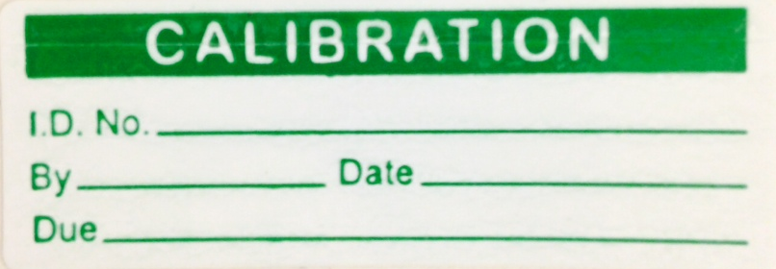  Calibration Label (or equivalent) | 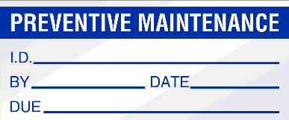  PM Label (or equivalent)
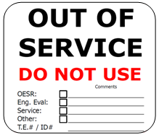  Out of Service / Do Not Use Label (or equivalent) | 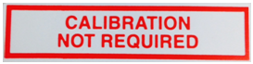  Calibration Not Required Label (or equivalent)  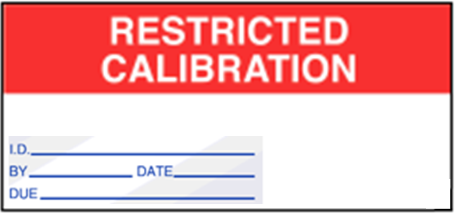  Restricted Calibration Label (or equivalent)

INSTRUCTION
Instruction

Adding Equipment to the Calibration/PM Tracker
Roles | Tasks/Instructions
Operator/ User(s) | On receipt of new equipment complete Calibration/PM Change Request (WPPL-FM-87).  Submit calibration PM/Change Request to Calibration Coordinator.  Review calibration/PM interval by considering the intended use of the equipment and taking into account supplier recommendations. Discuss with user and/or management if further information is required.
Calibration Coordinator /Designee | Review Calibration/PM Change Request for completeness.  When satisfied that all the required information has been provided Assign Equipment ID Number.  If the new equipment is to be a calibrated item, review any supplied ‘as new’ calibration certificates. If the supplied certificates are found to be acceptable update the tracker with calibration information and copy of certificate. If the ‘as new’ calibration certificate is not acceptable, or no such paperwork has been supplied arrange appropriate calibration before use. See section 8.3 External calibration or 8.4 internal calibration.  Write the ID number on a label pre-printed with the wording ‘Waters ID Number’ using indelible ink/printed label and affix to the new equipment.  Update Calibration/PM tracker with Equipment make, model, serial number, ID number, location and details of calibration/PM procedure and interval.  If calibration is not required apply the ‘Calibration Not Required’ label. See section 7.1.

Notification of calibration due
Roles | Tasks/Instructions
Calibration Coordinator/ Designee | Review Calibration/PM tracker identifying equipment due for calibration by monthly  Notify all operator/Users of calibrations due within the next month.
Operator/User | Receive notification from the Calibration coordinator/Designee of equipment due for calibration.  Locate the equipment due for calibration and affix an “Out of Service/Do Not Use” label.  If equipment cannot be located before the calibration due date the equipment will be classed as missing. Continue to section 8.5.  Determine how the calibration/PM is to be carried out.  For External Calibration/PM – Pass equipment to Calibration Coordinator. Continue to section 8.3.  For Internal Calibration/PM – Continue to section 8.4

external calibration/pm
Roles | Tasks/Instructions
Calibration Coordinator/ Designee | Receive items for calibration from Operator/User and arrange with vendor to complete calibration.  Send equipment to appropriate vendor for calibration.  RETURN OF EQUIPMENT – CALIBRATION COMPLETE  Receive equipment and calibration certificate back from vendor.  Check that the equipment has a label showing the next calibration due date, and the details correspond to the accompanying calibration certificate.  Review the calibration certificate. If the equipment has ‘Passed’ calibration without any failures, adjustment or repair go to section 8.3.8.  If repaired or calibration failed issue an “out of calibration notice” as needed to supervisor (management) of department where equipment is used.  If the equipment required adjustment refer to WPPL-SP-04, Control of Nonconforming Product.  Update the Calibration/PM tracker with the new calibration date. Records/Forms/Certificates may be stored in according to WPPL-SP-02, Control of Documented Information.  Remove any expired or ‘Out of Service/ Do Not Use’ labels and return equipment to user.

internal calibration
Operator/User | Obtain procedure for equipment being calibrated/PM.  Perform the calibration/PM as per the procedure and record the results on the ‘Calibration/PM Record’ (WPPL-FM-88).  If outside of the specified tolerances for calibration, send ‘out of calibration notice’ (WPPL-FM-89).  If adjustment is made refer to WPPL-SP-04, Control of Nonconforming Product.  When calibration/PM is complete, remove any expired or “Out of Service/ Do Not Use" labels and then affix the appropriate completed label on the equipment. This will include initials, date and next due date (with the desired format: MMM YYYY). See section 7.1 calibration label.  Pass completed ‘Calibration/PM Record to Calibration coordinator/Designee for review.
Calibration Coordinator/ Designee | Review the calibration certificate. If the equipment has ‘Passed’ calibration without any failures, adjustment or repair go to section 8.3.8.  If repaired or calibration failed issue an “out of calibration notice” as needed to supervisor (management) of department where equipment is used.  If the equipment required adjustment refer to WPPL-SP-04, Control of Nonconforming Product.  Update the Calibration/PM tracker with the new calibration date. Records/Forms/Certificates may be stored according to WPPL-SP-02, Control of Documented Information.

missing equipment
Roles | Tasks/Instructions
Operator/User | If the equipment cannot be located before the calibration/PM due date inform the Calibration Coordinator/Designee.
Calibration Coordinator/ Designee | Receive notification that the equipment cannot be located and is therefore classified as missing.  Update the Calibration/PM tracker to identify the equipment as missing.

APPENDICES / ATTACHMENTS
Not Applicable

DOCUMENT HISTORY

Version: | 01 | Originator: | Desmond Ann | Change ID: | D17040
Description of Change:
New Release

Version: | 02 | Originator: | Ng Jie Hui | Change ID: | N/A
Description of Change:
Use updated template.
Section 5 Changed procedure name for WPPl-SP-15, WPPL-SP-02 and WPPL-SP-04 to current name.
Section 8.3.7. Change to “If the equipment required adjustment refer to WPPL-SP-04, Control of Nonconforming Product.”

Section 8.3.8. Change to “Update the Calibration/PM tracker with the new calibration date. Records/Forms/Certificates may be stored in according to WPPL-SP-02, Control of Documented Information.”

Section 8.4.2. Change to “Perform the calibration/PM as per the procedure and record the results on the ‘Calibration/PM Record’ (WPPL-FM-88).

Section 8.4.3. Change to “If outside of the specified tolerances for calibration, send ‘out of calibration notice’ (WPPL-FM-89).”

Section 8.4.4. Change to “If adjustment is made refer to WPPL-SP-04, Control of Nonconforming Product.”

Section 8.4.5. Change to “When calibration/PM is complete, remove any expired or “Out of Service/ Do Not Use" labels and then affix the appropriate completed label on the equipment. This will include initials, date and next due date (with the desired format: MMM YYYY). See section 8.1 calibration label.”

Section 8.4.9. Change to “If the equipment required adjustment refer to WPPL-SP-04, Control of Nonconforming Product.”
Section 8.4.10. Changes to “Update the Calibration/PM tracker with the new calibration date. Records/Forms/Certificates may be stored according to WPPL-SP-02, Control of Documented Information.”

Version: | 03 | Originator: | Ng Jie Hui | Change ID: | N/A
Description of Change:
Section 8.1.4. Re-sequence to 8.1.3.
Section 8.1.8. Re-sequence to 8.1.6.

Section 8.1.6. Change to “If the new equipment is to be a calibrated item, review any supplied ‘as new’ calibration certificates. If the supplied certificates are found to be acceptable update the tracker with calibration information and copy of certificate. If the ‘as new’ calibration certificate is not acceptable, or no such paperwork has been supplied arrange appropriate calibration before use. See section 8.3 External calibration or 8.4 internal calibration.”
Section 8.1.9. change to “If calibration is not required apply the ‘Calibration Not Required’ label. See section 7.1.”

Section 8.2.5. Change to “If equipment cannot be located before the calibration due date the equipment will be classed as missing. Continue to section 8.5.”

Section 8.2.6.1. Change to “For External Calibration/PM – Pass equipment to Calibration Coordinator. Continue to section 8.3.“

Section 8.2.6. Change to “For Internal Calibration/PM – Continue to section 8.4.”

Section 8.3.5. Change to “Review the calibration certificate. If the equipment has ‘Passed’ calibration without any failures, adjustment or repair go to section 8.3.8.”

Section 8.4.5. Change to “When calibration/PM is complete, remove any expired or “Out of Service/ Do Not Use" labels and then affix the appropriate completed label on the equipment. This will include initials, date and next due date (with the desired format: MMM YYYY). See section 7.1 calibration label.”

Section 8.4.7. Change to “Review the calibration certificate. If the equipment has ‘Passed’ calibration without any failures, adjustment or repair go to section 8.3.8.”
Scope: Change to “The scope of this work instruction includes all tests and measuring equipment used at WPPL site for any Waters equipment requiring calibration. This work instruction was implemented on 22 December 2017, any equipment added to masterlist prior to 22 December 2017 may not have a Calibration/PM Change Request (WPPL-FM-87)”.

