Contract Manufacturer competency checks

Contract Manufacturer: | Flex
Date: | 26 Nov 2020
Auditor: | Luo HuaZhen
Audit scope: | Alliance (Flex)

Competency audit checklist
Man |  | Y | N
1. | Is the ASP/TSP displayed during production? | Y
2. | Is it the correct ASP/TSP and revision? | Y
3. | Does the operator know how to retrieve the ASP/TSP? | Y
4. | Did the operator pick the parts from the correct bin? | Y
5. | Are they appropriately attired for the assembly (e.g. ESD assembly) | Y
6. | Is the operator trained to perform ASP? (Refer to training records) | Y
Machine
7. | Are the tools within preventive maintenance schedule? | Y
8. | Are the tools readily available? | Y
9. | Are the testers within preventive maintenance/calibration schedule? | Y
10. | Did the operator verify the pre-checks/checklist of the tool/tester/equipment before using? | Y
Method
11. | Did the operator adhere to the latest procedure? | Y
12. | Did the operator use the correct tools for assembly? (e.g. Correct torque driver) | Y
13. | Did the operator adhere to critical clean requirement? (e.g. working in the fume hood, wearing glove etc.) | Y
Material
14. | Did the operator segregate the pre-build sub-assembly components properly? | Y
15. | Are the parts/components kept in a different compartment/bin? | Y
Environment
16. | Are they performing assembly in correct environment setups (critical clean process such as cleanroom) | Y
17. | Are the testers setup in the correct environment conditions? (e.g., heater cooler test, room temperature & humidity) | Y
Note:
1. Use only “Y” or “N”. Do not use any other characters in this checklist.
2. Please mark it as “Y” if the question is not applicable.

ASP/TSP audit table
Recommended: Sampling checks is ok on the ASP/TSP.

ASP/TSP no. | Rev | Page | Findings | Comments
WAT272239 | 34 | 1-10 | No Finding | Auditee: Chong Wooi Khip  Operator is following TSP and no finding was observed. Operator training records and testers PM records were verified.

Other findings

Immediate corrective action

5S table
Circle the 5S levels accordingly.
 | Sort | Set in Order | Shine | Standardize | Sustain
5  Continuous Improvement | Cleanliness problems are identified, and mess prevention actions are in placed | Essential items can be retrieved within 30 seconds with minimal motion. | Potential problems are identified, and countermeasures documented | Proven methods for area arrangement and practices are shared and used | Root causes are eliminated, and improvement actions include prevention
4  Proficient | Clearing schedules and responsibilities are documented and followed | Minimal needed items are arranged in an orderly manner based on retrieval frequency. | Work areas cleaning, inspection and supply restocking are done daily. | Proven methods for area arrangement and practices are used in the area | Sources, frequency of problems are noted with root cause and corrective actions
3  Advanced | Initial cleaning is completed, and mess sources are identified and corrected | Needed items are outlined, dedicated locations are labeled in planned quantities. | Visual controls and indicators are set and marked for work area | Agreements on labeling, quantities, and controls are documented | Work group is routinely checking area to maintain 5S agreements
2  Basics | Essential and non-essential items are identified. Non-essential items are removed. | Essential items are stored and organized based on usage frequency | Key area items are marked to check and required level of performance noted | Work area has designated area arrangement and controls | Initial 5S level is established and is posted in the area
1  Getting started | Essential and non-essential items are mixed throughout the area | Items are randomly placed throughout the area | Key area items are not identified and unmarked | Work area methods are not always followed and are not documented | Work area checks are randomly done and there is no 5S measurement

5S evaluation chart
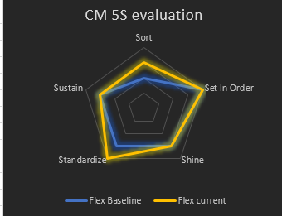

Pictures attachment
S/N | Pictures | Findings
1. | 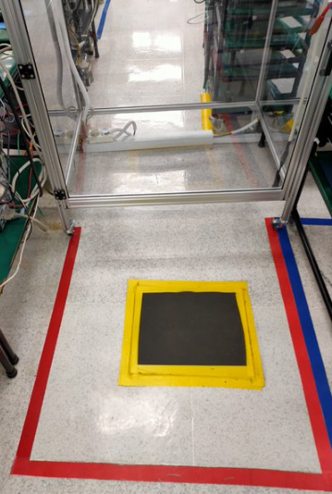 | Observed the hi-pot area has clearly marking with different colors for segregated area. It’s neat and clear.
2. | 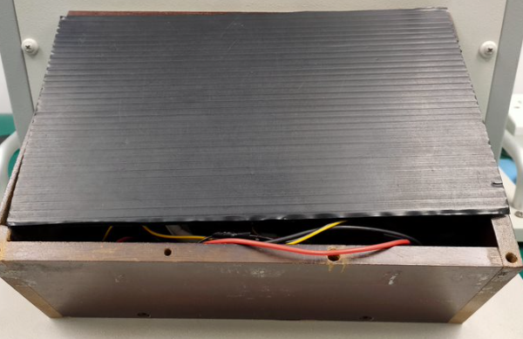 | The wire of keypad test area should have probably covered when off for break. It’s an area for improvement.
3.
4.
5.

