Contract Manufacturer competency checks

Contract Manufacturer: | Venture
Date: | 30 Mar 2021
Auditor: | LUO HUAZHEN
Audit scope: | FLR Detector

Competency audit checklist
Man & Method |  | Y | N
1. | Is the ASP/TSP displayed during production? | Y
2. | Is it the correct ASP/TSP and revision? | Y
3. | Does the operator know how to retrieve the ASP/TSP? | Y
4. | Did the operator pick the parts from the correct bin? | Y
5. | Are they appropriately attired for the assembly (e.g. ESD assembly) | Y
6. | Is the operator trained to perform ASP? (Refer to training records) | Y
7. | Did the operator follow to the instructions stated in the procedure? |  | N
8. | Did the operator use the correct tools for assembly? (e.g. Correct torque driver) | Y
9. | Did the operator adhere to critical clean requirement? (e.g. working in the fume hood, wearing glove etc.) | Y
Machine
10. | Are the tools within preventive maintenance schedule? | Y
11. | Are the tools readily available? | Y
12. | Are the testers within preventive maintenance/calibration schedule? | Y
13. | Did the operator verify the pre-checks/checklist of the tool/tester/equipment before using? | Y
Material
14. | Did the operator segregate the pre-build sub-assembly components properly? | Y
15. | Are the different parts/components kept in a separate compartment/bin? | Y
Environment
16. | Are they performing assembly in correct environment setups (critical clean process such as cleanroom) | Y
17. | Are the testers setup in the correct environment conditions? (e.g., heater cooler test, room temperature & humidity) | Y
Note:
1. Use only “Y” or “N”. Do not use any other characters in this checklist.
2. Please mark it as “Y” if the question is not applicable.

ASP/TSP audit table
Recommended: Sampling checks is ok on the ASP/TSP.

ASP/TSP no. | Rev | Page | Observations | Comments
279003273 | J | 18-52 | Operator is familiar with procedure. Although some parts were built ahead but she’s able to complete the rest of building according to ASP. | Auditee: Partik 25704968  Auditee is trained with Certificate.

Other observations
The tools are organized properly. Some steps of ASP were performed ahead as unit was partially built while waiting for Optica Bench. But Operator manage to finish the build as per ASP.

Immediate corrective action
- N2 Cylinder wasn’t secure properly although there’s metal chain in place. Corrected by securing N2 Cylinder.
- Worn procedure/document found in production line. Venture explained it’s switched to e-document. So they’re advised to properly disposal this old document.
- Line display board for Operator wasn’t updated. The board shows Operator SIE Seow Pei is working on Detector Line, but Operator Partik is actual personnel working in line although she’s trained on detector line as well.
5S table
Circle the 5S levels accordingly.
 | Sort | Set in Order | Shine | Standardize | Sustain
5  Continuous Improvement | Cleanliness problems are identified, and mess prevention actions are in placed | Essential items can be retrieved within 30 seconds with minimal motion. | Potential problems are identified, and countermeasures documented | Proven methods for area arrangement and practices are shared and used | Root causes are eliminated, and improvement actions include prevention
4  Proficient | Clearing schedules and responsibilities are documented and followed | Minimal needed items are arranged in an orderly manner based on retrieval frequency. | Work areas cleaning, inspection and supply restocking are done daily. | Proven methods for area arrangement and practices are used in the area | Sources, frequency of problems are noted with root cause and corrective actions
3  Advanced | Initial cleaning is completed, and mess sources are identified and corrected | Needed items are outlined, dedicated locations are labeled in planned quantities. | Visual controls and indicators are set and marked for work area | Agreements on labeling, quantities, and controls are documented | Work group is routinely checking area to maintain 5S agreements
2  Basics | Essential and non-essential items are identified. Non-essential items are removed. | Essential items are stored and organized based on usage frequency | Key area items are marked to check and required level of performance noted | Work area has designated area arrangement and controls | Initial 5S level is established and is posted in the area
1  Getting started | Essential and non-essential items are mixed throughout the area | Items are randomly placed throughout the area | Key area items are not identified and unmarked | Work area methods are not always followed and are not documented | Work area checks are randomly done and there is no 5S measurement

5S evaluation chart
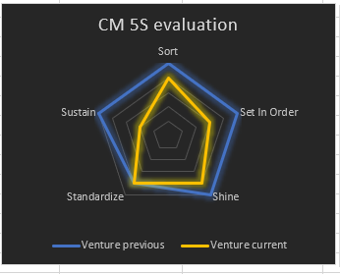

Pictures attachment
S/N | Pictures | Observations
1. | 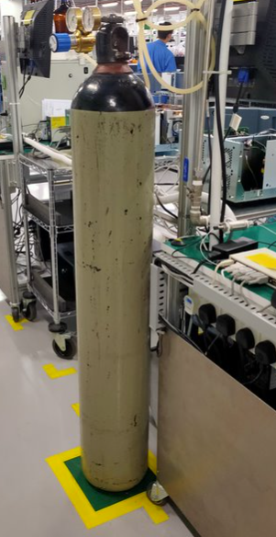 | N2 Cylinder wasn’t secure properly although there’s metal chain in place. Corrected by securing N2 Cylinder.
2. | 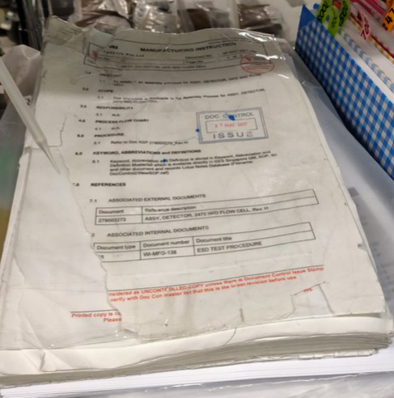 | Worn procedure/document found in production line. Venture explained it’s switched to e-document. So they’re advised to properly disposal this old document.
3. | 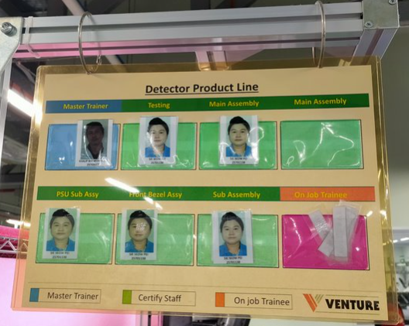 | Line display board for Operator wasn’t updated. The board shows Operator SIE Seow Pei is working on Detector Line, but Operator Partik is actual personnel working in line although she’s trained on detector line as well.
4.
5.

