IQ-02: Site Verification
Temperature (degrees C, RH)
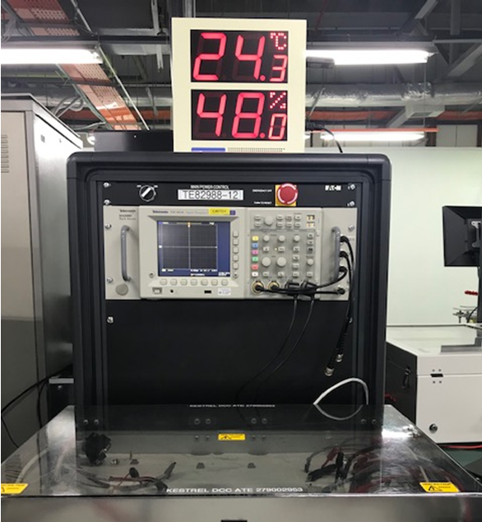
Workspace & Test Station Bench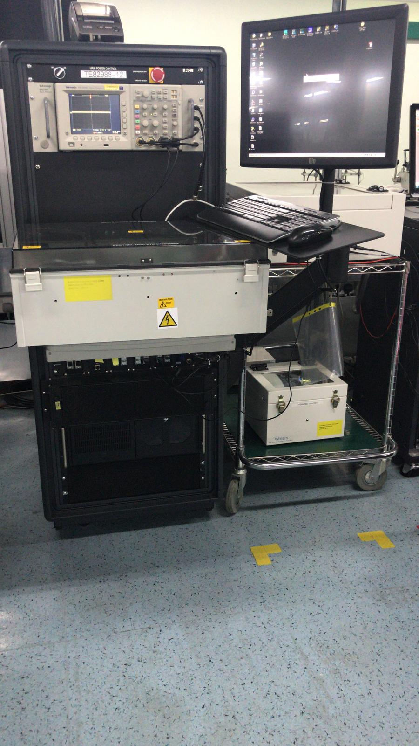

Voltage Electrical Supply in AC (3 Phase)
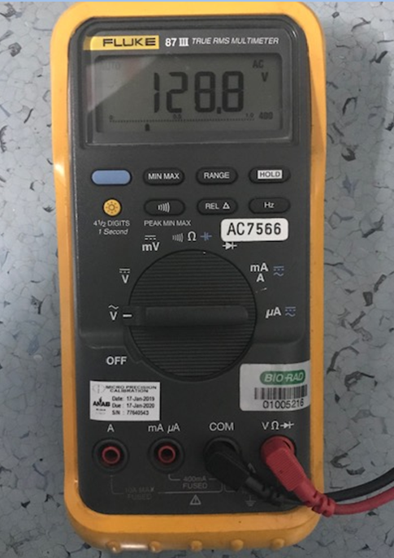
Frequency of Electrical Supply in HZ (3 Phase)
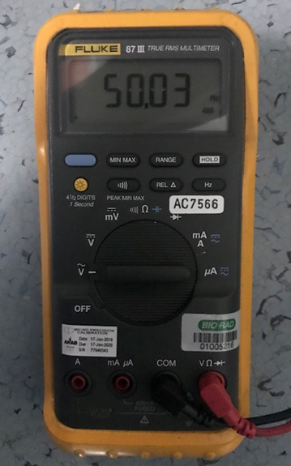

Vacuum Pressure

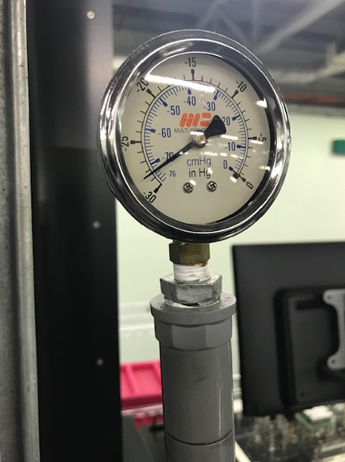

IQ-04: Test Software and Instrument Firmware Version
- Screen capture of Test Sequence 210001115HVC Version C
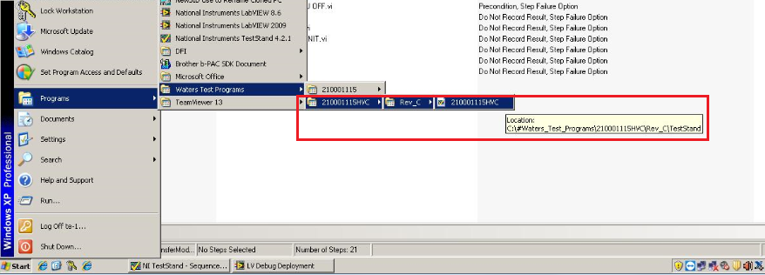
- Screen capture of Test Sequence 210001115 Version C
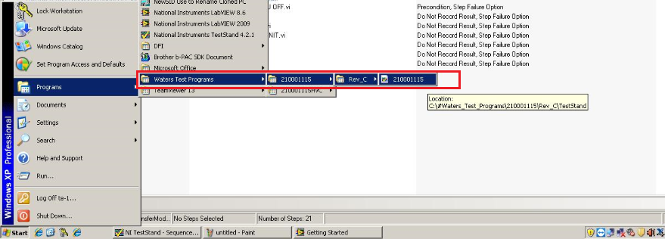

NI Test Stand
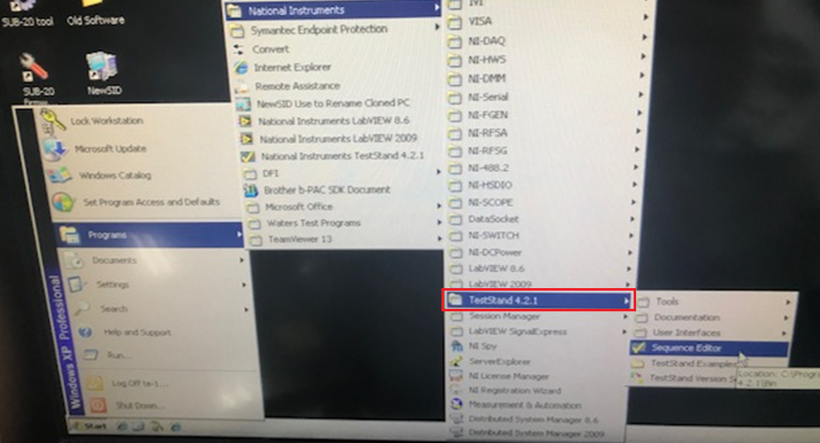

IQ-05: General Safety and Alarms
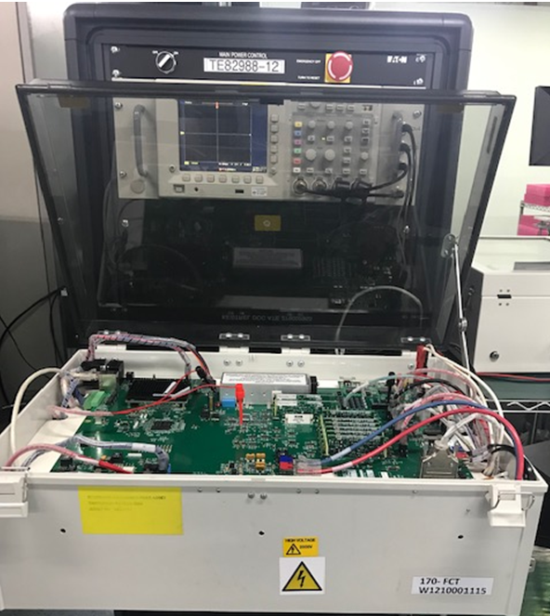

IQ-06: FUNCTIONAL VERIFICATION

Self test result using test fixture (TE83004) – Refer to the test log file “TE82988 Selftest rev L_Selftest Report[QUAL_12MAR19][10 49 33 AM][3 12 2019].txt”
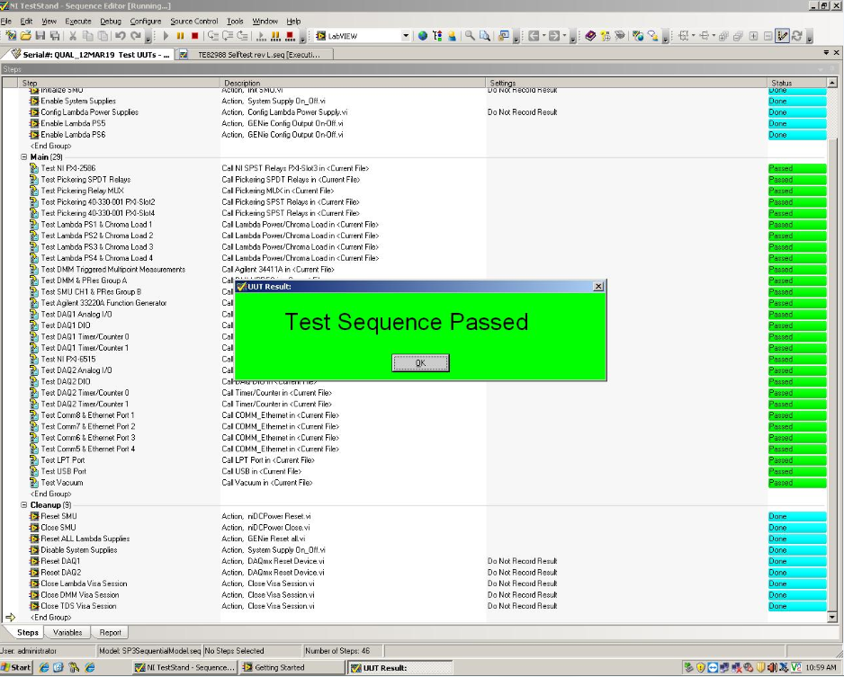

FCT2 Test Result - Refer to the test log file “210001115HVC_Report[21 066][11 10 39 AM][3 12 2019].xml”
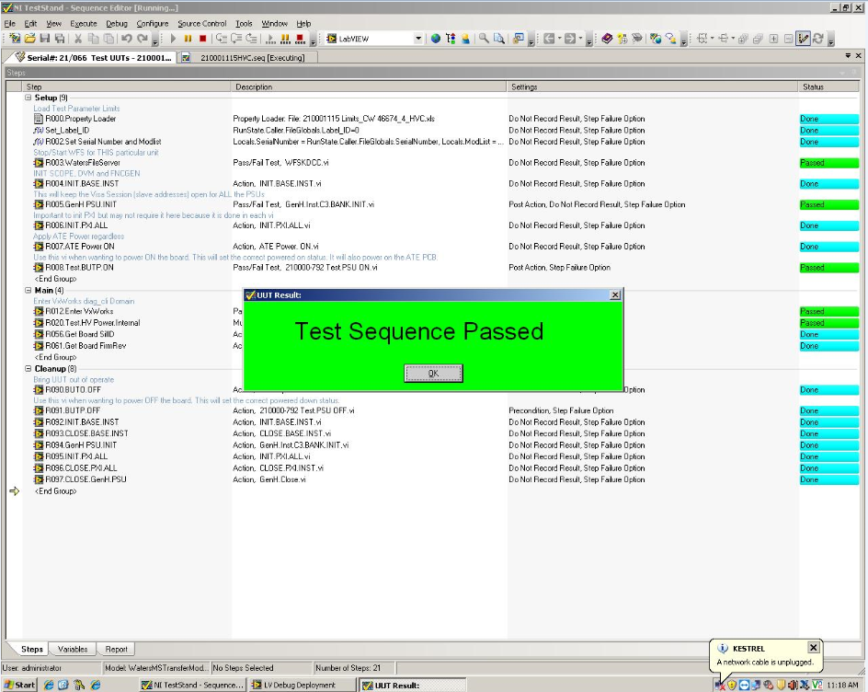

FCT3 test data – Refer to the test log file “210001115_Report[21 066][3 20 47 PM][3 12 2019].xml”
