

TE82988
Global Test System

Assembly Procedure
- Install rack-mount adapter to oscilloscope
  - Install rack-mount kit on oscilloscope per Tektronix instructions.
  - Install BNC bulkhead connectors to rack-mount kit. Label the connectors ‘ch1’ (bottom), ch2, ch3 and ‘ch4’ (top).
- Prepare electronic load chassis
  - Install rack-mount kit on electronic load chassis per Chroma instructions.
  - Remove and discard blank panel (labeled GPIB) from rear of Chroma electronic load chassis (retain screws).
  - Install GPIB Module into rear of Chroma electronic load chassis. Secure with two screws removed in step 2.2.
  - Slide input power selector switch to 115V.
  - Set load IEEE address (switches 2 and 4 on, all others off).
- Prepare DMM and waveform generator
  - Install rack-mount kit onto digital multimeter and waveform generator per Agilent instructions. Assemble DMM/waveform generator such that DMM is located to the left of the waveform generator, as viewed from outside the cabinet. See Figure 1.
  - Push DMM Front/Rear front-panel button to the ‘Rear’ position.
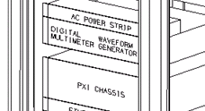
Figure 1
- Install rack-mount adapters to PXI chassis
  - On rear of GeoTest PXI Chassis, remove (4) screws that fasten the trim/bumpers. See Figure 2.
  - Using (4) M3x10 socket-head cap screws and lock washers, attach (2) PXI rack-mount brackets (see Figure 3) to the rear of the chassis. Use the same mounting holes as the trim/bumpers removed in step 4.1.
  - On the rear panel, slide the Fan Speed switch (if equipped) to the ‘Auto’ position.
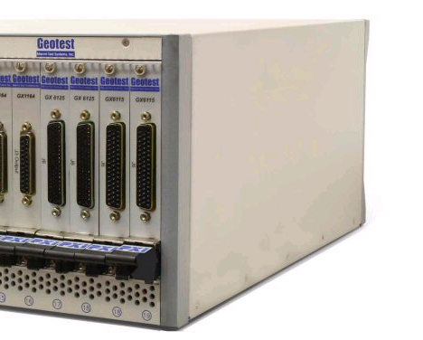  Mount bracket  using these holes.  Remove this Trim.  Figure 2 | 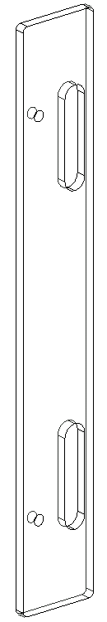  Figure 3

- Install Instrument Communication Cards
  - If not restoring from an image, perform basic PC config first – per Appendix 1 - TE82988 Computer Configuration, steps 21 - 35.
  - Record serial numbers for the IEEE and MXI communication cards on the system configuration sheet.
  - Remove top cover from GTS computer.
  - Install MXI communication card in the PCIEX 16 slot (the long slot). Move parallel port connector, if necessary.
  - Install IEEE communication card in PCI slot 1.
  - Install cover removed in step 5.3.
- Prepare power supplies
  - Record serial numbers of all power supplies on system configuration sheet (serial numbers are hidden when supplies are joined in the rack-mount configuration. Attach identification number to front of power supplies.
  - Separate power supplies into two groups (GENH30-25 and GENH60-12.5).
  - Install Lambda rack-mount kit to the supplies, keeping the GENH60-12.5 supplies together and the GENH30-25 supplies together.
GENH60-12.5
GENH60-12.5
GENH30-25
GENH60-12.5
GENH60-12.5
GENH30-25
  - Remove the green sense block connectors (J2) from all (6) power supplies.
  - Remove and discard the sense jumpers from all (12) connectors.
  - Connect the green sense block connectors to the VPC cable assembly. Connect (12 total) ‘PSx S+’ and ‘PSx S-‘ wires to ‘+S’ and ‘-S’ connector terminals.
- Configure Master Power Supply* switch settings.  - SW1: Position 9↑, all others ↓.  - LAN/232/485: ↑ ↓.  *top left power supply as viewed from front (top right from rear). | 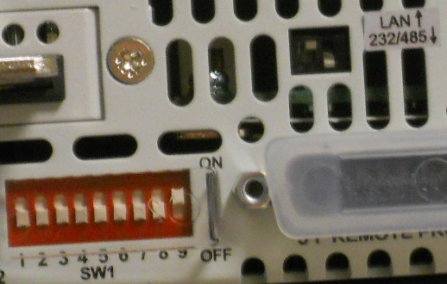  Master Power Supply
- Configure Slave Power Supply switch settings.  - SW1: Positions 9 ↑ and 6 ↑ all others ↓.  - LAN/232/485: ↓ ↓ (both down). | 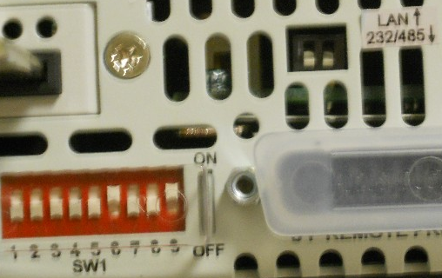  Slave Power Supplies
- Remove enclosure side panels
  - Remove and retain (8) fasteners from each side panel.
  - Remove and retain both side panels.
- Install power distribution unit support
  - The floorplate is fastened to the frame with (16) fasteners. Remove and discard the two floor-fastening screws located half-way between the front and rear of the frame (one on each side).
  - Install the PDU Support member using two 10-32 x 1-¹/₈” flat-head screws in these holes. See Figure 4.
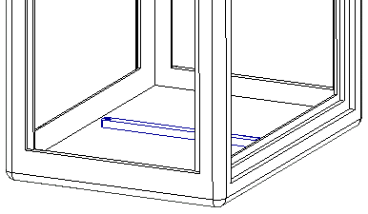
Figure 4
- Prepare VPC receiver filler panel
  - Remove the middle two filler panel fasteners and loosely install 10-32 x ⁵/₈” socket head cap screws in their place per Figure 5. Leave these screws loose (¹/₈” gap) to hang the VPC receiver table support.
Note: The lower holes are used to fasten the support and the upper holes to fasten the receiver to the frame.
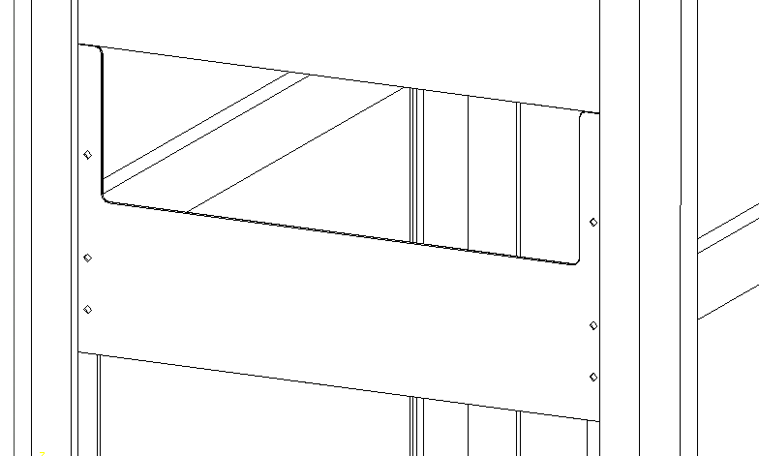
Loosely install cap screws in these holes

Figure 5
\
- Assemble vacuum panel
Notes: 1. Panel uses two valves. For simplicity, this procedure refers to them by the first 4 P/N characters (7221 and 7222).
2. Use Teflon tape on all pipe thread connections.
3. Use # 12 (or larger) hose clamps for hose fittings
3. Orient all hose clamps so they are serviceable when the panel is installed (screw heads facing up and out).
4. Arrow on valve body indicates direction of flow*.
5. When complete, all direction-of-flow arrows should point in the same direction (towards bulkhead fitting).
  - Attach a filter/muffler to the inlet port of the 7222 valve per Figure 6.
  - Attach a male reducing adapter to the outlet port of the 7222 valve per Figure 6.
  - Attach a male run tee to the inlet port of the 7221 valve per Figure 6.
  - Attach a street elbow to the outlet port of the 7221 valve per Figure 6.
  - Attach a street elbow to one outlet of the male run tee installed in step 10.3.
  - Attach male reducing adapters to all remaining pipe-threaded ports per Figure 6.
  - Attach a male reducing adapter to the bulkhead connector per Figure 7.
  - Mount 7221 valve to panel with M6x25 screws, spring-lock and flat washers per Figure 8. Use M6 flat washers to achieve proper spacing between the valve body and panel (one on the inlet side and two on the outlet).
  - Using a hose clamp, Attach a 2.625” piece of Vardex tubing to the inlet side of the 7221 valve (to the male run tee) per Figure 8.
  - Using a hose clamp, connect outlet port of 7222 valve to Vardex tubing and mount valve to panel using ¼-20 x 1” screws, spring-lock and flat washers per Figure 8.
  - Mount Bulkhead connector to panel per Figure 8.
  - Using two hose clamps, attach an 11” piece of Vardex tubing between bulkhead connector and 7221 valve outlet (street elbow) per Figure 8.
  - Mount 9-pin Amp CPC connector and terminal strip to panel using 4-40 nuts and spring-lock washers per Figure 8.
  - Mount two L-com RJ45 bulkhead connectors to panel using the included hardware (4-40 screws).
  - Mount power supply to panel using M3x8 screws, spring-lock and flat washers per Figure 8.
7221
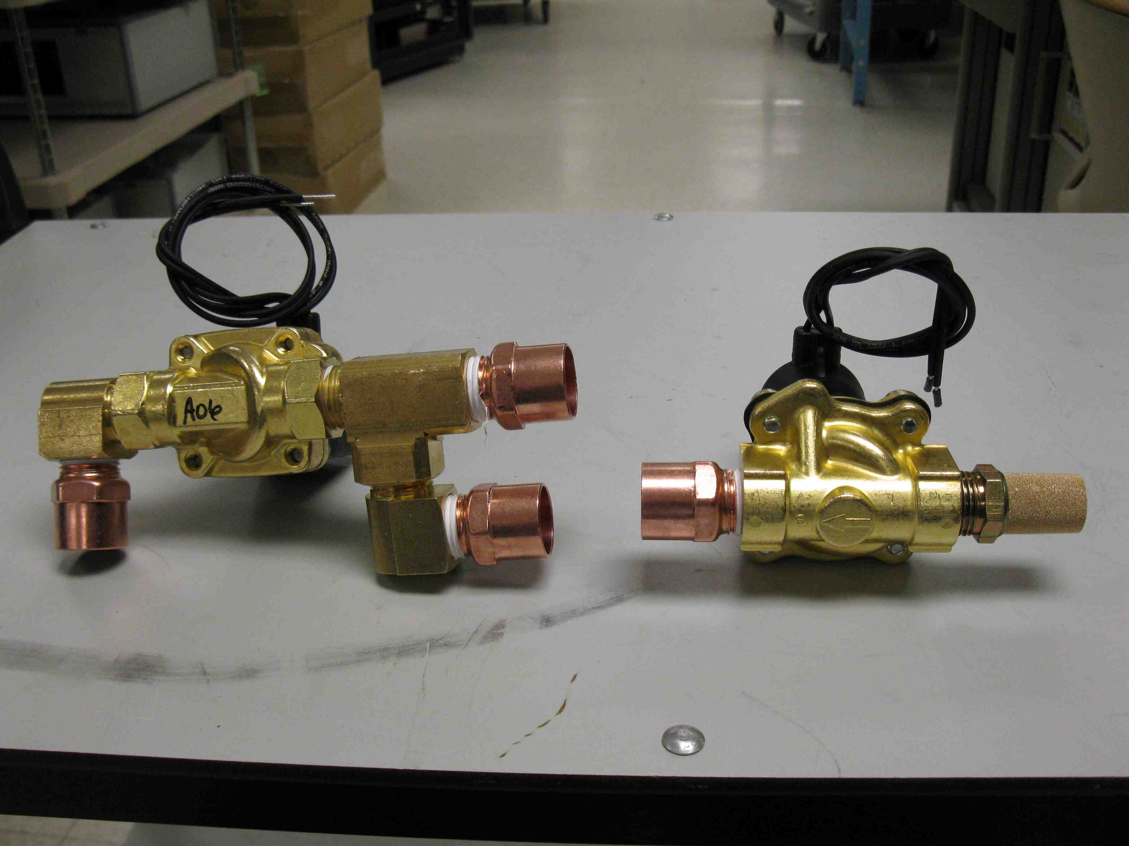  *Arrows  7222  Figure 6 | 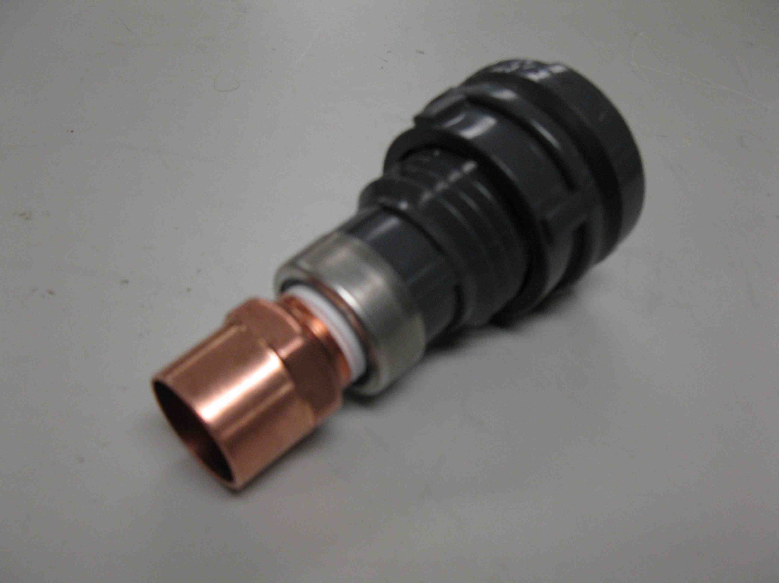  Figure 7 | 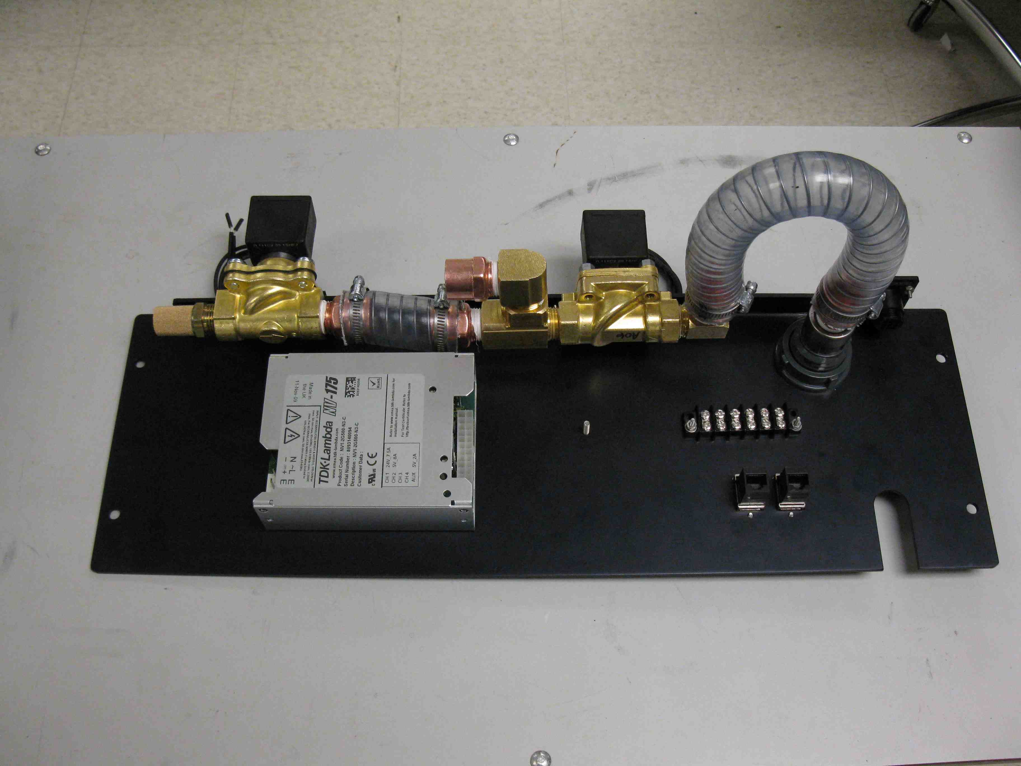  Figure 8

- Wire vacuum panel
  - Wire vacuum panel per Figure 9.
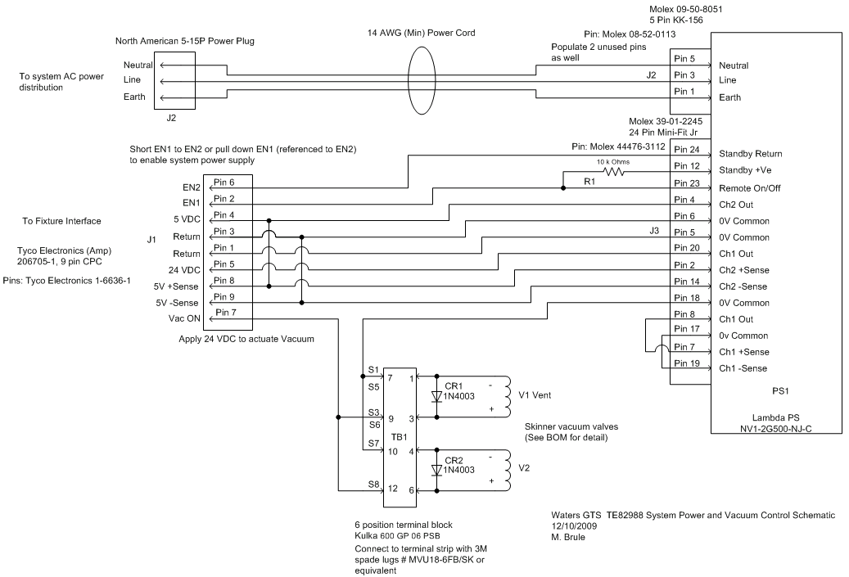
Figure 9

- Install instruments in rack
  - Using 10-32 clip nuts and panel-mount screws with nylon washers, install instruments (except vacuum panel) as per Figure 10 and Figure 11 (next page).
Note: Power supplies, PC, Electronics Loads and PXI chassis rest on support brackets.
Note: After installing the PC, Install the two GENH30-25 power supplies, followed by the four GENH60-12.5 supplies.
Note: Mount the external AC power strip by the lower two holes only (leave the top holes open).
Note: Install instruments from the bottom-up (except for electronic loads).
  - Install AC power distribution unit.
  - Install GTS computer.
  - Install power supplies.
  - Install signal bulkhead panel.
  - Install external AC power distribution.
  - Install oscilloscope.
  - Install AC power control panel.
  - Install internal AC power distribution strips.
  - Install Ethernet switch.
  - Install PXI chassis.
  - Install DMM and waveform generator.
  - Install ground wiring.
    - Connect all chassis grounds to cabinet ground stud.
  - Install power supply wiring
    - Connect AC, and (VPC cable) DC, Ground, Sense & Control wiring for power supplies. Use ¼-20 x ⁵/₈” hex bolt, ¼-20 hex nut and two star washers per power supply output lug.
  - Install electronic load chassis.
    - Connect electronic load chassis ground stud to cabinet ground stud.

TE 82988 - Basic Layout
(Leave 3U (5.25”) Panel Space Above this AC Terminal Strip)

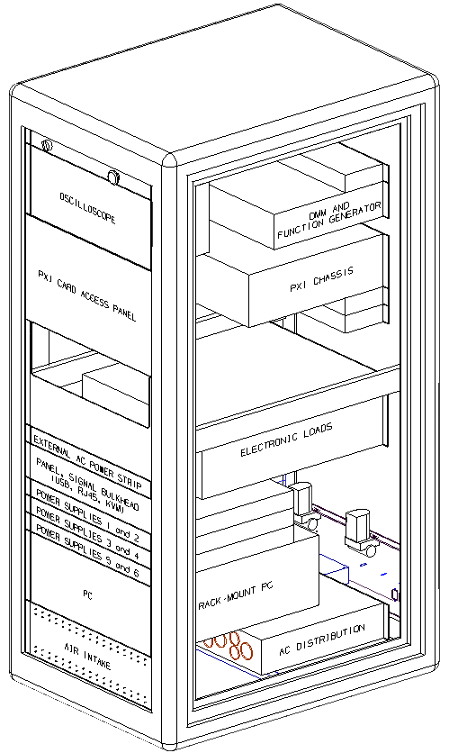  GENH60-12.5  GENH60-12.5  GENH30-25  Figure 10 – Front View (VPC Receiver/Table not shown for clarity) | 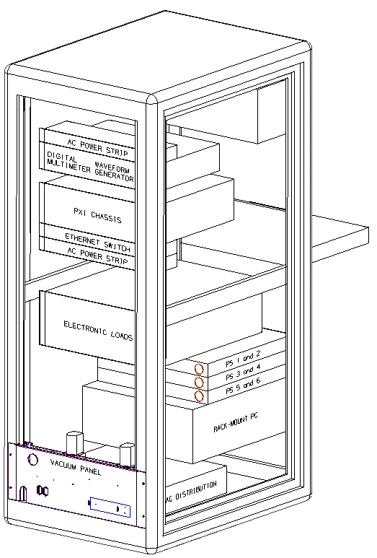  Figure 11 – Rear View

- Install Load Modules
  - Install Chroma load modules into Chroma electronic load chassis. Secure each module with two M3x16 screws.
- Install PXI instruments
  - Record the PXI instrument serial numbers on the system configuration sheet before installation in chassis.
  - Install PXI instruments in PXI chassis per Figure 12.
  - Connect PC to PXI chassis.
  - If not restoring from an image, boot PC and install PXI instrument drivers (perform basic PC config first – per Appendix 1 - TE82988 Computer Configuration, steps 21 - 35).
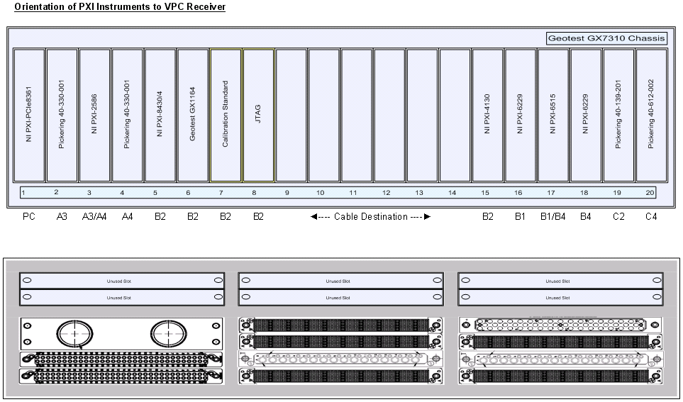
Figure 12

- Mount VPC receiver
  - Remove the upper two fasteners and the lower two fasteners holding the filler plate. The plate should now be loosely hanging by cap screws installed in step 9.1.
Note: The lowest holes will be used to fasten the support to the frame and the upper holes will fasten the receiver to the frame.
Remove the upper and lower screws (4)

Figure 13
  - Hang two VPC Receiver support trusses on the cap screws by the keyhole slots.
  - Using (4) 10-32 screws, fasten the support trusses to the frame.
  - Tighten (2) socket head cap screws in keyhole slots.
Note: Lowest truss mounting holes will line up with upper holes on external AC power strip.
  - Mount VPC G12 Rack Mount Gap Cover (VPC Part # 310113433) to receiver using (4) 4-40 flat head screws per VPC instructions.
  - Mount the VPC receiver table to the trusses using (4) ¼-20 x ½” screws and lock washers.
  - Mount VPC filler panel between the two trusses using (4) 6-32 flat head screws from the VPC kit.
  - Using (2) 10-32 x 1-¼” socket head cap screws, attach the receiver to the frame.
Note: VPC receiver handle must be in the ‘down’ position.

- Connect AC power wiring
  - Use the AC line cords from Figure 14 to connect the instruments per Figure 15 (next page).
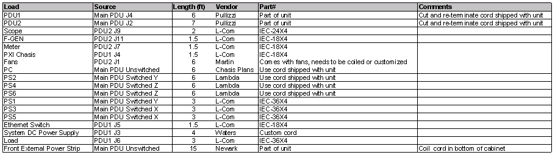
Figure 14

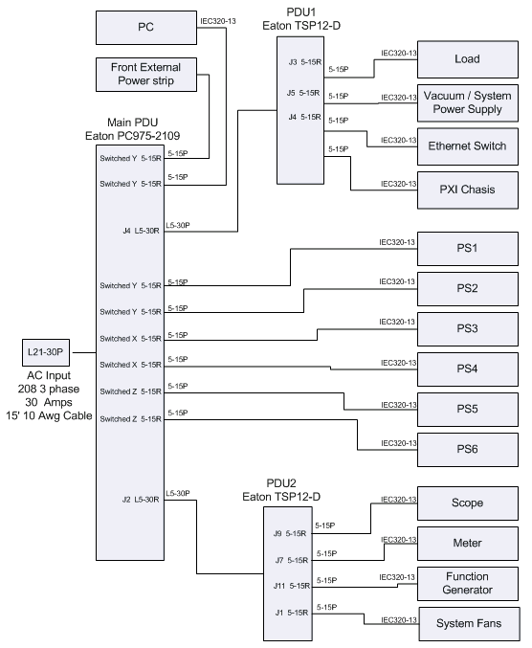
Figure 15

- Connect system communication wiring
  - Connect system communication wiring per Figure 16.
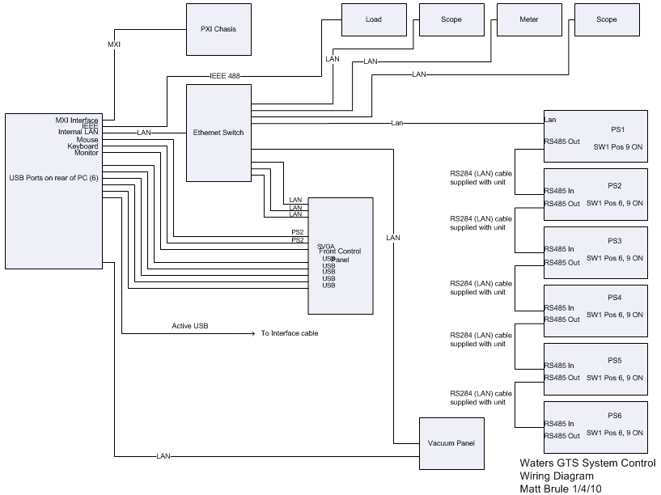
Figure 16
- Install signal wiring  - Install signal wiring (VPC cables) per Figure 17, Figure 18 and cable labels (wires terminating at power supplies, loads, DMM, function generator or oscilloscope).  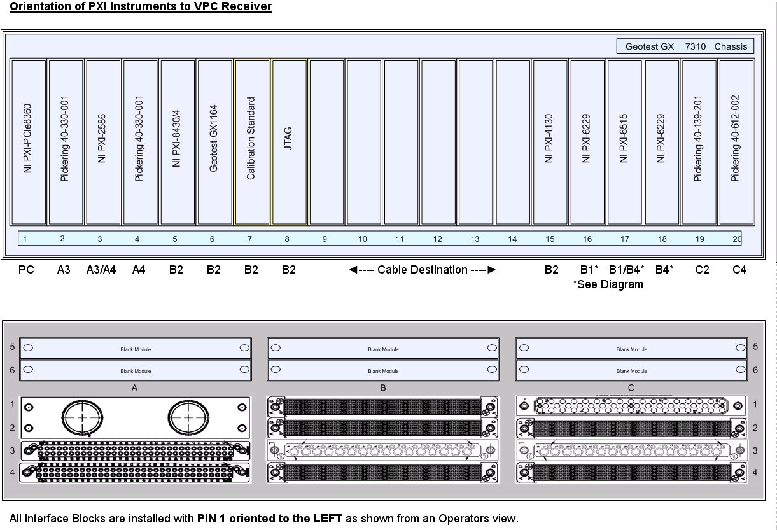  Figure 17 | 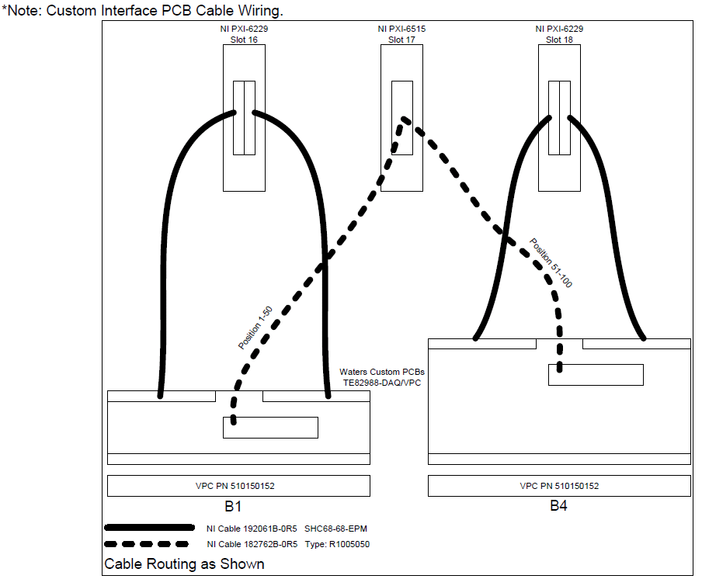  Figure 18
- Install vacuum panel
  - Mount the vacuum panel using ¼-20 x ½” screws.
  - Cut a 48” piece of Vardex tubing and connect to the outboard port on the VPC receiver using a hose clamp.
  - Route tubing back and along side of frame, passing:
  - Between electronic load chassis and horizontal frame member
  - On the outside of two support brackets (loads and power supplies)
  - On the inside of the PC support bracket (towards rear panel)
  - Connect Vacuum panel to Vardex tubing using a hose clamp.
  - Plug vacuum panel into lower internal AC distribution strip.
  - Connect 9-pin AMP CPC connector to vacuum panel.
  - Connect the two Ethernet bulkhead connectors (one to the main PC LAN and one to the instrument LAN). Mark panel accordingly.
- Install side panels
  - Install side panels with hardware removed in step 6.8.

Appendix 1 - TE82988 Computer Configuration
Note: Follow these instructions to configure a TE82988 system computer manually (if system restore image is unavailable).
- Install Windows XP
  - When prompted: choose to activate Windows and enable Automatic Updates.
- Configure Windows login
  - Click Start, Settings, Control Panel. Double-click User Accounts. Click ‘Change the way users log on or off’ and deselect ‘Use the Wecome Screen’.
- Configure Local Accounts
  - Setup 3 accounts (TE-1, TE-2 and Tester, all as administrator-level accounts, with the current TE passwords).
Note: to create TE-1 account, rename the ‘Administrator’ account to TE-1.
- Configure Windows XP
  - Disable active virtual memory management (Start, Settings, Control Panel, System, Advanced, Performance, Settings, Advanced, Change). Set initial and maximum to 6,000 MB. Reboot.
  - Turn disk indexing ‘off’ (in My Computer or Windows Explorer, right-click on C:. Select Properties and deselect ‘Allow Indexing to search…’).
  - Turn System Restore ‘off’ (Click Start, Settings, Control Panel, System, System Restore, Select ‘Turn off System Restore’).
  - Open the calculator (Start, Programs, Accessories, Calculator). Click View, Scientific and View, Digit Grouping. Close calculator.
  - Install UltimateZip, if required from W:\TE\PC Tools\Software\Ultimate Zip (free)\.
  - Change Windows Automatic updates time to late night, but not 3AM (Windows default).
  - In all accounts, perform the following:
    - Disable system sounds (Click Start, Settings, Control Panel. Double-click Sounds and Audio Devices, Sounds, select ‘No Sounds’ as the scheme).
    - Configure Start Menu (Right-click taskbar. Click Properties. Click Start Menu and select Classic Start Menu).
- Install and Configure Antivirus Software
  - Install Symantec antivirus software.
  - Configure software to schedule updates daily (and to retry within 24 hours).
  - Configure real-time protection and scans (if configured) to Clean (1st action) or Delete (2nd action). Set security risks to Delete (1st action) or Quarantine (2nd action).
  - Configure real-time protection and scans (if configured) to not backup file before attempting repair.
  - Configure auto-purge of items in Quarantine (after 10 days).
- Connect to Internet, update Antivirus Definitions and Install Windows Updates (Deselect unWanted Updates)
- Configure Video Settings in Each Account
  - Click Start, Settings, Control Panel. Double-click System. Click Advanced, (Performance) settings. Adjust for best performance then select: ‘Use Drop Shadows for desktop icon labels’.
  - Set TE-1 and TE-2 backgrounds to black (no image) and color resolution to 16 bit.
Note: while in the ‘Desktop’ tab, click ‘Customize Desktop…’. Deselect ‘Run Desktop Cleanup Wizard every 60 days’ (disable cleanup wizard in all accounts).
  - Configure the TE-1 and TE-2 screen saver to 3D text (Test Engineering, font = Century Gothic), rotation type = see-saw, time = 15 minutes, select ‘on resume, password protect’. Configure the ‘Monitor Power’ to turn monitor off after 3 hours.
  - Copy W:\TE\Backgrounds\Wallpaper1024.bmp to C:\Windows.
  - Set Tester account background to black, but use ‘Wallpaper 1024.bmp’ file for the background. Set color resolution to 16 bit.
  - Configure the Tester account screen saver to Starfield, time = 150 minutes, select ‘on resume, password protect’. Configure the ‘Monitor Power’ to turn monitor off after 3 hours.
- OptimizE Windows Explorer Settings
  - In Windows Explorer, click View, Details.
  - Click Tools, Folder Options…, View. Select ‘Do not Cache Thumbnails’.
  - Deselect ‘Automatically Search for Network Folders and Printers’ and ‘Use Simple File Sharing’.
  - Click ‘Apply to all Folders’.
- Install NetBEUI Protocol
  - Install the NetBEUI protocol using files and instructions from W:\TE\PC Tools\Software\Drivers.
- Add Sigmaserver2 to hosts file
  - Open C:\Windows\System 32\Drivers\Etc\Hosts with Notepad.
  - Add “10.2.240.189 sigmaserver2” after the localhost line as shown below:
127.0.0.1 localhost
10.2.240.189 sigmaserver2

  - Save the file and exit.
- Install Office, AdobE viewers, if required
  - Install necessary viewer applications. If installing MS viewers, also install the Office 2007 Compatibility Pack from W:\TE\PC Tools\Software\Microsoft Office viewers and upgrades\.
- Install and configure RealVNC, if required
  - Install RealVNC from W:\TE\PC Tools\Software\RealVNC v 4.1.2\.
  - Configure password authentication with current TE password.
  - Add winvnc4 to the list of Windows Firewall Exceptions (Start, Settings, Network Connections, Right-Click on Local Area Connection, select Properties, Advanced, Settings, Exceptions, Add Program – browse for C:\Program Files\RealVNC\RealVNC4\winvnc4, OK).
- Modify Tester Account Level (Set to User)
  - Right-click My Computer, Manage, Local Users and Groups, Users, Right-Click ‘Tester’, Properties, Member of – add Users and Remove Administrators.
- Install MXI and IEEE Communication Cards
  - Install drivers for new hardware.
- Install Labview, Teststand, Sigmaquest

TE82988 Waters Global Test System Build Checklist
1 Install rack-mount adapter to oscilloscope
2 Prepare electronic load chassis
3 Prepare DMM and waveform generator
4 Install rack-mount adapters to PXI chassis

5 Install Instrument Communication Cards
6 Prepare power supplies
7 Remove enclosure side panels
8 Install power distribution unit support
9 Prepare VPC receiver filler panel
10 Assemble vacuum panel
11 Wire vacuum panel
12 Install instruments in rack
12.2 Install AC power distribution unit.
12.3 Install GTS computer.
12.4 Install power supplies
12.5 Install signal bulkhead panel
12.6 Install external AC power distribution.
12.7 Install oscilloscope.
12.8 Install AC power control panel.
12.9 Install internal AC power distribution strips.
12.10 Install Ethernet switch.
12.11 Install PXI chassis.
12.12 Install DMM and waveform generator.
12.13 Install ground wiring.
12.14 Install power supply wiring
12.15 Install electronic load chassis.
13 Install Load Modules
14 Install PXI instruments
15 Mount VPC receiver
16 Connect AC power wiring
17 Connect system communication wiring
18 Install signal wiring
19 Install vacuum panel
20 Install side panels
TE82988 System Configuration Sheet
System: | TE82988-
Manufacturer |  | Part Number |  | Description | Serial Number | ID Number
Chroma |  | 6314 |  | Mainframe for 4 Load Module
Chroma |  | 63103 |  | Load Module 60A/80V/300W
Chroma |  | 63103 |  | Load Module 60A/80V/300W
Chroma |  | 63103 |  | Load Module 60A/80V/300W
Chroma |  | 63103 |  | Load Module 60A/80V/300W
Geotest |  | GX7310 |  | 20 Slot 3U Slave Rackmount Chassis
Geotest |  | GX1164 |  | Programmable Card, 4 channel 1 Ohm to 64 Kohm
Geotest (NI) |  | MXI-Express |  | MXI-Express Interface Kit including PCIe interface card
Lambda |  | GENH60-12.5-LAN-U |  | Genesys Series 750W, ½ Rack, Prog. PS, 0-60VDC
Lambda |  | GENH60-12.5-LAN-U |  | Genesys Series 750W, ½ Rack, Prog. PS, 0-60VDC
Lambda |  | GENH60-12.5-LAN-U |  | Genesys Series 750W, ½ Rack, Prog. PS, 0-60VDC
Lambda |  | GENH60-12.5-LAN-U |  | Genesys Series 750W, ½ Rack, Prog. PS, 0-60VDC
Lambda |  | GENH30-25-LAN-U |  | Genesys Series 750W, ½ Rack, Prog. PS, 0-30VDC
Lambda |  | GENH30-25-LAN-U |  | Genesys Series 750W, ½ Rack, Prog. PS, 0-30VDC
National Instr. |  | 778964-01 |  | NI PXI-6515
National Instr. |  | 778983-01 |  | NI PXI-8430/4
National Instr. |  | 778572-86 |  | NI PXI-2586
National Instr. |  | 779630-01 |  | NI PXI-6229
National Instr. |  | 779630-01 |  | NI PXI-6229
National Instr. |  | 779647-30 |  | NI PXI-4130
National Instr. |  | 778032-01 |  | NI PCI-GPIB
Pickering |  | 40-139-201 |  | 2A Relay Card 52xSPDT
Pickering |  | 40-612-002 |  | Hi-Density MUX
Pickering |  | 40-330-001 |  | PXI 24X SPST Power Relay Card 1KV
Pickering |  | 40-330-001 |  | PXI 24X SPST Power Relay Card 1KV
Tektronix |  | TDS3054C |  | Scope
Agilent |  | 34411A |  | DMM
Agilent |  | 33220A |  | Function Generator

