- GTS TESTER ( TE82988-12 ) FRONT VIEW
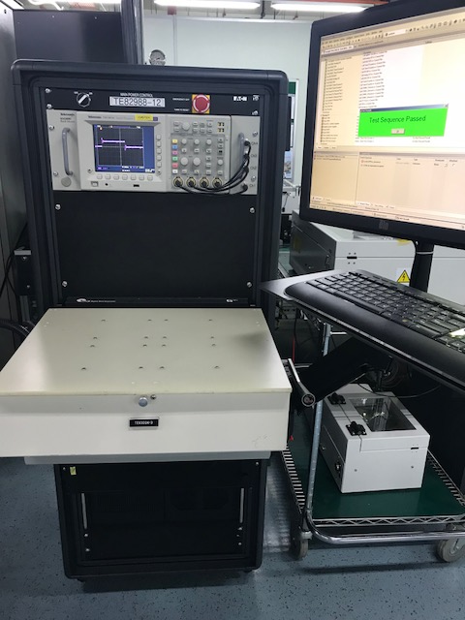
- GTS TESTER ( TE82988-12 ) BACK VIEW OVER LOOKING THE INSTRUMENT EQUIPPED

