How to create IT request without Lotus Notes
- Login VPN if you are not in office and click on link below. Bookmark the page on browser.
http://intranet.waters.com:8090/remedy.nsf/xIssueNew.xsp
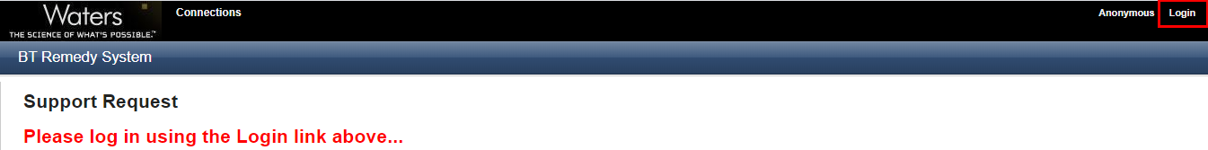

- Click on Login link and input Corp ID & PW.
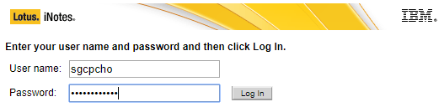

- Fill in highlighted fields and click save.
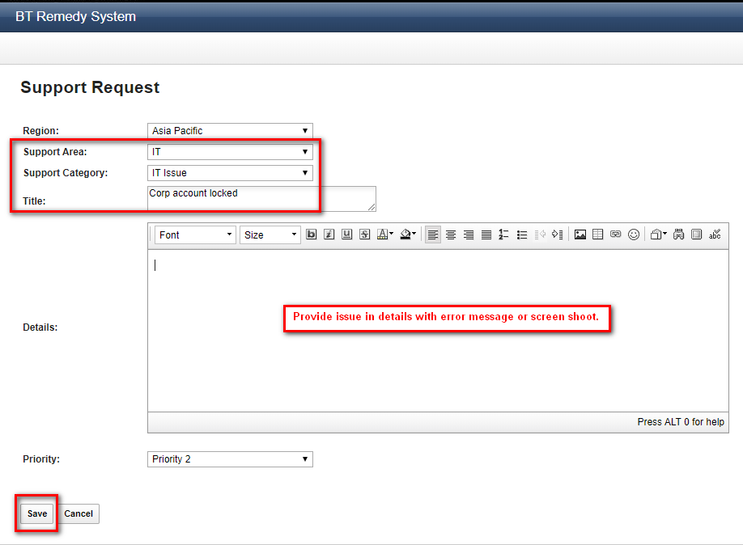

It works on mobile phone as well.

