ENGINEERING REPORT:
Project Information:
Report Title | Suggested Testing Methodology of New Hamamatsu Charge Amp Board (210001164)
Authors | Yang Zhen, Rick Davis
Date | 9/12/2017
Project Name | PDA Device second source |  |  | Room #:
Product Name | PDA |  |  | DIR #:
Report Type | ( ) Test Plan | ( ) Test Report | ( ) Design Analysis |  | ( ) Failure Analysis
 | ( X ) Other (explain) Engineering Note

Table of Contents
1.0 Objectives 2
2.0 Background 2
3.0 Summary 2
4.0 References 2
5.0 Definitions 2
6.0 Testing methodology 3
6.1. Linearity Testing 3
6.2. Latching Circuit Testing 6
6.3. Fixed Noise Testing 8
6.4. Charge Injection Testing 9
6.5. Charge Amplifier Speed Testing 10
7.0 Test Specifications 12

Objectives
Set the testing methodology of New Charge Amp Board without Hamamatsu 518-PDA. This testing methodology will help testing engineering to set up/modify the test fixtures.

Background
Original OnSemi PDA charge amp tester with simulated PDA did not meet noise specs.

Summary
Linearity, latching circuit, fixed noise, and charge injection testing methodologies have been developed for the new charge amp board.

References

Document Name | Document Number
SCHEM, PCB, HAMAMATSU 518 PIX PDA CA | 710001164
Hamamatsu 518 Pixel, CMOS, Selective Access PDA Source Control Drawing | 402000539
CPLD design used on 210001164 Rev B charge amplifier design | 361000697
New FPGA used on 210000415 personality design | 361000714
New FPGA used on 210000292 and 210000404 personality design | 361000715

Definitions
C.A. - Charge amp
PCB - Printed Circuit Board
PDA - Photodiode Array
CPLD - CMOS Programmable Logic Device
Sweep time - The time required for electronics to read all PDA pixels.
Exposure time - The time a pixel is exposed to light. Time cannot be less than sweep time. Restricted to an integer multiple of sample time.
Sample time- Data rate seen by user.
Well Capacity - Charge storage capacity of a pixel.

Testing methodology

Linearity Testing

Theory:
- The linearity specification is the measurement of how far the output varies from a straight line. To calculate the linearity error, calibration data is compared to the straight line that would best fit the points. This straight reference line is calculated from the calibration data using a technique called least squares fitting. The amount of error at the point on the calibration curve that is furthest away from this ideal line is the linearity error. Linearity error is usually expressed in terms of percent of full scale.
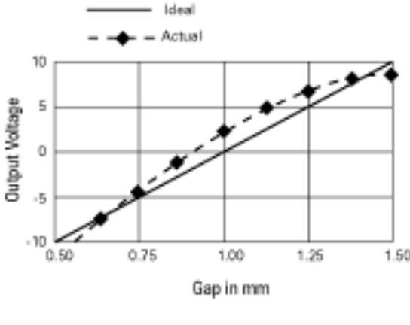
- The slope of the best linear fit straight line represents the transfer function of the Charge Amp board using a fixed input resistor.

Test setup:
- Refer to the Figure 1, a resistor R has been added between the inverting input of the op amp (ADA4627-1) and a high precision variable DC voltage source.
- Program an input voltage. Use serial port command “dcorrdata” to collect at least 100 pixel data points. Subtract the error term from the signal+error term. Average the resulting signal only data points.
- Repeat to collect 5 data points using different input voltages between 0 and 2V. Calculate the best linear fit straight line, slope of the straight line and the Linearity Error as a percent of full scale.

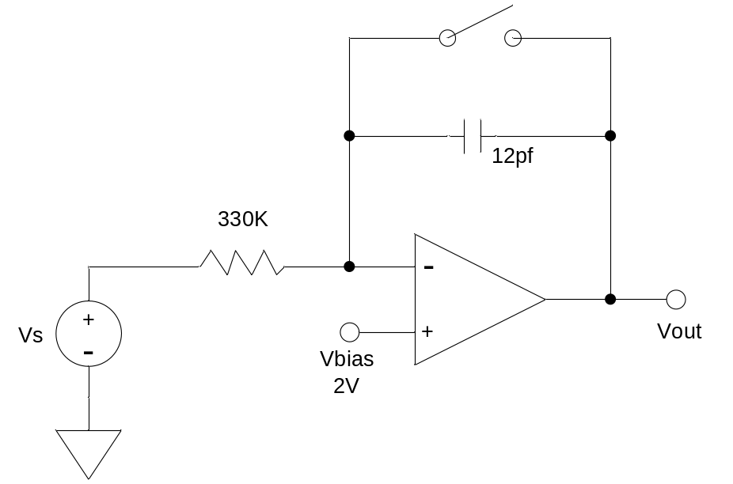
Figure 1: Linearity test setup

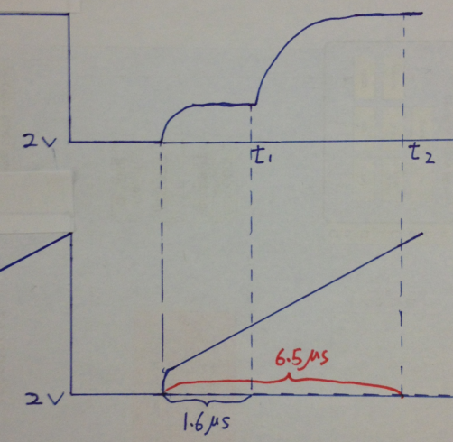
Operation with Resistor
Operation with Hamamatsu PDA
Figure 2: Output Voltage Plot of Charge Amp

Why select resistor R as 330kΩ?
- For analog front end circuitry on charge amp board, there is a latching circuitry highlighted in yellow, which will be triggered when Vout (INT_PDA) of charge amp is around 7V
- Vout = Vbias + Vci+Vsignal = 6.8V, where Vbias = 2V, charge injection voltage Vci = 0.3V, Vsignal = 4V.
- Charge injection voltage (Vci) is around 0.3V.
- To avoid this, while considering only 80% of 4V signal is suggested, let’s set Vout_max = 5.5V.
- Q = C*ΔV I*Δt = C*ΔV (Vbias/R)*Δt = C*ΔV
R = (Vbias* Δt )/( ΔV *C)
- Where Vbias = 2V, Δt = 6.5us, C = 12pF (1% tolerance)
- ΔV = Vout_max – Vbias – Vci = 5.5V-2V-0.3V = 3.2V
- Thus, R is about 330kΩ.
- After further bench verification, this value is finally selected.

Latching Circuit Testing

Theory:
- Monitoring comparator circuit was the selected method for resolving ADC damaging saturation voltages while using new Hamamatsu PDA. The circuit monitors the output voltage from difference amplifier against a threshold voltage. If voltage exceeds threshold, the CPLD will force the charge amplifier into a reset state for remaining pixel charge transfer time. The clamping circuit is highlighted in Figure 3.

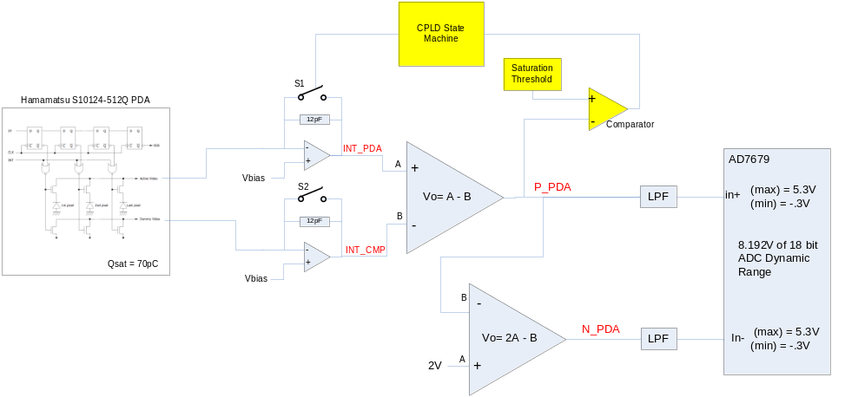
Figure 3: Latching Circuit Function Diagram (Highlighted)

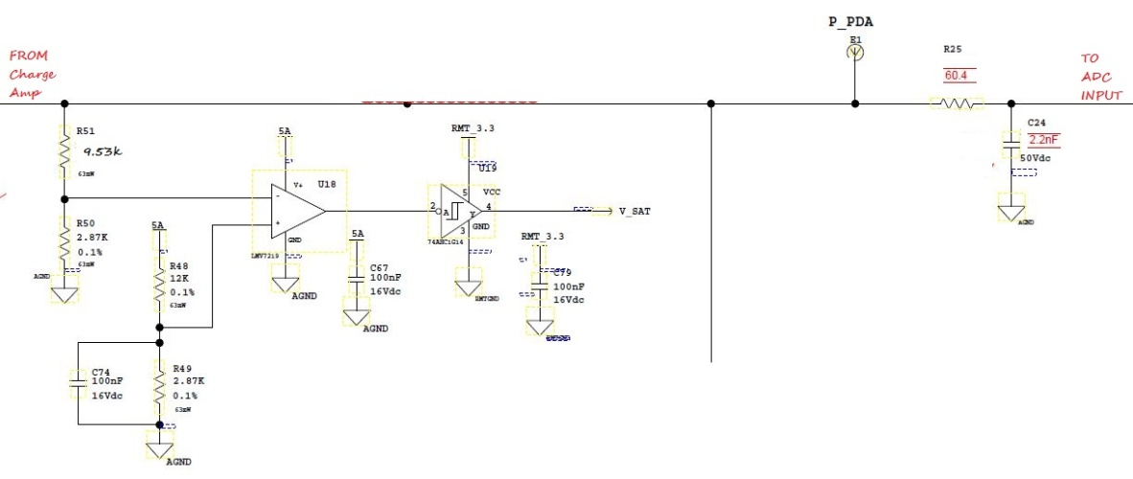
Figure 4: Latching Circuit

- Note: R51, R52, R48, and R49 resistors were selected to provide a 4.17 volt threshold (Figure 4). Tolerance analysis was completed to determine threshold range could be anywhere from 4.08 to 4.26 volts.

Test Setup:
- To verify the operation of the latching circuit with R = 330kΩ with 1% tolerance. This resistor value was selected to be able use up to 80% of the ADC range for linearity testing without triggering the Latching Circuit. In order to trigger the latching circuit negative input voltage is required. Refer to Figure 1.
- Setup oscilloscope to measure signal V_Sat and P_PDA, trigger the scope on signal V_Sat. Start with a 0.0VDC input voltage. Decrement the input voltage in -.02V increments until the scope is triggered.
- Measure signal V_Sat pulse width, P_PDA amplitude, and test the input voltage required to trigger the Latching circuit. Refer to Figure 5.
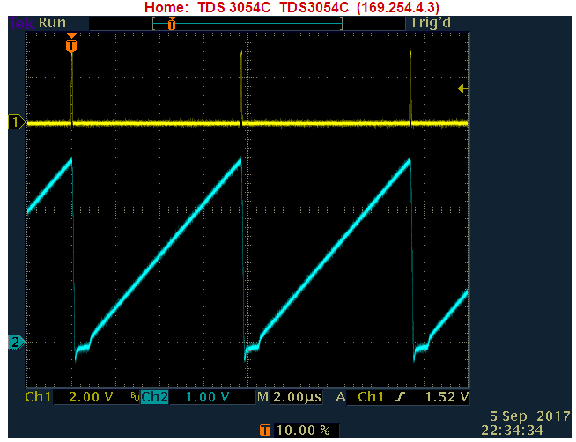
Signal P_PDA
Signal V_Sat
Figure 5: Latching Circuit Operation

Fixed Noise Testing

Theory:
- A “fixed” noise test provides noise data without the Shot noise contribution. The Fixed noise test closes the shutter to remove all light to the PDA. Without light the Photo diodes provide only a small dark current therefore removing virtually all of the PDA’s Shot noise contribution.

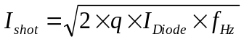 ; 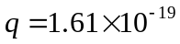

- The fixed noise results are represented in raw ADC counts. The fixed noise is simply the standard deviation of the double correlated value of raw counts. In a detector raw data must be captured while the shutter is closed. When testing the PCB only, disconnect the PCB from the input voltage source and the 330K resistor. Refer to Figure 6.

Test Setup:
- The input of the Charge Amplifier is disconnected from the outside world by releasing vacuum to the fixture. Use serial port command “dcorrdata” to collect several thousand pixels of data.
- The Fixed Noise is the standard deviation of the raw data after subtracting the error term from the error+pixel term.

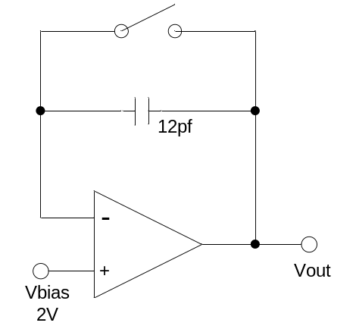
Figure 6: Fixed Noise Test Set-Up

Charge Injection Testing

Theory:
- The charge injection introduces a step change in output voltage when S1 switches from on to off, refer to Figure 7 below. The change is a function of the amount of charge injected and the load capacitance (12pF). And, the charge injection voltage is calculated by Vout (at T1) minus 2V.
- Note: T1 is the error voltage readout timing.
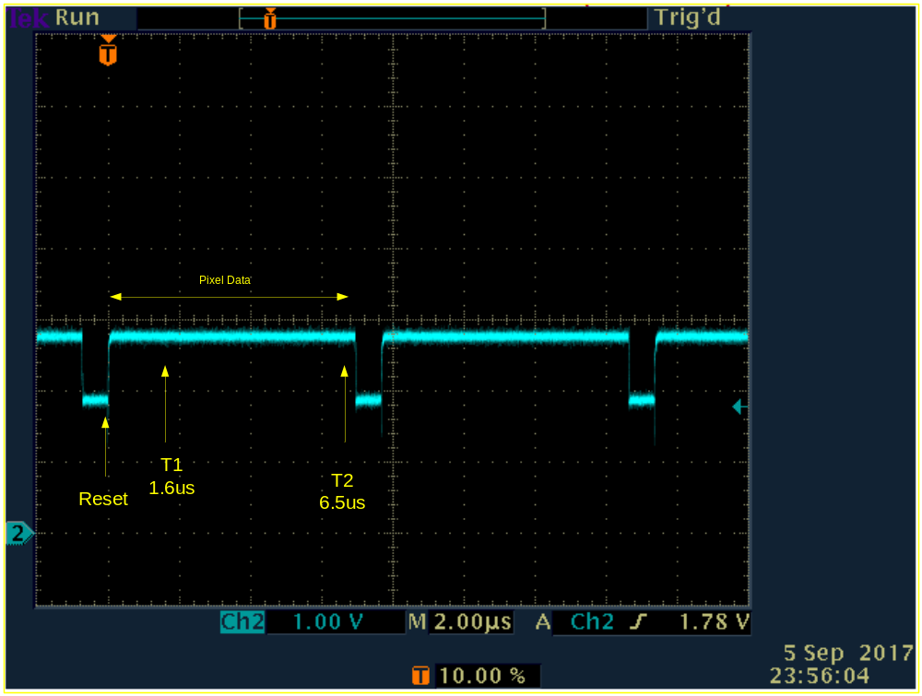
Figure 7: Charge Injection

Test Setup:
- Use the average raw error data collected from the Fixed Noise test.

Charge Amplifier Speed Testing

Theory:
- The Charge Amplifier is an integrating amplifier. It is important that signals integrated by the Charge Amplifier are fully integrated and stable at the time that they are converted by the A-D converter. This test will measure the speed in which the Charge Amplifier will integrate the charge injection. Refer to Figure 9.
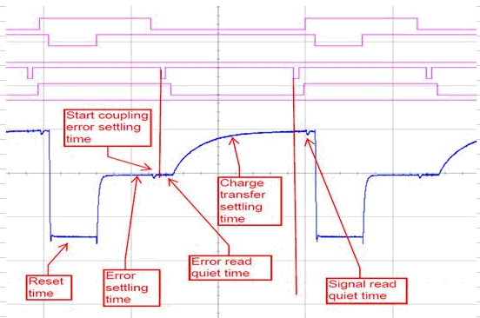
Figure 9: Timing Diagram of Operation with Hamamatsu PDA

Test Setup:
- The VBias voltage reference was measured prior to testing. This voltage is applied to the inverting input of the Charge Amplifier thru the 330K resistor by a precision voltage source, refer to figure 1. This is as close to true zero signal as is possible while still having a signal connected. The resulting output will be the charge injection only.
- The oscilloscope is set up to trigger on and measure the rise time of the INT_PDA signal, which is the output of the Charge Amplifier. See Figure 10.
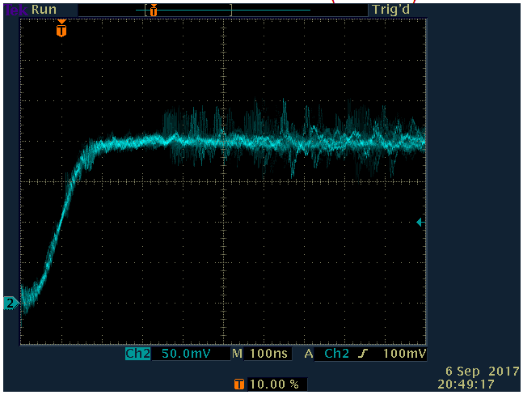
Figure 10: Charge Injection Rise Time

Test Specifications

LINEARITY TEST | SPECS LIMITS
- Linearity Error | -0.05 to +0.05 %FS
- Slope | -78500 to -75000 ADC Counts/Volt
LATCHING CIRCUIT TEST
- V_Sat pulse width | 25 to 75 ns
- Input Clamping voltage | -0.3 to -1 VDC
- P_PDA Peak Voltage | 4.096 to 4.5 VDC
NOISE TEST
- Fixed Noise | 2 to 7 ADC Counts
- Charge Injection | 8000 to 18400 ADC Counts
CHARGE AMP SPEED TEST
- Signal Rise Time | 30 to 150 ns

