DOCUMENT TITLE: PM / Setup Electrical Safety Testers
DOCUMENT TYPE: Calibration Preventive Maintenance
EQUIPMENT NAME: Electrical Safety Analyzer
QuadTech Guardian 6000
QuadTech Guardian 6000 Plus
Chroma 19032
EQUIPMENT NUMBER: 735003029

AUTHOR(S): Matt Brule | DATE: August 14, 2013
REVISED BY: Matt Brule | DATE: July 01, 2016

Table of Contents:
Reference Documentation 3
Scope and notes about this procedure 3
1. Calibration 4
2. Setup (All tester types) 4
3. QUADTECH Guardian 6000 Setup 5
4. Quadtech Guardian 6000 Installation 10
5. Quadtech Guardian 6000Plus or Chroma 19032 setup 11
6. Quadtech Guardian 6000 PLUS / CHroma 19032 Installation 17
Programming PARAMETERS QUADTECH Guardian 6000 19
Programming parameters QuadTech Guardian 6000 Plus / Chroma 19032 20
Electrical safety Analyzer Equipment List 21
QuadTech Guardian 6000 Setup Record 22
QuadTech Guardian 6000 PLUS / Chroma 19032 Setup Record 23

Equipment Required
Quantity | Part Number | Description
N/A | N/A | N/A

Disposables Required
Quantity | Part Number | Description
N/A | N/A | N/A

Reference Documentation
Document Number | Description
WAT046538 | GENERIC HI-POT & GND CONT Test PROC.
730001799 | Operating Procedure, Calibration and PM

Scope and notes about this procedure
This procedure details the programming of electrical safety test equipment for use in testing Waters’ product in manufacturing and at contract manufacturers worldwide.

There are three electrical safety analyzers that can be used to perform this testing:
- QuadTech Guardian 6000
- QuadTech Guardian 6000 Plus
- Chroma 19032

The QuadTech Guardian 6000, QuadTech Guardian 6000 Plus, and the Chroma 19032 are set up with a single program in memory location 1 named 12345678 to test all Waters’ product.

The programming parameters for memory location 1 in all testers are equal, there are some differences in nomenclature, and the more advanced units have additional capability that is not used, but the tests executed are equivalent.

All figures in this procedure are for reference only and are intended to be representative of actual testers and may not be exact.

- Calibration
  - Referring to 730001799, outsource the calibration of the electrical safety analyzer.
- Setup (All tester types)
Upon return from calibration (or anytime setup of a new or existing tester is required) follow the appropriate process below depending on the instrument model being setup.
  - Inspect all UUT interface cables and replace any that are worn.
  - Connect power cord
  - Power up instrument
    - Complete sections 3 and 4 for the QuadTech Guardian 6000.
    - Complete sections 5 and 6 for QuadTech Guardian 6000 Plus or the Chroma 19032.

- QUADTECH Guardian 6000 Setup
  - Key Lock
    - Look at the analyzers front panel to see if Key Lock is locked by observing the LED in Figure 1. If Key Lock is locked go to step 3.1.2 to disable it, if not continue to step 3.2.
    - Type the 4 digit password from the calibration database then press the Off key. The Key Lock LED will turn off, indicating that the Key Lock is unlocked.
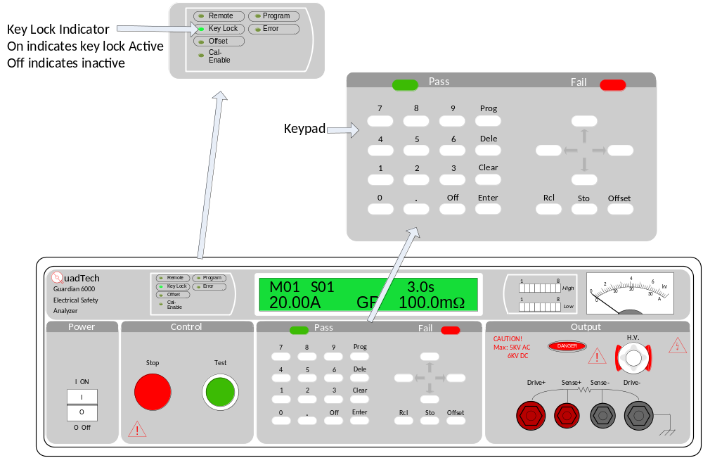
Figure 1: QuadTech Guardian 6000 front panel with Key Lock and keypad

  - Remove all installed programs.
    - With the analyzer in standby status, (no lights blinking).
    - Press the Red Stop button.
    - Press Clear, 6, 0, 0, 0, Clear, the display will appear as in Figure 2.

Figure 2: QuadTech Guardian 6000 Main screen with Memory location 1 loaded at step 1
    - Press the Enter key. The beeper will sound and all front panel LEDs will flash once, the display will return to STEP-01 in the upper left (Figure 3). The other text on the display can be ignored.
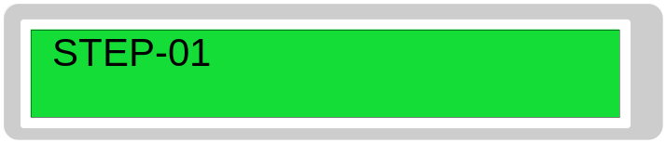
Figure 3: QuadTech Guardian 6000 at Step 1
  - Use left / right arrow keys to adjust the display contrast if necessary.

  - Program Memory Location 1.
Use the keypad and display (Figure 4) to program.
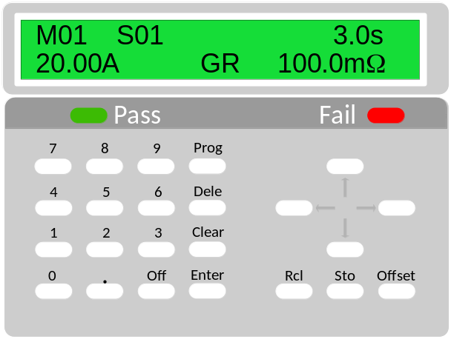
Figure 4: QuadTech Guardian 6000 display and keypad
    - Press the Prog key, the screen will appear as in Figure 5.
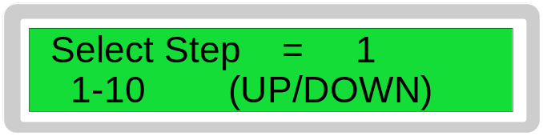
Figure 5: QuadTech Guardian 6000 Select Step

    - Press Enter to begin programming.
    - Enter all parameter settings to match the table below.
Use the Enter key to scroll through each parameter.
Use the up and down arrow keys to scroll through the settings for each parameter and the numeric keys to enter numeric values.
From the Select Step screen (Figure 5), use the up and down arrow keys to toggle between test steps.
    - Record all of the parameter settings on the QuadTech Guardian 6000 Setup Record on page 22.
PARAMETER | SETTING | DESCRIPTION
Step 1
Mode | GR | Ground Continuity / Bond test
Current | 20.00A | Test Current
High Limit | 100.0mΩ | Test Upper Limit
Low Limit | Disable | Test Lower Limit
Test Time | 3.0s | Total test time
Step 2
Mode | WDC | Dielectric Withstand (Hi-Pot)
Voltage | 2.121 kV | Test Voltage
High Limit | 5.00mA | Test Upper Limit
Low Limit | Disable | Test Lower Limit (Not used)
Arc Limit | Disable | Arc Limit (Not used)
Hold / Test Time | 3.0s | Time voltage is applied
Ramp Time | 2.0s | Time voltage takes to rise from 0 V to Test Voltage

    - When programming is complete and all parameter settings are correct, press the Prog key to exit programming mode.
  - Store the program in Memory location 1.
    - Press the Sto key, use the arrow keys to select location memory location 1 and Press Enter
    - Enter ‘12345678’ and Press the Enter key, the screen will appear as in Figure 6.
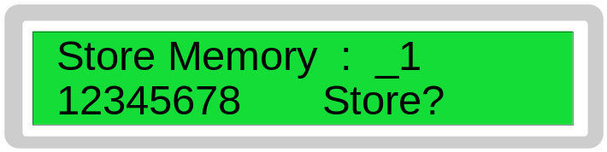
Figure 6: QuadTech Guardian 6000 Store memory location 1
    - Press Enter to store the program the display will look like Figure 7.
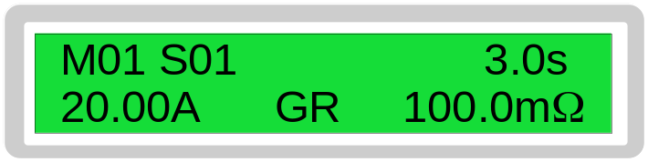
Figure 7 QuadTech Guardian 6000 programmed

- Quadtech Guardian 6000 Installation
  - Apply preventative maintenance sticker per 730001799.
  - Install at point of use per test procedure WAT046538.
  - Demonstrate correct parameter settings to Test Engineering and Manufacturing.
    - From the initial screen, press the RcL key.
    - Press Enter twice to recall memory location 1, 12345678.
    - From the initial screen, press the Prog key.
    - If necessary, scroll to step 1 using the arrow keys
    - Use the Enter key to scroll through each parameter for step 1, repeat as necessary to review all parameters. Test settings are summarized on page 19.
    - From the Select step screen use the arrow keys to select step 2.
    - Use the Enter key to scroll through each parameter for step 2, repeat as necessary to review all parameters. Test settings are summarized on page 19.
    - Press the Prog key to exit.
    - Load the correct program: Memory location 1.
      - Press the Rcl key
      - Use the up and down arrow keys to scroll to the correct program.
      - Press Enter twice to recall the program.
      - Press the Clear key.
  - Lock the Key Lock.
    - From the initial screen, type the 4 digit password from the calibration database then press the Off key. The Key Lock LED will illuminate. The display will appear as in Figure 8
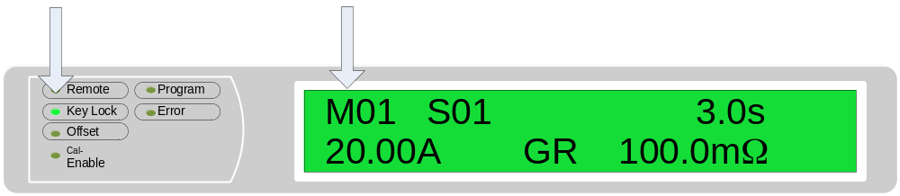
Figure 8: QuadTech Guardian 6000 Final setup screen
  - Sign and date the QuadTech Guardian 6000 Setup Record (Page 22).
  - Obtain signature on the QuadTech Guardian 6000 Setup Record of Test Engineering and the Manufacturing Technician that setup is correct, the correct program is loaded, and the keypad is locked.
  - Store the Setup Record in the calibration folder per procedure 730001799.

The Electrical Safety Analyzer is now ready for use. Sections 5 and 6 only need to be completed for the QuadTech Guardian 6000 Plus or Chroma 19032.

- Quadtech Guardian 6000Plus or Chroma 19032 setup
The only difference on the front control panel between a QuadTech Guardian 6000 Plus and a Chroma 19032 is the name of the instrument, see Figure 9. This section will refer to both testers, pictures will reference the QuadTech Guardian 6000 Plus.
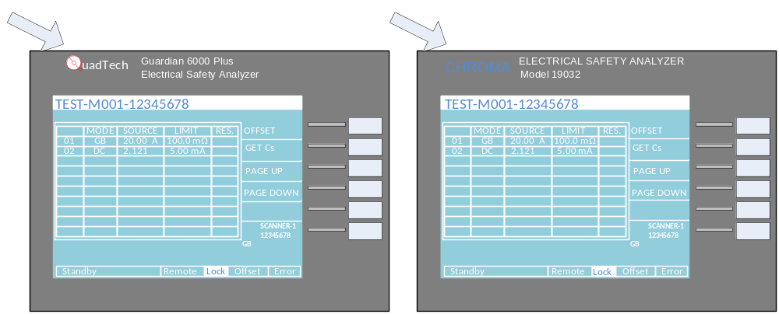
Figure 9: Difference between QuadTech Guardian 6000 Plus and the Chroma 19032
The primary interface for the QuadTech Guardian 6000Plus and the Chroma 19032 is the blue LCD, it’s ‘soft keys’, and the numeric keypad. Figure 10 shows the interface at the MAIN MENU.
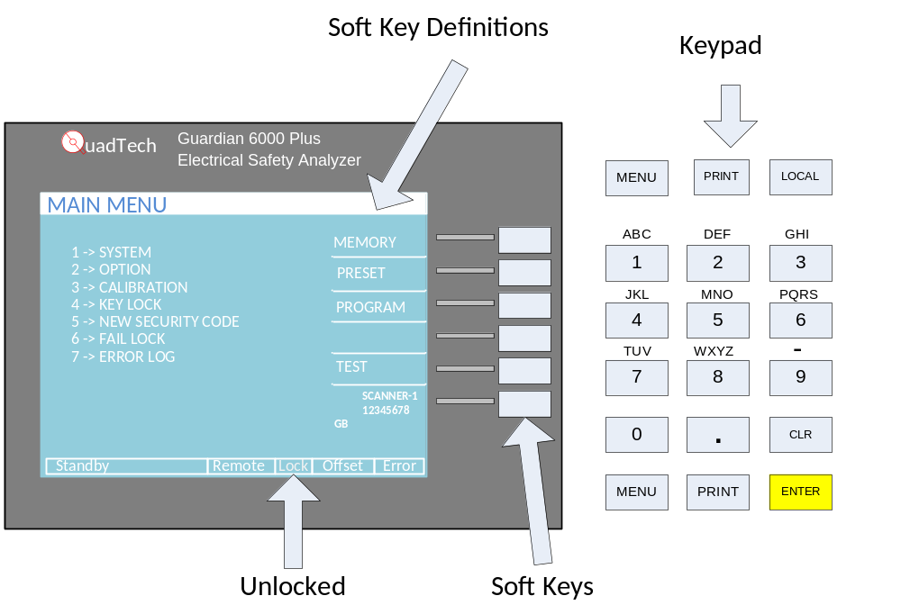
Figure 10: QuadTech Guardian 6000 Plus / Chroma 19032 Key soft keys and keypad
  - Key Lock
    - Look at the analyzers front panel to see if Key Lock is locked by observing ‘Lock’ on the bottom of the display is in reverse text (see Figure 11 left). If Key Lock is locked go to step 5.1.2 to unlock it, if not continue to step 5.2.
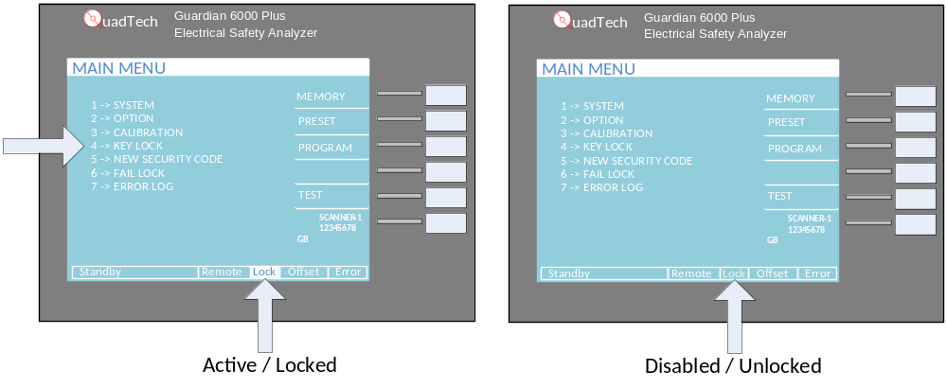
Figure 11: QuadTech Guardian 6000 Plus / Chroma 19032 Key Lock indicator and menu choice
    - From the Main menu (Figure 11), press the 4 key.
    - Type the 4 digit password from the calibration database then press Enter, the screen will return to the main menu with Key Lock unlocked.
  - Remove all installed programs.
    - From the MAIN MENU, press the MEMORY soft key.
    - Using the PAGE UP and PAGE DOWN soft keys, scroll through all 100 memory locations and verify that there are none programmed. Use the DELETE soft key to delete any found.
Program locations 2- 10 in Figure 12 are not programmed, note there is no program name and 0 program steps. While program location 1 shows 2 steps and the name .12345678’
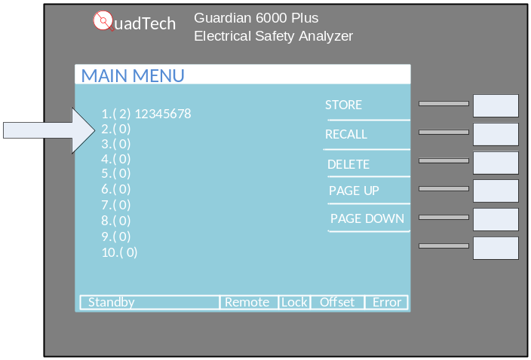
Figure 12: QuadTech Guardian 6000 Plus / Chroma 19032 Identifying a program
  - Program M emory Location 1.
  - Use the display and keypad (Figure 13) to program.
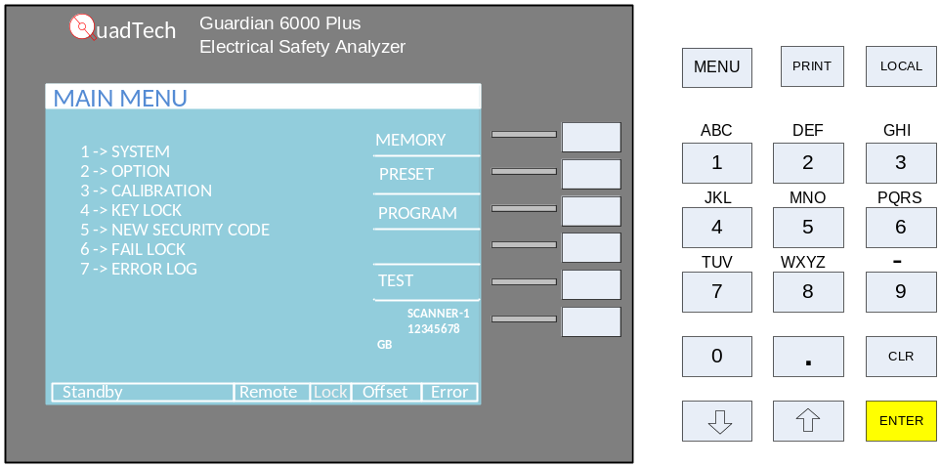
Figure 13: QuadTech Guardian 6000 Plus / Chroma 19032 display / keypad

    - From the MAIN MENU, press the PROGRAM soft key.
    - Enter all parameter settings to match the table below (also shown in Figure 14 for reference).
Use the up and down arrow keys to scroll through for each parameter, the soft keys to select setting, and the numeric keys to enter numeric values.
Use the UP / DOWN soft keys to navigate between test steps.
    - Record all parameter settings on the QuadTech Guardian 6000 Plus / Chroma 19032 Setup Record on page 23.
PARAMETER | SETTING | DESCRIPTION
Step 1
Mode | GB | Ground Continuity / Bond test
Current | 20.00A | Test Current
High Limit | 100.0mΩ | Test Upper Limit
Low Limit | OFF | Test Lower Limit
Test Time | 3.0s | Total Test Time
Twin Port | OFF | Not Used
Step 2
Mode | DC | Dielectric Withstand (Hi-Pot)
Voltage | 2.121 kV | Test Voltage
High Limit | 5.00mA | Test Upper Limit
Low Limit | OFF | Not Used
Dwell Time | OFF | Not Used
Arc Limit | OFF | Not Used
Arc Filter | 3-230 kHz | Not Used
Test Time | 3.0s | Time voltage is applied
Ramp Time | 2.0s | Time voltage takes to rise from 0 V to Test Voltage
*Fall time | OFF | Not used
CHNL (H_L) | OFF | Not Used
*Fall time is only present on the Chroma 19032 instruments, N/A Guardian 6000 Plus

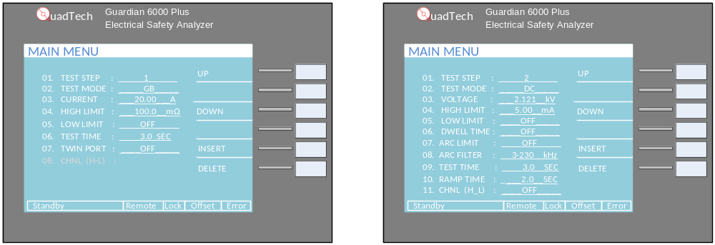
Figure 14: QuadTech Guardian 6000 Plus / Chroma 19032 step 1 settings

    - From the MAIN MENU, press the MEMORY soft key. The MEMORY SETUP screen will be displayed (Figure 15)
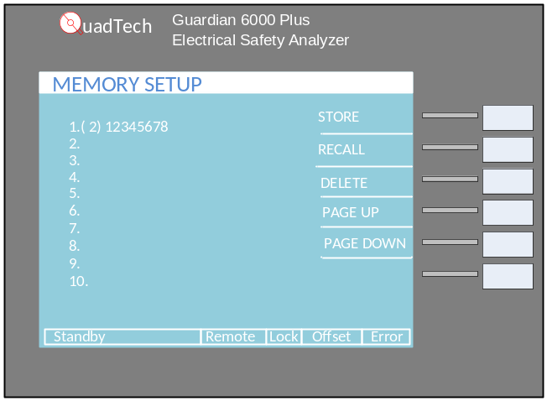
Figure 15: QuadTech Guardian 6000 Plus / Chroma 19032 memory setup
    - Press the STORE soft key.
    - Enter the program name 12345678, then press the ENTER key.
- Quadtech Guardian 6000 PLUS / CHroma 19032 Installation
  - Apply preventative maintenance sticker per 730001799.
  - Install at point of use, setup per test procedure WAT046538.
  - Demonstrate correct parameter settings to Test Engineering and Manufacturing Technician.
    - From the MAIN MENU, Press the MEMORY soft key.
    - Press the RECALL soft key with the program in memory location 1, 12345678 highlighted to recall it.
    - Press the ENTER key to confirm the recall.
    - Press the MENU key to display the MAIN MENU.
    - Press the PROGRAM soft key.
    - Verify test step 1 settings.
    - Press the UP soft key.
    - Verify test step 2 settings.
    - Press the MENU key to display the MAIN MENU
    - Press the MEMORY soft key. The MEMORY SETUP screen will be displayed.
    - Press the RECALL soft key with the program in memory location 1, 12345678 highlighted to recall it.
    - Press the ENTER key to confirm the recall.
    - Press the MENU key to display the MAIN MENU.

  - Lock the Key Lock.
    - Press the 4 key to recall the Key Lock
    - Type the 4 digit password from the calibration database then press Enter.
    - Verify that the MESSAGE is RECALL LOCK : YES, press the EXIT soft key. The MAIN MENU will be displayed.
    - Press the TEST soft key. The display will appear as in Figure 16, with the test program displayed (TEST-M001-12345678), and the LOCK text in reverse test.
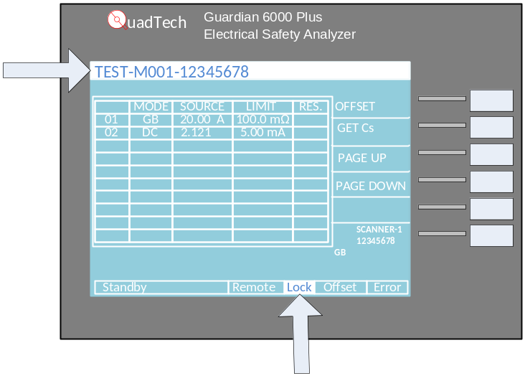
Figure 16: QuadTech Guardian 6000 Plus / Chroma 19032 Final Setup Screen
  - Sign and date the QuadTech Guardian 6000 Plus / Chroma 19032 Setup Record.
  - Obtain signatures on the QuadTech Guardian 6000 Plus / Chroma 19032 Setup Record of Test Engineering and Manufacturing that setup is correct, the correct program is loaded, and the keypad is locked.
  - Store the Setup Record in the calibration folder
Electrical Safety Analyzer is now ready for use.

Programming PARAMETERS QUADTECH Guardian 6000
Following is a summary of programming parameters for the QuadTech Guardian 6000. This procedure details how to program and verify these parameters into memory location 1 named 12345678. As well as provides record / sign off / and approval of these settings and the locking of the analyzer keypad before production use.

Step 1
PARAMETER | Memory Location _1  12345678 | DESCRIPTION
Mode | GR | Ground Continuity / Bond test
Current | 20.00A | Test Current
High Limit | 100.0mΩ | Test Upper Limit
Low Limit | Disable | Test Lower Limit
Test Time | 3.0s | Total test time
Twin Port | OFF | Channel selection (Not used)
Step 2
Mode | WDC | Dielectric Withstand (Hi-Pot)
Voltage | 2.121 kV | Test Voltage
High Limit | 5.00mA | Test Upper Limit
Low Limit | Disable | (Not used)
Arc Limit | Disable | (Not used)
Hold Time | 3.0s | Time voltage is applied
Ramp Time | 2.0s | Time voltage takes to rise from 0 V to Test Voltage

The critical parameters are in reverse text.
Waters instruments require a ground continuity test, an instantaneous measurement, on a routine production basis. The test equipment used performs a ground bond test, which is the same as a ground continuity test, but, with current applied, and for a specified time. This Ground Bond test is more stringent than the Ground Continuity requirement, due to the increased current and longer duration.
.

Programming parameters QuadTech Guardian 6000 Plus / Chroma 19032

Following is summary of programming parameters for the QuadTech Guardian 6000 Plus and the Chroma 19032. This procedure details how to program and verify these parameters into Memory location 1 named 12345678. As well as provides record / sign off / and approval of these settings and the locking of the keypad before production use.
Step 1
PARAMETER | Setting | DESCRIPTION
Mode | GR | Ground Continuity / Bond test
Current | 20.00A | Test Current
High Limit | 100.0mΩ | Test Upper Limit
Low Limit | OFF | Test Lower Limit
Test Time | 3.0s | Total test time
Twin Port | OFF | (Not used)
Step 2
Mode | DC | Dielectric Withstand (Hi-Pot)
Voltage | 2.121 kV | Test Voltage
High Limit | 5.00mA | Test Upper Limit
Low Limit | OFF | (Not used)
Dwell Time | OFF | (Not Used)
Arc Limit | OFF | (Not used)
Arc Filter | 3-230 kHz | Not Used
Test Time | 3.0s | Time voltage is applied
Ramp Time | 2.0s | Time voltage takes to rise from 0 V to Test Voltage
*Fall time | OFF | (Not used)
CHNL (H-L) | OFF | (Not used)
*Fall time is only present on the Chroma 19032 instruments, N/A Guardian 6000 Plus

The critical parameters are in reverse text.
Waters instruments require a ground continuity test, an instantaneous measurement, on a routine production basis. The test equipment used performs a ground bond test, which is the same as a ground continuity test, but, with current applied, and for a specified time. This Ground Bond test is more stringent than the Ground Continuity requirement, due to the increased current and longer duration.

Electrical safety Analyzer Equipment List

Instrument  Serial Number | Identifier | Manufacturer | Model | Location
8280865 | 86041 | Quadtech | Guardian 6000 | Flextronics
1140656 | 90259 | Quadtech | Guardian 6000 | Milford
1140659 | 90261 | Quadtech | Guardian 6000 | Milford
1140657 | 90265 | Quadtech | Guardian 6000 | Milford
1140663 | 90266 | Quadtech | Guardian 6000 | Milford
1140662 | 90270 | Quadtech | Guardian 6000 | Milford
1140660 | 90282 | Quadtech | Guardian 6000 | Flextronics
5037654 | 91354 | Quadtech | Guardian 6000 | Milford
7312754 | 91356 | Quadtech | Guardian 6000 | Venture
5278621 | 91683 | Quadtech | Guardian 6000 | Venture
1140658 | 91862 | Quadtech | Guardian 6000 | Milford (Regulatory)
11173729 | 91890 | Quadtech | Guardian 6000 | Venture
1140661 | 92599 | Quadtech | Guardian 6000 | Milford
19032G400201 | 93237 | Chroma | 19032 | Milford
19032G400202 | 93238 | Chroma | 19032 | Milford
19032G400225 | 93260 | Chroma | 19032 | CEI
19032G400264 | 93467 | Chroma | 19032 | Venture
5037655 | 95037 | Quadtech | Guardian 6000 | Flextronics
G60000000174 | 95050 | Quadtech | Guardian 6000 Plus | Venture
9111936 | 95051 | Quadtech | Guardian 6000 Plus | Milford
6069766 | 98206 | Quadtech | Guardian 6000 | Flextronics
8060121 | 98210 | Quadtech | Guardian 6000 Plus | Milford
3505384 | 99099 | Quadtech | Guardian 6000 | Milford
3505383 | 99102 | Quadtech | Guardian 6000 | Milford
3505382 | 99103 | Quadtech | Guardian 6000 | Milford
3505381 | 99104 | Quadtech | Guardian 6000 | Milford

QuadTech Guardian 6000 Setup Record
ID Number:
Performed By: Date:
 | Memory 1: 12345678
 | PARAMETER | VALUE | SETTING
Step 1 | Mode | GR
Step 1 | Current | 20.00A
Step 1 | High Limit | 100.0mΩ
Step 1 | Low Limit | Disable
Step 1 | Test Time | 3.0s
Step 2 | Mode | WDC
Step 2 | Voltage | 2.121 kV
Step 2 | High Limit | 5.00mA
Step 2 | Low Limit | Disable
Step 2 | Arc Limit | Disable
Step 2 | Test Time | 3.0s
Step 2 | Ramp Time | 2.0s
Key Lock locked (Key Lock LED illuminated)
Program displayed: (M01)
Approved by:
Performer: Date:
Verified By: Test Engineering
Name: Title
Signature: Date:
End User Approval: Manufacturing Technician
Name: Title
Signature: Date:

QuadTech Guardian 6000 PLUS / Chroma 19032 Setup Record
ID Number:
Performed By: Date:
 | Memory 1: 12345678
 | PARAMETER | VALUE | SETTING
Step 1 | Mode | GB
Step 1 | Current | 20.00A
Step 1 | High Limit | 100.0mΩ
Step 1 | Low Limit | OFF
Step 1 | Test Time | 3.0s
Step 1 | Twin Port | OFF
Step 2 | Mode | DC
Step 2 | Voltage | 2.121 kV
Step 2 | High Limit | 5.00mA
Step 2 | Low Limit | OFF
Step 2 | Dwell Time | OFF
Step 2 | Arc Limit | OFF
Step 2 | Arc Filter | 3-230 kHz
Step 2 | Test Time | 3.0s
Step 2 | Ramp Time | 2.0s
Step 2 | *Fall Time | OFF
Step 2 | CHNL (H-L) | OFF
*Fall time is only present on the Chroma 19032 instruments, N/A Guardian 6000 Plus
Key Lock locked (‘Lock’ text in reverse)
Program displayed: (TEST-M001-12345678)
Approved by:
Performer: Date:
Verified By: Test Engineering
Name: Title
Signature: Date:
End User Approval: Manufacturing Technician
Name: Title
Signature: Date:

