appendix C – MSv test fixture 999045028 mounting instructions

- Prior to installation position the encoder slot (black wheel) so that it is between ports 2 and 3 of the MSV.
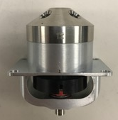

- Place the MSV onto the fixture with the encoder slot facing the front of the fixture. Twist the handle clock wise to tighten the handle to the MSV rotary shaft. Verify the valve is connected by attempting to pull up on the valve. If connected it will not be removable.

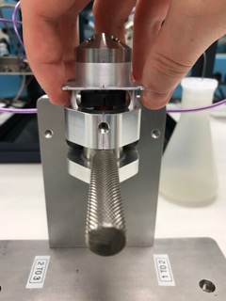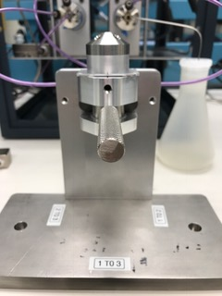

- Use the handle to rotate the valve to each port to port position.
