Instruction for PC Setup
Setting for Windows 10 & Software

Index
1. Delete PC name in AD 2
2. PXE of Ivanti 3
3. Lenovo ADS with USB (Future) 12
4. Copy Notes ID from old PC 26
5. Copy Data from old PC to new PC 29
6. Setup OneDrive 35
7. Install Adobe Reader (Optional) 40
8. Setup for IBM Connections 43
9. Windows Setting Change 47
10. Setting of Data format 53
11. Setting of Internet 58
12. Install Office 365 Language Pack 60
13. Setting of Office 64
14. Setting of Analysis Office 67
15. Setting of Notes 70
16. Setting of Wireless 88
17. Setting of SAP 91
18. Copy the shortcut 93
19. Install pDoc 94
20. Setting for CIT(Field user only) 104
21. Create FSR folder 105
22. Install PrimoPDF (Optional) 106
23. Install CutePDF 109
24. Setup Windows Firewall ON 113
25. Set the Windows Notification OFF 115
26. Mapping the network drive 116
27. Setup BitLocker 119

Delete PC name in AD
1-1 If this process for PC is a re-installation, please ask Waters APAC IT to delete the PC name in AD.

PXE of Ivanti
This instruction is for installation for PCs from Ivanti PXE server. If you are installing Windows 10 by ADS of Lenovo PCs, please go to step 3.

2-1 Start PC and click function key [F12] continue when the logo of Lenovo is shown. Select “PCI LAN“ and click “Enter”.
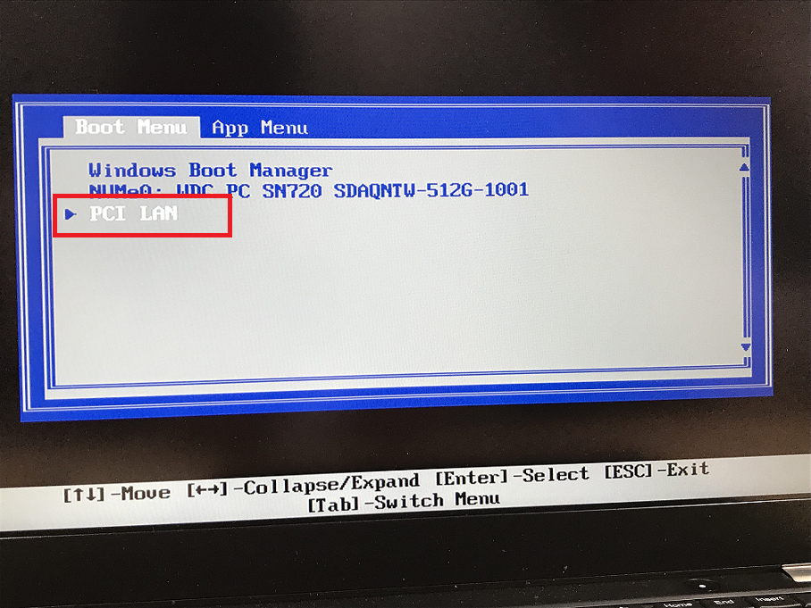

2-2 Please select the imaging file which you need to install. In this case, we selected Lenovo test imaging file.
Please select “\Provisioning templates\Public\xTest Windows 10\~Test Windows 10 64bit CFI Image O365”.
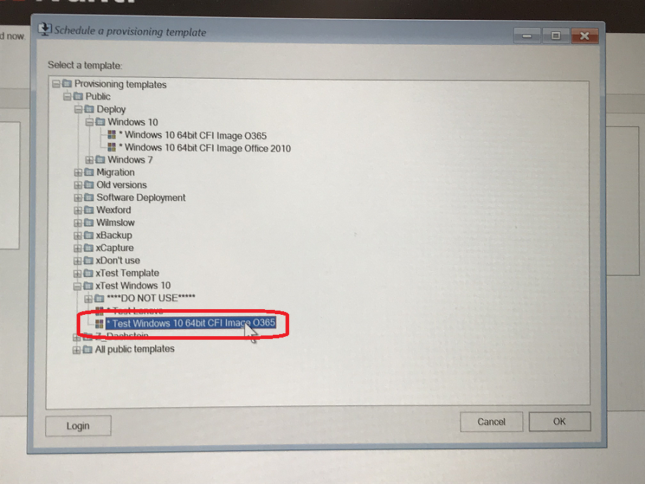

If you are using Dell PC now, please select “\Provisioning templates\Public\Deploy\Windows 10\~Windows 10 64bit CFI Image O365”.
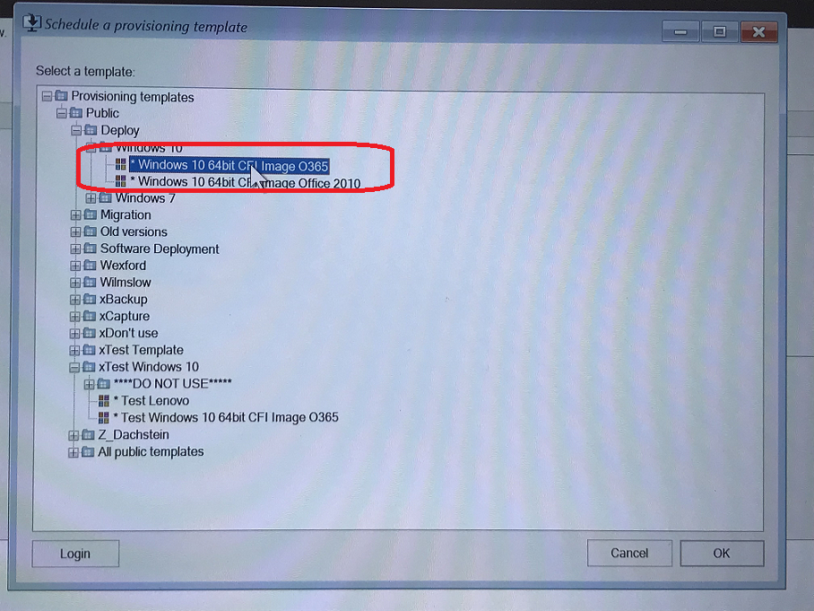

2-3 The program is running.
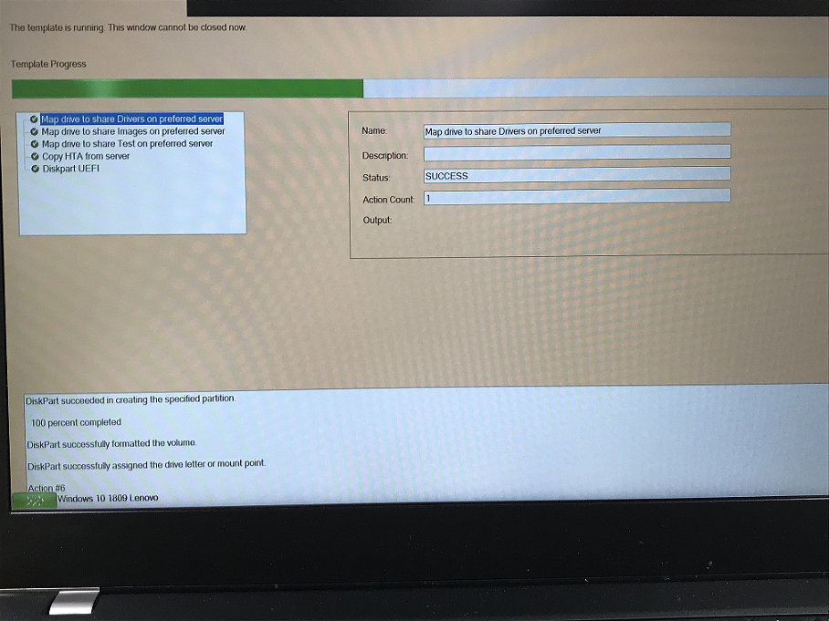
2-4 After the running the provisioning program, system will access Windows 10 to install Ivanti and SEP.
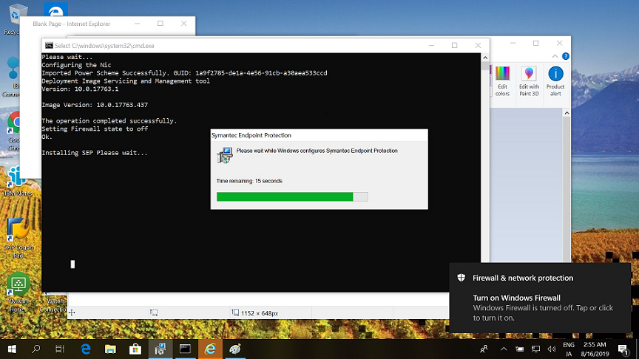

2-5 SEP is installed complete.
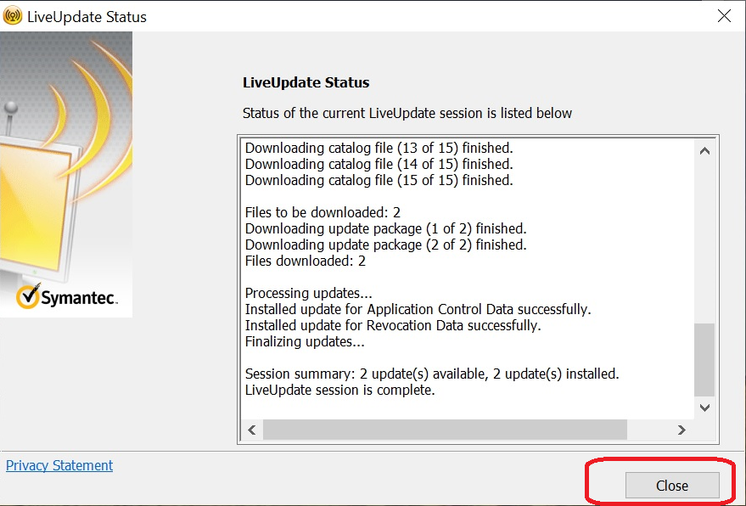
2-6 Naming Automation Tool will be shown.
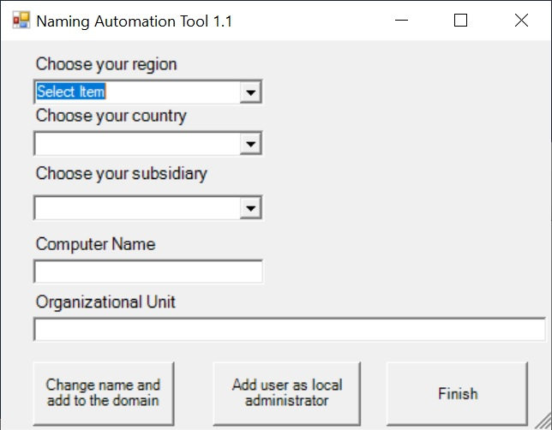

2-7 Select your region, country, and subsidiary, then click “Change name and add to the domain” button.
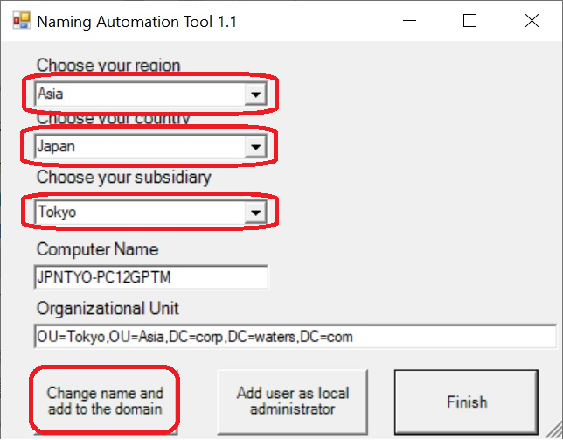
2-8 Input the user ID “corp\XXXXXX”, then click “Add user as local administrator” button.
Then click “Finish” button.
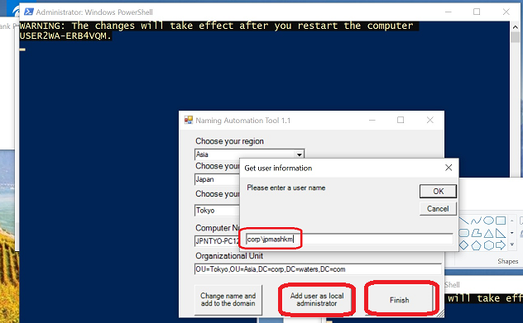

* If the PXE server is dead, you can use USB of PXE to install it. Please contact APAC IT to get the USB of PXE. Please click function key [F12], when the beginning of PC started. It will go to the following screen. Make sure the boot mode is “LEGACY” and select “USB Storage Device” to start. Then the nest screen will be the same as started from PXE server.
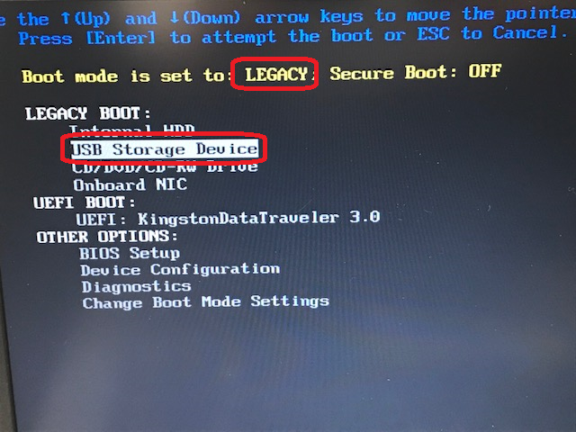
2-9 (For Dell Only) Since After the installation of Windows 10, it is only working in UEFI mode. Please change to UEFI mode. If you need to change to boot mode, please select the “Change Boot Mode Settings” option and push “Enter”.
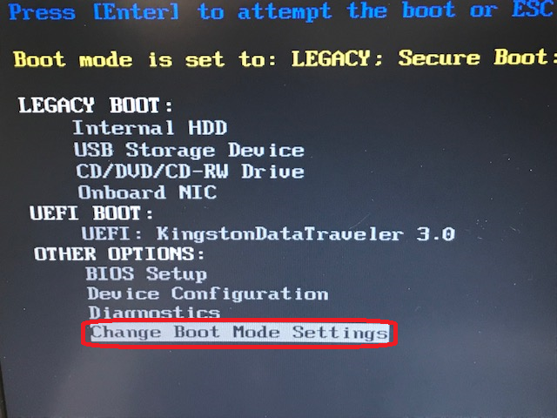

2-10 Select (1) UEFI Boot Mode, Secure Boot OFF” and push “Enter”.
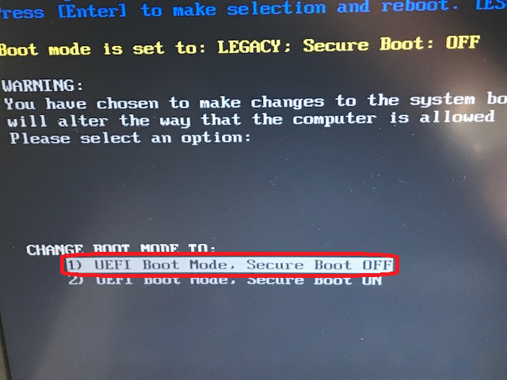
2-11 Select “Yes” and push ”Enter”.
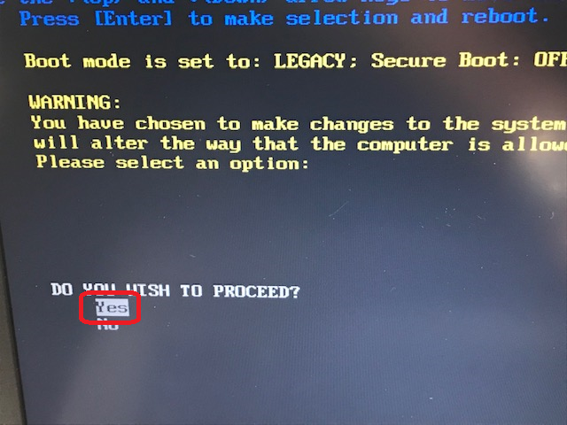

2-12 Select “Apply The Changes” and push “Enter”. Then you can change the boot mode which you want.
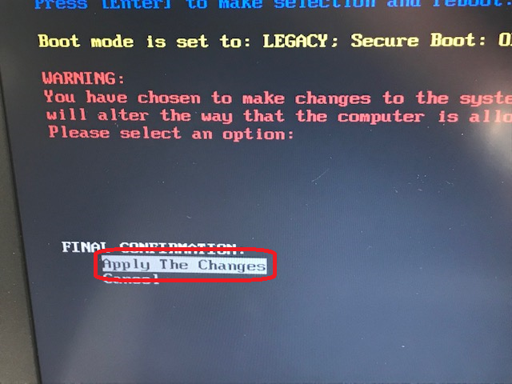

Lenovo ADS with USB (Future)
3-1 Basically, we will use PXE server or PXE USB to install PC. Just in case, maybe we will use USB of Lenovo ADS in future. When you started Lenovo PC tin the beginning and the text “To interrupt normal startup, press Enter” is shown to you, please click [F12] function key.
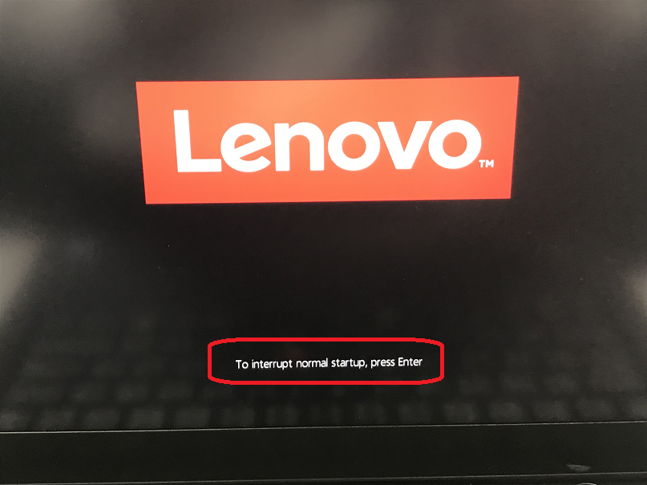

3-2 Select “USB HHD” to start it.
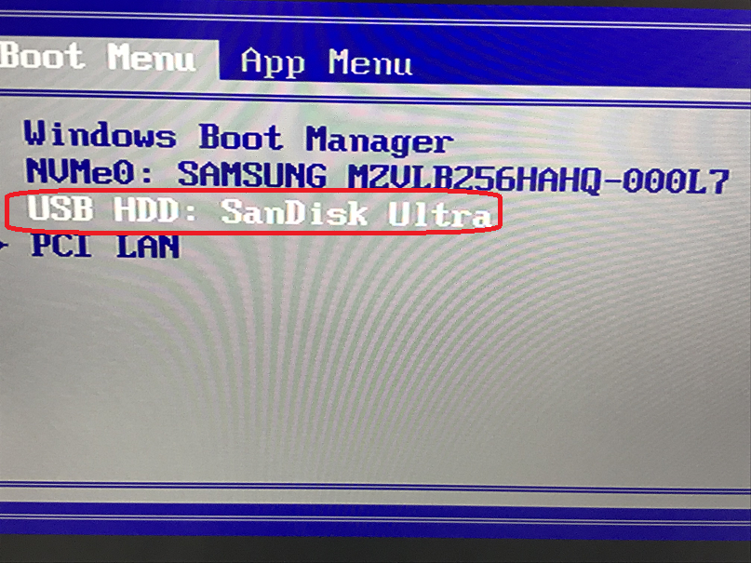
3-3 The program is running.
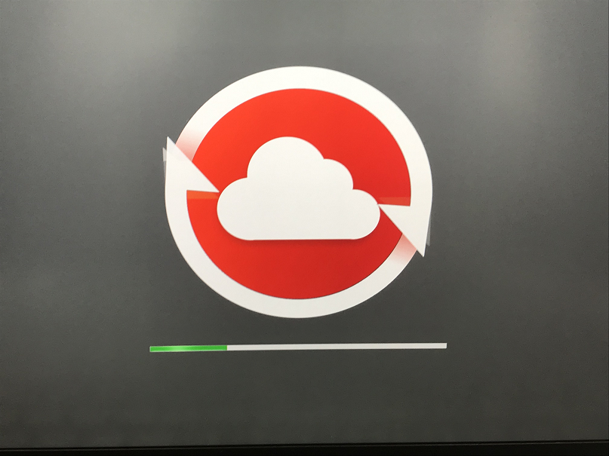

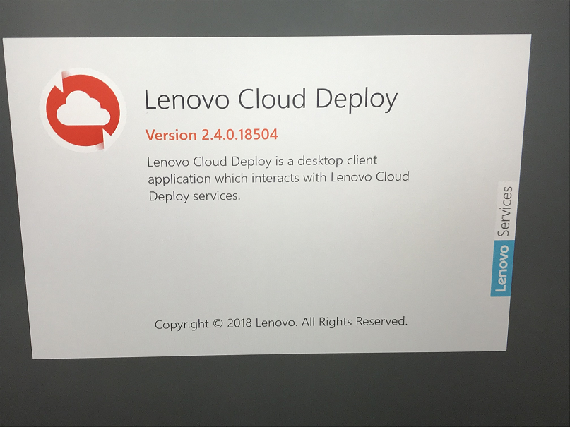
3-4 Input the ID and password to log in Lenovo Cloud Deploy. Currently, only Waters IT has the ID and password. In future, maybe it will be changed.
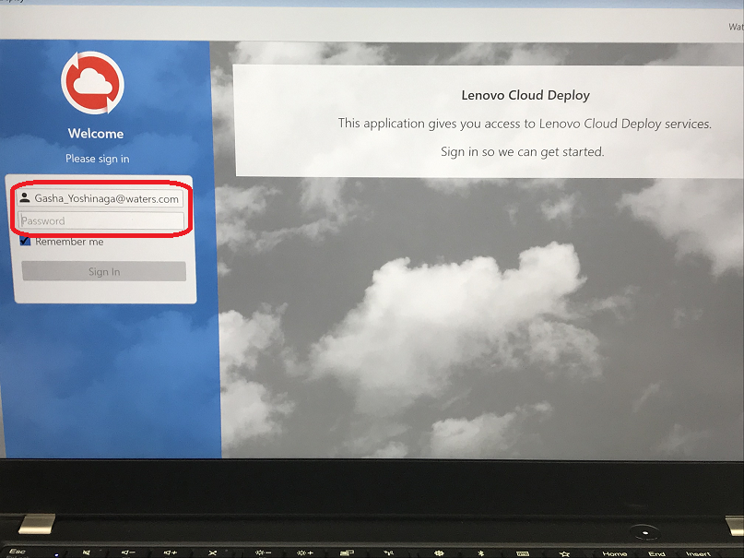

3-5 Click “Restore System” button.
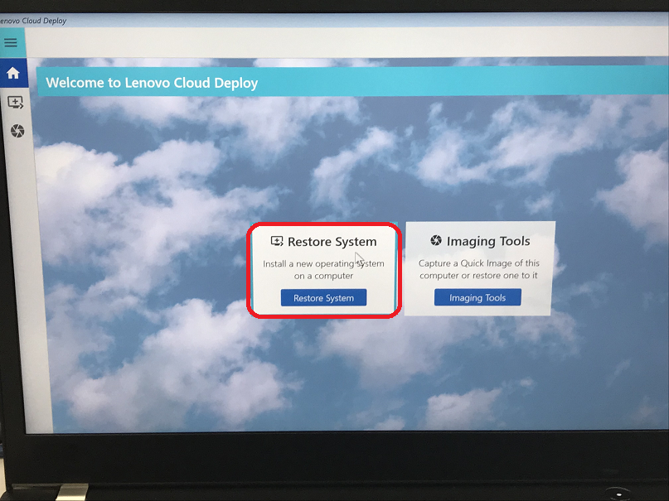
3-6 Click “Next”
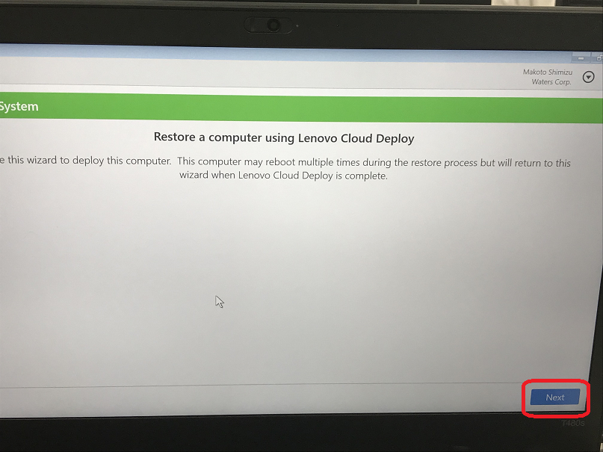

3-7 Tick the version which will be installed and click ”Next” button.
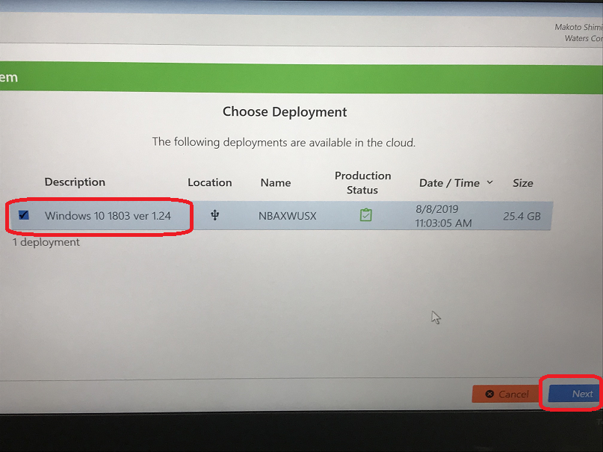
3-8 Tick the notification and click “Restore” button.
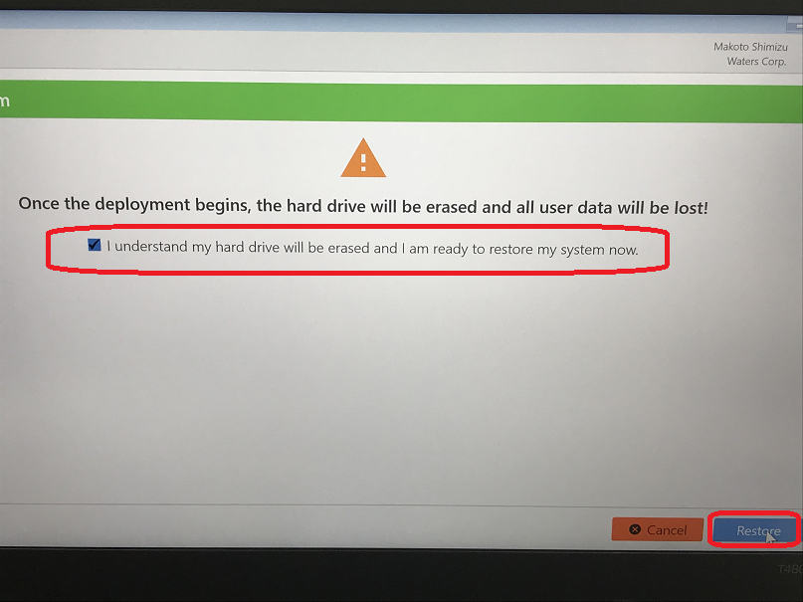

3-9 The copy is running.
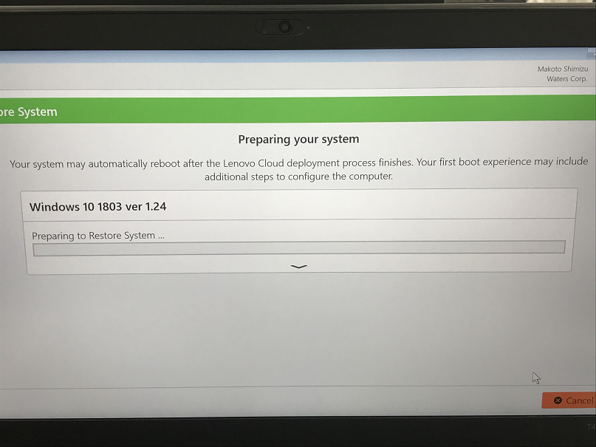
3-10 Click “No”.
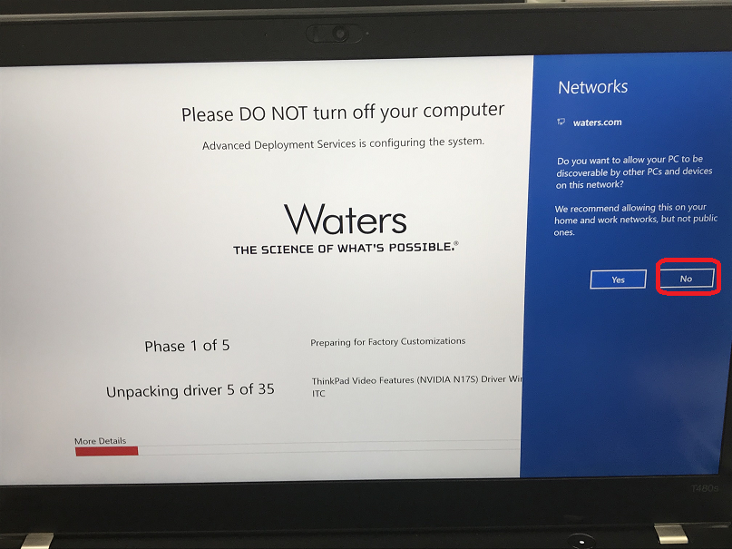

3-11 Phase 1 is running.
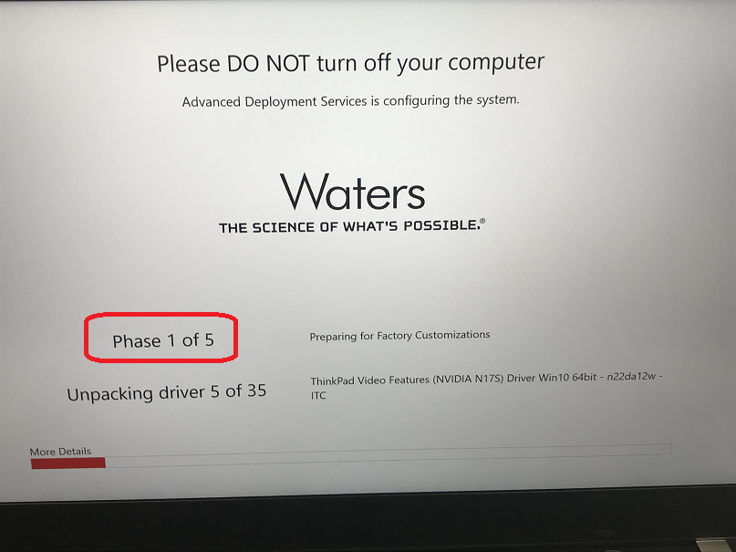
3-12 Phase 2 is running.
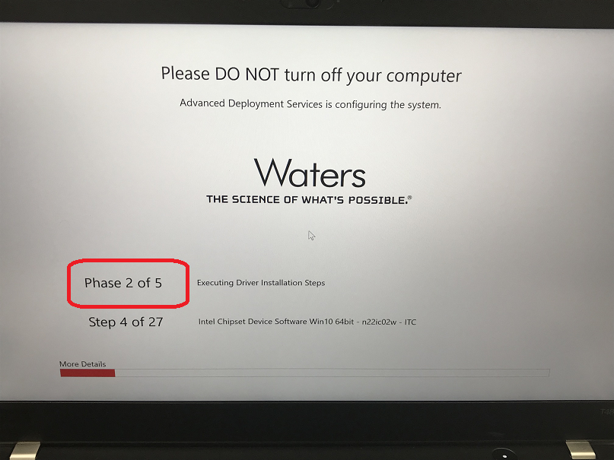

3-13 Phase 3 is running.
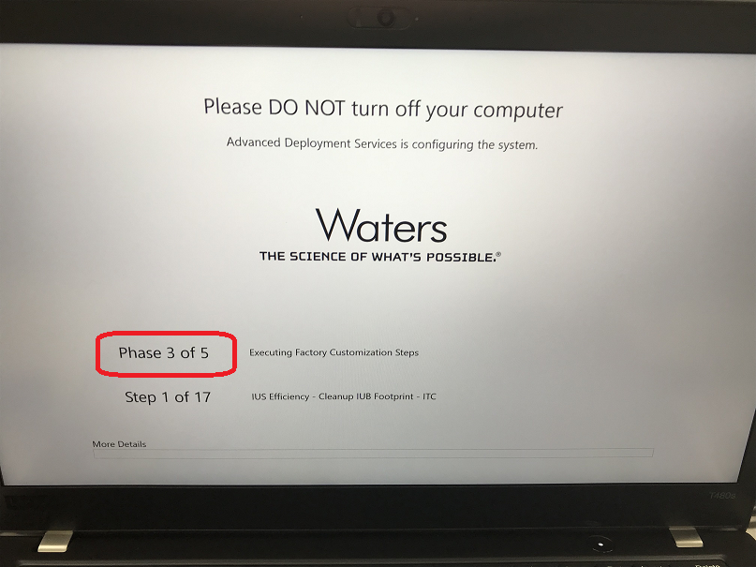
3-14 Following the instruction, remove the USB and reboot PC.
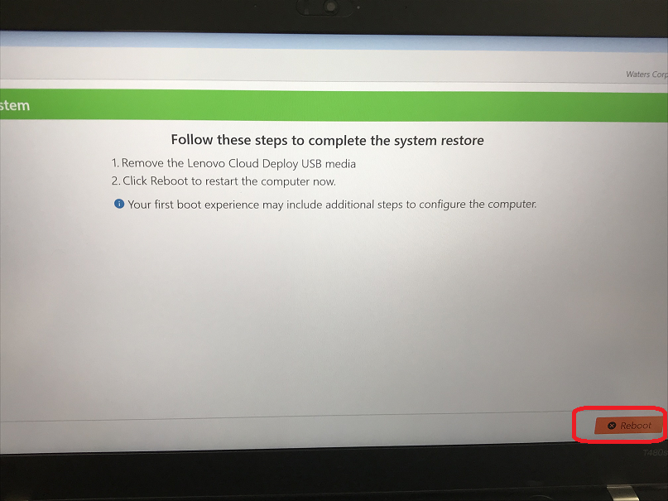

3-15 After PC is restarted, Phase 4 is running.
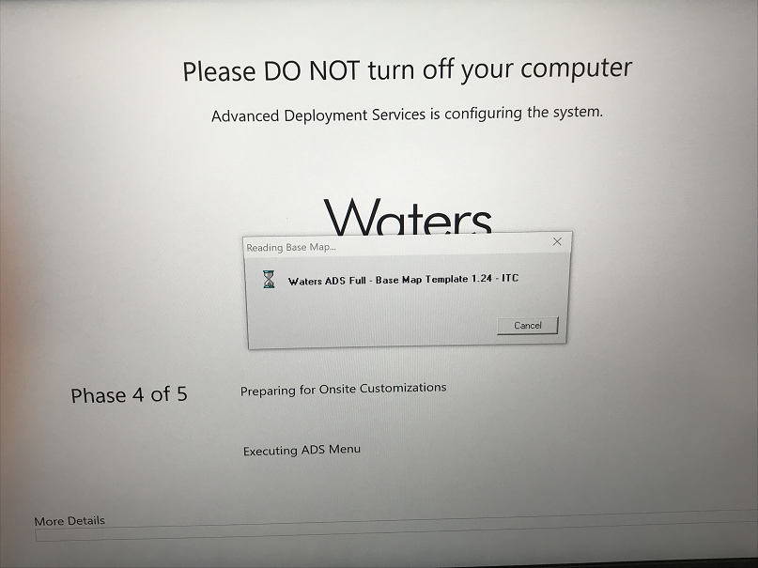
3-16 If you need to change the keyboard layout, select it and click “Next >” button.
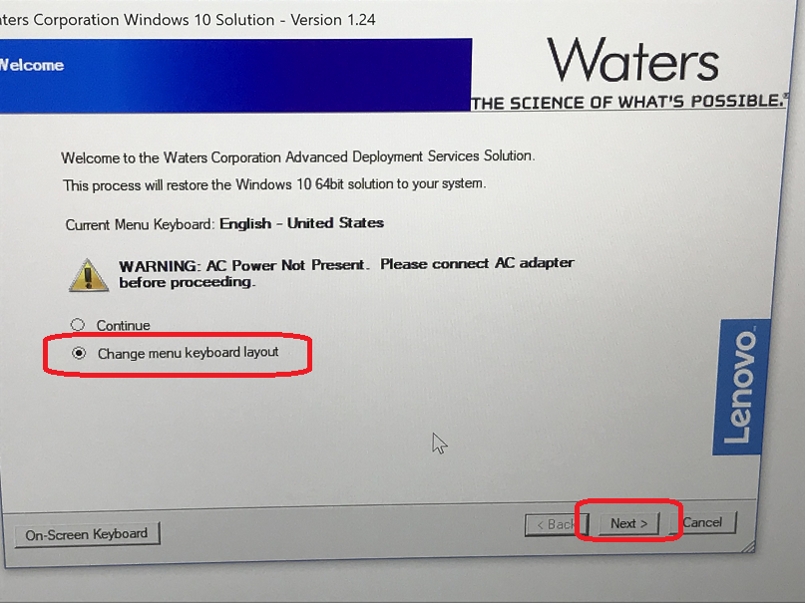

3-17 Select the keyboard you need and click “Next” button.
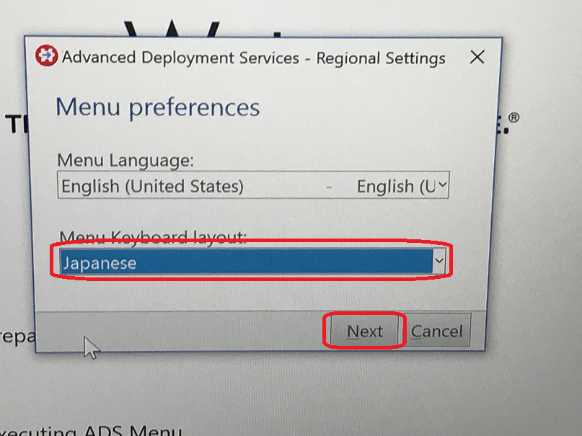
3-18 Click “Continue” and click “Next” button.
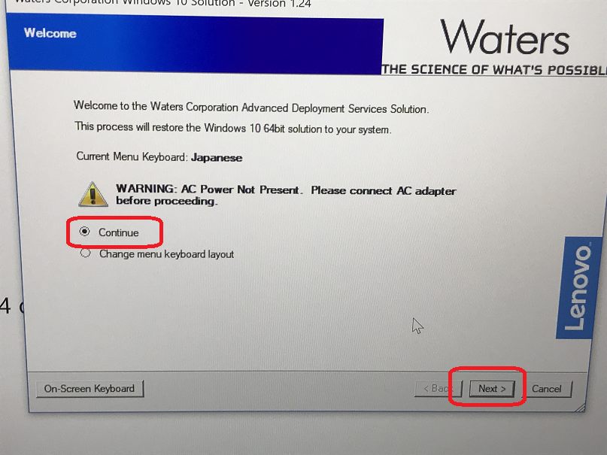

3-19 Select the region and click “Next” button.
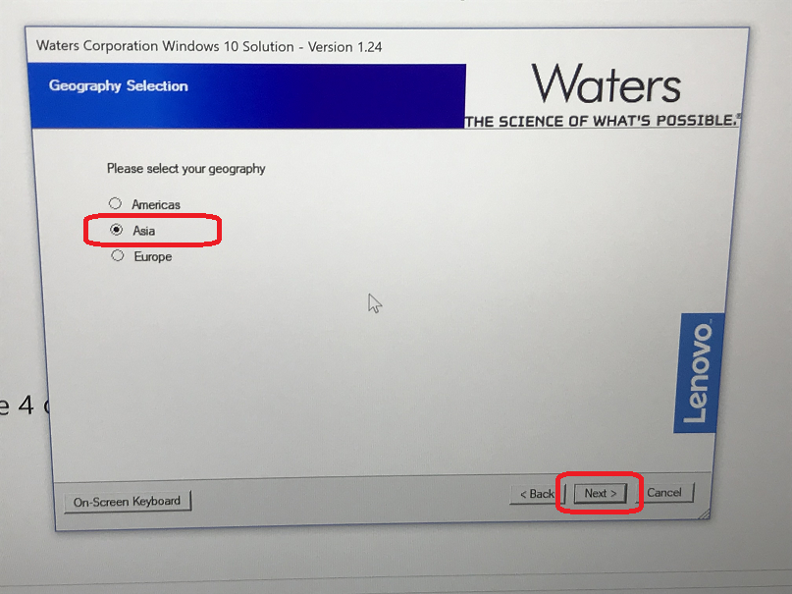
3-20 Select the country and click “Next” button.
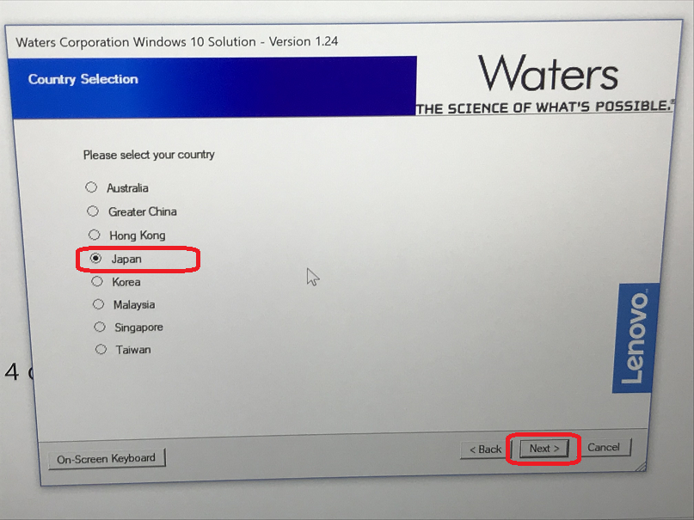

3-21 Select the city and click “Next” button.
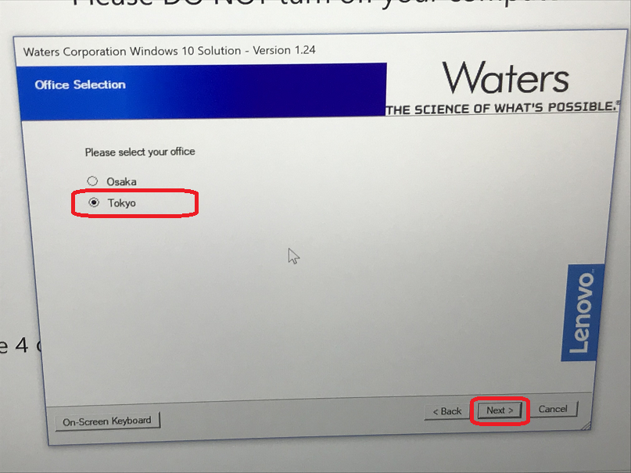
3-22 If the setting is OK, then select “Accept regional setting” and click “Next” button. If the setting is not OK, please click the item which you want to modify, then you can modify it.
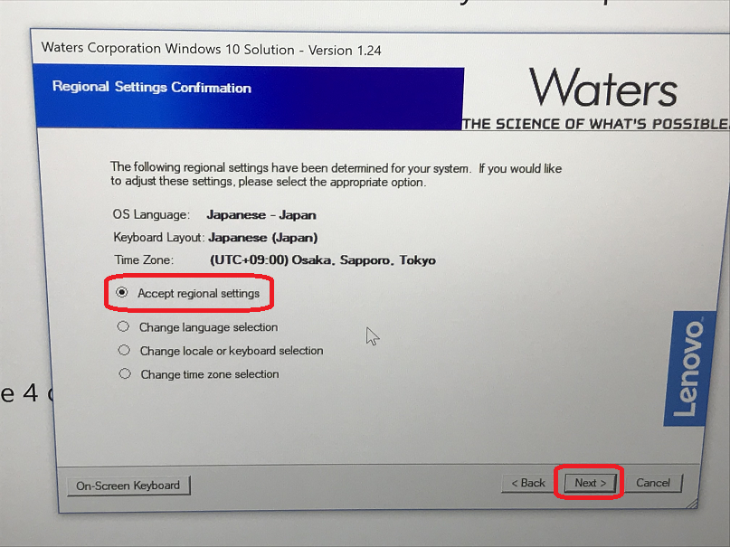

3-23 Input the ID and password of user whom you want to install for.
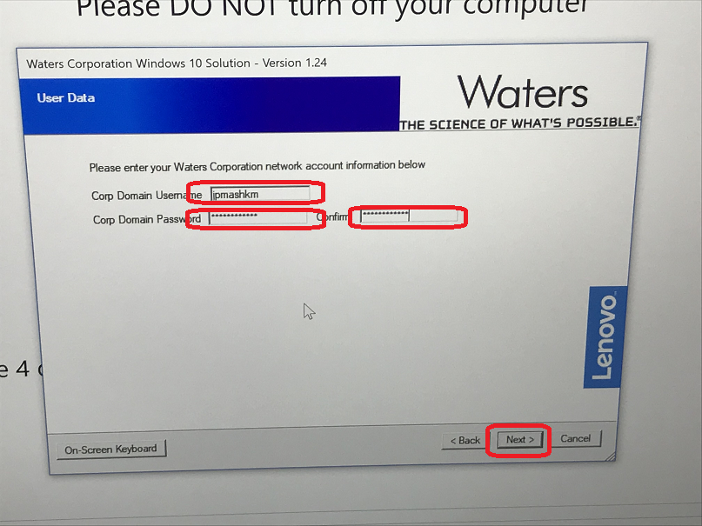
3-24 If the data is all correct, then select “Yes” and click “Next”. If not, please select to modify it.
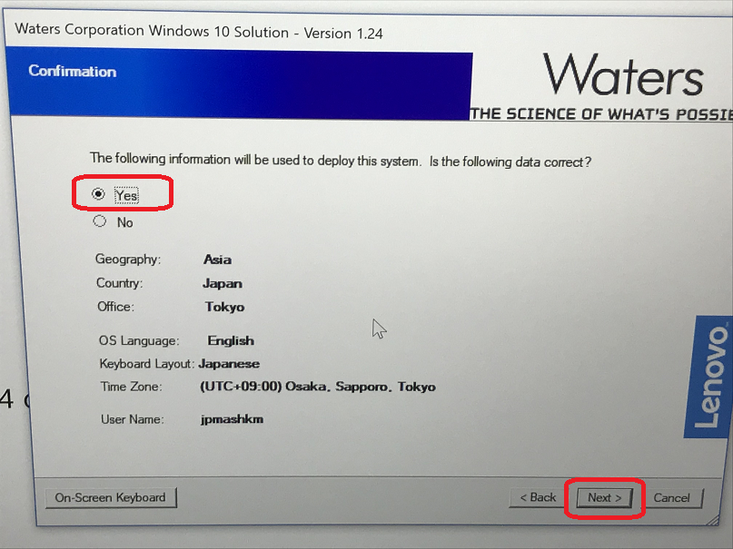

3-25 Phase 5 is running.
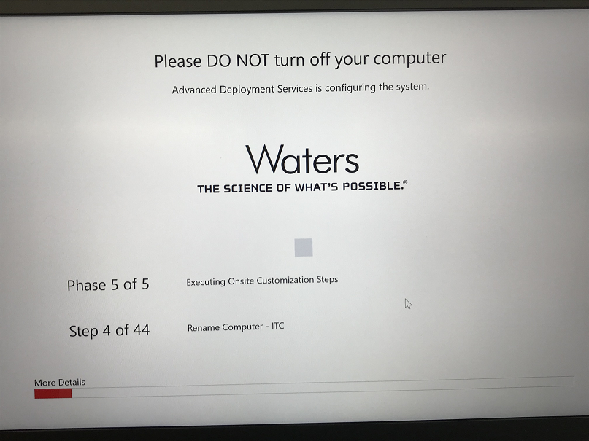
3-26 Click “Reboot” and the PC will be restarted.
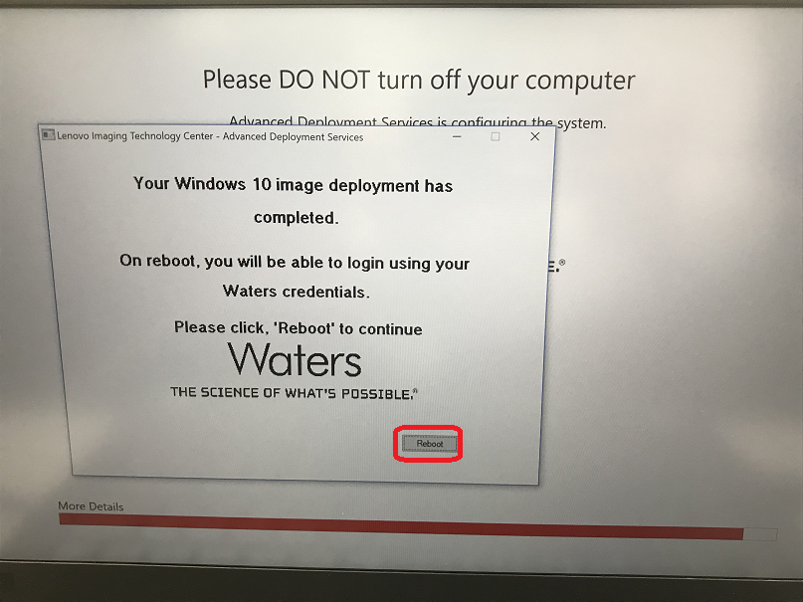

Copy Notes ID from old PC
4-1 Copy Notes IT from old PC. From Lotus Notes, click [File]-> [Security] and click “User Security…”.
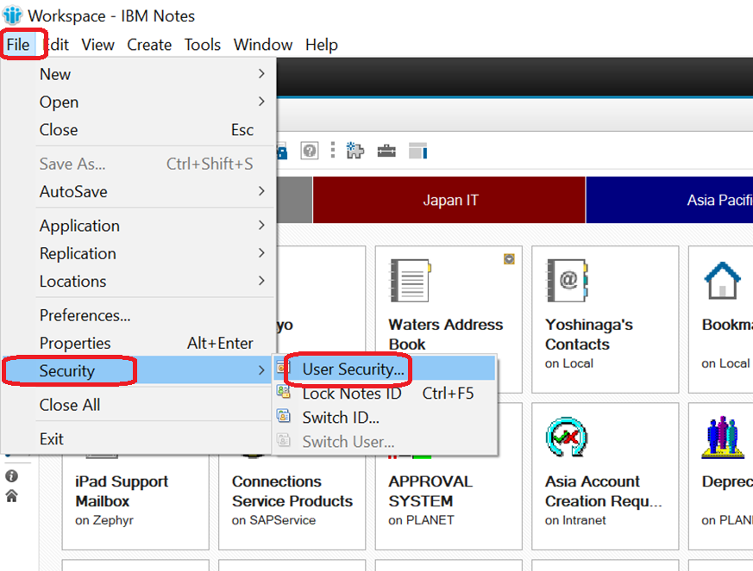

4-2 Input the password and click “OK” button.
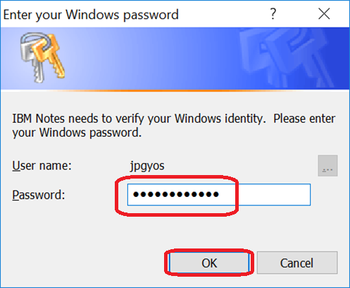
4-3 Please memo the user’s name, and click “Copy ID…” button.
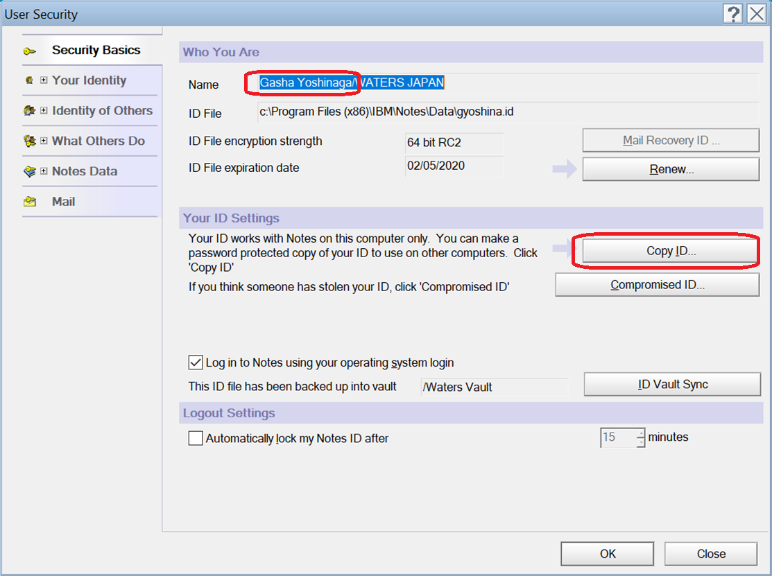

4-4 Select “Documents” folder and click “Save” to save the ID file.
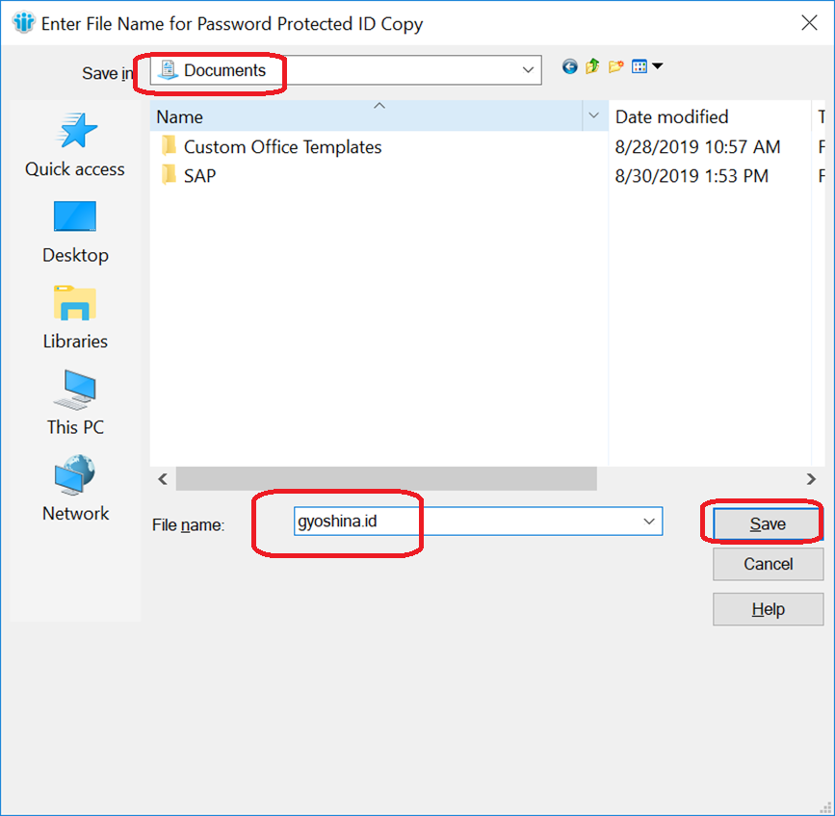
4-5 Click “OK”.
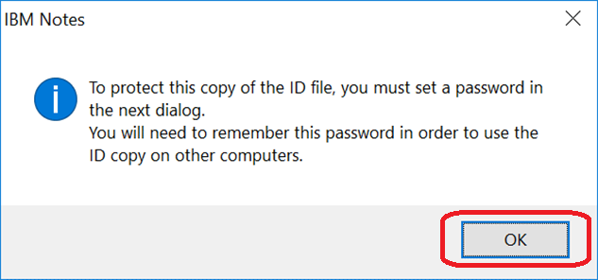

4-6 Input the “password” and click
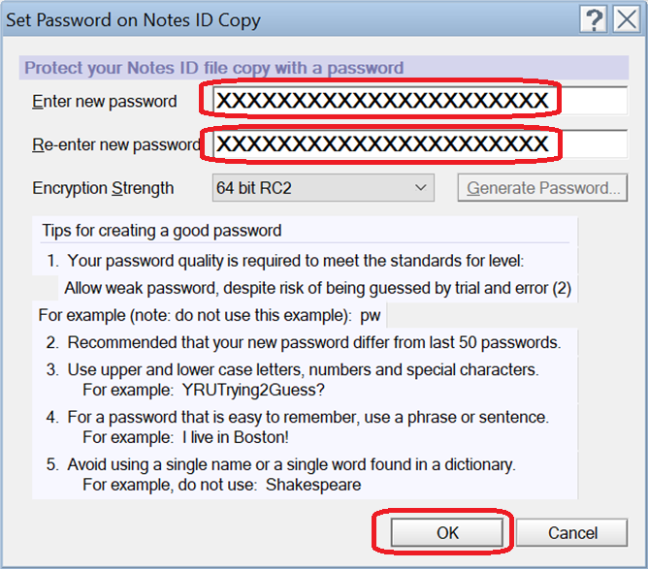

4-7 Click “OK”.
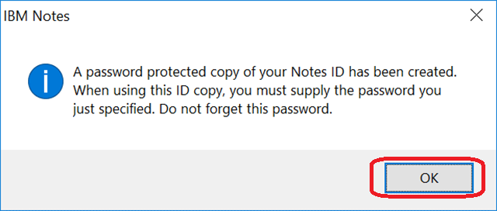

Copy Data from old PC to new PC
5-1 Please follow the steps to connect old PC and new PC to copy data. Double click “Network and Sharing Center” in “Control Panel”.
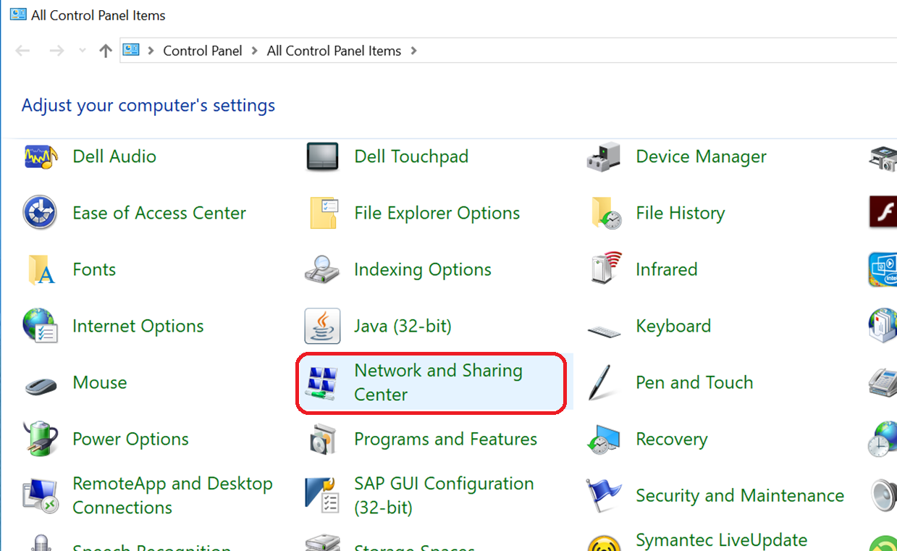

5-2 Double click “Change adapter setting” icon.
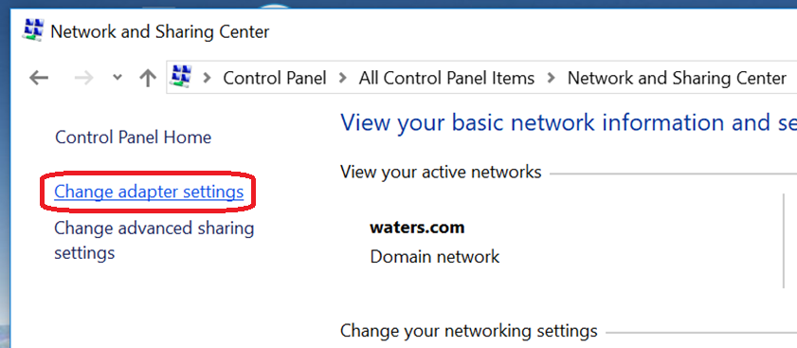
5-3 Double click the network icon which we will connect by LAN cable.
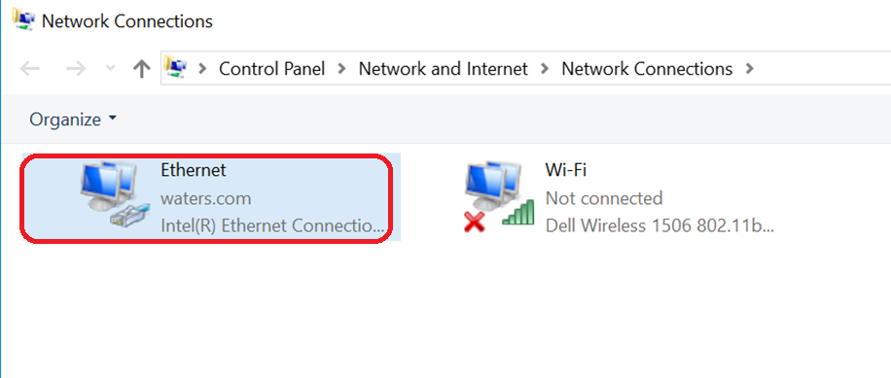

5-4 Click “Properties” button.
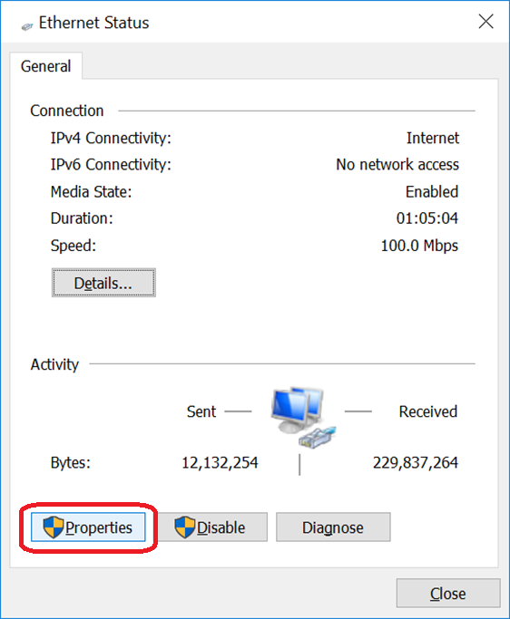
5-5 Select “Internet Protocol Version 4(TCP/IPv4), and click “Properties”.
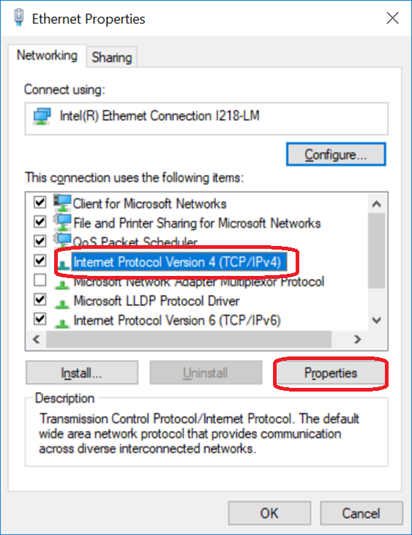

5-6 Input the IP address and subnet mask, and click “OK” button.
The example of old PC:
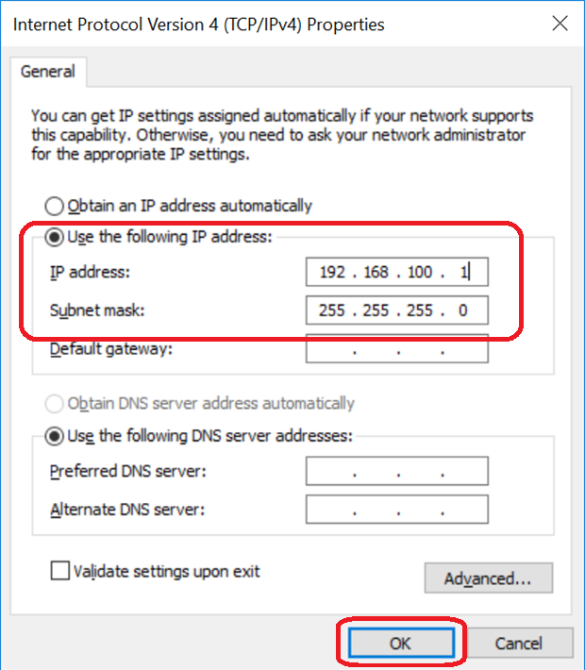
The example of new PC:
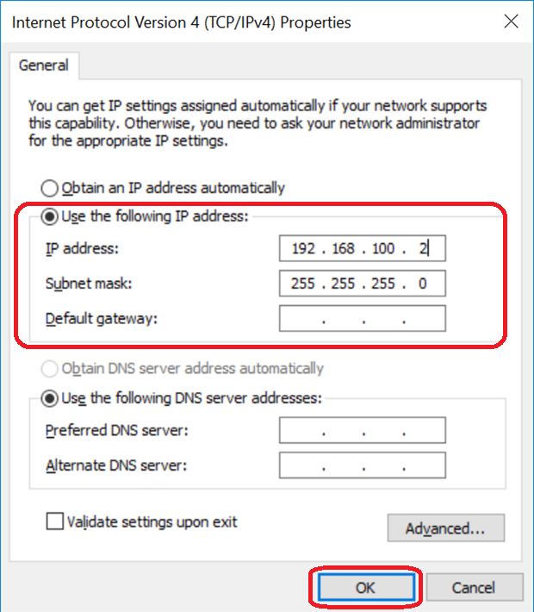

5-7 Please share OLD PC. Open Windows Explorer and select C:\ drive. Right click it and select “Properties”.
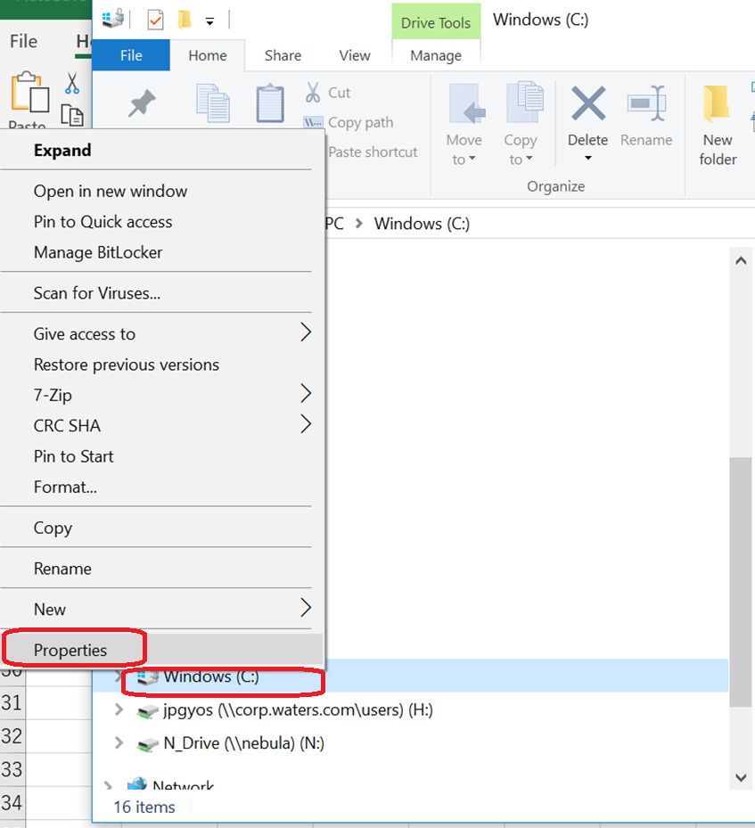
5-8 Click “Advance Sharing…” button.
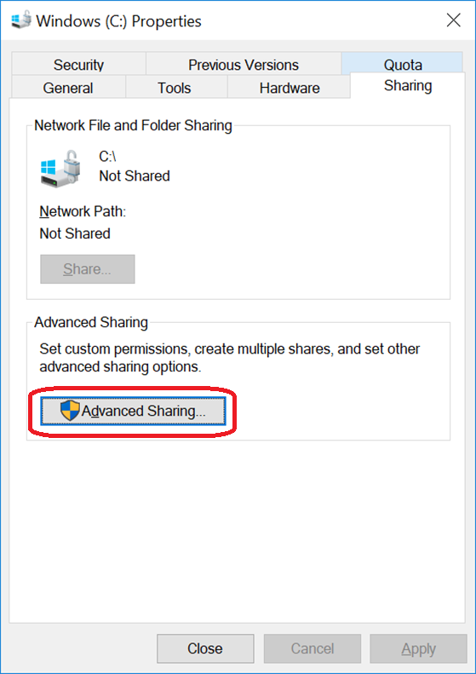

5-9 Tick “Share this folder” and click “OK”.
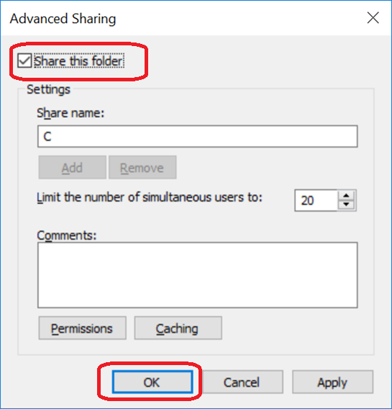
5-10 Then you should can see the C:\ drive of old PC from new PC. Please copy the data from old PC to new PC.
At least, it should have the following folders.

If user is not using OneDrive, please copy the following folders.

- My Favorites
- Desktop
- My Documents
- Notes\Data (copy to C:\temp folder)
- FSRReports
- Expense

Then go to the step 7..

If user is using OneDrive, please copy all files and all folder in C:\Users\XXXXXX\ OneDrive - Waters Corporation\.
And please also copy the following folders.

- Notes\Data (copy to C:\temp folder)
- FSRReports
- Expense

Then go to step 6 first.

5-11 After the copy, please return the setting which you changed in this step.
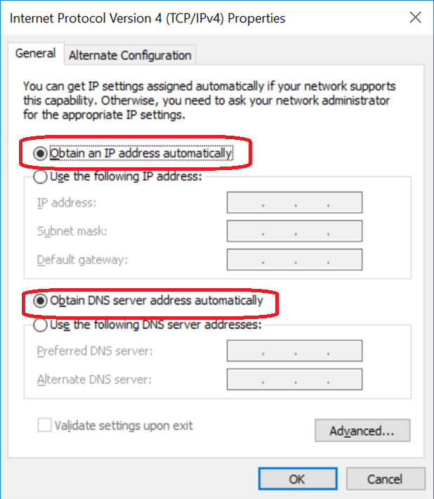

Setup OneDrive
6-1 Check user is using OneDrive or not in old PC. If user does not use OneDrive, please go to step 7.

6-2 Input “OneDrive” in the search icon. Make sure OneDrive is installed and running in that PC.
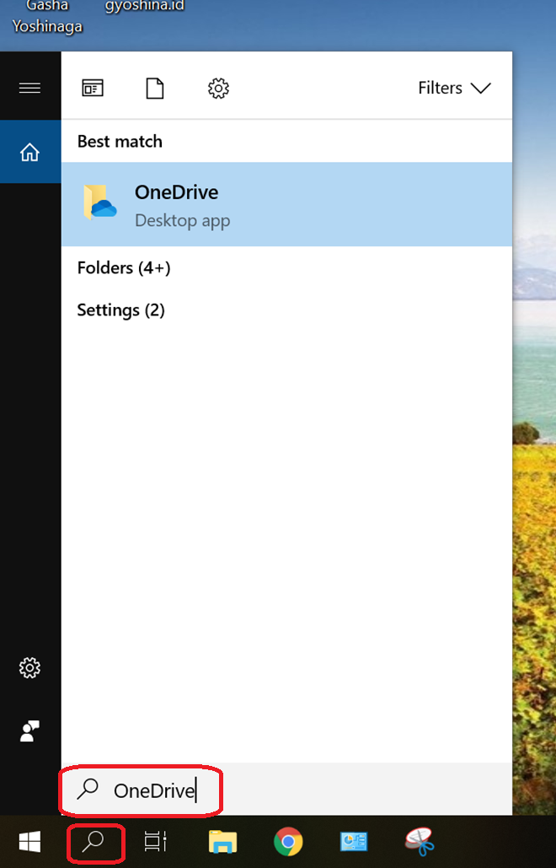

6-3 Click “OneDrive”.
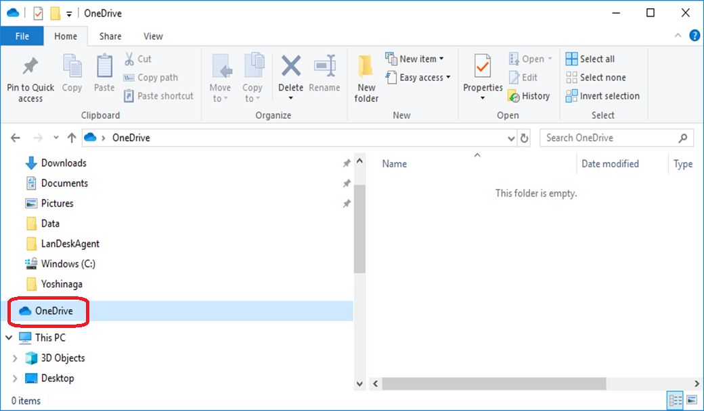
6-4 Make sure OneDrive is started and running. Click “Pause syncing” to stop running.
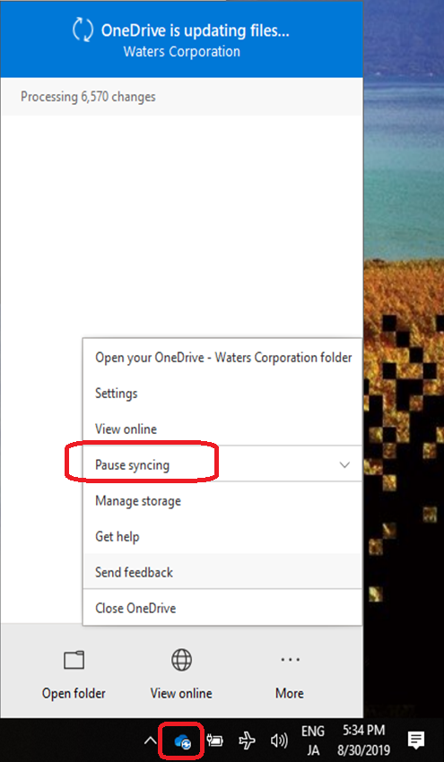

6-5 Click “24 hours”.
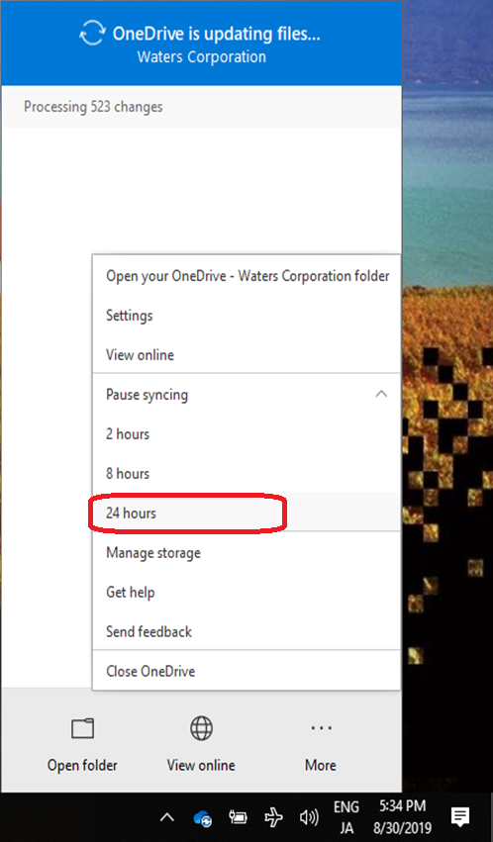

6-6 Make sure the OneDrive is not running.
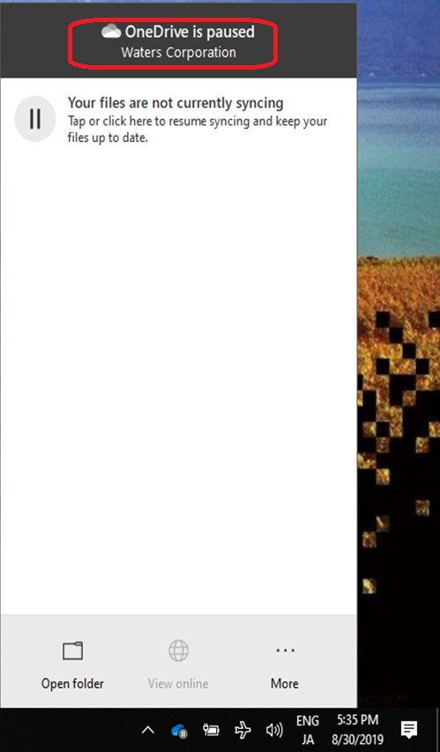

6-7 If synchronization mark is not shown in icons, please go to “User Accounts” in “Control Panel”.
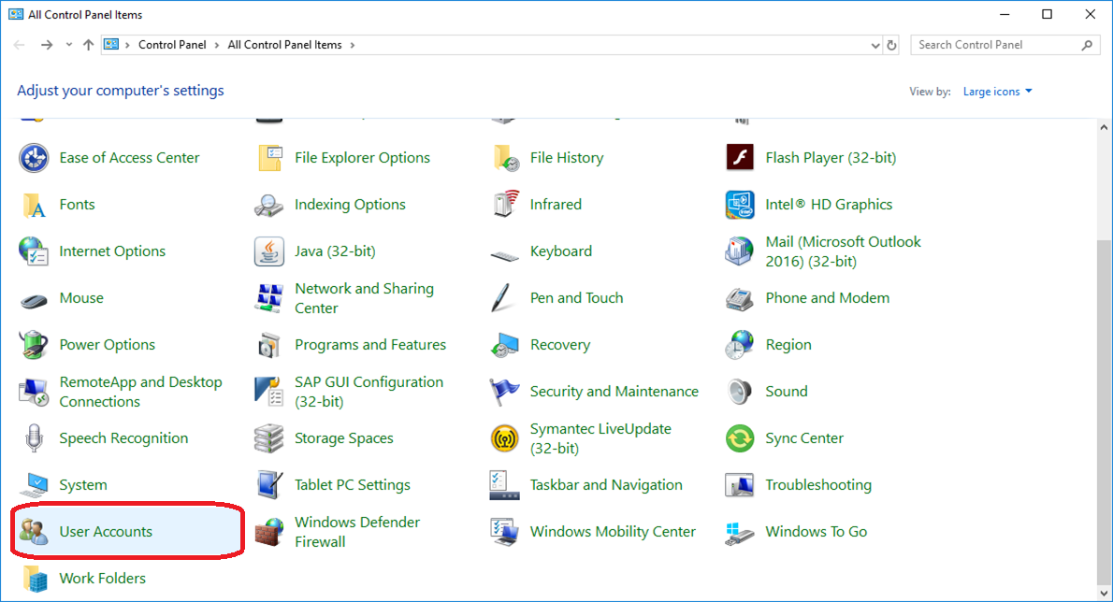

6-8 Click “Change User Account Control settings”.
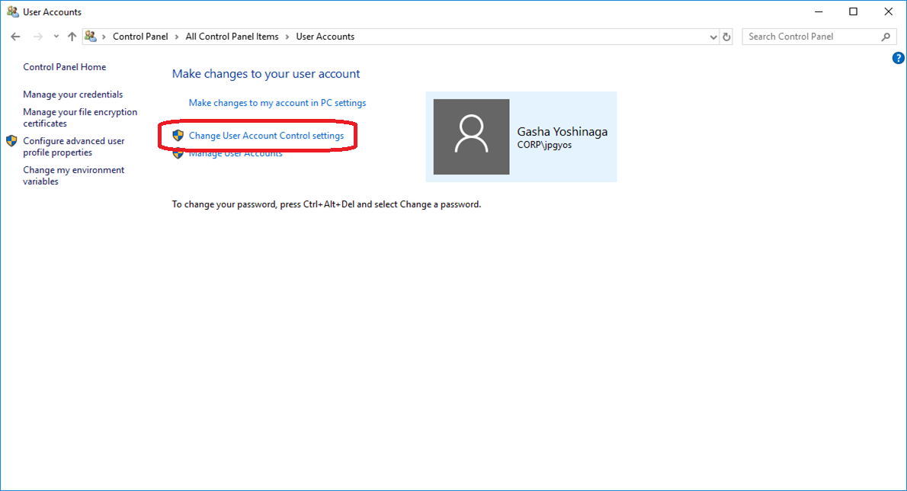

6-9 Pull up the level to 2.
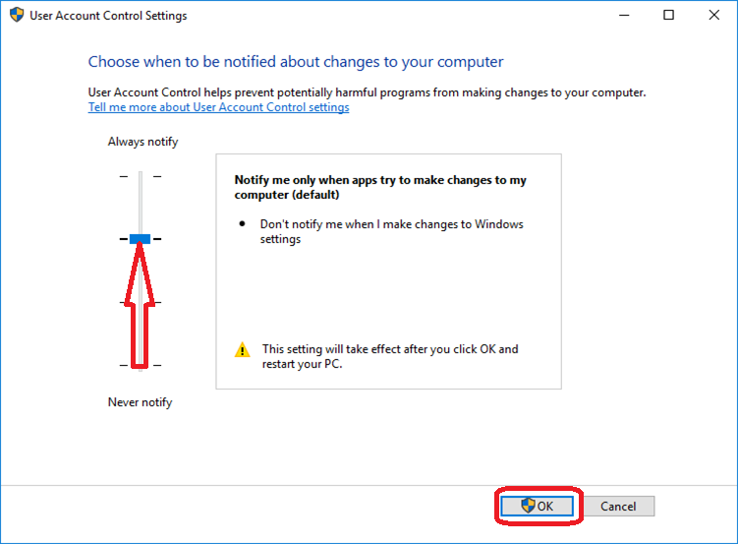
6-10 Click ”More” and select “Resume syncing” to resume synchronization of OneDrive.
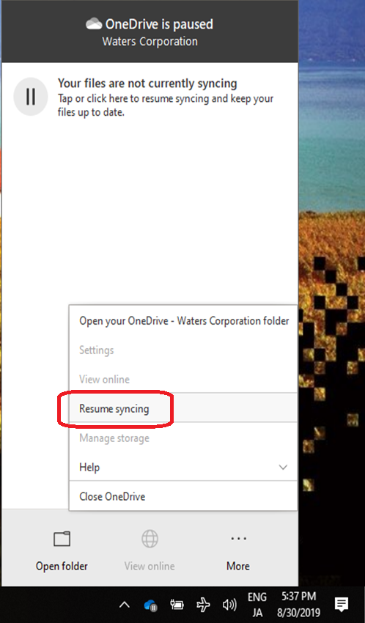

6-11 Restart your PC once.

6-12 Confirm the icon is show to us, then pull down the level to 0 again.
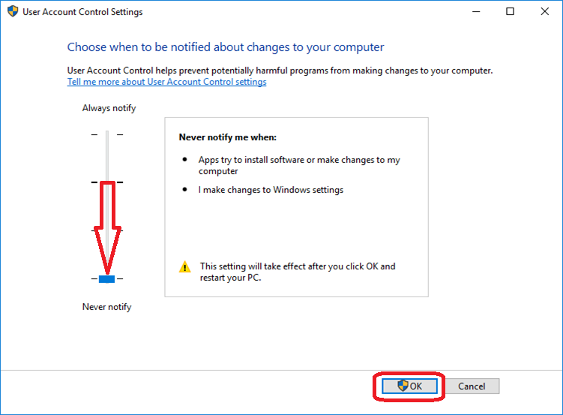

Install Adobe Reader (Optional)
7-1 Since the imaging is in English, the Adobe Reader is in English. If you want to change the language, we strongly to ask you uninstall the Adobe Reader in English and reinstall Adobe Reader in your local language. Open Internet Explorer and go to http://www.adobe.com/. Click “MENU”.
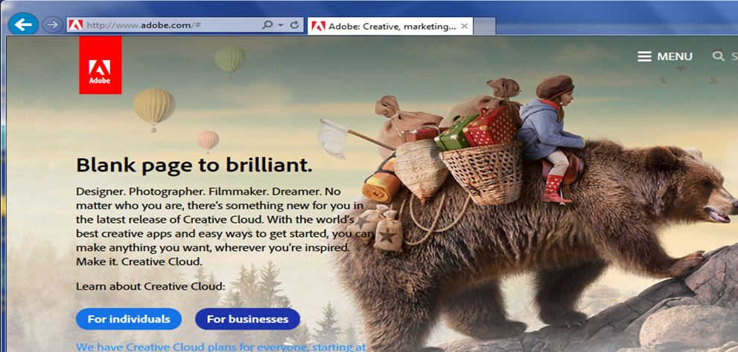

7-2 Click [Acrobat Reader DC].
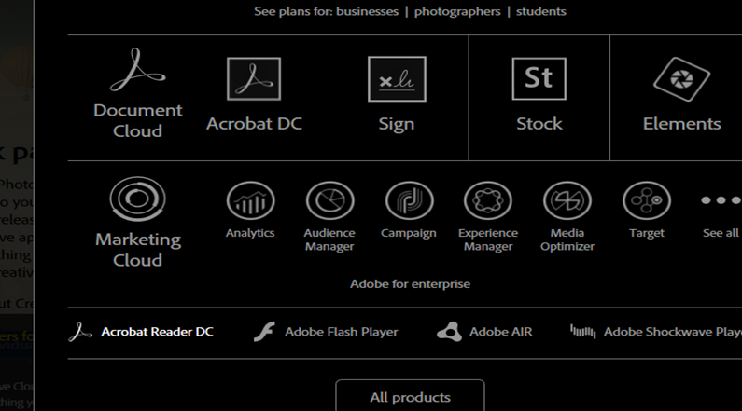

7-3 Do not select to install Chrome and Google toolbar and click [Install now].
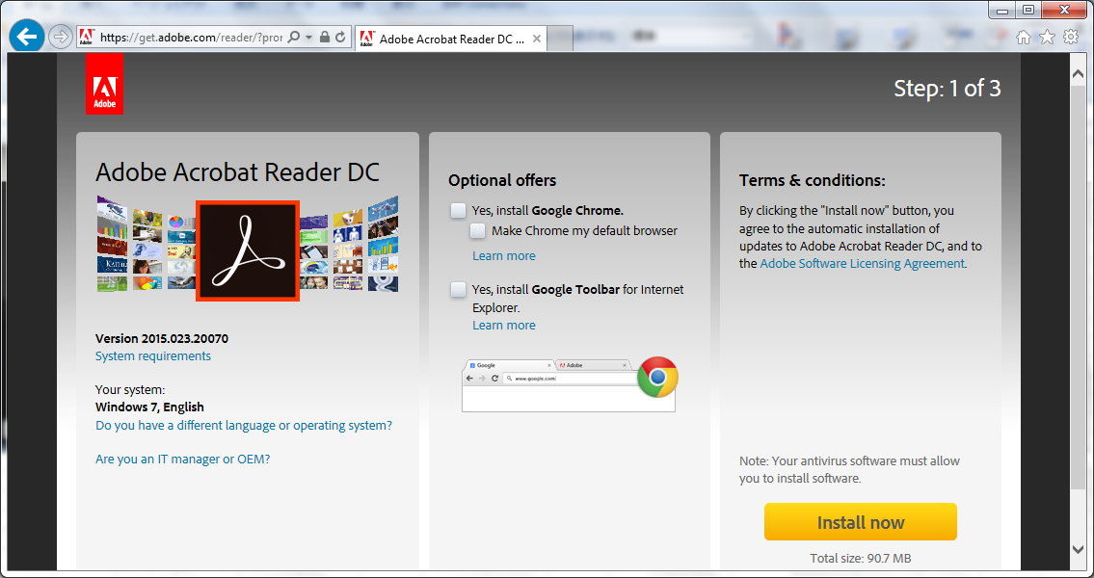

7-4 Click [Run].
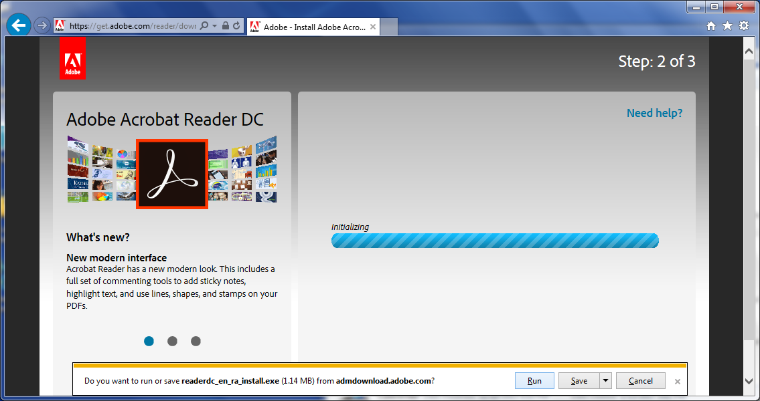

7-5 Installation is running.
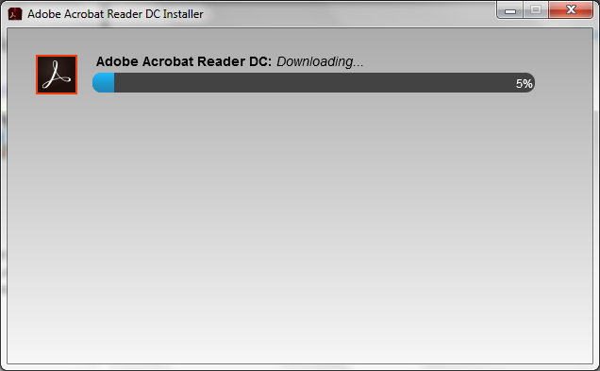

7-6 Installation is complete. Click [FINISH].
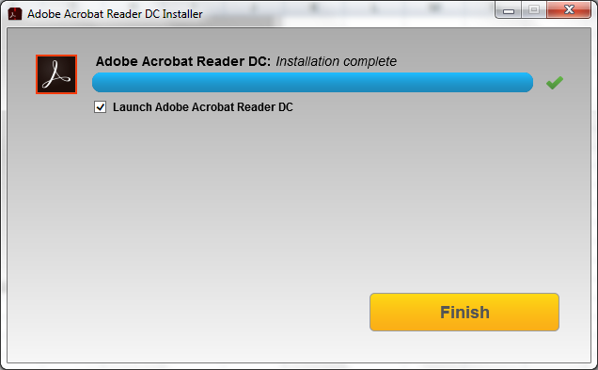

Setup for IBM Connections
8-1 Please double click “IBM Connections” icon.
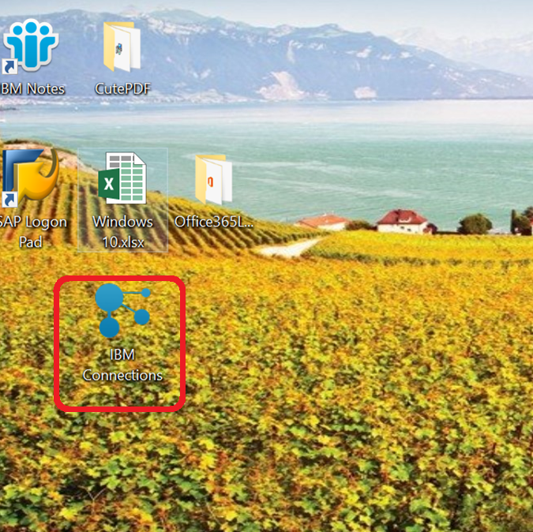

8-2 Click “Connect to a site” button.
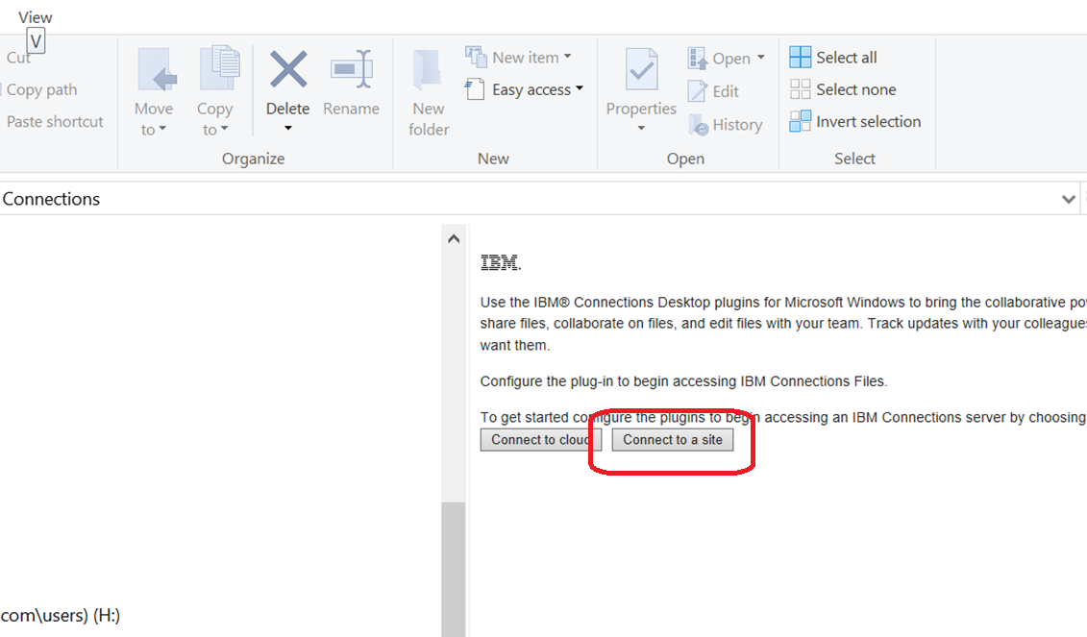
8-3 Input “connect.waters.com and select “Integrated Windows Authentication”, then click “Connect” button.
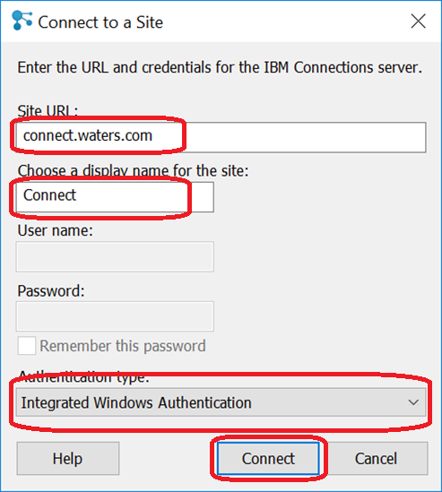

8-4 Click “OK” button.
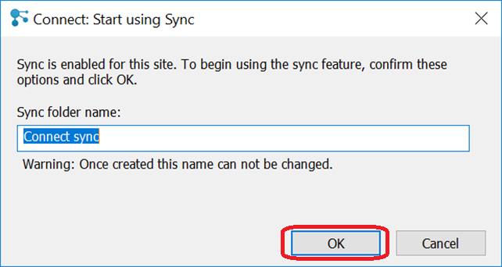
8-5 Click “OK” button.
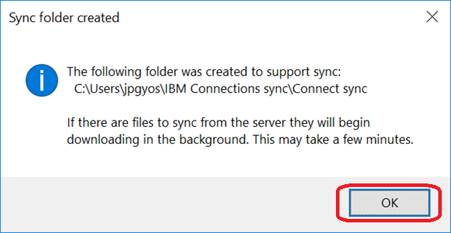

8-6 it is connected and shown properly.
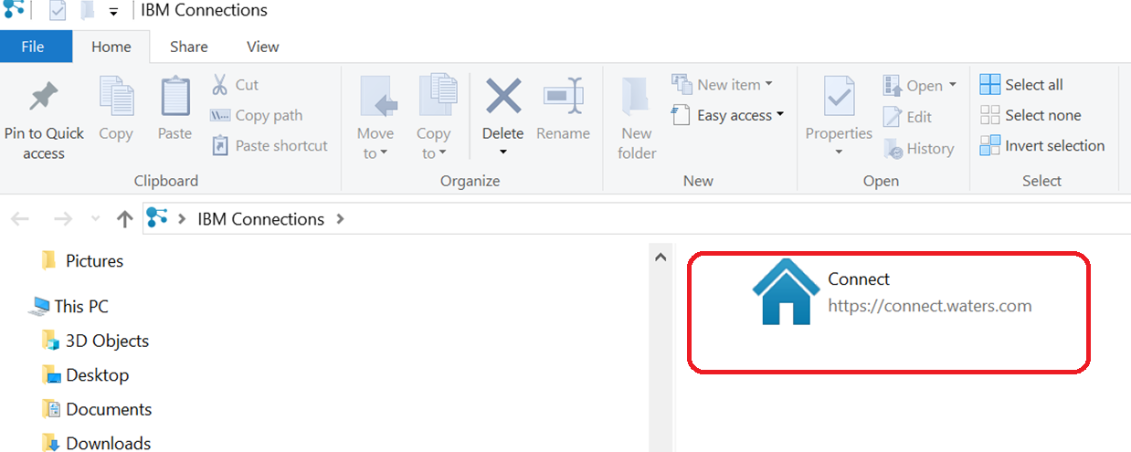

8-7 Since the icon of Waters Connections is not working, please delete it,
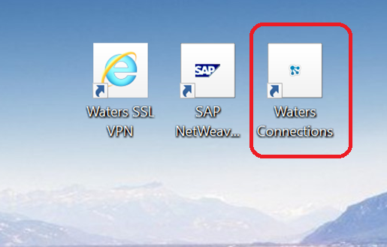
8-8 I have created the other icon called “IBM Connections Home Page” for it and copied it to N Drive of your country.
Please copy and use it.
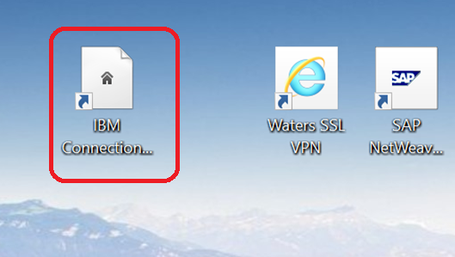

Windows Setting Change
9-1 Click Windows Start Mark, then select “Setting”.
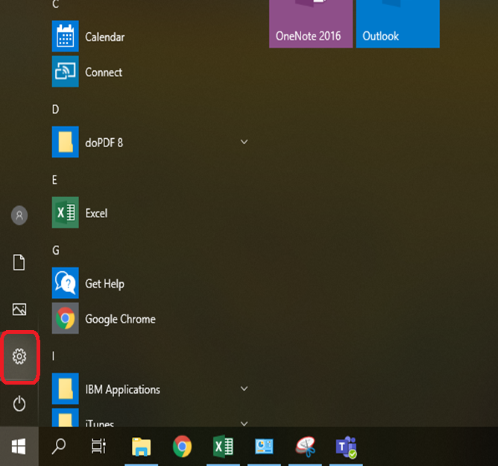
9-2 Click Apps icon.
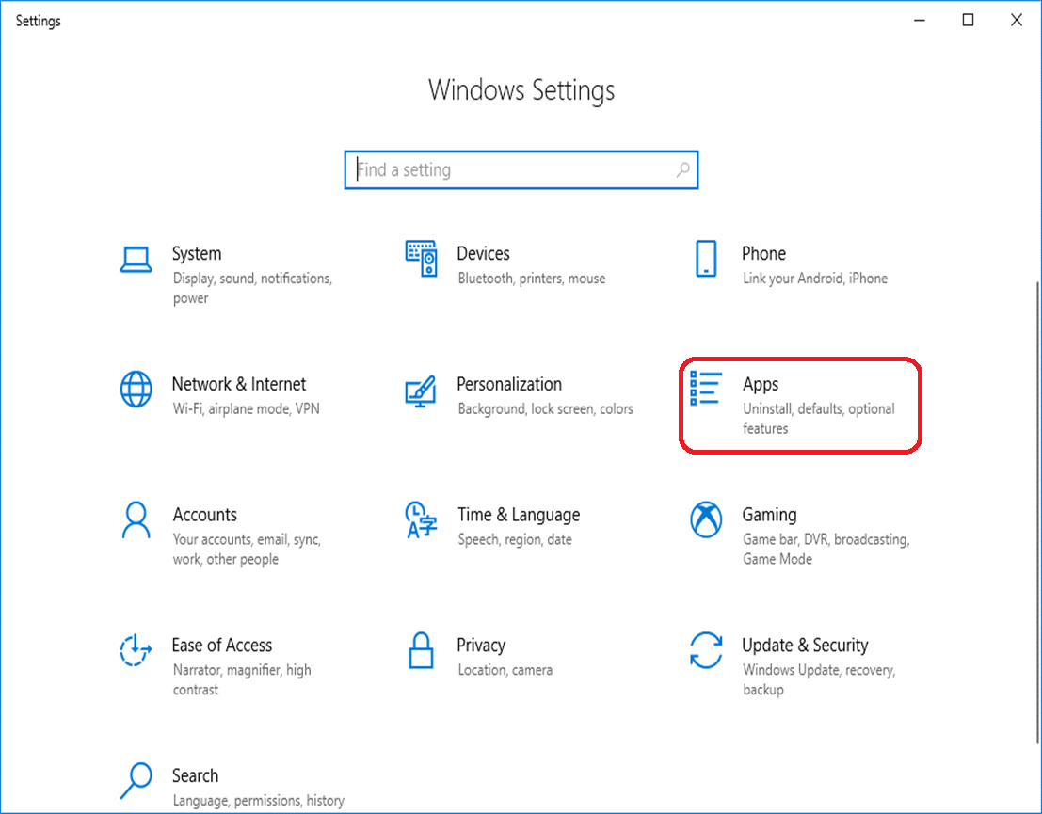

9-3 Click “Default apps” icon.
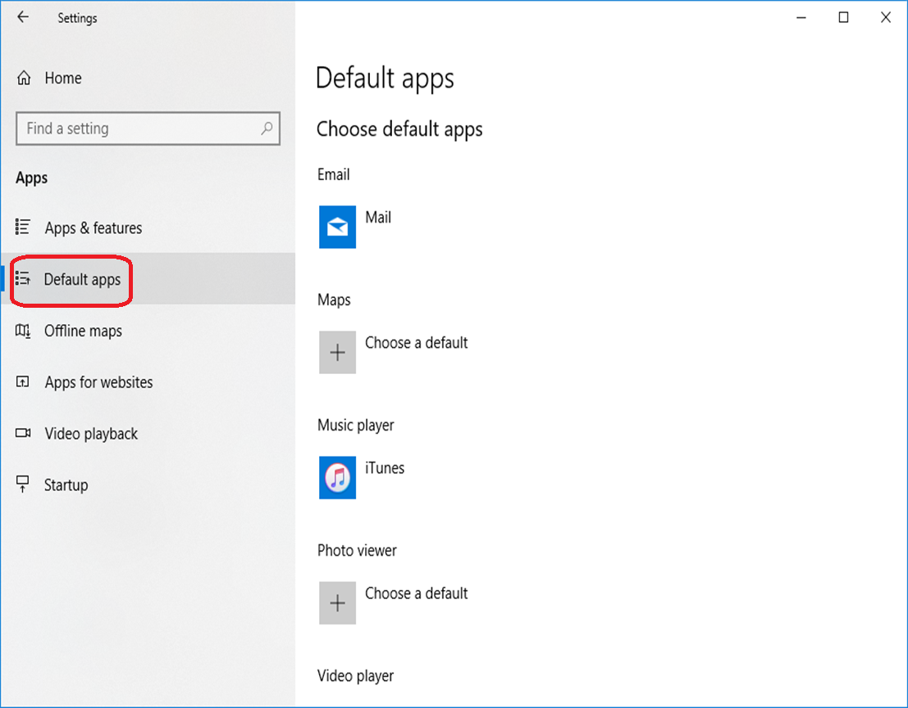
9-4 Click “Mail” and select “Outlook”.
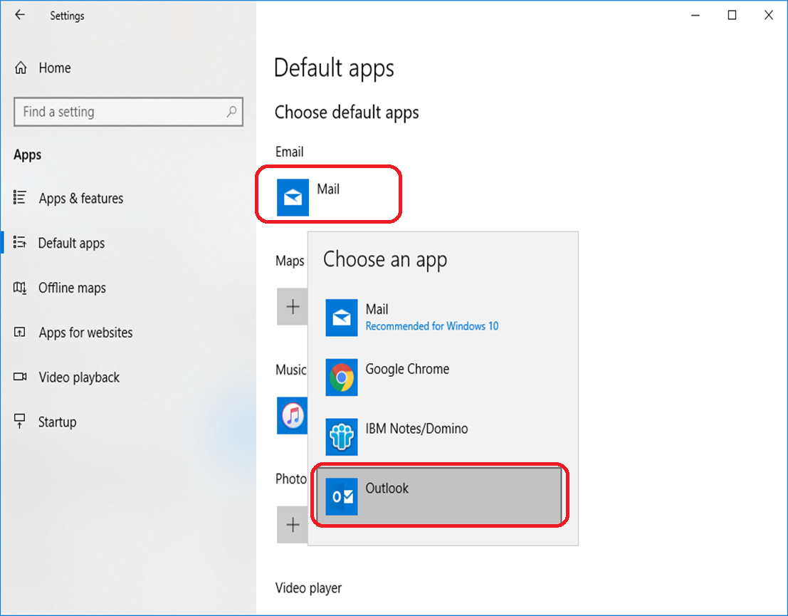

9-5 Click “Switch anyway”.
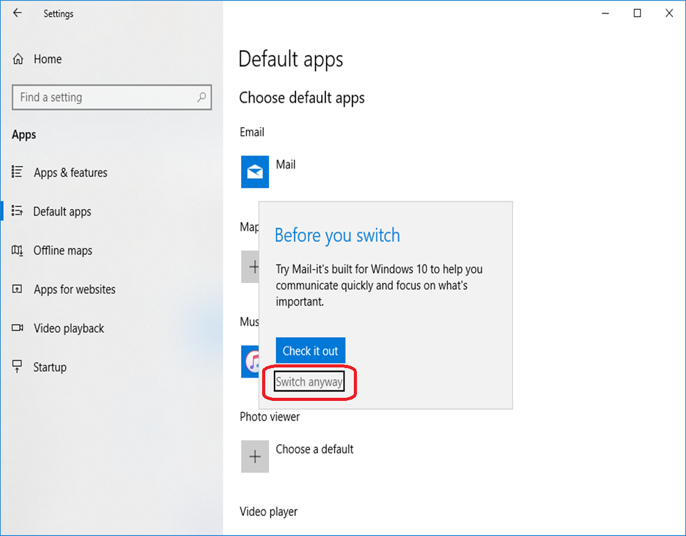
9-6 Click “Microsoft Edge” in Web Browser, then select “Internet Explorer”.
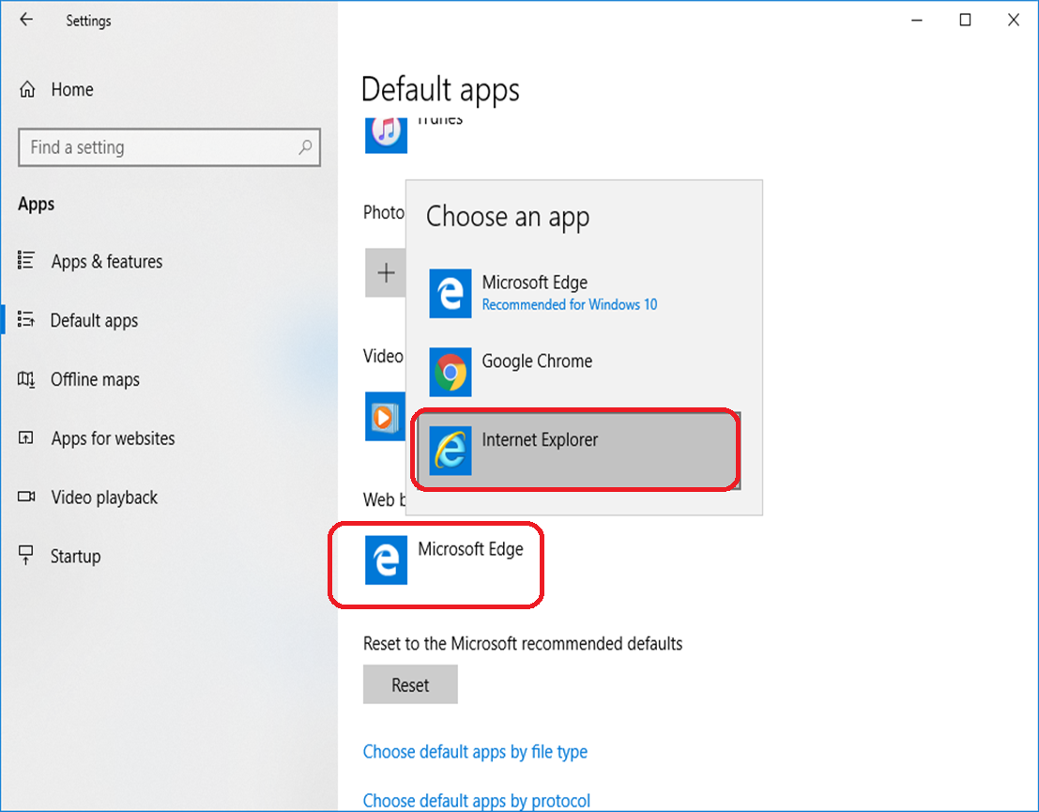

9-7 Click “Switch anyway”.
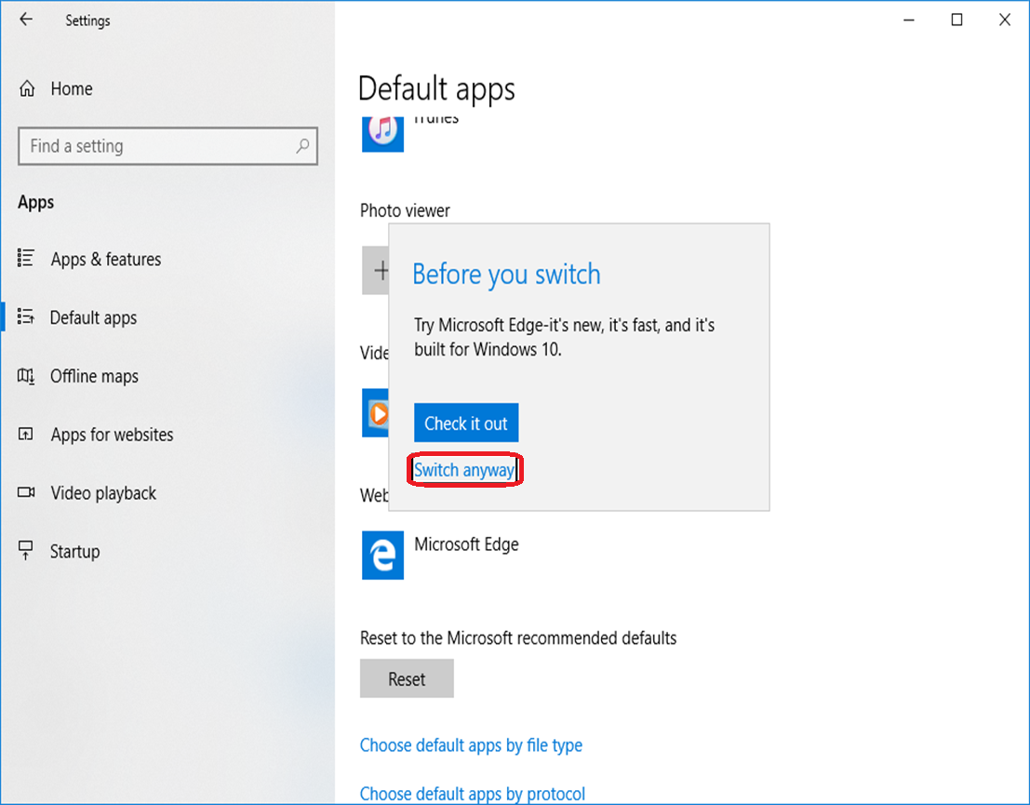
9-8 Click “Choose default apps by file type”.
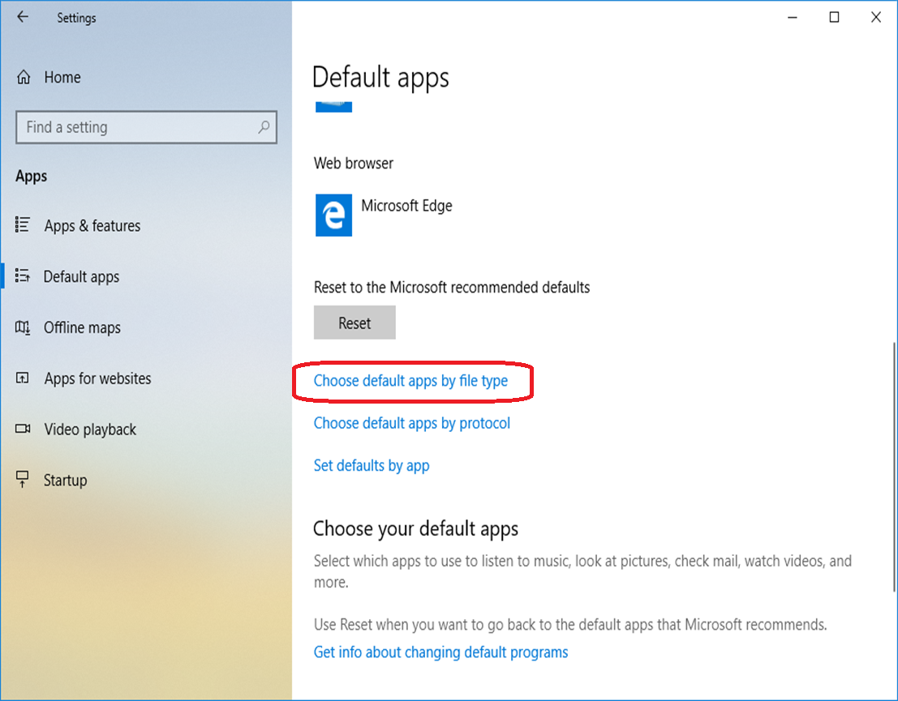

9-9 Find .pdf type and click “Microsoft Edge”, then select “Adobe Acrobat Reader DC”.
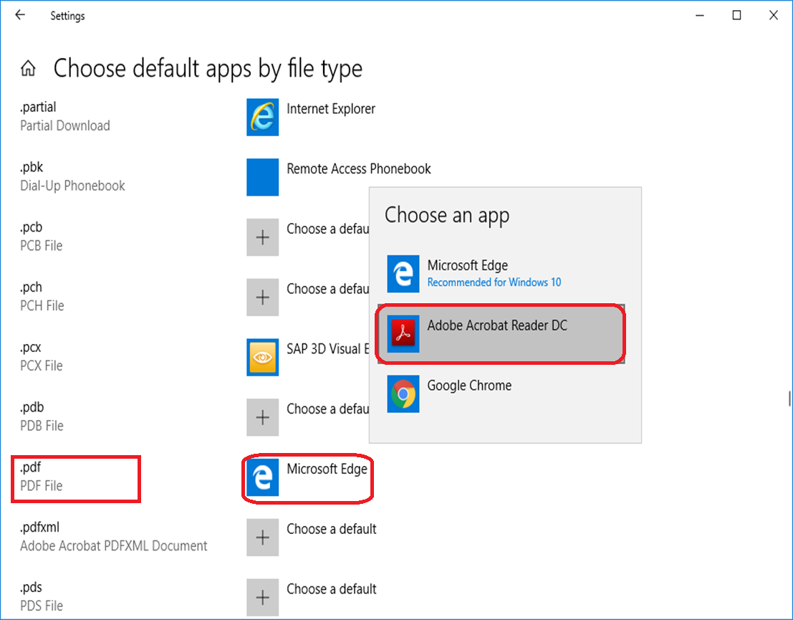
9-10 Click “Switch anyway”.
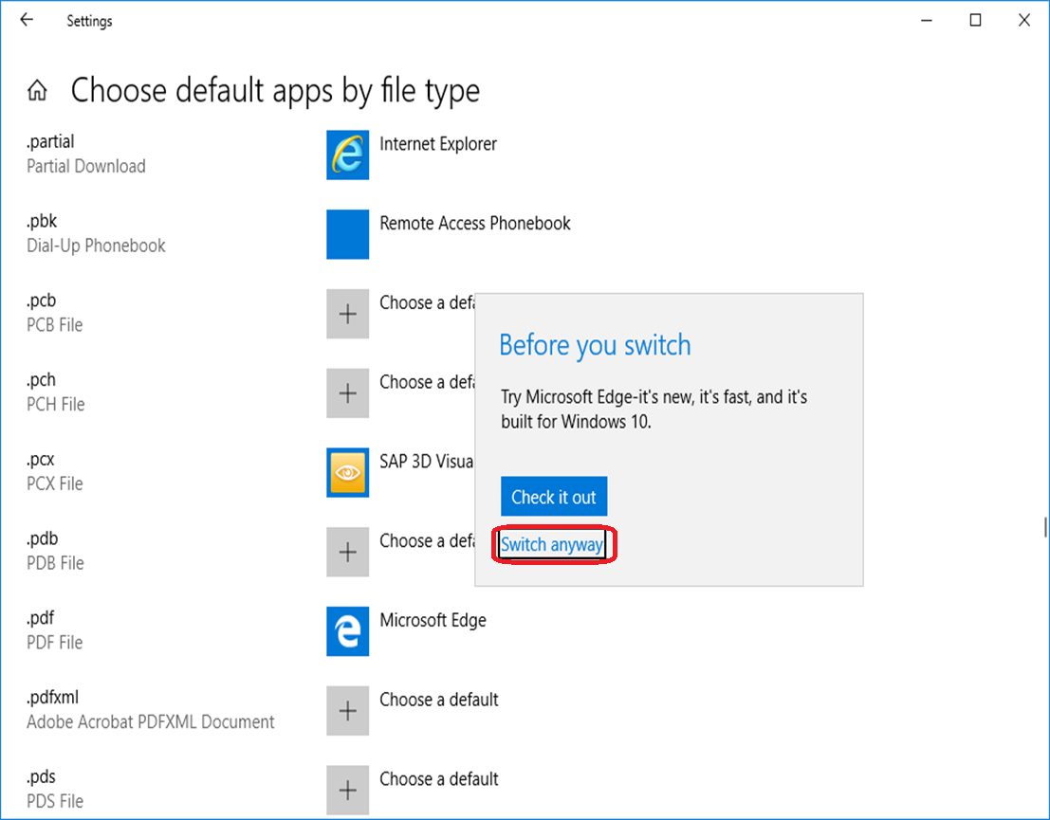

Setting of Data format
10-1 From Control Panel to click “Region” option.
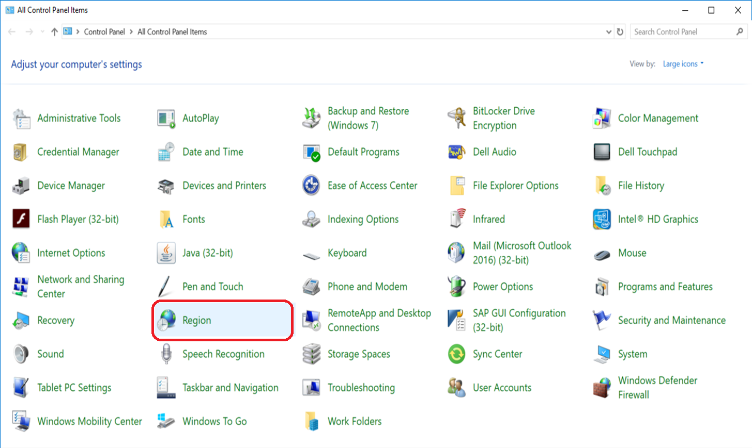

10-2 Click [Additional setting…].
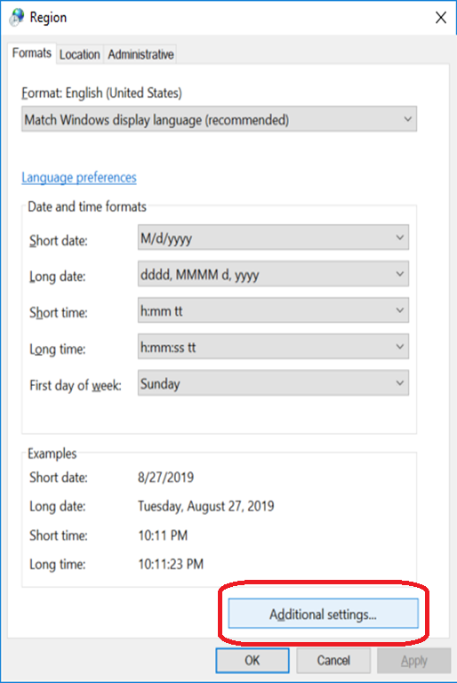

10-3 Please change the Date Short formats to “dd/MM/yyyy” or “MM/dd/yyyy”, and click [OK].
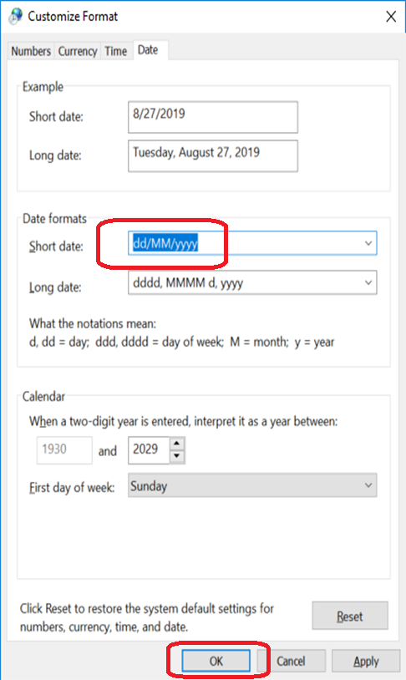
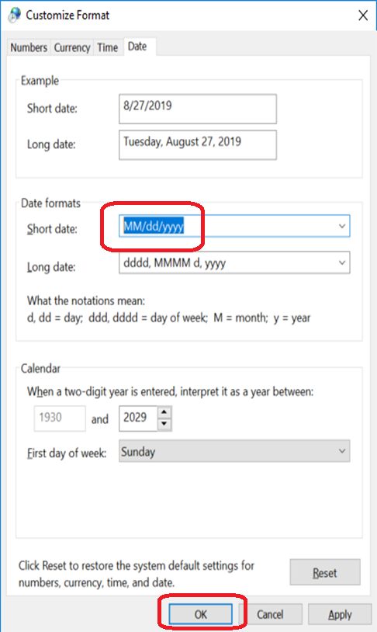
10-4 Please click [Time] tab and change to [HH:mm] for short time and [HH:mm:ss] for long time format, and click [OK].
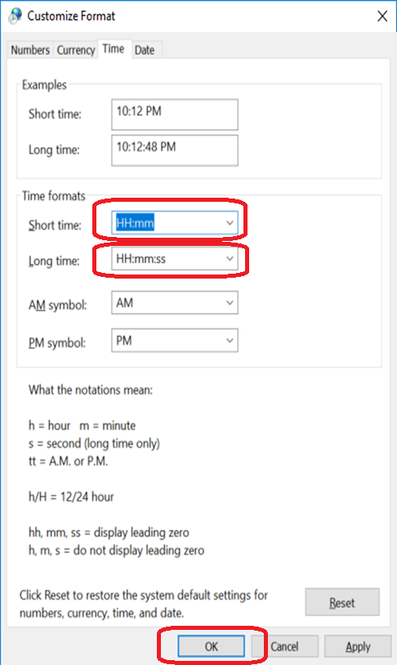

Setting of Internet
11-1 Start Internet Explorer, and select “Tools”->”Internet Options”.
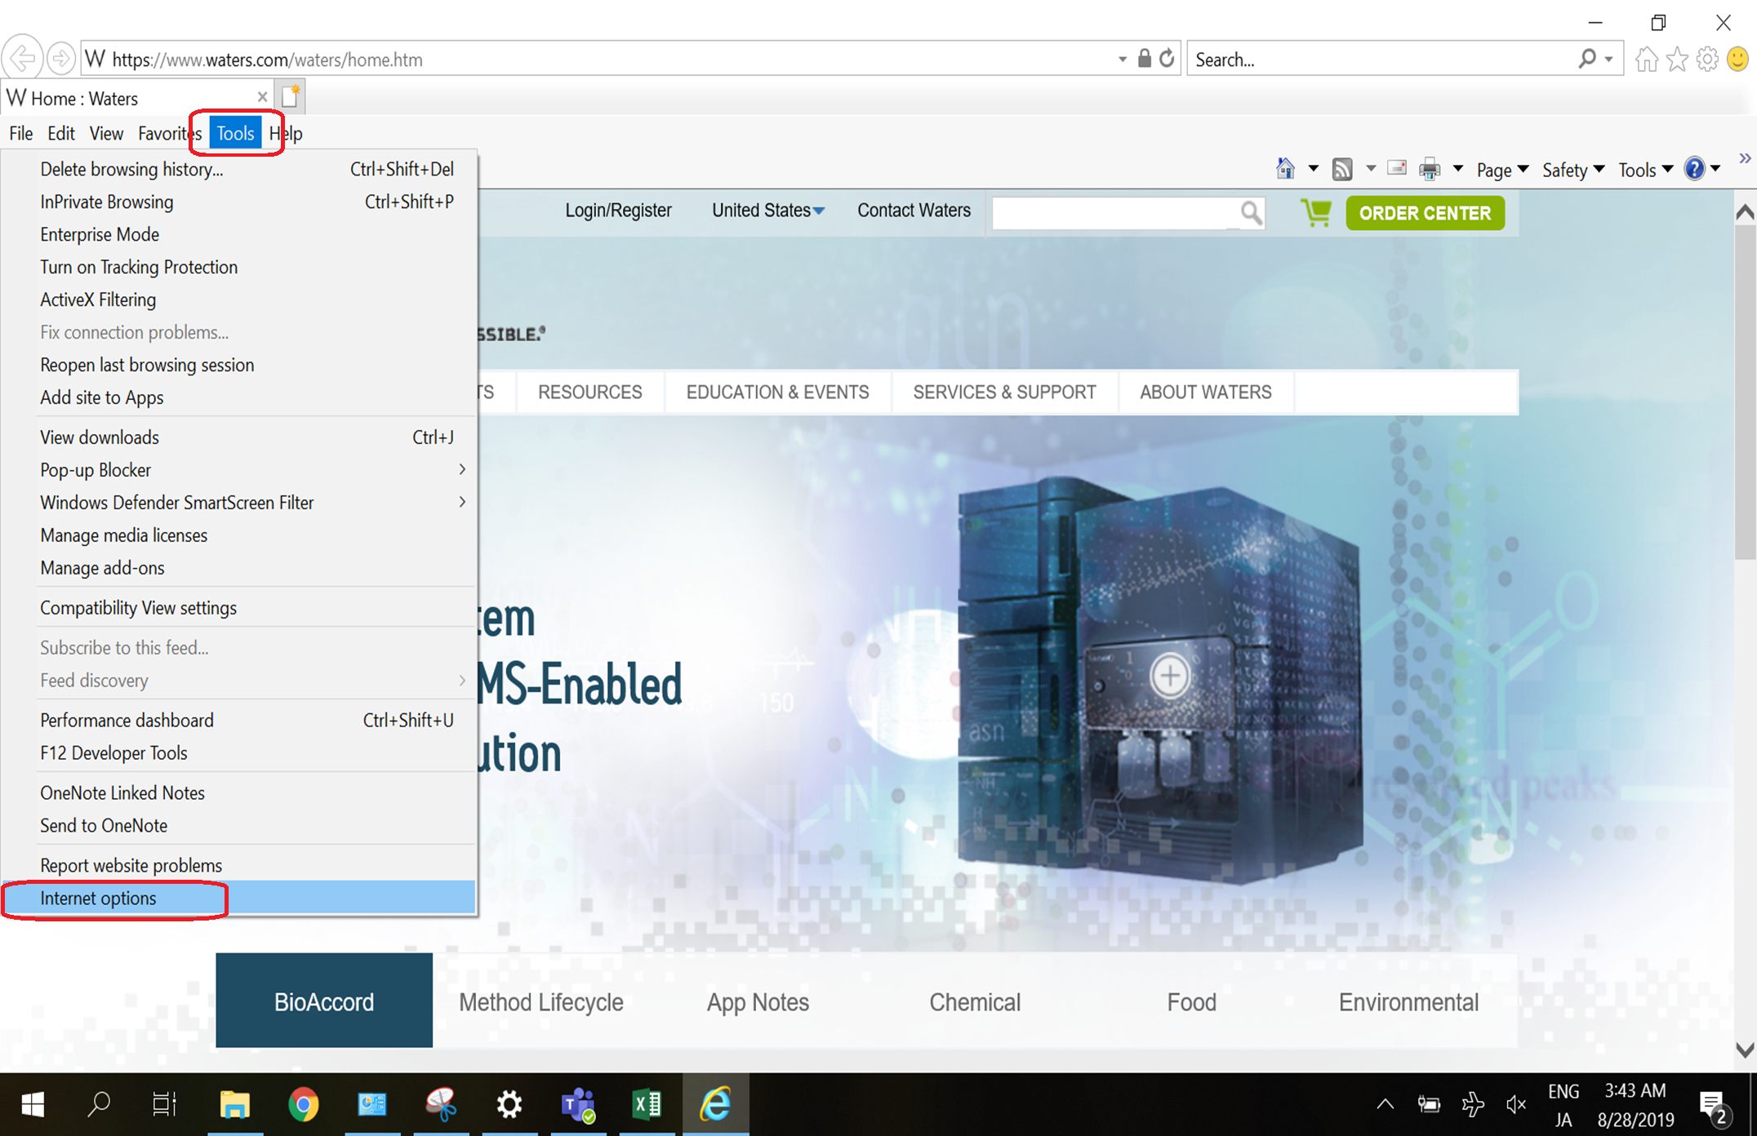

11-2 Add http://www.waters.com to your Home page, and tick “Delete browsing history on exit” option. Then click [OK].
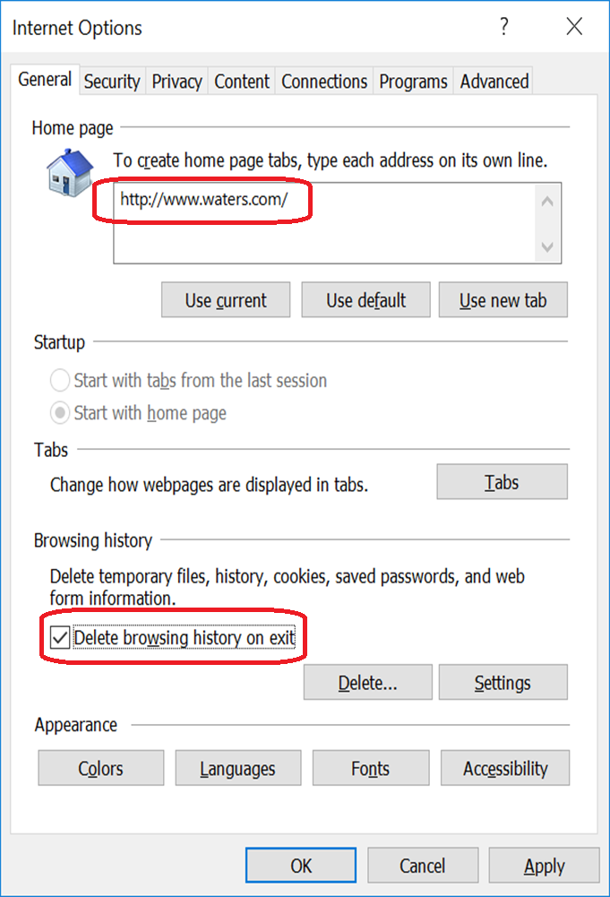

Install Office 365 Language Pack
12-1 Copy the language pack program from N Drive and double it.
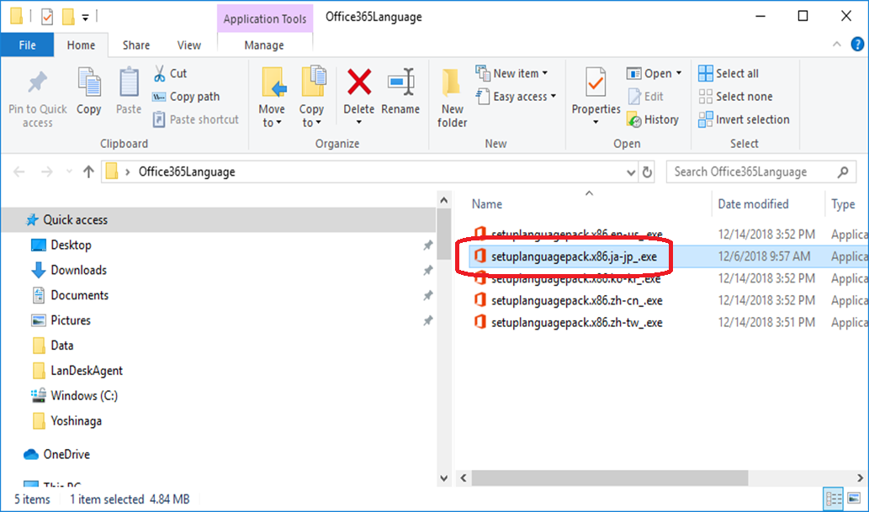

12-2 The program is running.
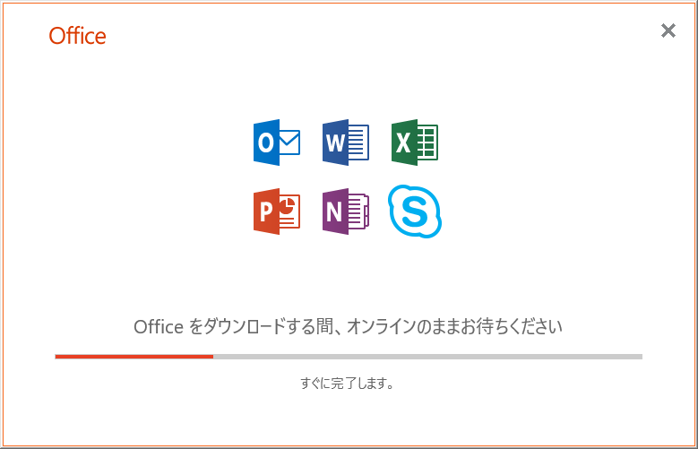
12-3 Click the “close” button to finish the installation.
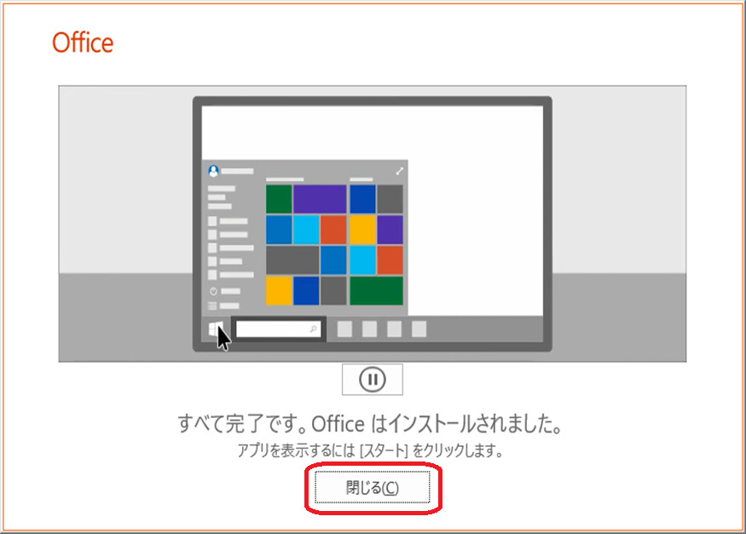

12-4 Start the Excel and click “File” button.
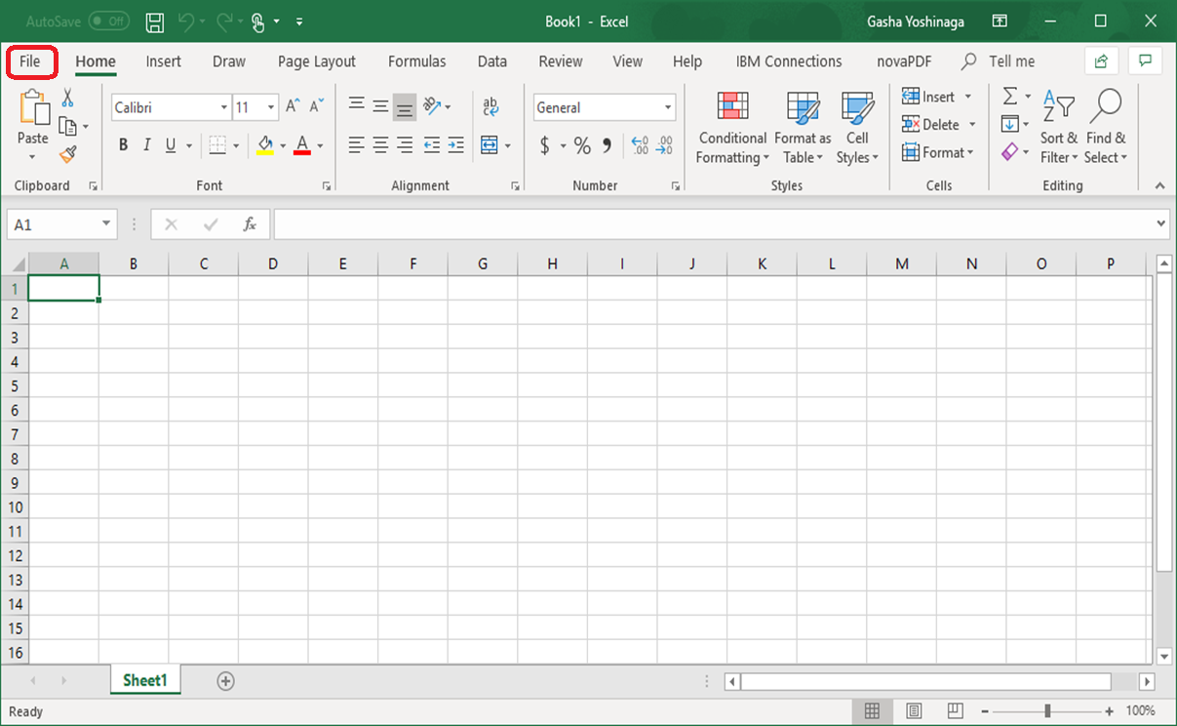
12-5 Click “options” button.
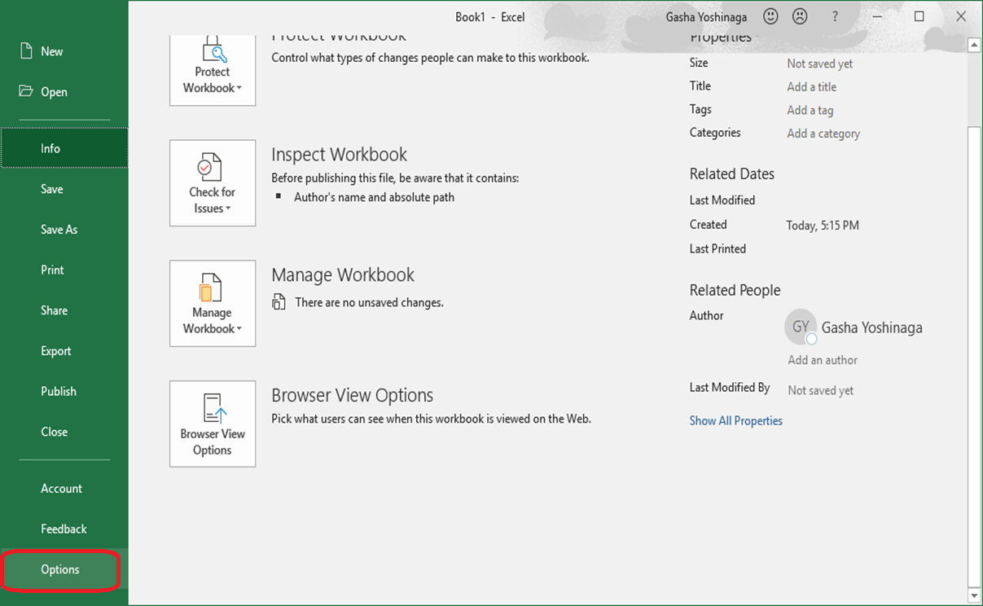

12-6 Select “Japanese” and click ”Set as Default”.
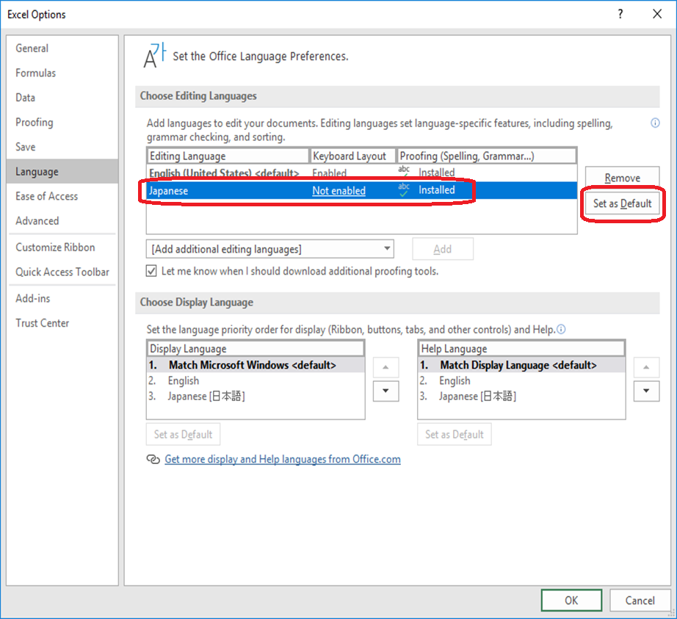
12-7 Click “Yes” button.
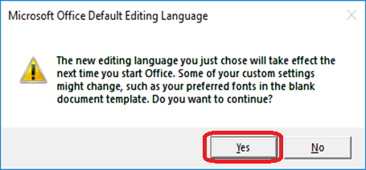

12-8 Then changed the default of editing language.
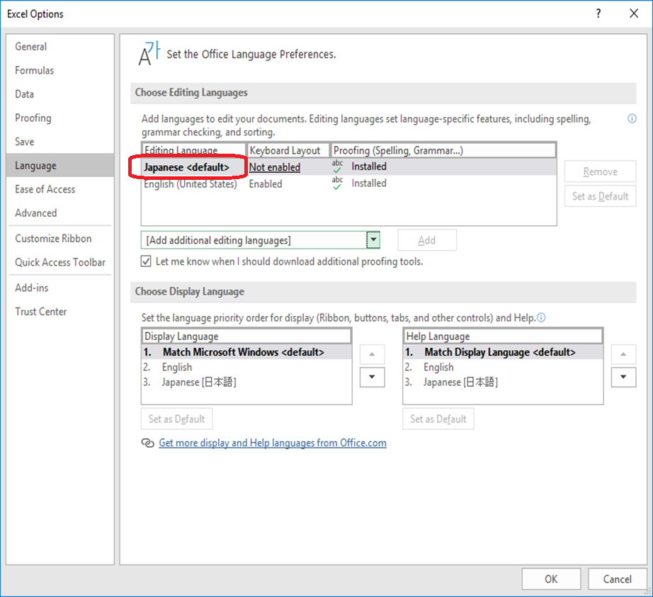

Setting of Office
13-1 Click [Start] of Windows 10, and click Excel of Office 365.
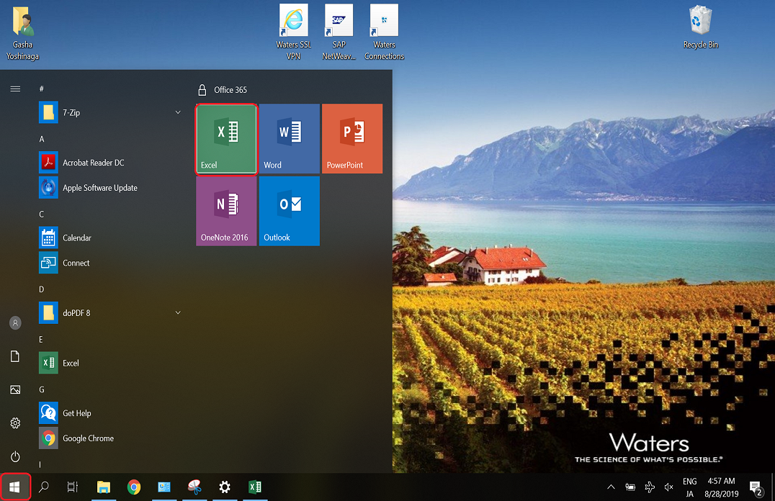

13-2 Click option.
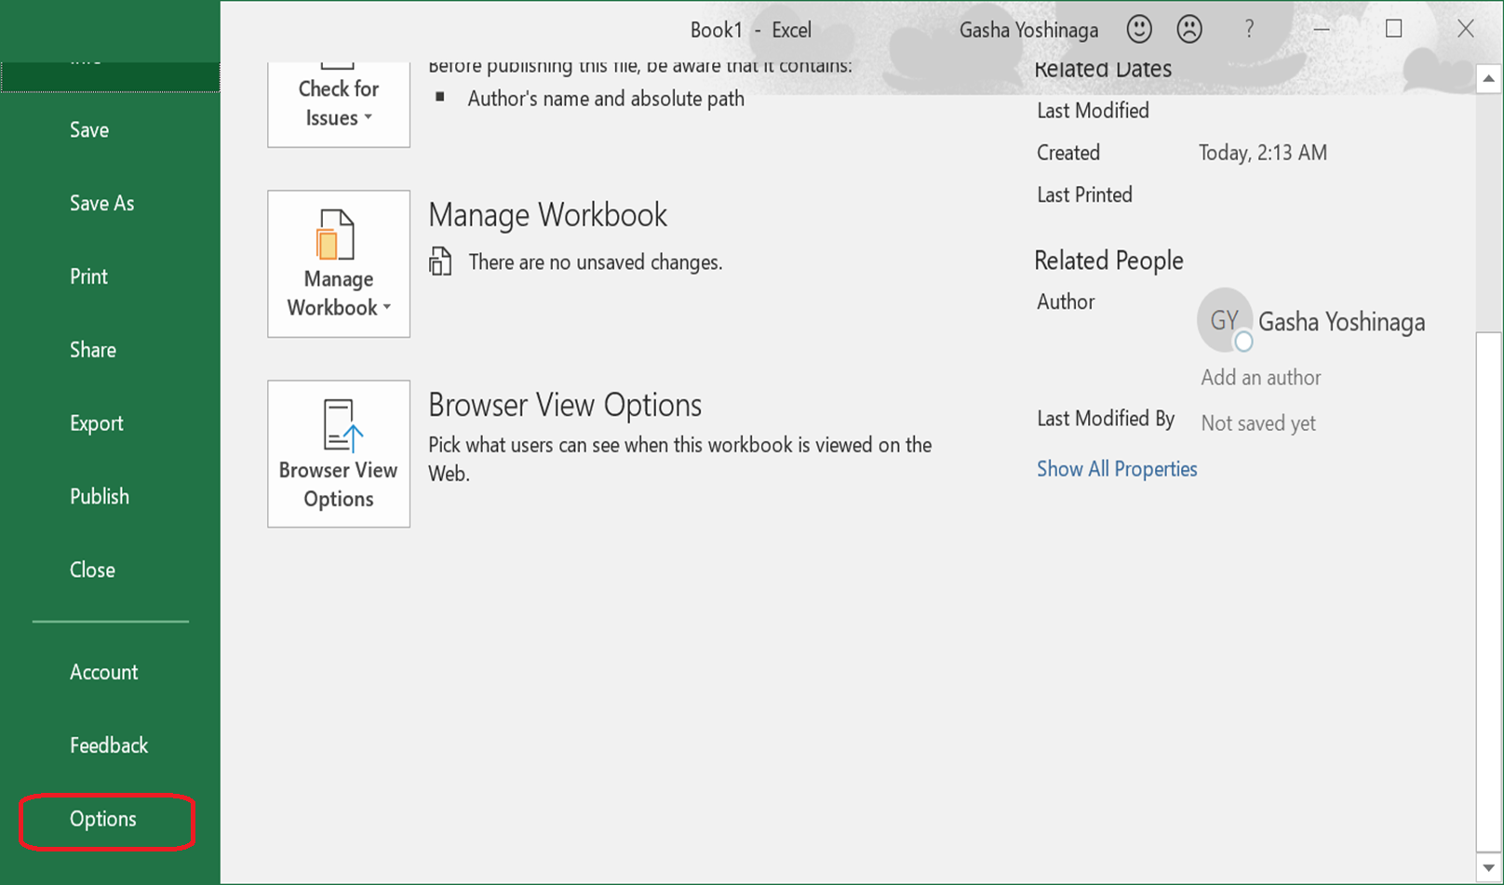

13-3 Select “Trust Center Setting” field from “Trust Center Option.
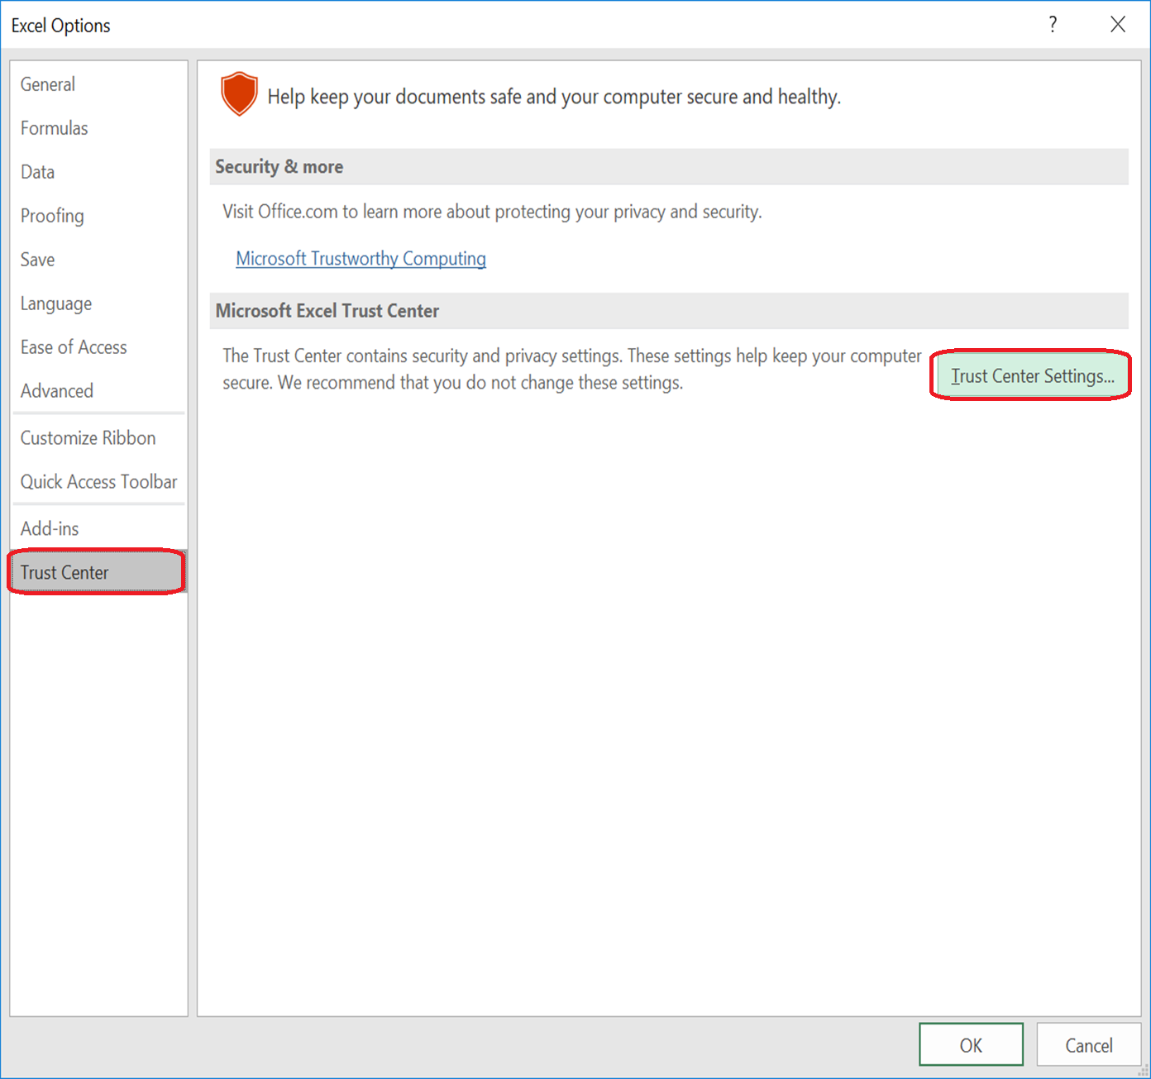

13-4 Change the setting to [Enable all macros….] and click [OK].
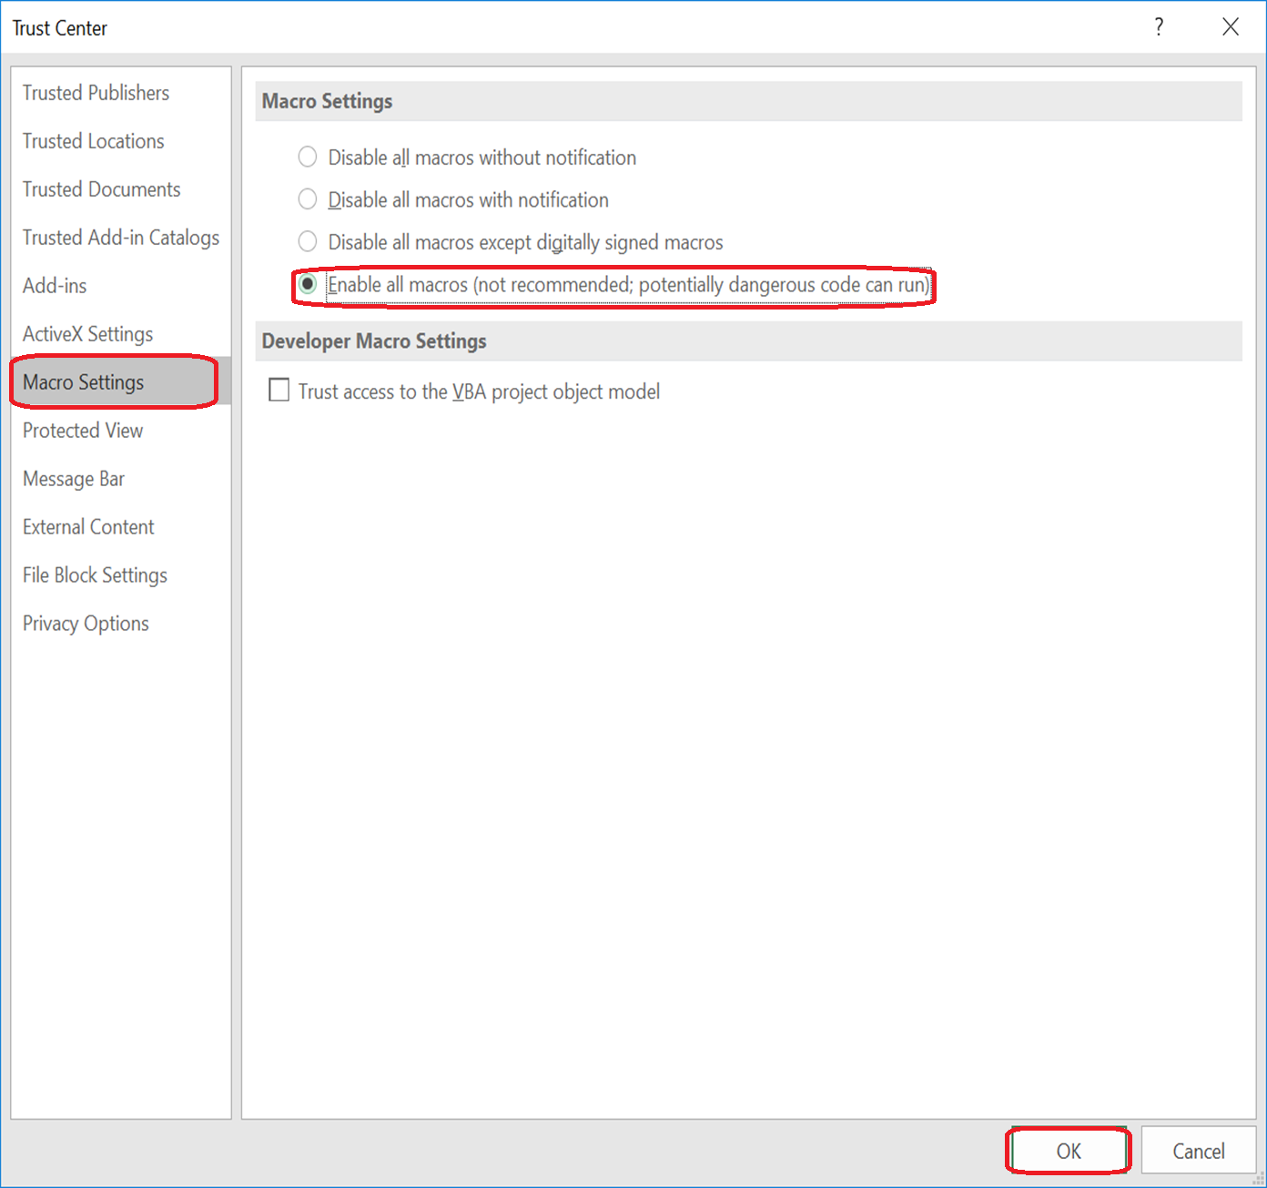

13-5 Do the same setting on Word and PowerPoint.

Setting of Analysis Office
14-1 Select “Analysis for Microsoft Excel” to start.
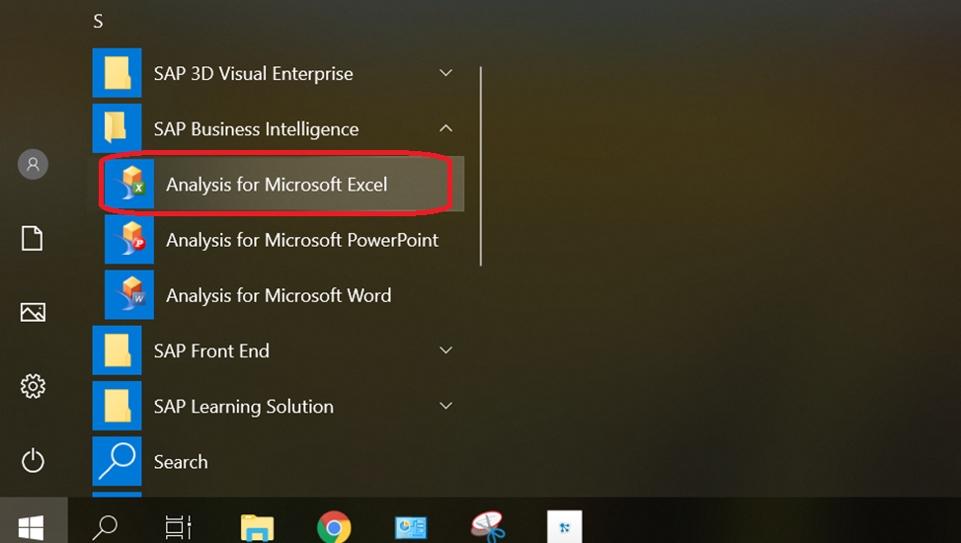

14-2 Click “File” button.
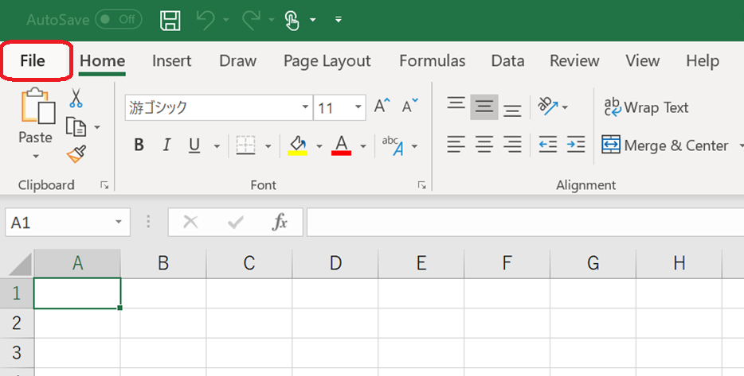
14-3 Click “Analysis” button.
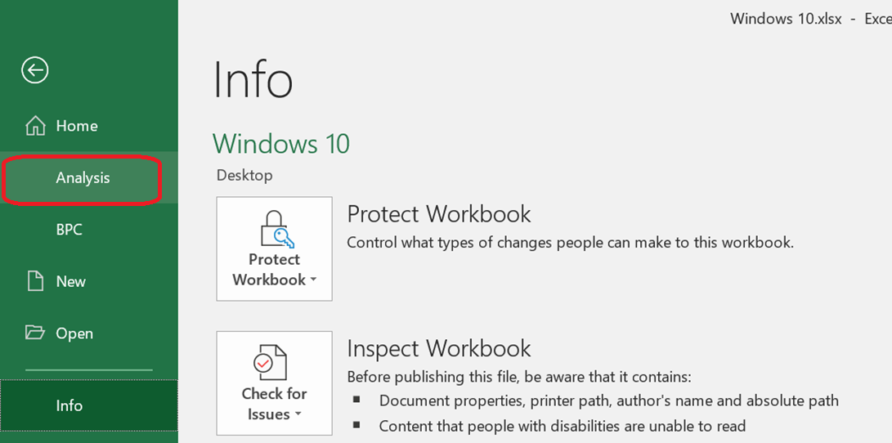

14-4 Click “Open Data Source” and select “Open Data Source” option.
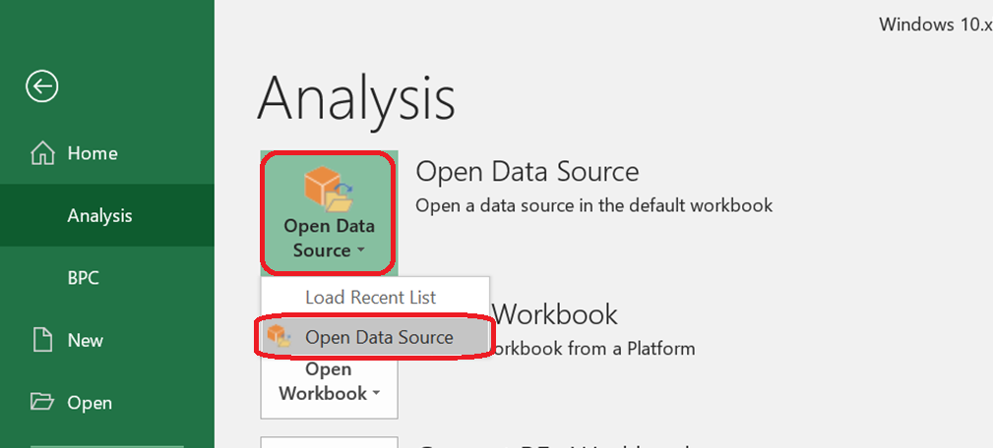

14-5 Tick “Do not show again” and click “OK” button.
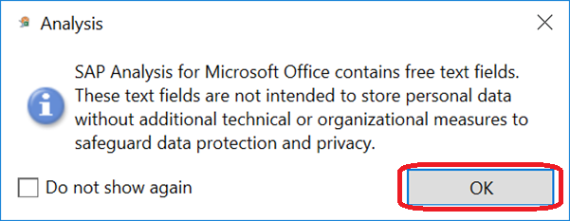

14-6 Please input the following information to
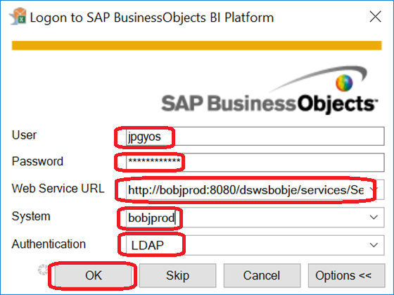
user ID
user password
http://bobjprod:8080/dswsbobje/services/Session
bobjprod
LDAP

Setting of Notes
15-1 The following steps are operating in New PC. Copy the ID file from “my documents” folder to C:\Program Files(x86)\IBM\Notes\Data folder.
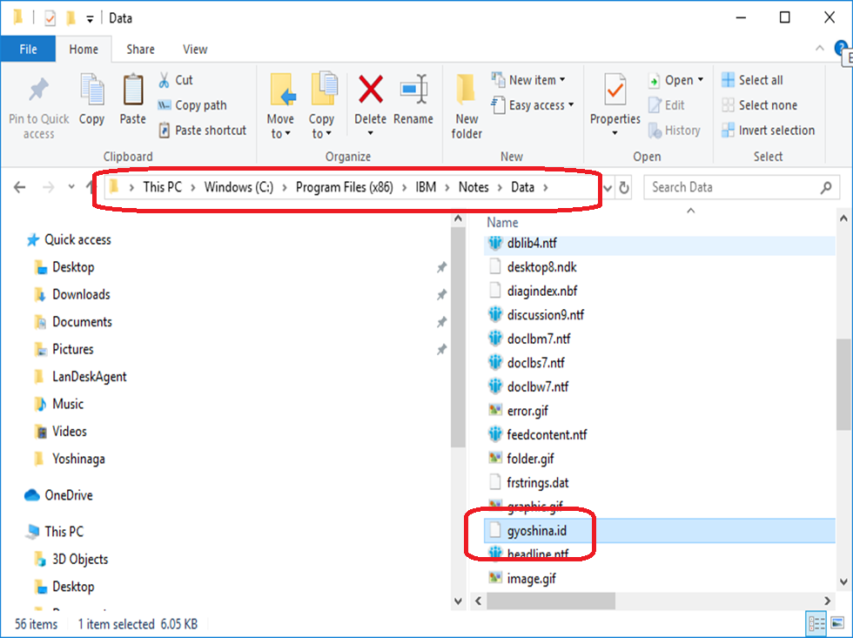

15-2 Click Lotus Notes icon in the desktop.


15-3 Click “Next” button.
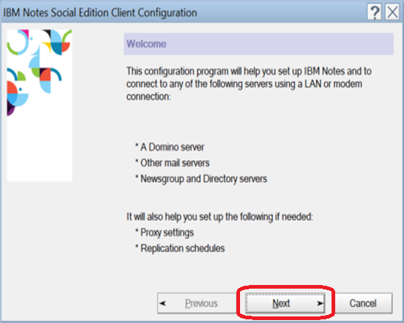
15-4 Please input the user name and input “CMN-Domino-01/Waters” in the Domino Server name.
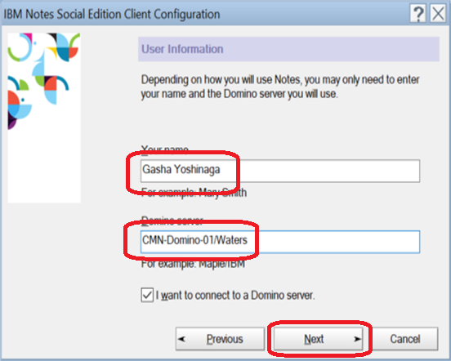

15-5 Click “Browse” to select ID file.
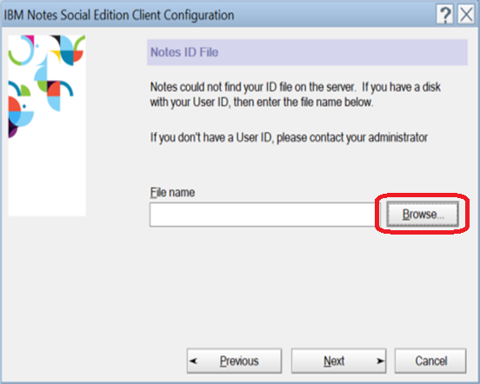
15-6 Select the ID file and click “open” button.
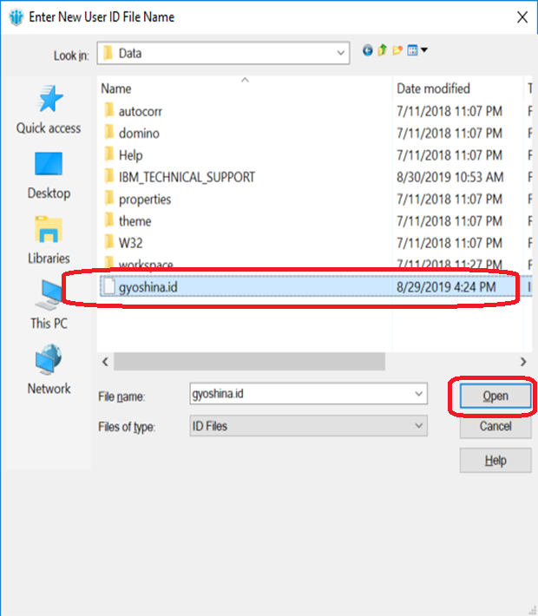

15-7 Click “Next” button.
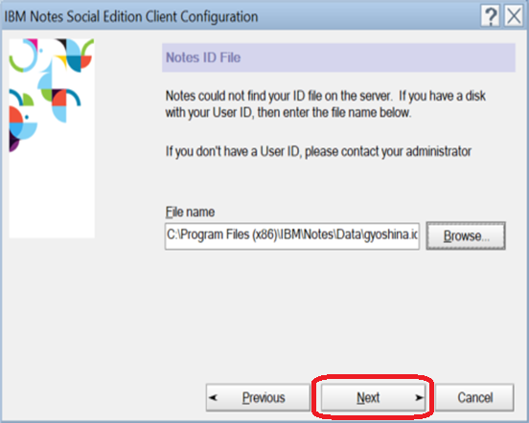
15-8 Input “password” and click “Log In” button.
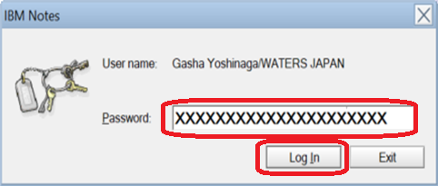

15-9 Click “OK” button.
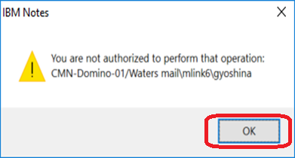

15-10 Click “Next” button.
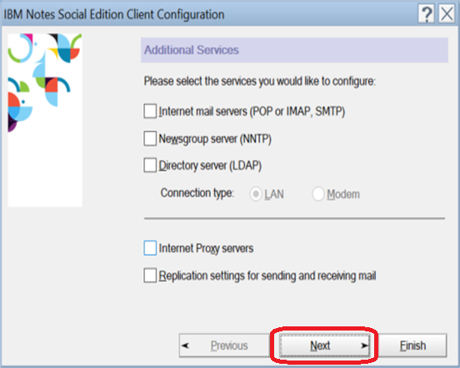
15-11 Tick “In the future…” and click “No” button.
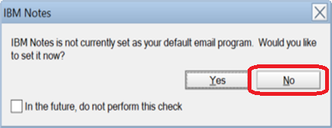

15-12 Notes is shown to you.
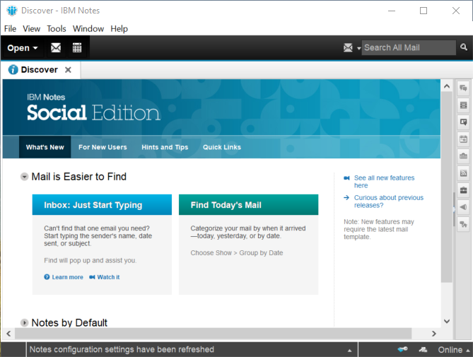
15-13 Click “View” and select “Dock the Open List” button.
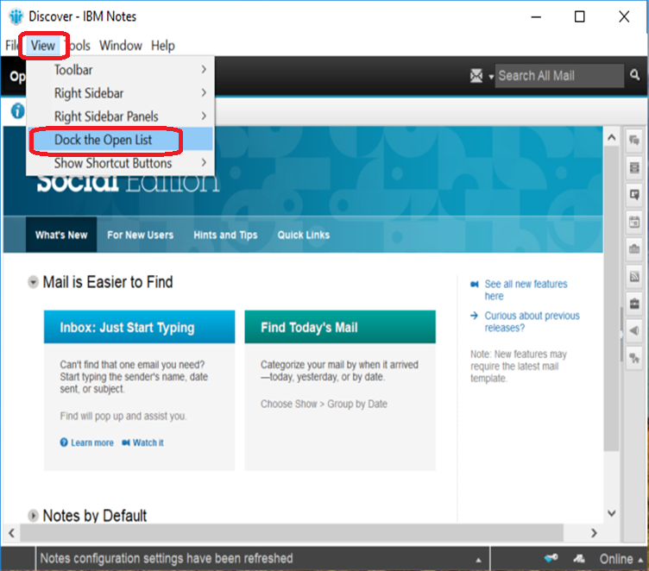

15-14 Click the open list and find “Workspace”, then right click “Workspace” and select “Set Bookmark as Home Page”.
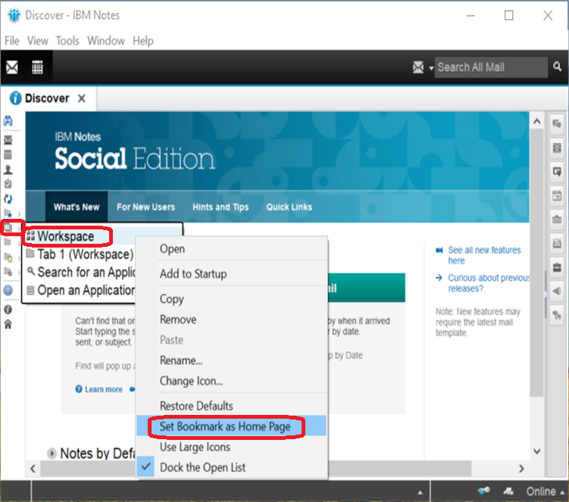
15-15 Click “Yes” button.
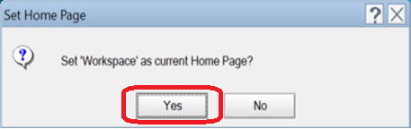

15-16 Click “View” and select “Toolbar” and click “Show Toolbars Only When Editing” button.
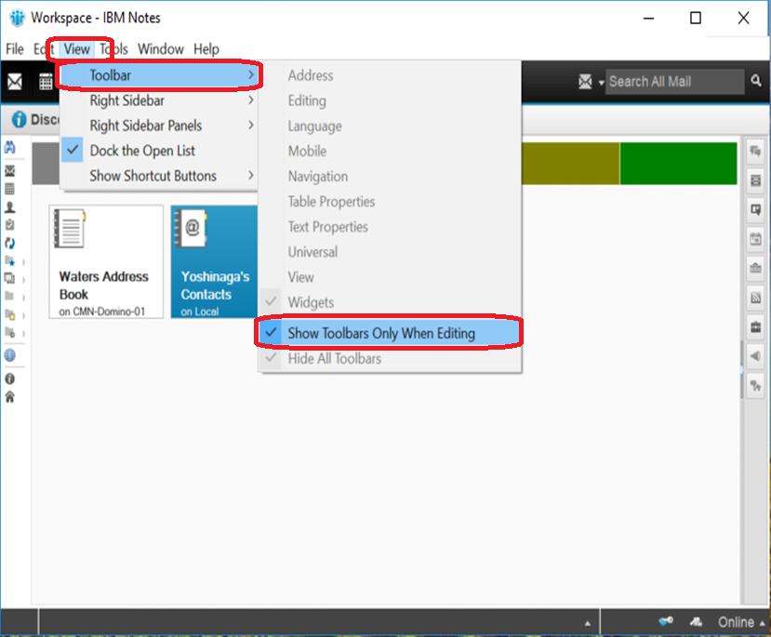
15-17 Click “View” and Select “Advanced Menus”.
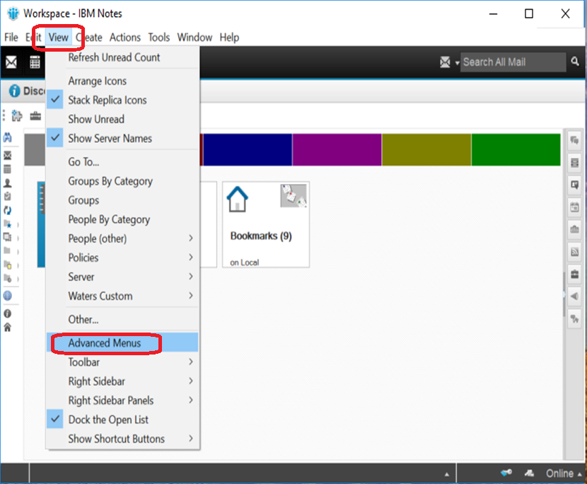

15-18 Click “File” and select “Preferences…”.
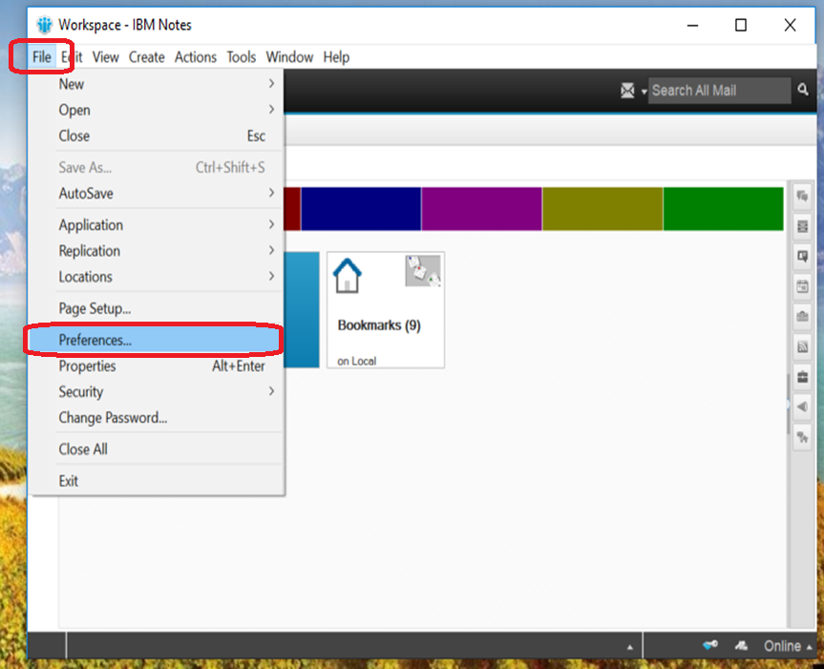
15-19 Select “Web Browser” and click “Use the browser I have set the default for this operating system”. Then click “OK” button
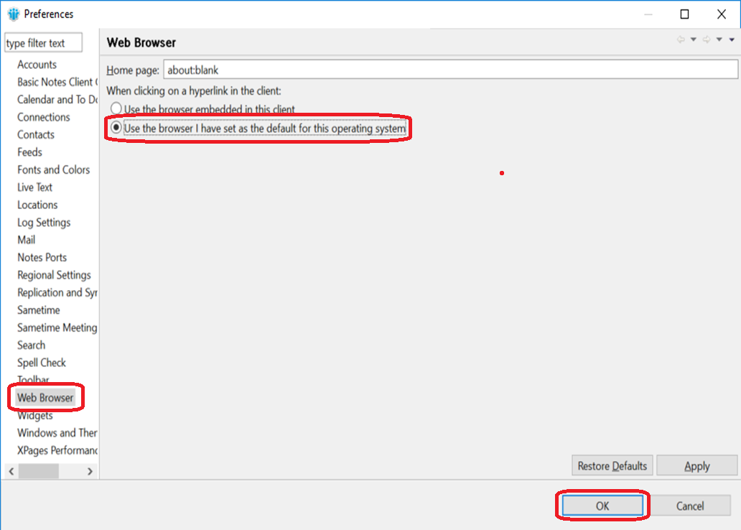

15-20 Click “File” and select “Security”, then select “User Security…”.

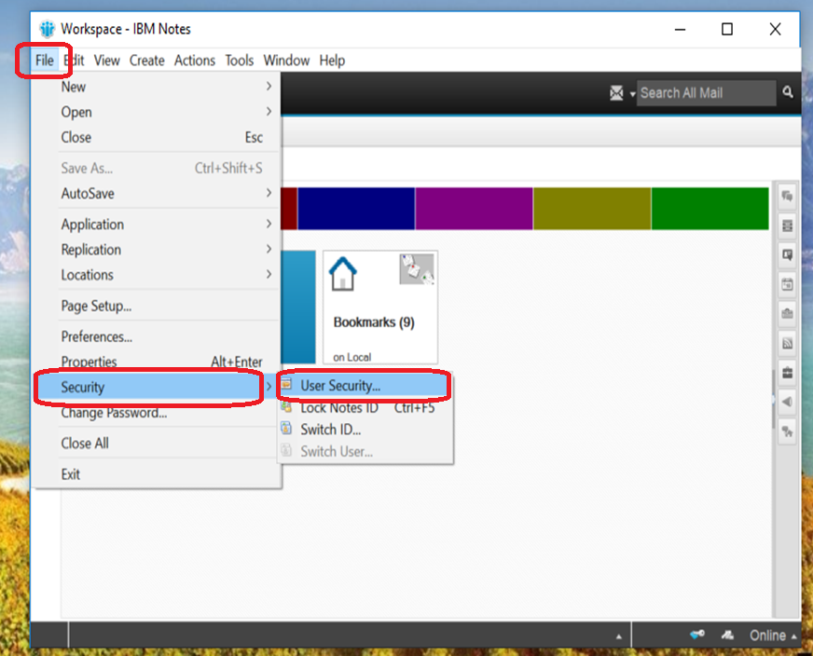
15-21 Input the “password” and click “Log In”.
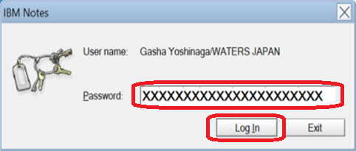

15-22 From “Secutiry Basics” tab, tick “Log in to Notes using your operating system login” option. And untick “the other 2 “Don’t let administrator set Domino…” and “Don’t prompt for a password from otherNotes-based….” options. Then select “What Others Do” tab.
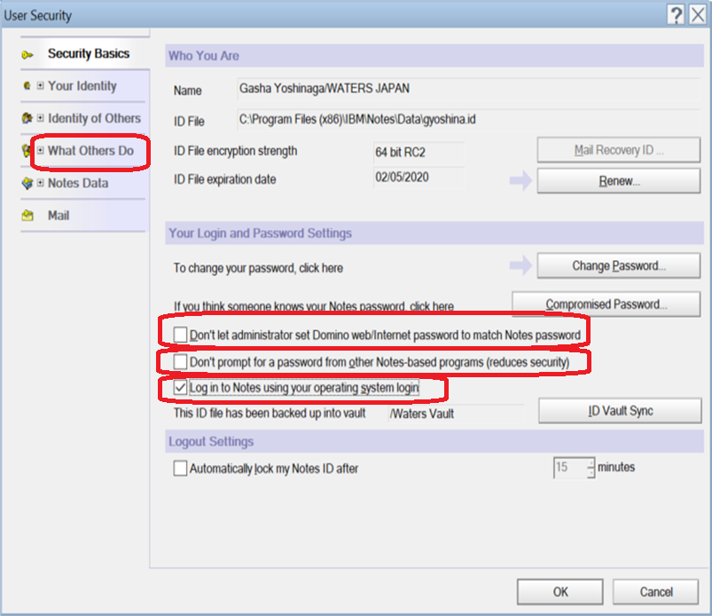
15-23 From “Using Workstation” atb, select “-default-“ option, and tick all check boxes.
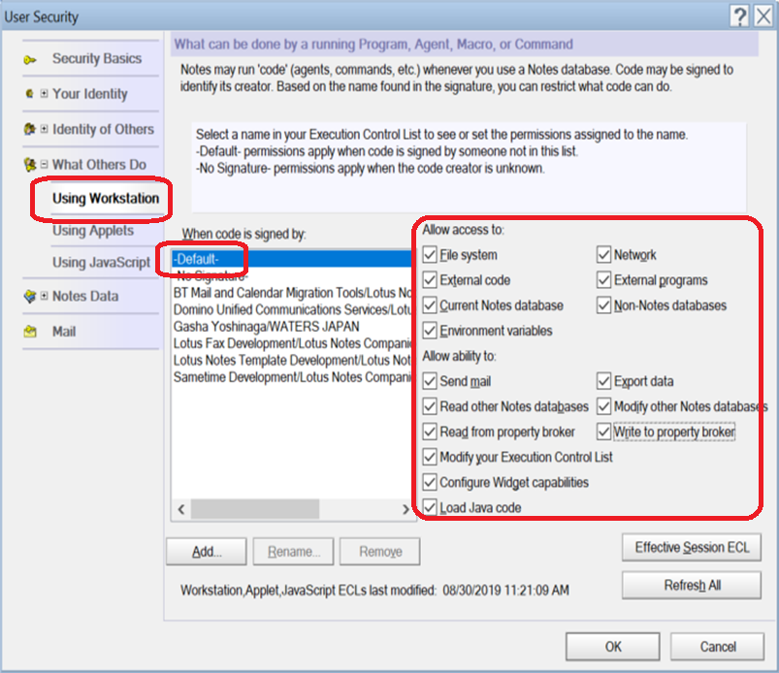

15-24 Select “-No Signature-“ option, and tick all check boxes.
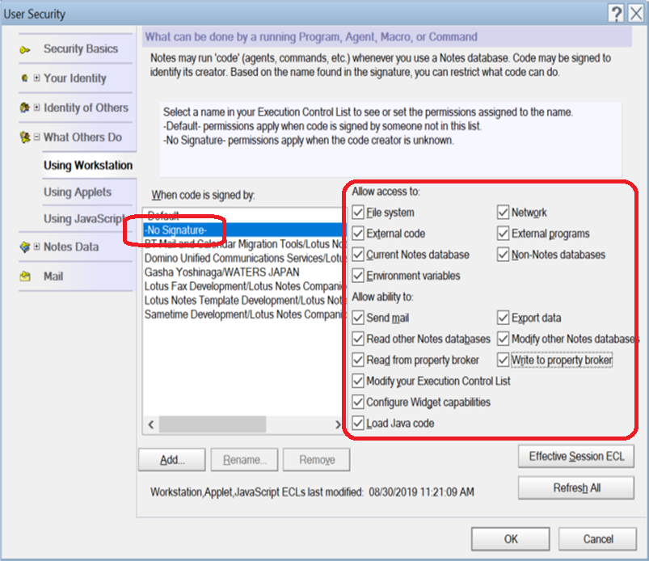

15-25 Remove all options of the other users xxxx/Waters, NOT GROUP. Click [OK].
15-26 Click “OK” button.
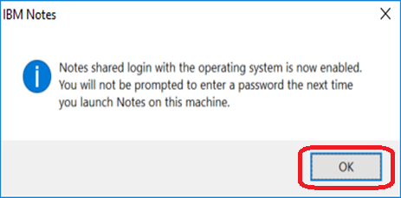

15-27 Click “OK” button.
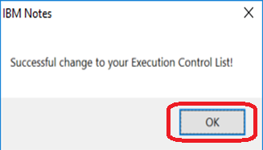

15-28 Click [X] to close the Notes.
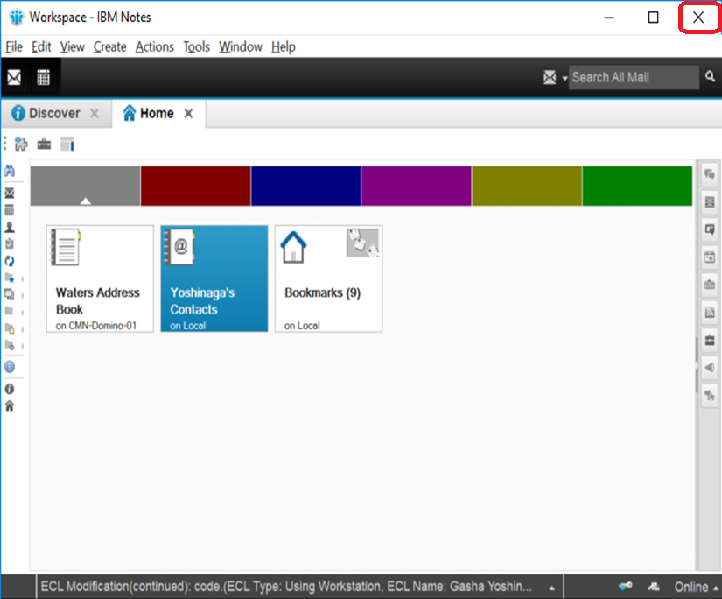
15-29 Tick “In the future, exit without prompting” option and click “Yes” button.
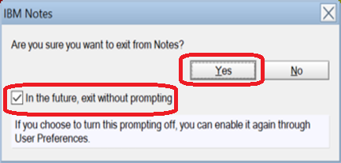

15-30 Go to C:\Program Files(x86)/IBM/Notes/Data folder and rename desktop8.ndk file.
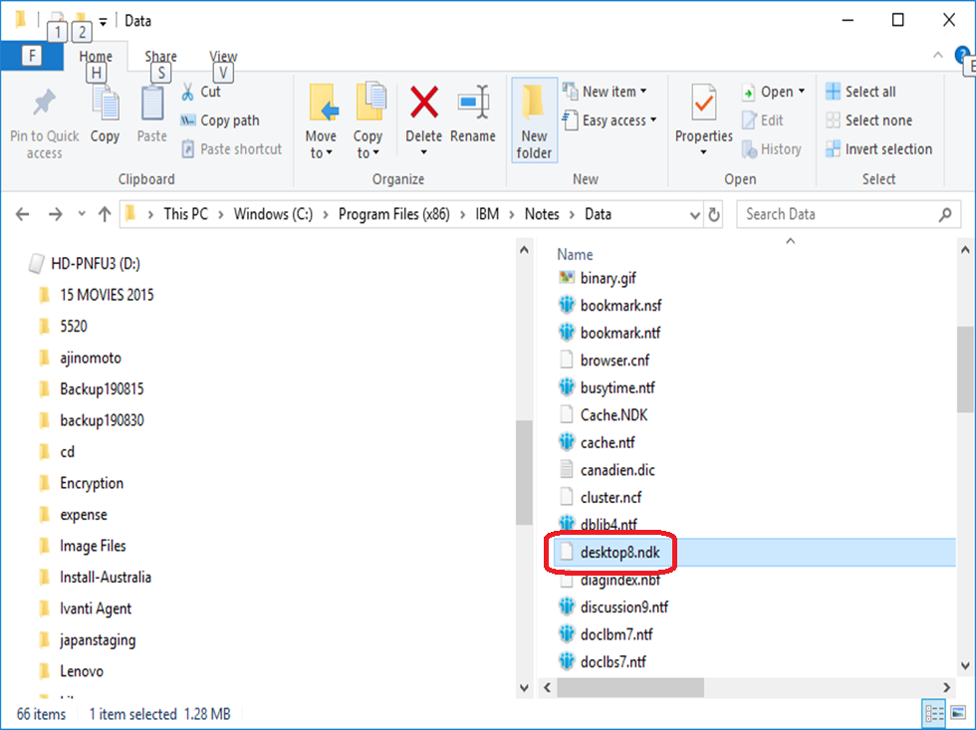

15-31 File name from desktop8.ndk to desktop8.new.ndk.
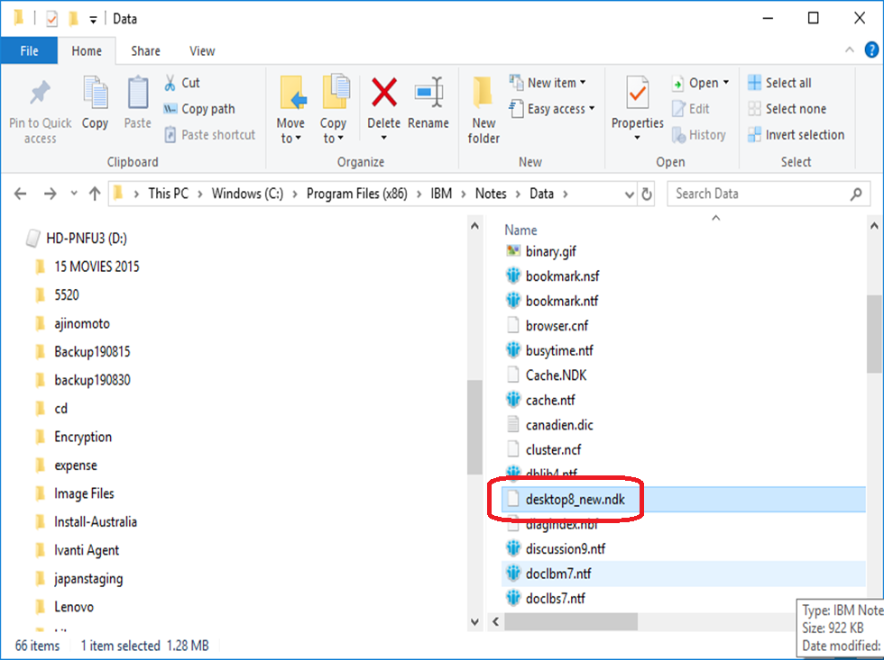
15-32 Copy Data folder from C:\temp
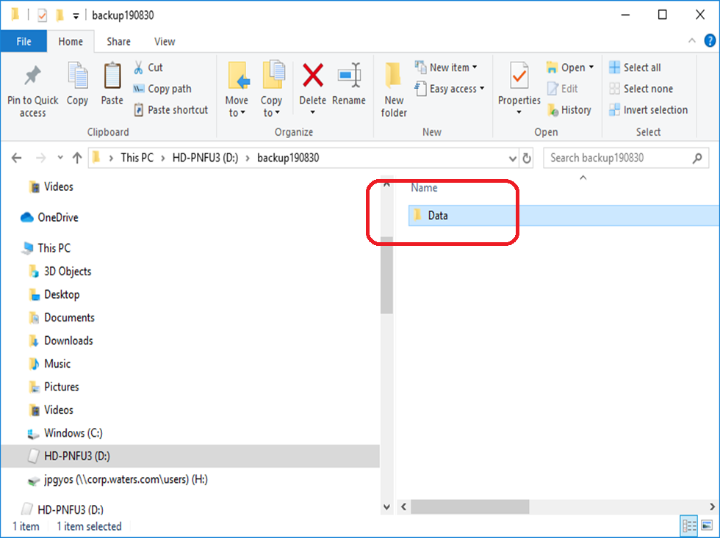

15-33 Paste it to the C:\Program Files(x86)/IBM/Notes/Data of new PC. But please DO NOT overwrite any file in this data folder.
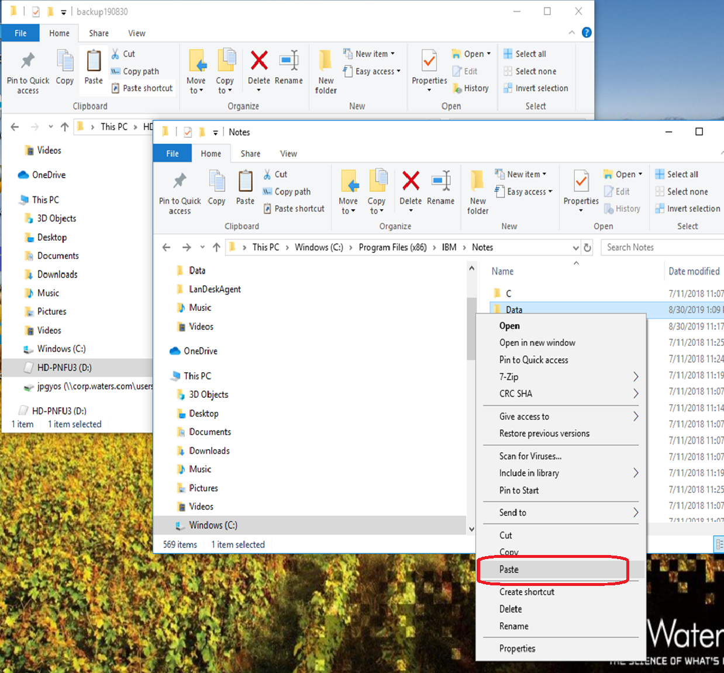
15-34 The data is copying.
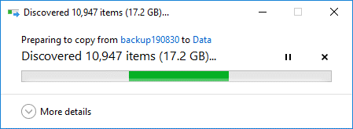

15-35 When the copy is finished, you can use Notes as usual.
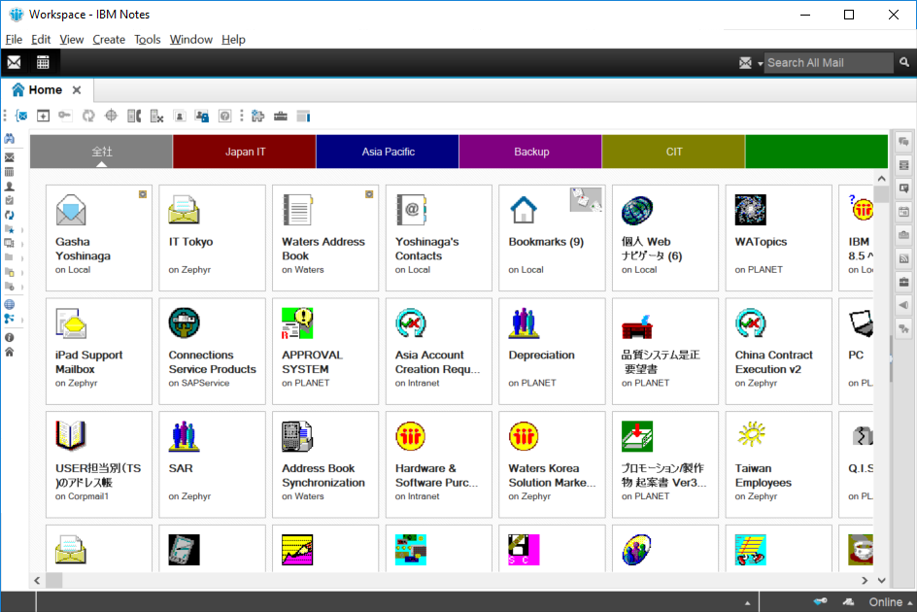

15-36 Select “Replication and Sync” button and click it.
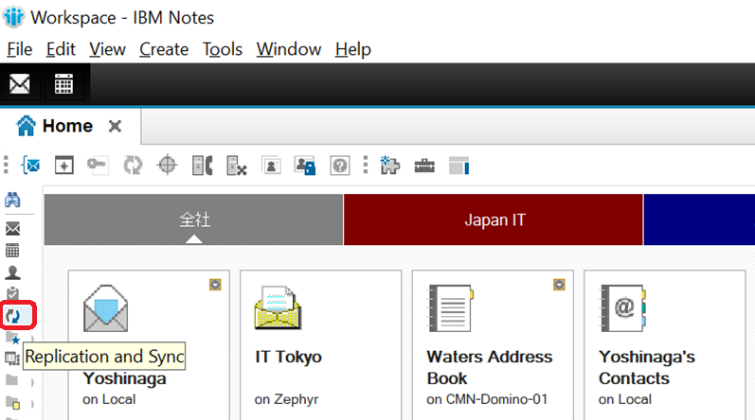

15-37 Click “Schedule” and select “Set Replication/Sync Schedule…”.
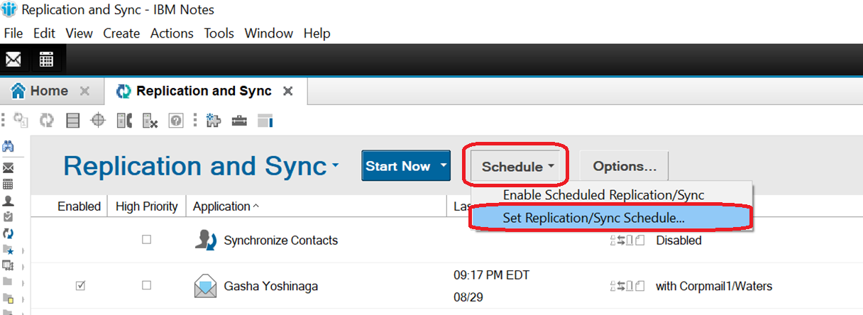

15-38 Please set up the “Normal-priority schedule” and “High-priority schedule” here. Please say the setting to user.
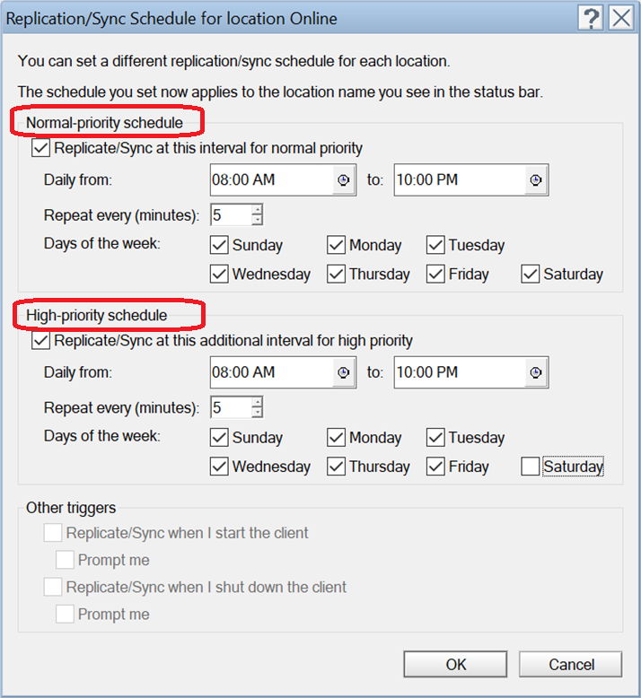

15-39 Please after replicated and double click person contacts.
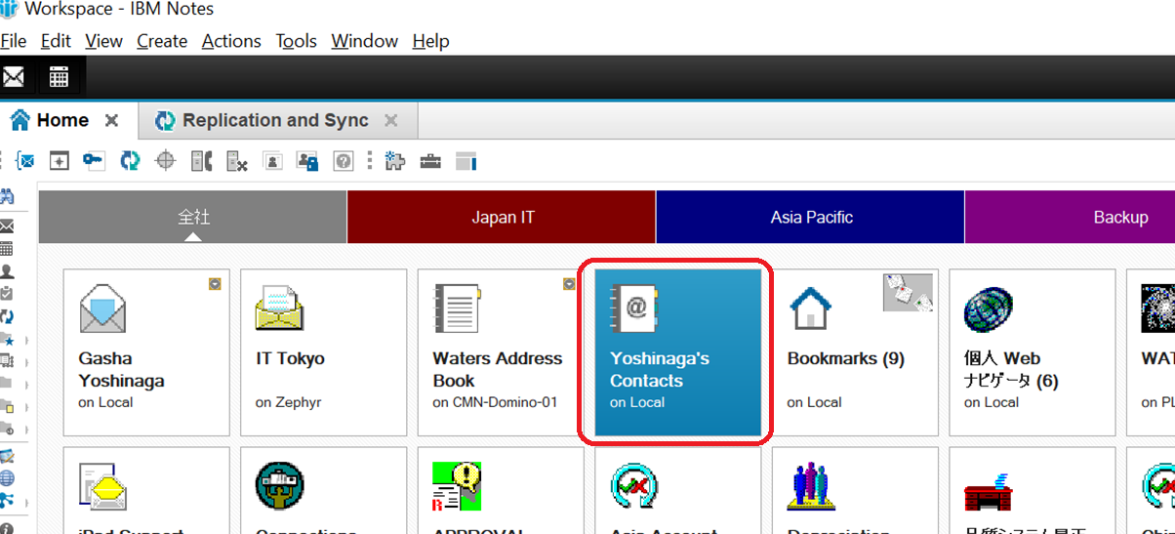
15-40 Please make sure the item in “Recent Contacts” is empty. If there is anything, please delete it.
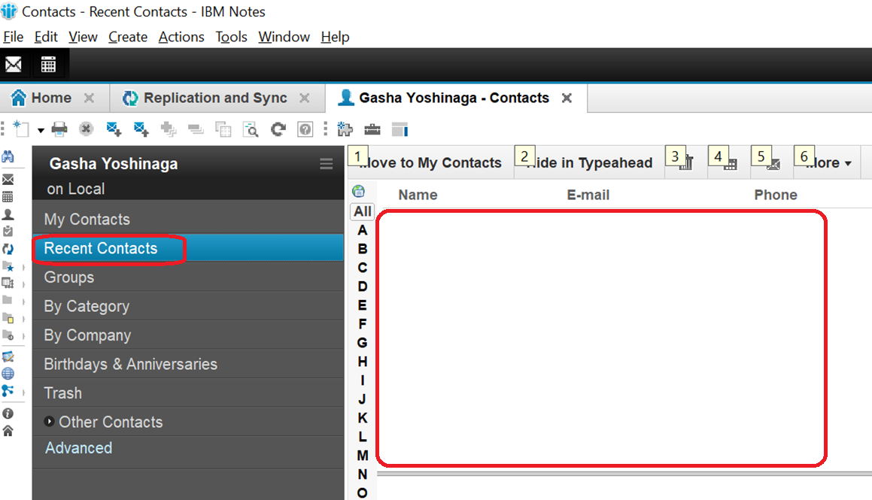

Setting of Wireless
16-1 Select the network icon in the right-down of Windows 10, then click ”WiFi”, Find “Backbone2” SSID and click “Connect” button.
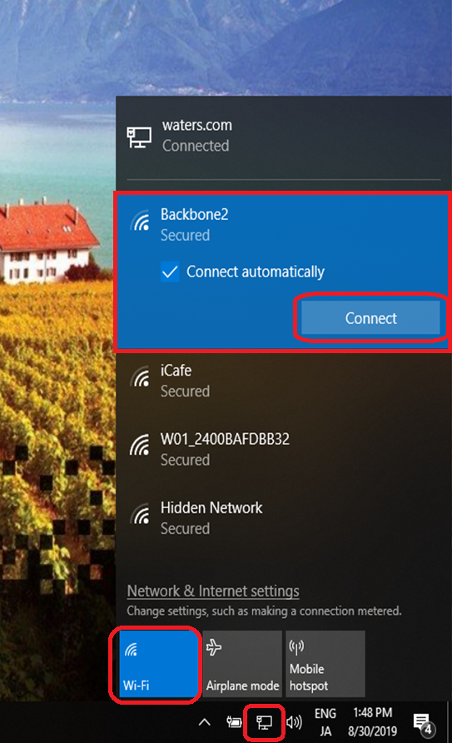
16-2 Tick “Use my Windows user account” option and input user’s ID and password, then click “OK” button.
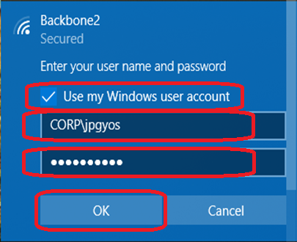

16-3 Click “Connect” button.
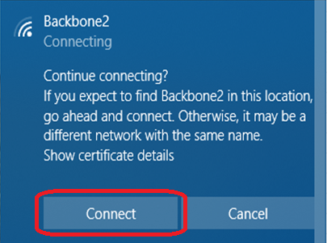
16-4 The WiFi is connecting.
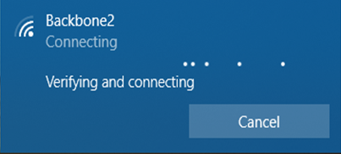

16-5 The WiFi is connected.
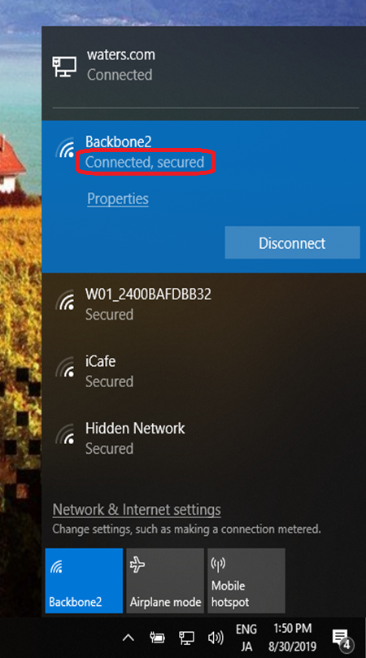

Setting of SAP
17-1 Start “SAP GUI Configuration” from “Control Panel”..
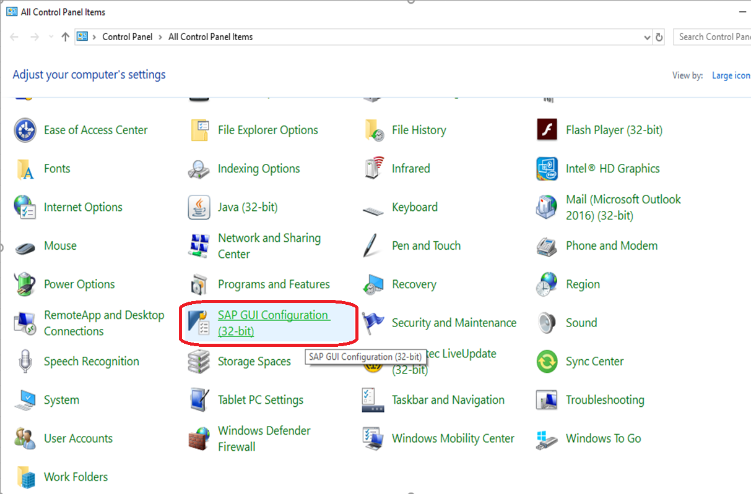

17-2 Select the item of “Visualization 1” option in “Interaction Design” folder, and tick “Show keys within dropdown lists” in “Controls” field.
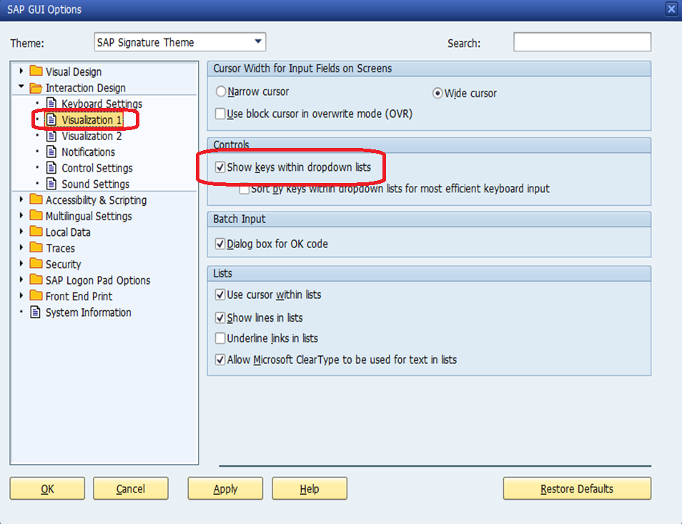
17-3 Select the item of “Visualization 2” option, and select “Do not show Enhanced Search” option in “Enhanced Search” field. Then click “OK” button.
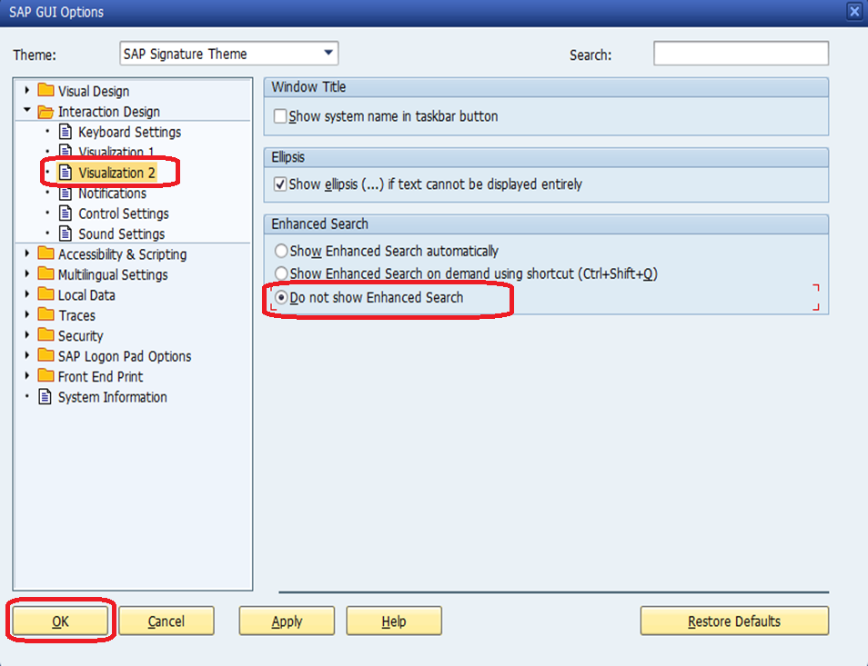

Copy the shortcut
18-1 Copy the all shortcut to Desktop, if it is necessary.

18-2 Open “Internet Explorer” from [Start]->[Windows Accessories], then pin IE to taskbar.

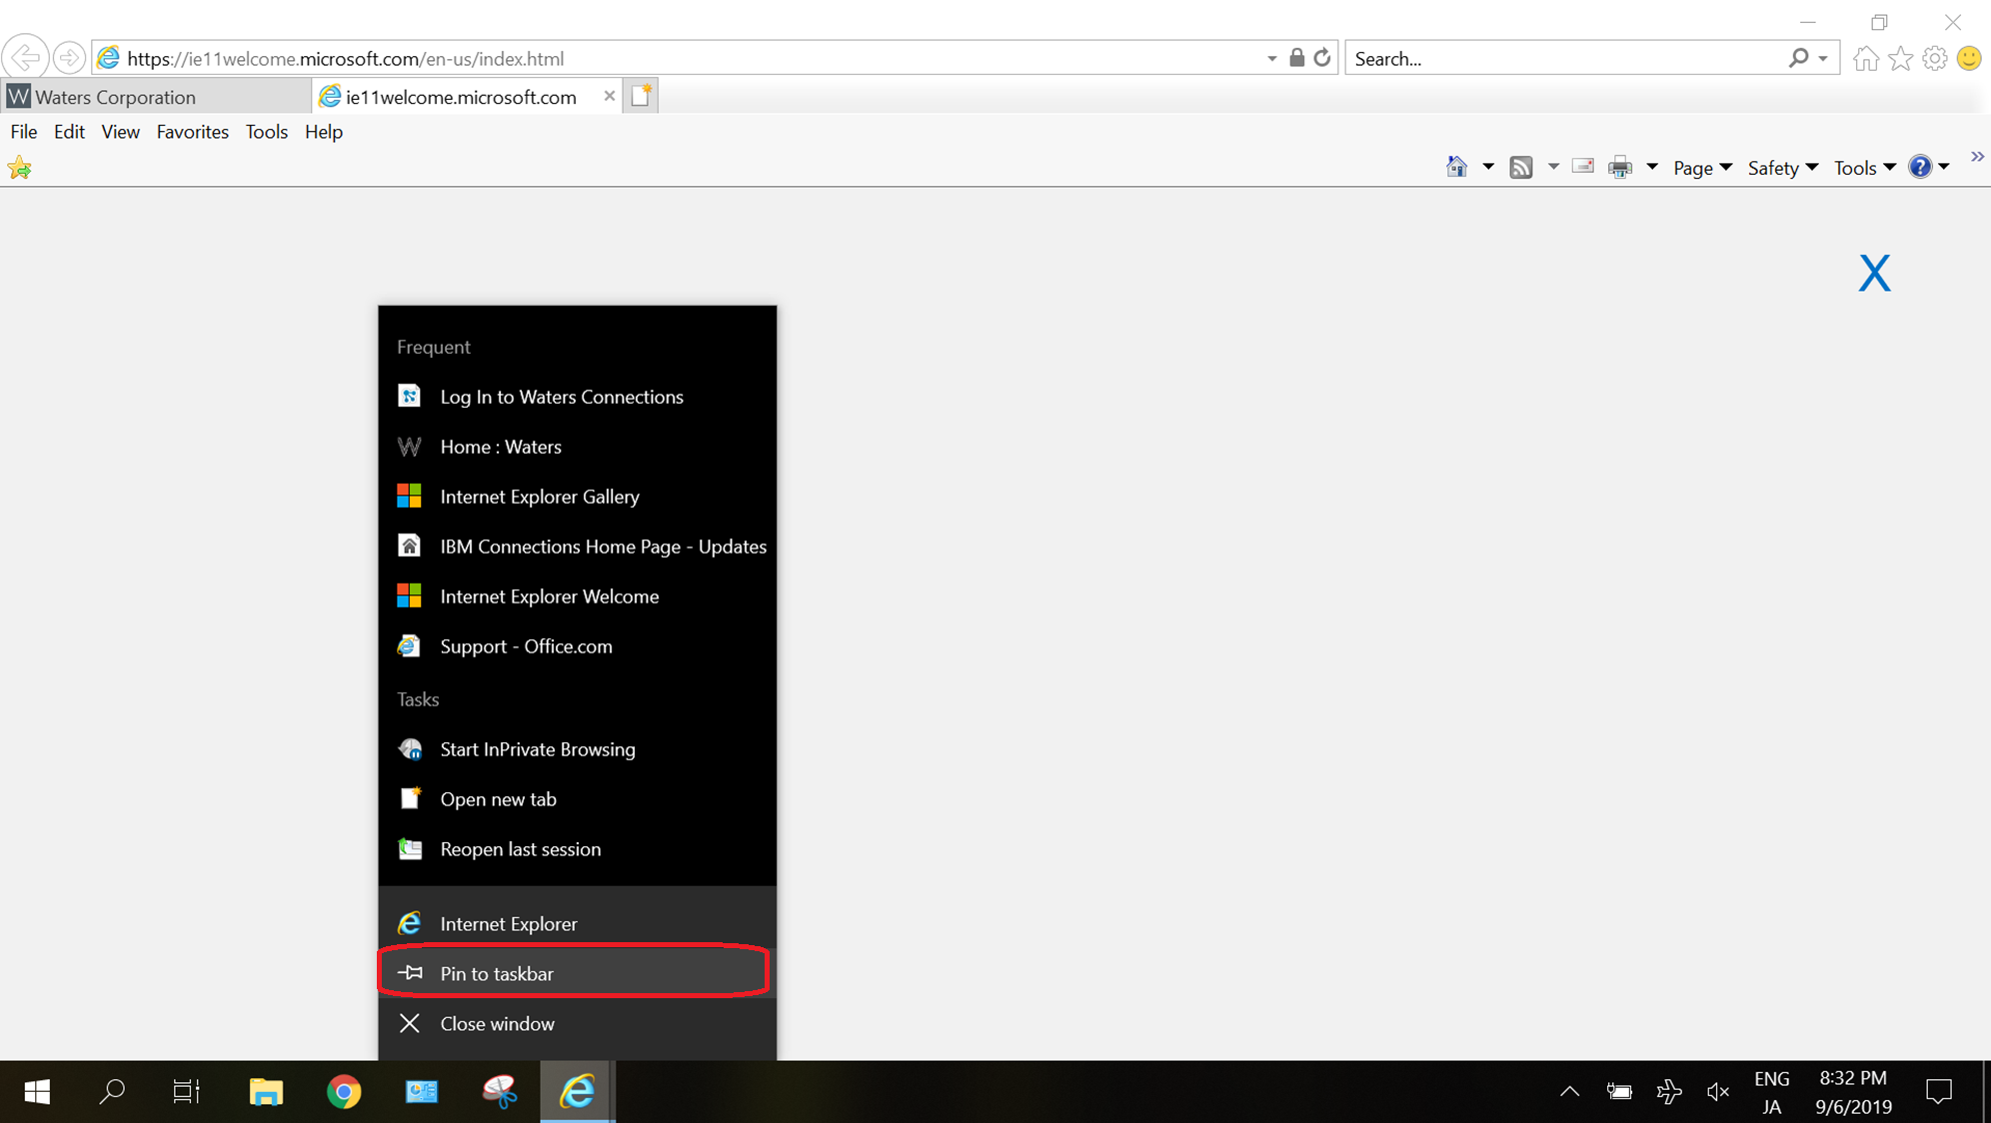

Install pDoc
(Just only for users who need the signature from customer)
19-1 Copy the program of pDoc to desktop and double click “pdoctablet.exe”
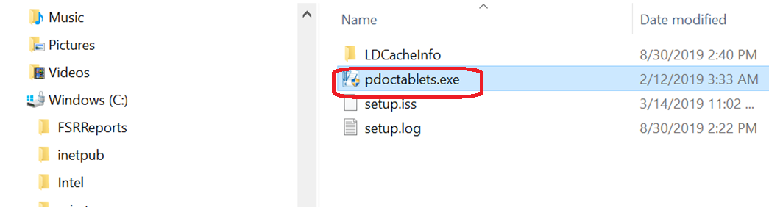

19-2 Click “Next >” button.
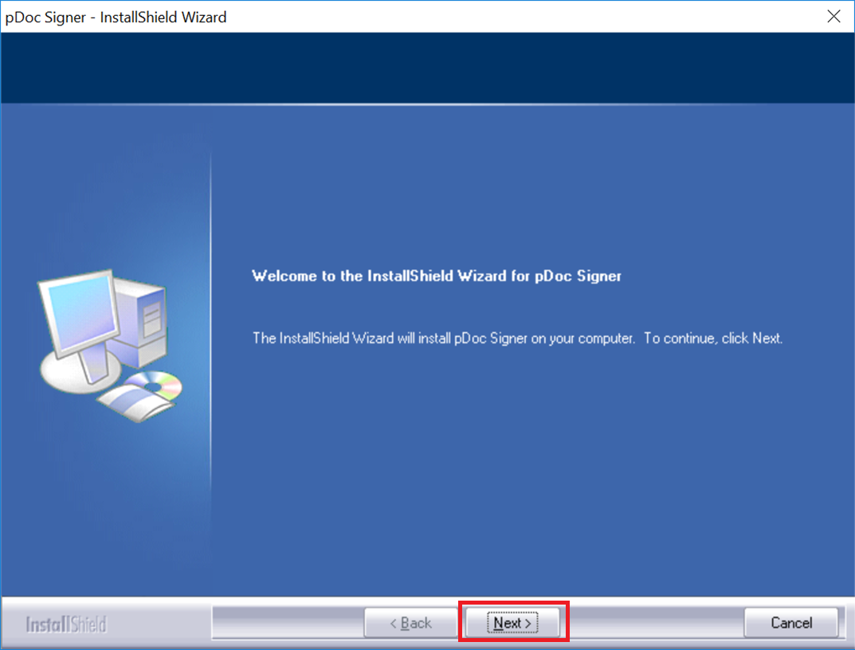
19-3 Click “Yes”.
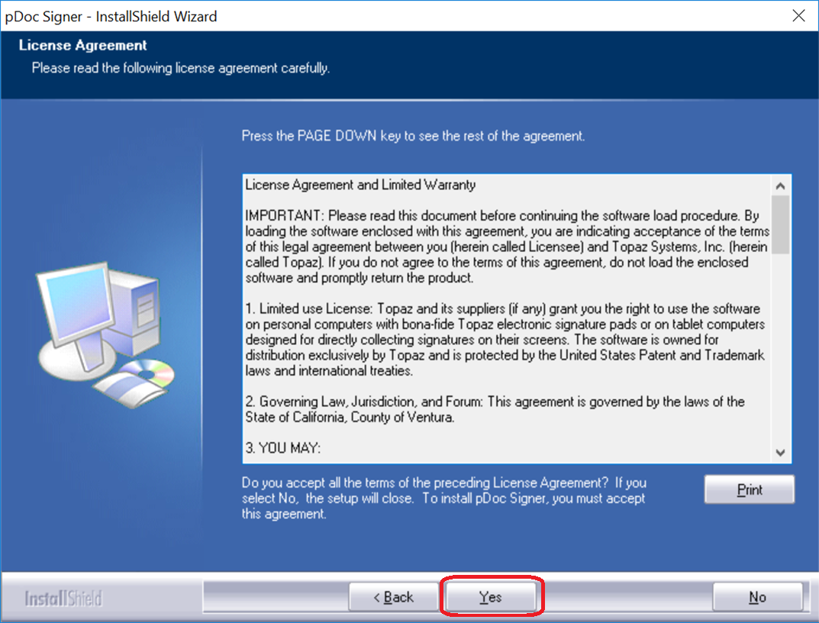

19-4 Click “Next >” button.
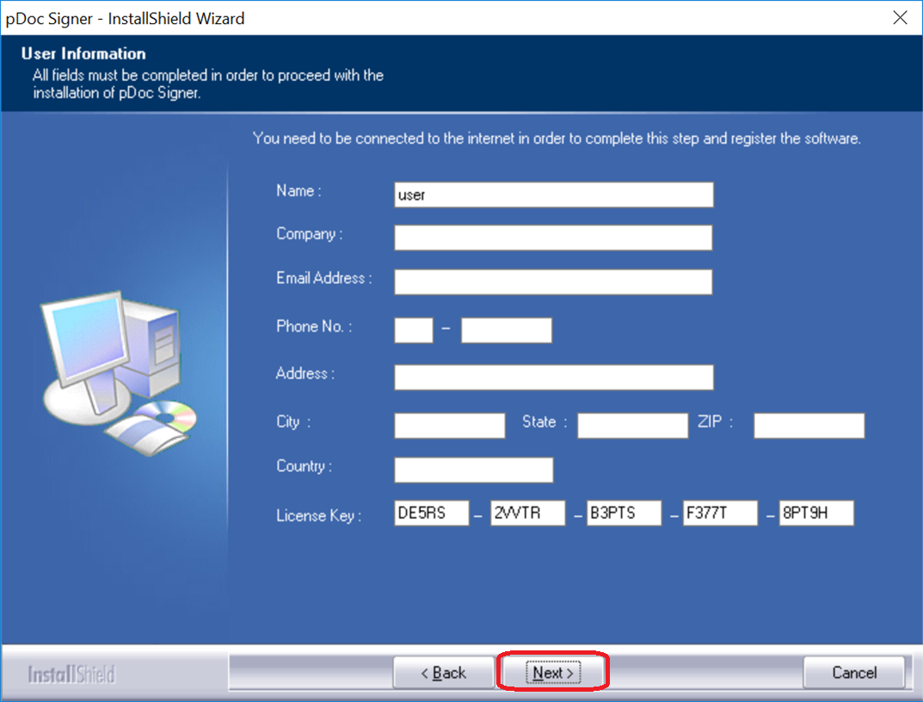
19-5 Click “Next >” button.
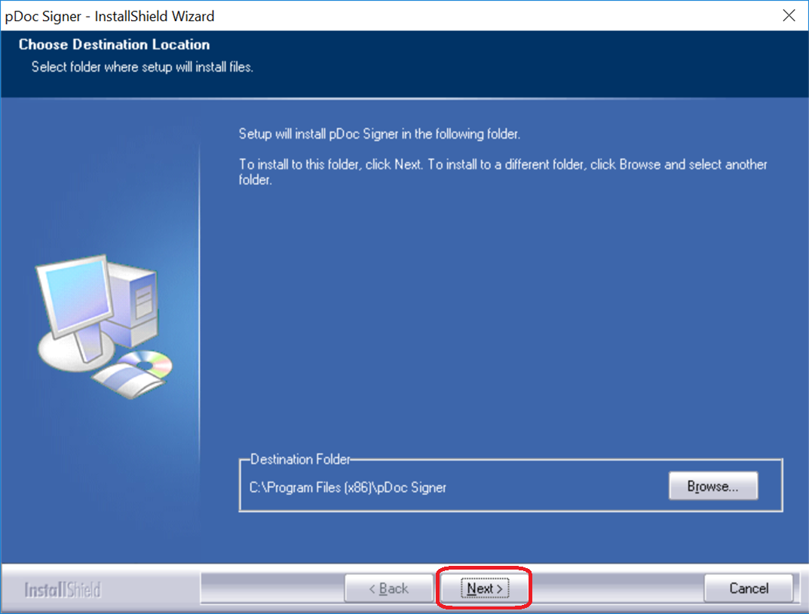

19-6 tick the pDoc and click “Next >”.
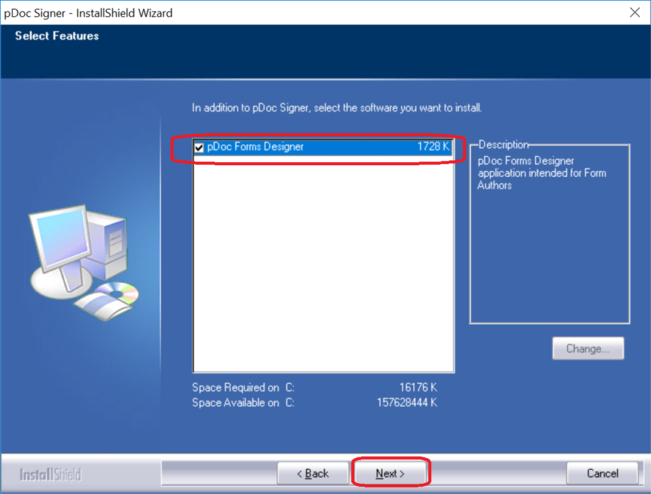
19-7 Select “English” and click “Next >” button.
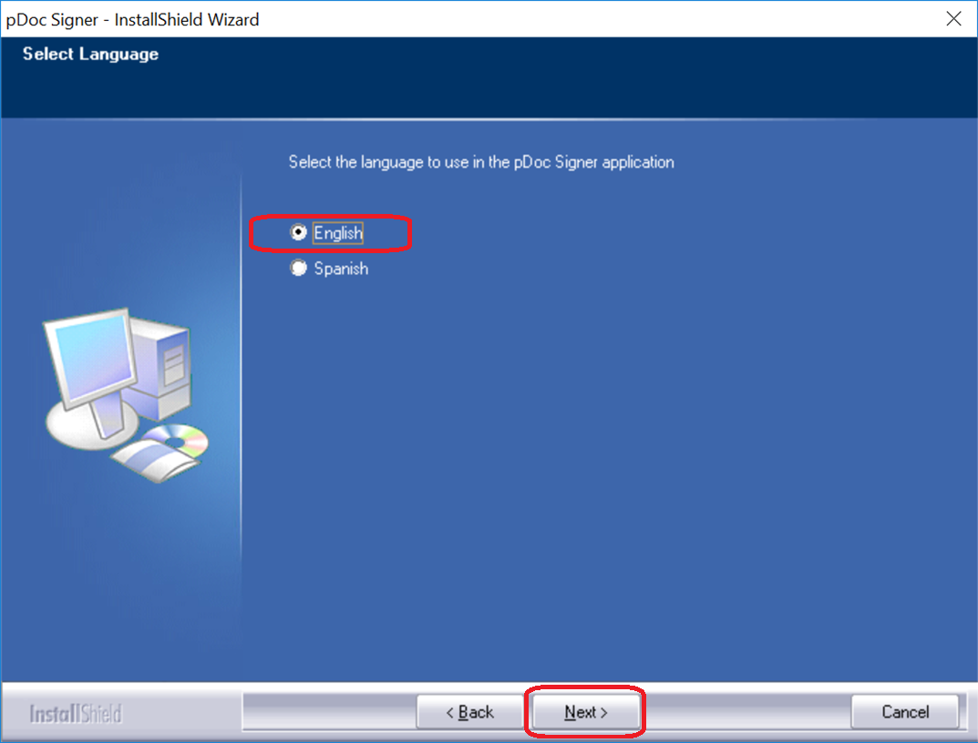

19-8 Click “Next >”.
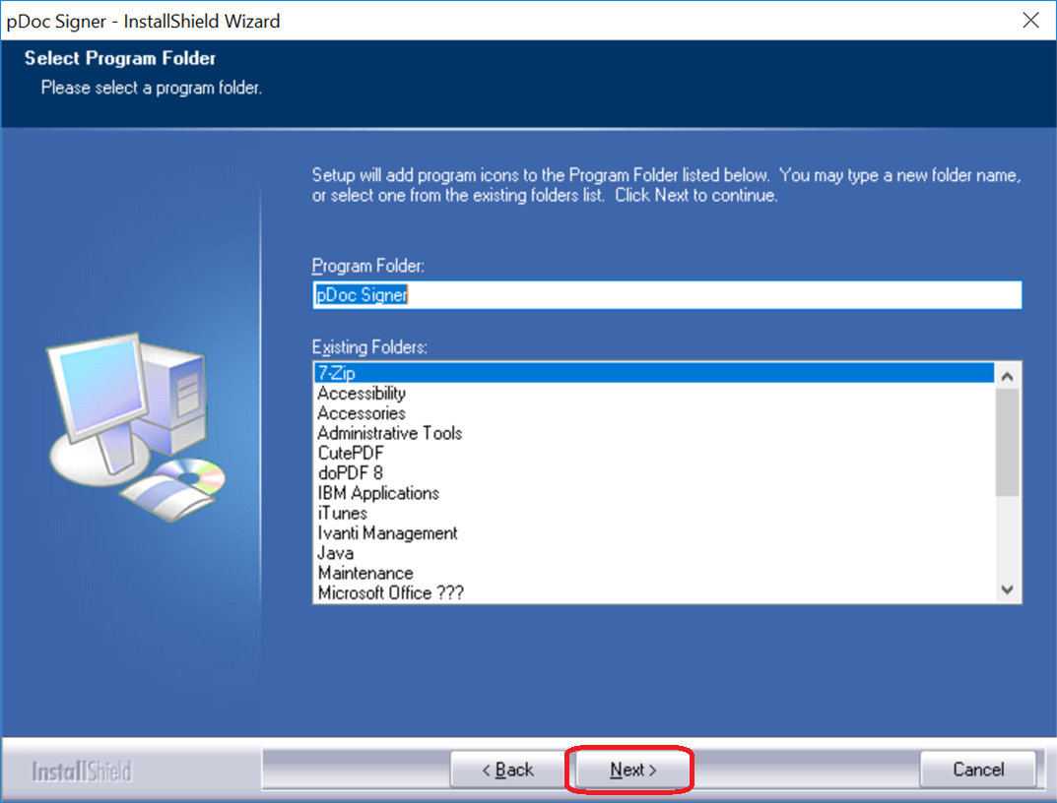
19-9 Click “Finish”.
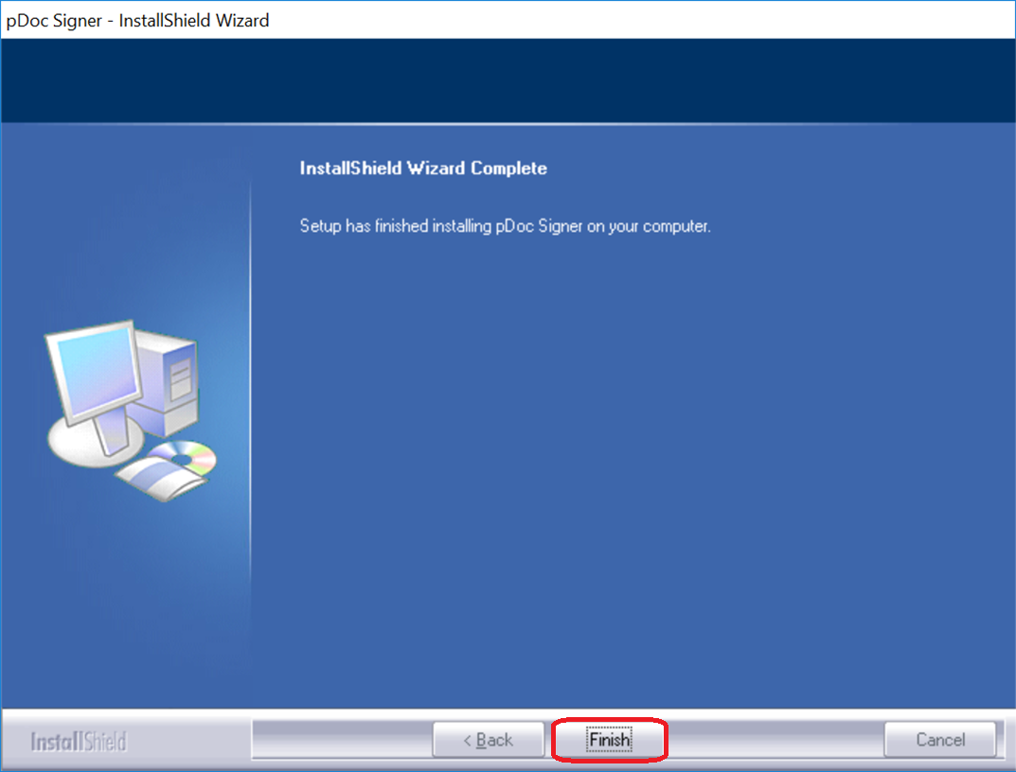

19-10 Double click the signplus_tpc.exe.
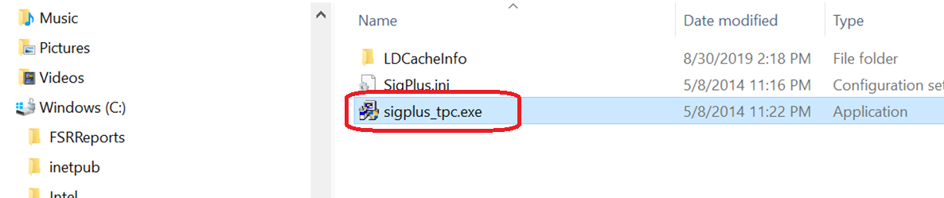

19-11 Click “Next >” button.
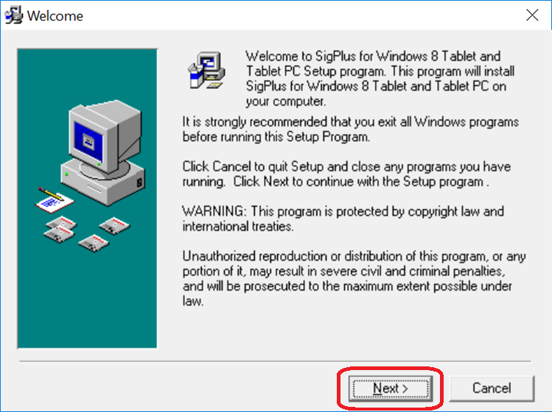
19-12 Click “Next >” button.
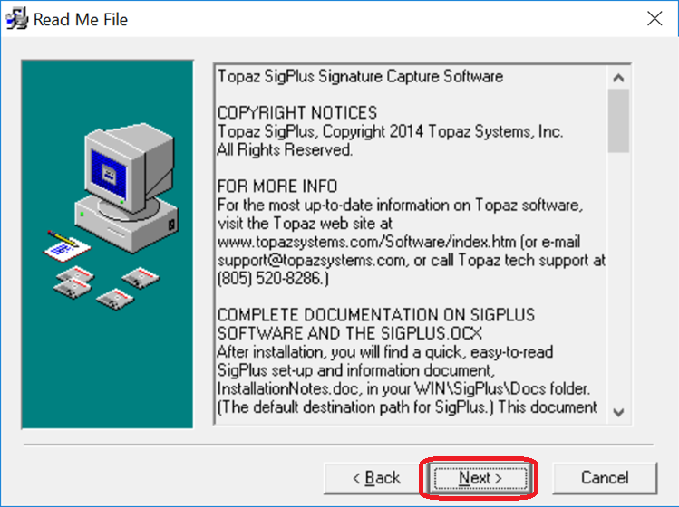

19-13 Click “Next >” button.
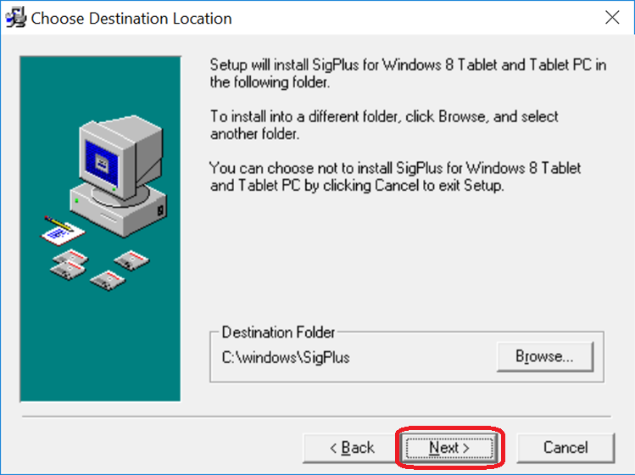

19-14 Click “OK” button.
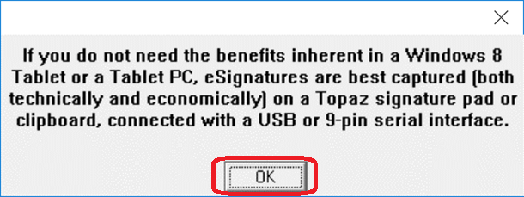
19-15 Click “Agree” button.
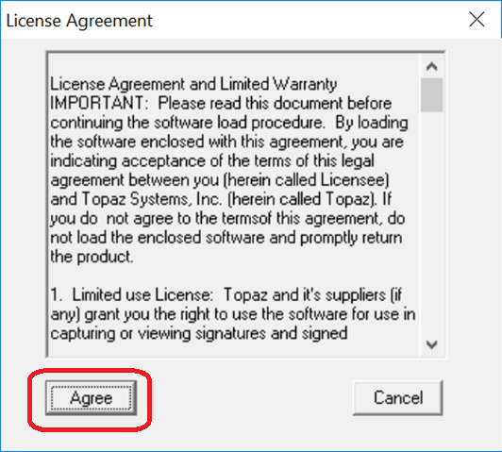

19-16 Click “I Agree” button.
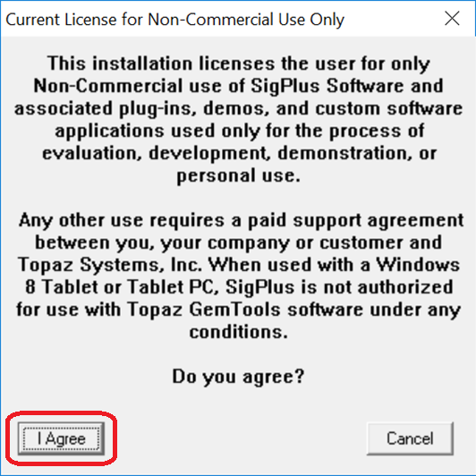
19-17 Click “OK” button.
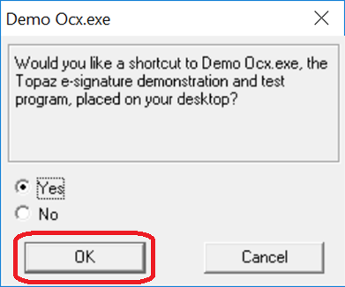

19-18 Click “OK” button.
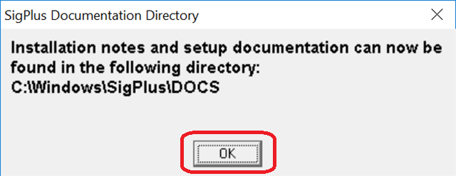

19-19 Click “OK” button.
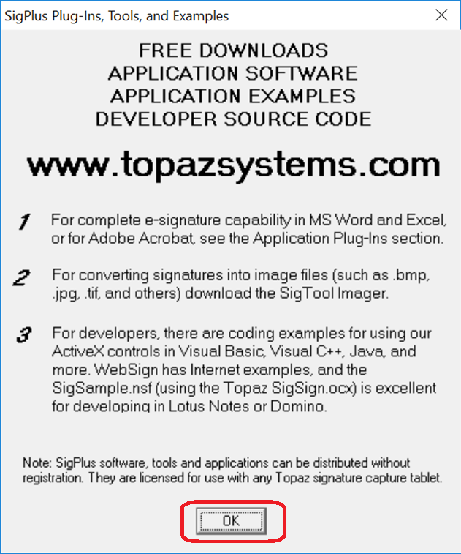
19-20 Click “Finish” button.
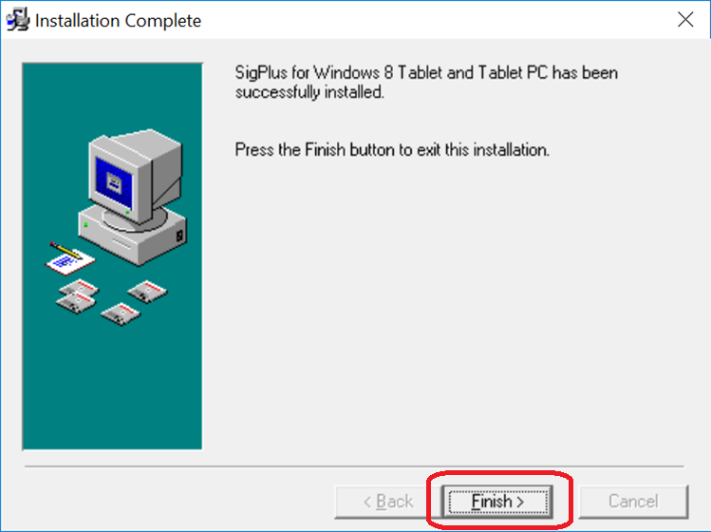

19-21 Since the license maybe will be expired, please renew it. Copy the pDocSigner.pfx file to C:\Program Files(x86)\pDoc Signer folder.
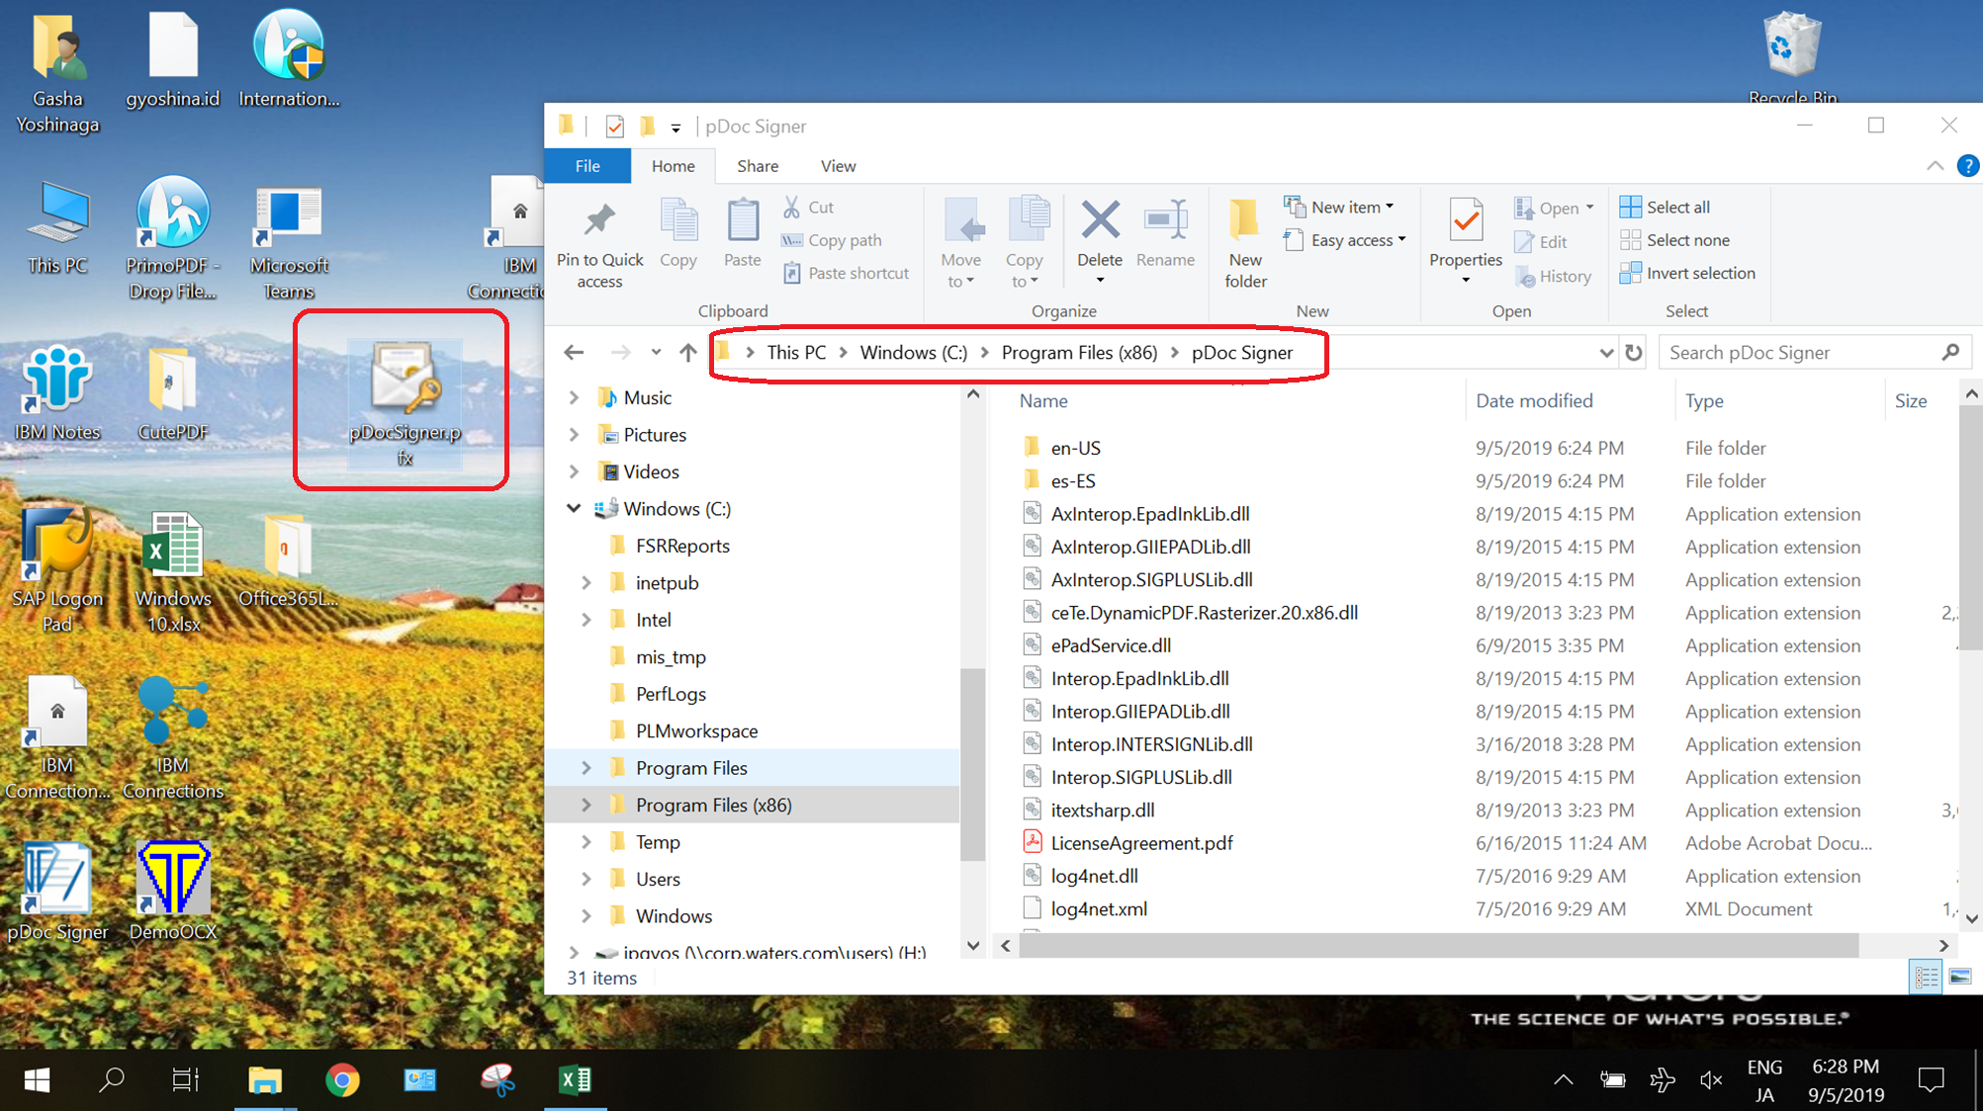
19-22 The file is renewed.
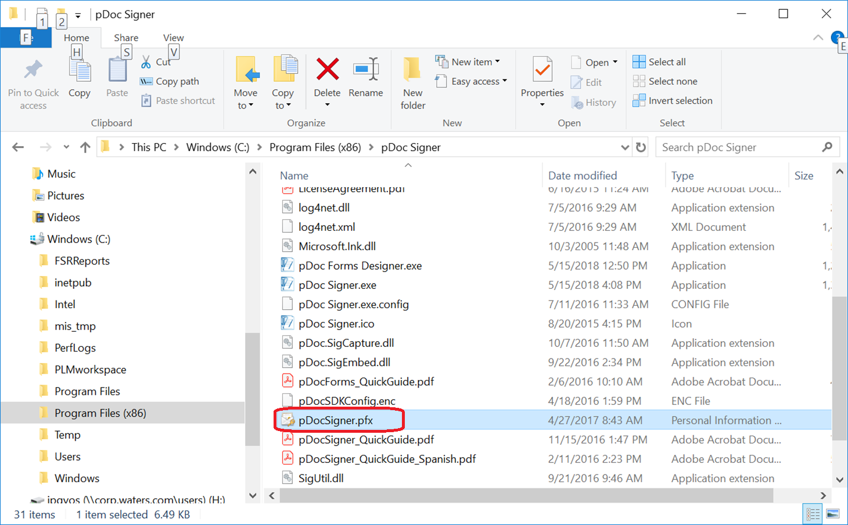

Setting for CIT(Field user only)
20-1 Please refer to the document named “CIT replication guide.doc” and “Setting Up CIT in Lotus Notes.pptx” files.

20-2 For setting of the all CIT users’ Notes, please setup working drive for therm.
Please click “Help” and select “Using This Application”.
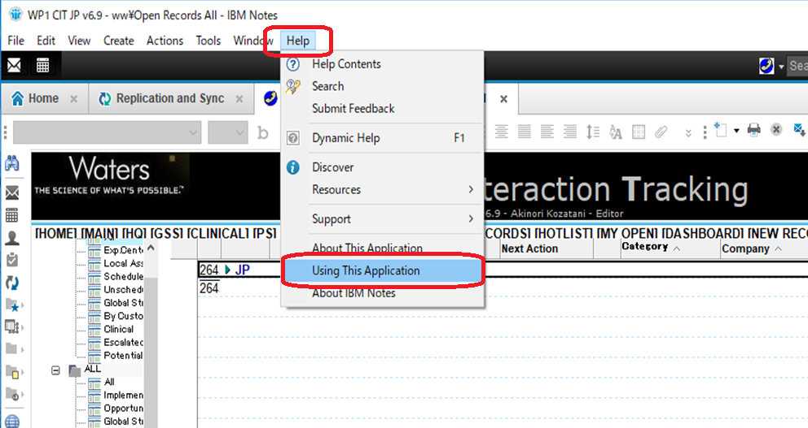

20-3 Click “Use C Drive” button.
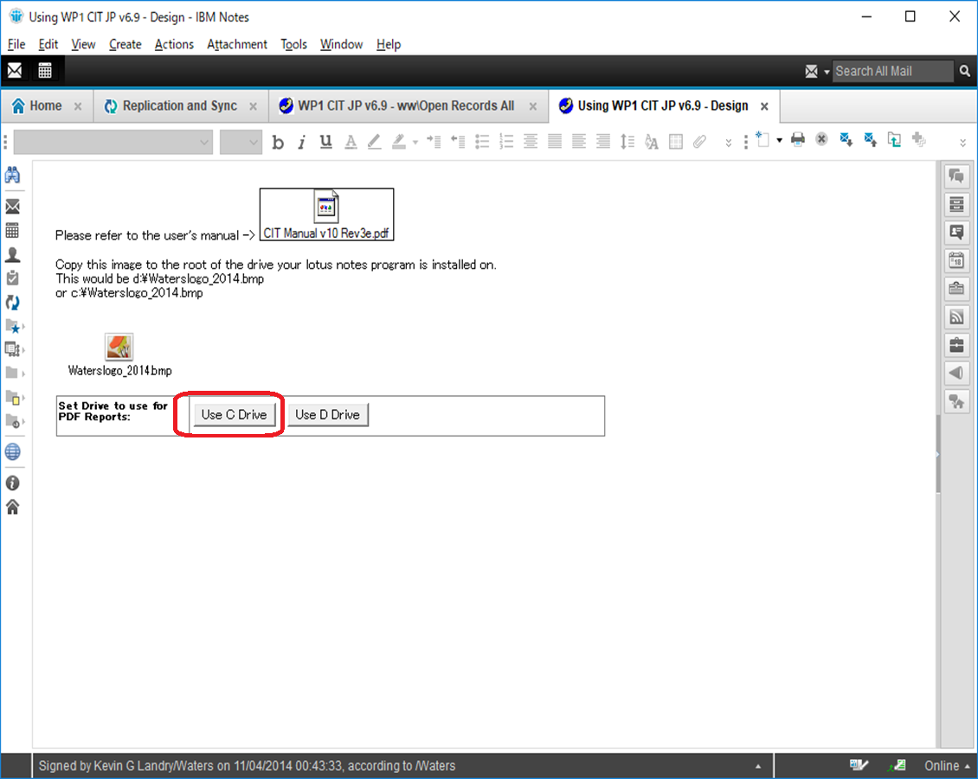

Create FSR folder (Service engineer and no folder user only)
21-1 Open Windows explorer and go to C:\ drive.
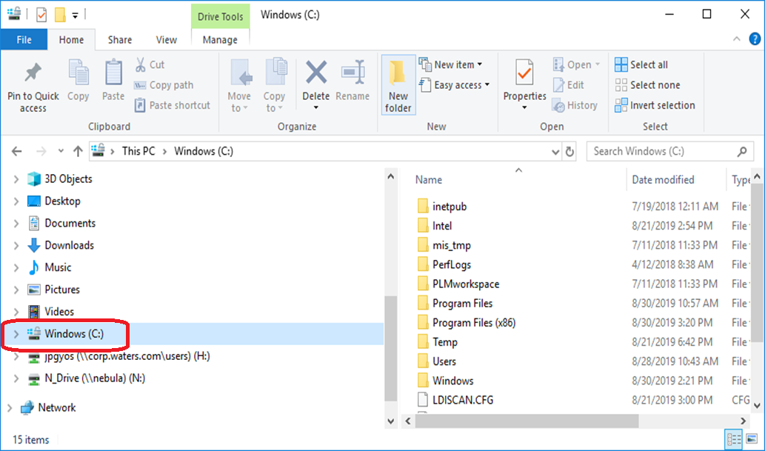

21-2 Create “FSRReports” folder.
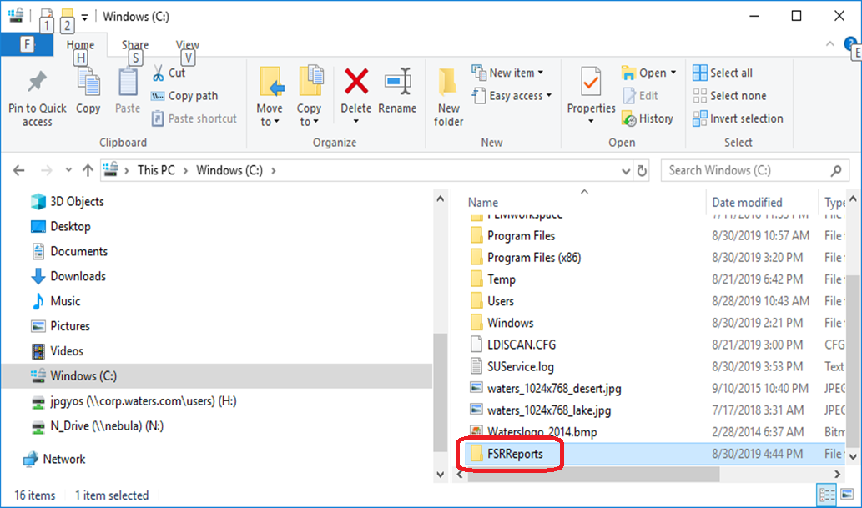

Install PrimoPDF (Optional)
22-1 From N drive, copy the file of PrimoPDF and double click it.
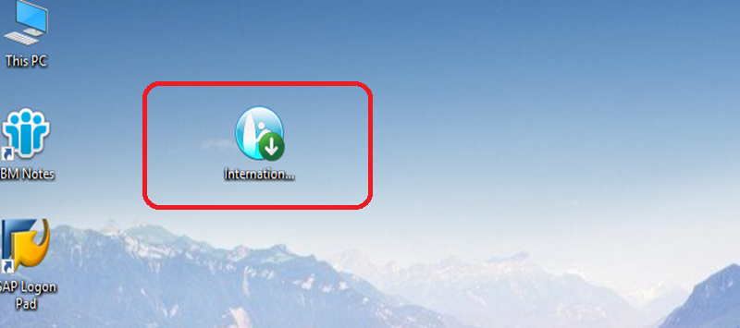

22-2 Select the language you want to install and click “OK” button.
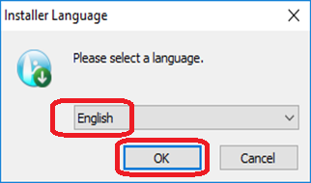

22-3 Click “Next >” button.
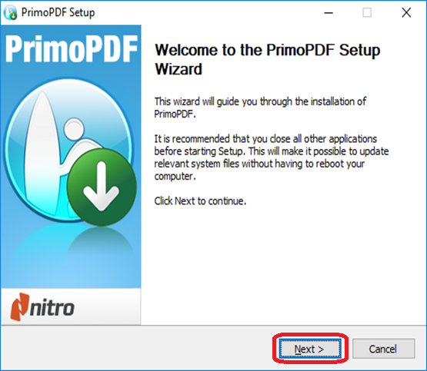
22-4 Click “I Agree” button.
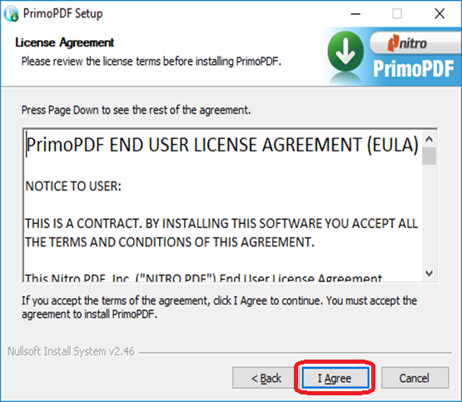

22-5 Click “Next >” button.
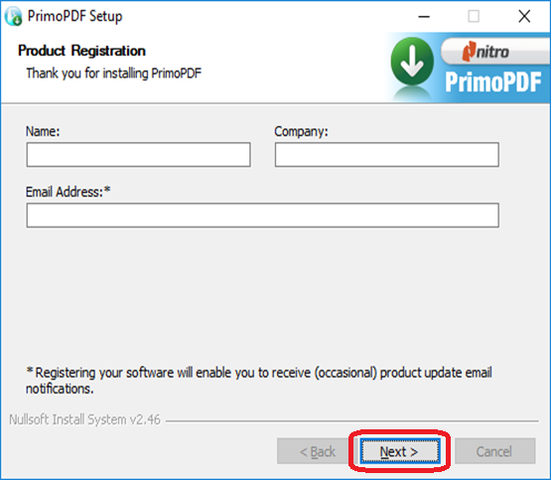
22-6 Click “Finish” to complete the installation.
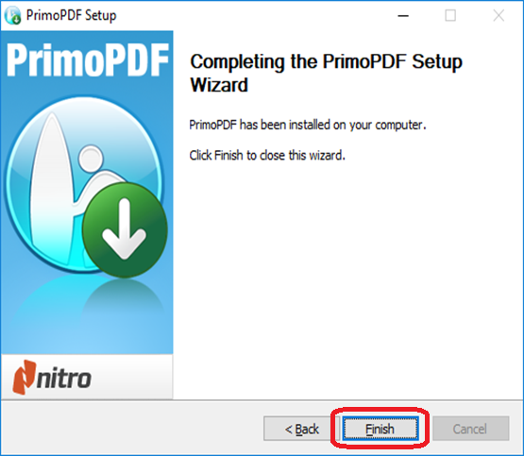

Install CutePDF
23-1 From N drive, copy the program to desktop. Double click “CuteWriter.exe”.
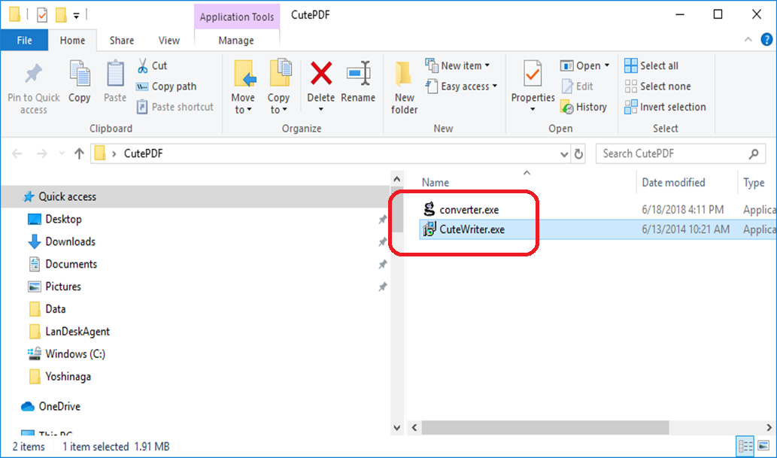

23-2 Click “Next >” button.
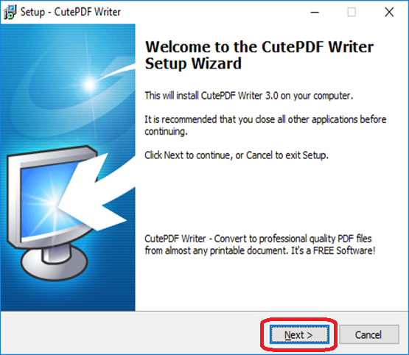
23-3 Select “I accept the agreement” option and click “Next >” button.
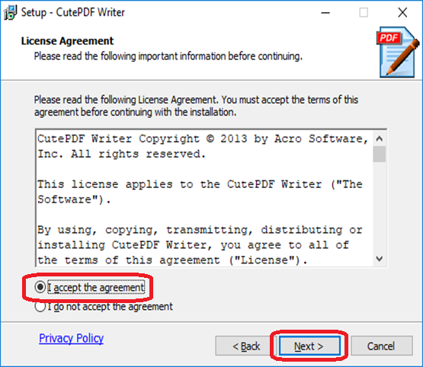

23-4 Untick the options and click “Next” button.
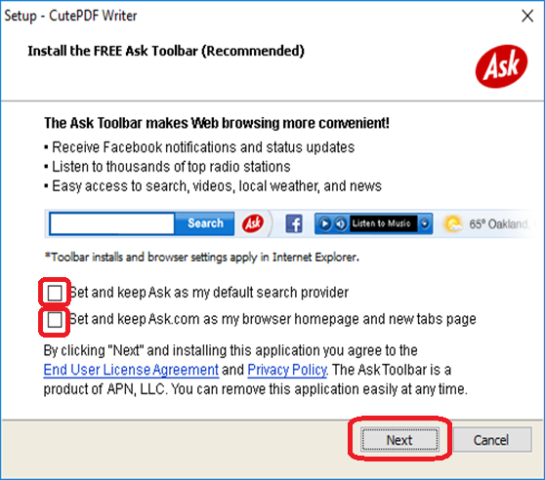
23-5 Click “Install” button.
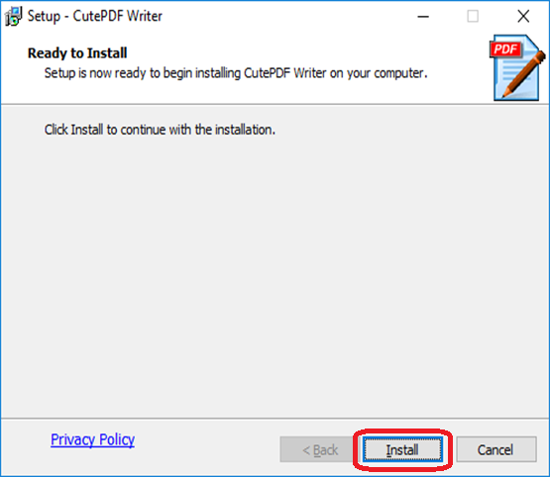

23-6 Click “Yes” button.
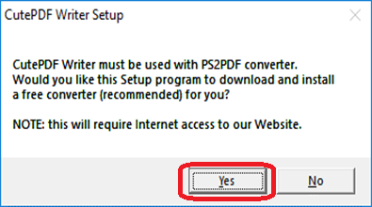

23-7 The program is installing.
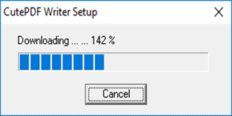
23-8 If program does not let you install from Internet, please double click the program “converter.exe”.
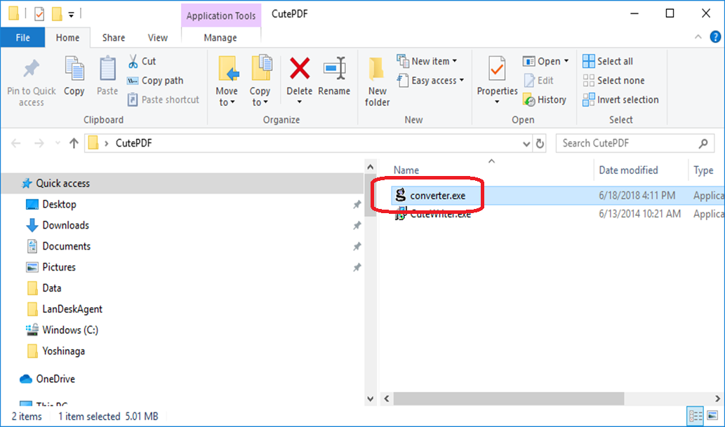

23-9 Click the “setup” button, then the program will be installed.
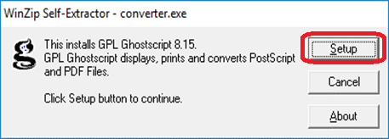

Setup Windows Firewall ON
24-1 For the reason of security, we setup the Windows firewall ON. Please click “Windows Defender Firewall” from “Control Panel”.
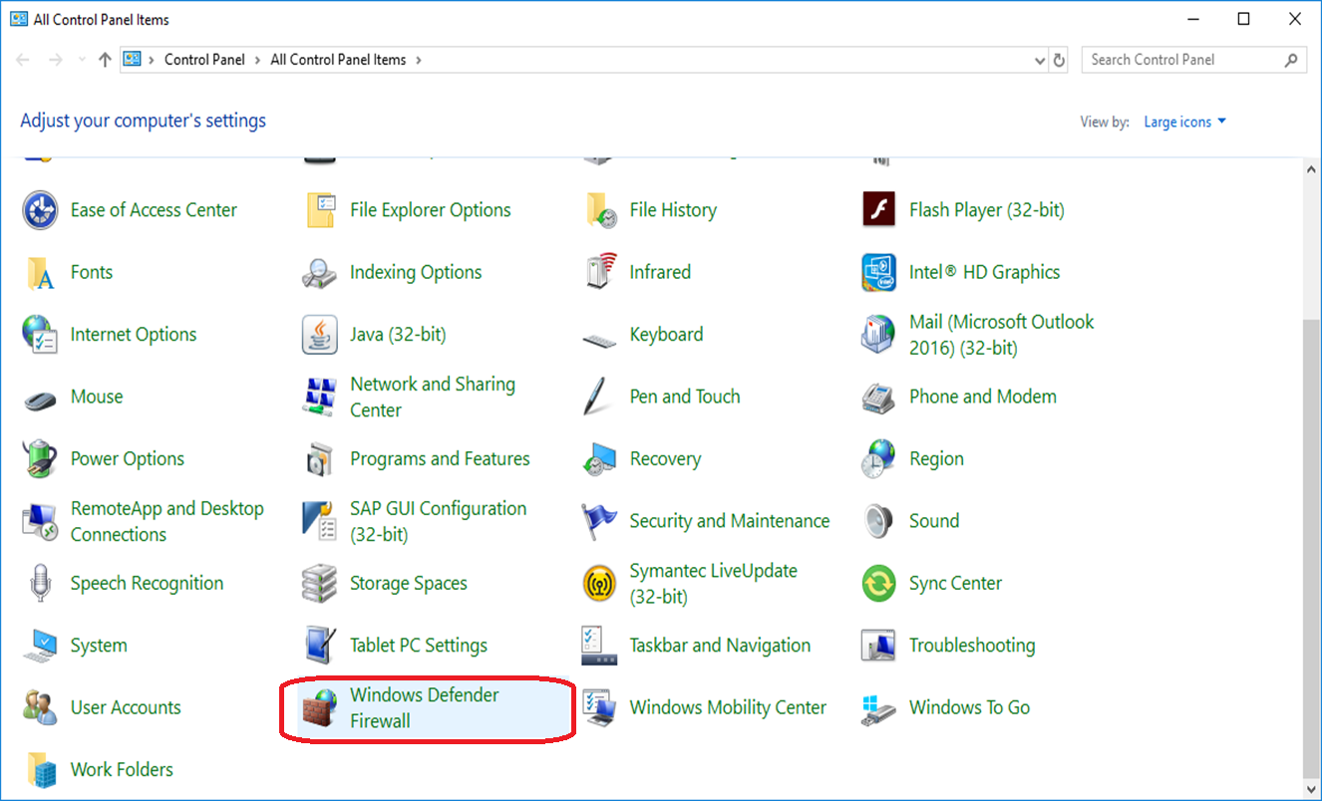

24-2 Click “Turn Windows Defender Firewall on or off”.
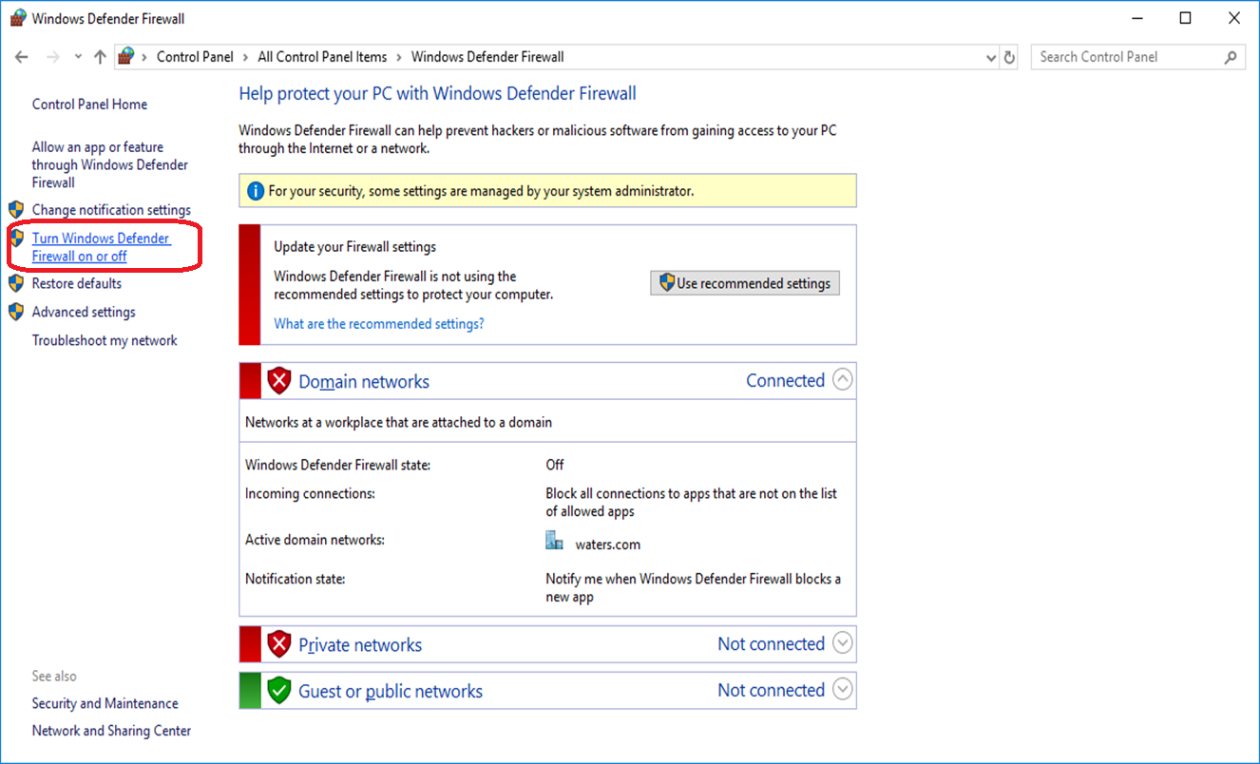
24-3 Turn on the all Windows Defender Firewall and click “OK” button.
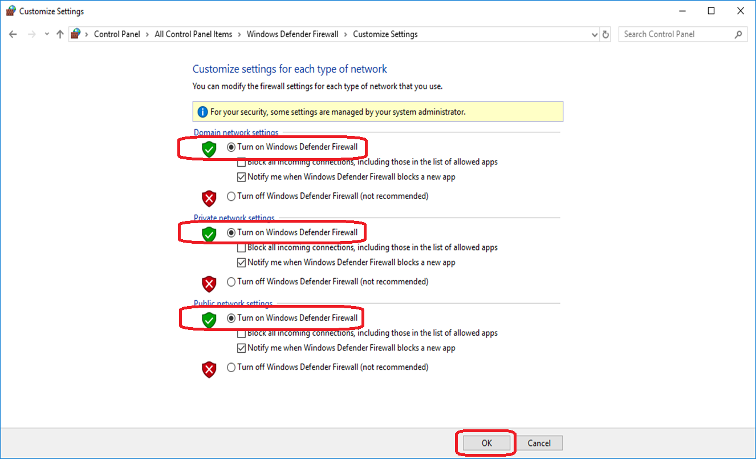

24-4 Then the Windows Defender Firewall is ON.
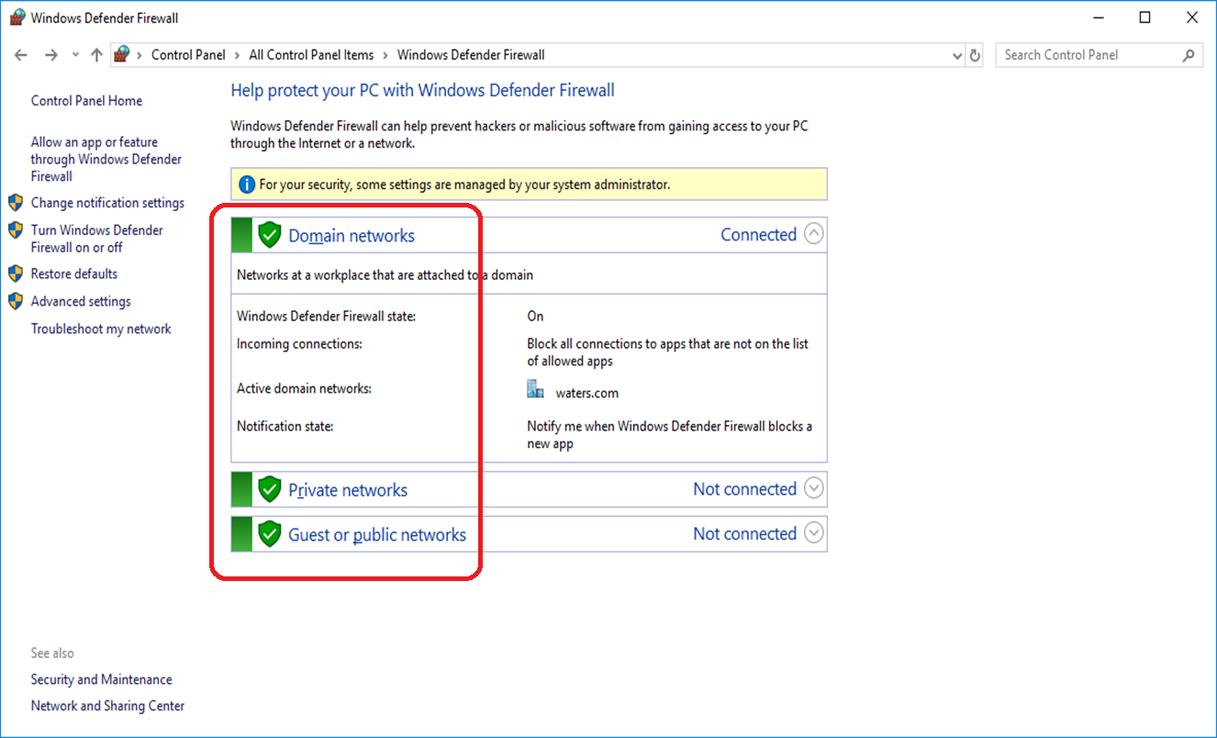

Set the Windows Notification OFF
25-1 Right click the Windows notification icon.


25-2 Select “Don’t show app icons”.
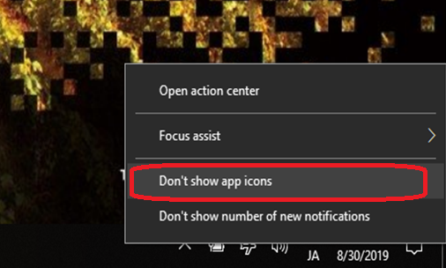

25-3 Select “Don’t show number of new notifications”.
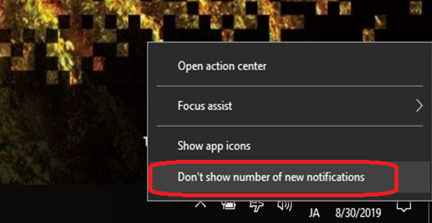

Mapping the network drive
26-1 Please map the network drive N_Drive of your country.
Open Windows Explorer and click “Map network drive” button.
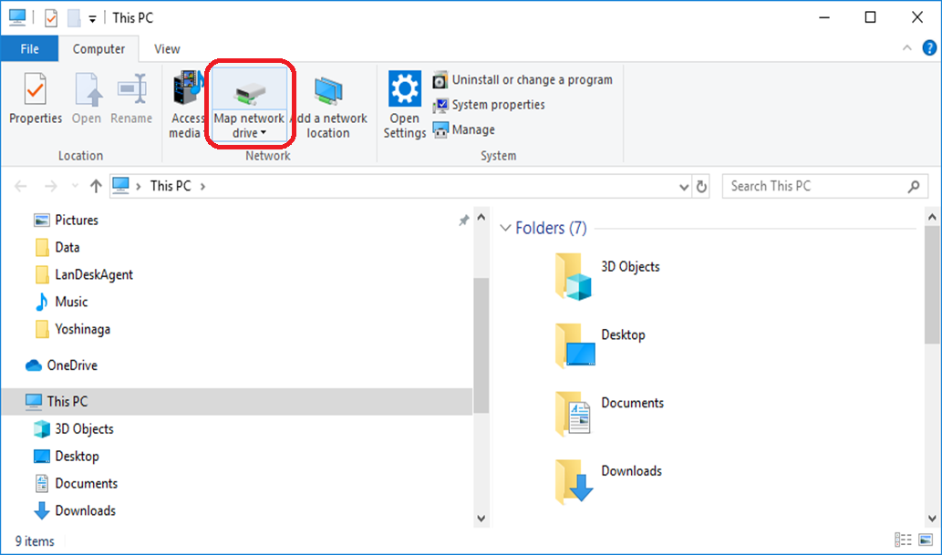

26-2 Select “N:” drive.
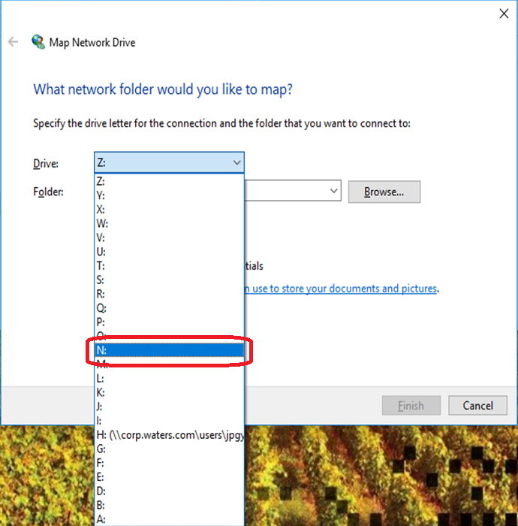
26-3 Input the server name which in your country and select the N_Drive which you ant to map.
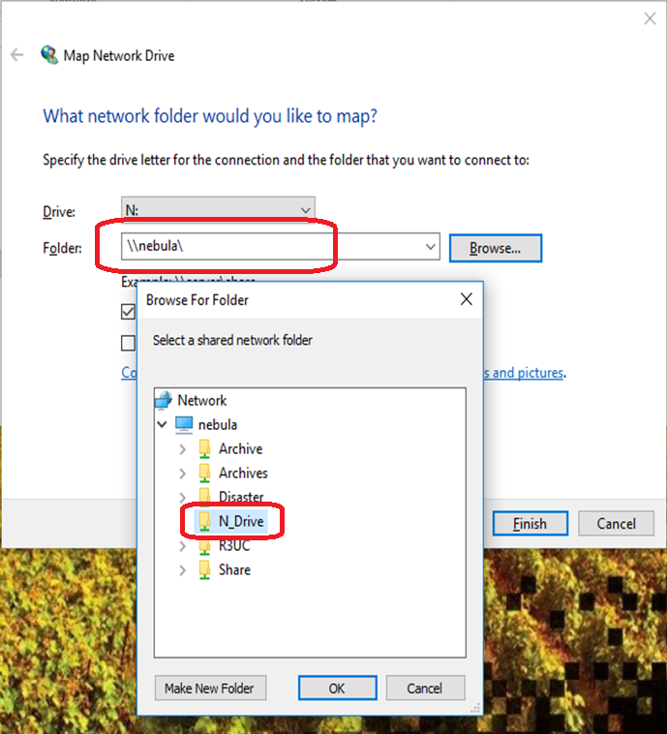

26-4 Click “Finish”.
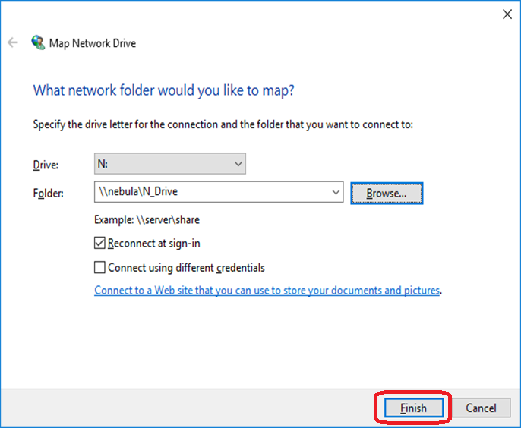
26-5 Then the network drive is mapped.
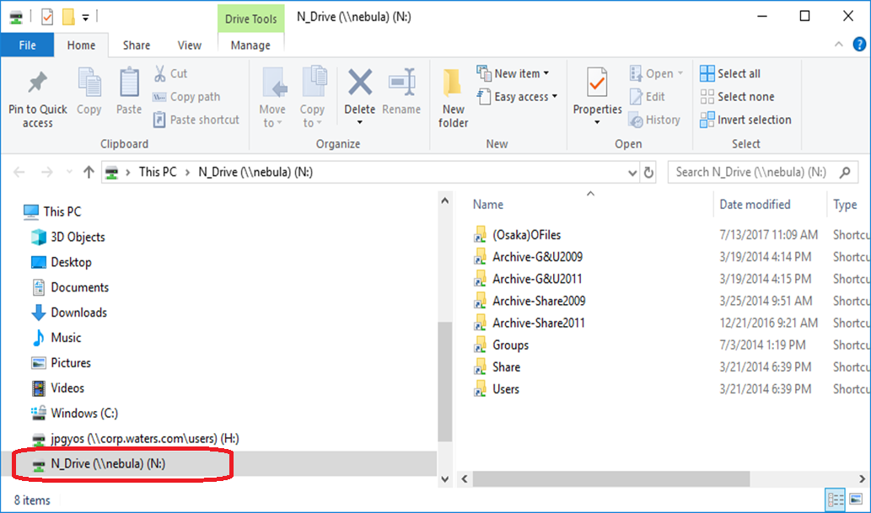

Setup BitLocker
27-1 Select “BitLocker Drive Encryption” from “Control Panel”.
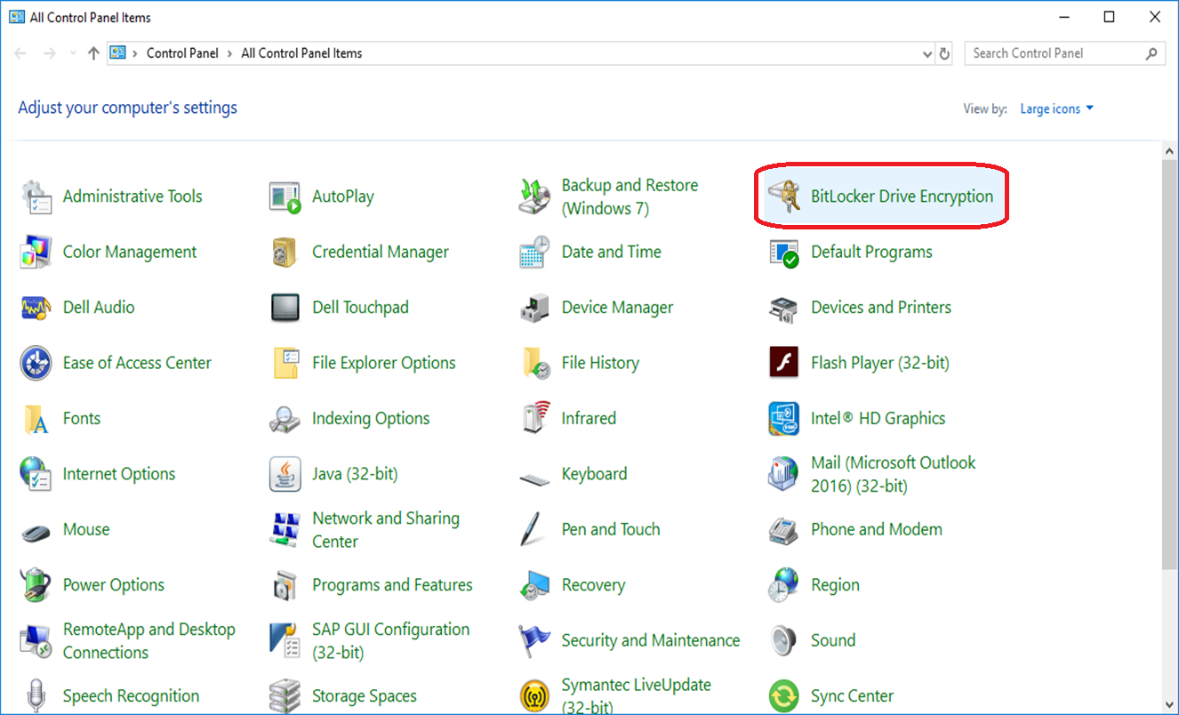

27-2 Click “Turn on BitLocker”.
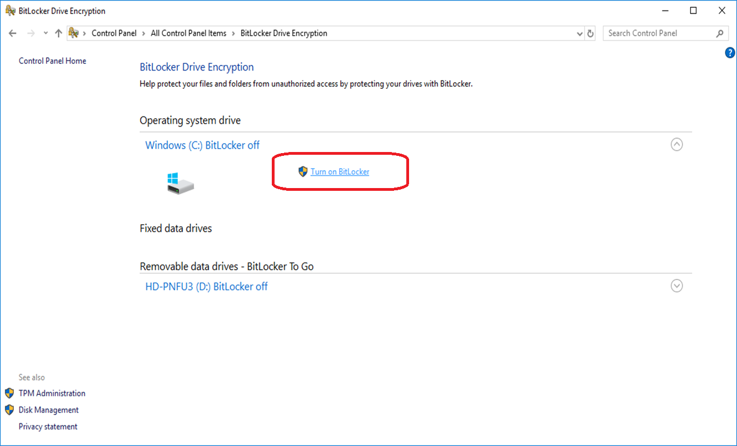

27-3 Click “Next” button.
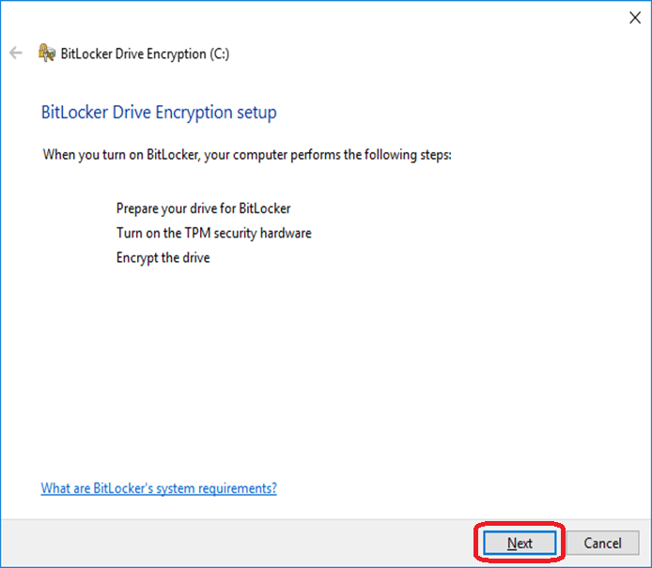

27-4 Click “Next” button.
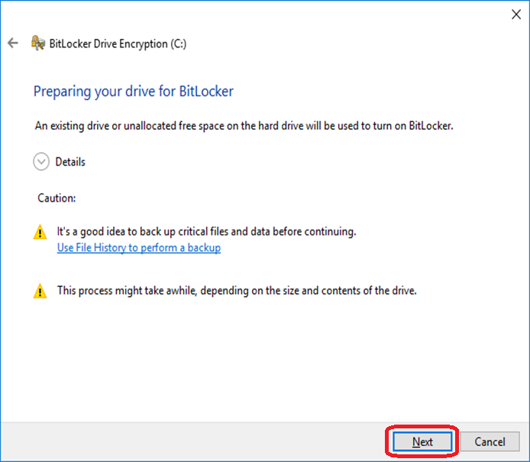
27-5 Click “Next” button.
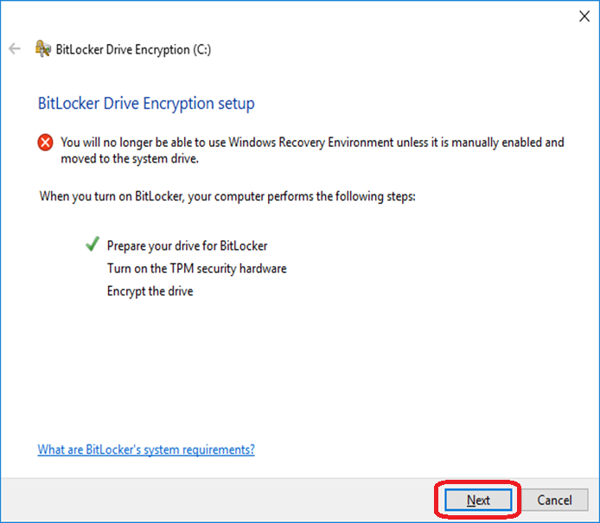

27-6 If the TPM of your PC is off, you have to turn it on. Click “Restart” to restart your PC.
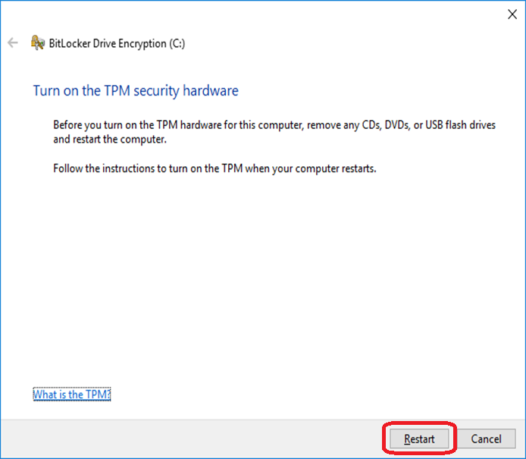
27-7 Enter BIOS and tick “TPM” is ON. Then restart your PC again.

27-8 Click “Next” button.
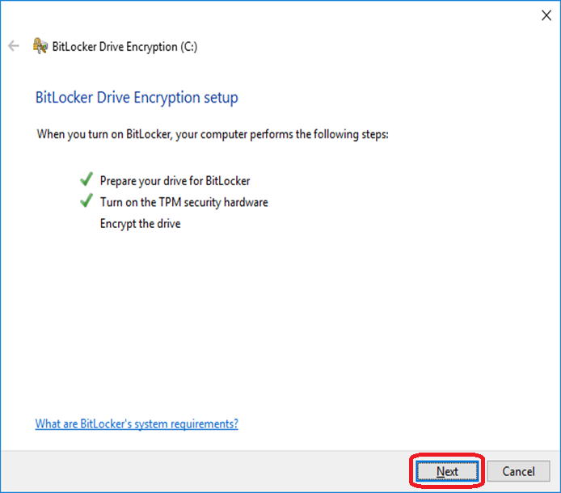

27-9 Click “Let BitLocker automatically unlock my drive”.
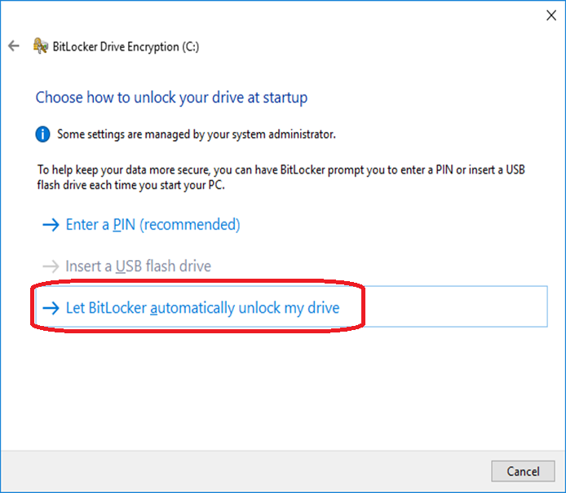
27-10 Do not select any option and click “Next”.
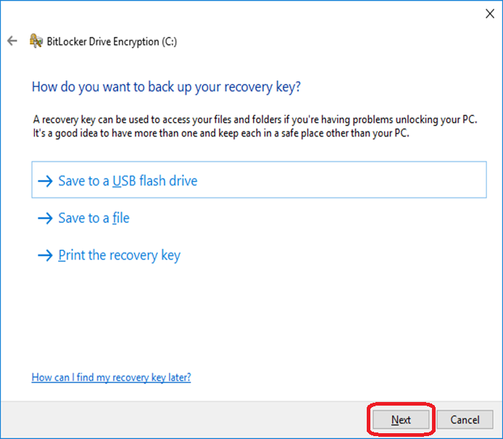

27-11 Select “Encrypt used disk space only(faster and best for new PCs and drives)” option.
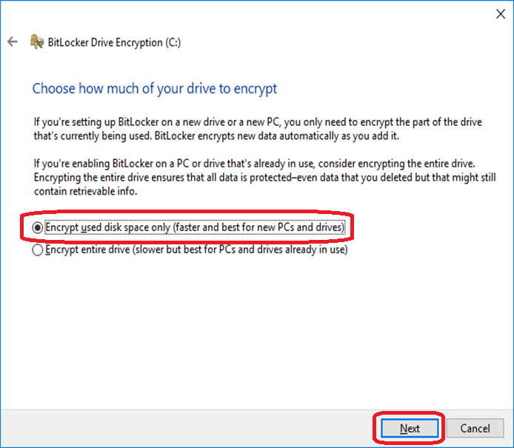
27-12 Select “New encryption mode(best for fixed drives on this device)” option.
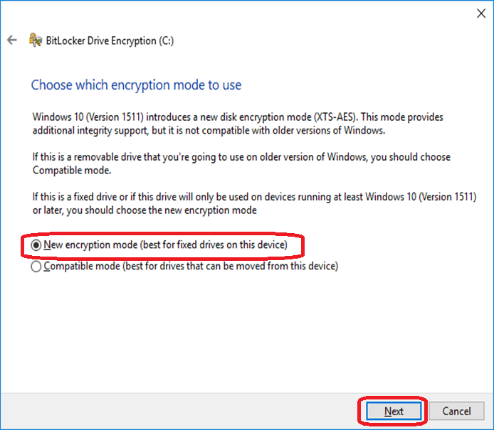

27-13 Make sure the “Run BitLocker system check” is ON, and click “Continue”.
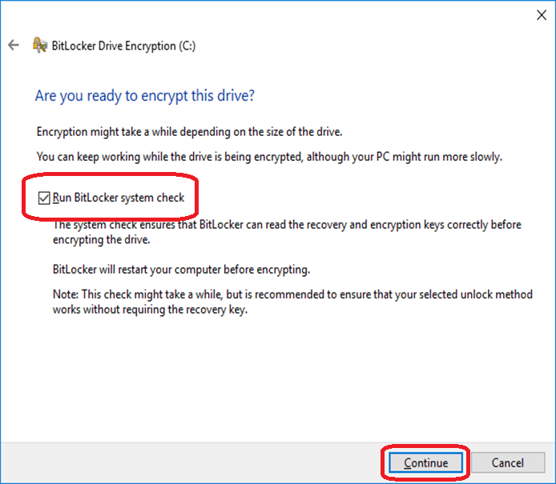
27-14 When the encryption is finished, please click “Restart now” to restart your PC once.
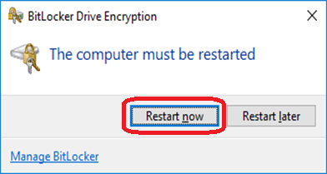

If user has any issue of BitLocker, please contact with APAC IT.

