DOCUMENT TITLE: tEST sPEC AND pROCEDURE, MSV Leak test
SYSTEM/ASSEMBLY NAME: metering syringe valve ASSy
PART NUMBER AFFECTED 289010714, 289012763
TEST EQUIPMENT NAME: metering syringe valve leak tester
TEST EQUIPMENT NUMBER: TE0084040
TEST SOFTWARE: *0.0*

AUTHOR(S): tyler modelski | DATE: March 16, 2018
REVISED BY: Adam Townsend | DATE: April 14, 2021

Equipment Required
Quantity | Part Number | Description
1 | 186016003 or 800000444 | Micro Binary Solvent Manager  (Firmware 1.50.221 (NANO_LEAKTESTER_V3) Apr 28 2011.sft)
1 | LM02-AAD-00-0-15D | Bronkhorst Flow Meter - Liqui-Flow Mini LM02
1 | 279012203 | Transducer, Pressure, 1000 psi
2 | C5-2004-EMH | VICI 4 Port Single Steam Valve (5kpsi) and Micro-Electric Actuator
1 | NES-150-24 | Meanwell AC/DC Power Supply Single-OUT 24V 6.5A 156W 7-Pin
1 | NI CB-68LPR | NI 68-pin I/O Connector Block
1 | NI PCI-6220 | NI PCI-6220 Multifunction DAQ Card
1 | SCH68-68-EPM | Cable, NI PCI-6220 to NI CB-68LPR
1 | 538-38770-0110 | Mouser (Molex) Barrier Terminal Blocks .375 LOW PROFILE 10P
1 | ECF504-SC5E | L-com Connectivity ECF504-SC5E
1 | 999045028 | MSV Test Fixture

Disposables Required
Quantity | Part Number | Description
102” | 430004290 | PEEK Tubing, 0.062” OD, 0.003” ID
18” | WAT027-08 | PEEK Tubing, 0.062” OD, 0.040” ID
A/R | 430000527 | PEEK Tubing, 0.062” OD, 0.010” ID
14 | 410000890 or 410000760 | Fitting, Compression, 10-32, 10 PK  FITTING, ONE-PIECE, 10-32 (or equivalent)
1 | WAT089801 | Union, 0.040” ID
1 | WAT022527 or  410001522 | WRENCH, OPEN END, 1/4" - 5/16"  FLANGELESS NUT EXTENDER, ALUMINUM (or equivalent)
A/R | N/A | 1-Liter Acetonitrile (Fisher Chemical Optima A996-4 or Equivalent/Higher Grade)

reference documentation
Document # | Description
735004417 | Metering Syringe Valve Subassembly Specification
735004437 | Cal/PM TE0084040 MSV Leak Test System

Definitions and Abbreviations
Term | Definition
MSV | Metering Syringe Valve
UUT | Unit Under Test
BSM | Binary Solvent Manager
ID | Inner Diameter
OD | Outer Diameter
USL | Upper Specification Limit
µL/min | Microliters Per Minute
psi | Pounds Per Square Inch
I/O | Input / Output
NI | National Instruments
UI | User Interface

Test SPecifications and Traceability Matrix
Test # | Test Specification & Condition | Acceptance criteria | Reference
1 | Port 2 to 3 Leak Test  Test Pressure: 210 psi  Solvent: Acetonitrile | USL= 2 µL/min | 735004417 Sec 5.2
2 | Port 1 to 3 Leak Test  Test Pressure: 210 psi  Solvent: Acetonitrile | USL= 2 µL/min | 735004417 Sec 5.2
3 | Port 1 to 2 Leak Test  Test Pressure: 210 psi  Solvent: Acetonitrile | USL= 2 µL/min | 735004417 Sec 5.2

Test Procedure
- electrical test setup
  - Refer to Appendix A for a cable setup diagram.
  - Plug in the Micro BSM to a power outlet
  - Plug in the test computer to a power outlet
  - Plug in the test box to a power outlet.
  - Connect the Cable, NI PCI-6220 to NI CB-68LPR from the connector on the rear panel of the test box to the connector on the rear of the test computer.
  - Connect a serial cable from the Micro BSM to serial port (COM1) on the rear of the test computer.
  - Connect the Bronkhorst cable to the L-com Connectivity ECF504-SC5E connector on the rear panel of the test box.
  - Connect the Bronkhorst power cord to a power outlet
  - Connect the Bronkhorst serial cable to serial port (COM2) on the rear of the test computer.
  - Power up the Micro BSM.
  - Power up the Test Computer and login.

- fluidic test setup
  - Refer to Appendix B for a fluidic setup diagram.
  - Drop all solvent lines from the BSM into the 1 Liter Acetonitrile bottle on top of the pump.
  - Connect 15 inches of PEEK Tubing, 0.062” OD, 0.003” ID from the output of the BSM Pump A to the fluidic input fitting on the side panel of the test box.
  - Connect 87 inches of PEEK Tubing, 0.062” OD, 0.003” ID from the side panel of the test box to a Union.
NOTE: Coil this tubing in the bottom of the test box.
  - Connect 18 inches of PEEK Tubing, 0.062” OD, 0.040” ID from the Union to the Bronkhorst Flow Meter.
NOTE: Coil this tubing in the bottom of the test box.
  - Connect approximately 3 inches of PEEK Tubing, 0.062” OD, 0.010” ID from the Bronkhorst to the Pressure Transducer.
  - Connect approximately 6 inches of PEEK Tubing, 0.062” OD, 0.010” ID from the Pressure Transducer to the IN port of the Port Select Valve on the front of the test box.
NOTE: Route this tubing through the hole on the front panel of the test box.
  - Connect PEEK Tubing, 0.062” OD, 0.010” ID, as required from Port Select Valve Port 1 to MSV Port 1.
  - Connect PEEK Tubing, 0.062” OD, 0.010” ID, as required from Port Select Valve Port 2 to MSV Port 2.
  - Connect PEEK Tubing, 0.062” OD, 0.010” ID, as required from Dead End Valve Port 1 to MSV Port 3.
  - Connect PEEK Tubing, 0.062” OD, 0.010” ID as required from Dead End Valve IN Port to a waste container.
REFER TO THE FOLLOWING SCREENSHOT OF THE TEST SOFTWARE UI WHEN PERFORMING STEPS 3 THROUGH 6:

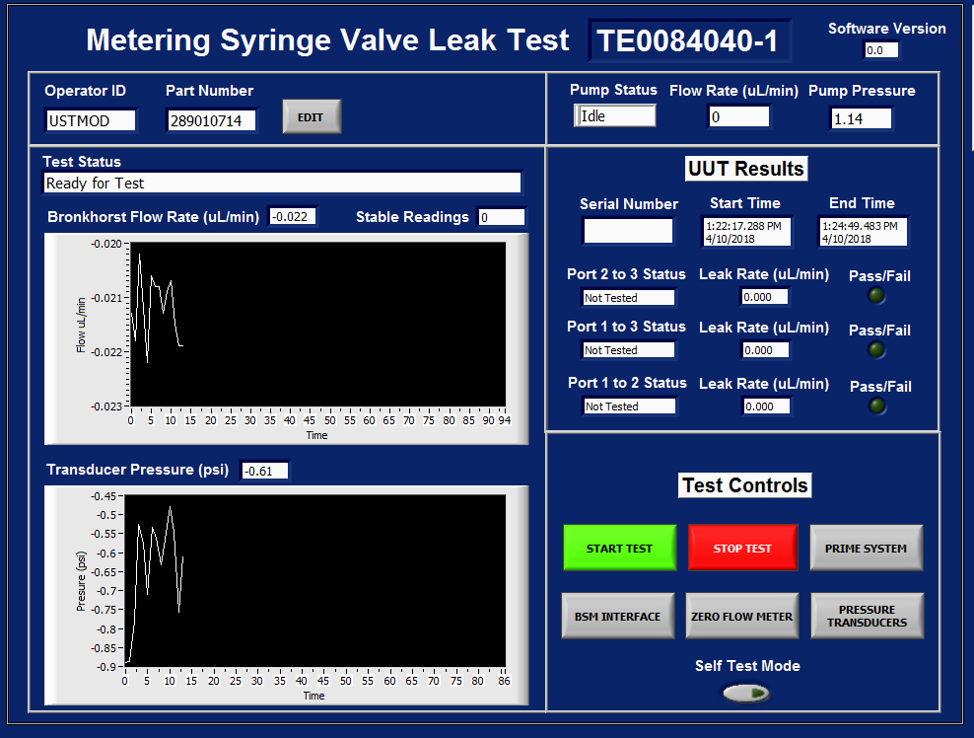

- prime the test system
  - From the Main GUI, click the BSM INTERFACE button.
  - Type the “runprime” command into the input buffer, then click the enter key.
  - Allow the BSM to prime to completion, then close the BSM INTERFACE.
NOTE: You can hear the BSM pump running, once the BSM cannot be heard is an indication it is done priming.
  - From the Main GUI, click the PRIME SYSTEM button.
NOTE: It is recommended to perform these PRIME SYSTEM steps prior to running a large batch of MSV’s or after multiple days of not testing. Priming before every valve is NOT required.
  - Connect the system fluidics to the 3-way (TEE) connector mounted to the testing fixture.
  - Set the Prime Flow Rate as desired, then click Start Prime.
NOTE: The default is 50 µL/min.
  - Monitor the output of the Dead-End valve. Once fluid is dripping, click Next Path.
NOTE: It is general guidance to wait for fluid to drip. If this is the initial setup of the system, allow the system to prime for at least 15 minutes.

  - Monitor the output of the Dead-End valve. Once fluid is dripping, click Done Prime.
NOTE: It is general guidance to wait for fluid to drip. If this is the initial setup of the system, allow the system to prime for at least 15 minutes.
  - Click Exit to return to the test sequence.

- zero pressure transducers (as required)
  - Click the button for PRESSURE TRANSDUCERS.
  - Enter the Administrative Password.
NOTE: Only trained individuals may perform this function.
  - Connect the system fluidics to the 3-way (TEE) connector mounted to the testing fixture.
  - Monitor the Transducer Pressure and BSM System Pressure until the readings indicate the system is in a zero-pressure state.
NOTE: The valves in the test system have been set to relieve all pressure. The pressure in the fluidics system should be hovering close to 0 psi during this monitoring stage.

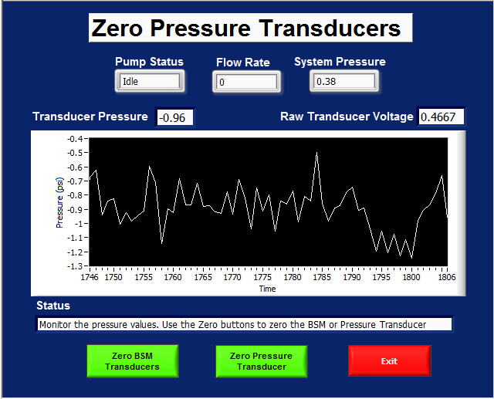

  - When ready to zero the transducers:
    - Click the Zero BSM Transducer button once.
    - Then click the Zero Pressure Transducer button once.
NOTE: This will set the zero-offset voltage of the transducer to the current Raw Transducer Voltage.
  - Click the Exit button once complete to return to the test sequence.

- zero flow meter (as required)
  - Click the button for ZERO FLOW METER.
  - Enter the Administrative Password.
NOTE: Only trained individuals may perform this function.
  - Connect the system fluidics to the 3-way (TEE) connector mounted to the testing fixture.
  - Wait for the Bronkhurst Flow Meter to become stable.
NOTE: This is a feature of the test software. Once the Bronkhurst is stable, the Zero Flow Meter button will appear. The valves in the test system have been set to dead end the system fluidics. The flow within the fluidics system is at 0 µL/min during this stage.

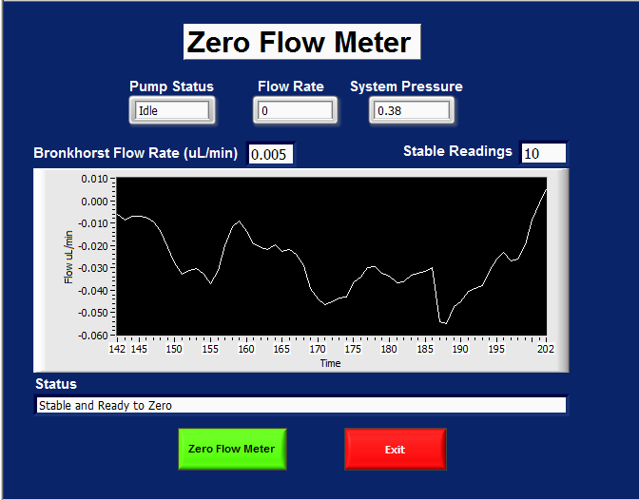

  - When ready to zero the flow meter, click the Zero Flow Meter button once.
  - Click the Exit button once complete to return to the test sequence.

- verify test system pressure and leak (as required)
  - Click the button for Self Test Mode.
NOTE: This is a button that can be toggled “On” or “Off”.
  - Connect the system fluidics to the 3-way (TEE) connector.
  - Click Start Test
  - Allow the test to run to completion.

- msv Leak test
  - Install the MSV onto fixture 999045028. Refer to Appendix C for pictures of the MSV mounted.
  - When ready to start the test, click START TEST on the Main GUI.
  - Connect the MSV per Appendix B.
  - Follow the on-screen instructions to move the MSV valve into positions for all three “port to port” tests.

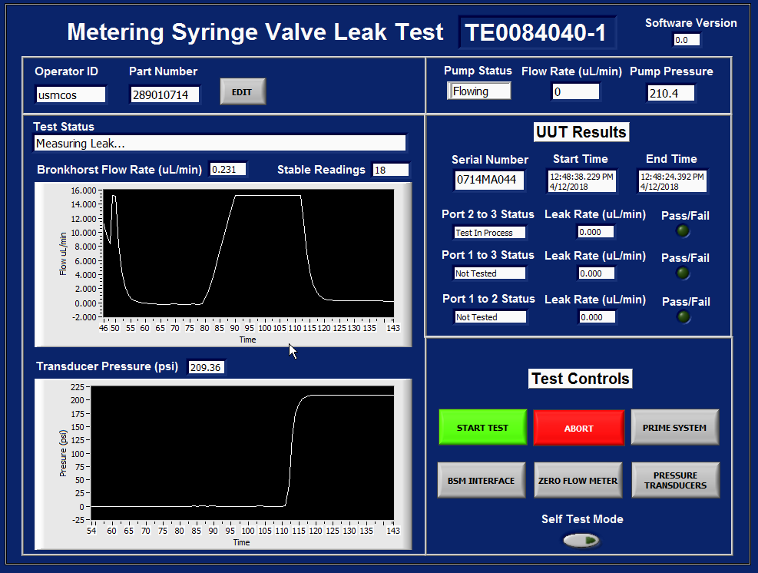
7.5. Start Test
7.6. Abort
7.8 Results
7.7.3 Pressure
7.7. Test Status
7.7.4 Flow Rate and Stability

  - When ready to test an MSV, click START TEST.
  - If at any point the test needs to stop, click ABORT which returns the test to the initial state.
  - Test Status has 6 statues which display in the following order:
    - “Ready for Test” – The test is waiting for user input.
    - “Priming Flow Path” – The pump flows through the valve at 50µL/min.
NOTE: The flow meter only displays up to 15.204 µL/min. It is intentionally configured that way.
    - “Waiting for Pressure” – The test is waiting for the pressure to reach the test pressure.
    - “Measuring Leak” – The test is monitoring the leak rate and waiting for 20 stable readings.
    - “Setting Pressure to Zero” – The “port to port” test is complete. Pressure is set to 0 psi.
    - “Test Complete” – All three “port to port” tests are complete. Result is displayed.
  - UUT Results displays the “Test Status”, “Leak Rate”, and “Pass/Fail” result for each “port to port” test.

appendix a – electrical cable diagram

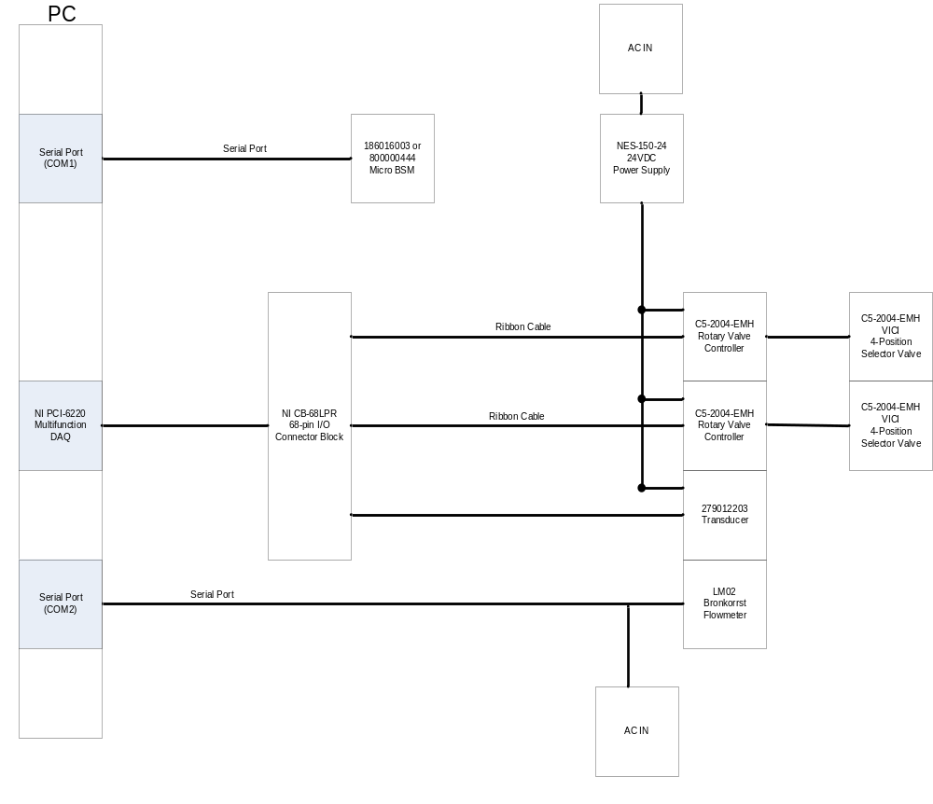

appendix b – fluidics diagram
Block Diagram:
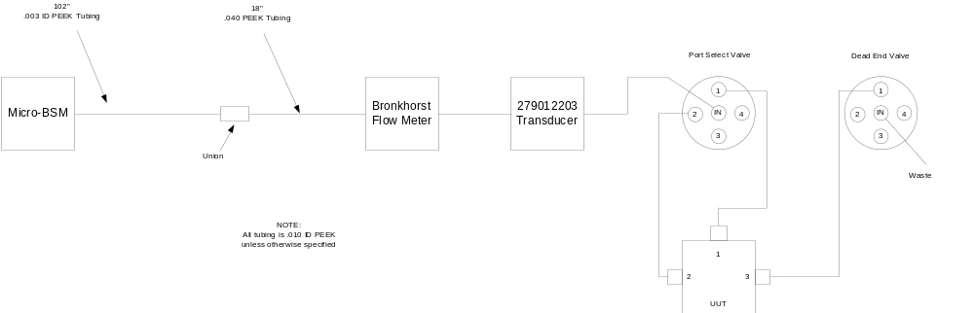

Valve Connection on Fixture:
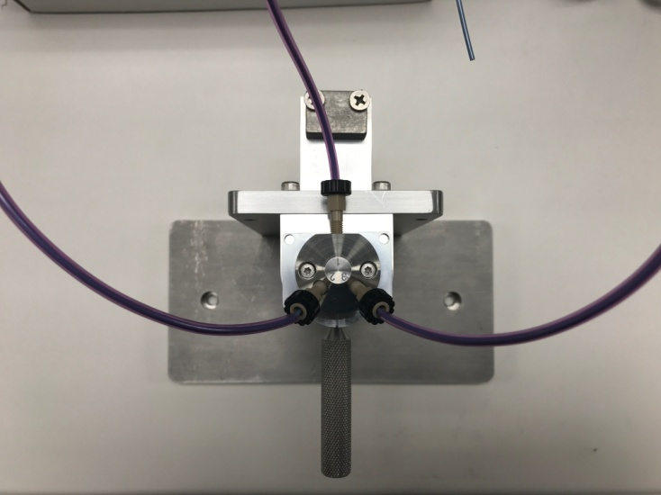
PORT 1
PORT 2
PORT 3

3-Way (TEE) Connector:
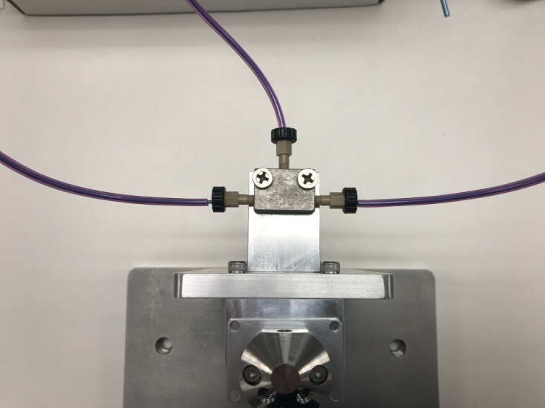
PORT 1
PORT 2
PORT 3

appendix C – MSv test fixture 999045028 mounting instructions

- Prior to installation position the encoder slot (black wheel) so that it is between ports 2 and 3 of the MSV.
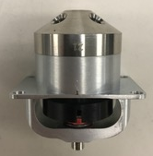

- Place the MSV onto the fixture with the encoder slot facing the front of the fixture. Twist the handle clockwise to tighten the handle to the MSV rotary shaft. Gently pull up on the valve to verify it is secure.

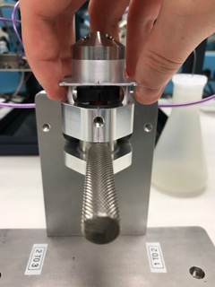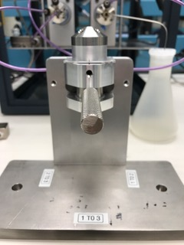

- Use the handle to set the valve “port to port” position when prompted during testing.
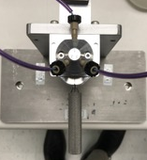
2 TO 3
1 TO 2
1 TO 3

