DOCUMENT TITLE: AcQuity Column Manager, and Column Manager Heater Cooler test specification and procedure
SYSTEM/ASSEMBLY NAME: AcQuity column manager, and column manager heater cooler
PART NUMBER AFFECTED 186015007, 186015008, 186015009, 800000238, 800000234, 800000248
TEST EQUIPMENT NAME: TE 82984 Column Manager Test System; Empower Workstation
TEST EQUIPMENT NUMBER: te 82984
TEST SOFTWARE: *1.1*

AUTHOR(S): matt brule | DATE: November 29, 2014
REVISED BY: tetiana morse | DATE: December 14, 2017

Equipment Required
Quantity | Part Number | Description
1 | TE 82948 | Column Manager Test System
1 | 186015028 | AcQuity TUV Detector
1 | 186015001 | AcQuity Binary Solvent Manager
1 | 186015005 | AcQuity Sample Manager
4 | 186000327 | 12x32 Glass Screw Neck Vial
4 | 410001901 | FITTING, ONE-PIECE, 10-32, BLACK
4 | 405003460 | Union, .020 ID, V-Detail
1 | 725000455 | Switch, Ethernet, 10/100, 8 Port
1 | 441000371 | (or equiv) Ethernet Cable
A/R | “ | Solvent containers
1 | “ | Empower Workstation
1 | P-550 | Upchurch Scientific Peek Plug (or equivalent)
A/R | “ | Center-less Ground .010 SS Tubing
1 | “ | 5/16” wrench
1 | “ | 1/4” wrench
1 | N/A | Empower Project: AcQuity_Column_Manager Revision 0.2
“-sections intentionally left blank

Disposables Required
Quantity | Part Number | Description
A/R | “ | Methanol
A/R | “ | Sample, 5.75 mg/L Propylparaben in Methanol
“ | “ | Para-film
“-sections intentionally left blank

reference documentation
Document # | Description
WAT046538 | Electrical Safety Test Procedure
735001307 | ACQUITY Column Manager Performance Spec

Definitions and Abbreviations
Term | Definition
DHCP | Dynamic Host Configuration Protocol
ID | Inside Diameter or User Indentification
I/O | Input/Output
IP | Internet Protocol
LED | Light-Emitting Diode
ºC | Degrees Celsius
PC | Personal Computer
SS | Stainless Steel
TE | Test Equipment
TUV | Tunable Ultraviolet
USB | Universal Serial Bus
UUT | Unit Under Test
DOS | Disc Operating System
CM | Column Manager
S/N | Serial Number
SAP | Systeme, Anwendungen und Produkte (Systems, Applications and Products), German Enterprise Resource Planning (ERP) software
RS232 | Recommended Standard 232
PID | proportional–integral–derivative controller

Test SPecifications and Traceability Matrix
Test # | Test Specification & Condition | Acceptance Criteria | Reference  FSD 735001307
1 | Electrical Safety Test | Pass | WAT046538
2 | Ethernet Port Test | Pass | Sec. 2.8.1.1  The Ethernet Port is verified using the DOS ping command
3 | LED Test | Pass | Sec. 2.8.1.2  The Front Panel LEDs verified to alternate between red and green
4 | Column LED Test | Pass | Sec. 2.8.1.3  4 Column LEDs are lit in an altering red and green pattern
5 | Ecord 1 | Pass | Sec. 2.8.1.4  The system reads that an installed eCord is able to be read
6 | Ecord 2 | Pass | Sec. 2.8.1.4  The system reads that an installed eCord is able to be read
7 | Ecord 3 | Pass | Sec. 2.8.1.4  The system reads that an installed eCord is able to be read
8 | Ecord 4 | Pass | Sec. 2.8.1.4  The system reads that an installed eCord is able to be read
9 | Set Serial Number | Pass | PSC to prepare instrument for use in field
10 | Fuses | Pass | PSC to verify good working condition of fuses
11 | Thermostats | Pass | Sec. 2.8.1.5  Each thermal sensor should register, be responsive, and be recognized as present.
12 | Left Valve | Pass | Sec. 2.8.1.6  A valve cartridge is installed to provide appropriate load and the valve is homed
13 | Right Valve | Pass | Sec. 2.8.1.6  A valve cartridge is installed to provide appropriate load and the valve is homed
14 | Leak Detector | Pass | Sec. 2.8.1.7  The tester simulates a leak detector present and leak / no leak
15 | Heater Cooler | Pass | Sec. 2.8.1.8  The heater cooler is driven from ambient to 90°C, then to 10°C, then back to ambient
16 | Bandspreading Test | Pass | PSC to verify correct size of tubing  Reference Test Engineering Memo located in TE0082984EQ DIR of SAP.

This section intentionally left blank
Test Procedure

Notes about this test:
The detector should be powered on and the lamp lit for at least 30 minutes before testing.
The detector lamp should be shut off when not in use to conserve lamp life.
This procedure assumes that the operator has a basic knowledge of personal computer operation in a Microsoft Windows environment, running Water’s Empower Software.
This procedure also requires that the operator have a knowledge and understanding of the use of Water’s AcQuity Detectors, pumps, and Auto-samplers.
To gain remote control of either AcQuity detector, double-click the AcQuity server desktop and then the AcQuity console desktop icon (use to turn lamp on/off, check lamp hours, etc.).
If the Empower workstation loses communication with any of the instruments:
Close all Empower windows.
Log out of Empower.
Double-click the Stop AcQuity Processes desktop icon.
Open Empower and try again.
If the above 4 steps do not resolve issue:
Cycle power on all instruments.
Shut down and restart the Empower workstation.
Re-power all instruments.
All figures in this procedure are for reference only and may differ slightly from actual.

Test description:
The test consists of two parts, the first part is automated with some operator involvement, this part verifies basic instrument I/O, programs the firmware and verifies heater / cooler operation. The second part uses Waters Empower software to perform Chromatography to verify system volumes and band spreading.

To Power up and Log on to the workstations:
Power up the PC and the monitor.
When prompted to, press the Ctrl, Alt, and Del keys simultaneously.
Login to the PC.

To Log into empower:
Double-click on the Empower desktop icon (See Figure 1).

Figure 1
Login = tester, no password, click OK (See Figure 2).
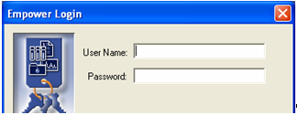
Figure 2

To shut down a workstation:
Close all programs.
Click on Start.
Shut Down.
Select Shut Down the Computer?
Select Yes.

Failure to follow these instructions may result in workstation damage.

- ELECTRICAL SAFETY TEST
  - Perform the Electrical Safety Test per High Pot and Ground Continuity Test Procedure, WAT046538.
  - Note whether the test passed or failed to log during automated test.
- Automated Initial TEST setup
Please refer to Appendix 1 for detailed test descriptions and more detailed operating instructions for each test.
  - Power up TE 82984 and log in, if not already done.
  - Click the Column Manager Test icon from the start menu or the desktop.
- UUt connection
  - If testing a Column Heater / Cooler, 186015008, remove the jumper located at position 1 of the 8 position jumper bank on the Column Manager personality card.
  - Plug in the RS232 cable.
  - Plug in the Ethernet at Port1
  - Connect the UUT power inlet to the cord from the tester. The power must come from the tester as it is controlled by the tester, this control is necessary for successful test.
  - Connect the 4 pin leak detector simulator cable to the connector on the lower right front of the UUT.
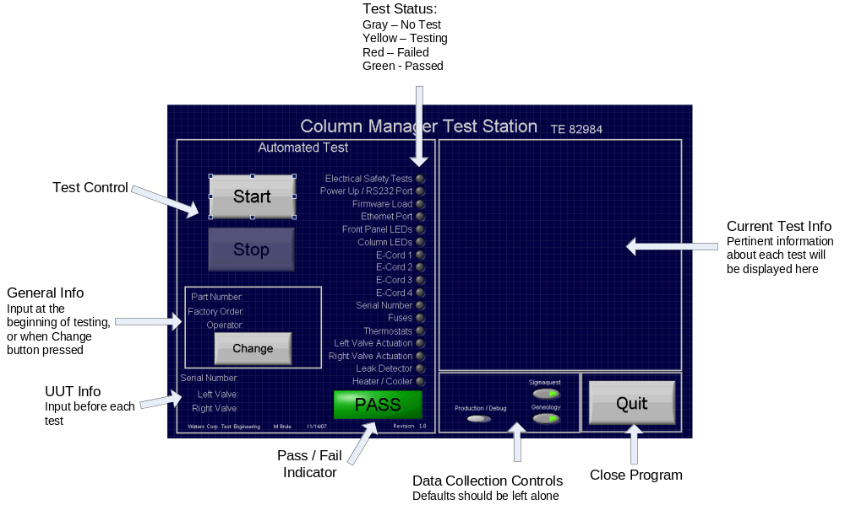
Figure 3

  - Press the Start Button under Automated test with the mouse.
  - Follow the on-screen instructions and supply the requested data, by scanning with the barcode scanner or typing. If something is entered that the tester does not support or recognize, the system will prompt for the input to be repeated.
The test will proceed sequentially through each of the tests listed in the “Test Status” list (see Figure 3). Pertinent test information will be displayed. Follow all instructions to complete testing. When the test is complete a Test Record will be generated, data will be written to the Sigmaquest data collection system. Either pass or fail will be displayed (see Figure 3).
  - When the test is complete, push the UUT power button to power it off, disconnect all cables and remove from the test station.
  - Go to Step 4 to begin fluidic testing.
- Fluidic Test Setup
AcQuity Column Manager: continue with this section.
  - Connect the UUT to the Column Manager Test station.
  - Attach the cables to the column manager.
  - Connect the unions to the pre-heaters and post-heaters.
  - Attach the UUT inlet tube to the Auto-sampler.
  - Connect the UUT outlet tube to the detector.
  - Power up UUT.
  - Fill a vial with sample solution. Place the capped sample vial in carousel position 2:A,1.
- BANDSPREADING TEST.
  - Launch Empower.
  - Click on the Configure System button.
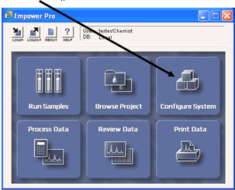
Figure 4
  - Select Systems, highlight row 1 (AcQuity_Column_Manager), right-click and select System Properties…. Click Configuration. Drag the UUT from the ‘Available Components’ into the ‘System Configuration’. Remove the previous UUT by dragging it from ‘System Configuration’ into the ‘Available Components’. Click OK.
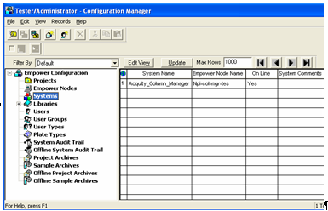  Figure 5 | 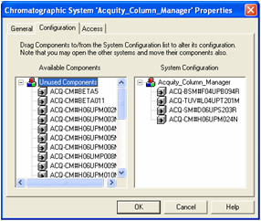  Figure 6
  - If a “Bringing system XX online… Conflicting System… Etc.” dialog box appears, click OK. Then close out. Valves should actuate if this is the first time the system is brought on-line.
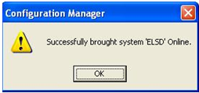
Figure 7
  - In the Empower main screen (See Figure 8) click on Run Samples.
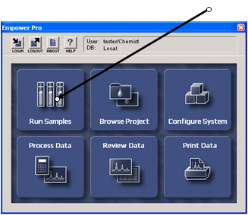
Figure 8
  - Select (if not already selected) the AcQuity_Column_Manager project and System. Click OK. This will launch the ‘Run Samples’ window (see Figure 9).
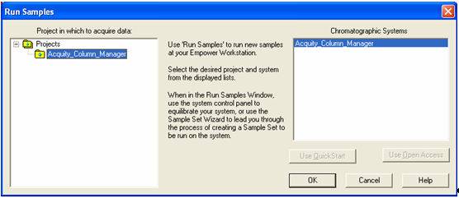
Figure 9
  - Flush the waste tube:
    - Select Waste from Column Manager.
    - Set Flow to 1 mL/min on Binary Solvent Manager.
    - Watch that fluid comes out of the waste tube.
    - Stop Flow.
  - In the ‘Run Samples’ Window, click on the ‘Load’ Button.
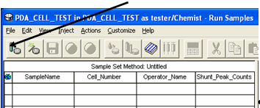
Figure 10
  - Accept the default setting (Load using a previously created sample set method). Click OK (See Figure 11).
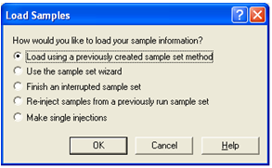
Figure 11
  - Select the desired sample set method from the list: and click Open.
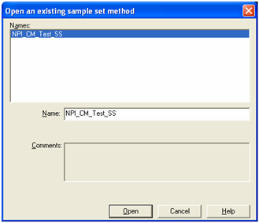
Figure 12
  - Click on the green Run icon (see Figure 13).
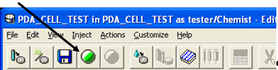
Figure 13
  - Type in S/N of the UUT, in the “Name for this Sample Set” box.
  - Select the desired printer.
  - Click Run.
Empower will generate a report for each test as it is completed. If the Acrobat Distiller is chosen as a printer, Empower will prompt the operator for a file name before creating and displaying the report Name the file with the serial number, after which, the report will be displayed and saved.
  - When the selected sample set is done, the ‘Run Samples’ status bar will display ‘System Idle – Sample Set Complete’.
  - Verify and record the test results from the Empower report on the final instrument test record. Verify that all 4 column peaks have data. Assuming that all peak data is present, failing summary results will be indicated with bold font.
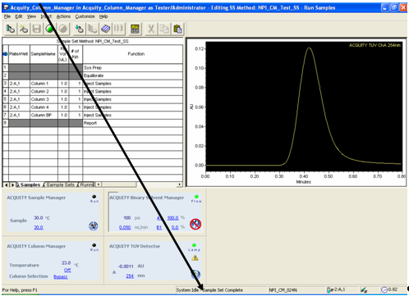
Figure 14
  - Select the “Stop AcQuity” button when the test has completed.
  - Test Complete Power down UUT and disconnect from the test station.
To repeat the same test, click on the green ‘Run’ icon.

- Appendix
Test descriptions for the automated test performed using TE 82984.
  - If it is the first test since the test program has started, the tester prompts for the user the part number to be tested. This part number controls the testing done. The part number must be valid and included in the list expected by the system.
  - If it is the first test since the test program has started, the tester prompts the user for their user identification. The ID can be a name or number, as protocol requires, but must not be blank.
  - If it is the first test since the test program has started, the tester prompts the user for the Factory order of the current UUT. The factory order can be any combination alpha-numeric characters, but cannot be blank.
  - The user is prompted for the serial number of the UUT. The serial number must not be blank.
  - If the system finds that the unit has been tested previously the system prompts the user to enter what the previous failure was and what was done to correct it. See Figure 15.
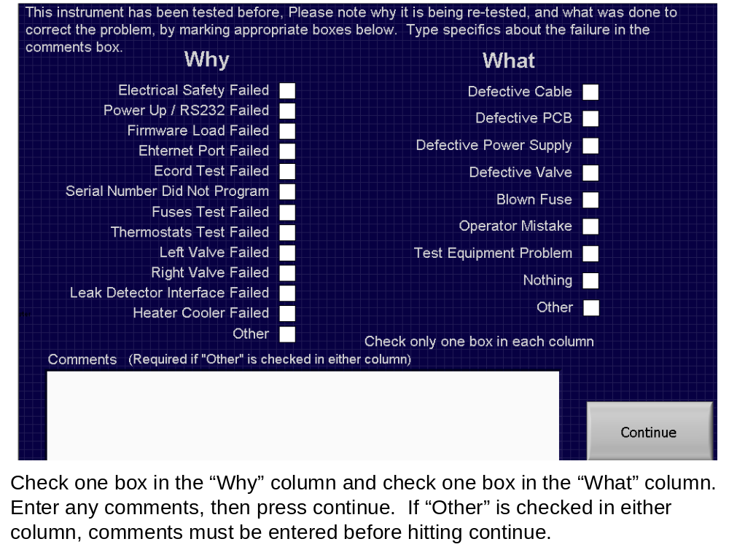
Figure 15
  - If testing a Column manager the system will prompt for the serial numbers of each valve pod. These serial numbers must be filled in, not blank.
  - The tester asks the operator for the results of the electrical safety test (Document # WAT046538). This test is primarily for data collection, a “yes” answer and the test progresses, a “no” answer and the test will fail and stop. All instruments must pass electrical safety testing prior to initial power up.
  - Power up / RS232 Port. UUT power is applied and the tester attempts to gain control of the UUT via COM1 to the RS232 port.
  - Firmware Load. The tester checks the revision of the firmware in the instrument, if the unit contains only “bootloader”; it is programmed with the current revision application code. If the unit is already programmed with the current revision, the programming is skipped. If the unit is programmed and the revision is not recognized the test fails. The tester uses the “loader” application to program the firmware through the Ethernet port using a fixed default IP address.
  - Ethernet Port, the tester communicates to the UUT via its Ethernet port. If the communication is successful the test passes. Communication is verified using the second Ether net port in the test system to “ping” the UUT’s Ethernet address, using windows command line. Prior to doing this the Ethernet options of the UUT are set and the IP address is set.
Commands: Setipflags N F, this disables DHCP and sets the UUT to its default IP address. The “setnetdefaults” command is used to return the UUT to it’s default DHCP enabled state.
  - Front Panel LEDs. The tester will prompt the operator to look at the “POWER” LED on the front panel and verify that it is lit green. The tester will then prompt the operator to verify that the “RUN” LED on the front panel is alternating between red and green. The tester uses the “poke” command to write to memory location 0x500005, 0x10 / 0x20 are written repeatedly to alternate the RUN LED between red and green.
  - Column LEDs. The tester will prompt the operator to verify that the 4 column LEDs on the right side of the UUT are lit in an alternating red and green pattern as indicated on the tester panel. The pattern will be reversed and the operator will be prompted to verify. The tester uses the “poke” command to write to memory location 0x500005, 0x10 / 0x20 are written repeatedly to alternate the RUN LED between red and green. The tester uses commands via the RS232 port to light the column LEDs in the patterns indicated. First the UUT task that polls the ECORDs must be stopped. It is restarted after the test is complete.
Commands:
“ecordsuspend”
“ecordresume”
First pattern: “poke 0x50002E 0x00”
“poke 0x50002f 0x02”
“poke 0x50002e 0x019”
Second Pattern: “poke 0x50002E 0x00”
“poke 0x50002e 0x026”
“poke 0x50002f 0x01”
  - Ecord Tests (1 - 4). The operator will be prompted to install the 4 Ecords provided with the test system it is important that the Ecords are installed at this time, not earlier in the test, or test failures will result. The system will then read and write to each Ecord to verify the interface. The “ecordinit” command is used via the RS232 Port to read and write to each ecord.
  - Serial Number. The UUT serial number is written to its non-volatile memory via the RS232 port, using the “setserial” commend. The serial number is then verified with the “showserial” command.
  - Fuses. The system verifies that all fuses on the personality card are functioning, using the “fuses” command via the RS232 port.
  - Thermostats. The system checks the status of the two system thermostats with the “thermostats” command via the RS232 port.
  - Left Valve Actuation. The system verifies movement of the left valve as well as its encoder and related circuitry, by instructing the valve to home using the “phome leftvalve” function via the RS232 port. No errors reported by the UUT indicates a successful home. This test is skipped when testing a Column Heater Cooler.
  - Right Valve Actuation. The system verifies movement of the left valve as well as its encoder and related circuitry, by instructing the valve to home using the “phome rightvalve” function via the RS232 port. No errors reported by the UUT indicates a successful home. This test is skipped when testing a Column Heater Cooler.
  - Leak Detector. The leak detector interface is verified using the “leakdetector” command via the RS232 port to check the leak detector status, and relays driven by the USB bus to toggle the leak detector present and leak bits.
  - Heater / Cooler. The Test system commands the UUT via the RS232 port to heat to 90 degrees C, then cool to 10 degrees C, then heat back to ambient (25 degrees C). Commands used are:
    - To drive the UUT to heat – “column PID 120”. The UUT is set to 120 degrees C, test is stopped when 90 degrees C successfully.
    - To drive the UUT to cool – “column PID 1”. The UUT is set to 1 degree C, test is stopped when UUT reaches 10 degrees C.
    - To drive the UUT to Ambient (heating) – “column PID 25”, test is stopped when temperature reaches ambient.
    - To monitor the temperature – “show columntemperature” is used.
    - The operator needs to note that this test takes approximately ½ hour, should the test take an inordinate amount of time the test can be stopped with the Stop button in the test status window (see Figure 16).
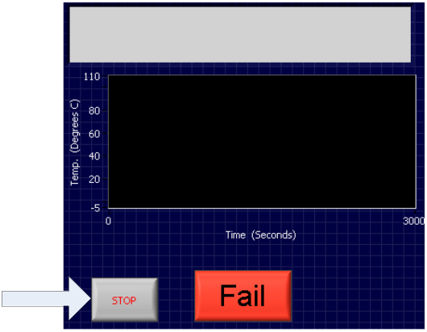
Figure 16

End of Test Description
Waters Corporation

INSTRUMENT - FINAL TEST RECORD
Part Number: | Description:
Tested By: | Date: / /
Serial Number: | Control Number:
Software Revision: | Factory Order:

ELECTRICAL SAFETY TEST | PASS FAIL see note # PASS
FIRMWARE DOWNLOAD, Version: | PASS FAIL see note # PASS
ECORD TEST | PASS FAIL see note # PASS
SET SERIAL # | PASS FAIL see note # PASS
HARDWARE TESTS
Jumpers | PASS FAIL see note # PASS
Fuses | PASS FAIL see note # PASS
Thermostats | PASS FAIL see note # PASS
PS Fan | PASS FAIL see note # PASS
Left Valve | PASS FAIL see note # PASS
Right Valve | PASS FAIL see note # PASS
Leak Detector | PASS FAIL see note # PASS
HEATER/COOLER TESTS | PASS FAIL see note # PASS
BANDSPREADING TEST. | PASS FAIL see note # PASS
Specifications: Asym @ 4.4%² < 2.75
USP Tailing < 1.35
All 4 peaks must be integrated
See Empower Report
Instrument Result: PASS FAIL Signed Date: / /
Notes:

