DOCUMENT TITLE: Electrical Safety Test Procedure
SYSTEM/ASSEMBLY NAME: All Final Test Levels with AC Power
PART NUMBER AFFECTED All Final Test Levels with AC Power

TEST EQUIPMENT NAME: Electrical Safety Analyzer
QuadTech Guardian 6000
QuadTech Guardian 6000 Plus
Chroma 19032
TEST EQUIPMENT NUMBER: N/A
TEST SOFTWARE: *N/A*

AUTHOR(S): Bryan Choquette | DATE: November 01, 1984
REVISED BY: Matt Brule | DATE: June 22, 2016

TOOLING AND EQUIPMENT REQUIRED
This procedure references the three types of electrical safety analyzers below, any one of these analyzers can be used to perform this testing. Corded product adaptors and cables are interchangeable on all analyzers.
Equipment Description | Manufacturer | Reference Number | Quantity
Electrical Safety Analyzer | QuadTech | Guardian 6000 | 1
Electrical Safety Analyzer | QuadTech | Guardian 6000 PLUS | 1
Electrical Safety Analyzer | Chroma | 19032 | 1
Corded product adapter or  Power connector test cable | QuadTech or Chroma | A190349 or  N/A (order by name) | 1
LOW terminal cable | QuadTech or Chroma | N/A (order by name) | 1
Standard line cord | Any | N5/15 male to C13 Female (IE60320) | 1
Hi-Pot Stamp (or Equivalent) | N/A | 999037507 | 1

REFERENCE DOCUMENTATION
Document Number | Description
735003029 | PM / Setup Electrical Safety Analyzers

SPECIFICATIONS
The following specifications are valid for all Waters instruments that use AC power.

Hi-Pot (Dielectric Withstand):
All instruments tested will withstand as a minimum:
2121 VDC ramped within 2 Seconds for a period of at least 3 Seconds, without drawing more than 5 mA.
Ground Continuity:
The resistance of the electrical safety ground path of all instruments tested will be no greater than 0.1Ω, as measured from the ground pin of the AC receptacle to the chassis of the instrument.

*** SAFETY PRECAUTION ***

This testing is imperative to the safety of Water’s customers as well as employees. It is very important that the equipment be set up properly. Please read and understand this entire procedure. Obtain answers to questions before performing any testing.

Do not touch, or allow anyone else to touch, the test equipment or the device under test while the analyzer is in operation. While the test equipment has built in safety feature to protect the operator, be aware that high voltage is present during testing.

The Guardian 6000 series analyzers and the Chroma 19032 are fully automated and programmed before manufacturing use, by Test Engineering. Once the operator starts the test, there is no further attention required until the test is complete.

This procedure has two distinct sections:
Sections 1 and 2 for the QuadTech Guardian 6000 analyzer.
Sections 3 and 4 for the QuadTech Guardian 6000 Plus and Chroma 19032.
Be sure to use the appropriate section.

All figures used in this procedure are for reference only and are intended to aid the operator in locating controls and connections. Figures may not be exact representations of equipment.

QuadTech Guardian 6000
- Setup QuadTech Guardian 6000
Refer to Appendix A at the end of this procedure to become familiar with the controls, indicators, and connections on the Guardian 6000.
  - Verify that calibration and preventative maintenance labels (both) are current on equipment to be used.
  - Verify that the Power switch is off reference Figure 1.
  - Connect the power inlet on the rear of the analyzer to an appropriate outlet.
  - Connect the Corded Product Adapter to the Guardian 6000 or as per Figure 1.
The banana plug into the Sense - jack
The spade terminal to the Drive - jack
The large white high voltage plug connects to the H - V Output jack
  - Connect the Alligator clip lead to the red inputs:
The banana plug into the Sense + jack
The spade terminal to the Drive + jack
  - Connect a line cord to the corded product adapter. Line cords that are well suited to this test are available from Test Engineering. A line cord should always be used as an interface to the UUT to prevent wear on the corded product adaptor. This line cord should be replaced if worn.
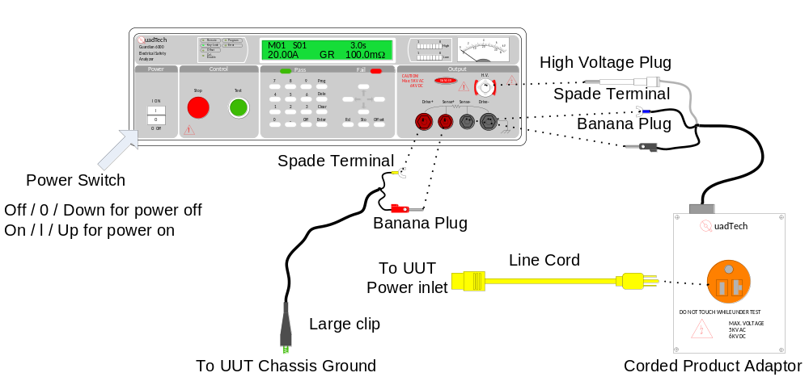
Figure 1 QuadTech Guardian 6000 setup
A cord adaptor supplied by QuadTech or Chroma may be substituted for the corded product adaptor and line cord. Connection is the same.

  - Power up the analyzer by putting the power switch on the On position. The unit will power on. Verify that the unit is ready to test, by verifying that the Key Lock indicator is illuminated and M01 displayed (reference Figure 2). If not, do not use the analyzer, label the analyzer accordingly and notify Test Engineering immediately.
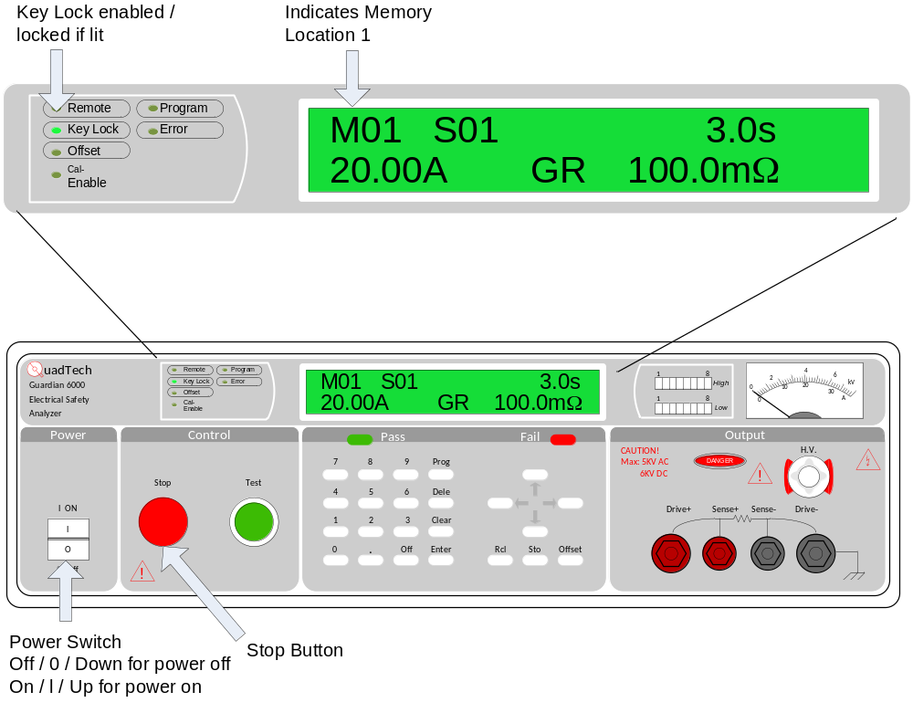
Figure 2: QuadTech Guardian 6000 Display
  - Press the Red Stop button once. Unit is now ready to test.

- Operation QuadTech Guardian 6000
Refer to Appendix A at the end of this procedure to become familiar with the controls, indicators, and connections on the Guardian 6000.
  - Verify that the unit is ready to test, by verifying that the Key Lock indicator is illuminated and M01 displayed (reference Figure 3). If not, do not use the analyzer, label the analyzer accordingly and notify Test Engineering immediately.
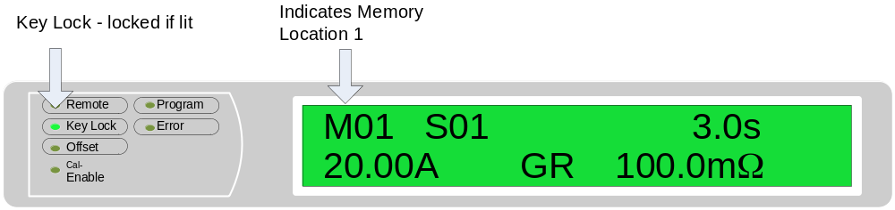
Figure 3 Key Lock / program indication
  - Verify that the UUT is set up for 110/115/120 VAC operation, (if applicable).
Note: Most UUTs are universal input so no input voltage configuration is necessary. If configuration is necessary, the UUT will have a switch (not part of the power input module) to do so.
  - Plug the cord from the corded product adaptor to the AC inlet of the UUT.
  - Verify that the UUT power switch is in the ON position.
If it is not possible to confirm whether power switch is in the on or off position, repeat Section 2 with the switch in each position. The UUT must pass with the switch in both the on and off positions.
  - Connect the large clip from the analyzer to the chassis of the UUT, preferably the ground stud but any part of the chassis may be used as long as it is conductive.
If at any time during the test it becomes necessary to stop the test, press the red Stop button on the analyzer.
  - Press the green Test button on the analyzer. The test will begin.
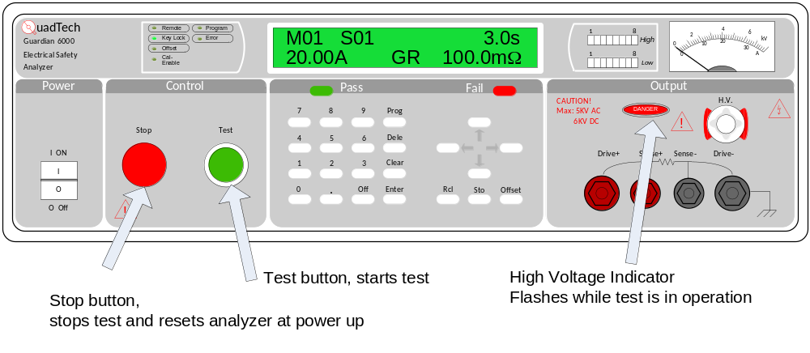
Figure 4 QuadTech Guardian 6000 Test and Stop buttons
  - When the test is complete:
If the UUT passed:
The beeper will emit an audible tone for about a second.
The green Pass light will illuminate.
If the UUT failed:
The beeper will emit a continuous tone, until the red Stop button is pressed.
The red Fail light will illuminate.
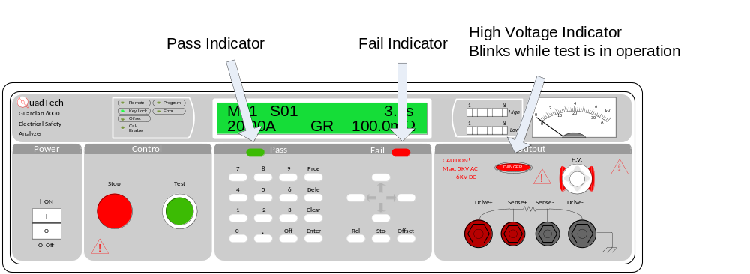
Figure 5 Guardian 6000 Test / Stop buttons and Pass / Fail indicators.
  - If the UUT has a separate input voltage select switch (not part of the power inlet module), repeat Section 2 for each voltage selection.
  - If all testing passed, stamp the UUT instrument chassis with stamp 999037507 per the assembly procedure, if no stamp location is called out in the assembly procedure Place the stamp in a convenient and visible location inside chassis near power inlet if possible.
  - Disconnect UUT and repeat Section 2 to test additional UUTs.

***QuadTech Guardian 6000 Section complete**

QuadTech Guardian 6000 PLUS or Chroma 19032
The only difference on the front control panel between a QuadTech Guardian 6000 Plus and a Chroma 19032 is the name of the instrument, see Figure 6. This section will refer to both analyzers, pictures will reference the QuadTech Guardian 6000 Plus.
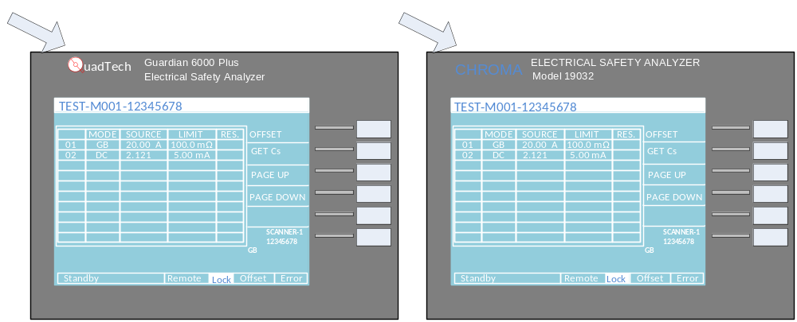
Figure 6 Differences between QuadTech Guardian 6000 Plus and Chroma 19032

- setup QuadTech Guardian 6000 Plus or Chroma 19032
Refer to Appendix B at the end of this procedure to become familiar with the controls, indicators, and connections on the Guardian 6000 Plus and Chroma 19032.
  - Verify that calibration and preventative maintenance labels (both) are current on equipment to be used.
  - Verify that the Power switch is off.
  - Connect the power inlet on the rear of the analyzer to an appropriate outlet.
  - Connect the Corded Product Adapter to the Guardian 6000 or as per Figure 7.
The banana plug into the Sense - jack
The spade terminal to the Drive - jack
The large white high voltage plug connects to the Output jack
  - Connect the Alligator clip lead to the red inputs:
The banana plug into the Sense + jack
The spade terminal to the Drive + jack
  - Connect a line cord to the corded product adapter. Line cords that are well suited to this test are available from Test Engineering. A line cord should always be used as an interface to the UUT to prevent wear on the corded product adaptor. This line cord should be replaced if worn.
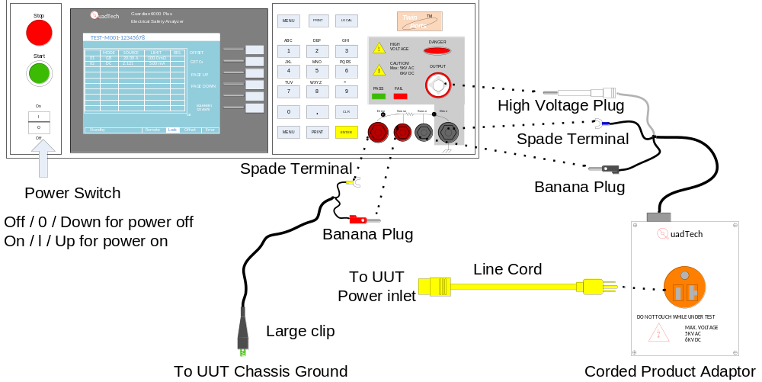
Figure 7 QuadTech Guardian 6000 Plus or Chroma 19032 setup
A cord adaptor supplied by QuadTech or Chroma may be substituted for the corded product adaptor and line cord. Connection is the same.

  - Power up the analyzer by putting the power switch in the ON position. The unit will power. Verify that the unit is ready to test:
The Key Lock indicator should be in reverse text (refer to Figure 8).
The top of the screen should read TEST-M001-12345678 refer to (Figure 8)
If not, do not use the analyzer, label the analyzer accordingly and notify Test Engineering immediately.
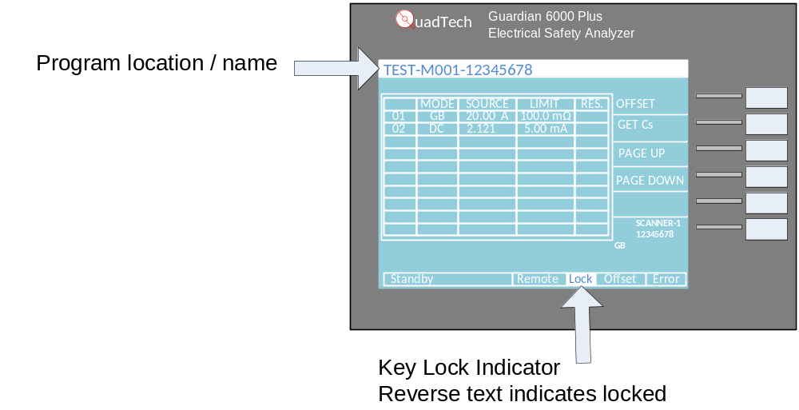
Figure 8 QuadTech Guardian 6000 Plus. / Chroma 19032 ready to test
  - Press the red Stop button once. Unit is now ready to test.

- Operation QuadTech Guardian 6000 Plus or Chroma 19032
Refer to Appendix B at the end of this procedure to become familiar with the controls, indicators, and connections on the Guardian 6000 Plus and Chroma 19032.
  - Verify that the unit is ready to test, by verifying that the Key Lock indicator is in reverse text and TEST-M001-12345678 is displayed (reference Figure 8). If not, do not use the analyzer, label the analyzer accordingly and notify Test Engineering immediately.
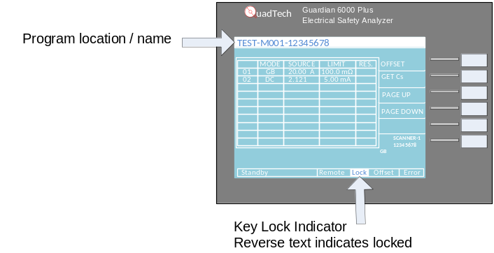
Figure 9: QuadTech Guardian 6000 Plus. / Chroma 19032 ready to test
  - Verify that the UUT is set up for 110/115/120 VAC operation, (if applicable).
Note: Most UUTs are universal input so no input voltage configuration is necessary. If configuration is necessary, the UUT will have a switch (not part of the power input module) to do so.
  - Plug the cord from the corded product adaptor to the AC inlet of the UUT.
  - Verify that the UUT power switch is in the ON position.
If it is not possible to confirm whether power switch is in the on or off position, repeat Section 4 with the switch in each position. The UUT must pass with the switch in both the on and off positions.
  - Connect the Large clip from the analyzer to the chassis of the UUT, preferably the ground stud but any part of the chassis may be used as long as it is conductive.
If at any time during the test it becomes necessary to stop the test, press the red Stop button on the analyzer.
  - Press the green Test button on the analyzer. The test will begin.
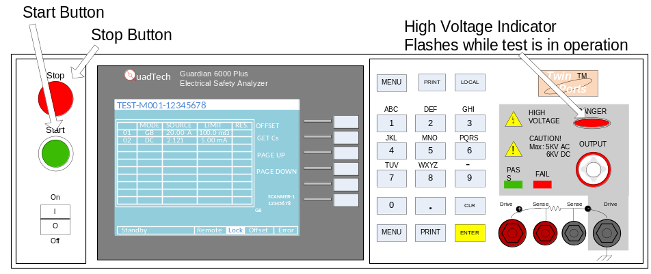
Figure 10
QuadTech Guardian 6000 Plus / Chroma 19032 Start / Stop Buttons and Pass / Fail Indicators
  - When the test is complete:
If the UUT passed:
The beeper will emit an audible tone for about a second.
The green Pass light will illuminate.
If the UUT failed:
The beeper will emit a continuous tone, until the red Stop button is pressed.
The red Fail light will illuminate.
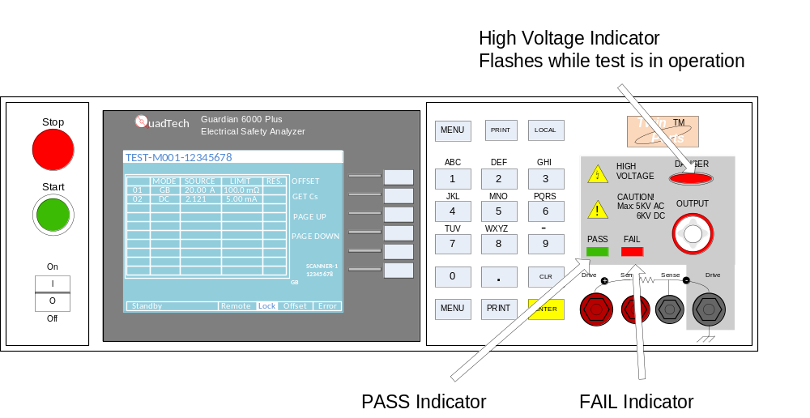
  - If the UUT has a separate input voltage select switch (not part of the power inlet module), repeat Section 4 for each voltage selection.
  - If all testing passed, stamp the UUT instrument chassis with stamp 999037507 per the assembly procedure, if no stamp location is called out in the assembly procedure Place the stamp in a convenient and visible location inside chassis near power inlet if possible.
  - Disconnect UUT and repeat Section 4 to test additional instruments.

***QuadTech 6000 Plus / Chroma 19032 section complete.***

Appendix A
Locations of controls and connectors for QuadTech Guardian 6000 Electrical Safety Analyzer.

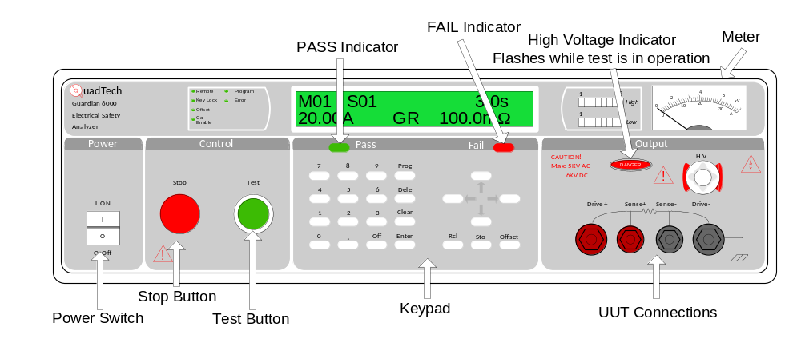
Figure 11 QuadTech Guardian 6000 Front

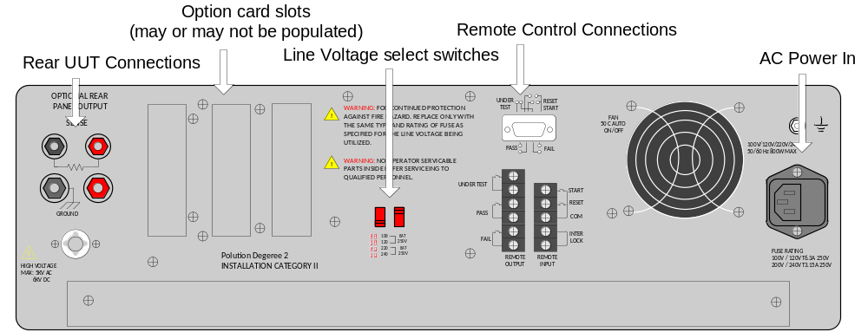
Figure 12 QuadTech Guardian 6000 Rear

Appendix B
Locations of controls and connectors for QuadTech Guardian 6000 Plus and Chroma 19032 Electrical Safety Analyzers.
The only difference between the two analyzers is the name (refer to Figure 6).
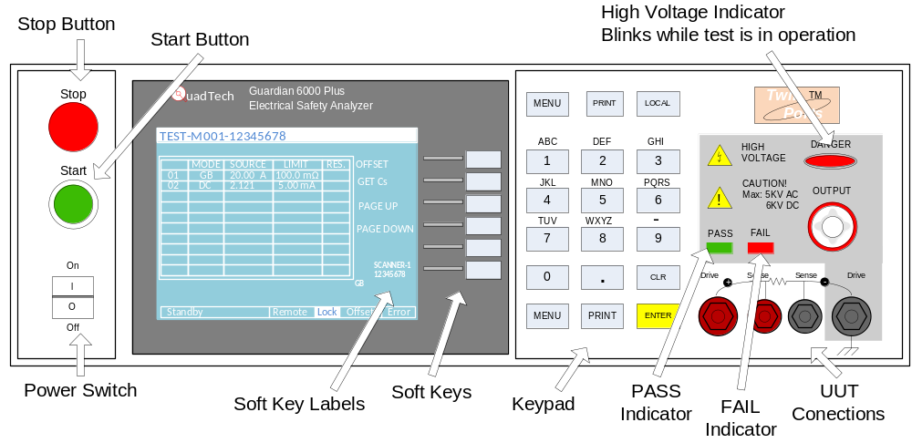
Figure 13 QuadTech Guardian 6000 Plus / Chroma 19032 Front

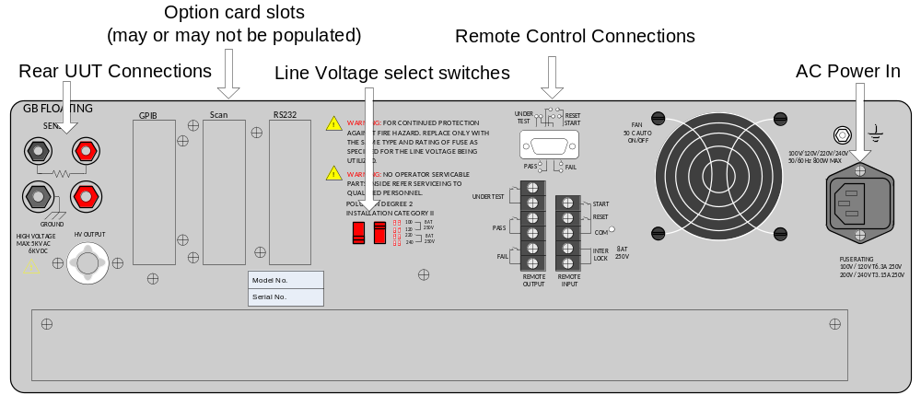
Figure 14 QuadTech Guardian 6000 Plus / Chroma 19032 Rear

Appendix C
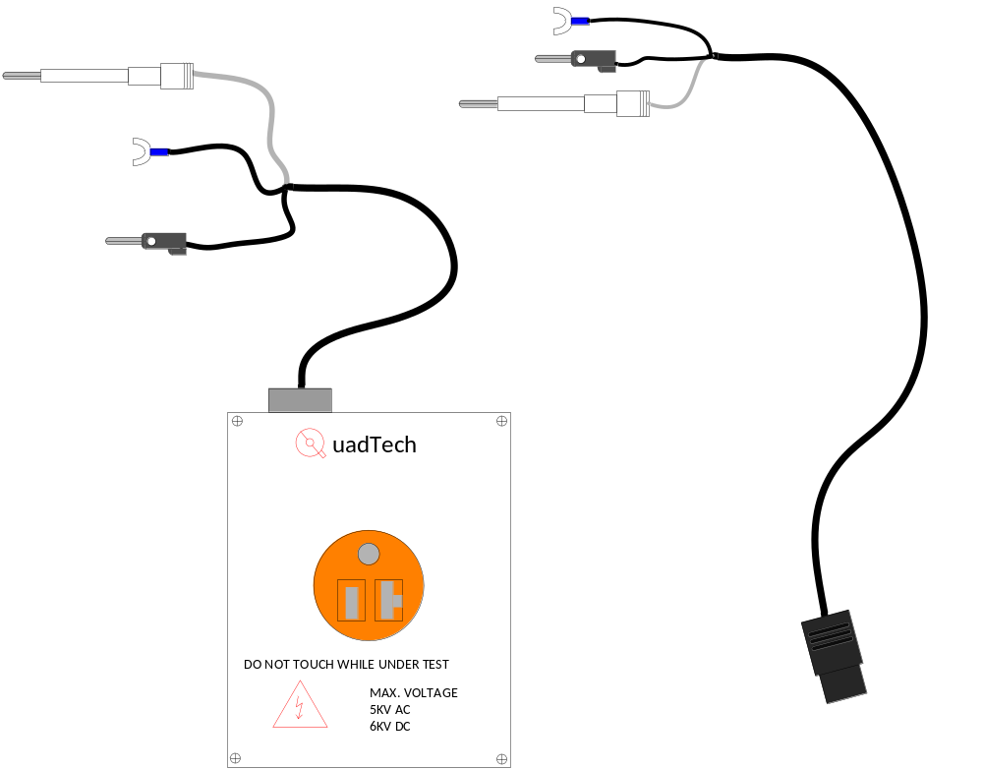
Figure 15
Corded Product Adaptor and Cord Adaptor, respectively. Used with any analyzer type

Preferred UUT interface is the Corded Product Adaptor and a standard power cord that can be used as a ‘wear out’ connection. However, the Cord Adaptor may be used instead.

