DOCUMENT TITLE: tEST sPEC AND pROCEDURE, MSV Leak test
SYSTEM/ASSEMBLY NAME: metering syringe valve ASSy
PART NUMBER AFFECTED 289010714, 289012763
TEST EQUIPMENT NAME: metering syringe valve leak tester
TEST EQUIPMENT NUMBER: TE0084040
TEST SOFTWARE: *0.0*

AUTHOR(S): tyler modelski | DATE: March 16, 2018
REVISED BY: N/A | DATE: N/A

Equipment Required
Quantity | Part Number | Description
1 | 186016003 or 800000444 | Micro Binary Solvent Manager  (F/W 1.50.221 (NANO_LEAKTESTER_V3) Apr 28 2011.sft)
1 | LM02-AAD-00-0-15D | Bronkhurst Flow Meter - Liqui-Flow Mini LM02
1 | 279002203 | Transducer, Pressure, 1000 psi
2 | C5-2004-EMH | VICI 4 Port Single Steam Valve (5kpsi) and Micro-Electric Actuator
1 | NES-150-24 | Meanwell AC/DC Power Supply Single-OUT 24V 6.5A 156W 7-Pin
1 | NI CB-68LPR | NI 68-pin I/O Connector Block
1 | NI PCI-6220 | NI PCI-6220 Multifunction DAQ Card
1 | SCH68-68-EPM | Cable, NI PCI-6220 to NI CB-68LPR
1 | 538-38770-0110 | Mouser (Molex) Barrier Terminal Blocks .375 LOW PROFILE 10P
1 | ECF504-SC5E | L-com Connectivity ECF504-SC5E
1 | 999045028 | MSV Test Fixture

Disposables Required
Quantity | Part Number | Description
102” | 430004290 | PEEK Tubing, 0.062” OD, 0.003” ID
18” | WAT027-08 | PEEK Tubing, 0.062” OD, 0.040” ID
A/R | 430000527 | PEEK Tubing, 0.062” OD, 0.010” ID
14 | 410000890 | Fitting, Compression, 10-32, 10 PK
1 | WAT089801 | Union, 0.040” ID
1 Liter | N/A | Acetonitrile – Fisher Chemical Optima A996-4

reference documentation
Document # | Description
735004417 | Metering Syringe Valve Subassembly Specification
735004437 | Cal/PM TE0084040 MSV Leak Test System

Definitions and Abbreviations
Term | Definition
MSV | Metering Syringe Valve
BSM | Binary Solvent Manager
ID | Inner Diameter
OD | Outer Diameter
USL | Upper Specification Limit
µL/min | Microliters Per Minute
psi | Pounds Per Square Inch
F/W | Firmware
I/O | Input / Output
NI | National Instruments
UI | User Interface

Test SPecifications and Traceability Matrix
Test # | Test Specification & Condition | Acceptance criteria | Reference
1 | Port 2 to 3 Leak Test  Test Pressure: 210 psi  Solvent: Acetonitrile | USL= 2 µL/min | 735004417 Sec 5.2
2 | Port 1 to 3 Leak Test  Test Pressure: 210 psi  Solvent: Acetonitrile | USL= 2 µL/min | 735004417 Sec 5.2
3 | Port 1 to 2 Leak Test  Test Pressure: 210 psi  Solvent: Acetonitrile | USL= 2 µL/min | 735004417 Sec 5.2

Test method description
The MSV is leak tested in each of the three port to port fluidic paths. The following method is used to test each path:
- User is prompted to set the valve using the fixture to the specified port to port fluidic path.
- The port select and dead end valves are moved to open the fluidic path to waste.
- The flow rate on the pump is set to 50 µL/min, and allows Acetonitrile to prime the port to port path. The system stops flowing once the 50 µL/min flow rate is reached.
NOTE: This part of the method is skipped when testing Port 1 to Port 2 as the fluidics have already been completely primed.
- The pump is used to set pressure to 210 psi and the port select and/or dead end valves are moved to dead end the fluidic path.
- The test waits for the test pressure to reach 210 psi +/- 3 psi.
- The flow rate on the Bronkhorst is monitored until 20 consecutive stable readings are achieved. A stable reading is set in the test software as being +/- 0.02 µL/min of the previous reading.
- The results are processed as follows:
  - Leak Rate: Average of the last 5 stable readings
  - Test Pressure: Last transducer pressure point when looking for stable flow readings

Test Procedure
- electrical test setup
  - Refer to Appendix A for a cable setup diagram.
  - Plug in the Micro BSM to a power outlet
  - Plug in the test computer to a power outlet
  - Plug in the test box to a power outlet.
  - Connect the Cable, NI PCI-6220 to NI CB-68LPR from the connector on the rear panel of the test box to the connector on the rear of the test computer.
  - Connect a serial cable from the Micro BSM to serial port (COM1) on the rear of the test computer.
  - Connect the Bronkhorst cable to the L-com Connectivity ECF504-SC5E connector on the rear panel of the test box.
  - Connect the Bronkhorst power cord to a power outlet
  - Connect the Bronkhorst serial cable to serial port (COM2) on the rear of the test computer.
  - Power up the Micro BSM.
  - Power up the Test Computer and login.
- fluidic test setup
  - Refer to Appendix B for a fluidic setup diagram.
  - Drop all solvent lines from the BSM into the 1 Liter Acetonitrile bottle on top of the pump.
  - Connect 15 inches of PEEK Tubing, 0.062” OD, 0.003” ID from the output of the BSM Pump A to the fluidic input fitting on the side panel of the test box.
  - Connect 87 inches of PEEK Tubing, 0.062” OD, 0.003” ID from the side panel of the test box to a Union.
NOTE: Coil this tubing in the bottom of the test box.
  - Connect 18 inches of PEEK Tubing, 0.062” OD, 0.040” ID from the Union to the Bronkhorst Flow Meter.
NOTE: Coil this tubing in the bottom of the test box.
  - Connect approximately 3 inches of PEEK Tubing, 0.062” OD, 0.010” ID from the Bronkhorst to the Pressure Transducer.
  - Connect approximately 6 inches of PEEK Tubing, 0.062” OD, 0.010” ID from the Pressure Transducer to the IN port of the Port Select Valve on the front of the test box.
NOTE: Route this tubing through the hole on the front panel of the test box.
  - Connect PEEK Tubing, 0.062” OD, 0.010” ID as required from Port Select Valve Port 1 to MSV Port 2.
  - Connect PEEK Tubing, 0.062” OD, 0.010” ID as required from Port Select Valve Home Port to MSV Port 1.
  - Connect PEEK Tubing, 0.062” OD, 0.010” ID as required from Dead End Valve Home Port to MSV Port 3.
  - Connect PEEK Tubing, 0.062” OD, 0.010” ID as required from Dead End Valve IN Port to a waste container.

REFER TO THE FOLLOWING SCREENSHOT OF THE TEST SOFTWARE UI WHEN PERFORMING STEPS 3 THROUGH 6:

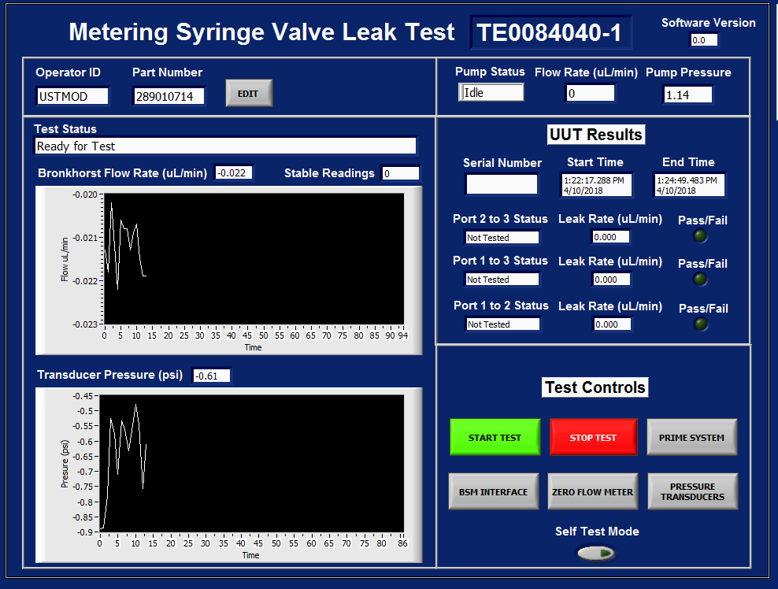

- prime the test system
  - From the Main GUI, click the BSM INTERFACE button.
  - Type the runprime command into the input buffer, then click the enter key.
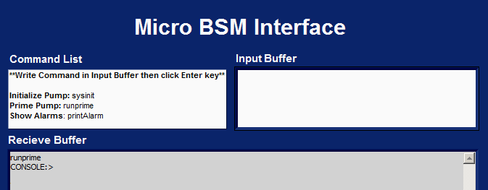
  - Allow the BSM to prime to completion, then close the BSM INTERFACE.
NOTE: You can hear the BSM pump running, once the BSM cannot be heard is an indication it is done priming.
  - From the Main GUI, click the PRIME SYSTEM button.
NOTE: It is recommended to perform these PRIME SYSTEM steps prior to running a batch of MSV’s, but does not need to be performed for every valve.
  - Connect the system fluidics to the 3-way connector.
  - Set the Prime Flow Rate as desired, then click Start Prime.
NOTE: The default is 50 µL/min.
  - Monitor the output of the Dead End valve. Once fluid is dripping, click Next Path.
NOTE: It is general guidance to wait for fluid to drip. If this is the initial setup of the system, allow the system to prime for at least 15 minutes.
  - Monitor the output of the Dead End valve. Once fluid is dripping, click Done Prime.
NOTE: It is general guidance to wait for fluid to drip. If this is the initial setup of the system, allow the system to prime for at least 15 minutes.
  - Click Exit to return to the test sequence.

- zero pressure transducers (as required)
  - Click the button for PRESSURE TRANSDUCERS.
  - Enter the Administrative Password.
NOTE: Only trained individuals may perform this function.
  - Connect the system fluidics to the 3-way connector.
  - Monitor the Transducer Pressure and BSM System Pressure until the readings indicate the system is in a zero pressure state.
NOTE: The valves in the test system have been set to relieve all pressure. The pressure in the fluidics system should be hovering close to 0 psi during this monitoring stage.

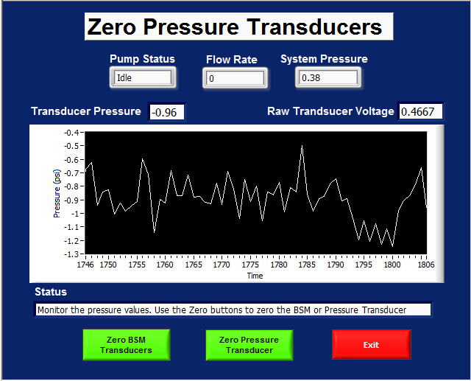

  - When ready to zero the transducers:
    - Click the Zero BSM Transducer button once.
    - Click the Zero Pressure Transducer button once. This will set the zero offset voltage of the transducer to the current Raw Transducer Voltage.
  - Click the Exit button once complete to return to the test sequence.

- zero flow meter (as required)
  - Click the button for ZERO FLOW METER.
  - Enter the Administrative Password.
NOTE: Only trained individuals may perform this function.
  - Connect the system fluidics to the 3-way connector.
  - Wait for the Bronkhurst Flow Meter to become stable.
NOTE: This is a feature of the test software. Once the Bronkhurst is stable, the “Zero Flow Meter” button will appear. The valves in the test system have been set to dead end the system fluidics. The flow within the fluidics system is at 0 µL/min during this stage.

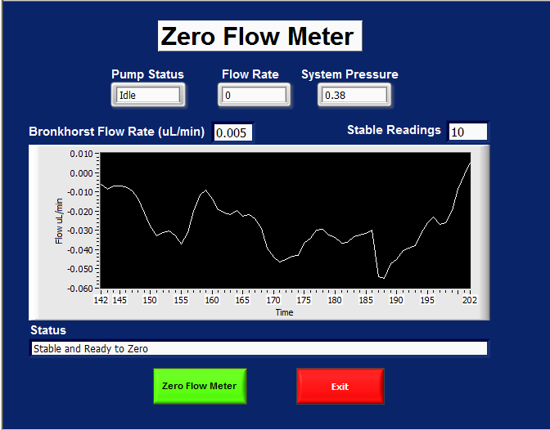

  - When ready to zero the flow meter, click the Zero Flow Meter button once.
  - Click the Exit button once complete to return to the test sequence.

- verify test system pressure and leak (as required)
  - Click the button for Self Test Mode.
NOTE: This is a button that can be toggled “On” or “Off”.
  - Click Start Test.
  - Connect the system fluidics to the 3-way connector.
  - Allow the test to run to completion.

- msv Leak test
  - Install the MSV onto fixture 999045028. Refer to Appendix C for mounting instructions.
  - When ready to start the test, click START TEST on the Main GUI.
  - Connect the MSV per Appendix B.
  - Follow the on screen instructions to move the MSV valve into positions for all three port to port tests.

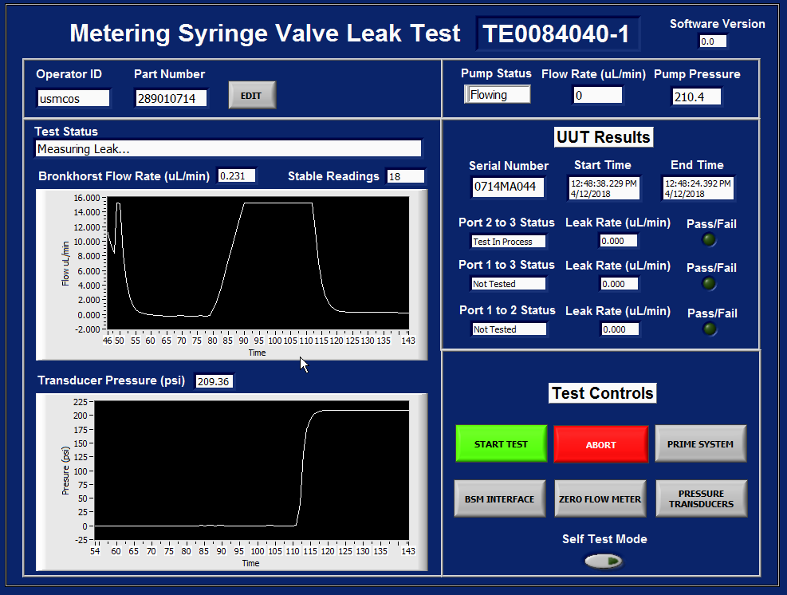
7.5. Start Test
7.6. Abort
7.8 Results
7.7.3 Pressure
7.7. Test Status
7.7.4 Flow Rate and Stability

  - Start Test: When ready to test an MSV, click START TEST.
  - Abort: If at any point the test needs to stop, click ABORT. Returns test to the initial state.
  - Test Status: There are 6 test statuses in the following order:
    - Ready for Test – The test is waiting for user input.
    - Priming Flow Path – The pump flows through the valve at 50µL/min.
NOTE: The flow meter only displays up to 15.204 µL/min. It is intentionally configured that way.
    - Waiting for Pressure – The test is waiting for the pressure to reach the test pressure.
    - Measuring Leak – The test is monitoring the leak rate and waiting for 20 stable readings.
    - Setting Pressure to Zero – The port to port test is complete. Pressure is set to 0 psi.
    - Test Complete – All three port to port tests are complete. Result is displayed.
  - Results: Displays the Test Status, Leak Rate, and Pass/Fail result for each port to port test.

appendix a – electrical cable diagram

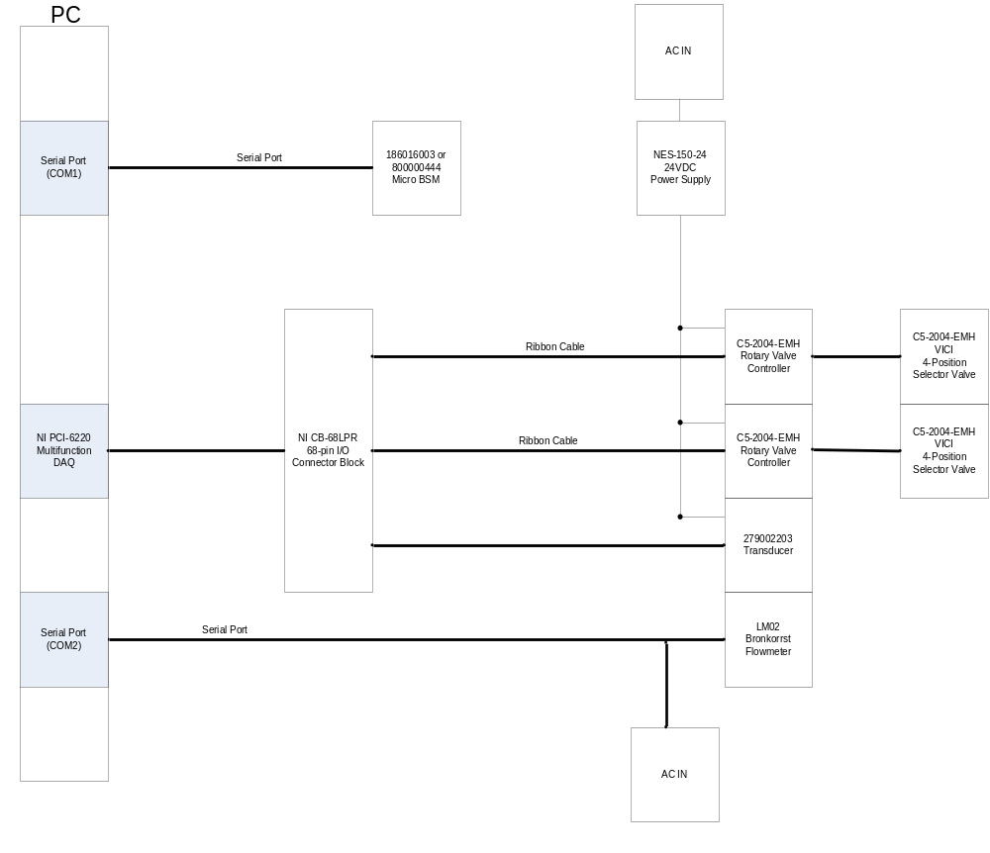

appendix b – fluidics diagram
Block Diagram:
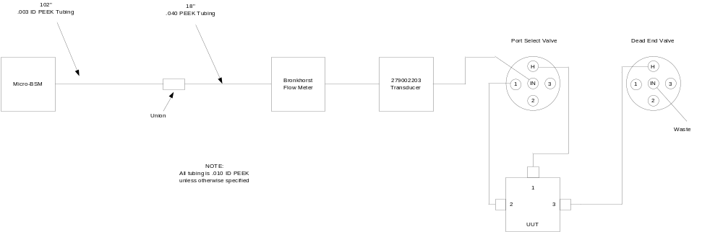

Valve Connection on Fixture:
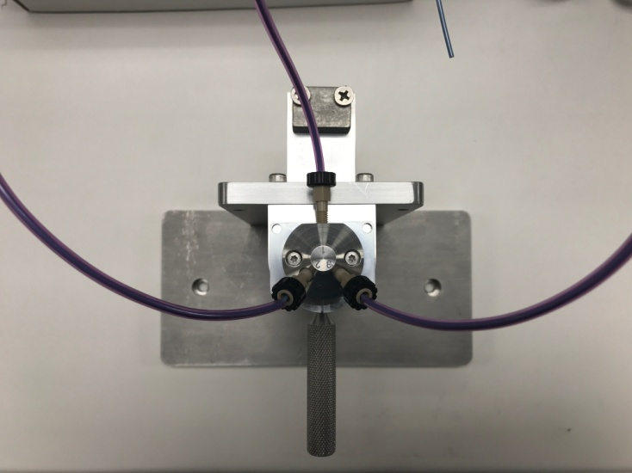

3-Way Connector:
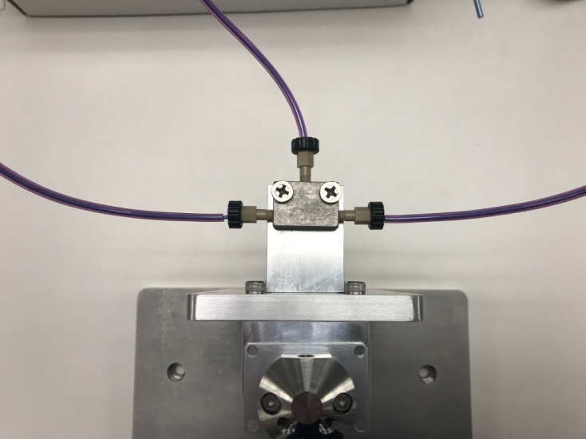

appendix C – MSv test fixture 999045028 mounting instructions

- Prior to installation position the encoder slot (black wheel) so that it is between ports 2 and 3 of the MSV.
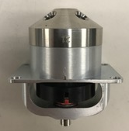

- Place the MSV onto the fixture with the encoder slot facing the front of the fixture. Twist the handle clock wise to tighten the handle to the MSV rotary shaft. Verify the valve is connected by attempting to pull up on the valve. If connected it will not be removable.

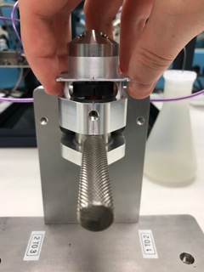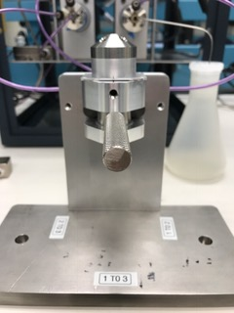

- Use the handle to rotate the valve to each port to port position.
