INSTALLATION QUALIFICATION REPORT
For the PCM II Final Test Station (TE82817-2)

PREPARED BY
Name | Role | Signature | Date
Luo HuaZhen | Senior Test Engineer
The “Prepared By” signature denotes that this document accurately describes the qualification activities.
REVIEWED BY
Name | Role | Signature | Date
Matthew Brule | Senior Test Engineer
Chan Yee Hwa | Manufacturing Engineer
The “Reviewed By” signature[s] denotes agreement with the description of the qualification activities.
APPROVED BY
Name | Role | Signature | Date
Tan Kah Chin | Senior Quality Assurance Manager
The “Approved By” signature denotes that this document has been reviewed and approved for overall quality and completeness.

REVISION HISTORY
Version: | 00 | Originator: | Luo HuaZhen | Change ID: | N/A
Summary of Change: First document for approval, after transfer the tester from Venture Singapore to CEI Singapore

PURPOSE
The purpose of this Installation Qualification Report is to detail the activities associated with the execution of Test Specification and Procedure 735000887 for the TE82817-2, PCM II Final Test Station.

SYSTEM BACKGROUND
The TE82817-2, PCM II Final Test Station, facilitates the functional test of the following part numbers: 186002449, 800000178, 279001290, 800000224. The system performs testing to ensure the product meets the critical to quality specifications in accordance with TSP 735000887.
In the final test, the UUT is connected to the test station and the performance of the rear panel I/O, the pump status, pump pressure, and pump control is verified to operate within design specifications. When complete, a hard copy of the final test record is printed
The PCM II Final Test Station (TE82817-2) is located in the Singapore Contract Manufacturing site CEI Singapore.

SCOPE
This Installation Report details the Qualification activities undertaken for the TE82817-2, PCM II Final Test Station, based on the requirements of the Installation Qualification Procedure, 730004135 Ver.03, as detailed in TE82817-2-26SEP19-VAF.

SUMMARY OF RESULTS – STATEMENT OF FITNESS FOR INTENDED USE
The TE82817-2, PCM II Final Test Station was tested in accordance with the Installation Qualification Procedure, 730004135 Ver. 03. All Test Scripts were performed and all objective evidence requirements have been met.
Waters now has the necessary documentation in place to ensure that the TE82817-2, PCM II Final Test Station complies with Waters’ requirements, the latest relevant quality system regulations, and cGMP practices.
Following the approval of this Qualification Report, the TE82817-2, PCM II Final Test Station can be considered fully qualified and fit for intended use.

DEFINITIONS / ABBREVIATIONS
The following definitions are used in this document:
Term | Explanation
cGMP | Current Good Manufacturing Practice
ID | Identification
IQ | Installation Qualification
IQR | Installation Qualification Report
TSP | Test Specification and Procedure
CAL/PM | Calibration/Preventive Maintenance
NPI | New Product Introduction
UUT | Unit Under Test
S/N | Serial Number
P/N | Part Number
PCB | Printed Circuit Board
PCM II | Pump Control Module II
PMP | Pump
ANSI | American National Standards Institute
N/A | Not Applicable

TRAINING
The operators of the PCM II Final Test Station (TE82817-2) were trained according to the PCM II Final Test Procedure, 735000887, Ver. 06. The executor of this qualification was trained according to the Installation Qualification Procedure 730004135, Ver. 03. Both training records are provided as Attachments 7.15 and 7.16, respectively.

QUALIFICATION Results

Test Script IQ-01: Associated Documentation Verification was performed according to Installation Qualification Procedure 730004135, Ver. 03. The completed Test Script Data Sheet is provided as Attachment 7.1.

The PCM II Final Test Procedure, 735000887, Ver. 06, was confirmed to be in SAP with a status of Release General, as evidenced below.

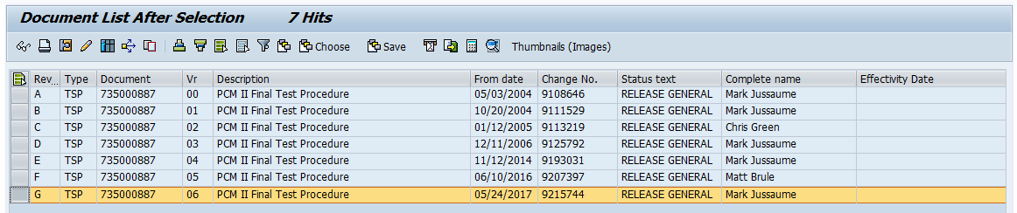

The TE82817-2 PM Procedure, 735002828, Ver. 00, was confirmed to be in SAP with a status of Release General, as evidenced below.

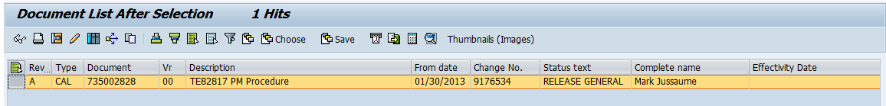

Test Script IQ-02: Site Verification was performed according to Installation Qualification Procedure 730004135, Ver. 03. The completed Test Script Data Sheet is provided as Attachment 7.2.

The ambient temperature and humidity were measured using a Prostat Psychrometer PHT-771, ID#10169590, and was determined to be within specification as defined by Performance Specification, PCB, Pump Control WAT200454, Ver. 00. The calibration record is provided as Attachment 7.3.

The electrical supply was measured using a Fluke 117 Multimeter, ID#37781258WS, and was determined to be within specification accordance with ANSI C84.1 – Voltage Tolerance Standard. The calibration record is provided as Attachment 7.4.

The Test Station was confirmed to have more than the four (4) dedicated electrical outlets required.

The space and test bench of the PCM II Final Test Station (TE82817-2) were confirmed to have adequate space for testing and service. The bench was confirmed to be large and strong enough to support all test equipment. A picture of the Test Station work area is provided as Attachment 7.5.

The Test Station was confirmed to have one (1) network available.

Test Script IQ-03: Instrumentation Calibration Verification was performed according to Installation Qualification Procedure 730004135, Ver. 03. The completed script is provided as Attachment 7.6.

The PCM II Final Test Station (TE82817-2) was confirmed to be in the Tooling/Equipment PM Master List with a three (3) month maintenance cycle.

The Test Station was confirmed to have had preventative maintenance within this time frame. A copy of the PCM II Final Test Station (TE82817-2) from the Tooling/Equipment PM Master List is provided as Attachment 7.7.

Test Script IQ-04: Test Software and Instrument Firmware Version was performed according to Installation Qualification Procedure 730004135, Ver. 03. The completed Test Script Data Sheet is provided as Attachment 7.8.

The Test Equipment Software version listed in PCM II Final Test Procedure 735000887, Ver. 06 is Test Software 0.0 and was verified to match the version listed in the Test Equipment program displays of the PCM II Test Program. A screen capture of the program displays is provided as Attachments 7.9.

The PCM II Firmware version listed in Production Master PCMII 361000331, Ver. 00 is Firmware v4.00 and was verified to match the version listed in the Loader Dialog Box. A screen capture of the program is provided as Attachment 7.10.

Test Script IQ-05: General Safety and Alarms was performed according to Installation Qualification Procedure 730004135, Ver. 03. The completed Test Script Data Sheet is provided as Attachment 7.11.

It was confirmed that there were no mechanical safety pinch points or sharp edges.

The PCM II Final Test Station was confirmed to pass an Electrical Safety Hi-Pot/Ground Continuity test. The calibration record is provided as Attachment 7.12.

Test Script IQ-06: Functional Verification was performed according to Installation Qualification Procedure 730004135, Ver. 03. The completed Test Script Data Sheet is provided as Attachment 7.13.

One (1) UUT Part #186002449 (Serial #M18PC2543G) was tested using the PCM II Final Test Station (TE82817-2) program with all tests passing. The final test record is provided as attachment 7.14.

This table provides a summary of each test script as performed according to 730004135 Ver. 03 along with the attachment location of all objective evidence. The table also indicates any deviation taken from the scripts during qualification.

Script or Section | Pass/Fail | Objective Evidence | Deviations
IQ-01 | Pass | Attachment 7.1 | None
IQ-02 | Pass | Attachments 7.2, 7.3, 7.4, and 7.5 | None
IQ-03 | Pass | Attachments 7.6 and 7.7 | None
IQ-04 | Pass | Attachments 7.8, 7.9, and 7.10 | None
IQ-05 | Pass | Attachments 7.11 and 7.12 | None
IQ-06 | Pass | Attachments 7.13 and 7.14 | None

ATTACHMENTS

Completed Test Script IQ-01: Associated Document Verification

Completed Test Script IQ-02: Site Verification

Objective Evidence IQ-02: Prostat Psychrometer PHT-771 (ID#10169590) Calibration Record

Objective Evidence IQ-02: Fluke 117 Multimeter (ID#37781258WS) Calibration Record

Objective Evidence IQ-02: Photo of Test Station Work Area

Completed Test Script IQ-03: Instrument Calibration Verification

Objective Evidence IQ-03: Tooling/Equipment PM Master List

Completed Test Script IQ-04: Test Software and Instrument Firmware Version

Objective Evidence IQ-04: Screen Capture of PCM II Test Equipment Software

Objective Evidence IQ-04: Screen Capture of Test Equipment Firmware

Completed Test Script IQ-05: General Safety and Alarms

Objective Evidence IQ-05: Hi-Pot Ground Continuity Tester (ID#19032G400225) Calibration Record

Completed Test Script IQ-06: Functional Verification of UUT Part #186002449 (M18PC2543G)

Objective Evidence IQ-06: Instrument Final Test Record for UUT Part #186002449

Completed Operator Training Record 735000887 Ver. 06

Completed Executor Training Record 730004135 Ver. 03

DEVIATION FROM THE QUALIFICATION PROTOCOL
There were no deviations generated during the execution of the Installation Qualification Procedure 730004135 Ver. 03.

References
The current approved versions of the following documents are referenced within this document:
Document Number | Document title
730004135 Ver. 03 | Installation Qualification Procedure
735000887 Ver. 06 | PCM II Final Test Procedure
735002828 Ver. 00 | TE82817 PM Procedure
WAT200454 Ver. 00 | Performance Spec, PCB, PMP Control
WAT046538 Ver. 12 | Generic Electrical Safety Test Procedure
361000331 Ver. 00 | Pump Control Module II Recreate Procedure v4.00.12
ANSI C84.1 | Voltage Tolerance Standard

