DOCUMENT TITLE: UPC² PDA DETECTOR & VEYRON PDA DETECTOR FINAL TEST
SYSTEM/ASSEMBLY NAME: UPC² PDA DETECTOR & VEYRON PDA DETECTOR
PART NUMBER AFFECTED 279002224, 800000414, 800000439, 279002897, 186015034, 186015053
TEST EQUIPMENT NAME: UPC² PDA DETECTOR & VEYRON PDA DETECTOR FINAL, Linearity and wavelength accuracy test system
TEST EQUIPMENT NUMBER: TE82882, TE82969
TEST SOFTWARE: 4.0(TE82882) 2.0(TE82969)

AUTHOR(S): GARY BOHABOY | DATE: January 11, 2012
REVISED BY: eric turner | DATE: December 6,2017

Equipment Required
Quantity | Part Number | Description
1 | TE82882 | PDA Final Test System
1 | 289007555 | UPC² Analytical Flow Cell
1 | 289007941 | Veyron PDA Analytical Flow Cell
1 | n/a | Empower Workstation, Wave Accy & Firmware loader
1 | TE82969 | PDA Linearity Test Station

Disposables Required
Quantity | Part Number | Description
1 | WAT047689 | Two Cuvette Set
1 | WAT042885 | 996 Wavelength Accuracy Kit
1 | WAT047691 | Linearity Cuvette Kit
1 | WAT042881 | Absorbance Detector 10mm Cell Linearity Kit

reference documentation
Document # | Description
721001093 | UPC² PDA Functional Specification (Author: Brett Cook)
721003976 | Veyron PDA Functional Specification (Author: Senthil Bala)
721007611 | Velox 2998 PDA Detector FSD

Test SPecifications and Traceability Matrix
Test # | Test Specification & Condition | Acceptance criteria | Reference
1 | Noise (dry) | <8uAu | 721007611 Sec. 5.15.2
2 | Drift (dry) | <1000uAu/min | 721001093 Sec 5.16.3  721003976 Sec.5.15.3
3 | Linearity | %RSD<=5 | 721007611 Sec 5.3.2
4 | Wavelength Accuracy | +/- 1nM | 721001093 Sec 5.16.4  721003976 Sec.5.15.4

UPC² & Veyron PDA Detector Final Test procedure
- initial setup & firmware load
  - Tape a “Test Checklist” to the front cover. Use this to keep track of completed tests.
  - Perform the Electrical Safety test (document # WAT046538).
  - Remove the optics bench front cover and associated hold-on pieces and place in a plastic bag. Retain for later use.
  - Install the appropriate flow cell (SFC or Veyron) into the optics bench. Hand tighten the 3 hold down screws then tighten another 1/8 turn. Connect the Flow Cell ID cable from the PDA to the Flow Cell.
  - Invoke the “loader.exe” program and load the firmware. Once the firmware is loaded cycle the power to the UUT (Unit under Test).
  - Power on the unit and verify the proper operation of the Power On and Lamp leds.
Power Led: Solid Green
Lamp Led: Solid Red (~10sec)
Flashing Green (Initialization and Lamp warm-up ~ several minutes)
Solid Green (Lamp warm-up complete)
  - Invoke the Console program. Note: Once the console is opened the message “Wavelength Verification Failure” will be displayed this is normal and is because the optics bench is not yet calibrated.

  - Remove the top cover and verify that the 3 fans are blowing in the correct direction. (See Diagram below).
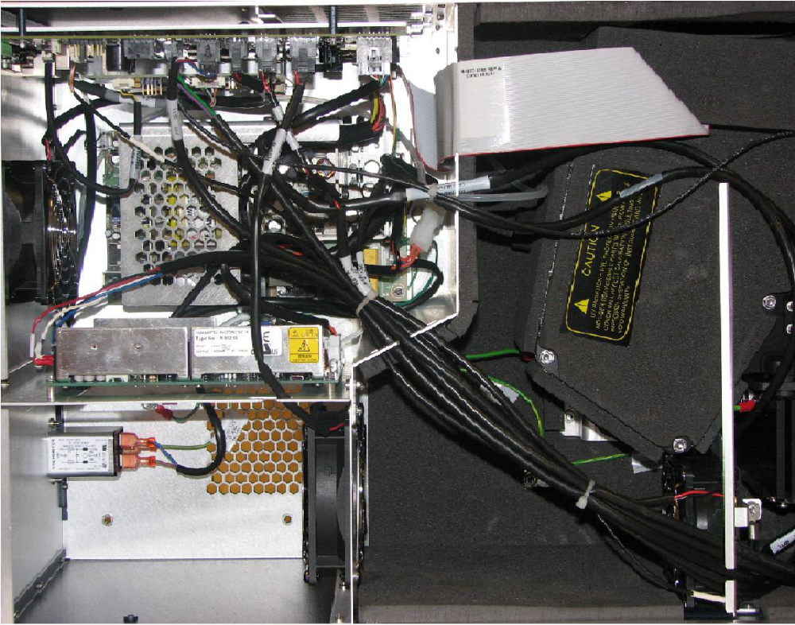
A

  - Verify that the software jumper is installed on J7, on the 4th pin from the back.
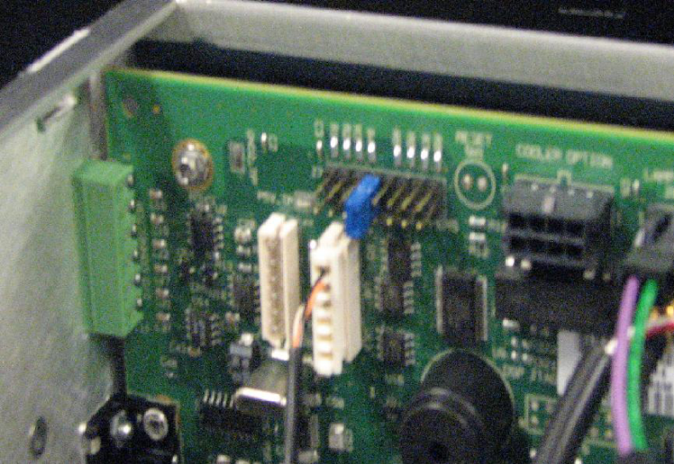
  - Also inspect for loose or disconnected cables or other visible issues.
  - Replace the cover and secure with 2 torx screws.
  - Run the Erbium Calibration routine.
    - Select “PDA Detector” from the left pane.
    - Troubleshoot→Service Mode→1147, Enter.
    - Troubleshoot→Erbium Calibration
    - Press Optimize Exposures
    - Select the Erbium Absorbance radial button→Start
    - Press→Stop→Save (under Wavelength Calibration)→OK →Close
    - Control→Reset PDA
    - Ensure the “power” and “lamp” led’s come on solid green.
  - Collect Energy Data
Maintain →Read Energy
    - Select 230nm from the dropdown list.
    - Set Exposure time to 5ms
    - Select √ Continuous Read
    - Set the shutter position to “open”.
    - Set the x-axis to Wavelength
    - Capture and Save the Energy Scan: Use Filename xxxxx_EnergyScan1 (where xxxx = unit Serial Number)
    - Print out the Energy Scan and record the value.
    - Press Stop → Close
  - Configure the unit serial number.
    - Configure → View module information
    - Enter the unit serial number. Press OK then press Yes
  - Enable the Lamp and Flow Cell ID:
    - Configure→Preferences
Enable the following:
√ Lamp Resident Identification
√ Flow Cell Resident Identification
  - Verify the software jumper configuration
    - Invoke Hyperterminal
    - Type: Dump Controller, Enter
    - Verify: PIN4: IS_SFC_APC_PDA = Installed.
    - All other PINs = Not Installed.

- WAVELENGTH ACCURACY TEST
Conditions: Wavelength range: 200 to 800nm. Resolution: 1.2nm, Sampling rate: 1 point/sec, Interpolate 656nm, Interpolate 2nd order filter (340nm) region, Filter response: Normal (1 sec).
  - Open the Empower Application
  - Press the Configure Icon
  - Select Systems from the left side pane.
  - Select UPC2_Veyron_PDA from the list on the right side pane, Right click and select “System Properties”
  - Click on the Configuration Tab
  - Drag and Drop the UUT serial number from the Left Pane into the Right Pane.
  - Drag and Drop the unused serial number from the Right Pane into the Left Pane.
  - Press OK, File →Exit.
  - Press the Run Samples icon select UPC2_Veyron_PDA project from the Left Pane and UPC2_Veyron_PDA_Wave_Accy from the Right Pane, Click OK.
  - Click on the Single tab (bottom of screen).
  - Enter a filename with the convention: xxxxxxxx_Wave_Accy.
Where: xxxxxxxx = UUT serial number.
  - Set the injection volume to 1µl and run time to 10min.
  - Click the Prepare icon.
  - Click the Inject Icon.
  - After the baseline is stable, insert the cuvette containing the erbium perchlorate solution into the cuvette holder.
  - Make sure the erbium perchlorate spectrum appears in the real time plot. Allow the erbium perchlorate solution to remain in the cuvette holder for at least 2 minutes.
  - Press the Abort Icon.
  - Confirm the absorbance of the max wavelength in the spectrum by extracting the 3D chromatogram.
  - From the PDA Spectrum window, right click and select “Review”.
  - Right click in the Contour Plot window and select “Extract Spectrum” and move it to a stable portion of the display.
  - Select from the pull down menu: Spectrum Review→Spline→Spline.
  - From the extracted spectrum window right click and select “Print”, OK.
  - Record the values of the 255nm, 379nm and 523nm peaks in the Instrument Final Test Record sheet.

- LINEARITY TEST
  - Connect the UUT to the Linearity Test Station (Power, Ethernet and RS232 Cables).
  - Power up the UUT and invoke the PDA Linearity Program.
  - Press Start
  - Select the Operator name from the dropdown list and press Enter
  - The Console program screen will then come up.
  - Select: Troubleshoot → Service Mode → 1147 → Enter
  - Select: Maintain → Read Energy
  - Select: Exposure Time 5.0 msec
  - Select: √ Continuous Read
  - Select: Shutter Position: Closed
  - Select: 257nm from the dropdown list
  - Press: Read
  - Press: Capture 3 times approx 5 seconds apart to capture the spectrum
  - Press: Stop, Save. Type in a filename with the following format: darkxxx, where xxx is the last 3 digits of the UUT serial number.
  - Place the cuvette filled with methanol into the holder then slide it into the UUT.
  - Select: Shutter Position: Open, press: Read
  - Press: Capture 3 times, press Stop, Save. Use the following format: meohxxx.
  - Place the cuvette filled with a 5mg/L solution of propylparaben into the UUT.
  - Press: Capture 3 times, press Stop, Save. Use the following format: 5mgxxx.
  - Repeat steps 2.18 & 2.19 for cuvettes with 10mg/L, 15mg/L, 20mg/L, 25mg/L and 30mg/L.
  - Once the 30mg/L file has been saved, remove the cuvette from the UUT and press Close to exit out of the screen. Then press the X to exit out of console. After a few seconds a graph of the linearity curve should appear on the screen. Ensure the % RSD value displayed on the graph is ≤ 5%. If this is the case, then press the Print and Exit button.
  - Save the printout as part of the UUT and record the %RSD on the Final Test Record.
  - Power down and remove the UUT from the test station.
- Final Test
  - NOTE: If you are switching from one model to another, follow 4.1.1- 4.1.7, if not, proceed to step 4.2.
    - Open Empower by double clicking on the Empower desktop icon or find it in the All Programs list using the start button.
    - Login as system, pw: metsys.
    - Select Configure System from the menu blocks.
    - Click on Systems
    - There are up to twelve systems configured for use with the test system, PDA 1 through PDA 4, 2998 1 through 2998 4, and ELAMBDA 1 through ELAMBDA 4. Only four of these systems can be online at a time so whatever slot on the test system you are using (1-4), the proper system needs to be on-line. To take a system off line, right click on the system name and select take offline from the menu. Then, right click on the system you would like to bring online and select bring online.
    - NOTE: the SFC(Model C2P) and Veyron (model ADT) shall be tested as eLambdas, so bring the eLambda systems on line for those models.
    - The recommended configuration is to test all of one type at a time or you may experience Lost Comm errors.
    - Exit out of configuration manager by clicking on the small x in the top right corner of the window. Exit out of Empower by clicking on the small x on the block menu window. For extra stability, run the StopAcquityProcesses.cmd from the desktop.
  - Connect UUT to final tester, selecting a position (1-4). Connect the power cable, the serial cable, and the Ethernet cable from that position – they are grouped together.
  - The power switch on the UUT should be in the ON position. The UUT will not power up, however, as it is software controlled by the tester.
  - Click Run. Enter the required information and follow all instructions on the screen. System will automatically launch Empower and run a noise and drift test.
  - Upon finishing the test, click Remove Unit, and follow instructions on screen. A printout will print at the test station default printer.
- troubleshooting
  - If the system has trouble launching console or Empower, run Waters DHCP Server Configuration.exe and verify there are less than 255 IP addresses, serial numbers in list. If not, delete them all. If you cannot locate the program do a search of *DHCP* with the XP search function.
  - You may also need to run “Stop Acquity Processes.cmd“ if you are having connection problems or, if all else fails, re-boot system.
  - Verify the proper systems are on-line (4.1.1-4.1.7).
  - To verify a connection to a single system
    - Plug AC into a regular power outlet and power up
    - Open HyperTerminal and connect to the appropriate serial port (COM15 for Station 1, COM16 for station 2 etc.) with 38400 baud, 8, n,1.
    - Change the serial number of the unit to 1-4 for AcqPda, position 1-4, 5-8 for 2998, position 1-4, or 9-12 for eLambda, position 1-4. eg. 2998 in position 2 would be setserialnumber 6 <enter>.
    - Type setipflags N F <enter>.
    - Type setipaddress 192 168 0 x <enter> where x = 5-8 for AcqPda 1-4, x=9-12 for 2998 1-4, and x=13-16 for eLambda 1-4. So for an eLambda in position 2, you would type setipaddress 192 168 0 14 <enter>.
    - Power cycle UUT.
    - Plug Ethernet cable directly into switcher, or card in PC.
    - Launch empower and login as system pw:metsys. Click Configure System.
    - Select Empower Nodes and right click on the empower node on the right. Select properties from the drop down list.
    - Select Instruments and check to see if the instrument in question is “OK”. You may run scan instruments to see if it helps. If not, call TE. Sometimes these steps “awaken” Empower to now recognize the UUT.
  - To troubleshoot Lost Comm errors:
    - In the list of instruments, there should only be up to 12 systems (Address ACQ-PDA#1 through #4, and #9 through #12, and W2998#5 through #8). If there are any other systems listed with typical serial numbers (A09UPD011M) or ‘serial number uninitialized’, click remove.
    - Click on the Configure DHCP tab. Click on the Configure DHCP button. If there are any instruments listed in the Waters DHCP server configuration list, highlight them and remove them. Click OK.
    - Click OK, then use the X in the top corner of the Configuration Manager window and the then the Empower Pro window to exit.
    - Put any removed cabling back and try running application again.
    - If problems persist, reboot system.
    - Do not run eLambdas at the same time as PDAs – this can result in Lost Comm errors.

Waters Corporation

INSTRUMENT - FINAL TEST RECORD
Part Number: | Description:
Tested By: | Date: / /
Serial Number: | Control Number:
Software Revision: | Factory Order:

Electrical Safety  FANS  LED’S FUNCTIONALITY | PASS FAIL see note # PASS  PASS FAIL see note # PASS  PASS FAIL see note #______PASS
Linearity (% RSD) Actual:  Wavelength Accuracy  255nm_______ 379_________ 523________  Final Test | PASS FAIL see note # PASS  PASS FAIL see note # PASS  PASS FAIL see note # PASS
Instrument Result: PASS FAIL Signed Date: / /

Notes:
This Test Record and any data contained within it are proprietary to Waters Corporation and must be retained by Waters for the time period prescribed in its Quality Records Retention Policy. If any of the individual tests noted above fail, a note must be referenced that details the work performed to correct that specific deficiency. An overall failure indicates a special circumstance in which case a complete retest is to be done. A second form is required to document that testing. The initial form must be attached and retained.

END OF DATA

