ENGINEERING REPORT:
 | Project Information:
 | Report Title |  | Evaluating A New Over Temp Switch in The TUV and PDA Refresh Detectors
Author |  | Ziad El-Massih
 | Date |  | 7 May 2014
 | Project Name |  |  |  |  | Room #:
 | Product Name |  | 2489 Refresh & 2998 Refresh |  |  | DIR #:
 | Report Type |  | ( ) Test Plan | ( X) Test Report | ( ) Design Analysis |  | () Failure Analysis
 |  |  | ( ) Other (explain)

Table of Contents
1.0 Objectives 2
2.0 Background 2
3.0 Summary and Recommendations 4
4.0 Conclusions 4
5.0 References 4
6.0 Definitions 4
7.0 Device under Test or Analysis 5
8.0 Procedure 5
8.1 Second Evaluation - Using Samples with Beryllium Copper C17510 Spring Contact Arm 5
8.1.1 Baseline Using the Current OTS 5
8.1.2 Testing Five Samples of the Proposed Sensata OTS with Beryllium Copper C17510 Spring Contact Arm 6
8.1.3 Testing Five Samples of the Previously Proposed Sensata OTS with Beryllium Copper C17500 spring Contact Arm 6
9.0 Equipment 6
10.0 Results and Discussion 7

Objectives
The objective of this evaluation is to evaluate a new cost reduced over temperature switch, which is used in the 2489 and 2998 Refresh Detectors. The current Over Temp Switch cable costs $31.40 while the new proposed solution, Switch and cable, costs about $11.92. That’s a saving of $19.48 per cable. For a yearly usage of 3000 instruments per year, the estimated yearly cost saving is $58,443. Only the 2489 TUV and 2998 PDA Refresh detectors are targeted for this change.

After approving the new thermostat from Sensata, parts to manufacture the thermostats had encountered procurement challenges and threatened to cause the Waters manufacturing of the 2 detector models that use the thermostat to be shut down for few weeks. The manufacturer Sensata proposed to change the material of the spring contact arm from beryllium copper C17500 to beryllium copper C17510. The new material is readily available while the previous material has very long lead time. The material differences are very minor. Sensata conducted full evaluation to validate the new material. Sensata also had conducted a reliability test with more than 25,000 successful cycles. The testing was conducted on thermostats from the same model but with different temperature settings.

Since the material is not specifically called out in the UL/CSA files and the part number of the thermostat will not change, there is no need to edit our safety approval records and Sensata doesn’t need to update the UL/CSA qualification for that part.

The objective of this reevaluation is to ensure the functionality of the new thermostat with the new beryllium copper C17510. Five samples are evaluated and compared to the previous samples made with beryllium copper C17500 and the original thermostat made by Selco.

Background
For the past 15 years, all TUV and PDA detectors had utilized a 70°C Over Temperature Switch (OTS), aka thermostat, that is mounted on the lamp housing. The switch is intended to cut the power going to the lamp power supply when an abnormal lamp housing temperature reaches 70°C. The OTS also known as thermostat is used in our detectors as a safety switch that shuts the lamp off when overheating is detected preventing more severe damage to other components due to excessive heating.
In the newly introduced 2489 TUV and 2998 PDA Refresh detectors, the OTS was changed to 80°C to improve performance. At the time, the new proposed switch had very long lead time, therefore, an 80°C OTS (Waters P/N 353000103) that is currently used in the Column Heaters was chosen since it was readily available.

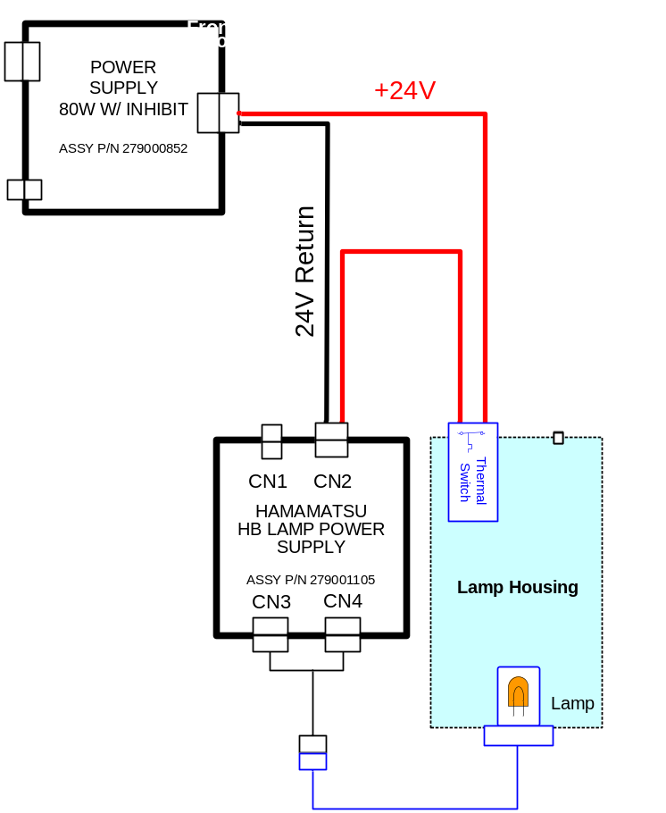
Thermostat (or OTS)
Figure 1- Illustration of how the thermal switch is used in the instrument

The drawing shown in Figure 1 illustrates how the Over Temperature Switch is connected in line with the power feeding the lamp power supply. In case of a failure (switch open), the power is cut off to the lamp power supply, shutting off the lamp, which is the major source of heat in the instrument.

Here are the major differences between the current OTS (P/N 353000103) and the proposed OTS (P/N 352000115):

1- The current switch (P/N 351000103) is hermitically sealed while the new switch (P/N 352000115) is not. However, older models of the TUV and PDA detectors have been using non-hermitically sealed switch, similar to the proposed switch, for the past 15 years.
2- The new switch (P/N 352000115) has a re-close rating at about 71°C while the current Over Temperature Switch (P/N 351000103) has a re-close rating of 60C. That should not pose a problem in the design since the switch is used as safety switch on the upper limit. When the OTS opens, that indicates that you have a major problem and the instrument would have to be fixed. Therefore rating of the OTS reclosing is not very important.

In this design, the OTS is connected in line with the 24VDC power line feeding the lamp power supply. The lamp power supply is rated for 24V at 3A and the new Sensata OTS has UL approvals for 3A @ 24VDC and 100,000 cycles.

Summary and Recommendations
The test conducted in this evaluation shows that the new proposed OTS opened when the temperature reached an average of 81.5°C, which is with the acceptable range. The new proposed switch was presented to the Reliability and Regulatory groups for review to ensure that the new switch meets all the regulatory and reliability requirements.
Based on the testing, the new Sensata should be used as a cheaper alternative to the current Over Temperature Switch. The cost savings is significant and the risk is low since similar switch has been used in the detectors for many years.

Instead of having the OTS soldered to the wires as part of the cable assembly, the new proposed solution is to separate the cable and the OTS. A cable is designed to have a quick disconnect terminals without having the OTS as part of the assembly. This approach has a good cost saving advantage as well, since the switch is not procured and marked up by the cable assembly manufacturer, rather, the switch is procured directly by Waters or Contract Manufacturer.
Since the OTS is listed in the Regulatory Safety Report as a safety component, the reports need to be updated to include the new Sensata Switch, which is estimated to be about $2700 for each report.

The reevaluation of the new OTS samples using beryllium copper C17510 and C17510 spring contact arm shows that they are a viable replacements for the Selco OTS.

Conclusions
The new proposed Over Temperature Switch from Sensata should be used as a replacement for the more expensive switch from SELCO. The risk should be low considering that similar switch of the same model (70°C set temperature) from Sensata’s has been used for many years in previous models of the TUV and the PDA detectors.
The second evaluation shows that both types of Sensata thermostats using beryllium copper C17500 and C17510 spring contact arms are viable replacements.

References
- SENSATA AIRPAX 5003 Series datasheet
- SELCO Thermostats datasheet
- Cable P/N 441001398
- Cable PN 441001xxx
- Thermostat P/N 351000103, SELCO P/N KO-176ST
- Thermostat P/N 352000115, SENSATA O53HCH175A-160A
- Hamamatsu Lamp Power Supply P/N 279001105
- 2489 TUV Refresh Assembly Procedure P/N 279002733
- 2998 PDA Refresh Assembly Procedure P/N 279002744
- Calibration Database

Definitions
TUV: Tunable Ultra Violet
PDA: Photo Diode Array
BOM: Bill of Materials
OTS: Over Temperature Switch
LPS: Lamp Power Supply

Device under Test or Analysis

Devices Under Test
Qty | Description | Waters PN # | Waters Revision | Serial #
1 | 2489 TUV Refresh | 186248900 | D | M1287E902N
5 | SENSATA Over Temp Switch using beryllium copper C17500 spring contact arm | 352000115 | NA | NA
5 | SENSATA Over Temp Switch using beryllium copper C17510 spring contact arm | 352000115 | NA | NA

Procedure

Second Evaluation - Using Samples with Beryllium Copper C17510 Spring Contact Arm
A 2489 TUV detector was used to conduct this test. The thermocouple was placed under a screw and a washer placed about an inch away from the OTS under test as shown in Figure 2. This ensures that the thermocouple is undisturbed when the OTS samples are replaced for testing. The cover was removed and the optics bench fan was disconnected to get the instrument to reach high temperature. Forced air on the optics bench and a foam cover were used occasionally to speed up the process of reaching closer to the desired temperature.

Five samples of the new thermostats using beryllium copper spring C17510, five samples of the previous new thermostats using beryllium copper spring C17500, and one original thermostat made by Selco that is being replaced.

The unit was turned on, letting the lamp to turn on and wait for it until the temperature reaches the Over Temperature Switch’s open threshold. The lamp then turns off and the lamp housing cools off. When the temperature reaches the re-close temperature setting of the OTS, the lamp turns on again and the instrument resets. This testing sequence was repeated three times on the eleven samples under test.

After the lamp turns on, the current to the LPS that is switched by the thermostat is measured using a clamp Ammeter that is clamped over one of the thermostat wires. The accuracy of this measurement is not critical since the current drifts with time as the lamp is turned on. The voltage to the LPS (24V) is also measured at the board using a Multimeter.

Baseline Using the Current OTS
The unit is tested using the original switch made by Selco that came in the 2489 TUV Refresh used for testing per the procedure listed above.

Testing Five Samples of the Proposed Sensata OTS with Beryllium Copper C17510 Spring Contact Arm
A new cable was assembled that has a quick disconnect terminals similar to the final proposed implementation of the new switch. All five samples were tested and the data was collected and compared to the other thermostats under test.

Testing Five Samples of the Previously Proposed Sensata OTS with Beryllium Copper C17500 spring Contact Arm
Five samples using the previous proposed OTS with beryllium copper C17500 were tested. The data was collected and compared to the new OTS under test.

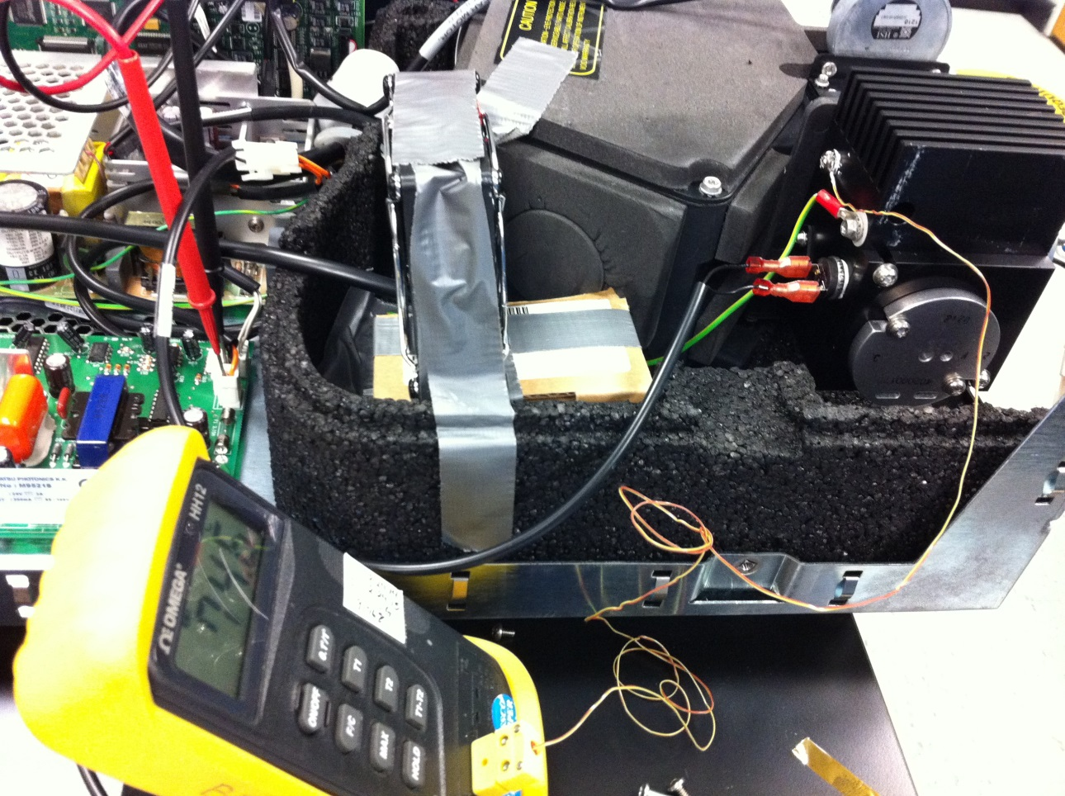
Thermostat Under Test
Thermocouple placed under a screw and a washer
Figure 2- Location of the Over Temperature Switch and the thermocouple for the second evaluation

Equipment

Test Equipment Used:
Qty | Description | Waters Calibration ID # | Calibration Due Date
1 | Thermometer: OMEGA HH12 with Thermocouple type K | 91768 | Feb 24, 2015
1 | Ammeter: EXTECH 380942 | 93252 | April 29, 2015
1 | Multimeter: Fluke 87 | 91422 | November 26, 2014

Results and Discussion
The testing results are shown in Table 1. Note that the original over temperature switch reclosed at a lower temperature than the new proposed switch as expected. That is acceptable since the OTS is used as a safety switch to open at the upper limit (80°C). The reclose temperature setting of the thermostat is not critical since the instrument is in failure mode when the OTS opens.

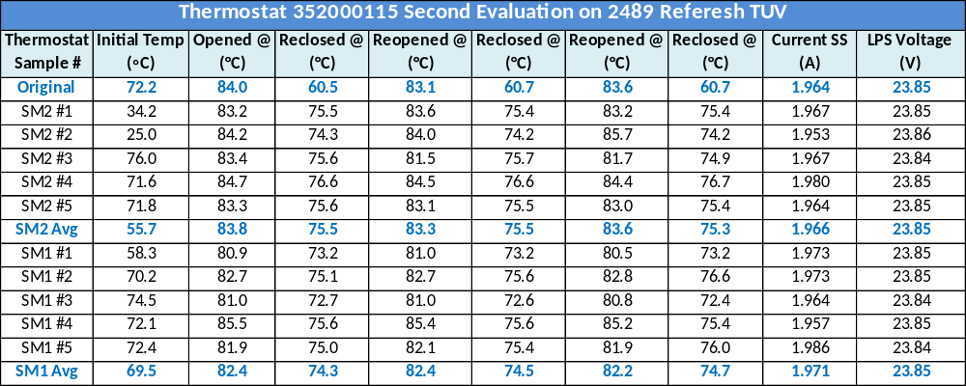
Table 1- Testing Results

SUMMARY | SM1 | SM2 | ORIG
Avg Open of 5 Samples (°C) | 82.4 | 83.6 | 83.6
Avg Close of 5 Samples (°C) | 74.5 | 75.5 | 60.6
Avg Current (A) | 1.971 | 1.966 | 1.964
Avg LPS Voltage (V) | 23.85 | 23.85 | 23.85
Table 2- Summary Results

SM1: Samples Model 1 from Sensata – It contains beryllium copper C17500 spring contact arm
SM2: Samples Model 2 from Sensata – It contains beryllium copper C17510 spring contact arm
ORIG: Original Thermostat being replaced that is made by Selco

The summary results of all 3 styles of thermostats are shown in Table 2. The results indicate the average open temperature of the OTS is very close between all three types. The datasheet specifies a tolerance of ± 2.8°C. The new switch is close to be within the allowed tolerance. The differences may be caused of the location of the thermocouple to the thermostat, about an inch away. There are some variations in the results caused by the response time and tolerance of the thermometer and the thermocouple. The results of the switch opening are acceptable for both types of Sensata samples.
The current through the thermostat and the voltage being switched to the LPS are very comparable between all 3 types of thermostats.

The results are plotted below in Figure 3. The tolerance of the open and close is shown in the highlighted regions.

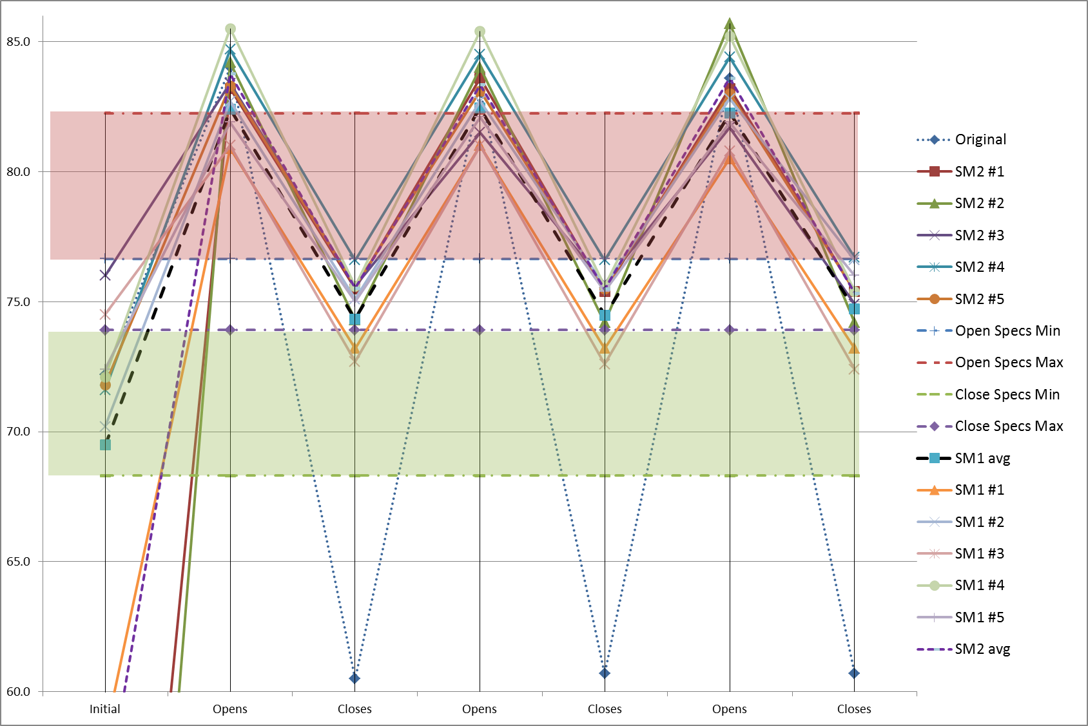
Figure 3- Graph of the testing results

During the evaluation, it was observed that when the over temperature switch recloses, it causes the instrument to reset, issuing an initialization sequence. This is not a design feature; when the thermostat recloses, the power is restored to the lamp power supply, which lights up the lamp. The resetting is caused by an instantaneous power draw on the 24V line, causing the 5V to dip momentarily. That 5V dip causes the 5V supervisory chip on the CPU board to trigger a reset. This problem has nothing to do with having the new thermostats. It also occurs using the current OTS from SELCO. This is a not a major concern, since when the OTS opens is usually a result of a failure. Resetting the instrument is not affecting the protection mode. However, this problem should be investigated later in a separate evaluation.

