DOCUMENT TITLE: tEST sPECIFICATION AND pROCEDURE, CPSM Sample Manager Final Test
SYSTEM/ASSEMBLY NAME: Acquity CPSM Sample Managers
PART NUMBER AFFECTED See Table, page 2, Part Numbers Affected
TEST EQUIPMENT NAME: CPSM FINAL TEST
TEST EQUIPMENT NUMBER: TE83064 | TEST SOFTWARE: See Part Numbers Table
TEST EQUIPMENT NUMBER: TE0084050 | TEST SOFTWARE: See Part Numbers Table

AUTHOR(S): Richard Davis | DATE: May 30, 2013
REVISED BY: eric turner | DATE: March 30, 2021

NOTE: This test procedure applies to both Test Equipment numbers listed above, using their respective Test Software versions as stated in the Part Numbers table. This allows different locations to use previously qualified Test software versions based on the Part numbers they are testing.

Part Numbers
Part Number | Description | TE83064  Test Software Version* | TE0084050  Test Software Version*
N2971031 | Altus A-30 Sampling Module | *1.42* | *1.03*
186015017 | ACQUITY UPLC Sample Manager FTN | *1.42* | *1.03*
186015035 | ACQUITY UPC2 Sample Manager-Fixed Loop | *1.42* | *1.03*
186015040 | ACQUITY UPLC H-Class BioSM-FTN | *1.42* | *1.03*
186015046 | ACQUITY UPLC I-Class Sample Manager-FTN | *1.42* | *1.03*
186015051 | ACQUITY APC Sample Manager w/FTN | *1.42* | *1.03*
186015060 | ACQUITY UPLC I-Class Sample Manager-FL | *1.42* | *1.03*
186015085 | ACQUITY UPLC H-Class PLUS SM FTN-H | *1.42* | *1.03*
186015086 | ACQUITY UPLC H-Class PLUS Bio SM FTN-H | *1.42* | *1.03*
186015087 | ACQUITY UPLC I-Class PLUS SM FL-I | *1.42* | *1.03*
186015088 | ACQUITY UPLC I-Class PLUS SM FTN-I | *1.42* | *1.03*
186016012 | Micro Sample Manager - Fixed Loop | *1.42* | *1.03*
186017001 | ACQUITY Arc SM FTN-R with Temp Control | *1.42* | *1.03*
186017007 | ACQUITY Arc SM FTN-R w/out Temp Control | *1.42* | *1.03*
186017011 | ACQUITY Arc Bio SM FTN-R w/Temp Control | *1.42* | *1.03*
186017017 | Arc HPLC SM FTN-R with Temp Control | *1.43* | *1.03*
186018002 | ACQUITY PREMIER FTN | N/A | *1.03*
186019002 | Arc PREMIER Sample Mgr FTN-R w/Temp Ctrl | N/A | *1.03*
800000298 | Ref. Acquity Sample Mgr FTN | *1.42* | *1.03*
800000313 | Ref. Acquity H-Class BioSM-FTN | *1.42* | *1.03*
800000373 | Ref Acq I-Class Sample Mgr-FTN | *1.42* | *1.03*
800000410 | Ref. Acquity I-Class Sam Mgr-FL | *1.42* | *1.03*
800000412 | Ref. UPC2 Sam Mgr-Fixed Loop | *1.42* | *1.03*
800000429 | Ref. APC Sample Manager w/FTN | *1.42* | *1.03*
800000442 | Ref Micro Sample Manager-FL | *1.42* | *1.03*
800000461 | Refurb Acquity Arc FTN WO Temp | *1.42* | *1.03*
800000462 | Refurb Acq Arc FTN W/Samp Temp | *1.42* | *1.03*
800000472 | Refurb Arc Bio SM FTN-R W/TC | *1.42* | *1.03*
800000481 | Refurb Acq I-Class FL-I Plus | *1.42* | *1.03*
800000482 | Refurb Acq I-Class FTN-I Plus | *1.42* | *1.03*
800000483 | Refurb H-Class FTN-H Bio Plus | *1.42* | *1.03*
800000489 | Refurb Acq H-Class FTN-H Plus | *1.42* | *1.03*
800000509 | Refurb Arc HPLC SM FTN-R w/Temp Control | *1.43* | *1.03*
800000530 | Refurb ACQUITY PREMIER FTN | N/A | *1.03*
800000544 | Refurb Arc PREMIER Sample Mgr FTN-r w/TC | N/A | *1.03*
*The Test Software Versions in this table represents the minimum version for that part number/Test Station. All succeeding versions are acceptable as well.

Equipment Required
Quantity | Part Number | Description
1 | 186015022 | Acquity TUV Detector
1 | 186015000 | Acquity SDS 18K
1 | 186015043 | Acquity UPLC CM-A (column manager)
1 | 205000898 | Kit, ACQ. UPLC I-Class CM-A Tubing 2 Col
2 | 289006760 | Assy, Cart, 9 Port CM, 18 KPSI, Dome
1 | 205015016 | Acquity UPLC Cell, TUV
1 | 725000455 | Switch, Ethernet, 10/100 (or equivalent – 4 port minimum)
1 | 405013532 | Calibration Pin
2 | 405003460 | Union, .020 – V Detail
2 | 186002631 | 384 Well Plate, 100uL Square well
1 | 405003743 | 48 Vial Plate
1 | 289001680 | Assy, Bottle Tray
5 | 441000371 | (or equiv.) Ethernet Cable
1 | TE83064 | Test System w/cables
1 | TE0084050 | Test System w/cables
2 | 999038144 | Weighted well plates for testing Theta belt tension
1 | 999034358 | Gap Tool, Needle to Rotary Sample Tray

Disposables Required
Quantity | Part Number | Description
60” | WAT027-08 | Tubing, .062 x.040 PEEK
36” | 430001054 | ½” Tygon Tubing (SM waste line)
A/R | 405005721 | Screw, Comp, HPFT
A/R | 405004241 | Collet, HPFT
A/R | 415000786 | Ferrule, PEEK, HPFT
A/R | WAT027-01 | Tubing, .062 x .005 PEEK
A/R | Various | 12 x 32 mm Vials and caps, from the following list:
A/R | 186003886C | Amber Max Recovery Vial Kit (vials and blue preslit septum caps)
A/R | 186002127 | Screw Cap with Preslit Septum, Green
A/R | 186002128 | Screw Cap with Preslit Septum, Red
A/R | 186002457 | Screw Cap with Preslit Septum, White
45” | 430001102 | Tube, 316L, SS, 1/16OD X .010 ID, 16 RMA
30” | 430001101 | Tube, 316L, SS, 1/16OD X .005 ID, 16 RMA
A/R | 405003608 | Scr, Comp, 10-32,1/4 Hex,304 SS,Gold,FLT
A/R | 410001349 | Ferrule, Set, .062. Two-Piece
A/R | 410001125 | Ferrule, Flangeless
A/R | 410001124 | Screw, Flangeless, Comp, SM
A/R | 700004107 | Acquity UPLC Carryover Test Solutions (Carryover Challenge & Calibration Standard)
A/R | 700004105 | Acquity UPLC Production Test Solution (Precision and Linearity)
A/R | See Appendix B | Carryover Blank Test Solution
1 Liter | See Appendix B | Needlewash & Mobile Phase solution, 5%/95% MeOH/Milli-Q H₂0
A/R | A454-4 | Optima Methanol, Fisher Scientific
1 | 186002350 | Acquity UPLC BEH C18 1.7um 2.1x50 mm Column
1 | 186006049 | XBridge BEH C8 2.5µm 4.6x50mm XP col

reference documentation
Document # | Description
WAT046538 | HI Pot and Ground Continuity Test Procedure
721001299 | Acquity Common Platform Sample Manager (H-Class / Bio H-Class / Nano / I-Class / I-Class IVD / UPC²) FTN and FL Functional Specification
721007514 | Velox FTN Functional Specification
721003992 | Veyron CPSM FTN Functional Specification
721013356 | Acquity Arc Bio FTN Functional Specification
721020210 | Product Requirements Document, ARC HPLC
721020317 | Product Requirements Document, Inert LC Product Requirements

Definitions and Abbreviations
Term | Definition
PSC | Production Support Check
CPSM | Common Platform Sample Manager
FTN | Flow Thru Needle Sample Manager
FL | Fixed Loop Sample Manager
IVD | In-Vitro Diagnostic
BSM | Binary Solvent Manager
CM | Column Manager
TUV | Tunable Ultra Violet Absorption Detector

Test SPecifications and Traceability Matrix
Note:
- Part Number 186018002 is not specifically covered in an FSD. Instead the PRD, 721020317 section 5.2 references FSD 721001299 for Performance specifications.
- Part Number 186017017 is not specifically covered in an FSD. Instead the PRD, 721020210 section 5.2 references FSD 721007514 for Performance Specifications.

Common Specifications
Applies to Part Numbers: 186015017, 186015040, 186016012, 186015060, 186015046, 186015035, 186015051, 186015085, 186015086, 186015087, 186015088, N2971031, 186018002
Test Step | Specification | 721001299 REFERENCE
Electrical Safety Test | see test procedure WAT046538 | PSC - GMP
Power-on Initialization | Initializes without alarms | PSC – Preparation for test
Fans | Verify Fans are ON | 5.1.1.1.8.  PSC - This step verifies the build process which is not validated
Firmware Download | Firmware downloads without errors | psc – Preparation for test
Restart Initialization | Instrument initializes without Alarms | PSC – This test step runs only if firmware was downloaded. It ensures the UUT is in a ready state and is able to continue testing
Sample Compartment Door & Lights | Open door lights turn on  Close door lights turn off | 5.1.1.1.15 & 5.2.11.1  PSC - This step verifies the build process which is not validated
Test Event Inputs | Set Input high = Read back High  Set Input low = Read back Low | 5.2.10 and Control Board Performance Spec sec. 5.3 of 810000367
Test Event Outputs | Set Event High = Event Output High Set Event Low = Event Output Low | 5.2.9 and Control Board Performance Spec sec. 5.4 of 810000367
Test Leak Detectors | See Table 1.0 | PSC- This step verifies the build process which is not validated
Test SPI Interface | Dump HTCH =  Active Preheater ID: 1 \[connected\]  &  Column Heater ID : 2 \[connected\] | 5.2.8.  PSC - Active Preheater and Column Heater chosen among variety of Waters peripherals to challenge the Interface function.
Ecord Interface | Perform writes and read back to iButton device | 5.2.2.1.3.
Theta Drive Calibration | Action – Completes without errors | 5.15.2.1
Tray Cal Offset | -180 to 180 Degrees | 5.15.1.1
R Axis Calibration | Action – Completes without errors | 5.15.2.2
R Offset | -3.00 to 3.00 mm | 5.15.1.2
Z Axis Calibration | Action – Completes without errors | 5.15.2.3 and 5.15.2.4
Z Offset | -3.00 to 3.00 mm | 5.15.1.3
Zp Offset | -3.00 to 3.00 mm | 5.15.1.4.
Sample Tray Select Switch | Open Door = tray 1 presented  Select tray 2 = tray 2 presented  Select tray 1 = tray 1 presented | 5.1.1.1.4  PSC - This step verifies the build process which is not validated
Check Theta Drive Belt | Action - Completes without instrument alarms | 5.1.1.1.1.  PSC - This step verifies the build process which is not validated
R/Theta Positioner Test | Action – Completes without errors | 5.15.2.5
1st Move Error | -0.3 to 0.3 Degrees | 5.15.1.5 and 5.15.2.5.1
Zp axis | -20 to 20 Lost Steps | 5.15.1.6 and 5.15.2.5.2
Z axis | -20 to 20 Lost Steps | 5.15.1.7 and 5.15.2.5.3
R axis | -20 to 20 Lost Steps | 5.15.1.8 and 5.15.2.5.4
Sample Cooling Test | ≤ -0.6 deg C/Min | 5.15.1.9. and 5.15.2.6
BOS Pump Test | Fluid flows from the Waste port | 5.1.1.1.14  PSC - This step verifies the build process which is not validated
Test Pressure Transducer | 0.45 to 0.55 Volts | 5.15.1.10
Needlewash Prime | Action – Completes without errors | Preparation for Chemistry tests
Test Preblank Injections | ≤ 10% of previous Calibration Injection Area | 5.15.2.13  Preparation for Carryover testing
Chemistry Precision Area | 0.0 to 0.5 %RSD | 5.15.1.11 & 5.15.1.32
Chemistry Precision Height | 0.0 to 0.9 %RSD | 5.15.1.12 & 5.15.1.33
Chemistry Linearity R² | 0.999 to 1.000 R² | 5.15.1.13 & 5.15.1.34
Chemistry X-Intercept | -.2 to 0.2 uL | 5.15.1.14 & 5.15.1.35
Methanol Purge | Action – Completes without errors | Preparation for Shipping
Air Purge | Action – Completes without errors | Preparation for Shipping
Park Inject Valve | Action – Completes without errors | Preparation for Shipping
Home Needle | Action – Completes without errors | Preparation for Shipping
Save Serial Number | Write Scanned Serial Number. Read Back Serial Number = Scanned Serial Number | Preparation for Customer Use

Specifications unique to H-Class FTN Sample Managers
Applies to Part Numbers: 186015017, 186015040, 186015085, 186015086, N2971031, 186018002
Test Step | Specification | 721001299 REFERENCE
Jumper Configuration | Jumpers = 129 | PSC – This step verifies the build process which is not validated
Needle Seal Calibration | Action – Completes without errors | 5.15.2.8
Needle Seal Force | 48 to 68 lbs/in | 5.15.1.36
Needle Seal Position | 55 to 58 mm | 5.15.1.41
Methanol Prime | Action – Completes without errors | Preparation for Decay and Dynamic Leak tests
Sample Syringe Decay | -15 to 15 PSI | 5.15.1.38
Dynamic Leak Test | ≤ 0.5 uL/min. | 5.15.1.37
Carryover | ≤ 0.128 PPM (0.0032%) | 5.15.1.29
Carryover (186015085 and 186015086) | ≤ 0.06 PPM (0.0015%) | 5.15.1.29

Specifications unique to I-Class FTN Sample Managers
Applies to Part Numbers: 186015046, 186015088
Test Step | Specification | 721001299 REFERENCE
Jumper Configuration | Jumpers = 133 | PSC - This step verifies the build process which is not validated
Needle Seal Calibration | Action – Completes without errors | 5.15.2.8
Needle Seal Force | 48 to 68 lbs/in | 5.15.1.36
Needle Seal Position | 55 to 58 mm | 5.15.1.41
Methanol Prime | Action – Completes without errors | Preparation for Decay and Dynamic Leak tests
Sample Syringe Decay | -15 to 15 PSI | 5.15.1.38
Dynamic Leak Test | ≤ 0.5 uL/min. | 5.15.1.37
Carryover | ≤ 0.04 PPM (0.001%) | 5.15.1.30

Specifications unique to FL Sample Managers
Applies to Part Numbers: 186015060, 186015035, 186016012, 186015087
Test Step | Specification | 721001299 REFERENCE
Jumper Configuration | Jumpers = 129 | PSC - This step verifies the build process which is not validated
Needle Seal Position | 57 to 61 mm | 5.15.1.29
Wash Syringe Prime | Action – Completes without errors | Preparation for Decay tests
Sample Syringe Prime | Action – Completes without errors | Preparation for Decay tests
Strong Wash Syringe Decay | -5 to 30 psig | 5.15.1.17
Weak Wash Syringe Decay | -5 to 30 psig | 5.15.1.18
Sample Syringe Decay | -5 to 40 psig | 5.15.1.19
Needle Seal Decay | -5 to 50 psig | 5.15.1.20
Back Pressure Regulator | 135 to 165 psig | 5.15.1.21
Air Sensor Calibration | 7 to 10 uL | 5.15.1.22
Dislodge Bubbles | Action – Completes without errors | Preparation for volume measurements
Loop Volume (186015060, 1860150350) | 7.5 to 13 uL | 5.15.1.23
Loop Volume (186016012) | 3.0 to 7.5 uL | 5.15.1.24
Needle Volume | 9 to 13 uL | 5.15.1.25
System Compliance (186016012) | 0.0 to 2.0 uL | 5.15.1.26
Carryover (186015060) | ≤ 0.04 PPM (0.001%) | 5.15.1.15
Carryover (186015035, 186016012) | ≤ 0.128 PPM (0.0032%) | 5.15.1.16
Empty Wash Syringes | Action – Completes without errors | Preparation for Shipping

Specifications for ARC Sample Managers
Applies to Part Numbers: 186017001, 186017007, 186017017
Test Step | Specification | 721007514 REFERENCE
Electrical Safety Test | see test procedure WAT046538 | PSC - GMP
Power-on Initialization | Initializes without alarms | PSC – Preparation for test
Fans | Verify Fans are ON | PSC – This step verifies the build process which is not validated
Firmware Download | Firmware downloads without errors | psc – Preparation for test
Restart Initialization | Instrument initializes without Alarms | PSC – This test step runs only if firmware was downloaded. It ensures the UUT is in a ready state and is able to continue testing
Sample Compartment Door & Lights | Open door lights turn on  Close door lights turn off | 5.1.1.18 and 5.2.3.1  PSC - This step verifies the build process which is not validated
Jumper Configuration | Jumpers = 128 | PSC - This step verifies the build process which is not validated
Test Event Inputs | Set Input high = Read back High  Set Input low = Read back Low | 5.2.2.4.2 and Control Board Performance Spec sec. 5.3 of 810000367
Test Event Outputs | Set Event High = Event Output High Set Event Low = Event Output Low | 5.2.2.4.1 and Control Board Performance Spec sec. 5.4 of 810000367
Test Leak Detectors | See Table 1.0 | 5.1.1.7  PSC - This step verifies the build process which is not validated
Test SPI Interface | Dump HTCH =  Active Preheater ID: 1 \[connected\]  &  Column Heater ID : 2 \[connected\] | 5.2.2.3.3.  PSC - Active Preheater and Column Heater chosen among variety of Waters peripherals to challenge the Interface function.
Ecord Interface | Perform writes and read back to iButton device | 5.2.2.1  PSC – This step verifies the build process which is not validated
Theta Drive Calibration | Action – Completes without errors | 5.14.2.1
Tray Cal Offset | -180 to 180 Degrees | 5.14.1.1
R Axis Calibration | Action – Completes without errors | 5.14.2.2
R Offset | -3.00 to 3.00 mm | 5.14.1.2
Z Axis Calibration | Action – Completes without errors | 5.14.2.3 and 5.14.2.4
Z Offset | -3.00 to 3.00 mm | 5.14.1.3
Zp Offset | -3.00 to 3.00 mm | 5.14.1.4
Sample Tray Select Switch | Open Door = tray 1 presented  Select tray 2 = tray 2 presented  Select tray 1 = tray 1 presented | 5.1.1.5  PSC - This step verifies the build process which is not validated
Check Theta Drive Belt | Action - Completes without instrument alarms | PSC - This step verifies the build process which is not validated
R/Theta Positioner Test | Action – Completes without errors | 5.14.2.5
1st Move Error | -0.3 to 0.3 Degrees | 5.14.1.5
Zp Pierce Lost Steps | -20 to 20 Lost Steps | 5.14.1.6
Z Pierce Lost Steps | -20 to 20 Lost Steps | 5.14.1.7
R Lost Steps | -20 to 20 Lost Steps | 5.14.1.8
Sample Cooler Decay (186017001 and 186017017 only) | ≤ -0.6 deg C/min | 5.14.1.9
Methanol Prime | Action – Completes without errors | Preparation Dynamic Leak tests
BOS Pump Test | Fluid flows from the Waste port | 5.1.1.16  PSC - This step verifies the build process which is not validated
Dynamic Leak Test | ≤ 0.5 uL/min. | 5.14.1.18
Needlewash Prime | Action – Completes without errors | Preparation for Chemistry tests
Test Preblank Injections | ≤ 10% of previous Calibration Injection Area | 5.15.2.13  Preparation for Carryover testing
Carryover | ≤ 0.06 PPM (0.0015%) | 5.15.1.12
Chemistry Precision Area | 0.0 to 0.25 %RSD | 5.15.1.13
Chemistry Precision Height | 0.0 to 0.9 %RSD | 5.15.1.14
Chemistry Linearity R² | 0.999 to 1.000 R² | 5.15.1.15
Chemistry X-Intercept | -.2 to 0.2 uL | 5.15.1.16
Methanol Purge | Action – Completes without errors | Preparation for Shipping
Air Purge | Action – Completes without errors | Preparation for Shipping
Park Inject Valve | Action – Completes without errors | Preparation for Shipping
Home Needle | Action – Completes without errors | Preparation for Shipping
Save Serial Number | Write Scanned Serial Number. Read Back Serial Number = Scanned Serial Number | Preparation for Customer Use

Specifications unique to Veyron FTN (APC) Sample Manager
Applies to Part Numbers: 186015051
NOTE: FSD 721003992 Section 1 “The Veyron SM-FTN will conserve all functionality except if stated in the contents of this FSD performance and functionality of an H-Class FTN”.
Test Step | Specification | 721003992 REFERENCE
Jumper Config | 129 | PSC - This step verifies the build process which is not validated
Needle Seal Calibration | Action – Completes without errors | 5.16.2.8
Needle Seal Force | 48 to 68 lbs/in | 5.16.1.17
Needle Seal Position | 55 to 58 mm | 5.16.1.11
Sample Syringe Decay | -15 to 15 PSI | 5.16.1.19
Dynamic Leak Test | ≤ 0.5 uL/min. | PSC – Not Specified. Tested to be consistent with other FTN models. Reference 721001299 line 5.15.1.35
Carryover | ≤ 0.128 PPM (0.0032%) | 5.16.1.16
Chemistry Precision Area | 0.0 to 0.5 %RSD | 5.16.1.12
Chemistry Precision Height | 0.0 to .9%RSD | 5.16.1.13
Chemistry Linearity R² | 0.999 to 1.000 R² | 5.16.1.14
Chemistry X-Intercept | -.2 to 0.2 uL | 5.16.1.15

Specifications for ARC-BIO Sample Managers
Applies to Part Numbers: 186017011
Test Step | Specification | 721013356 REFERENCE
Electrical Safety Test | see test procedure WAT046538 | PSC - GMP
Power-on Initialization | Initializes without alarms | PSC – Preparation for test
Fans | Verify Fans are ON | PSC – This step verifies the build process which is not validated
Firmware Download | Firmware downloads without errors | psc – Preparation for test
Restart Initialization | Instrument initializes without Alarms | PSC – This test step runs only if firmware was downloaded. It ensures the UUT is in a ready state and is able to continue testing
Sample Compartment Door & Lights | Open door lights turn on  Close door lights turn off | 5.1.1.18 and 5.2.3.1  PSC - This step verifies the build process which is not validated
Jumper Configuration | Jumpers = 128 | PSC - This step verifies the build process which is not validated
Test Event Inputs | Set Input high = Read back High  Set Input low = Read back Low | 5.2.2.4.2 and Control Board Performance Spec sec. 5.3 of 810000367
Test Event Outputs | Set Event High = Event Output High Set Event Low = Event Output Low | 5.2.2.4.1 and Control Board Performance Spec sec. 5.4 of 810000367
Test Leak Detectors | See Table 1.0 | 5.1.1.7  PSC - This step verifies the build process which is not validated
Test PSPI Interface | Dump HTCH =  Active Preheater ID: 1 \[connected\]  &  Column Heater ID : 2 \[connected\] | 5.2.2.3.3.  PSC - Active Preheater and Column Heater chosen among variety of Waters peripherals to challenge the Interface function.
Ecord Interface | Perform writes and read back to iButton device | 5.2.2.1  PSC – This step verifies the build process which is not validated
Theta Drive Calibration | Action – Completes without errors | 5.14.3.1
Tray Cal Offset | -180 to 180 Degrees | 5.14.1.1
R Axis Calibration | Action – Completes without errors | 5.14.3.2
R Offset | -3.00 to 3.00 mm | 5.14.1.2
Z Axis Calibration | Action – Completes without errors | 5.14.3.3 and 5.14.2.4
Z Offset | -3.00 to 3.00 mm | 5.14.1.3
Zp Offset | -3.00 to 3.00 mm | 5.14.1.4
Sample Tray Select Switch | Open Door = tray 1 presented  Select tray 2 = tray 2 presented  Select tray 1 = tray 1 presented | 5.1.1.5  PSC - This step verifies the build process which is not validated
Check Theta Drive Belt | Action - Completes without instrument alarms | PSC - This step verifies the build process which is not validated
R/Theta Positioner Test | Action – Completes without errors | 5.14.3.5
1st Move Error | -0.3 to 0.3 Degrees | 5.14.1.5
Zp Pierce Lost Steps | -20 to 20 Lost Steps | 5.14.1.6
Z Pierce Lost Steps | -20 to 20 Lost Steps | 5.14.1.7
R Lost Steps | -20 to 20 Lost Steps | 5.14.1.8
Sample Cooler Decay (186017001 only) | ≤ -0.6 deg C/min | 5.14.1.9
Methanol Prime | Action – Completes without errors | Preparation Dynamic Leak tests
BOS Pump Test | Fluid flows from the Waste port | 5.1.1.16  PSC - This step verifies the build process which is not validated
Dynamic Leak Test | ≤ 0.5 uL/min. | 5.14.1.18
Needlewash Prime | Action – Completes without errors | Preparation for Chemistry tests
Test Preblank Injections | ≤ 10% of previous Calibration Injection Area | 5.14.2.13  Preparation for Carryover testing
Carryover | ≤ 0.06 PPM (0.0015%) | 5.14.1.12
Chemistry Precision Area | 0.0 to 0.25 %RSD | 5.14.1.13
Chemistry Precision Height | 0.0 to 0.9 %RSD | 5.14.1.14
Chemistry Linearity R² | 0.999 to 1.000 R² | 5.14.1.15
Chemistry X-Intercept | -.2 to 0.2 uL | 5.14.1.16
Methanol Purge | Action – Completes without errors | Preparation for Shipping
Air Purge | Action – Completes without errors | Preparation for Shipping
Park Inject Valve | Action – Completes without errors | Preparation for Shipping
Home Needle | Action – Completes without errors | Preparation for Shipping
Save Serial Number | Write Scanned Serial Number. Read Back Serial Number = Scanned Serial Number | Preparation for Customer Use

TABLE 1.0 Leak Detector Test States
Inputs |  |  |  |  | Read back
Upper Power | Upper State | Lower Power | Lower State |  | Upper Sensor Present | Upper Sensor Status | Lower Sensor Present | Lower Sensor Status
0 | 0 | 0 | 0 |  | not present | no leak | not present | no leak
1 | 0 | 1 | 0 |  | present | no leak | present | no leak
1 | 1 | 1 | 1 |  | present | leak | present | leak
0 | 1 | 0 | 1 |  | not present | no leak | not present | no leak

Test Procedure

Test Setup
  - See Appendices A for Cable and Fluidic setup details.
  - Power up the Acquity TUV Detector.
  - Power up the Acquity Solvent Delivery System.
  - Power up the Acquity Column Manager.
  - Power up PC and Monitor.
  - The test program should automatically boot-up after logging in. If it is not running, double-click the “CPSM Final Test System” desktop icon.
  - Fill vials with chemistry solutions and populate a 48 position vial plate as follows:
Vial Position Test Solution Vial/Cap color
F1 Precision & Linearity 700004105 Amber/Blue
A1 Carryover (Blank) See Appendix B Amber/White
A2 Carryover (Calibration) 700004107 Amber/Green
A3 Carryover (Challenge) 700004107 Amber/Red

Note: Make Needlewash/ Mobile Phase solution (5/95 MeOH/Milli-Q water) in batches no larger than 1 week’s supply per test station. Discard at week’s end. See Appendix B

Note: Whenever either the Needlewash or the MEOH bottle is replaced the BSM must be primed. Use Console to prime the BSM prior to starting a test.

- Test
  - Click “Test Sequence” button
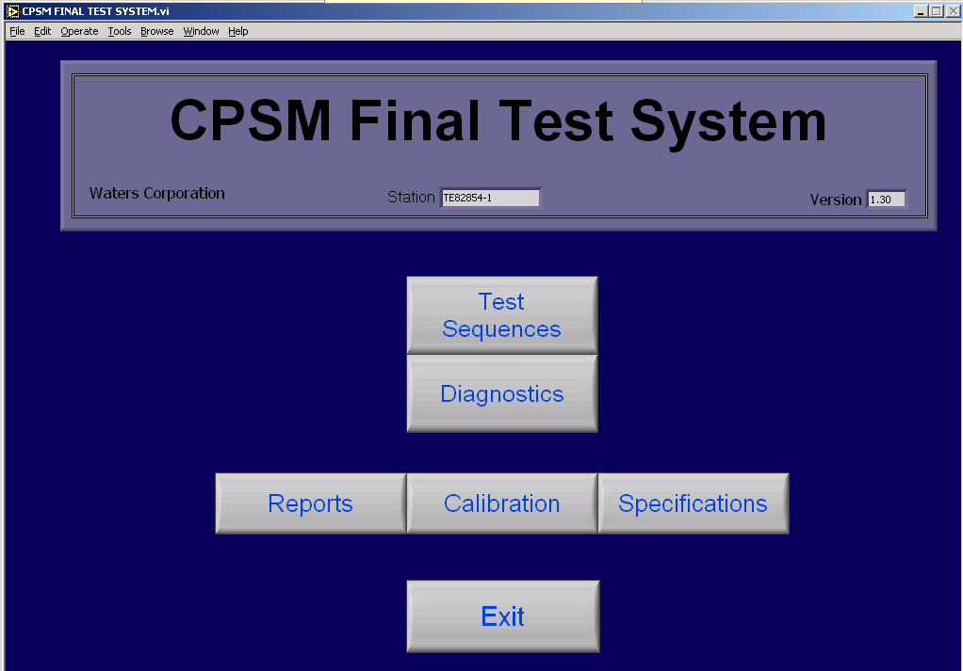
Click on “Test Sequence” to launch automated test program.

  - Select the type of CPSM FL, FTN or ARC
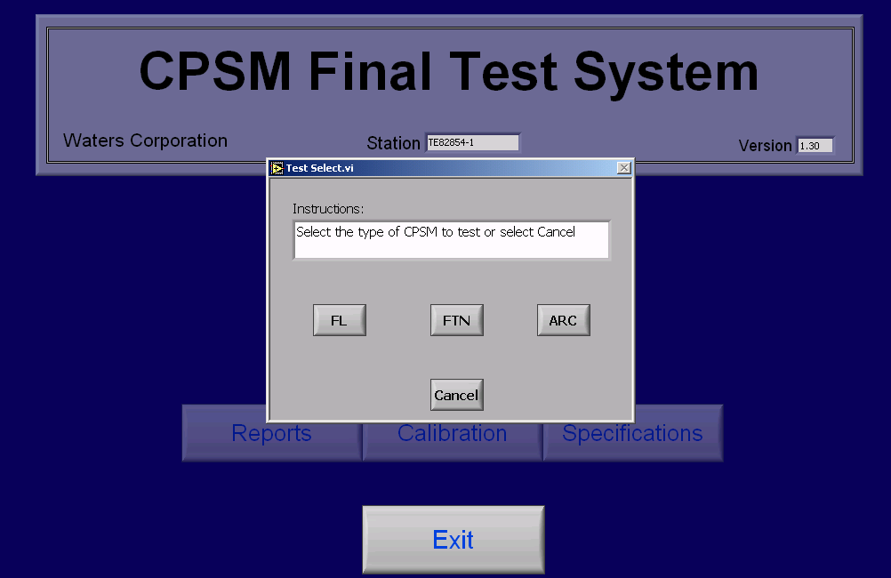
Select the type of Autosampler to test or Cancel to quit.

  - Click the “Test” button to begin testing.
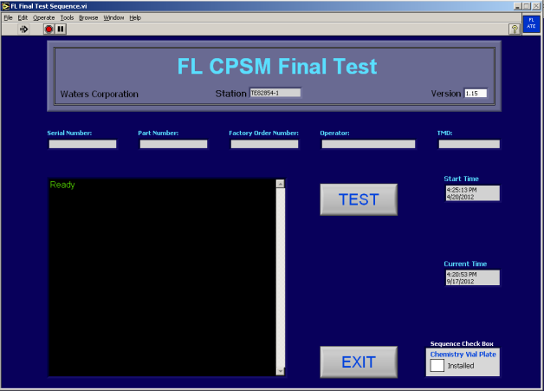
Click on “TEST” to start the test sequence.

  - Test sequence provides on time, pop-up windows with step-by-step instructions for the operator.
  - When testing is completed for the day EXIT the test sequence.

Appendix A– TE83064 Test Station Setup
- Place SDS on bench, Column Manager on SDS, TUV on Column Manager, and solvent tray on TUV.
- Install Flowcell into TUV Detector.
- Install XBridge BEH C8 2.5µm 4.6x50mm XP Column in column manager position ‘2’ and Acquity UPLC BEH C18 1.7um 2.1x50 mm Column in position “4”. Pin-plug unused valve ports (purge air from right valve, port 5).
- Plug the PC, Monitor, Tester, Acquity SDS, Acquity TUV Detector, and Ethernet Hub into properly grounded AC outlets.
- Connect the PC and instruments per cable diagram below for TE83064.

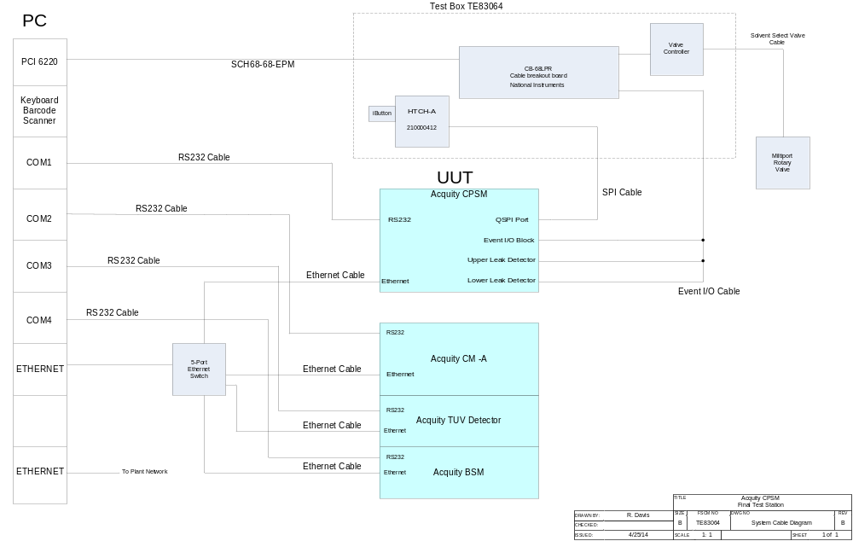

- Connect the PC and instruments per cable diagram below for TE0084050.

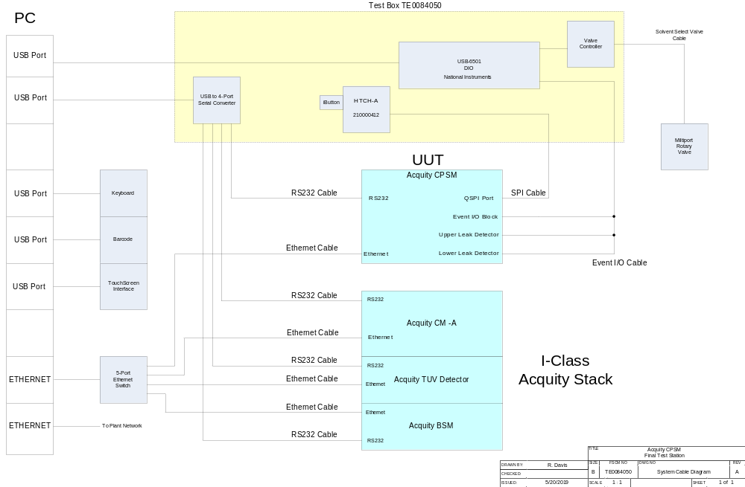

- Place a bottle of Fisher Optima Methanol in solvent tray and connect to BSM and the solvent select valve per Fluidics Diagram below.
- Place a 1 Liter bottle of 5% methanol / 95% Milli-Q water in solvent tray and connect to BSM per Fluidics Diagram below.
- Connect BSM waste port to a waste bottle.
- Prime BSM pumps A and B.

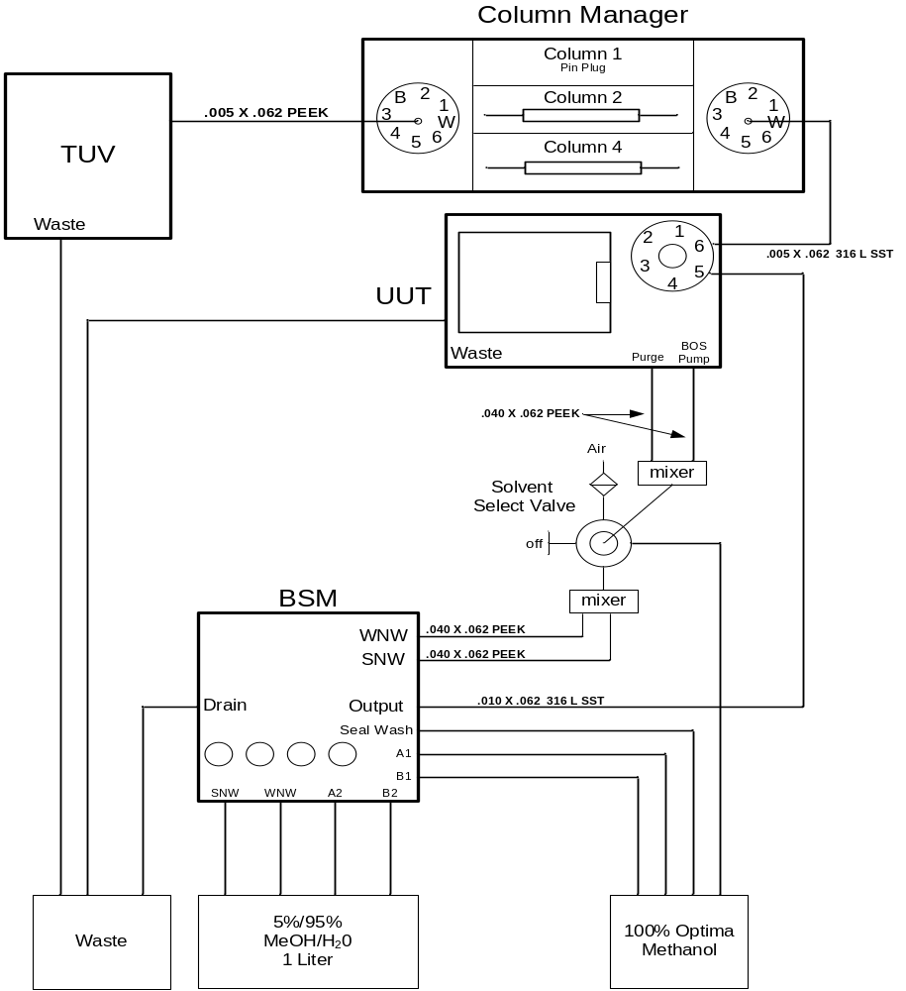

TE83064/TE0084050 Fluidics Diagram

Appendix B

Preparing Needle Wash and Blank Sample

Needle Wash Solution
    - Discard the Needle Wash at the end of the work week.
    - Do not let Needle Wash bottles with Needle Wash solution sit out over holidays and/or weekends.
    - Protect the BSM lines over holidays and/or weekends by placing them in a sealed, clean, empty bottle or in a clean bag.
    - Prepare fresh Needle Wash solution at the beginning of each work week.
    - Clean the Needle Wash bottles and caps by rinsing with 100% MEOH.
    - Clean the graduated cylinders and funnels used to prepare Needle Wash each time the solution is made by rinsing with 100% MEOH.
    - Do not make more Needle Wash than can be used in the work week.

Preparing Blank Sample
    - Always use new vials and vial caps. Do not reuse vials or vial caps.
    - Prepare the Blank Sample when the Needle Wash solution is made. Do not open the Needle Wash bottle at the test system to aspirate more Blank Solution.
    - Using a new pipette aspirate some of the Needle Wash solution and dispense in a new vial. It is not required to fill the vial. About ¼ full is adequate. If the pipette cannot reach the Needle Wash solution in its bottle, pour some of the Needle Wash into a clean flask and aspirate from there.
    - Cap Blank vials using a white vial cap and store in a well plate.
    - Prepare as many vials as there are instruments to test that week.
    - Use a new blank vial on each UUT.

Sample Handling
    - Do not allow well plates with sample vials to sit out on benches. Store in a cabinet or drawer.
    - Do not touch the top of the vial caps.
    - Discard Blank sample vial after each UUT is tested. Do not reuse on the next UUT.
    - Discard all unused sample vials at the end of the work week.

