SUMMARY

SUMMARY 1

1. RECEPTION OF REFURBISHED BOX 2
1.1 Check list of different elements into the box when it come back 2
1.2 Report of informations about return Ion block 2
1.2.1 Report on remanufacturing receipt paper 2
1.2.2 Report on Excel file 2

2. DECONTAMINATION OF RETURNED PARTS 3

RECEPTION OF REFURBISHED BOX :
Only authorized personnel, who work for Ion block activity can open the refurbished box, with Ion block and its Ion guide.

For all these steps, use gloves before to open box and work with refurbished parts.

Check list of different elements into the box when it come back
Verify the presence of :

- Instruction paper, with DHL Waybill, S/N of Ion block and Ion guide ;
- One Ion block ;
- One Ion guide ;
- PM Parts into green bag.

Report of informations about return Ion block

Report on remanufacturing receipt paper
Use the FR3/300PR5, to add all informations :

- Reception date ;
- Name of operator ;
- Reference of Ion block, Ion guide and quantity received ;
- S/N of Ion block and Ion guide in observation case ;
- Quantity in SAP if, the return parts are correct ;
- Country of origin.

Report onExcel file
With informations reported in remanufacturing receipt paper, add this informations into "Ion block EDC only" Excel file :

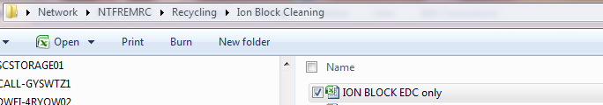
Open the file, and add missing informations (orange cases) with the last paper :

DECONTAMINATION OF RETURNED PARTS
- Put all returned parts into Isopropanol bath, during 20minutes, to remove all contaminations.
- Put into oven to dry the parts.
- Add in stock, before Process cleaning specific by type of Ion block.

