SUMMARY

SUMMARY 1

1. THE XEVO TQ-MS ION BLOCK 2
1.1. General view of Ion Block and needed equipment 2
1.2. Legend 2
1.3. Disassembling 3
1.4. Cleaning 6
1.5. Reassembly 7

2. THE XEVO TQ-MS HEXAPOLE 8
2.1. General view of Hexapole and needed equipment 8
2.2. Legend 8
2.3. Disassembling 10
2.4. Cleaning 10
2.5. Reassembly 11

3. CONDITIONING THE XEVO TQ-MS ION BLOCK AND HEXAPOLE 11

- THE XEVO TQ-MS ION BLOCK

General view of Ion Block and needed equipment :
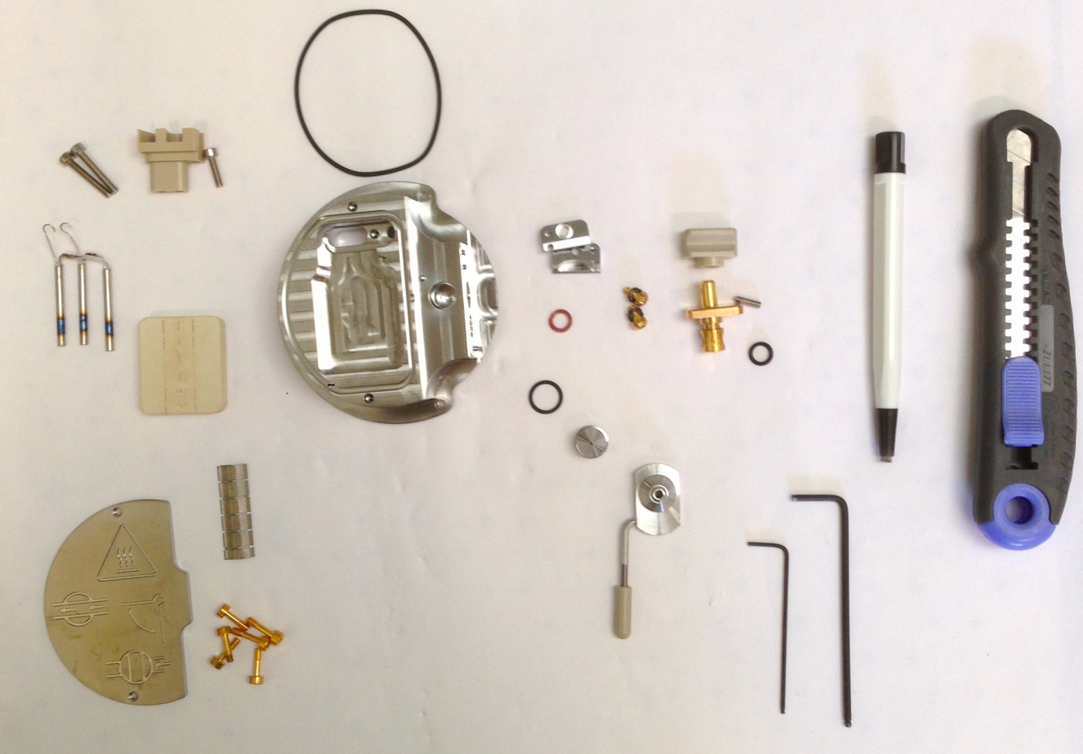
1
22
21
20
19
18
17
16
15
14
13
12
11
10
9
8
7
6
5
4
3
2

Legend :
# 1 = Xevo TQ-MS source (# 700004203)
# 2 = Cartridge heater (# 700004332)
# 3 = Screw M3 (# 5313123)
# 4 = Terminal PEEK (# 700001251)
# 5 = Screw M3x12 cap Hd (# 5313069-S)
# 6 = O-ring viton AS035 (# 700000904)
# 7 = Gas cone position block (# 700004338)
# 8 = Screw shoulder M3 socket (# 700004404) & Spring belleville (# 700003080)
# 9 = O-ring silicone FEP size 009 (# 700004728)
# 10 = Valve stem knob (# 700004335)
# 11 = Grub screw M3x10 (# 5316038-S)
# 12 = Valve stem (# 700004339)
# 13 = O-ring AS007 Kalrez (# 700000902)
# 14 = O-ring size 10 (# 700004321)
# 15 = Sample cone (# 700004219)
# 16 = Cone gas nozzle (# 700004216) & Cone gas nozzle handle (# 700004337)
# 17 = Captive screw (# 700004344)
# 18 = Cover plate (# 700004342)
# 19 = Allen key of 1.5 mm
# 20 = Allen key of 2.5 mm
# 21 = Fiberglass pen
# 22 = Cutter

Recommendation : All these steps require gloves !

Disassembling
- Turn the valve stem to release the gas cone with the sample cone. The sample cone and its seal are thrown.

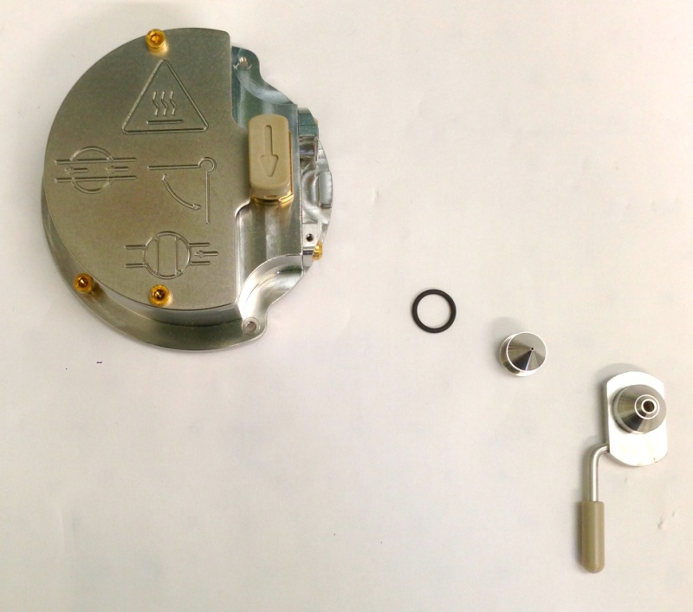

- Dismount the plate of face maintained by screws, with an Allen key of 2.5 mm, screws are thrown.

- Remove the 3 screws fixed on the PEEK part which maintain the heater, with Allen keys. Only the PEEK part is preserved, the rest will be changed.

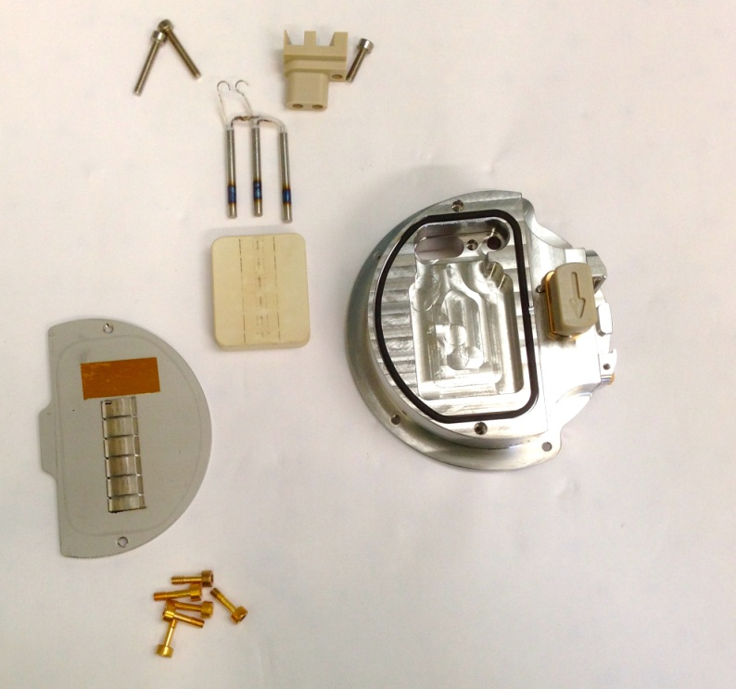

- Take off delicately with the cutter the black seal around the heater, without contact with the block for not damaging the sealing.

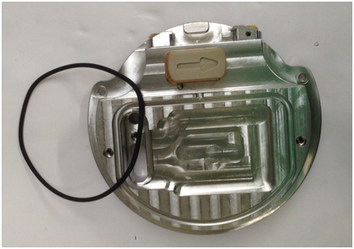

- Remove valve stem, and then take out the valve stem on its place. Discard the seal, and unscrew with an Allen key of 1,5 mm the grubscrew, maintaining knob and valve stem. All these pieces are conserved.

- Cut the small black seal on the valve.

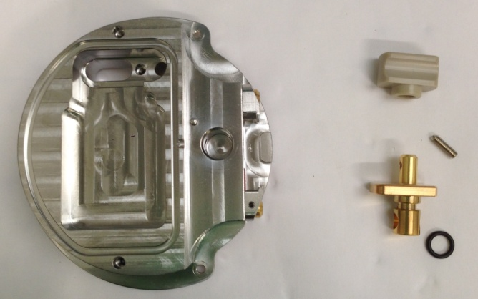

- Tap out two screw maintaining gas cone position blocks, and its seals. All these pieces are conserved to be cleaning on the next step.

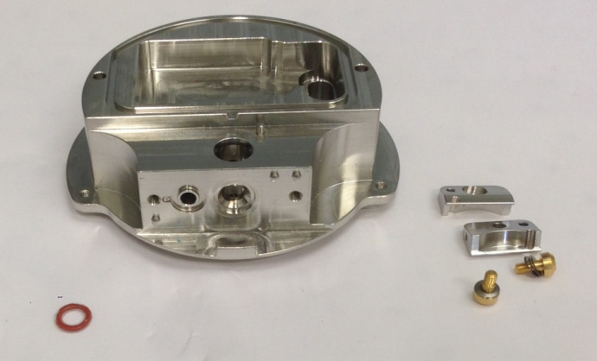

- So, to conclude, on the picture below you will find a resume of all the parts we will keep for cleaning with a red number :

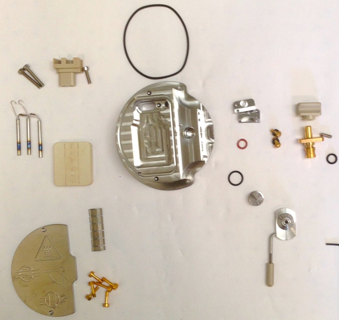
15
14
18
17
16
10
9
8
7
13
12
11
1
6
5
4
3
2

Cleaning
- Brush thoroughly all pieces (principal block, spring clip, cone gas, plate-shaped half-disc, Ion block plug, extraction lens, valve stem, sample cone locator block and its two screws) with a fiberglass pen.

- Sonicate 45 min with 10% aqueous formic acid, 45% MeOH and 45% MilliQwater at 55°C.

- Rinse one time pieces with MilliQ water.

- Sonicate 45 min with MilliQ water at 55°C.

- Rinse all pieces with MilliQ water.

- Rinse with LC/MS grade MeOH.

- Blow-dry with nitrogen to avoid water marks.

Reassembly

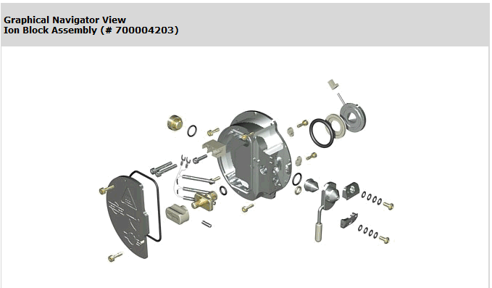

- Reassembly different parts of Ion block on its places following the PM protocol and the graphical navigator view.

- Warning : The valve stem must be replaced on its place before the cover plate.

- THE XEVO TQ-MS HEXAPOLE

General view of Step wave and requirement equipment

Recommendation : All these steps require gloves !

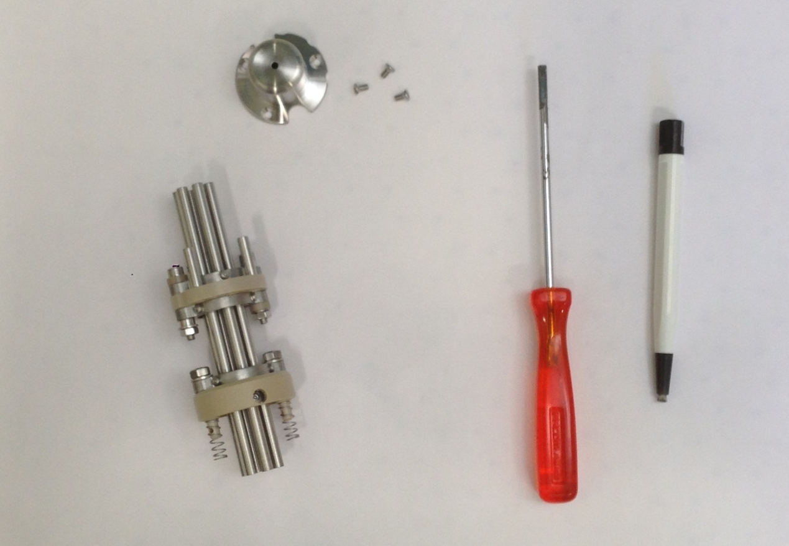
5
4
3
2
1

Legend
# 1= Xevo TQ-MS Hexapole (700004200)
# 2 = Hexapole cap
# 3 = Screws of cap
# 4 = Small flat screwdriver
# 5 = Fiberglass pen

Disassembling
- Unscrew three screw and conserve it for the next step.

- Unscrew 12 screws to remove the 6 rods, and brush it with lapfilm before to reassemble it.

Cleaning
- Submerge the hexapole with methanol in a graduated cylinder. Suspend the hexapole to not touch the walls.
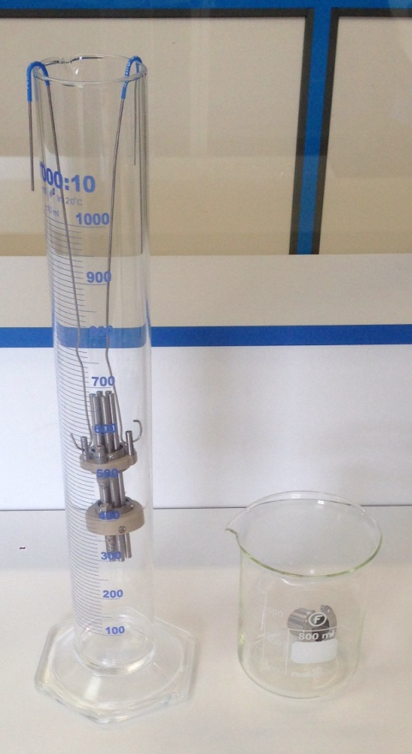

- Brush the cap with a fiberglass pen before submerge into water bath.

- Sonicate hexapole and its cap 45 minutes at 55°C.

- Rinse hexapole and cap with MilliQwater before submerge into methanol bath.

- Sonicate them 45 minutes at 55°C.

- Dispose on absorbent paper the hexapole and cap before blow dry with nitrogen to avoid water marks.

Warning : All baths are at 55°C !

Reassembly
- Reassembly hexapole and its cap with the three same screws.

- CONDITIONING THE XEVO TQ-MS ION BLOCK AND HEXAPOLE

- The Ion block and hexapole disassembling - cleaning - reassembly are closed on a special conditioning bag without PEG (source of different contaminations) (# 290000931), this one on the box (BMA06), ready to be sent.

- On the box, there are instructions papers (FR1/1478PS), one green bag for unused parts, special bag without PEG, it's for return dirty parts, one paper : "Important information about the return of Ion block" (FR2/1478PS); Test report which is obtained after Tests (FR2/10640TS), and a label with our address for the return.

Warning : One box is opened randomly by lot at the end of the process to check if all parts and esthetic appearance are OK.



Xevo TQ-MS Ion block Instructions

This box contains :
- One Ion block.
- One Hexapole.
- Green bag for unused parts of “PM kit”.
- One pre-paid sticker.
- One information paper about the pre-paid return of Ion block with TNT
- Instructions paper.

MANDATORY :
- Replace dirty Ion block and Hexapole with the cleaned components.
- Re-use the original bags for packing the dirty components.
- Insert unused ion block parts (see table below) from the PM kit into the green bag & complete the table, to confirm that the unused parts have been returned. These parts will be used for the cleaning process.
- Fill in the Health & Safety declaration on the back.
- Insert these bags into the original box and apply the pre-paid return label, after completing it with your address and shipping information, then call TNT (see document about the return) for the pickup.

If you believe there is a problem with this product, please give us the following information so we are able to investigate and come back to you :
- Print screen showing the problem
- Print screen from the tune page using setup juice (if possible)
- An explanation to help us to understand the problem
After investigation in our facility we will come back to you to let you our finding.

Thank you for your collaboration !

"Quality is everyone's responsibility"

Part number | Part name | Returned in this box
5711294 | O RING, 6.1 IDx1.6 Kalrez, eZMD
5711968 | O RING VITON AS035
5711996 | 214 ENCAPSULATED O-RING
279002715 | CARTRIDGE HEATER
405006555 | SAMPLE CONE
425000606 | O RING VITON SIZE 10 I/D x 1.5 C/S
425000758 | O RING SILICONE FEP SIZE 009

TNT WAYBILL :

S/N Ion block :

S/N Hexapole :

Health & Safety Declaration

Dirty parts have been contaminated with :

- Biohazardous ? (including blood or body fluidics) : Yes No

- Hazardous chemicals ? Yes No

I have made reasonable inquiry and I have supplied accurate information in this declaration. I have not withheld any information.

Please complete with the S/N of your Instrument :

Application :

FSE Name :

Signed : Date :

