SUMMARY

SUMMARY 1

1. THE SQD2 / XEVO TQD ION BLOCK 2
1.1. General view of Ion Block and needed equipment 2
1.2. Legend 2
1.3. Disassembling 3
1.4. Cleaning 8
1.5. Reassembly 9

2. THE SQD2 / XEVO TQD ION GUIDE 10
2.1. General view of Hexapole and needed equipment 10
2.2. Legend 11
2.3. Disassembling 11
2.4. Cleaning 11
2.5. Reassembly 12

3. CONDITIONING 12

- THE SQD2 / XEVO TQD ION BLOCK

General view of Ion Block and needed equipment :

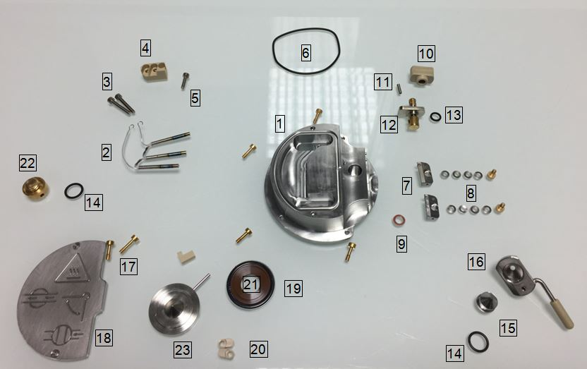
21
19
15
14

Legend :
# 1 = SQD2 / Xevo TQD source (# 700005999)
# 2 = Cartridge heater (# 700004332)
# 3 = Screw M3 (# 5313123)
# 4 = Terminal PEEK (# 700001251)
# 5 = Screw M3x12 cap Hd (# 5313069-S)
# 6 = O-ring viton AS035 (# 700000904)
# 7 = Gas cone position block (# 700004338)
# 8 = Screw shoulder M3 socket (# 700004404) & Spring belleville (# 700003080)
# 9 = O-ring silicone FEP size 009 (# 700004728)
# 10 = Valve stem knob (# 700004335)
# 11 = Grub screw M3x10 (# 5316038-S)
# 12 = Valve stem (# 700004339)
# 13 = O-ring AS007 Kalrez (# 700000902)

# 14 = O-ring size 10 (# 700004321)
# 15 = Sample cone (# 700005997)
# 16 = Cone gas nozzle (# 700004216)
# 17 = Captive screw (# 700004344)
# 18 = Cover plate (# 700004342)
# 19 = 214 Encapsulated O-Ring (# 700001897)
# 20 = Extraction cone retainer (# 700004217)
# 21 = Extraction cone seal (# 700004218)
# 22 = M10 plug O-ring seal (# 700004345)
# 23 = Extraction cone (# 700005998)

Recommendation : All these steps require gloves !

Disassembling
- Turn the valve stem to release the gas cone with the sample cone. The sample cone and its seal are thrown.

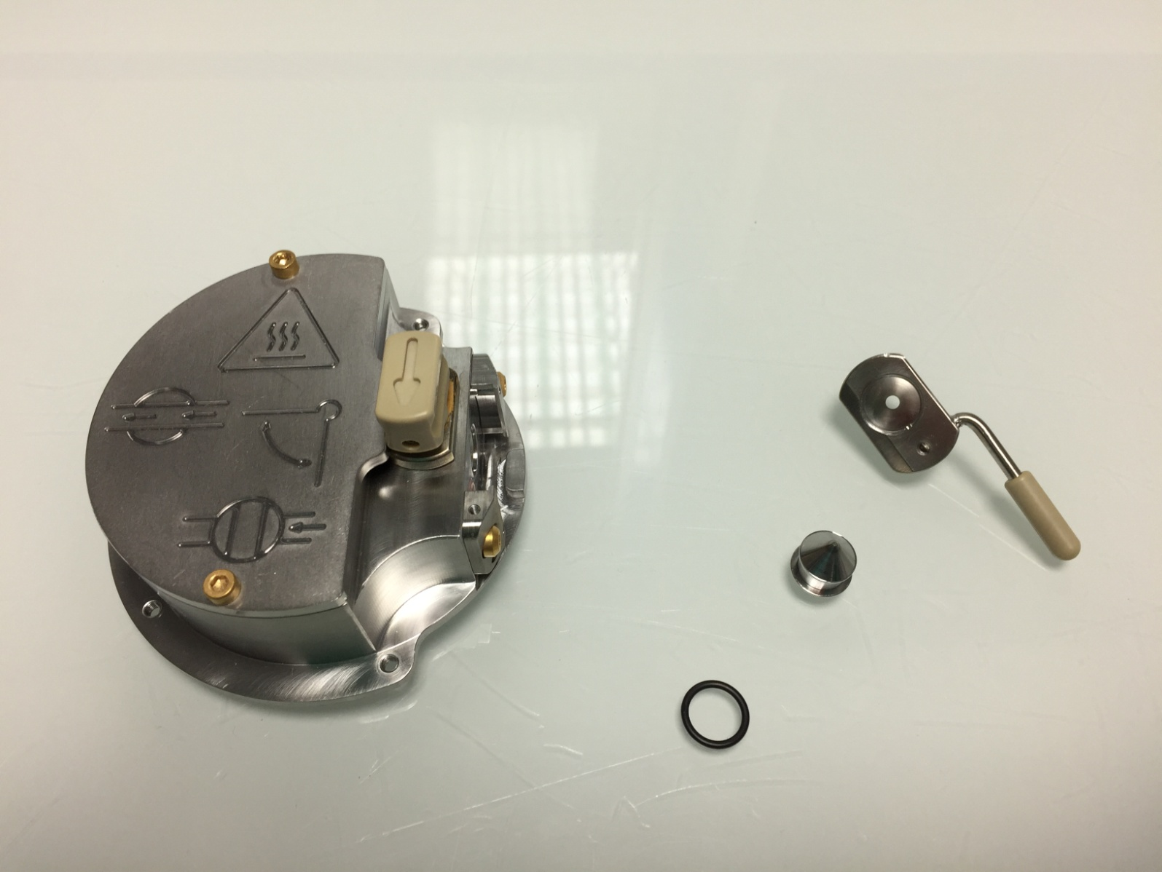

- Dismount the plate of face maintained by screws, with an Allen key of 2.5 mm, screws are thrown.

- Unscrew the Ion block plug, the seal is thrown.

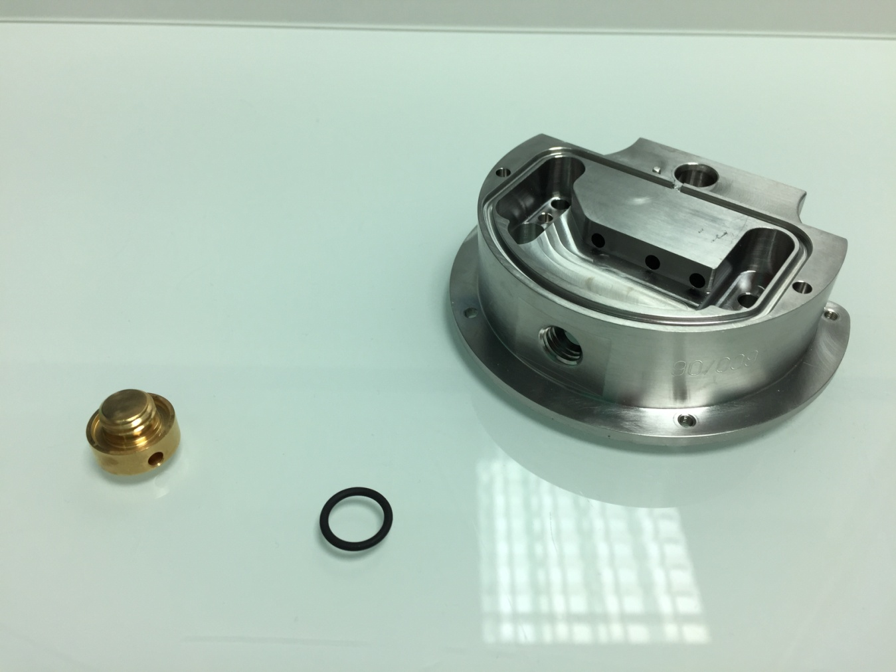

- Loosen the screws, maintaining the extraction lens, with an Allen key (2.5mm). Only the PEEK parts and the extraction lens are preserved. The two seals (Seal boxing ring & Black Viton O-boxing ring) will be replaced.

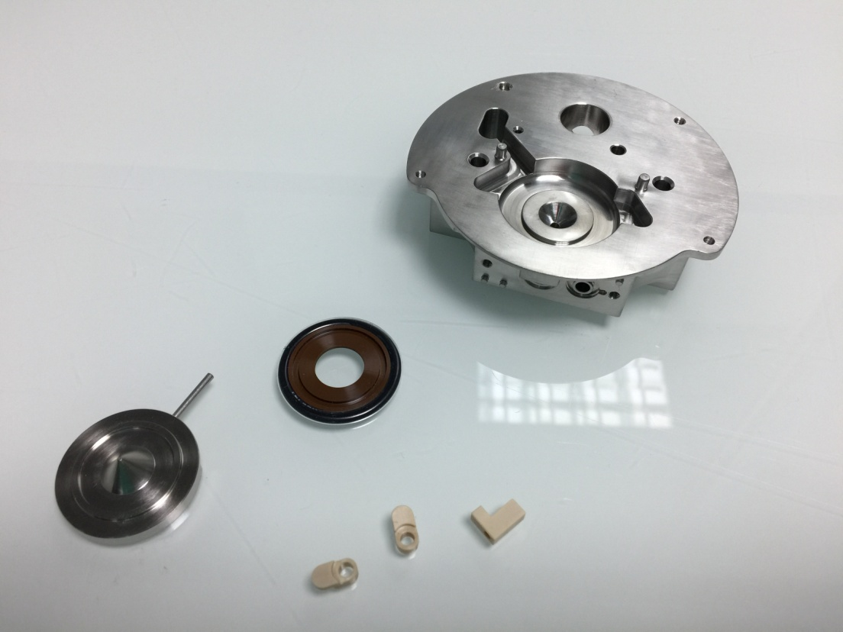

- Remove the 3 screws fixed on the PEEK part which maintain the heater, with Allen keys. Only the PEEK part is preserved, the rest will be changed.

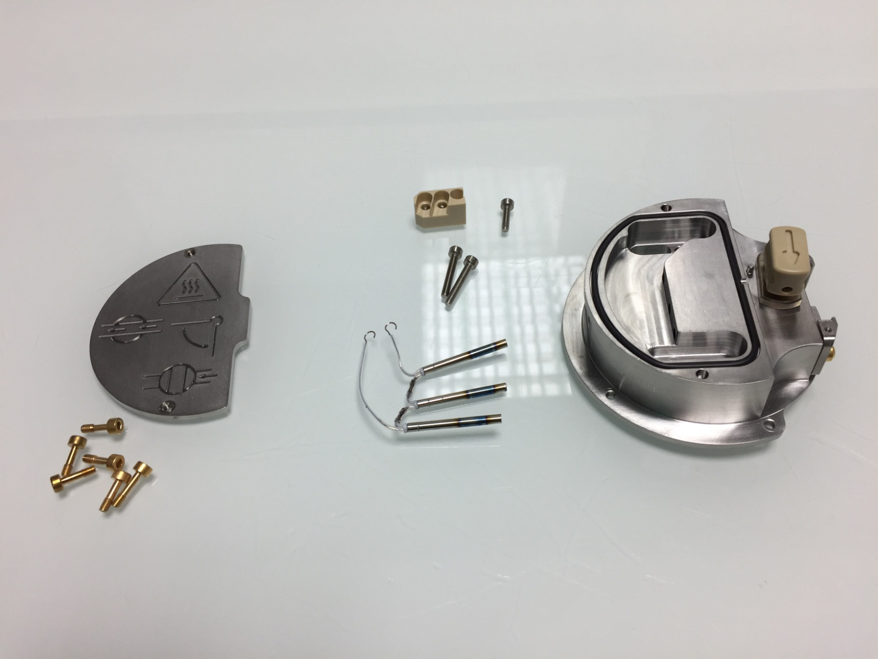

- Take off delicately with the cutter the black seal around the heater, without contact with the block for not damaging the sealing.

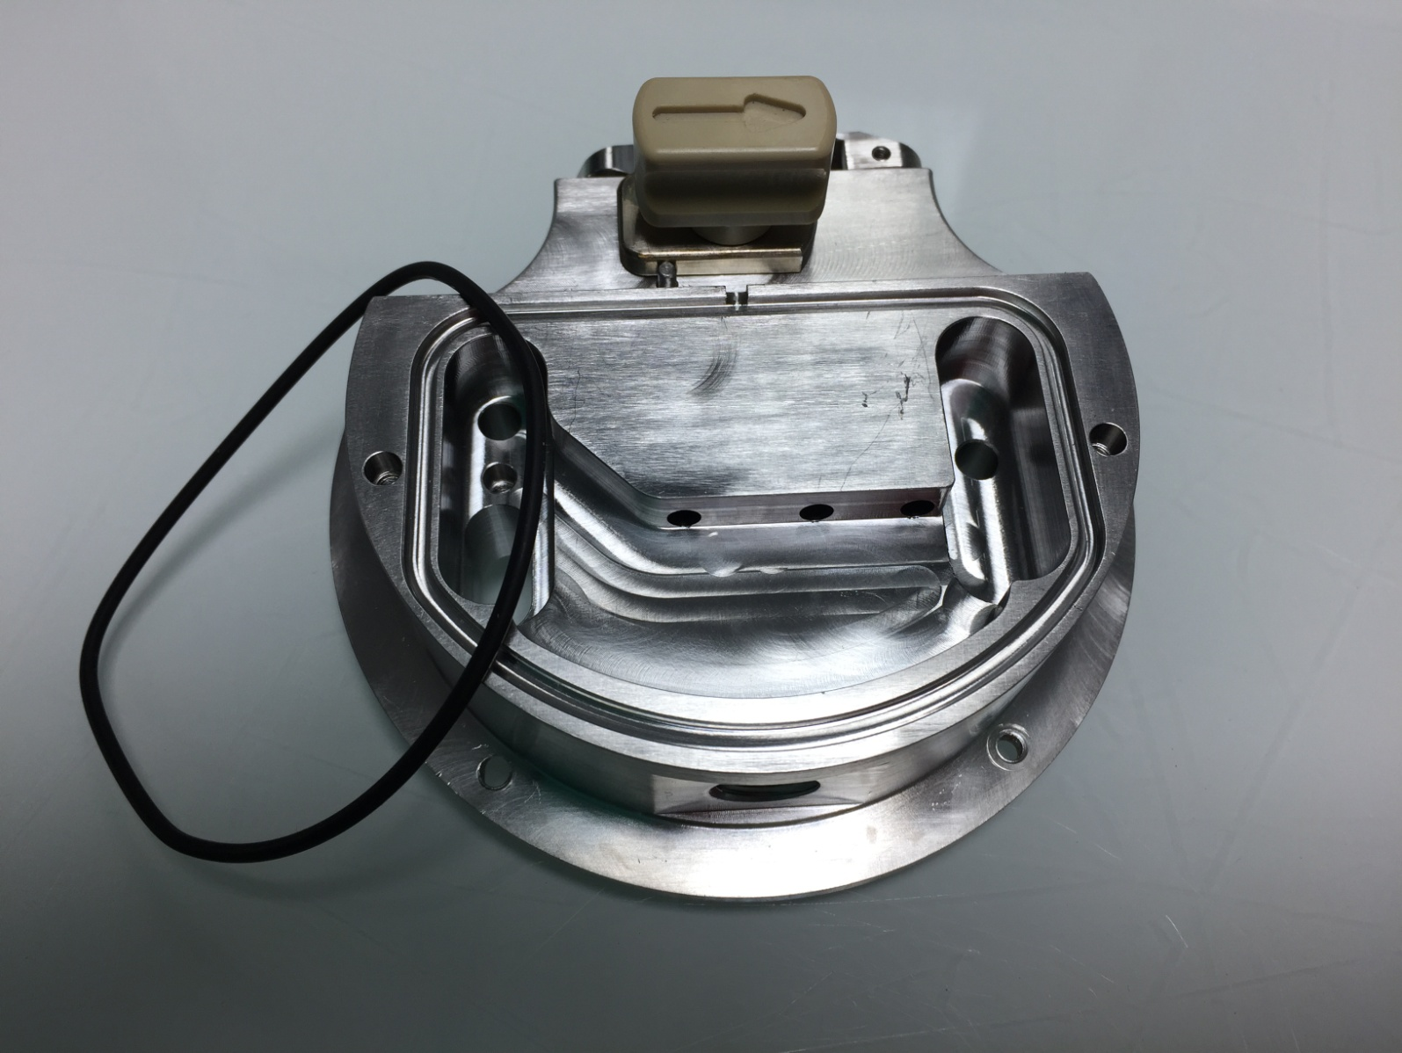

- Remove valve stem, and then take out the valve stem on its place. Discard the seal, and unscrew with an Allen key of 1,5 mm the grubscrew, maintaining knob and valve stem. All these pieces are conserved.

- Cut the small black seal on the valve.

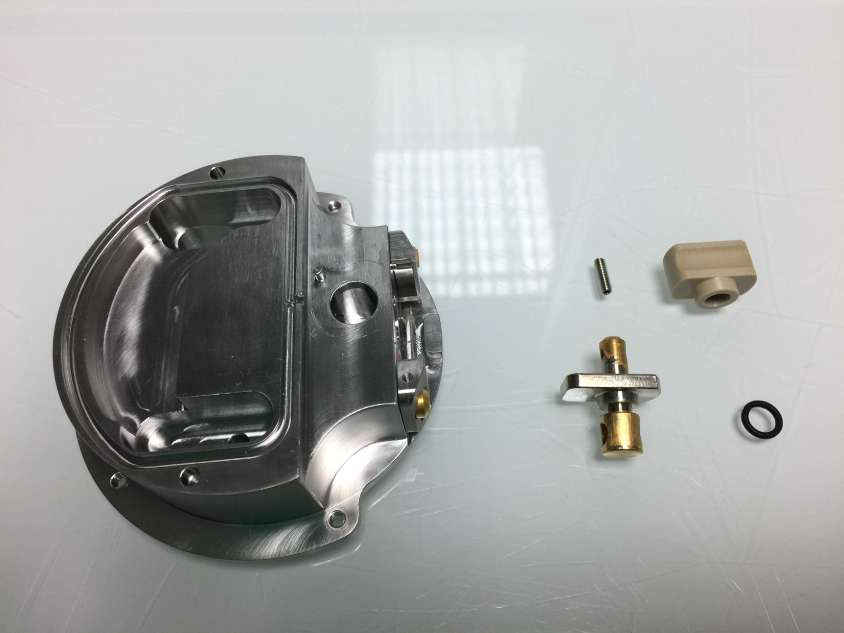

- Tap out two screw maintaining gas cone position blocks, and its seals. All these pieces are conserved to be cleaning on the next step.

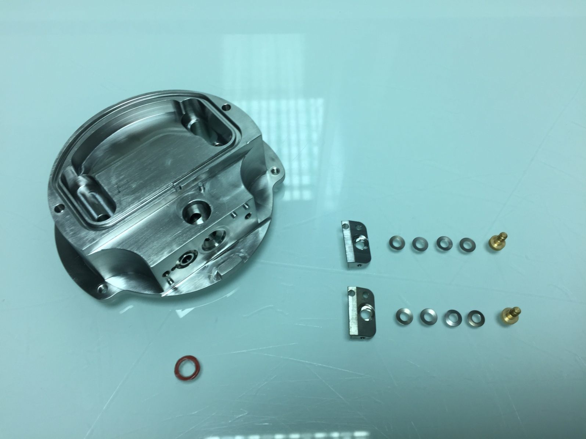

- So, to conclude, on the picture below you will find a resume of all the parts we will keep for cleaning with a red number :
15
18
17
16

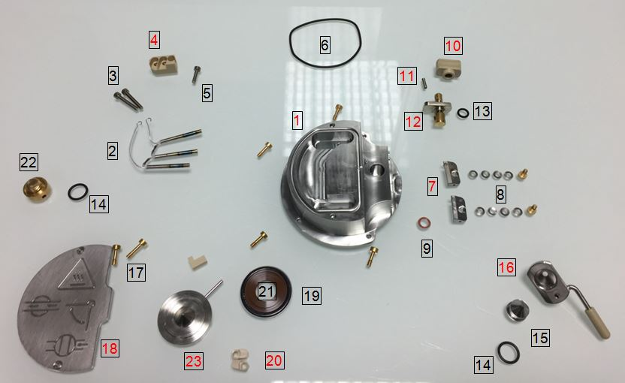

Cleaning
- Brush thoroughly all pieces (principal block, spring clip, cone gas, plate-shaped half-disc, Ion block plug, extraction lens, valve stem, sample cone locator block) with a fiberglass pen.

- Sonicate 45 min with 10% aqueous formic acid, 45% MeOH and 45% MilliQwater at 55°C.

- Rinse one time pieces with MilliQ water.

- Sonicate 45 min with MilliQ water at 55°C.

- Rinse all pieces with MilliQ water.

- Rinse with LC/MS grade MeOH.

- Blow-dry with nitrogen to avoid water marks.

Reassembly
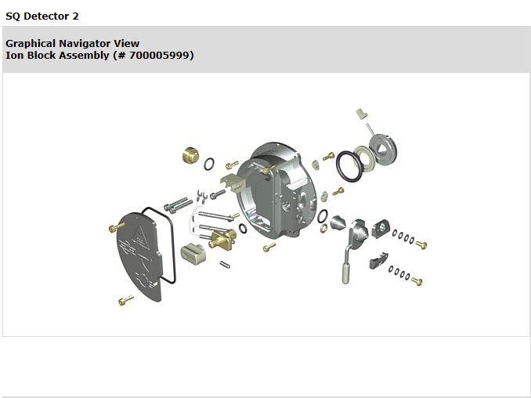

- Reassembly different parts of Ion block on its places following the PM protocol and the graphical navigator view.

- Warning : The valve stem must be replaced on its place before the cover plate.

- THE SQD2 / XEVO TQD ION GUIDE

General view of Ion guide and requirement equipment

Recommendation : All these steps require gloves !

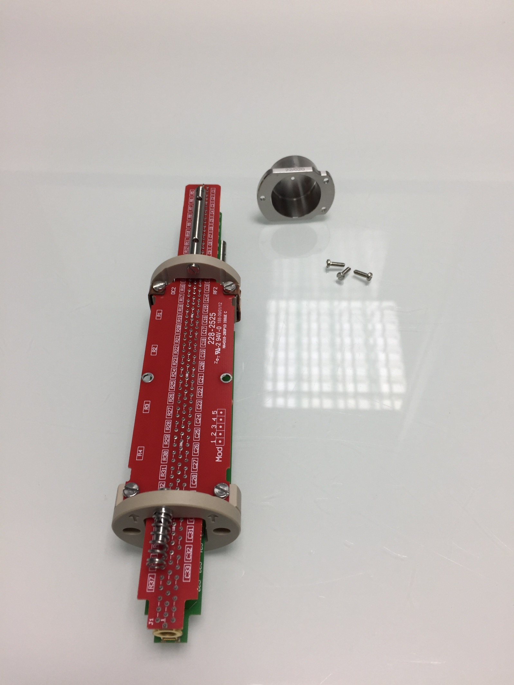
2
3
1

Legend
# 1= SQD2 / XEVO TQD Ion Guide (# 700005837)
# 2 = Ion guide cap
# 3 = Screws of cap

Disassembling
- Unscrew three screw and conserve it for the next step.

Cleaning

- Brush into the ion guide with a bottlebrush.
- Submerge the ion guide with MS Solution in a graduated cylinder. Suspend it to doesn't touch the walls.

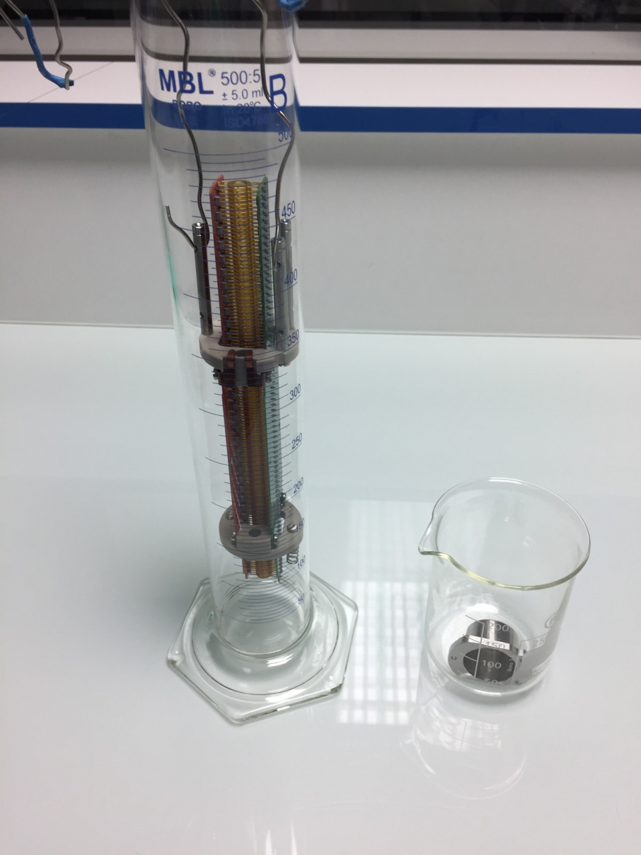
- Brush the cap with a fiberglass pen before submerge into MS solution bath

- Sonicate ion guide and its cap 45 minutes at 55°C.

- Rinse ion guide and cap with MilliQwater before a second wash with MilliQwater (45 min at 55°C).

- Rince with MilliQwater before final wash with methanol (45 min at 55°C).

- Dispose on absorbent paper, before blow dry with nitrogen to avoid water marks.

Warning : All baths are at 55°C !

Reassembly
- Reassembly Ion guide and its cap with the same screws.

- Go to 10606 TS for the tests.

3. Conditioning

- The ion block and ion guide disassembling - cleaning - Reassembly – Testing are closed on a special conditioning bag without PEG (source of different contaminations) (# 290000931), this one on the box (BMA06), ready to be sent.
- On the box, there are an instruction paper (FR1/1485PS), one green bag, for unused parts and the special bag without PEG it’s for return dirty parts, one paper : "Important information about the return of Ion block" (FR2/1485PS); one paper for the precaution during installation (FR3/1485PS); Test report which is obtained after Tests (FR2/10606TS) and a label with our address for the return.

WARING : One box is opened randomly by lot at the end of process to check if all parts and esthetic appearance are ok.



Xevo TQD Ion block Instructions

This box contains :
- One Ion block.
- One Ion guide.
- Green bag for unused parts of “PM kit”.
- One pre-paid sticker & its bag.
- One information paper about the pre-paid return of Ion block with TNT
- Instruction paper & Test report.

MANDATORY :
- Replace dirty Ion block and Ion guide with the cleaned components.
- Re-use the original bags for packing the dirty components.
- Insert unused ion block parts (see table below) from the PM kit into the green bag & complete the table, to confirm that the unused parts have been returned. These parts will be used for the cleaning process.
- Fill in the Health & Safety declaration on the back.
- Insert these bags into the original box and apply the pre-paid return label, after completing it with your address and shipping information, then call TNT (see document about the return) for the pickup.

If you believe there is a problem with this product, please give us the following information so we are able to investigate and come back to you :
- Print screen showing the problem
- Print screen from the tune page using setup juice (if possible)
- An explanation to help us to understand the problem
After investigation in our facility we will come back to you to let you our finding.

Thank you for your collaboration !

"Quality is everyone's responsibility"

Part number | Part name | Returned in this box
5711294 | O RING, 6.1 IDx1.6 Kalrez, eZMD
5711968 | O RING VITON AS035
5711996 | 214 ENCAPSULATED O-RING
279002715 | CARTRIDGE HEATER
405011167 | SAMPLE CONE
425000606 | O RING VITON SIZE 10 I/D x 1.5 C/S
425000758 | O RING SILICONE FEP SIZE 009

TNT WAYBILL :

S/N Ion block :

S/N Ion guide :

Health & Safety Declaration

Dirty parts have been contaminated with :

- Biohazardous ? (including blood or body fluidics) : Yes No

- Hazardous chemicals ? Yes No

I have made reasonable inquiry and I have supplied accurate information in this declaration. I have not withheld any information.

Please complete with the S/N of your Instrument :

Application :

FSE Name :

Signed : Date :

