SUMMARY

SUMMARY 1
1. THE QPREMIER/XE ION BLOCK: 2
1.1. General view of Ion block and requirement equipment : 2
1.2. Legend : 2
1.3. Needed Equipment 3
1.4. Disassembling 3
1.5. Cleaning 8
1.6. Reassembly 9
2. THE QPREMIER/XE ION GUIDE 10
2.1. General view of Ion guide and requirement equipment : 10
2.2. Legend : 10
2.3. Disassembling 11
2.4. Cleaning 11
2.5. Reassembly 11
3. CONDITIONING 102

- THE QPREMIER/XE ION BLOCK:

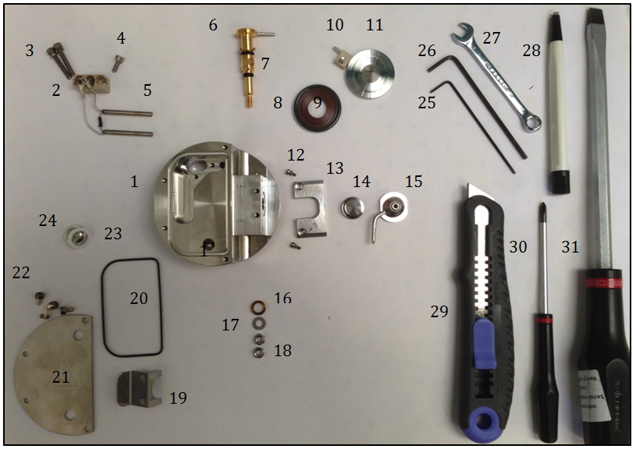
General view of Ion block and requirement equipment :

Legend :

# 1 = QPrem/Xe Ion block (# M945818CC2-S)
# 2 = PEEK Terminal Block (# 700001251)
# 3 = Screw, M3 x 20, Cap Hd SS (# 5313123) & Washer, M3 Spring (1/pk) (# 700004727)
# 4 = Screw, M3 x 8, Cap Hd (10/pk) (# 5313142-S)
# 5 = Cartridge Heater Assembly (# 700001201)
# 6 = Valve Stem (# 700001240)
# 7 = Washer, Valve Stem (large) (# 700001038) & O-Ring, Kalrez, 6.1mm x 1.6mm (# 700000902) & O-Ring, Kalrez (AS007) (# 700000903)
# 8 = O-Ring, AS214 Black Viton, PTFE Encap. (# 700001897)
# 9 = Seal Ring (# 700001239)
# 10 = Cone Retainer (# M946683AD1-S) & Screw, M3 x 10, Pozi Drive, Csk Hd (# 5311065-S)
# 11 = Extraction Cone (# M946698BD1-S)
# 12 = Screw, M2 x 5, Cap Hd (10/pk) (# 5312015-S) & Washer, M2 Spring (# 5336013-S)
# 13 = Sample Cone Location Block (# 700001245)
# 14 = Sample Cone [# M946699BD1-S]
# 15 = Cone Gas Nozzle (# M946549CD1-S)
# 16 = Washer, Valve Stem (small) (# 700001039)
# 17 = Washer, M4 Plain, SS (# 5331006-S)
# 18 = Nut, M4, SS (20/pk) (# 5321005-S)
# 19 = Cone Gas Spring Clip (# 700001232)
# 20 = O-Ring, Viton, AS035, Encapsulated (# 700001192)
# 21 = Ion Block Cover Plate (# 700001234)
# 22 = Screw, M3 x 6 Cap Hd. Ag-plated (# 5340000)
# 23 = Ion Block Plug Seal (# 700000907)
# 24 = Ion Block Plug, M10 (# 700000906)

Needed Equipment

- Allen key of 1.5 (# 25)
- Allen key of 2.5 (# 26)
- Key of 7 (# 27)
- Fiberglass pen (# 28)
- Cutter (# 29)
- Small Phillips screwdriver (# 30)
- Large flat screwdriver (# 31)
- Gloves

Recommendation : All these steps require gloves !

Disassembling

- Unscrew the two screws with an Allen key of 2.5 to release the spring clip, and the gas cone. The sample cone and the two screws are thrown.

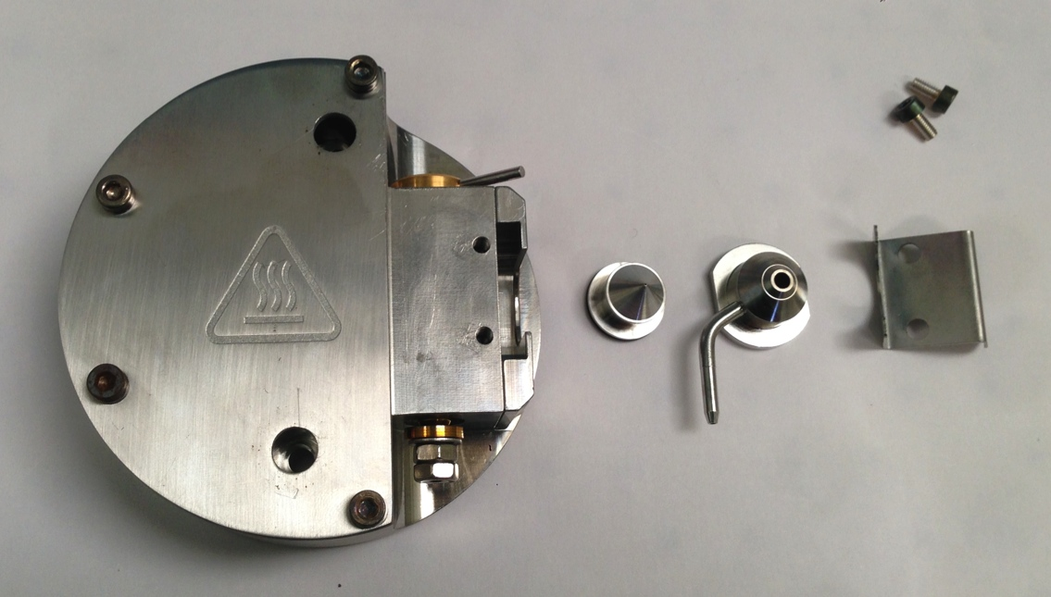
- Dismount the plate of face maintained by the 4 screws, with an Allen key of 2.5, the 4 screws are thrown.
- Remove the 3 screws fixed on the PEEK part which maintain the heater, with an Allen key of 2.5. Only the PEEK part is preserved, the rest will be changed.

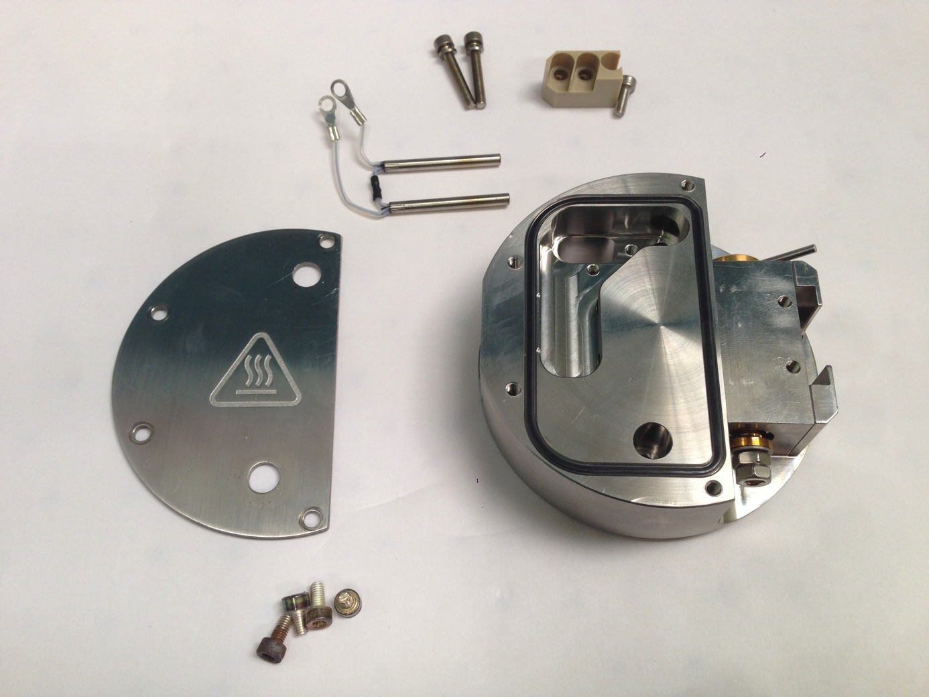

- Unscrew the Ion block plug, with the flat screwdriver, the seal is thrown.

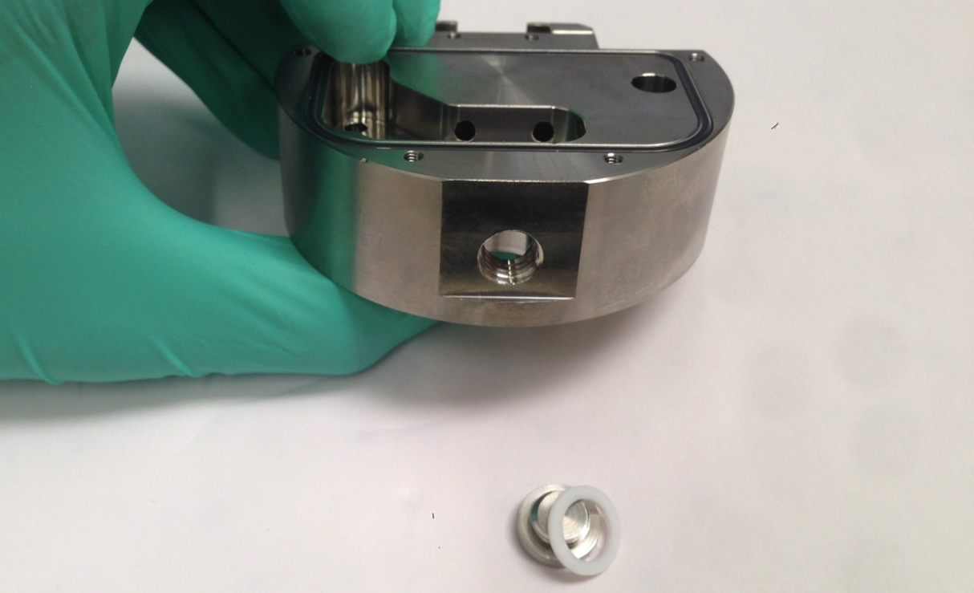
- Loosen the screw, maintaining the extraction lens, with a small Phillips screwdriver. Only the PEEK part and the extraction lens are preserved. The two seals (Seal boxing ring & Black Viton O-boxing ring) will be replaced.

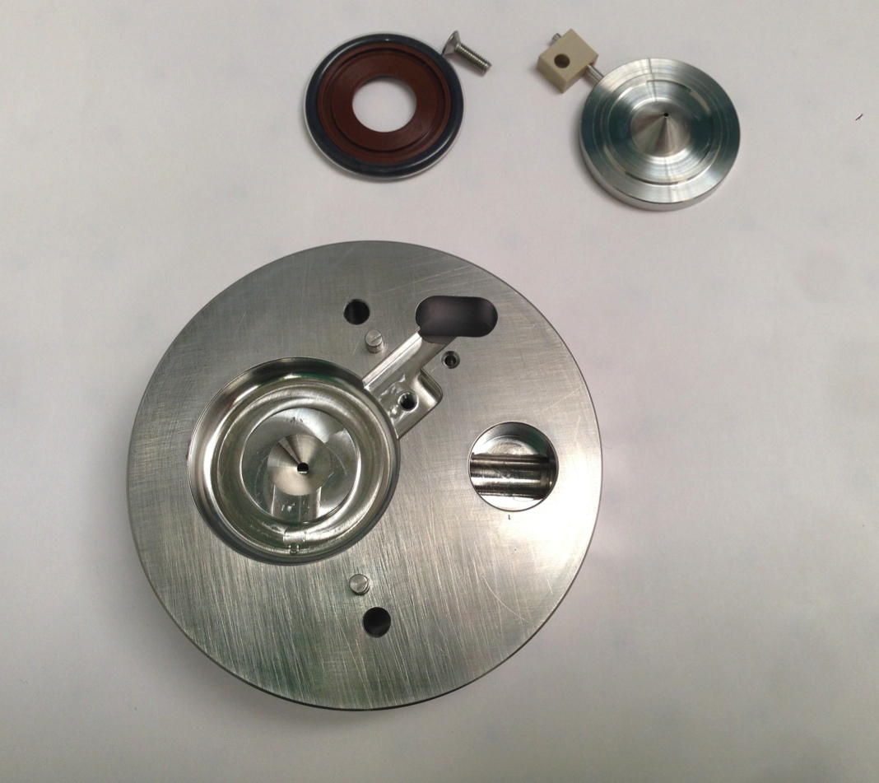

- Take off delicately with the cutter, the black seal around the heater (O-ring encapsulated), without contact with the block for not damaging the sealing.

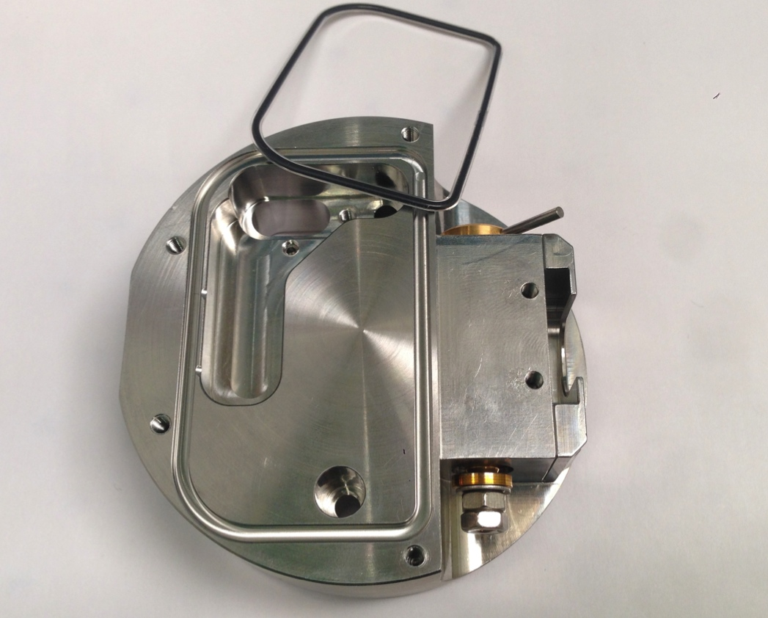

- Remove bolts bottoms valve stem with a key of 7. Discard two bolts with their two seals, and then, take out the valve stem on its place.

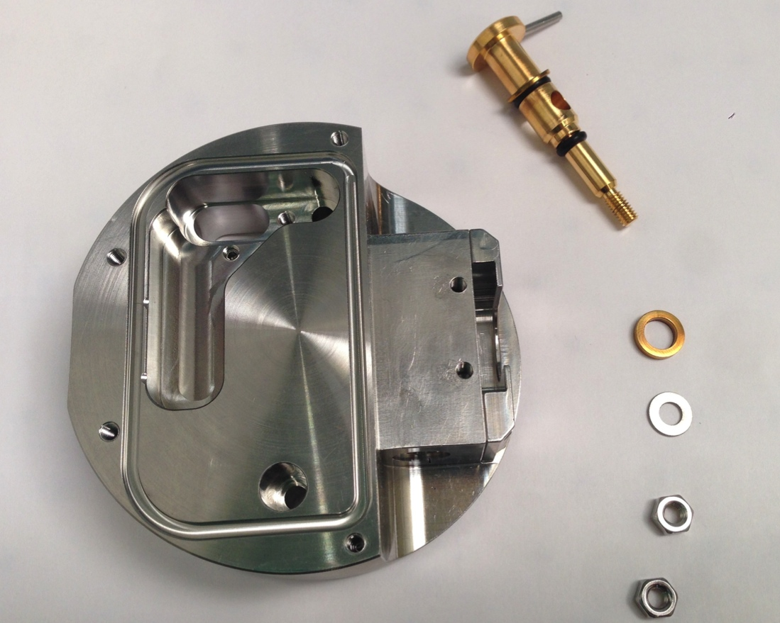

- Cut two seals on the valve and remove the Washer LG valve.
- Tap out two screw maintaining the sample cone locator block with an Allen key of 1,5, and its seals. All these pieces are conserved to be cleaning on the next step.

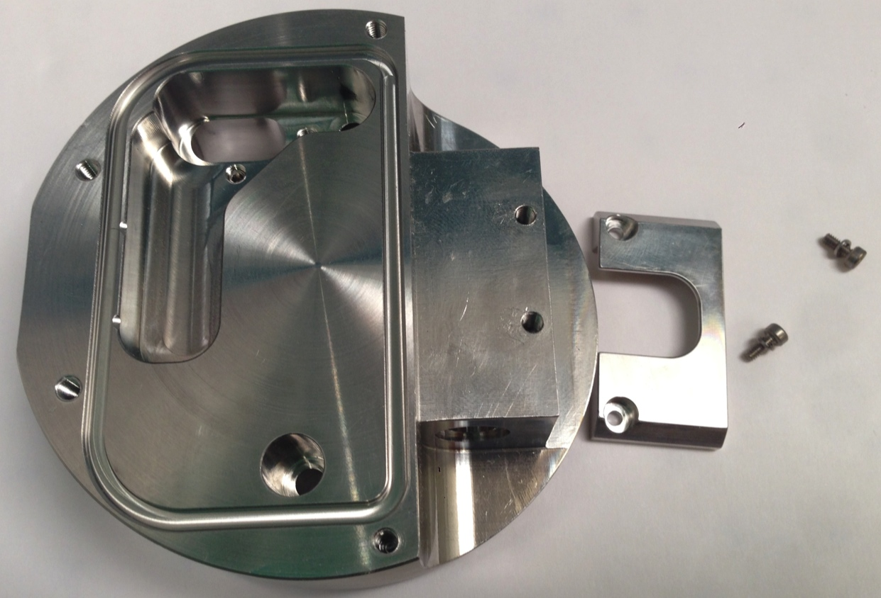
So, to conclude, on the picture below you will find a resume of all the parts we will keep for cleaning :

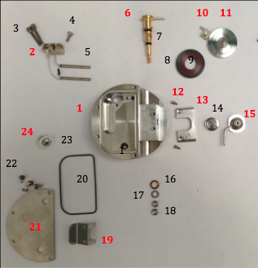

Cleaning

- Remove all marks with a stick & formic acid, and then, move into water. Brush thoroughly all parts (ion block, spring clip, cone gas, plate-shaped half-disc, Ion block plug, extraction lens, valve stem, sample cone locator block and its two screws) with a fiberglass pen.
- Sonicate 45min with 10% aqueous formic acid, 45% MilliQwater, 45% MeOH, at 55°C
- Rinse one time pieces with water.
- Sonicate 45min with milliQ water at 55°C.
- Rinse all pieces with milliQ water.
- Rinse with LC/MS grade MeOH.
- Blow-dry with nitrogen to avoid water marks.

Reassembly

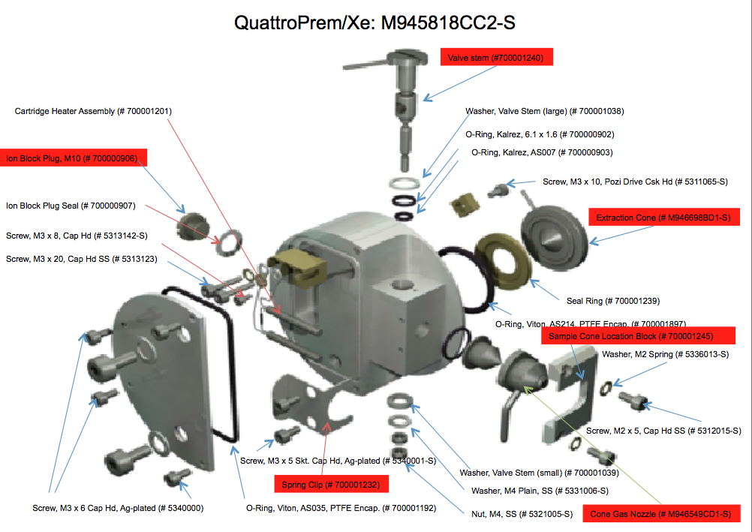
- Reassembly differents parts of Ion block on its places following the PM protocol and the graphical navigator view.
- Warning : The valve stem must be replaced on its place before the cover plate.

- THE QPREMIER/XE ION GUIDE

Recommendation : All these steps require gloves !

General view of Ion guide and requirement equipment :
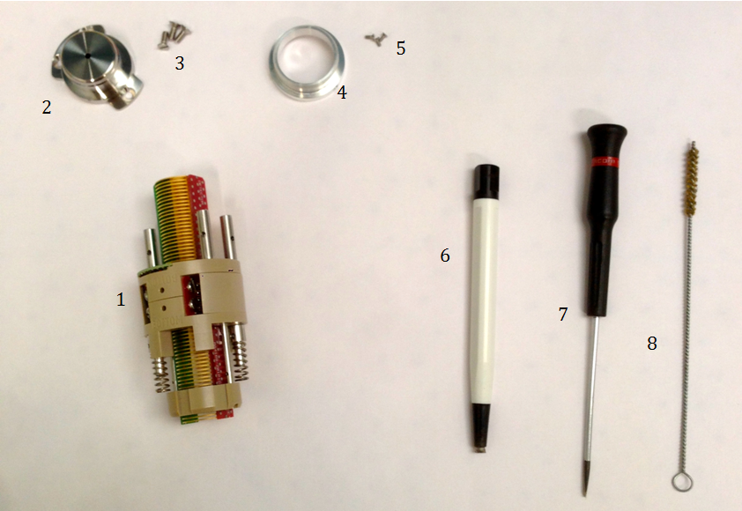
2

Legend :

# 1 = QPremier Ion guide (M946438CC1)
# 2 = Ion guide cap
# 3 = Cap screws
# 4 = Retaining ring & Ni-graphite Seal
# 5 = Ring screws
# 6 = Fiberglass pen
# 7 = Small flat screwdriver
# 8 = Small bottlebrush
Gloves

Disassembling

- Unscrew six screws and conserve its for the next step.

Cleaning
- Brush into the ion guide with a bottlebrush.
- Submerge the ion guide with MS solution in a graduated cylinder. Suspend it to doesn’t touch the walls.

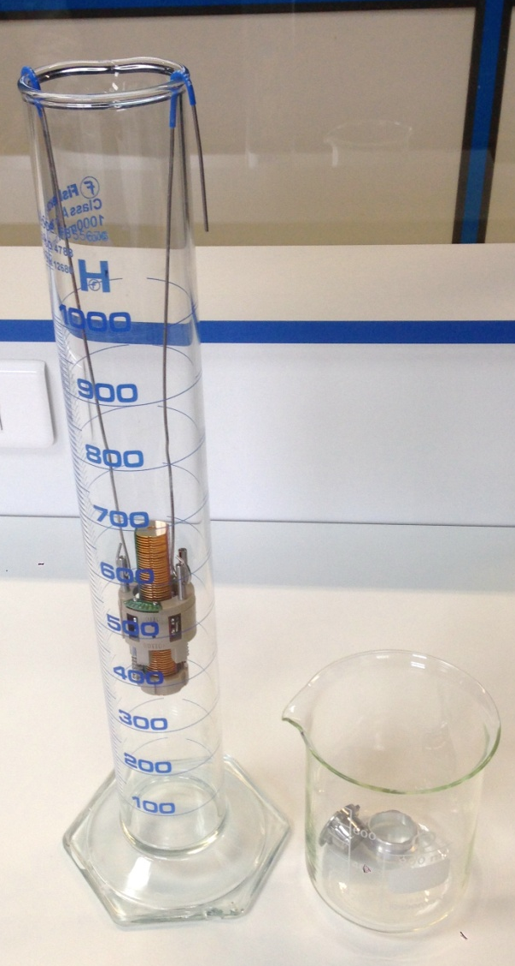
- Brush the cap with a fiberglass pen, before submerge into MS solution bath.
- Sonicate Ion guide with its cap 45 min at 55°C.
- Rinse with MilliQwater before a second wash with MilliQwater (45 min at 55°C).
- Rince with MilliQwater before final wash with methanol (45 min at 55°C).
- Dispose on absorbent paper, before blow dry with nitrogen to avoid water marks.

Reassembly

1. Reassembly Ion guide and its cap with same screws.
2. Go to 10606 TS for the tests.

3. Conditioning

- The ion block and ion guide disassembling - cleaning - Reassembly – Testing are closed on a special conditioning bag without PEG (source of different contaminations) (# 290000931), this one on the box (BMA06), ready to be sent.
- On the box, there are an instruction paper (FR1/1485PS), one green bag, for unused parts and the special bag without PEG it’s for return dirty parts, one paper : "Important information about the return of Ion block" (FR2/1485PS); one paper for the precaution during installation (FR3/1485PS); Test report which is obtained after Tests (FR2/10606TS) and a label with our address for the return.

WARING : One box is opened randomly by lot at the end of process to check if all parts and esthetic appearance are ok.


Q1er Ion block Instructions

This box contains :
- One Ion block.
- One Ion guide.
- Green bag for unused parts of “PM kit”.
- One pre-paid sticker.
- One information paper about the pre-paid return of Ion block with TNT
- Instructions paper.

MANDATORY :
- Replace dirty Ion block and Ion guide with the cleaned components.
- Re-use the original bags for packing the dirty components.
- Insert unused ion block parts (see table below) from the PM kit into the green bag & complete the table, to confirm that the unused parts have been returned. These parts will be used for the cleaning process.
- Fill in the Health & Safety declaration on the back.
- Insert these bags into the original box and apply the pre-paid return label, after completing it with your address and shipping information, then call TNT (see document about the return) for the pickup.

If you believe there is a problem with this product, please give us the following information so we are able to investigate and come back to you :
- Print screen showing the problem
- Print screen from the tune page using setup juice (if possible)
- An explanation to help us to understand the problem
After investigation in our facility we will come back to you to let you our finding.

Thank you for your collaboration !

"Quality is everyone's responsibility"

Part number | Part name | Returned in this box
5311065 | SCREW POZIDRIV CSK M3X10 STSTL (PK 1)
5321005 | NUT M4 ST STL (PK 2)
5331006 | WASHER PLAIN M4 ST STL (PK 2)
5336000 | WASHER SPRING M3 ST STL
5711293 | O-Ring,AS007 Kalrez,eZMD
5711294 | O-Ring, 6.1 IDx1.6 Kalrez,eZMD (PK 1)
5711312 | O-RING, AS035, VITON, PTFE ENDCAP (PK 1)
5711321 | O-ring viton 12.00 x 1.50
5711996 | 214 ENCAPSULATED O-RING (PK 1)
700001201 | SOURCE HEATER ASSY
5340000 & 5340001 | SCREW SKT CAP M3 X 5 AG PLT (PK 4 & PK 2)
5711352-S | O-ring Ni Graph Si
M945810AD1 | SEAL RING, EXTRACT CONE
M946699BD1-S | SAMPLE CONE 0.36 DIA
M955116AD1 | WASHER, LG, VALVE STEM
M955116AD2 | WASHER, SM, VALVE STEM
M955153AD1 | Plug,Ion Block Seal,eZMD

TNT WAYBILL :

S/N Ion block :

S/N Ion guide :

Health & Safety Declaration

Dirty parts have been contaminated with :

- Biohazardous ? (including blood or body fluidics) : Yes No

- Hazardous chemicals ? Yes No

I have made reasonable inquiry and I have supplied accurate information in this declaration. I have not withheld any information.

Please complete with the S/N of your Instrument :

Application :

FSE Name :

Signed : Date :

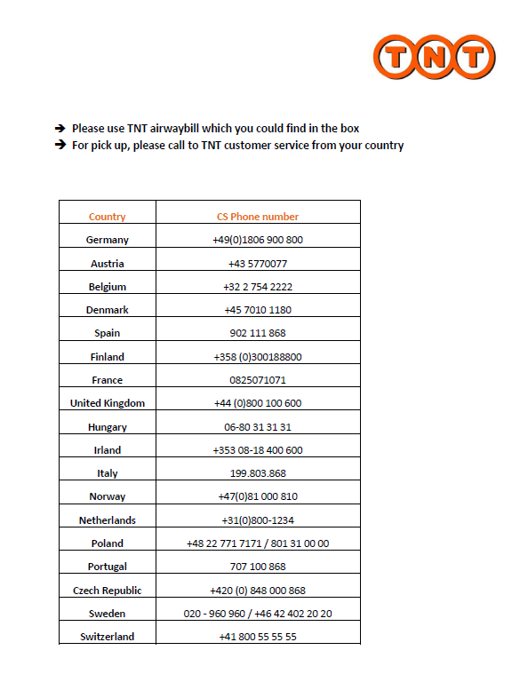

Ion Block assembly precautions
See Waters Customer Assurance Documentation HARDWARE on portal

Scope Technical Discussion
As part of the source cleaning procedure there have been recent occurrences whereby the grub screw within the Ion Block (5316021-S, highlighted in red on the picture) has either fallen out during sonication or has not been installed correctly causing damage to the thermocouple. This grub screw is designed to ensure good thermal contact is made to the tip of the thermocouple assembly. Insufficient care when re-fitting the ion block or the non presence of this screw can lead to poor source heater control or damage to the thermocouple.
For you information
Precautions to be taken when fitting the Ion Block:
When the Ion Block is fitted on the instrument, carefully put and tight the grub screw attached in the bag into the Ion Block to the point whereby the screw can felt to be making contact with the thermocouple. DO NOT OVERTIGHTEN

