SUMMARY

SUMMARY 1
1. THE SQD/TQD ION BLOCK: 2
1.1. General view of ion block and requirement equipment: 2
1.2. Legend : 2
1.3. Requirement equipment : 3
1.4. Disassembling 3
1.5. Cleaning 7
1.6. Reassembly 8
2. THE SQD / TQD HEXAPOLE 8
2.1. General view of hexapole and requirement equipment : 9
2.2. Legend 9
2.3. Disassembling 9
2.4. Cleaning 9
2.5. Reassembly 10
3. CONDITIONING...................................................................................................................11

THE SQD/TQD ION BLOCK:

  - General view of ion block and requirement equipment:

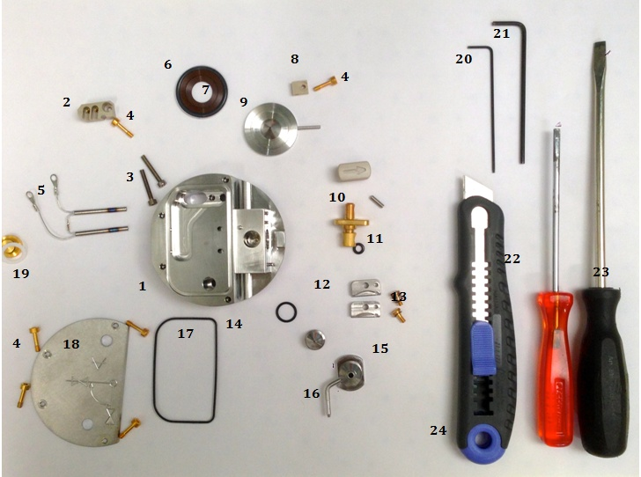

  - Legend :

# 1 = Ion block Assembly [700003523]
# 2 = PEEK Terminal Block (# 700001251)
# 3 = Screw, M2 x 20, Cap Hd (2pk) (# 700005255)
# 4 = Screw, Captive, M3 x 12, SS, Au-Plated (# 700003571)
# 5 = Cartridge Heater (# 700003050)
# 6 = O-Ring, AS214 Black Viton, PTFE Encap. (# 700001897)
# 7 = Seal Ring (# 700001239)
# 8 = Cone Retainer (# M946683AD1-S)
# 9 = Extraction Cone, 0.73 Diam. (# 700003257)
# 10 = Valve Stem Knob (# 700004335) & Grub Screw, M3 x 10 (5/pk) (# 5316038-S) & Valve Stem (# 700004339)
# 11 = O-Ring, Kalrez, 6.1mm x 1.6mm (# 700000902)
# 12 = Cone Gas Position Block (# 700003735)
# 13 = Screw, M3, Slotted (# 700003063) & Spring, Belleville (# 700003080)
# 14 = O-Ring, Viton, 12 x 1.5 (# 700001194)
# 15 = Sample Cone, 0.5 Diam. (# 700003055)
# 16 = Gas Cone, Camlock (# 700003054)
# 17 = O-Ring, Viton, AS035, Encapsulated (# 700001192)
# 18 = Ion Block Cover Plate (# 700001234)
# 19 = Ion Block Plug Seal (# 700000907) & Ion Block Plug, M10 (# 700000906)

  - Requirement equipment :

- Allen key of 1.5 (# 20)
- Allen key of 2.5 (# 21)
- Small flat screwdriver (# 22)
- Large flat screwdriver (# 23)
- Cutter (# 24)
- Gloves

Recommendation : All these steps require gloves !

  - Disassembling

- Turn the valve stem to release the gas cone with the sample cone. The sample cone and it’s seal are thrown.

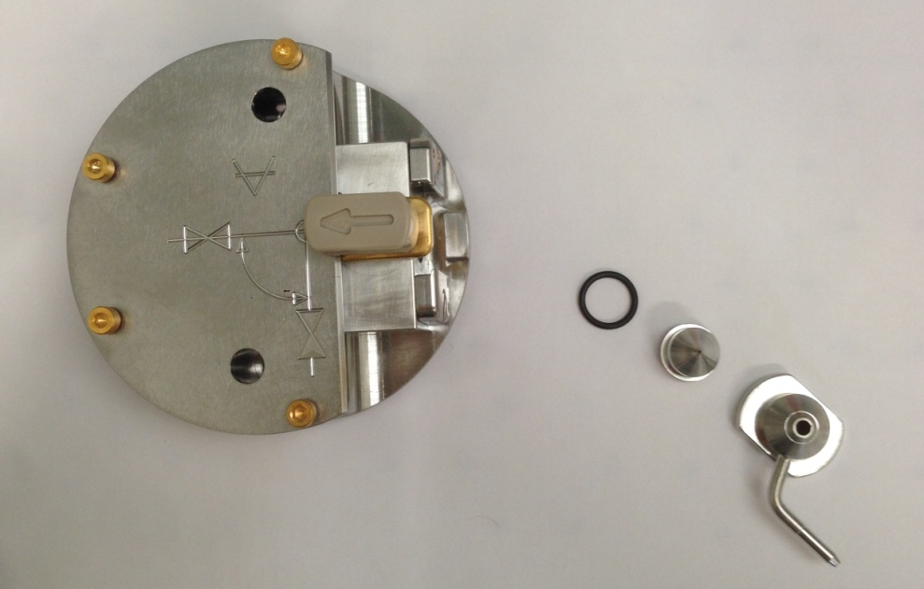

- Dismount the plate of face maintained by the 4 screws, with an Allen key of 2.5, the 4 screws are thrown.
- Remove the 3 screws fixed on the PEEK part to maintain the heater, with Allen keys. Only the PEEK part is preserved, the rest will be changed.

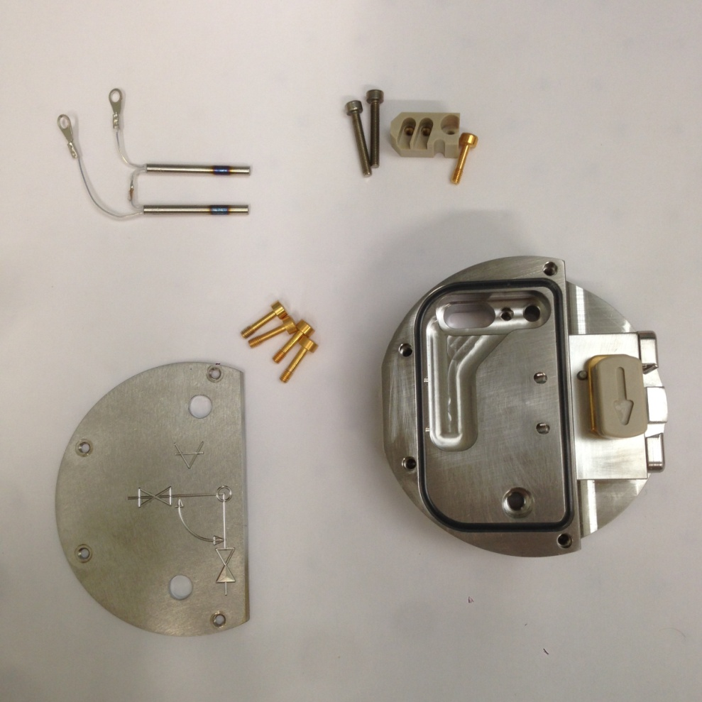

- Unscrew the Ion block plug, with the flat screwdriver, the seal is thrown.

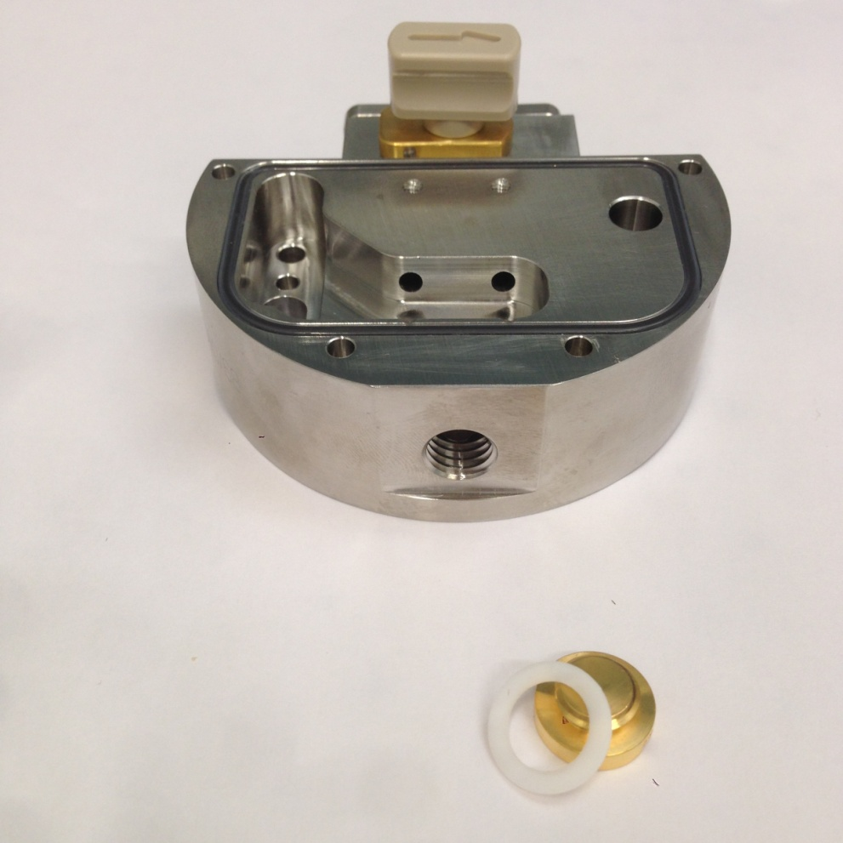

- Loosen the screw, maintaining the extraction lens, with an Allen key of 2,5. Only the PEEK part and the extraction lens are preserved. The two seals (Seal boxing ring & Black Viton O-boxing ring) will be replaced.

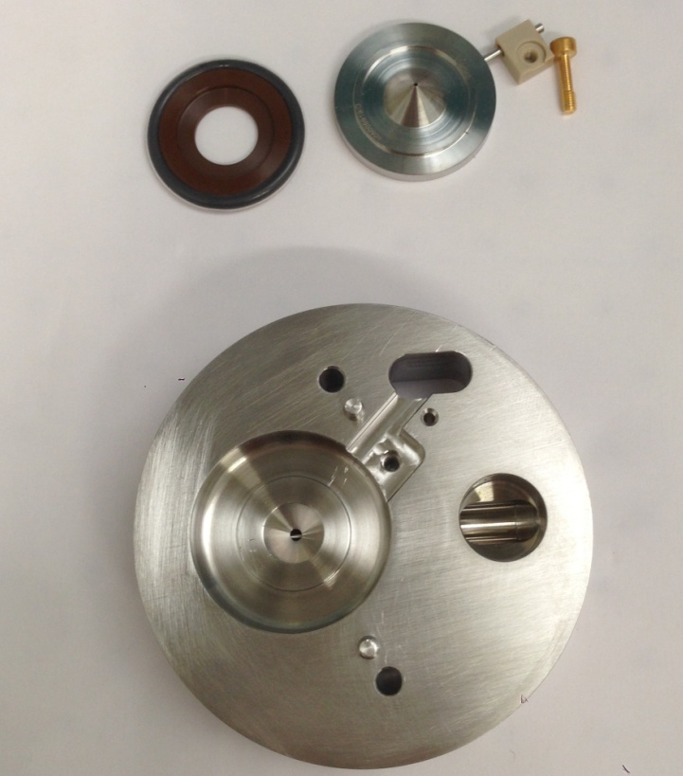

- Take off delicately with the cutter, the black seal around the heater (O-ring encapsulated), without contact with the block for not damaging the sealing.

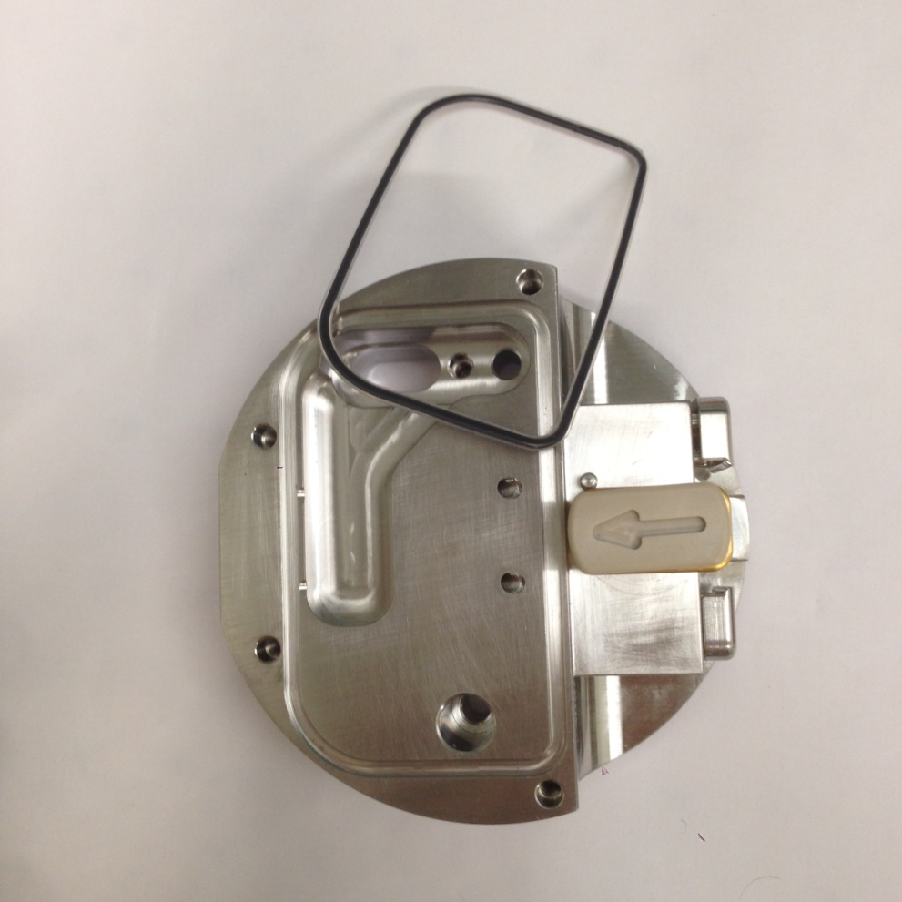

- Remove valve stem., and then, take out the valve stem on its place. Discard the seal, and unscrew with an Allen key of 1,5, the grubscrew, maintaining knob and valve stem. All these pieces are conserved.
- Cut the small black seal on the valve.

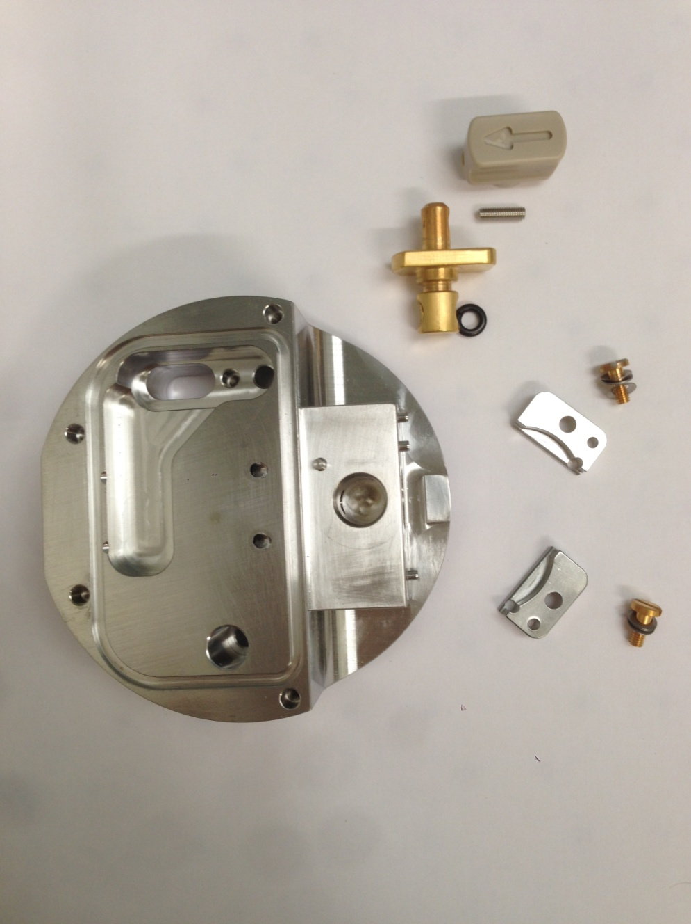

In the picture below you will find a resume of all the parts we will keep for cleaning (red numbers) :

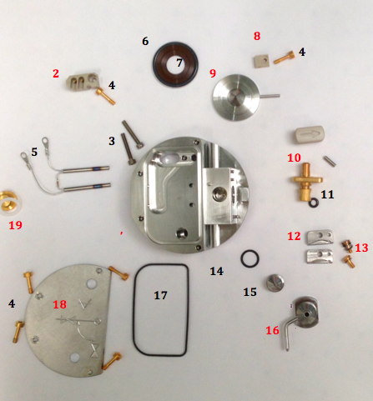
1

  - Cleaning

- Brush thoroughly all parts (Ion block, spring clip, cone gas, plate-shaped half-disc, Ion block plug, extraction lens, valve stem, sample cone locator block with its screws and spring belleville) with a fiberglass pen.
- Sonicate 45 min with 10% aqueous formic acid, 45% MeOH and 45% MilliQwater, at 55°C
- Rinse one time pieces with water.
- Sonicate 45 min with milliQ water at 55°C.
- Rinse all pieces with milliQ water.
- Rinse with LC/MS grade MeOH.
- Blow-dry with nitrogen to avoid water marks.

  - Reassembly
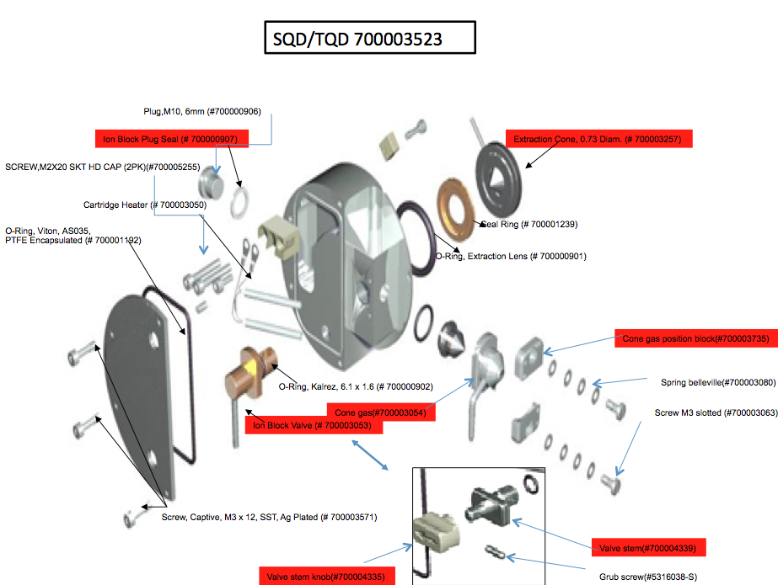

  - Reassembly different parts of Ion block on its places following the PM protocol and the graphical navigator view.

Warning : The valve stem must be replaced on its place before the cover plate.

THE SQD / TQD HEXAPOLE
Recommendation : All these steps require gloves !

  - General view of hexapole and requirement equipment :

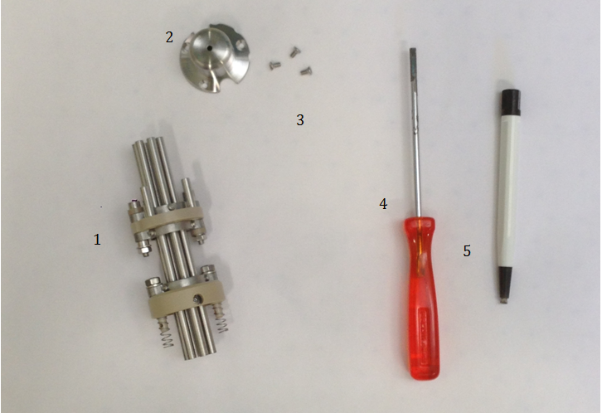

  - Legend
# 1= SQD/TQD Hexapole (700003629)
# 2 = Hexapole cap
# 3 = Screws of cap
# 4 = Small flat screwdriver
# 5 = Fiberglass pen
Gloves

  - Disassembling
- Unscrew three screws on caps and conserve it for the next step.
- Unscrew 12 screws to remove the 6 rods, and bruh it with the lapfilm, before reassemble it.

  - Cleaning
- Submerge the hexapole with water in a graduated cylinder. Suspend the hexapole to doesn’t touch the walls.
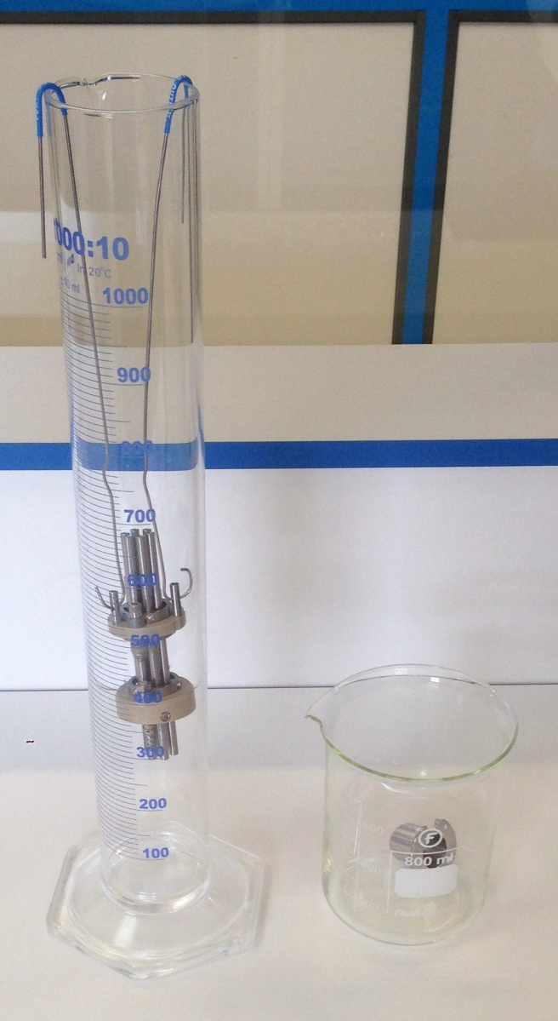

- Brush the cap with a fiberglass pen, before submerge into water bath.
- Sonicate hexapole and its cap 45 min at 55°C.
- Rinse hexapole and cap with MilliQwater before submerge it into methanol bath.
- Sonicate them 45 min at 55°C.
- Dispose in absorbent paper, the hexapole and cap before blow dry with nitrogen to avoid water marks.

  - Reassembly
- Reassembly hexapole and its cap with three same screws.
- Go to 10607 TS for the tests.

Conditioning
- The ion block and ion guide disassembling - cleaning - Reassembly – Testing are closed on a special conditioning bag without PEG (source of different contaminations) (# 290000931), this one on the box (BMA06), ready to be sent.
- On the box, there are an instruction paper (FR1/1486PS), one green bag, for unused parts special bag without PEG it’s for return dirty parts, one paper : "Important information about the return of Ion block" (FR2/1486PS); Test report which is obtained after Tests (FR2/10607TS) and a label with our address for the return.

WARNING : One box is opened randomly by lot at the end of the process to check if all parts and esthetic appearance are ok.


SQD/TQD Ion block Instructions

This box contains :
- One Ion block.
- One Hexapole.
- Green bag for unused parts of “PM kit”.
- One pre-paid sticker.
- One information paper about the pre-paid return of Ion block with TNT
- Instructions paper.

MANDATORY :
- Replace dirty Ion block and Hexapole with the cleaned components.
- Re-use the original bags for packing the dirty components.
- Insert unused ion block parts (see table below) from the PM kit into the green bag & complete the table, to confirm that the unused parts have been returned. These parts will be used for the cleaning process.
- Fill in the Health & Safety declaration on the back.
- Insert these bags into the original box and apply the pre-paid return label, after completing it with your address and shipping information, then call TNT (see document about the return) for the pickup.

If you believe there is a problem with this product, please give us the following information so we are able to investigate and come back to you :
- Print screen showing the problem
- Print screen from the tune page using setup juice (if possible)
- An explanation to help us to understand the problem
After investigation in our facility we will come back to you to let you our finding.

Thank you for your collaboration !

"Quality is everyone's responsibility"

Part number | Part name | Returned in this box
5711294 | O-ring AS007 Kalrez
5711312 | O-ring Viton Encapsulated
5711321 | O-ring viton 12.00 x 1.50
5711967 | O-ring extraction lens
410001785 | Screw Captive M3x12 SST Ag Plated
410001786 | Shoulder screw, M3, Slotted
700003050 | Cartridge Heater
700003055 | Sample cone SQD
M945810AD1 | Seal ring
M955153AD1 | Ion plug seal

TNT WAYBILL :

S/N Ion block :

S/N Hexapole :

Health & Safety Declaration

Dirty parts have been contaminated with :

- Biohazardous ? (including blood or body fluidics) : Yes No

- Hazardous chemicals ? Yes No

I have made reasonable inquiry and I have supplied accurate information in this declaration. I have not withheld any information.

Please complete with the S/N of your Instrument :

Application :

FSE Name :

Signed : Date :

