SUMMARY

SUMMARY 1

1. THE XEVO TQ-S ION BLOCK 2
1.1. General view of Ion Block and needed equipment 2
1.2. Legend 2
1.3. Disassembling 3
1.4. Cleaning 6
1.5. Reassembly 7

2. THE XEVO TQ-S STEP WAVE (DUAL ION GUIDE) 8
2.1. General view of Hexapole and needed equipment 8
2.2. Legend 8
2.3. Disassembling 9
2.4. Cleaning 9
2.4.1. Electronics parts 9
2.4.2. Metalic parts 10
2.5. Reassembly 10

3. CONDITIONING THE XEVO TQ-S ION BLOCK AND STEP WAVE 11

- THE XEVO TQ-S ION BLOCK

General view of Ion Block and needed equipment :
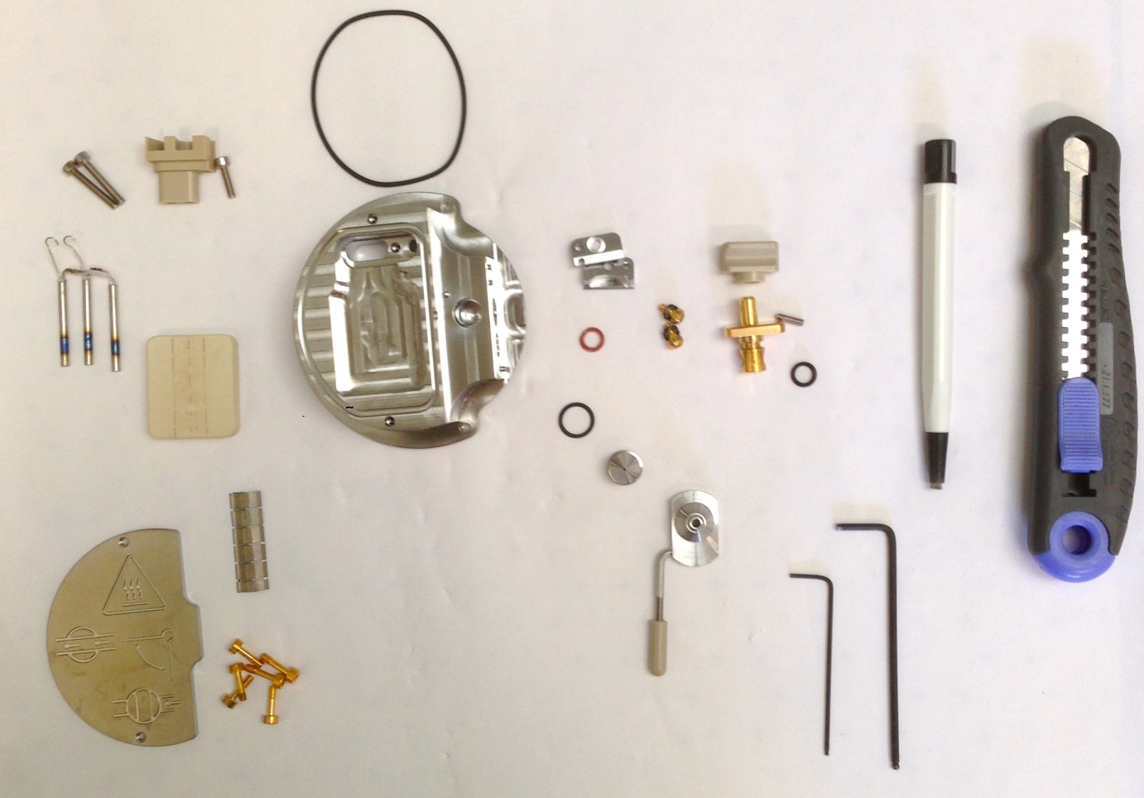
24
23
1
22
21
20
19
18
17
16
15
14
13
12
11
10
9
8
7
6
5
4
3
2

Legend :
# 1 = Xevo TQ-S source (# 700005349)
# 2 = Cartridge heater (# 700005347)
# 3 = Screw M3 (# 5313123)
# 4 = Terminal PEEK (# 700005348)
# 5 = Screw M3x12 cap Hd (# 5313069-S)
# 6 = O-ring viton AS035 (# 700000904)
# 7 = Gas cone position block (# 700004338)
# 8 = Screw shoulder M3 socket (# 700004404) & Spring belleville (# 700003080)
# 9 = O-ring silicone FEP size 009 (# 700004728)
# 10 = Valve stem knob (# 700004335)
# 11 = Grub screw M3x10 (# 5316038-S)
# 12 = Valve stem (# 700004339)
# 13 = O-ring AS007 Kalrez (# 700000902)
# 14 = O-ring size 10 (# 700004321)
# 15 = Sample cone (# 700005350)
# 16 = Cone gas nozzle (# 700004216) & Cone gas nozzle handle (# 700004337)
# 17 = Captive screw (# 700004344)
# 18 = Coverplate (# 700004342)
# 19 = Allen key of 1.5 mm
# 20 = Allen key of 2.5 mm
# 21 = Fiberglass pen
# 22 = Cutter
# 23 = Ceramic block
# 24 = Metal plate

Recommendation : All these steps require gloves !

Disassembling
- Turn the valve stem to release the gas cone with the sample cone. The sample cone and its seal are thrown.

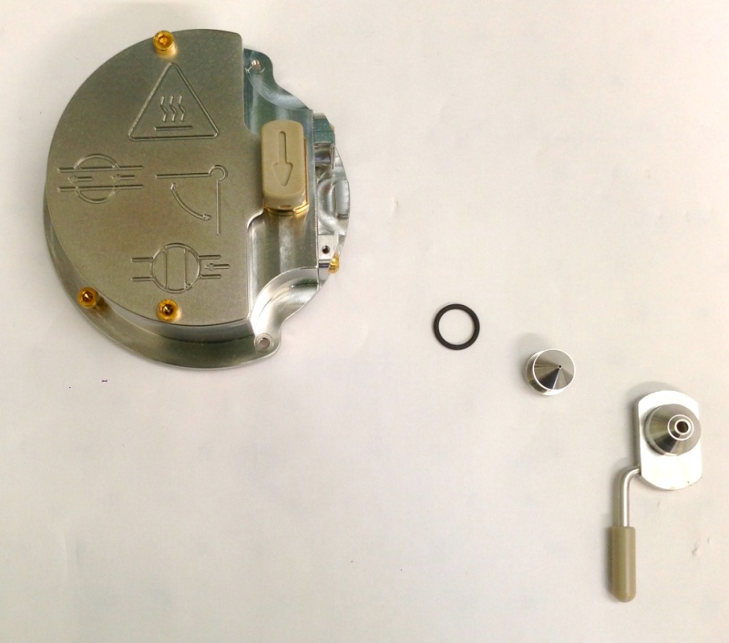

- Dismount the plate of face maintained by screws, with an Allen key of 2.5 mm, screws are thrown.

- Remove the 3 screws fixed on the PEEK part which maintain the heater, with Allen keys. Only the PEEK part is preserved, the rest will be changed.

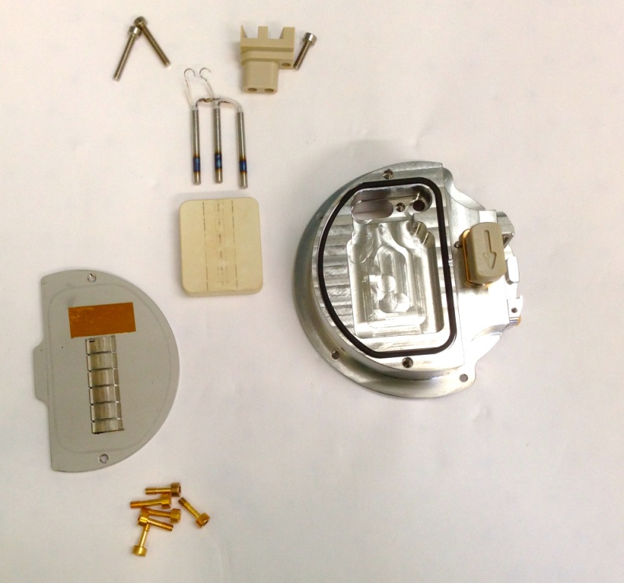

- Take off delicately with the cutter the black seal around the heater, without contact with the block for not damaging the sealing.

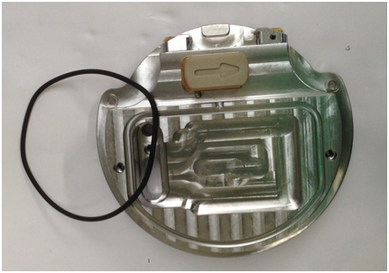

- Remove valve stem, and then take out the valve stem on its place. Discard the seal, and unscrew with an Allen key of 1,5 mm the grubscrew, maintaining knob and valve stem. All these pieces are conserved.

- Cut the small black seal on the valve.

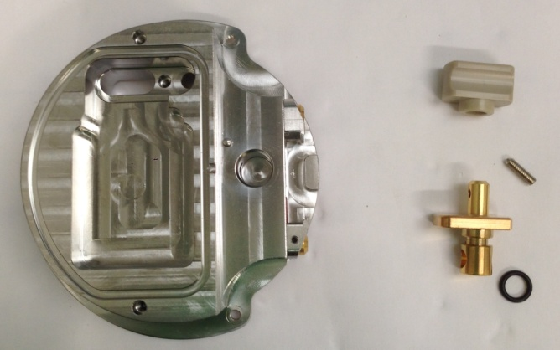

- Tap out two screw maintaining gas cone position blocks, and its seals. All these pieces are conserved to be cleaning on the next step.

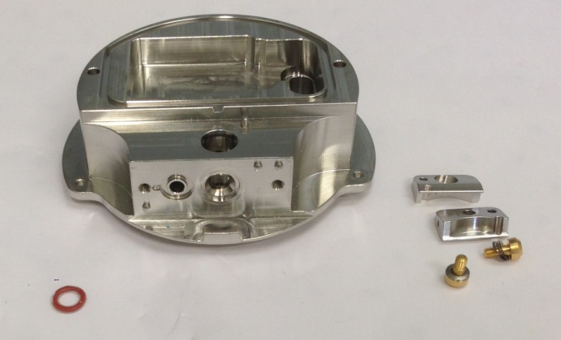

- So, to conclude, on the picture below you will find a resume of all the parts we will keep for cleaning with a red number :
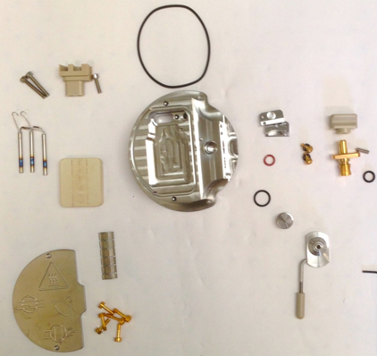
24
23
15
14
18
17
16
10
9
8
7
13
12
11
1
6
5
4
3
2

Cleaning
- Brush thoroughly all pieces (principal block, spring clip, cone gas, plate-shaped half-disc, Ion block plug, extraction lens, valve stem, sample cone locator block and its two screws) with a fiberglass pen.

- Sonicate 45 min with 10% aqueous formic acid, water, methanol (45/45) at 55°C.

- Rinse one time pieces with a lot of water to delete all formic acid, and one time with MilliQ water.

- Sonicate 45 min with MilliQ water at 55°C.

- Rinse all pieces with MilliQ water.

- Rinse with LC/MS grade methanol.

- Blow-dry with nitrogen to avoid water marks.

Reassembly
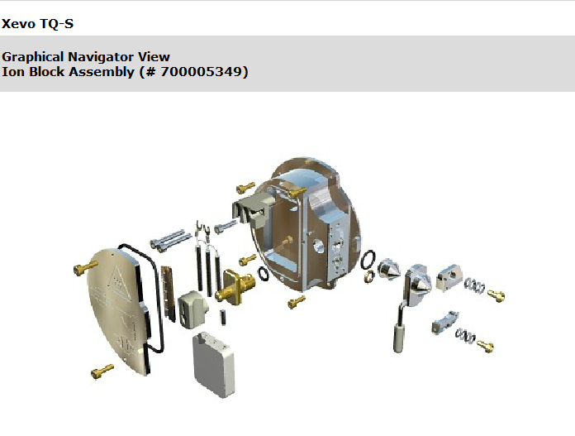

- Reassembly different parts of Ion block on its places following the PM protocol and the graphical navigator view.

- Warning : The valve stem must be replaced on its place before the cover plate.

- THE XEVO TQ-S STEP WAVE (DUAL ION GUIDE)

General view of Step wave and requirement equipment

Recommendation : All these steps require gloves !

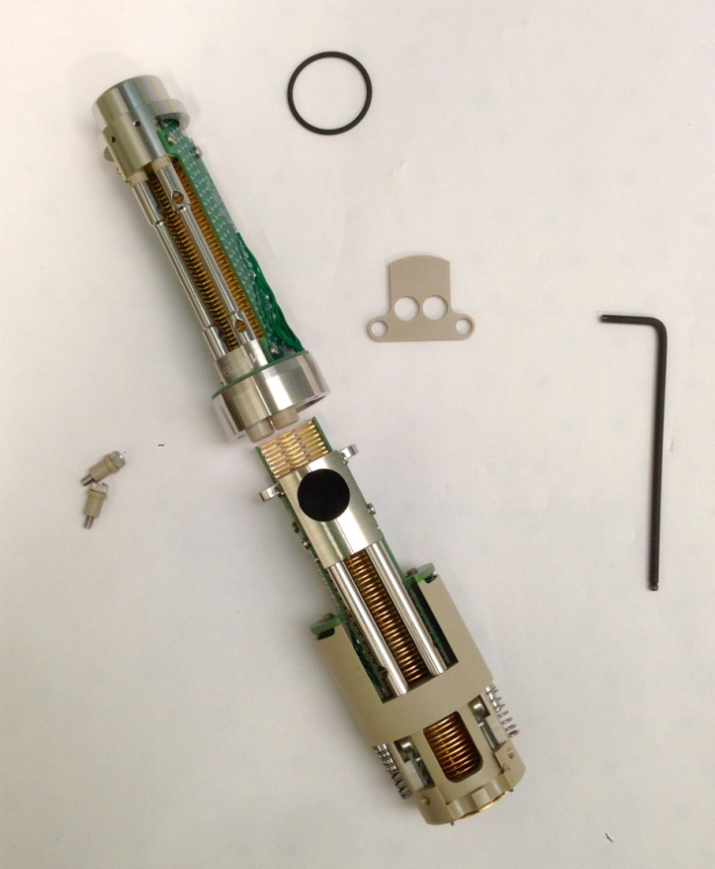
6
5
4
3
2
1

Legend
# 1= First ion guide
# 2 = Second ion guide
# 3 = Securing screws
# 4 = O-ring
# 5 = Brown PEEK gasket
# 6 = Allen key of 2,5 mm

Disassembling
- Use the Allen key of 2,5 mm to remove the 2 screws securing the first ion guide assembly to the second ion guide.

- Separate the first and the second ion guide assemblies.

- Remove the brown PEEK gasket from the second ion guide assembly.

- Remove the O-ring from the differential pumping aperture on the first ion guide assembly.

- Remove all screws to separate the 2 peaks with electronics and metal parts.

Cleaning
2.4.1. Electronics parts
- Brush into tunnels with a bottle brush.

- Bend a PEEK tube into a hook shape.

- Use the hook to carefully suspend the first ion guide electronic assembly in the glass vessel so that the bottom of the assembly doesn't touch the bottom of the vessel.

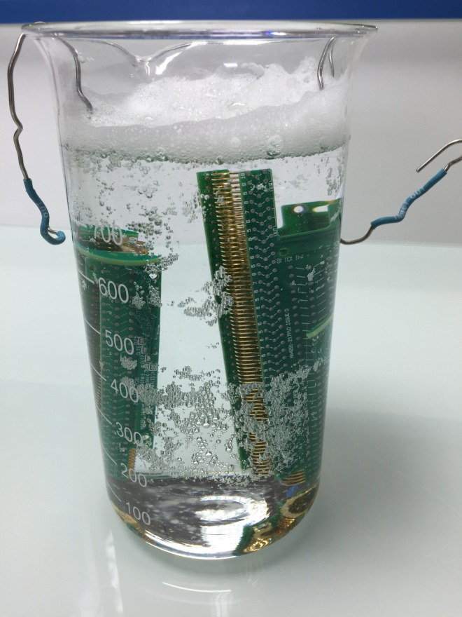

- Add used Waters MS cleaning solution until the first ion guide assembly is immersed completely.

- Repeat the same steps for the second ion guide.
- Place the two ion guides into vessel in ultrasonic bath for 30 minutes.

- Rinse two ion guides with MilliQwater.

- Repeat all the same steps with a new Waters MS cleaning solution for the two ion guides.

- Carefully pour the cleaning solution into the initial container (the MS cleaning solution can be reused 2 times).

- Rinse the two ion guides with MilliQwater.

- Add MilliQwater until the first ion guide assembly is immersed completely into the vessel.

- Repeat the same step for the second ion guide.

- Place the two ion guides into vessel in ultrasonic bath 30 minutes.

- Carefully pour the MilliQ water.

- Rinse the two ion guides with MilliQ water.

- Add Propan-2-ol until the first ion guide assembly is immersed completely into the vessel.

- Repeat the same step for the second ion guide.

- Place the two ion guides into vessel in ultrasonic bath for 30 minutes.

- Carrefully pour propan-2-ol.

- Add methanol until the first ion guide assembly is immersed completely into the vessel.

- Repeat the same step for the second ion guide.

- Place the two ion guides into vessel in ultrasonic bath for 30 minutes.

- Carefully pour methanol and blow dry with nitrogen to don't have water marks.

Warning : All baths are at 55°C !
2.4.2. Metalic parts
- Brush parts with fiberglass pen.

- Place parts into glass vessel with a mix water methanol : 45/45 and 10% of formic acid. Bath during 30 min at 55°C.

- Rinse with MilliQwater.

- Bath 30 min at 55°C with MilliQwater.

- Rinse with Methanol.

- Blow dry with nitrogen.

Reassembly
- Reassembly step wave in the opposite direction with the disassembling stage.

- Go to TS10617 for tests.

- CONDITIONING THE XEVO TQ-S ION BLOCK AND STEP WAVE

- The Ion block and Step wave disassembling - cleaning - reassembly are closed on a special conditioning bag without PEG (source of different contaminations) (# 290000931), this one on the box (BMA06), ready to be sent.

- On the box, there are instructions papers (FR1/1490PS), one green bag for unused parts, special bag without PEG, it's for return dirty parts, one paper : "Important information about the return of Ion block" (FR2/1490PS); one "stepwave0 alignment" (FR3/1490PS). Test report which is obtained after Tests (FR4/10634TS), and a label with our address for the return.

Warning : One box is opened randomly by lot at the end of the process to check if all steps and esthetic appearance are OK.



Xevo TQ-S Ion block Instructions

This box contains :
- One Ion block.
- One Stepwave.
- Green bag for unused parts of “PM kit”.
- One pre-paid sticker.
- One information paper about the pre-paid return of Ion block with TNT
- Instructions paper.

MANDATORY :
- Replace dirty Ion block and Stepwave with the cleaned components.
- Re-use the original bags for packing the dirty components.
- Insert unused ion block parts (see table below) from the PM kit into the green bag & complete the table, to confirm that the unused parts have been returned. These parts will be used for the cleaning process.
- Fill in the Health & Safety declaration on the back.
- Insert these bags into the original box and apply the pre-paid return label, after completing it with your address and shipping information, then call TNT (see document about the return) for the pickup.

If you believe there is a problem with this product, please give us the following information so we are able to investigate and come back to you :
- Print screen showing the problem
- Print screen from the tune page using setup juice (if possible)
- An explanation to help us to understand the problem
After investigation in our facility we will come back to you to let you our finding.

Thank you for your collaboration !

"Quality is everyone's responsibility"

Part number | Part name | Returned in this box
5711294 | O RING, 6.1 IDx1.6 Kalrez, eZMD
5711968 | O RING VITON AS035, PKG 5
5711978 | O RING, VITON AS021
425000606 | O RING VITON SIZE 10 I/D x 1.5 C/S
425000758 | O RING SILICONE FEP SIZE 009
700005347 | CARTRIDGE HEATER FOR CERAMIC BLOCK
700005350 | SAMPLE CONE 0,8mm

TNT WAYBILL :

S/N Ion block :

S/N Stepwave :

Health & Safety Declaration

Dirty parts have been contaminated with :

- Biohazardous ? (including blood or body fluidics) : Yes No

- Hazardous chemicals ? Yes No

I have made reasonable inquiry and I have supplied accurate information in this declaration. I have not withheld any information.

Please complete with the S/N of your Instrument :

Application :

FSE Name :

Signed : Date :

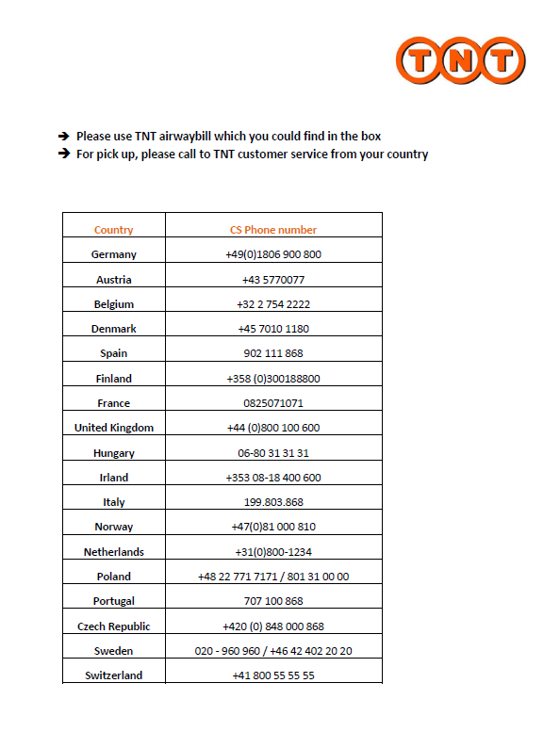

Waters Customer Assurance Documentation
StepWave Alignment
Informational
Rev: 01  Creation or revision date: 11/06/2013  Approval date: 07/11/2013  Model: XEVO TQ-S |  | Originator: Simon Munro
The purpose of an Informational Service Note is to communicate detailed product related information to the Field Service Engineer.
Scope Technical Discussion
Aligning the StepWave when fitting
Product Affected
Xevo TQ-S
For your information
It is important to align the StepWave correctly when fitting it to the instrument. The StepWave is free to rotate by a small amount and if misaligned the conductive pads on the StepWave will not make good contact with the pogo pins on the ion guide connection PCBs, this can result in loss of signal over time in positive, negative or both ion modes.
Service Action Required
Take great care when fitting the StepWave. When fitting the StepWave ensure that it is not at either of the two extremes of rotation that are possible i.e. that it is centred. This will ensure good electrical contact to the ion guide connection PCBs.
Implementation
When fitting a StepWave to an instrument. If after fitting the guide, signal loss over time is seen, refit the StepWave.

