SUMMARY

SUMMARY 1
1. Testing the QDa Ion block & Pumping Block 2
1.1. Requirement equipment for different Tests : 2
1.2. Changing QDa block : 2
1.3. TESTS 3
1.3.1. Source pressure test 3
1.3.2. Resolution, calibration check and recalibration 5
1.3.3. Printing Tests reports 5
1.4. Beams 6
2. Storage of the Test Results 7

Testing the QDa Ion block & Pumping Block

Requirement equipment for different Tests :
- Allen key of 3 mm
- Gloves
- Safety glasses
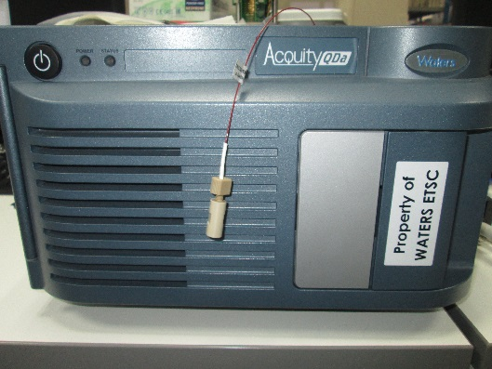

Changing QDa block :

- Switch off instrument with the power button
- Open the door

- Unscrew the 2 black plastic screws on the connector (red circles)
- Unscrew the 2 white plastic screws on the source (yellow circles)

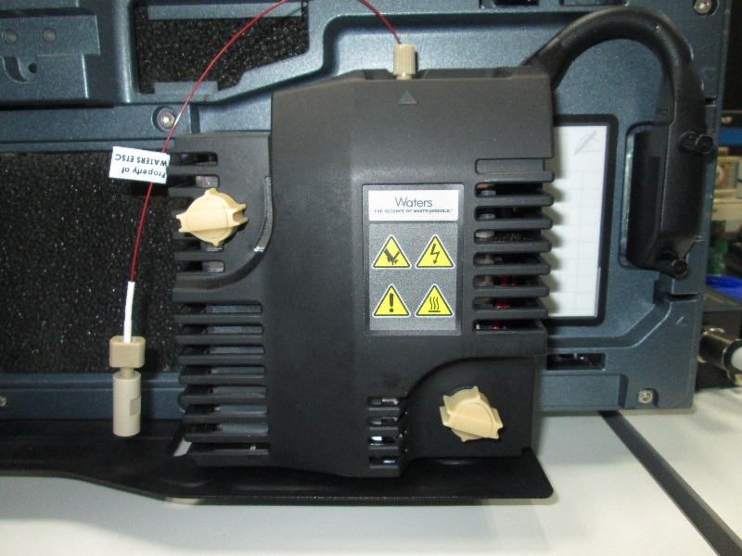

- Remove the source
- Unscrew the four screws on the pumping block with an Allen key of 3.
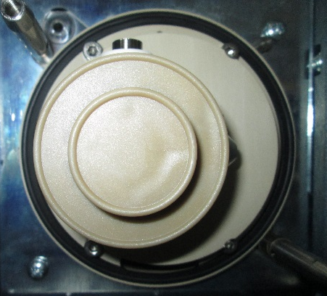
- Take off delicately the Pumping block and ion block

- Put a new assembly in the instrument, align the two lines (one on the pumping block and one on the instrument)
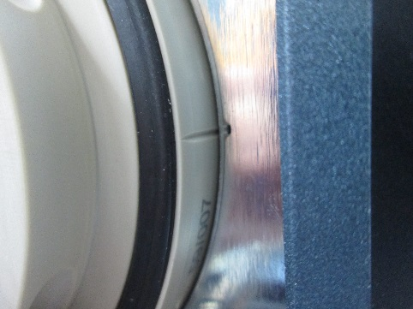

- Tight the 4 screws on the pumping block, replace the source and tight the 4 plastic screws (black end white)
- Close the door
- Switch on the instrument.

TESTS

Source pressure test

- Open Hyperterminal
- Once the “Done executing startup script” message is displayed, open the Dashboard
- When the Turbo Speed Readback is at 97% (you will hear a click), the source pressure test begins, you can start a record to check the values of the probe, the heater and the pressure sensor

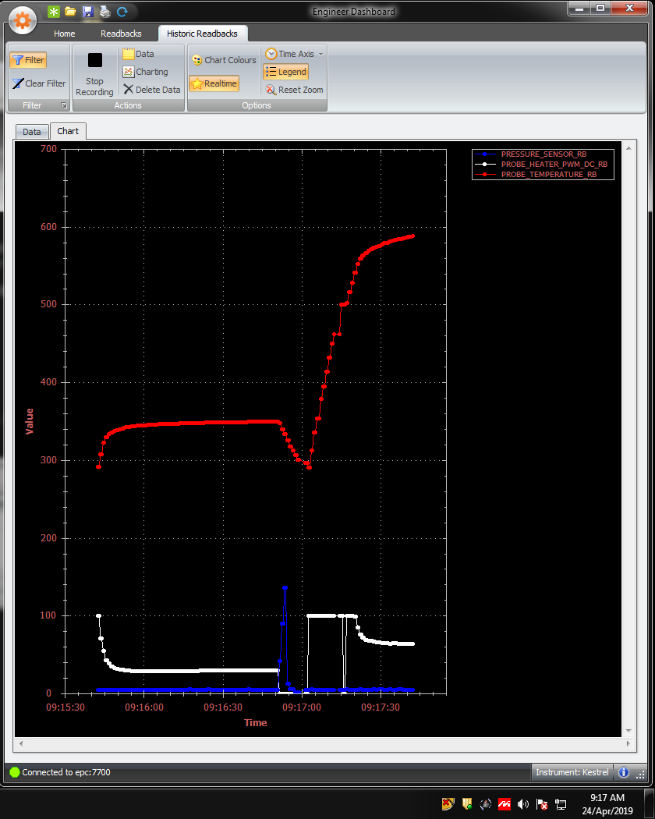
- Open Masslynx and MS Console
- When the SPT is completed, the critical readback checks start.
- When done, click on “Troubleshoot/Service Mode”
- Type pin : 1147 in the window

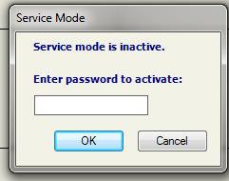

- Click on Troubleshoot/Show tune page
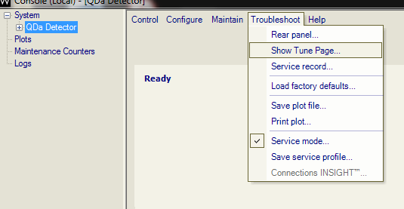
- Enable calibrant heater and wait for it to be at 150°C then enable High voltage supply and open the calibrant valve in negative mode (click Ion Mode/Electrospray -)
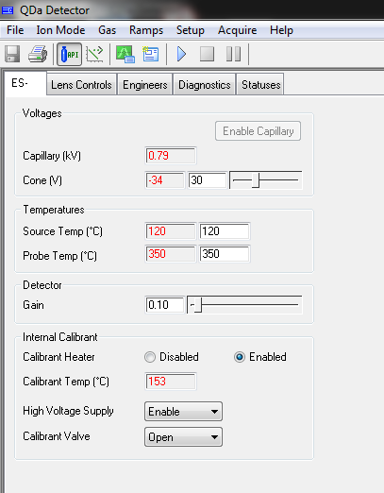

- Check the beams on the entire spector (Select one table, choose mass 640 and 1220 of span)
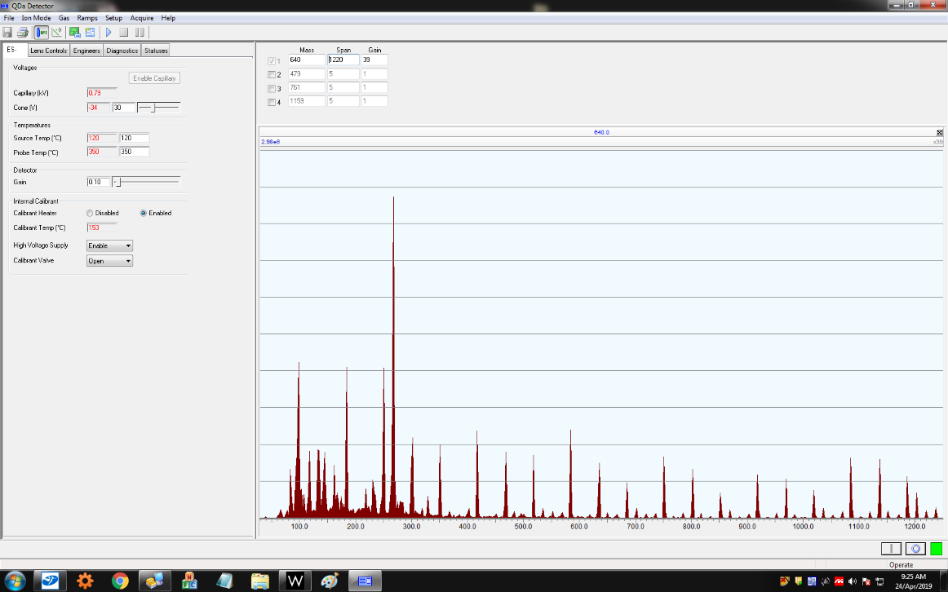

Resolution, calibration check and recalibration

- Close the tune page
- Click on Maintain/Check Resolution
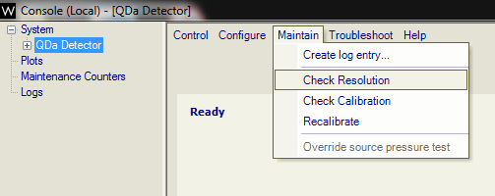
- Wait for it to be finished, the instrument will be “Ready”
- Open the tune page again
- Change the Low mass resolution of 0.20 in the engineers tab
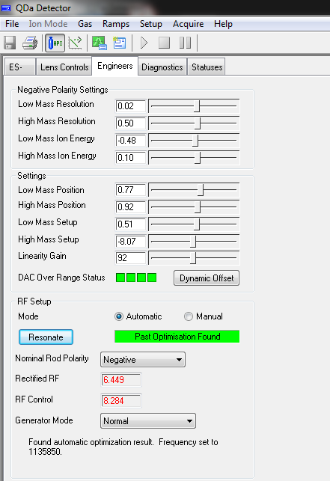

- Close the tune page
- Click on Maintain/Check Resolution and wait for it to complete
- When the message “There is not a valid resolution for the instrument” is displayed, click on the “Resolve” Button on the right
- The calibration check will start automatically after.
- When done, click on Maintain/Recalibrate

Printing Tests reports

- Click on “Logs”
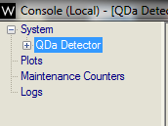
- Save the 1st Resolution check diagnostic on a notepad file
- Save the resolution setup diagnostic on a notepad file
- Save the calibration check diagnostic on a notepad file
- Save the recalibration check diagnostic on a notepad file
- Make a screen capture of the Turbo Power page, in “QDA Detector” line on the left
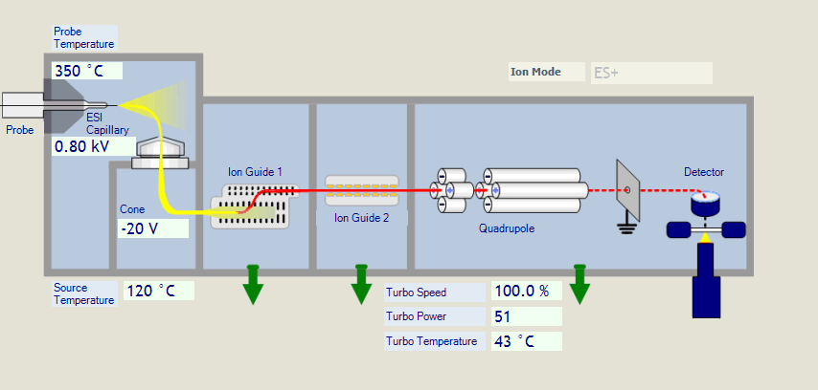

Beams

- Open the tune page, enable the calibrant heater, high voltage supply
- Print a PDF page of the entire spector in negative mode (click Ion Mode/Electrospray -) with the calibrant valve opened, call it IC Neg FS
- Print a PDF page of the entire spector in negative mode with the calibrant valve closed, call it Neg Noise
- Print a PDF page of the entire spector in positive mode (click Ion Mode/Electrospray +) with the calibrant valve closed, call it Pos Noise
- Print a PDF page of the 4 specific masses in negative mode (135, 417,749 and 1081), call it Neg Beam
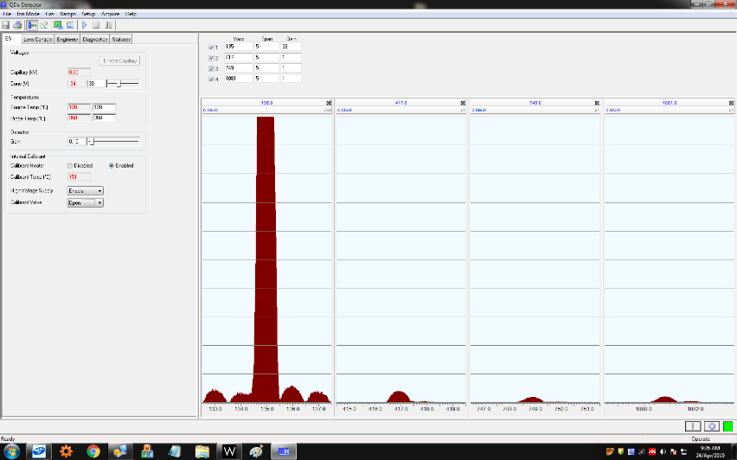
- Print a PDF page of the 4 specific masses in positive mode (169, 479, 761, 1159), call it Pos Beam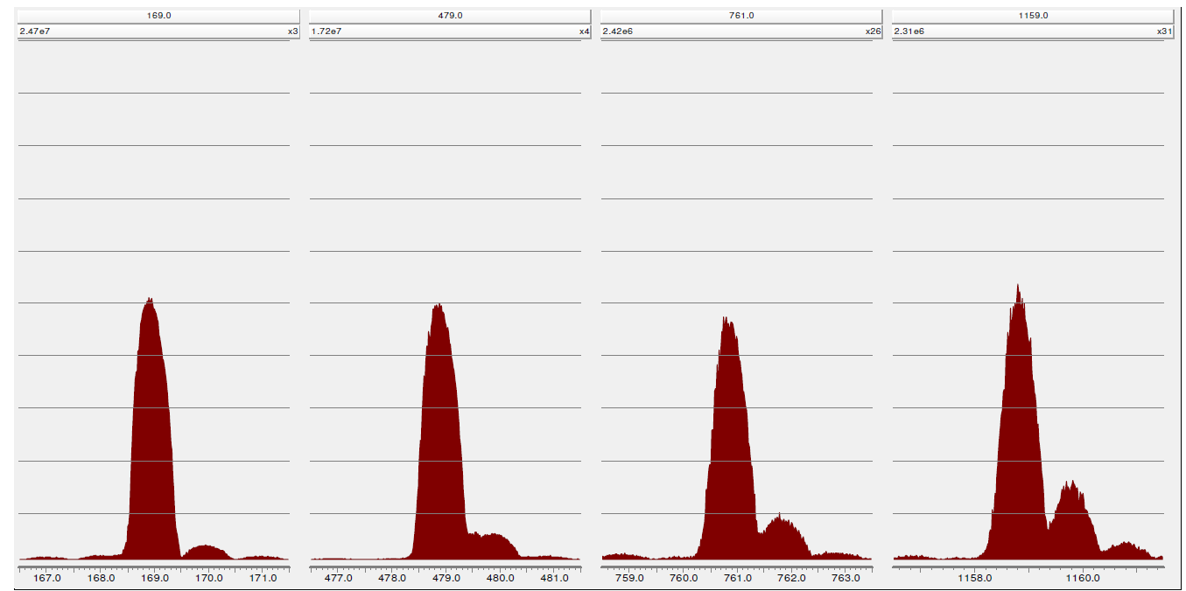
- Close Masslynx and switch off the instrument

Storage of the Test Results
Stock results on network :

- Go on: ETSCSTORAGE01
- Ion block cleaning backup.
- QDA
- Save here

Test Report SQD2 / Xevo TQD

Lot number :

Serial number of Ion block :
Serial number of Hexapole :

Set-up solution :

MS1 tests | m/z  59.05 | m/z  455.27 | m/z  1080.80 | m/z  2034.64
Measured mass (Da)
FWHM (Da)
Peak intensity

Charging test :

%Difference Low mass Pos | %Difference High mass Pos | %Difference Low mass Neg

Name of operator : ...

Signature :

Date : 30-Apr-19

