SUMMARY

SUMMARY 1
1 TESTING THE ZQ/Qmicro ION BLOCK & HEXAPOLE: 2
1.1 Requirement equipment for different Tests : 2
1.2 Changing Ion block and its hexapole 2
1.3 TESTS 3
1.3.1 Initial test : 3
1.3.2 API Set-up Test _ Data processing acquisition 4
1.3.3 Test positive ionization with the probe ESI 6
1.3.4 Test negative ionization with the probe ESI 7
1.3.5 When the test is finished : 7
2 Storage of the Test Results 8

TESTING THE ZQ/Qmicro ION BLOCK & HEXAPOLE:

Requirement equipment for different Tests :

- Allen key of 6
- Allen key of 3
- Gloves
- Safety glasses

Changing Ion block and its hexapole

- Remove the vacuum and lower the source temperature in the tune page.
- Open the window, disconnect the cone gas tubing and unscrew 2 screws which maintain Ion block with its support, with an Allen key of 6.

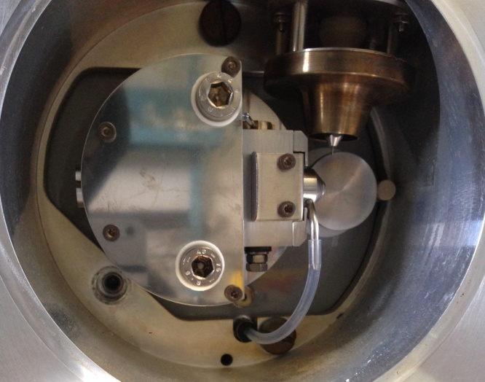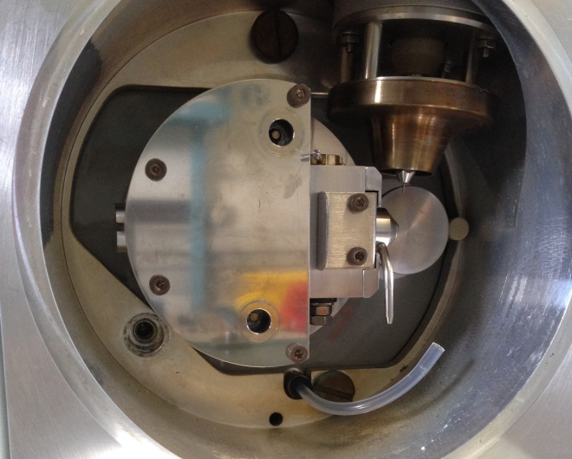

- Take the sample cone and its seal, to take on next Ion block.
- Unscrew the three screws of the Ion block support with an Allen key of 3.

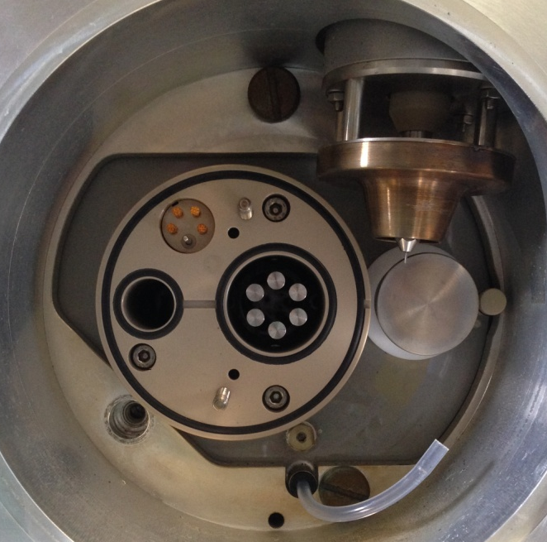
- Take off delicately the hexapole.
- Put a new hexapole in the sense that the springs are in the vertical direction and with the notches on the plastic are backing down. Push until it stops.

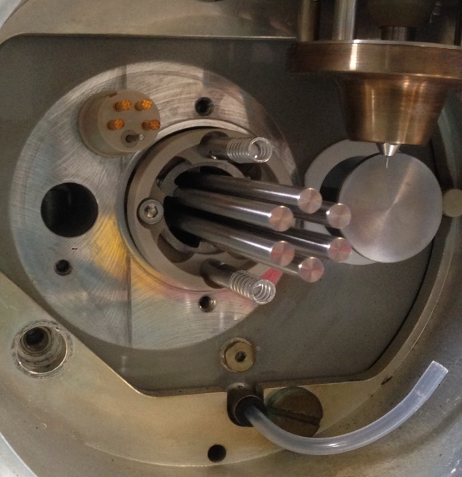
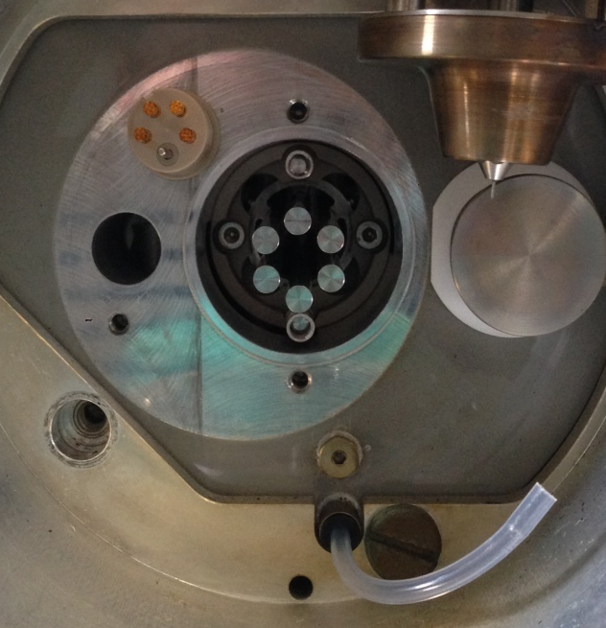

- Screw support and Ion block. And take on place the tubing before close the window.

TESTS

Initial test :

- Start Mass spectrometer and when it has booted, start specific Masslynx for ZQ Mass Spectrometer (SCN 627).
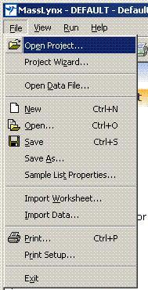
- File, open new project, Ion block cleaning project.
- Project is on the following path:

"ETSC STORAGE 01"
ION BLOCK CLEANING
BACKUP\DATA ZQ\

- Click on tab MS Tune, and Options, Pump ; The vacuum is for at least half a day before starting the tests.
- Click on the LED on the bottom right, to turn green, --> Switches the instrument to operate.

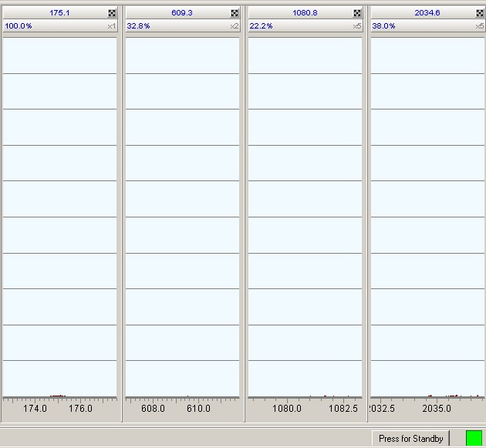

- Clean Hamilton syringe of 250µL (# 5810106) with the test solution.

API Set-up Test _ Data processing acquisition
- In the MS Tune page
- Check that vacuum is on 1.10⁻⁴, and gas valve is open for the nebulisation.

Check the following parameters:

Voltages | Voltage capillary (kV) | 3
 | Cone (V) | 60
 | Extractor (V) | 3
 | RF Lens (V) | 0,1
 | Source Temp | 80
 | Desolvation Temp | 150
Gas flow | Desolvation | 550
 | Cone | 0

- For « Analyser parameters »

Analyser | LM Resolution | 15
 | HM Resolution | 15
 | Ion Energy | 0,8
 | Multiplier | 650
- Use an Api Set-up solution (#700002646-10).
- Infusion flow rate 10uL/min.
- Let flush the capillary.
- Check the mass parameters.
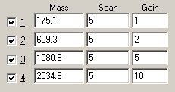
- Check the Beam
- Start the acquisition in the sample set and use "ZQ Cleaning test".

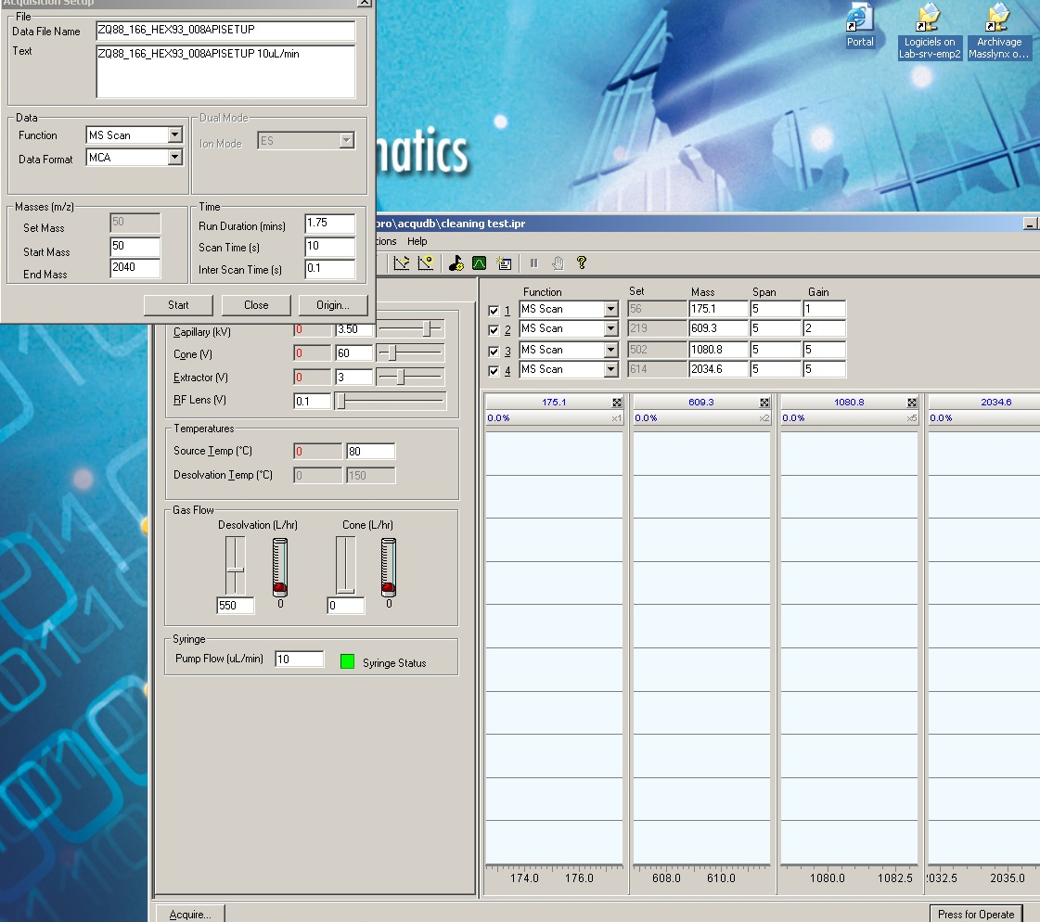

- Go on next Test.

Test positive ionization with the probe ESI

- Open the Tune Page "ESIPOSW".
- Click on the icon "API Gas".
- Fill the syringe of "Daidzein" at 250µg/L, located in the "chimical test kit" P/N : 700002157.
Note : Handling this solution requires wearing protective glasses and nitrile gloves.
Note : To avoid any risk of contamination, it is important to use a different syringe for each sample.
- Adjust the flow of the syringe at 10µL/min. Click on "Operate".
- Optimize the height of the peak at 255.1 Da by the nitrogen flow and the probe position. Then optimize the tensions applied on the cones and the capillary, as well as the nitrogen flow and the ionization energy.
- Adjust the resolution sliders to obtain a width at half height lower than 1.5 Da.
- Select "Acquire" and enter the follow parameters :
Data format : Continuum
Start Mass : 150
End Mass : 650
Scan Time (sec.) : 0.6
Run Duration (min.) : 0.2
Inter Scan Time : 0.1
- Name the file "ESIPOS". In the text window, enter "ESI Positive". Start the acquisition.
- Open the acquisition spectrum. In the menu "Process", select "Combine" and inscribe in "Average" 1 : 18. Select "Smooth" to refine the form of the peaks. Enter the follow parameters :
Window size (scans) : 1.5
Number of Smoothes : 2
Smoothing Method : Savitzky Golay
- Reduce baseline at the lowest level by selecting "Subtract" in the menu "Process". Enter the follow parameters :
Polynomial Order : 1.5
Below Curve (%) : 2
Tolerance : 0.01
Flatten Edges : Do not tick
Make Graph of Polynomial : Do not tick
- Calculate the signal to noise ratio :
- With the mouse pointer, select a portion of baseline between 500 and 600 AMU of width 30 AMU.
- Click on the icon "Magnifier +".
- Select the icon "Stopwatch" to redisplay the spectrum in full scale.
- Click on the icon "Magnifier +" until the portion of baseline selected reaches the peak height at 255.1 Da.
Note : If thereby the bottom part of the noise is located out of the spectrum, it is necessary to remake the manipulation with a smaller subtraction value (below curve %).
- Determine the signal to noise ration by comparing the magnification value at the height of the highest peak.
Specifications : signal to noise ratio ≥ 50 : 1
- Print the Tune Page and the spectrum.
- Enter the initials of the technician for the test "ESI Positive" and inscribe the signal to noise ratio on the test sheet.

Test negative ionization with the probe ESI

- Open the Tune Page "ESINEGW".
- Change the ionization mode in "ESI Negative".
- Open the nitrogen by clicking on "API Gas ON".
- Select "Operate" to apply the tensions.
- Fill the syringe of the sample of Daidzein at 250µg/L. Infuse the sample with a flow of 10µL/min.
- Optimize the height of the peak at 253.1 Da by the nitrogen flow and the probe position. Then optimize the tensions applied on the cones and the capillary, as well as the nitrogen and the ionization energy.
- Click on "Acquire". Enter the follow parameters in the dialog box :
Data Format : MCA
Start Mass : 150
End Mass : 650
Scan time (sec.) : 0.6
Run Duration (min.) : 0.2
Inter Scan time : 0.1
- Name the file "ESINEG". In the text window, enter "ESI Negative". Click on "Start the acquisition".
- In the menu "Process", click on "Smooth" and enter the follow parameters :
Window Size (scans) : 0.5
Number of Smoothes : 2
Smoothing Method : Savitzky Golay
- In the menu "Process", click on "Subtract" to reduce the spectrum baseline to the horizontal axis. Enter the follow parameters :
Polynomial Order : 2
Below Curve (%) : 10
- Select a portion of baseline of 30 AMU between 500 and 650 Da.
- Calculate the signal to noise ratio.
Specifications : signal to noise ratio ≥ 50 : 1.
- Print the Tune Page and the spectrum.
- Enter the initials of the technician for the test "ESI Negative" and inscribe the signal to noise ratio on the test sheet.

When the test is finished :

- Switch the instrument to standby
- Set the source temperature to 25
- Vent the instrument; on MS Tune, Options, Vent.
- Switch off the API gas.
- Open source location once the pump stops working, take off Ion block, its support and the hexapole.

Storage of the Test Results
Stock results on network :

- Go on: ETSCSTORAGE01
- Ion block cleaning backup.
- Specific Ion block of interests.
- Copy here the project

