SUMMARY

SUMMARY 1
1. Testing the QPremier/Xe Ion block & Ion guide 2
1.1. Requirement equipment for different Tests : 2
1.2. Changing Ion block and its Ion guide 2
1.3. TESTS 3
1.3.1. Initial Test 3
1.3.2. API Set-up Test _ Data processing acquisition 4
1.3.3. Charging Test 5
1.3.4. When the test is finished : 11
2. Storage of the Test Results 11

Testing the QPremier/Xe Ion block & Ion guide

Requirement equipment for different Tests :

- Allen key of 6
- Allen key of 3
- Gloves
- Safety glasses

Changing Ion block and its Ion guide

- Remove the vacuum and lower the source temperature in the tune page.
- Open the window, disconnect the cone gas tubing and unscrew 2 screws which maintain Ion block with its support, with an Allen key of 6.

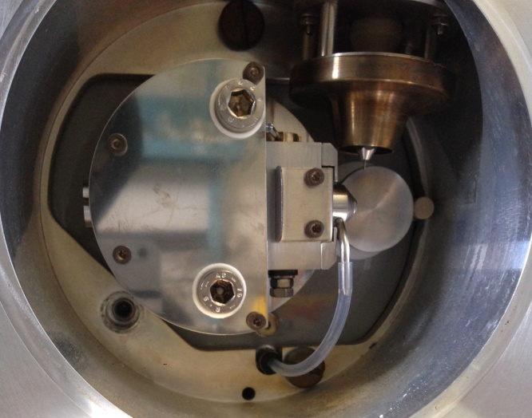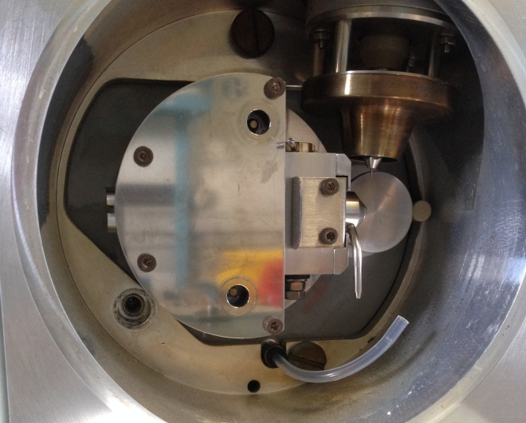

- Take the sample cone and its seal, to take on next Ion block.
- Unscrew three screws on Ion block support with an Allen key of 3.
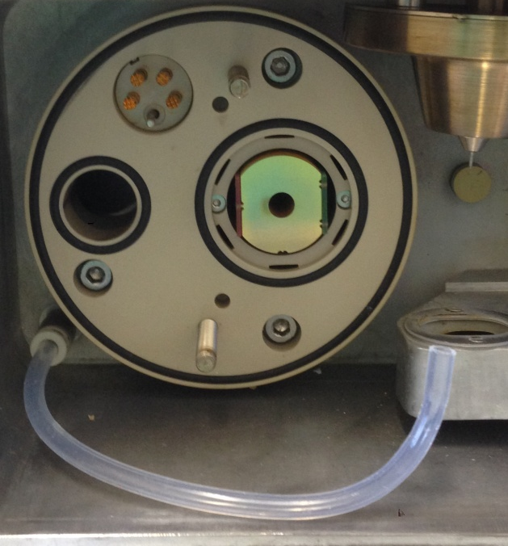
- Take off delicately the ion guide.
- Put a new ion guide in the sense that the TOP brand is above. Push until it stops.

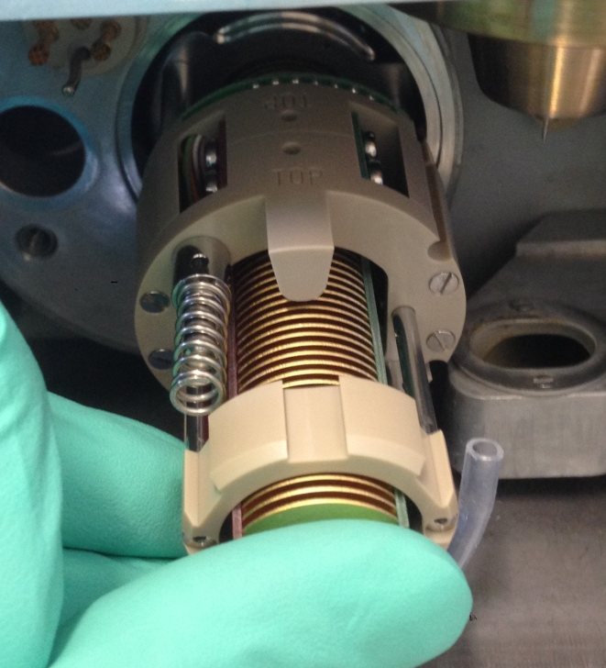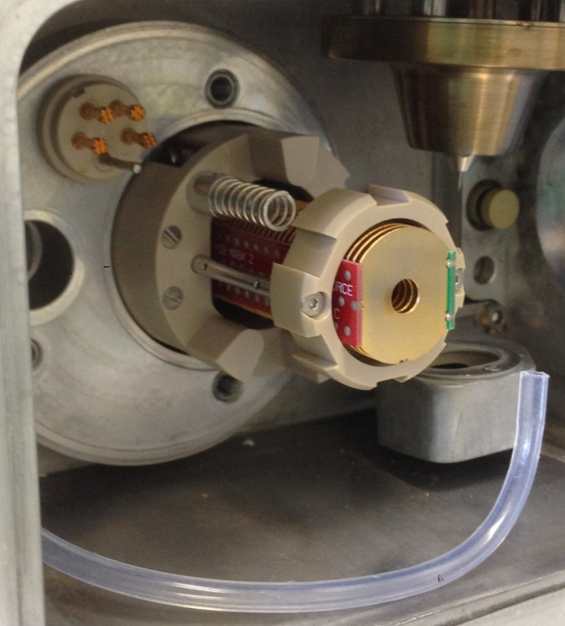

- Screw support and Ion block. Reconnect the cone gas tubing before close the window.

TESTS

Initial Test

- Start Mass spectrometer and when it has booted, start specific MassLynx for QPremier/Xe Mass Spectrometer (SCN 805)
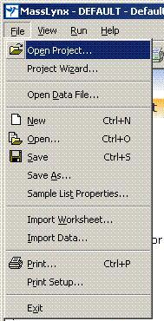
- File, open new project, Ion block cleaning project.
- Project is on the following path:

"ETSC STORAGE 01"
ION BLOCK CLEANING
BACKUP\DATA QPre\

- Click on tab MS Tune, and Options, Pump ; The vacuum is for at least half a day before starting the tests.

- Click on the LED on the bottom right, to turn green, --> Switches the instrument to operate.

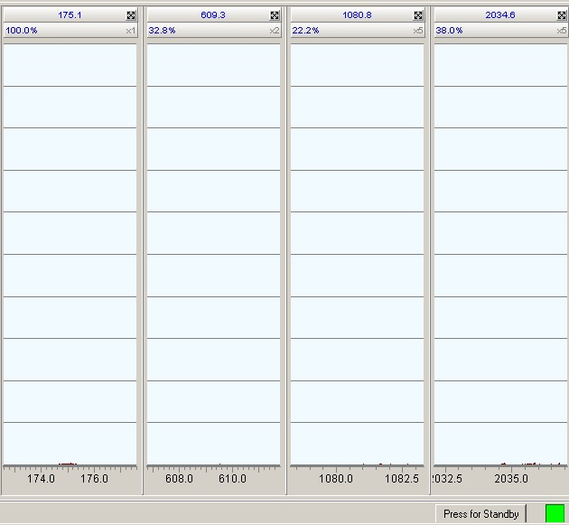

- Clean Hamilton syringe of 250µL (# 5810106) with the test solution.

API Set-up Test _ Data processing acquisition

- In the MS Tune page
- Check that vacuum is on 1.10⁻⁴, and gas valve is open for the nebulisation.

Check the following parameters:

Voltages | Voltage capillary (kV) | 3
 | Cone (V) | 60
 | Extractor (V) | 3
 | RF Lens (V) | 0,1
 | Source Temp | 80
 | Desolvation Temp | 150
Gas flow | Desolvation | 550
 | Cone | 0

- For « Analyser parameters »,

Analyser | LM Resolution | 15
 | HM Resolution | 15
 | Ion Energy | 0,8
 | Multiplier | 650

- Use an Api Set-up solution (#700002646-10).
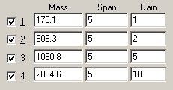
- Infusion flow rate 10uL/min.
- Let flush the capillary.
- Check the Beam
- Start the acquisition in the sample set and use "Q 1er Cleaning Test".

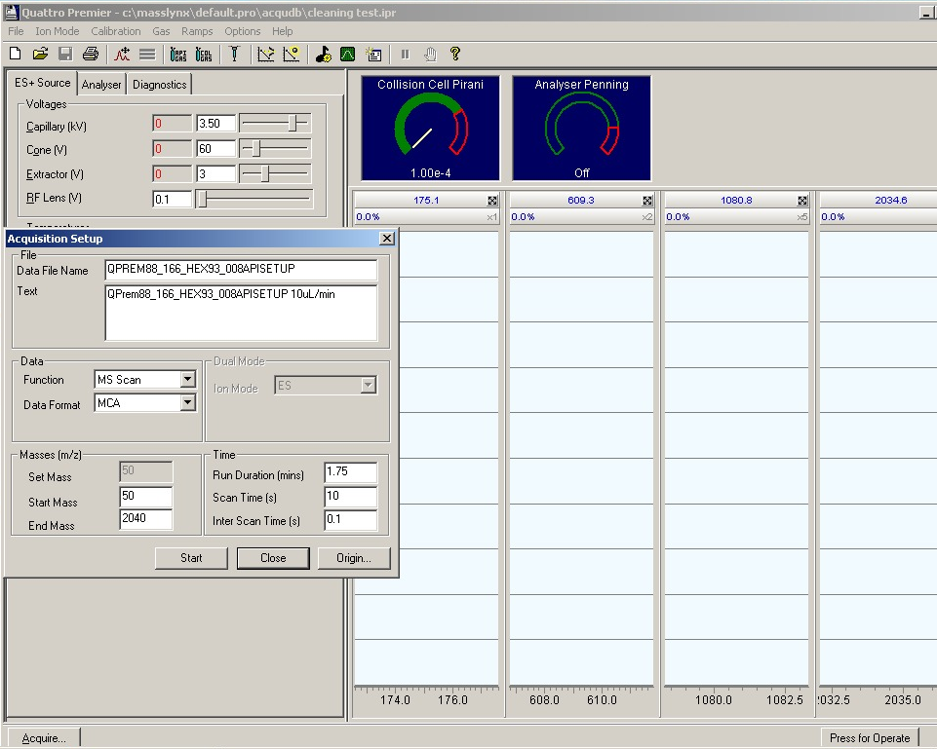

- Go on next Test.

Charging Test

CAUTION : Ensure that the instrument has been pumping for at least 2 hours before running the charging test.
Positive ion beam test
Switch on the API gas, place the instrument into Operate, and then infuse the Api Set-up solution QPrem/XE SQD/TQD at 10 μL/min.

1. Set the Desolvation temperature and gas flow rate to the same values in the ESI positive and the ESI negative tunes pages (250 L/hr, 150 °C).
2. On the Tune page, set the following parameters:
Tune page parameters

Function | Set | Mass | Span | Gain
MS1 Scan | n/a | 175.1 | 5 | 10
MS1 Scan | n/a | 455.27 or 609.3 | 5 | 10
MS1 Scan | n/a | 1080.8 | 5 | 10
MS1 Scan | n/a | 2034.62 | 5 | 15

3. Optimize the capillary voltage.
4. Set the following parameters:
- Sample cone voltage 60 V
- MS1 LM resolution 15
- HM resolution 15

5. Set the ion energy to the optimum for the instrument.
6. Click Ion mode > ESI –ve ion and check for a beam in negative ion.
7. Set the following masses:
- Window 1 59 Da
- Window 2 255.3 Da
- Window 3 554.3 Da

8. Optimize the capillary voltage.
9. Set the following parameters:
- Sample cone voltage 40 V
- MS1 LM resolution 15
- HM resolution 15

10. Set the ion energy to the optimum for the instrument.

Preparation
1. Create the following MS method experiment file for positive, and after one for negative Ion beam.

NOTE : Each Function has the parameters MS1 mode, Continuum, scan time of 0.5 seconds.
Function | ES Mode | Start Time | End Time | Start Mass | End Mass
1 | Positive | 0.50 | 1.00 | 55.00 | 65.00
2 |  | 5.50 | 6.00 | 55.00 | 65.00
3 |  | 0.30 | 0.40 | 55.00 | 65.00
4 |  | 1.00 | 5.50 | 55.00 | 65.00
5 |  | 0.50 | 1.00 | 2030.00 | 2040.00
6 |  | 5.50 | 6.00 | 2030.00 | 2040.00
7 |  | 0.30 | 0.40 | 2030.00 | 2040.00
8 |  | 1.00 | 5.50 | 2030.00 | 2040.00
1' | Negative | 6.10 | 6.20 | 55.00 | 65.00
2' |  | 6.30 | 6.80 | 55.00 | 65.00
3' |  | 0.00 | 0.30 | 55.00 | 65.00
4' |  | 11.80 | 12.30 | 55.00 | 65.00
5' |  | 6.80 | 11.80 | 55.00 | 65.00
6' |  | 11.80 | 12.30 | 2030.00 | 2040.00
7' |  | 6.30 | 6.80 | 2030.00 | 2040.00
8' |  | 6.10 | 6.20 | 2030.00 | 2040.00
9' |  | 0.00 | 0.30 | 2030.00 | 2040.00
10' |  | 6.80 | 11.80 | 2030.00 | 2040.00

2. Change the inter-scan delay to duplicate the Tune page.
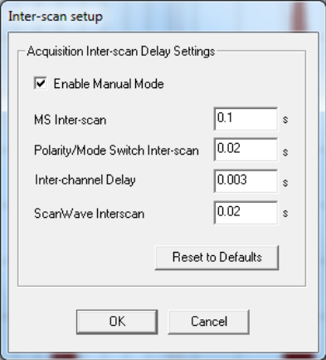
Figure 1 - Inter-scan setup dialog

CAUTION : Once the charging test is complete, the inter-scan delay must be reset to the state (automatic or manual) used by the customer.

3. Use this experiment file in the sample list page.
4. Ensure that the file name represents the serial number of the instrument.
5. Save the sample list.

Acquisition

1. Set fluidics to Infusion.
2. Set a flow rate of 10 μL/min and start the infusion.
3. Start the acquisition on ES+, and after the ES-.

Processing

1. Open the chromatogram TIC functions shown in Table : Chromatogram TIC functions

Function Number | ESI Mode | Description
1 | Positive | Low mass intensity at start of run
2 | Positive | Low mass intensity at end of run
5 | Positive | High mass intensity at start of run
6 | Positive | High mass intensity at end of run
Function Number | ESI Mode | Description
2' | Negative | Low mass intensity at start of run
4' | Negative | Low mass intensity at end of run

2. Use Global / Replace and Smooth all the chromatograms using the settings in Figure 2 :

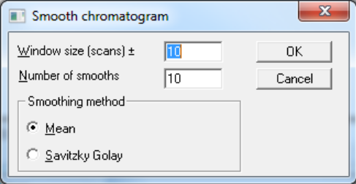
Figure 2 - Smooth chromatogram settings

3. Calculate the % difference between the following functions, using the equation:
- Functions 1 and 2 (Low mass Positive Ion mode on positive chromatogram)
- Functions 5 and 6 (High mass Positive Ion mode on positive chromatogram)
- Functions 2' and 4' (Low mass Negative Ion mode on Negative chromatogram)

% Difference = 100 x ((End of run smoothed TIC Intensity /Start of run smoothed TIC Intensity ) - 1)

NOTE: Negative % results = loss of intensity over time. Positive % results = a gain of intensity over time.

Specification

If any of the traces are outside the following tolerances, then charging is present.

- Functions 1 and 2 must not exceed -18% to +13%
- Functions 5 and 6 must not exceed -23% to +27%
- Functions 2' and 4' must not exceed -19% to +15%

1. If the charging test fails, clean the collision cell, check the quadrupole for ion burn, and clean if necessary.
2. Repeat the charging test as described above.

Report and printout :

Screen capture and print the chromatogram in portrait configuration and label with the ION block serial number and their respective % Difference values.
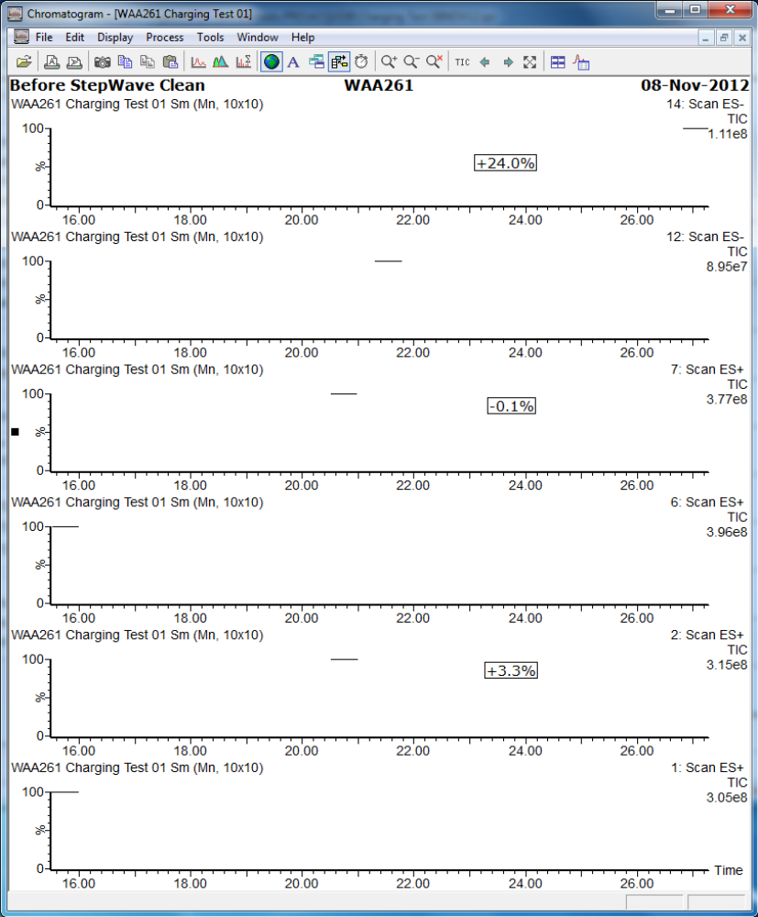

Figure 3 - Example of Charging Test Chromatogram
CAUTION : Once the charging test is complete, the inter-scan delay must be reset to the state (automatic or manual) used by the customer.

When the test is finished :

- Switch the instrument to standby.
- Set the source temperature to 25.
- Vent the instrument; on MS Tune, Options, Vent.
- Switch off the API gas.
- Open source location once the pump stops working, take off Ion block, its support and the ion guide.

Storage of the Test Results

Stock results on network :

- Go on: ETSCSTORAGE01
- Ion block cleaning backup.
- Specific Ion block of interests.
- Copy here the project.

Test Report Qpremier/XE

Lot number :

Serial number of Ion block :
Serial number of Ion guide :

Tested on Qpremier/XE S/N : VAB325

Set-up solution :

MS1 tests | m/z  175.13 | m/z  609.30 | m/z  1080.80 | m/z  2034.64
Measured mass (Da)
FWHM (Da)
Peak intensity

Charging test :

%Difference Low mass + mode | %Difference High mass + mode | %Difference Low mass - mode

Name of operator : ....

Signature :

Date : 16/03/2017

