SUMMARY

SUMMARY 1
1. TESTING THE XEVO TQS ION BLOCK & STEPWAVE 2
1.1. Requirement equipment for different tests 2
1.2. Changing ion block and its hexapole 2
1.3. Tests 3
1.3.1. Initial test 3
1.3.2. API set-up test _ Data processing aquisition 4
1.3.3. Charging test 5
1.3.4. When the test is finished 11
2. STORAGE OF THE TEST RESULTS 11

- TESTING THE XEVO TQ-S ION BLOCK & STEPWAVE

Requirement equipment for different tests

- Allen key of 2.5 mm
- Allen key of 3 mm
- Gloves
- Safety glasses

Changing ion block and its hexapole

- Remove the vacuum.

- Open the isolation chamber, unscrew 4 screws which maintain ion block with its support, with an Allen key of 2.5 mm.

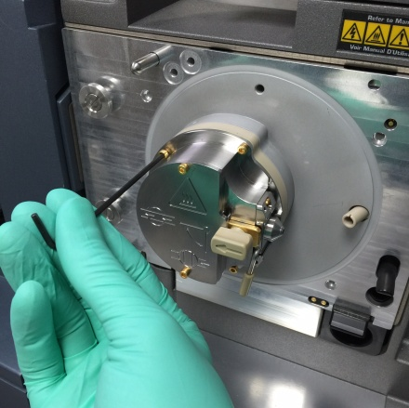

- Unscrew the four screws of the ion block support with an Allen key of 3 mm.

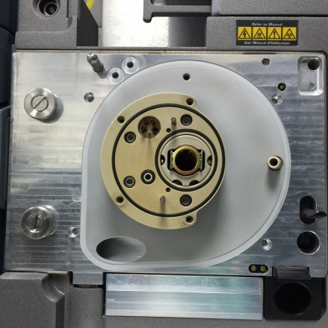

- Take off delicately the stepwave with the helper tool.

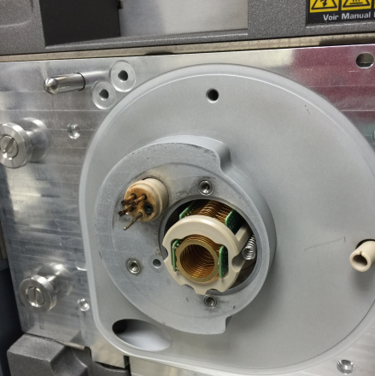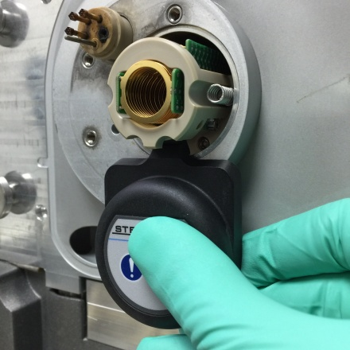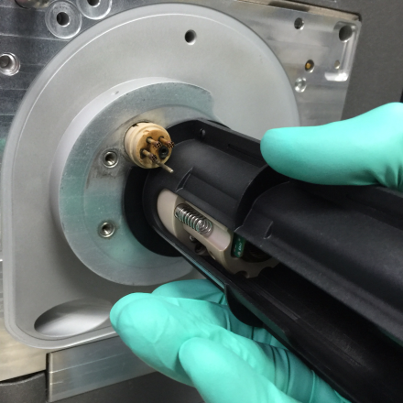

- Put a new stepwave with the same tool. Push until it stops.

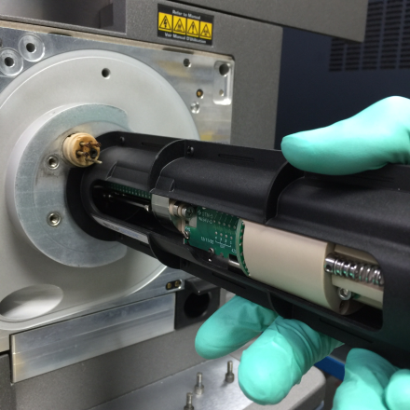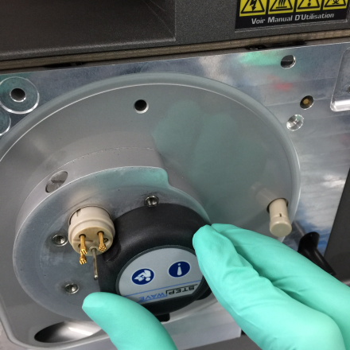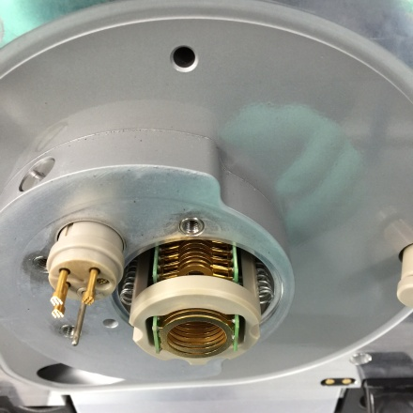

- Screw support and ion block.

- Close the isolation chamber.

Tests

Initial test

- Start Mass spectrometer and when it has booted, start specific Masslynx for Xevo TQ-S Mass Spectrometer (SCN 905).

- File, open new project, ion block cleaning project.

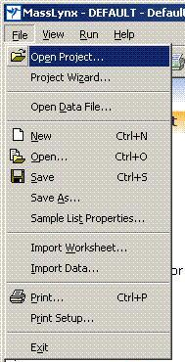
- Project is on the following path :

"ETSC STORAGE 01"
ION BLOCK CLEANING
BACKUP\DATA Xevo TQS\

- Click on tab MS Tune, and Vacuum Pump ; The vacuum is for at least 2 hours before starting the test.

- Click on the LED on the bottom right, to turn green => Switches the instrument to operate.

API set-up test _ Data processing acquisition

- In the MS Tune page.

- Check that vacuum is on and gas valve is open for the nebulisation.

- Analyser M52 Penning : 1.10⁻⁵
- Ion guide pinami : 5.10⁻³
- Collision cell pinami : 2.10⁻⁴

- Check the following parameters :

Voltages | Capillary (kV) | 3.50
Voltages | Cone (V) | 80
Voltages | Source offset (V) | 60
Temperatures | Desolvation temp (°C) | 200
Gas flow | Desolvation (L/Hr) | 550
Gas flow | Cone (L/Hr) | 150
Gas flow | Nebuliser (Bar) | 7

- For "Analyser parameters" :

LM Resolution 1 | 3
HM Resolution 1 | 15
Ion Energy 1 | Adjust it (see after table)

- Use an API set-up solution (#700002646-10).

- Infusion flow rate 10µL/min.

- Let flush the capillary.

- Adjust ion energy :

- Select only 1080.8 Da on one window.
- Increase ion energy at 2V.
- Adjust the peak to have it in 100% of the window.
- Reduce ion energy to have 5% of original peak.
- Add 5 units.
- You have optimal ion energy.
- Select all windows with all masses : 59 Da ; 455.3 Da ; 1080.8 Da ; 2034.6 Da.

- Check the mass parameters.

- Check the Beam.

- Start the acquisition in the sample set and use "Xevo TQS Cleaning Test".

- Go on next test.

Charging test

CAUTION : Ensure that the instrument has been pumping for at least 2 hours before running the charging test.

Positive ion beam test

Switch on the API gas, place the instrument into Operate, and then infuse the API set-up solution Xevo TQS at 10 µL/min.

- Set the Desolvation temperature and gas flow rate to the same values in the ESI positive and the ESI negative tunes pages (250 L/hr, 150°C).

- On the tune page, set the following parameters :

Function | Set | Mass | Span | Gain
MS1 Scan | N/A | 59 | 5 | 10
MS1 Scan | N/A | 455.27 | 5 | 10
MS1 scan | N/A | 1080.8 | 5 | 10
MS1 Scan | N/A | 2034.62 | 5 | 15

- Optimize the capillary voltage.

- Set the following parameters :

- Sample cone voltage : 80V
- MS1 LM resolution 3
- HM resolution 15

- Set the ion energy to the optimum for the instrument.

- Click ion mode > ESI -ve ion and check for a beam in negative ion.

- Set the following masses :

- Window 1 59 Da
- Window 2 255.3 Da
- Window 3554.3 Da

- Optimize the capillary voltage.

- Set the following parameters :

- Sample cone voltage 40V
- MS1 LM resolution 3
- HM resolution 15

- Set the ion energy to the optimum for the instrument.

Preparation

- Create the following MS method experiment file for positive, and after one for negative ion beam.
NOTE : Each function has the parameters MS1 mode, Continuum, Scan time of 0.5 seconds.

Function | ES Mode | Start Time | End Time | Start Mass | End Mass
1  2  3  4  5  6  7  8 | Positive | 0.50  5.50  0.30  1.00  0.50  5.50  0.30  1.00 | 1.00  6.00  0.40  5.50  1.00  6.00  0.40  5.50 | 55.00  55.00  55.00  55.00  2030.00  2030.00  2030.00  2030.00 | 65.00  65.00  65.00  65.00  2040.00  2040.00  2040.00  2040.00

9  10  11  12  13  14  15  16  17  18 | Negative | 6.10  6.30  0.00  11.80  6.80  11.80  6.30  6.10  0.00  6.80 | 6.20  6.80  0.30  12.30  11.80  12.30  6.80  6.20  0.30  11.80 | 55.00  55.00  55.00  55.00  55.00  2030.00  2030.00  2030.00  2030.00  2030.00 | 65.00  65.00  65.00  65.00  65.00  2040.00  2040.00  2040.00  2040.00  2040.00

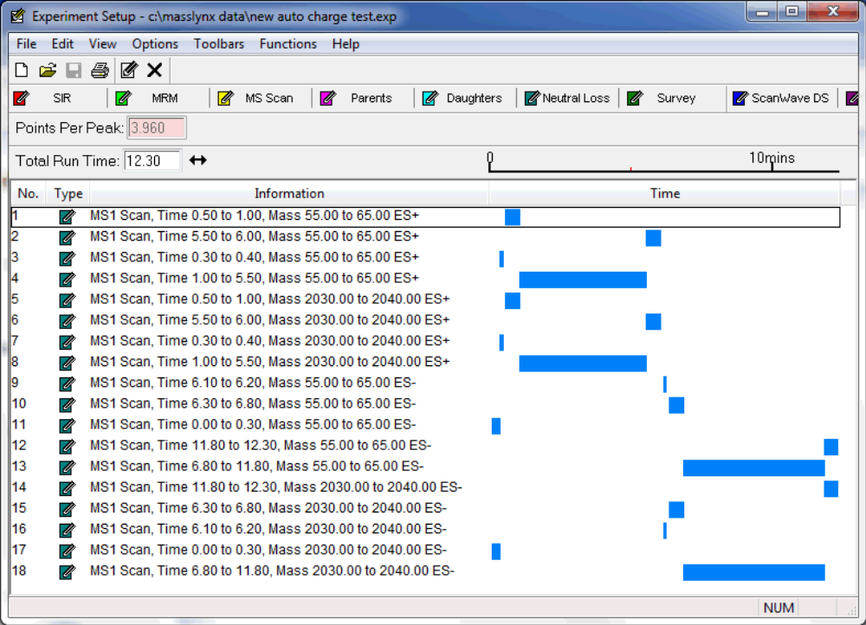
MS method experiment

- Change the inter-scan delay to duplicate the tune page.

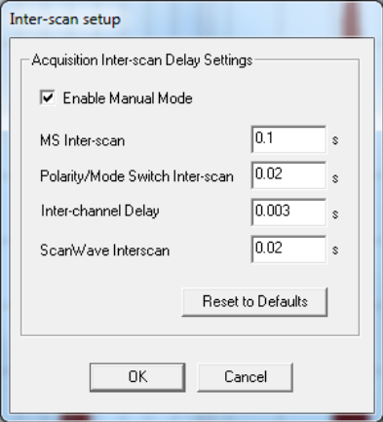
Figure 1 : Inter-scan setup dialog

CAUTION : Once the charging test is complete, the inter-scan delay must be reset to the state (automatic or manual) used by the customer.

- Use this experiment file in the sample list page.

- Ensure that the file name represents the serial number of the instrument.

- Save the sample list.

Acquisition

- Set fluidics to infusion.

- Set a flow rate of 10µL/min and start the infusion.

- Start the acquisition.

Processing

- Open the chromatogram TIC functions shown in table :

Function Number | ESI Mode | Description
1 | Positive | Low mass intensity at start of run
2 | Positive | Low mass intensity at end of run
5 | Positive | High mass intensity at start of run
6 | Positive | High mass intensity at end of run
10 | Negative | Low mass intensity at start of run
12 | Negative | Low mass intensity at end of run

- Use Global / Replace and Smooth all the chromatograms using the setting in Figure 2 :

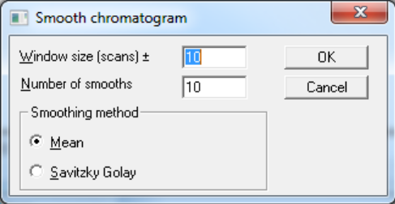
Figure 2 : Smooth chromatogram settings

- Calculate the % difference between the following functions, using the equation :

- Functions 1 and 2 (Low mass positive ion mode on positive chromatogram)
- Functions 5 and 6 (High mass positive ion mode on positive chromatogram)
- Functions 10 and 12 (Low mass negative ion mode on negative chromatogram)

% Difference = 100 X ((End of run smoothed TIC Intensity/Start of run smoothed TIC Intensity) - 1)

NOTE : Negative % results = loss of intensity over time.
Positive % results = a gain of intensity over time.

Specification

If any of the traces are outside the following tolerances, then charging is present.

- Functions 1 and 2 must not exceed -18% to +13%
- Functions 5 and 6 must not exceed -23% to +27%
- Functions 10 and 12 must not exceed -19% to +15%

- If the charging test fails, clean the collision cell, check the quadrupole for ion burn, and clean if necessary.

- Repeat the charging test as described above.

Report and printout

Screen capture and print the chromatogram in portrait configuration and label with the Ion block serial number and their respective % Difference values.

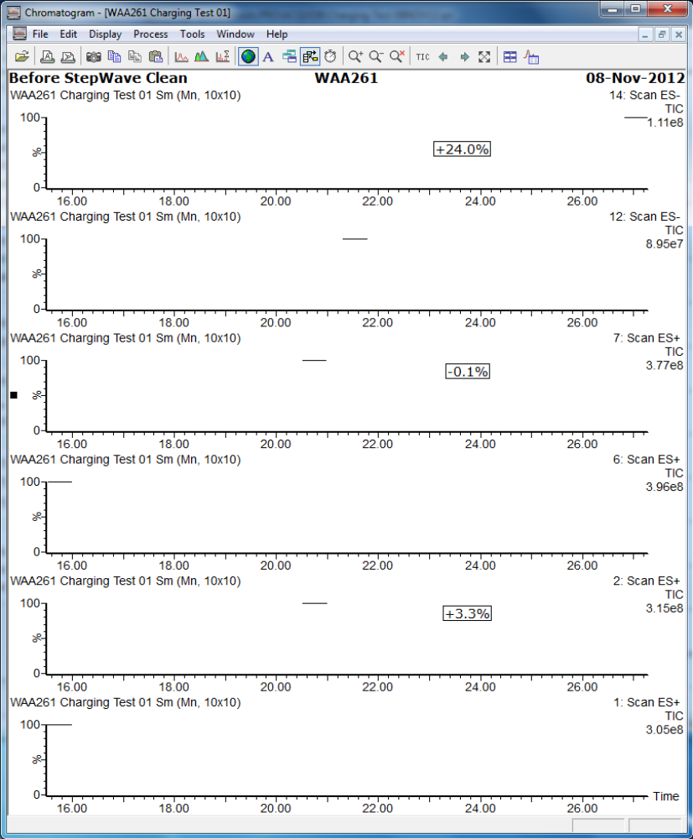
Figure 3 : Example of charging test chromatogram

CAUTION : Once the charging test is complete, the inter-scan delay must be reset to the state (automatic or manual) used by the customer.

When the test is finished

- Switch the instrument to standby
- Vent the instrument : on MS tune, vacuum, vent
- Switch off the API gas
- Open source location once the pump stops working, take off ion block, its support and the stepwave

- STORAGE OF THE TEST RESULTS

Stock results on network :
- Go on : ETSCSTORAGE01
- Ion block cleaning backup
- Specific ion block of interests
- Copy here the project

Test Report

Lot number :

Serial number of Ion block :
Serial number of Stepwave :

Tested on Xevo TQS S/N : WAA139

Set-up solution :

MS1 tests | m/z  59.05 | m/z  455.27 | m/z  1080.80 | m/z  2034.64
Measured mass (Da)
FWHM (Da)
Peak intensity
MS2 tests | m/z  59.05 | m/z  455.27 | m/z  1080.80 | m/z  2034.64
Measured mass (Da)
FWHM (Da)
Peak intensity

Charging test :

%Difference 1-2 | %Difference 5-6 | %Difference 10-12

Name of operator : ...

Signature :
Date : 16-Mar-17

