These are CARRLANE COMPONENTS
https://www.carrlane.com/en-us/product/spring-loaded-devices/hand-retractable-plungers/hand-retractable-plungers-knurled-head-locking-type/hand-retractable-plungers-knurled-head-locking-type
Part Number: CL-6-HRP
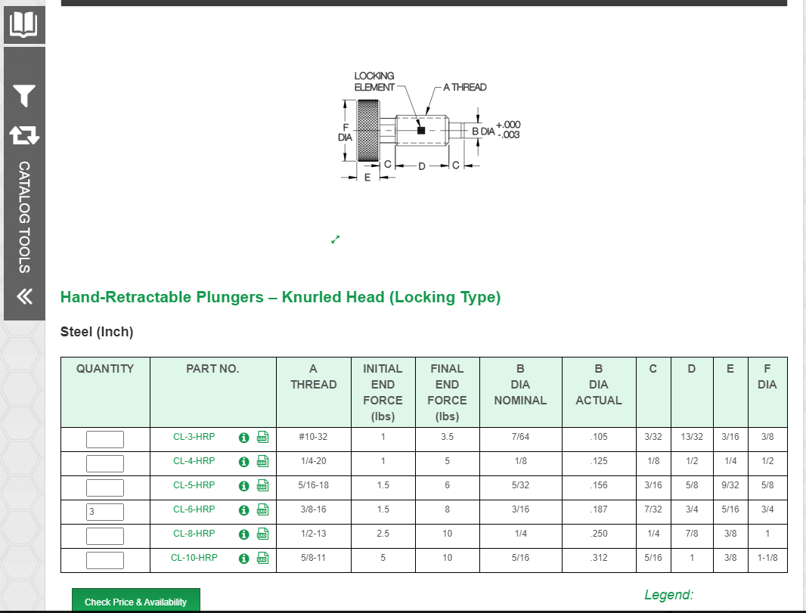
https://www.carrlane.com/en-us/product/handles-knobs-screw-clamps/knurled-knobs-screw-clamps/swivel-head-screws/swivel-head-screws-large-foot
Part Number: CL-17-SHS
