

34 Maple Street Milford, MA 01757-3696 U.S.A.
[T] 508.478.2000 [T] 1.800.252.4752 [F] 508.872.1990 [W] www.waters.com
To: File located in SAP DIR TE0082943EQ
From: Ed Jackson
Date: 24 Jan 2017
Re: Acquity BSM Seal Wash pump flow rate testing on TE82943 Tester

Conclusion
The seal wash pump test acceptance criteria range (2-5mL/min) is suitable for evaluating the seal wash pump fluid path assembly and the seal wash pump component (PN WAT270594) with the Acquity BSM i-class pump (PN 186015000 (IVD)) and Acquity BSM pump (PN 186015001).

Objective
The objective of this report is to describe the acceptance criteria development of a test as a Production Support Check (PSC) for the evaluation of the Seal Wash Pump (PN WAT270594) installation performed during manufacturing testing of the Acquity BSM i-class pump (PN 186015000(IVD)) and Acquity BSM pump (PN 186015001) assembly.

Background
The function of the Seal Wash Pump is to wash the seals within all four actuators of the Acquity BSM pumps. The seal wash flow path does not enter the solvent or sample path. The seal wash pump system is specified to have range of 0.030-0.100 mL/pulse per the Functional Specifications Document (FSD) 721001454.

Summary and Recommendations
The seal wash pump manufacturing acceptance criteria range, 2-5 mL/min as measured via test, indirectly correlates within the 0.030-0.100 mL/pulse component level specification set forth in the Functional Specification Documentation. The testing method sets the pump pulse rate of 60 pulses per minute, which would translate the specifications to a 1.8-6mL/min flow rate at the component level. The testing criteria are set tighter than the component specification. These tighter limits are to compensate for the modest backpressure within the system and tester fluid path produced while testing as well as other minor sources of system variation that would affect the flow measurement. These acceptance criteria for testing the seal wash pump component and the seal wash path is considered acceptable by Research and Development, Test and Quality Engineering.

Test Method Development
The final instrument seal wash pump test strategy is to run the seal wash pump at 60 pulse/min flow rate (“swpprime” command) for manufacturing test and measure the flow using a mass-based calculation method. The seal wash flow path will be routed to the balance and the flow rate will be calculated, as done with all the Acquity pump flow rate testing.

System Diagram
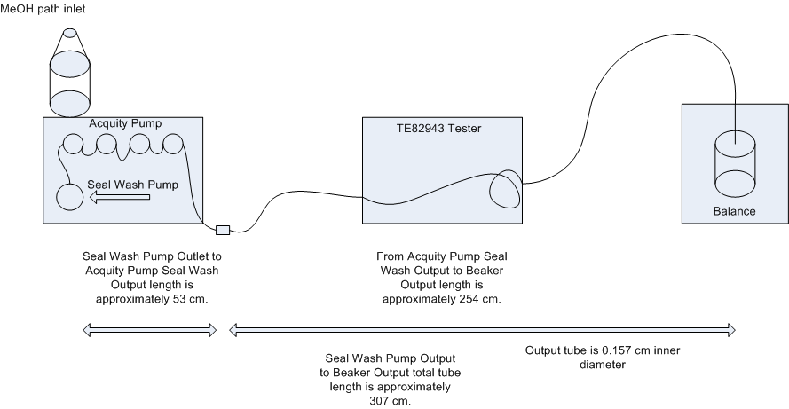
h₁ = Approximately
15 cm
h₂ = Approximately
15 cm

Using the component specification for WAT270594, the minimum and maximum flow rates calculate as follows.
Equation 1. Flow Calculation for lower specification limit
$$Lower Specification Limit (LSL) =0.030 \frac{mL}{pulse} * 60 pulses = 1.8 \frac{mL}{min}$$
Equation 2. Flow Calculation for upper specification limit
$$Upper Specification Limit (USL) = 0.100\frac{ mL }{pulse}* 60 pulses = 6 \frac{mL}{min}$$

Simplified Back pressure calculations

Assumptions
Fluid temperature = 20 °C
Testing fluid = methanol
Testing fluid is considered incompressible
Diameter of tubing is uniform
All measurements are approximate

Variables and Constants

¹Density (ρ) = 0.79 g/mL
²Gravitational acceleration (g) = 980.7 cm/s²

Height (h₁,h₂) = 15cm, 15cm
Flow Rate at USL (Q) = 6 mL/min = 0.1cm³/s
Length of Tube (L) = 307cm
Diameter of tube (D) = 0.157cm
¹Viscosity of Methanol (ƞ) = 0.6 mPa*s =0.006 g/(cm*s) Cross-sectional Area (A)

Equation 3. Velocity Calculation
$V=\frac{Q}{A}$
$$=\frac{Q}{{(D/2)}^{2}π}$$
$=\frac{0.1{cm}^{3}/s}{{(0.157cm/2)}^{2}π}$
$$=5.2 cm/s$$

Equation 4. Reynolds Number to determine if there is laminar or turbulent flow
$$Re= \frac{ρD\left|V\right|}{η}$$
$=\frac{\left(0.79\frac{g}{{cm}^{3}}\right)\left(0.157cm\right)(5.2 \frac{cm}{s})}{0.006 \frac{g}{cm*s} }$
$=107.5 → Re < 2100, which in a tube is considered laminar flow$ ²

Equation 5:
$Height Differential { Pressure }_{h1+h2}=ρ\left(h_{1}+h_{2}\right)$g
$=0.79\frac{g}{{cm}^{3}}\left(15cm+15cm\right)*980.7 \frac{cm}{s^{2}}$
$= 2.3 kPa=0.33psi$

Equation 6: Fluid resistance back pressure through the Hagen–Poiseuille equation
$$Fluid Resistance Pressure =\frac{8ηLQ}{πr^{4}}$$
$$=\frac{8ηLQ}{πr^{4}}$$
$$=\frac{8* 0.6mPa(s)* 307cm*0.1{cm}^{3}/s }{π{*\left(\frac{0.157}{2}cm\right) }^{4}}$$
$=$1.23 kPa = 0.18 psi
Equation 5: Total Back Pressure for pump to overcome to maintain specified flow rate
$$Total Back Pressure= Fluid Resistance+ Pressure Height Differential { Pressure }_{h1+h2}$$
$$= 0.18 psi+ 0.33psi$$
$$= 0.18 psi+ 0.33psi$$
$=0.51psi →Considered negliable compared with pump output$
Specification limits of the seal wash pump component range from 1.8-6mL/min (equations 1 and 2). These component level specifications were translated to a tighter range of 2-5mL. These tighter specifications are to account for marginal back pressure, temperature, and other sources of variation within the flow measurement produced through BSM system testing.

References:
- Yaw C., 2012, Yaw’s Critical Property Data for Chemical Engineers and Chemists, Knovel, Norwich NY
- 2. Kaminski, D., 2000, Introduction to Thermal and Fluids Engineering, Wiley and Sons, USA

