

34 Maple Street Milford, MA 01757-3696 U.S.A.
[T] 508.478.2000 [T] 1.800.252.4752 [F] 508.872.1990 [W] www.waters.com
To: File located in SAP DIR TE0082943EQ
From: Ed Jackson
Date: Jan 24, 2017
Re: Rationale to justify Acquity BSM pump High Pressure testing on the TE82943 Tester.

Objective
The object of this report is to describe the test method and justification of a test as a Production Support Check (PSC) for performing high pressure testing of the Acquity BSM pump, PN 186015000, PN 186015000IVD, and PN 186015001.

Background
The High Pressure Test is performed on the BSM pump at the end of all of the flow rate and dynamic leak testing. The intent of this test is to provide confidence in the instrument build by running the instrument at a moderate flow rate at high back pressure. The back pressure is read after a two minute run to determine if the instrument is operating as expected.

Results and Discussion
The High Pressure test is run at a flow rate of 1.0 mL/min. using 100% MeOH.
For PN 186015000 and PN 186015000IVD, the maximum back pressure specification is 18,000 PSI for the 1.0 mL/min. flow rate. This specification can be referenced in the Functional Specification Document (FSD) 721001454 section 5.3.11.

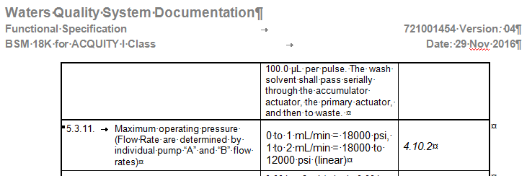

For PN 186015001, the maximum back pressure specification is 15,000 PSI for the 1.0 mL/min. flow rate. This specification can be referenced in the Functional Specification Document (FSD) dated July 13, 2004 Rev.01 – Figure 1 Flow Rate/Pressure Envelope Diagram.

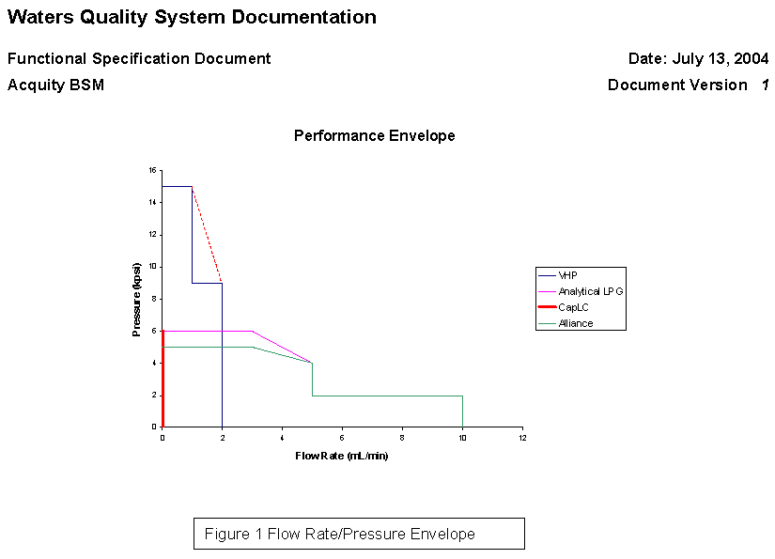

The High Pressure test is performed using restrictor #3 in TE82943 test box. This test station restrictor when using 100% MeOH and flowing at 1.0 mL/min. flow rate will produce a back pressure of approximately 11,287 PSI (see table below). Slight variations (±1,000 PSI) around this value will occur due to slight variations in exact lengths, diameter tolerances, and small particulates within the restrictor.

TE82943 Restrictor #3 specification:
R3: 10,000 PSI, 47" (120 cm) of 50um ID PEEKsil, (old PN SGE OT03016) new PN Trajan PN 0624400

Back Pressure Calculation, according to the Hagen-Poiseuille equation: $Q= \frac{πR^{4}}{8νL} Δp$
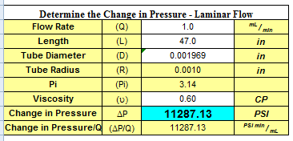

Test limits of 9,000 PSI to 14,500 PSI were chosen to represent a window sufficiently large enough to accommodate any variability across multiple testers and to confirm the pump is flowing at a high back pressure.

Conclusions
The High Pressure test for the BSM pump is designed to provide an extra layer of confidence in the instrument build. The test limits are margined wide enough to allow for any large variation in the restrictors used across all of the TE82943 test boxes. A failure of this test will occur if the BSM goes into an alarm state and shuts down, in which the back pressure will drop to a reading near zero as a result.
An instrument would have proven to have tight seals and able to produce correct flow rates due to passing previous tests. This test checks for the ability of the BSM to sustain high pressure. Long-term functionality of the pump has been determined by reliability, and is outside of the scope of a manufacturing test.

