Upgrading a CPSM
  - (TE83064-7 was converted to TE084050-10 for this guide)

Disassembly
- Remove the Top Panel and set it aside for reuse.
- Unscrew the 3 connections from the Old Power Panel.
- Disconnect the wires from the AC Power Inlet. In this case, the wires needed to be cut. They will be reattached later.
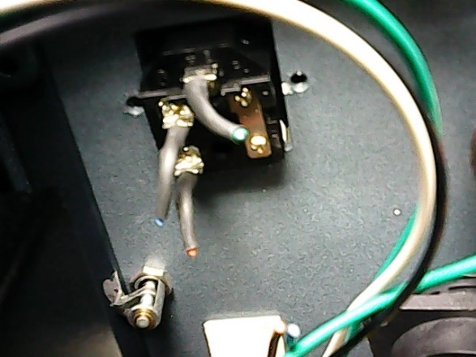
- Remove the Old Power Panel. It can be discarded.
- Disconnect the 3 connections to the Custom Ecord Board.
- Remove the Custom Ecord Panel leaving the Custom Ecord Board screwed in place. This section will be reused.
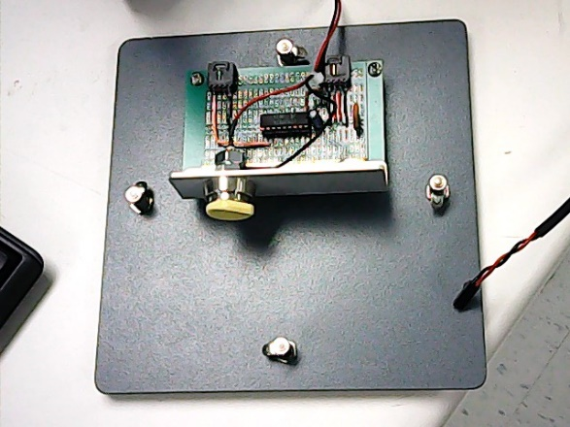
- Pop out the VICI 10 Pin Cord from the Back Panel.
- Disconnect the Back Panel.

- Unscrew the Column Heater Board (to be reused) and discard the Back Panel.
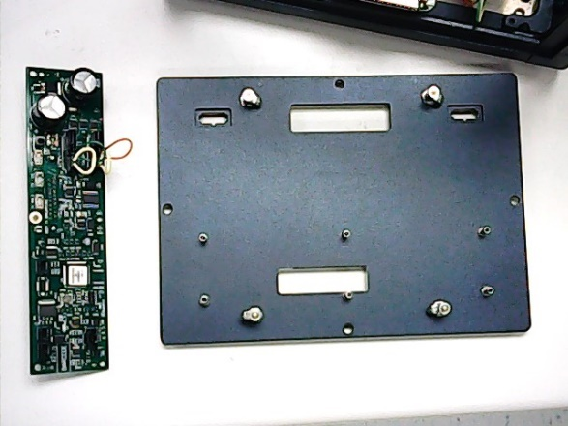
- Remove the Front Panel and set it aside for reuse.
- Remove the Bottom Panel.
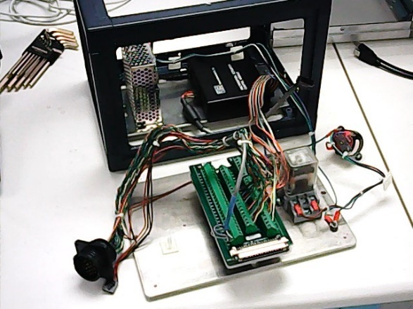
- Disconnect all the wires from the Old NI Card.
- Remove the Relay (5V) and discard.
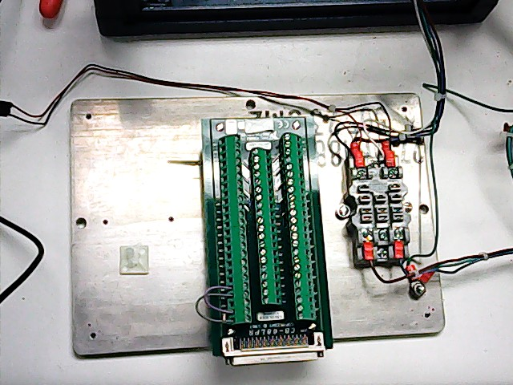

- Unscrew the Relay Block and any grounding wires from the Bottom Panel. The Relay Block will be reused. The Bottom Panel can be discarded.
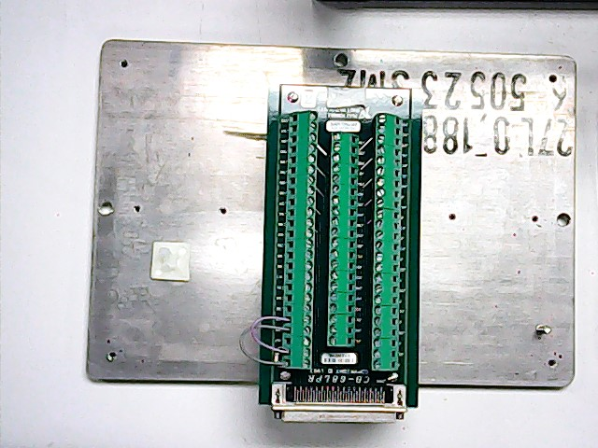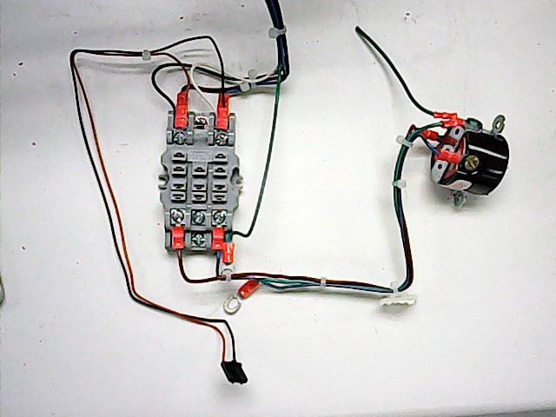

Rewire
- Remove the NI USB-6501 from its housing.
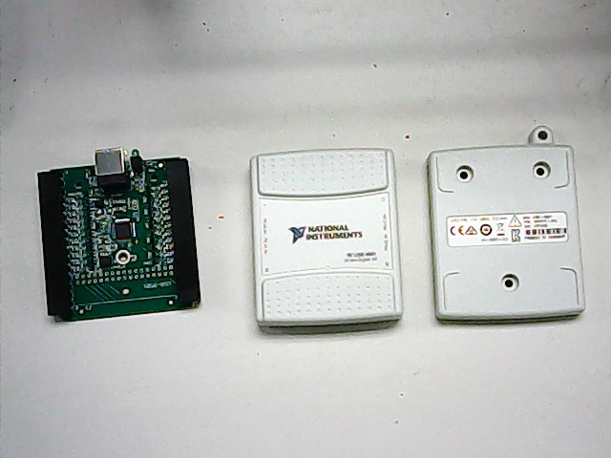
- Attach the 2 female pin connectors to the NI USB-6501 and label accordingly.
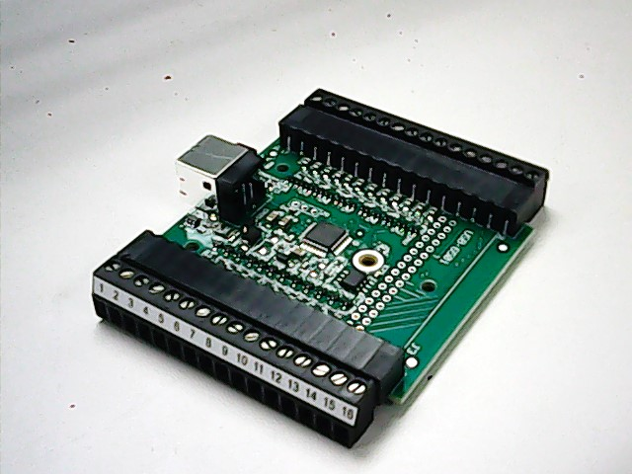
- Using the Internal Wiring II tab of the Wiring Diagram, connect the PSU Wire Bundle to the NI USB-6501.
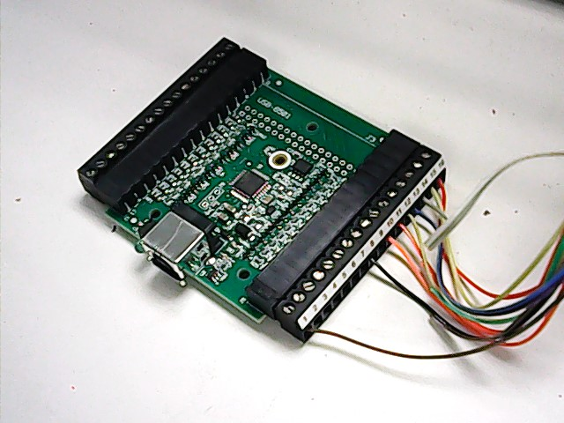

- Using the Internal Wiring I tab of the Wiring Diagram, connect a CPC Connector (16 Pin) to the NI USB-6501. Thread the wires through the appropriate slot in the New Back Panel as you connect them (see the first image below).
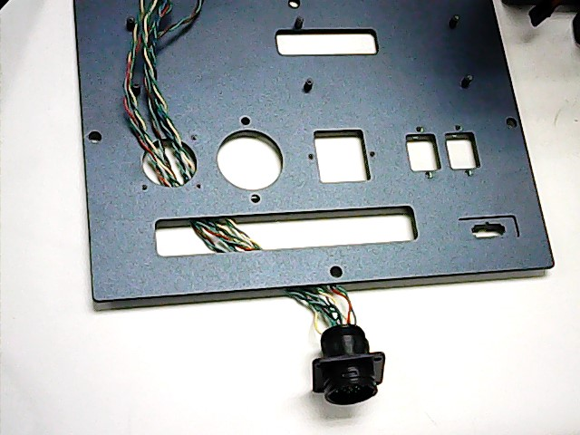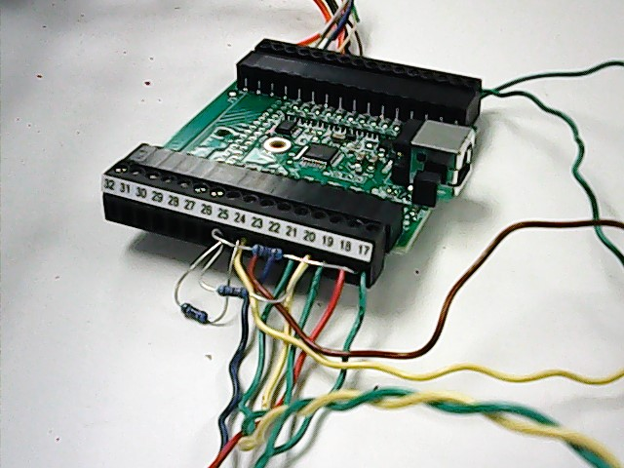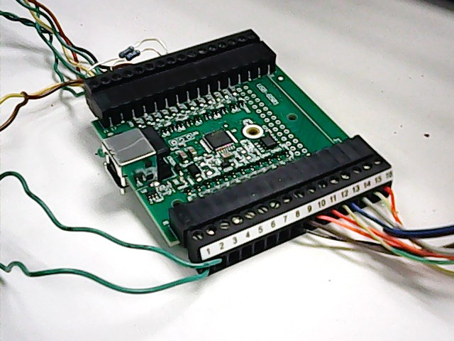
- Thread the NI USB-6501 through the appropriate side of the box (see below). Attach the NI USB-6501 to the NI USB-6501 Panel.
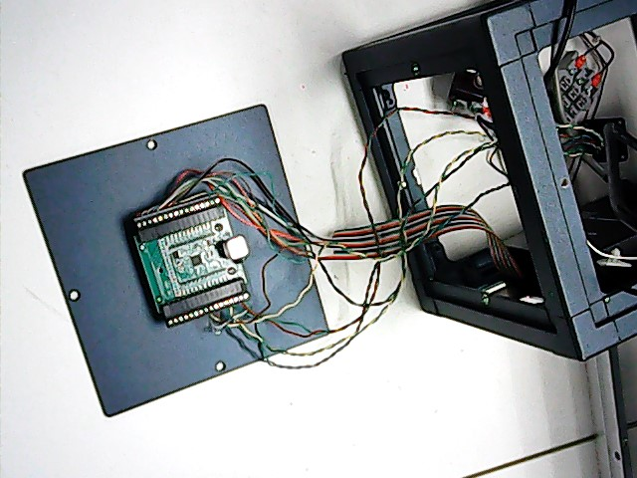
- Cut the center wire of the Custom 5 Pin Cord.
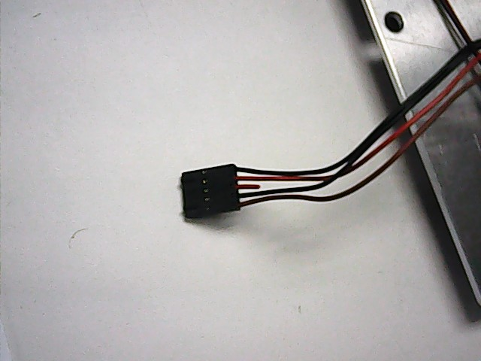

- Using the Relay Driver tab of the Wiring Diagram, connect the wires to the PSU and NI USB-6501.
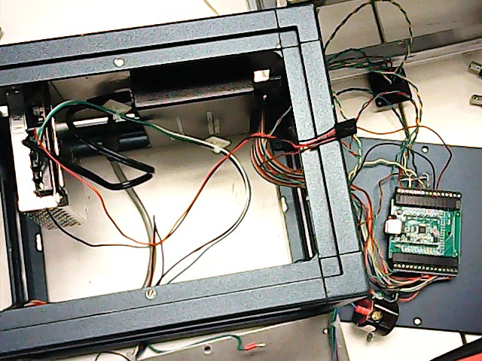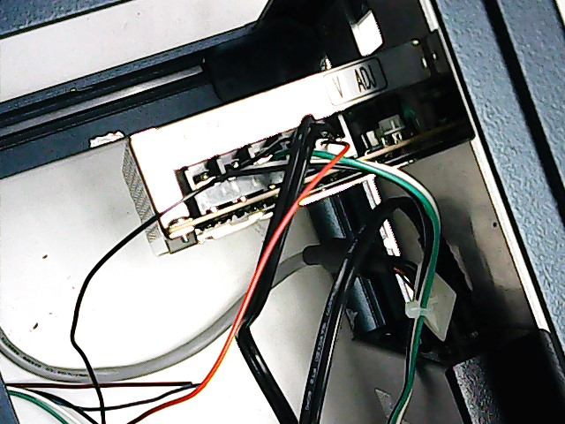

Assembly
- Assemble the New Bottom Panel Assembly as shown below.
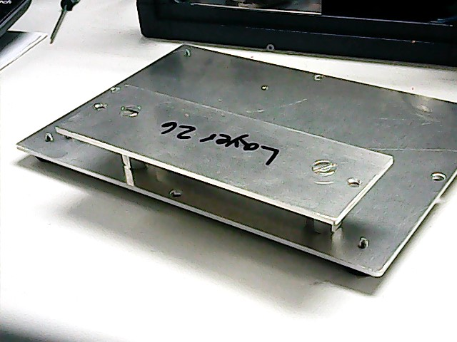
- Attach the Startech Serial Port to the New Bottom Panel.
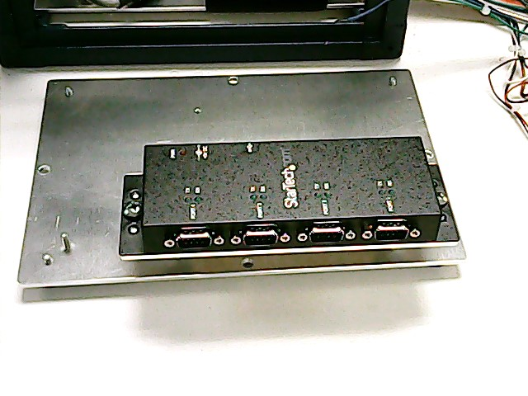
- Attach the Relay Block to the New Bottom Panel. If there are ground wires, connect them to the ground screw anchor.

- Plug the Relay (24V) into the Relay Block.
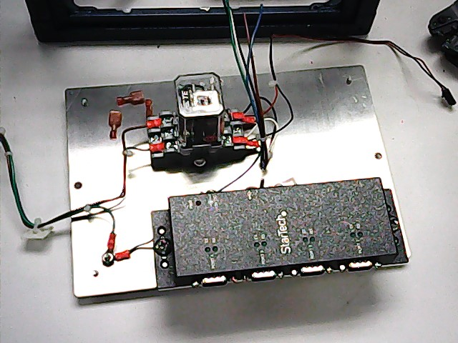
- Attach the New Bottom Panel to the CPSM Structure.
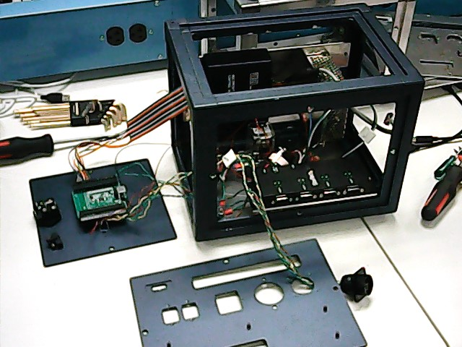
- Attach the CPC Connector (16 Pin), the AC Power Inlet, and 2 AB USB Adaptors to the New Back Panel.
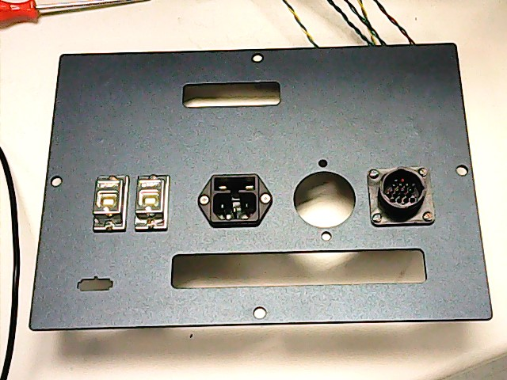

- Per the AC Wiring tab of the Wiring Diagram, place a 10A / 125V fuse into the AC Power Inlet.
- Attach the Column Heater Board to the New Back Panel.
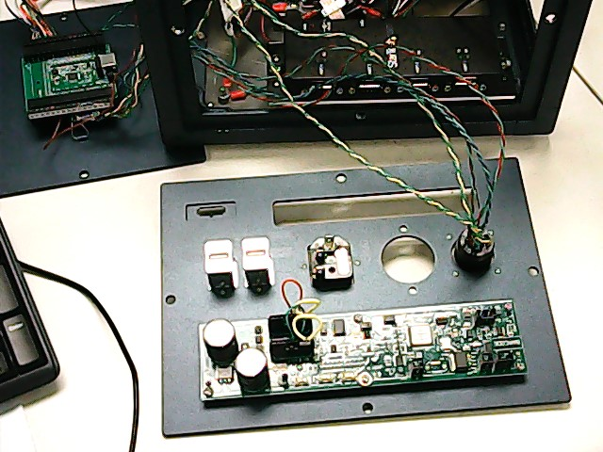
- Attach the New Back Panel to the CPSM Structure.
- Attach the Hubbell Adaptor to the New Back Panel.
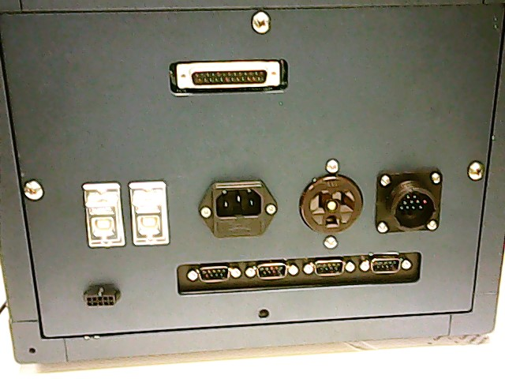
- Connect the wires from the Relay Block and the Hubbell Adaptor to the AC Power Inlet per the AC Wiring tab of the Wiring Diagram.
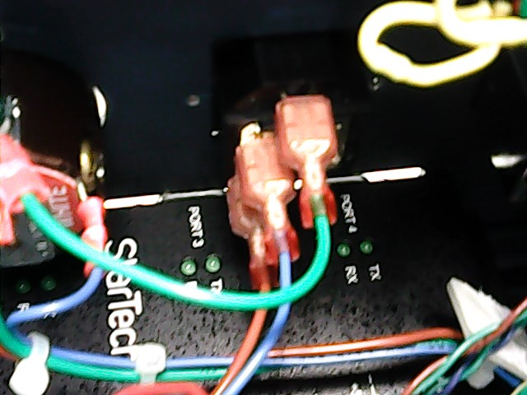

- Pop the VICI 10 Pin Cord into the appropriate slot.
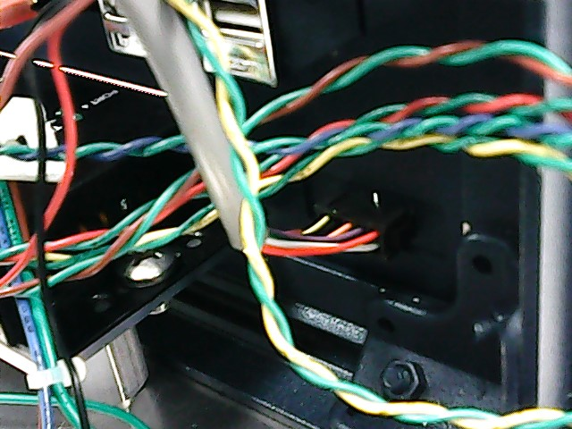
- Take 2 AB USB Cords and connect the NI USB-6501 and the Startech Serial Port to the 2 AB USB Adaptor.
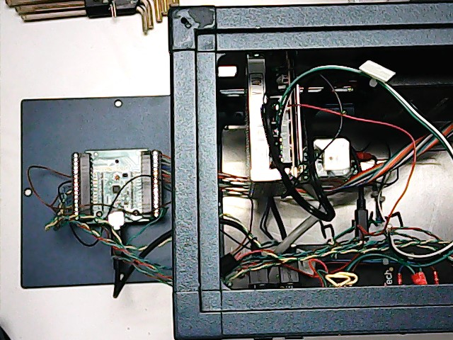
- Attach the NI USB-6501 Panel to the CPSM Structure.
- Connect the wire from the Relay Block and the Custom 5 Pin Cord to the Custom Ecord Board.
- Connect the wire fro the Custom Ecord Board to the Column Heater Board.
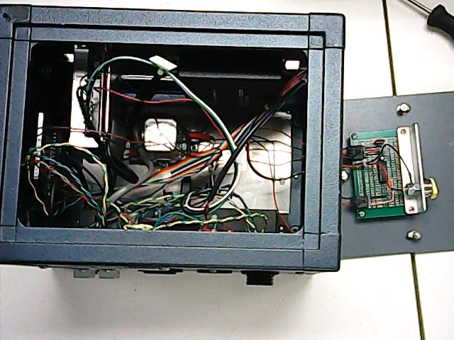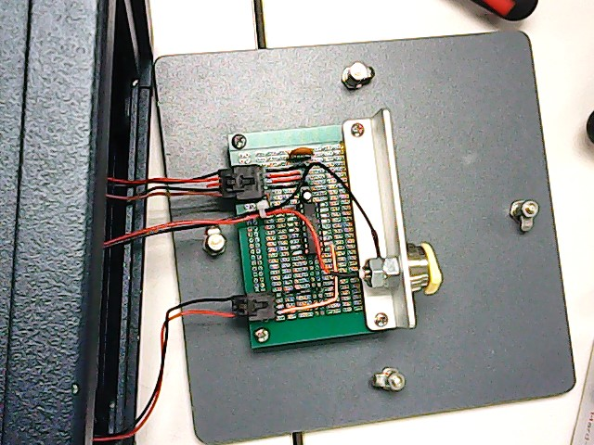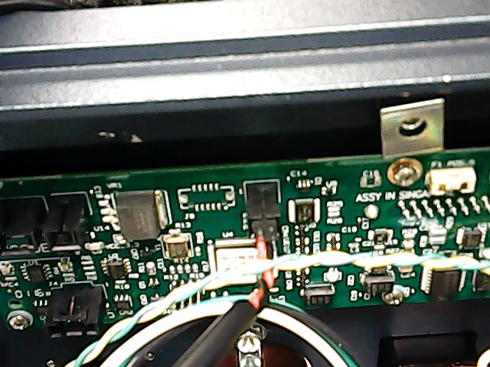
- Attach the Custom Ecord Panel to the CPSM Structure.
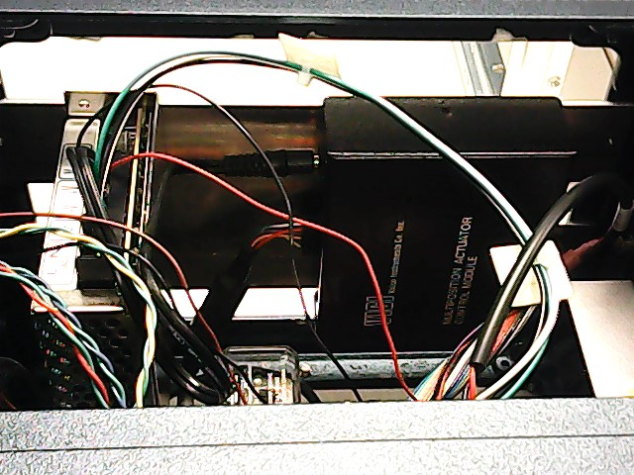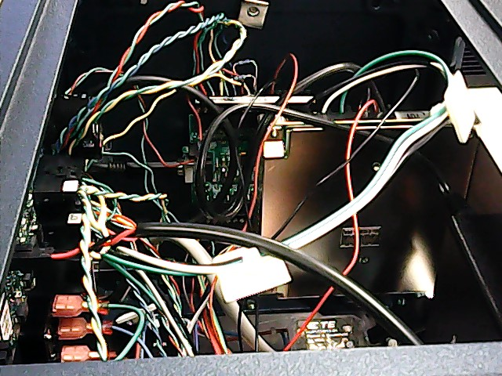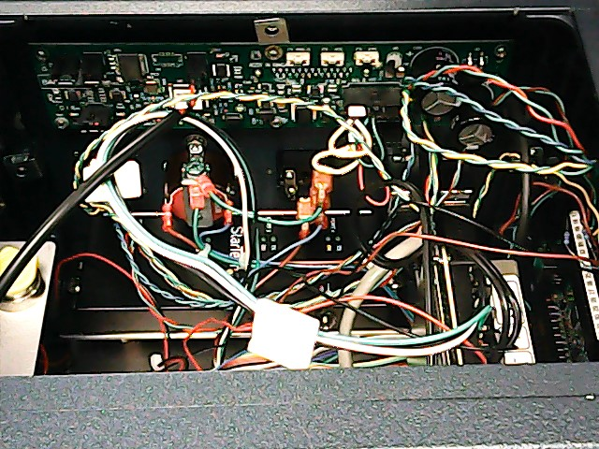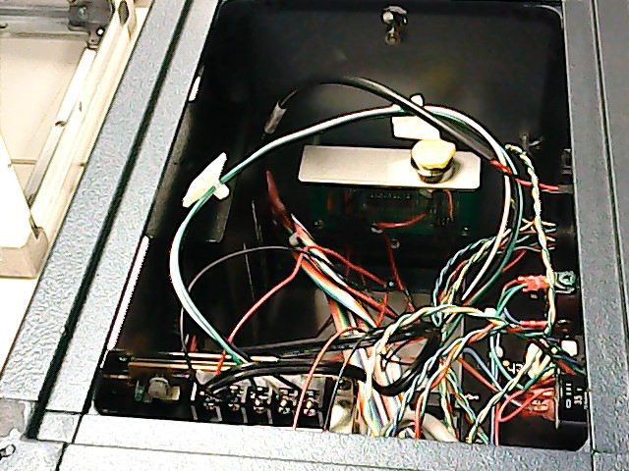
- Attach the Top Panel and the Back Panel.
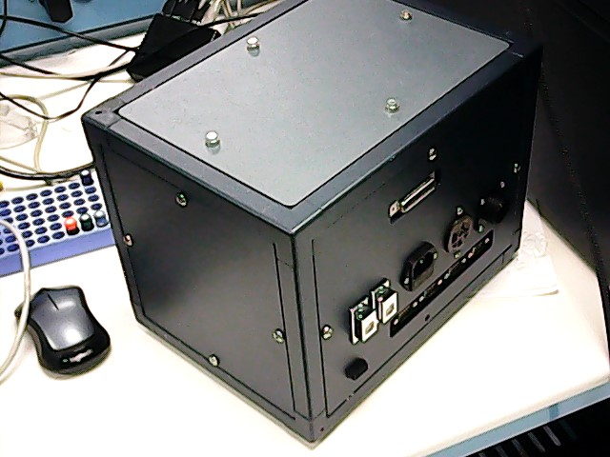

Glossary
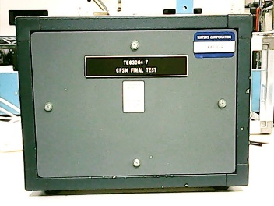  Front Panel | 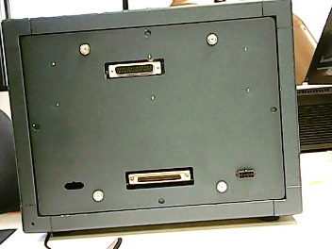  Back Panel | 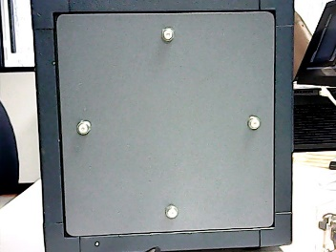  Custom Ecord Panel | 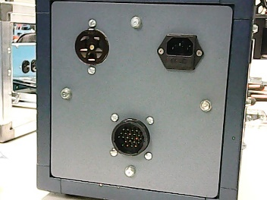  Old Power Panel
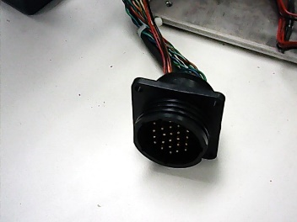  CPC Connector (24 Pin) | 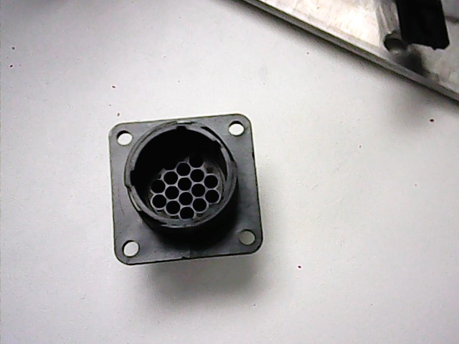  CPC Connector (16 Pin) | 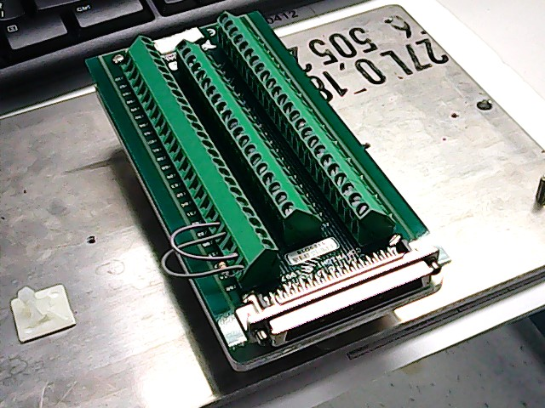  Old NI Card | NI USB-6501
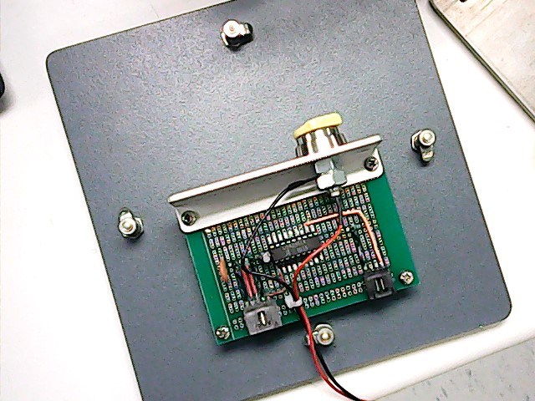  Custom Ecord Board | 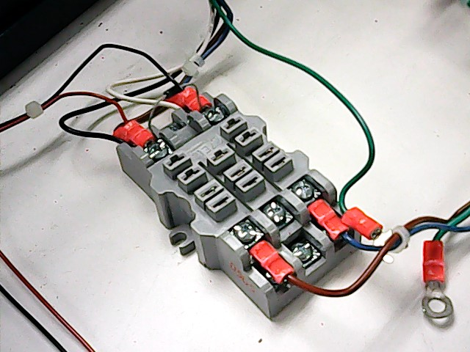  Relay Block | 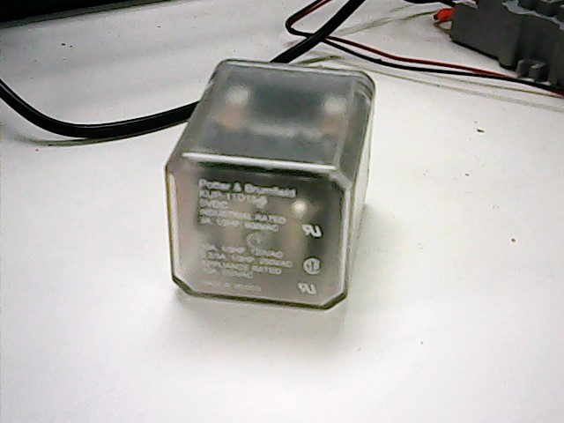  Relay (5V) | 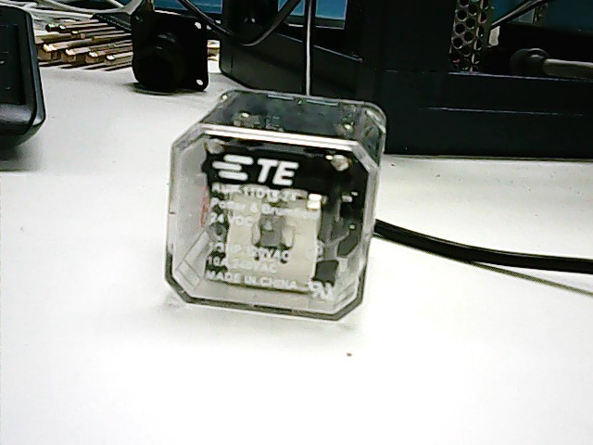  Relay (24V)
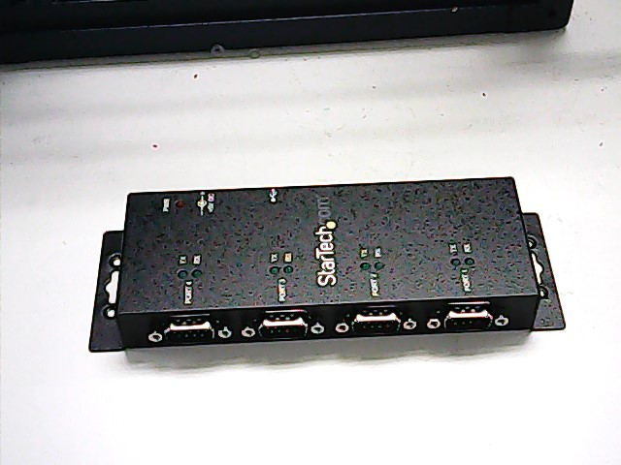  Startech Serial Port | 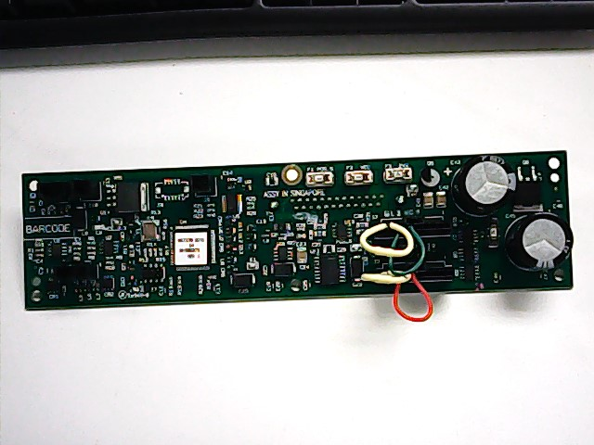  Column Heater Board | 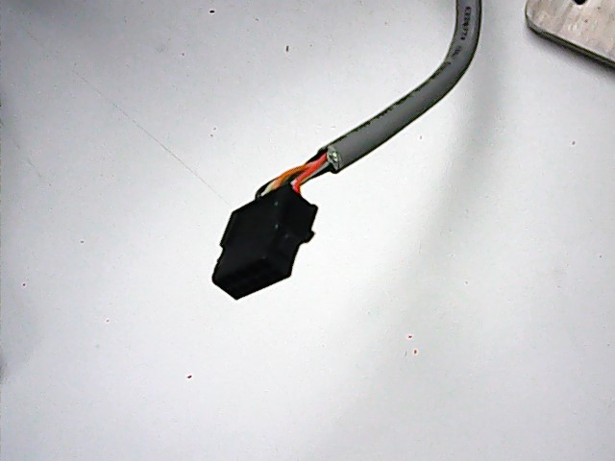  VICI 10 Pin Cord | 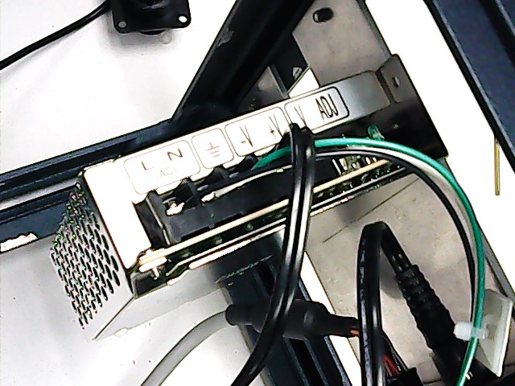  PSU
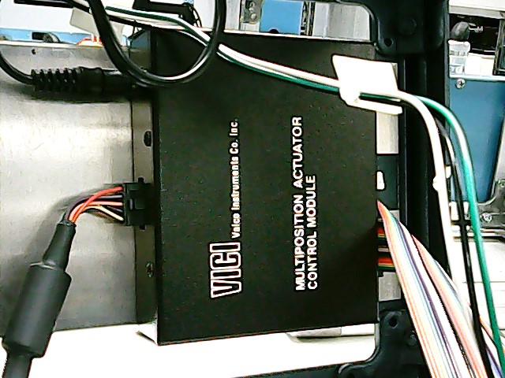  Controller | 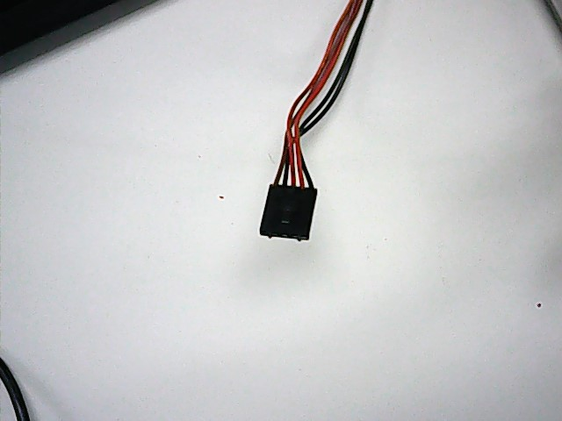  Custom 5 Pin Cord | 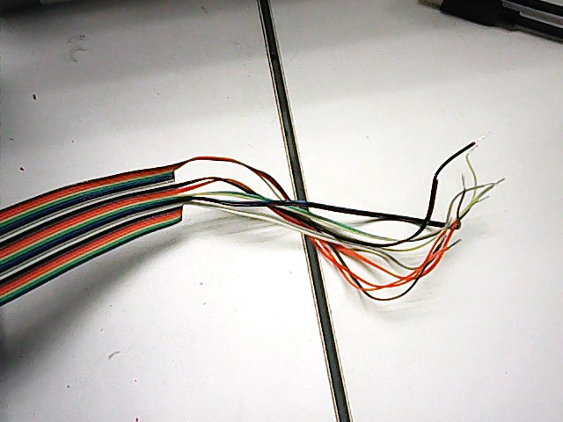  PSU Wire Bundle | 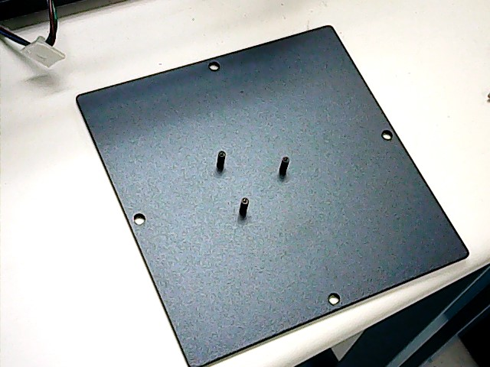  NI USB-6501 Panel
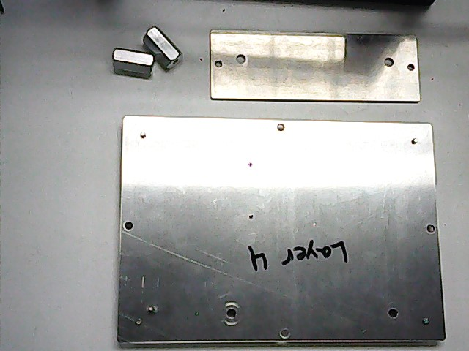  New Bottom Panel Assembly | 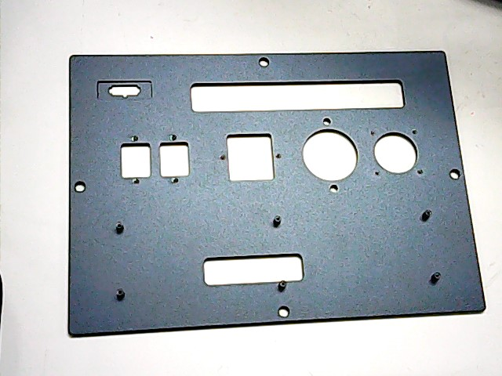  New Back Panel | 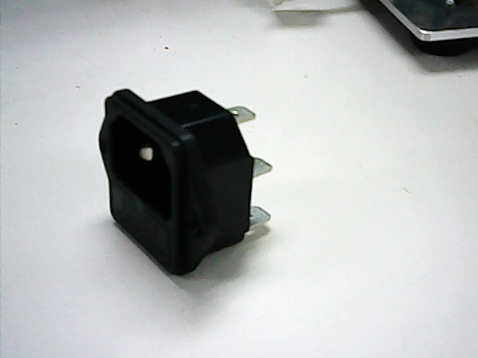  AC Power Inlet | 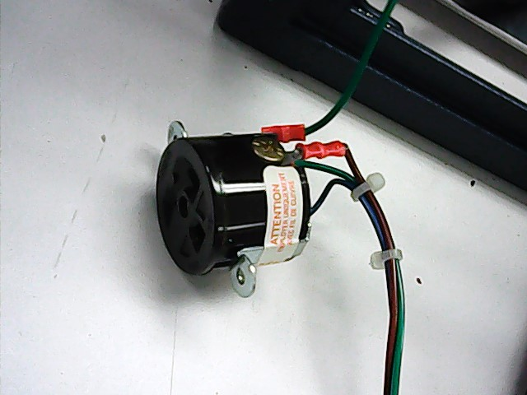  Hubbell Adaptor
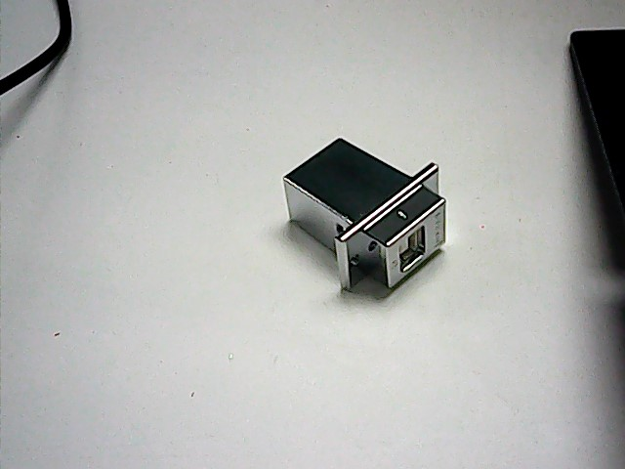  AB USB Adaptor | 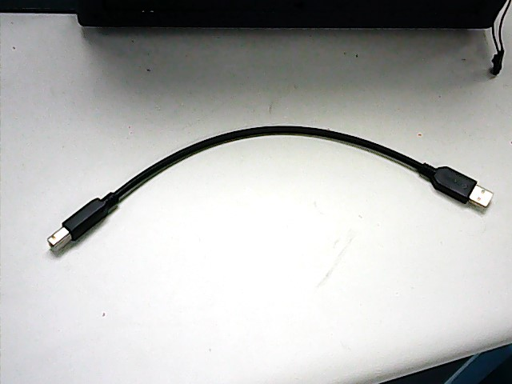  AB USB Cord

